CO2020- Computer Aided Numerical Methods
HomeWork 5 – Parabolic PDEs

Ishaan Jain
CO21BTECH11006

Ans1.
(a)

We know that,
eqn(i)
eqn(ii)
where, and ,
On calculating, , ,and

And the unit vectors are defined as:

and

Substituting in the first equation,
eqn(iii)
eqn(iv)

from i, ii, iii and iv,

i.e.

To solve the continuity equation,

and

Hence,

In 2D, we can neglect z-axis term;
So the final equation becomes:

(b) The Gradient operator in Cylindrical coordinates we already defined and proved in the last part, using that result:

We can neglect the z axis for 2D form:

Ans 2.
(a) The stencils for and are calculated the by the following taylor series expansion:

Find the inverse and find the second row which will give the value of .
Similarly find the right stencil at i = nx-2.
The values calculated are implemented in the code.
(b) Von-Neumann stability analysis:

where n in the time instance and j is the position.

For The analysis to be stable,

In limiting case, r holds it’s maximum value as
at r = 0.5,

number of partitions = at which the system is stable. After this the error starts growing.
There may be an error in calculations because for me, after n = 62, error is starting to grow.
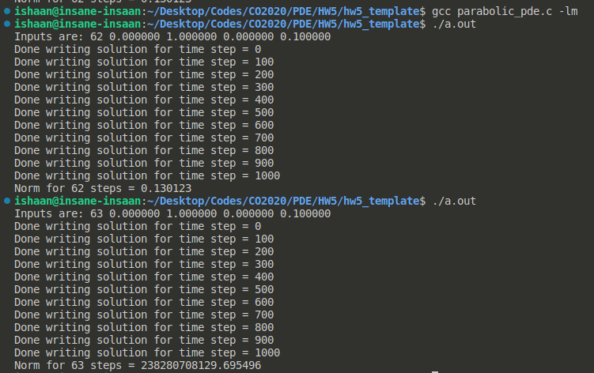
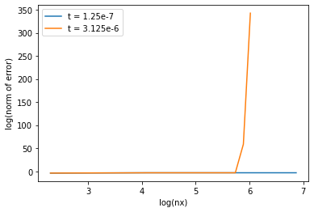
(c)

The graph above is the error vs nx plot for two different time intervals.
Initially, the log-log values are parallel to the straight line with slope = -4.
for second case, after nx = 350 (approx), the error starts to grow and we see a asymptotic curve in our plot.

