**Tools & Technologies Used: Bootstrap 4, HTML, CSS, PHP, WAMP x64**

1) Install WAMP Server

2) Copy the extracted file to C:\wamp64\www

3) Start the mySQL & Apache server.

4) Edit connection.php with your sql credentials.

5) Import the dummy database via phpmyadmin <http://localhost/phpmyadmin/>

6) Open http://localhost/udaan/index.php to open the administration panel.

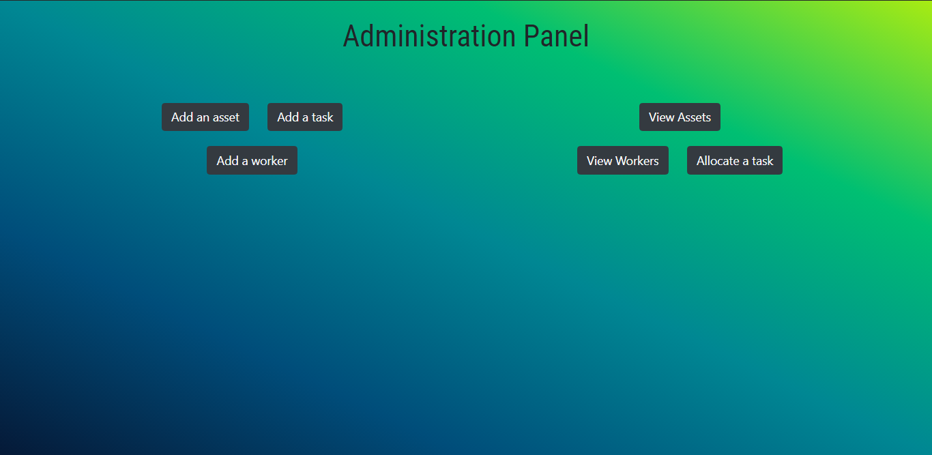

To add a task click "Add a task" button

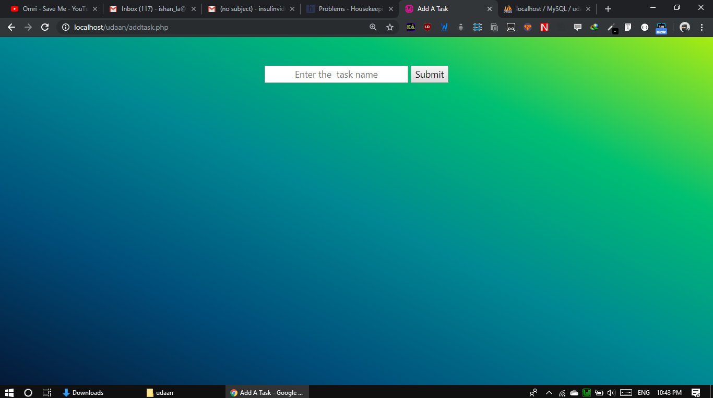

To add an asset click on "Add an asset" button

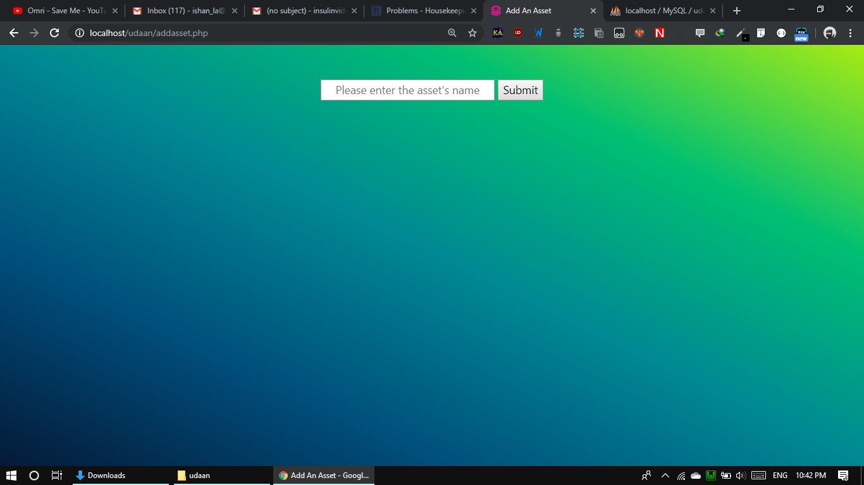

To add a worker click on "Add a worker" button

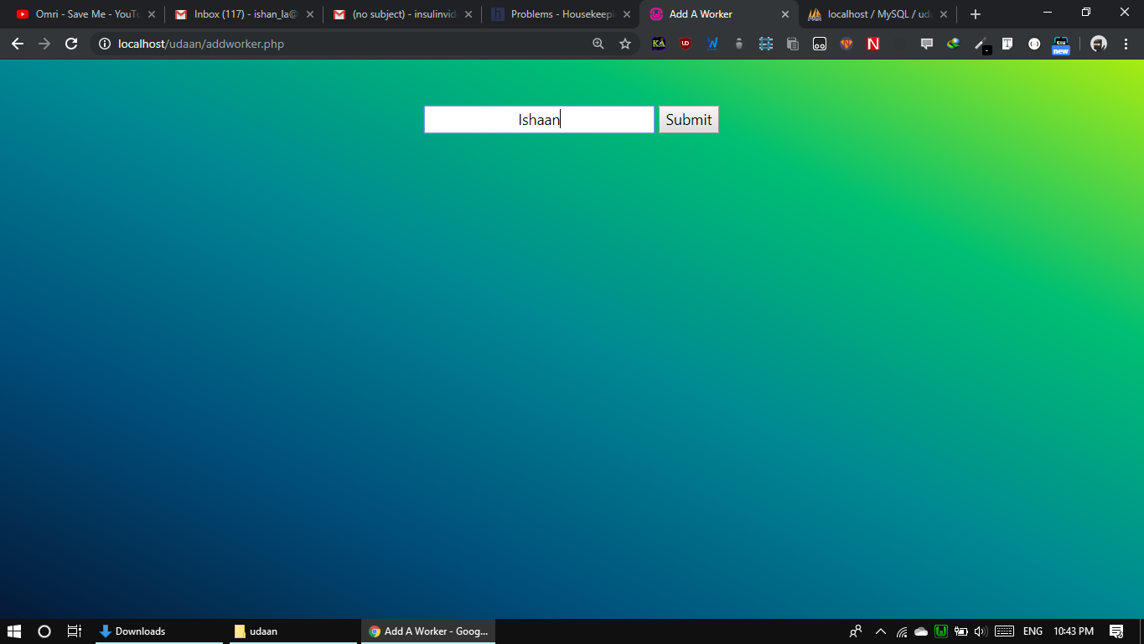

To view all assets click on "View Assets" button

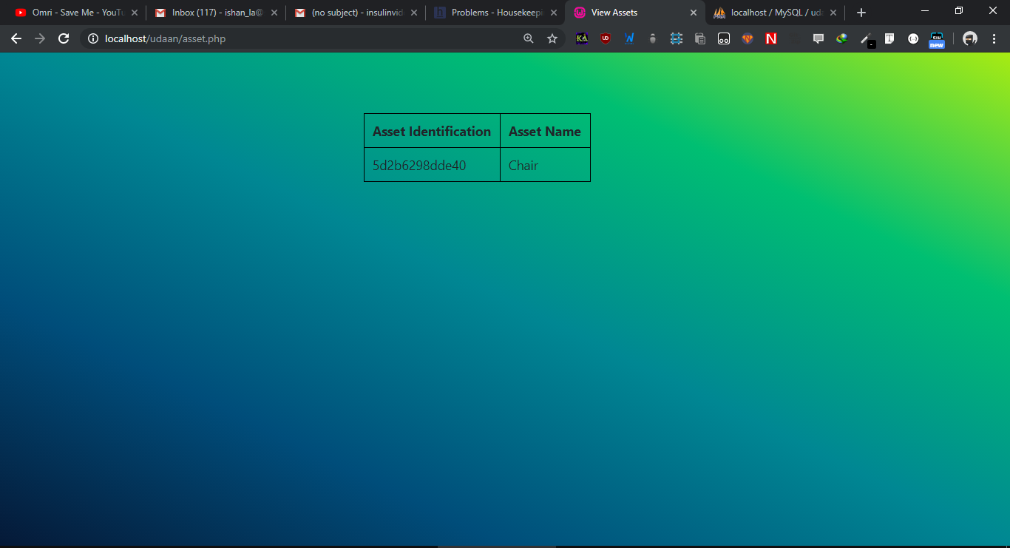

To view workers click on "View Workers" button

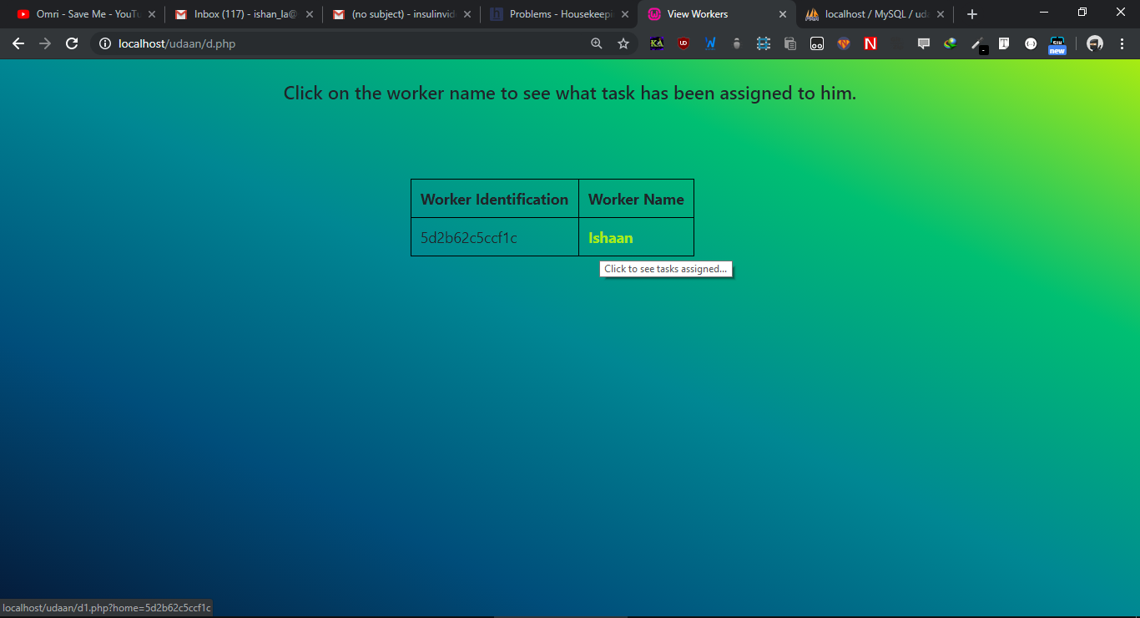

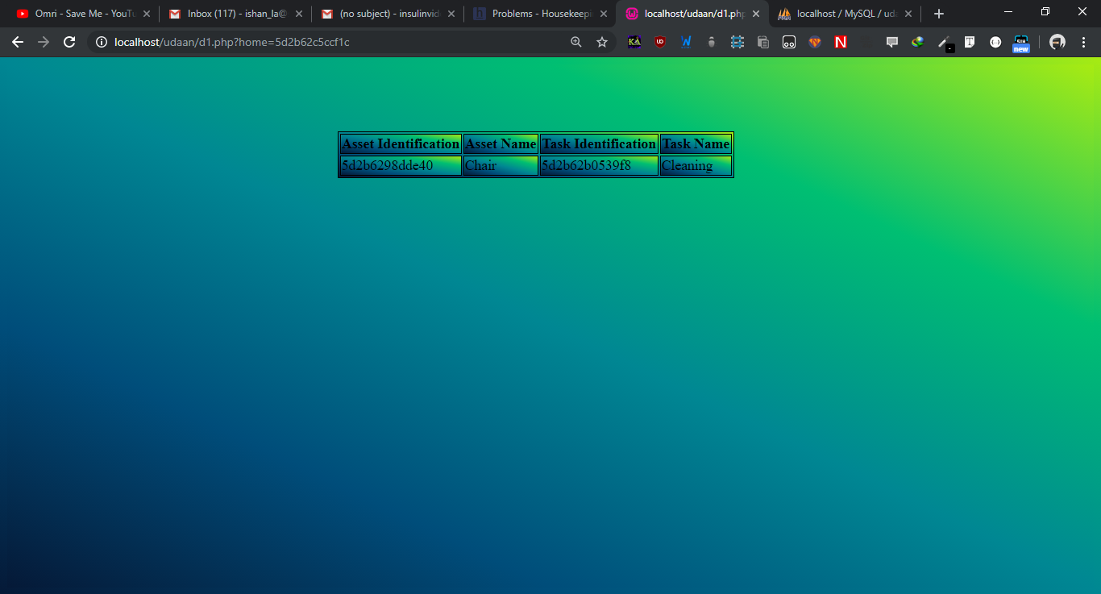

To Allocate a task click on "Allocate a task button"

To allocate a task select the asset, worker, task and frequency.

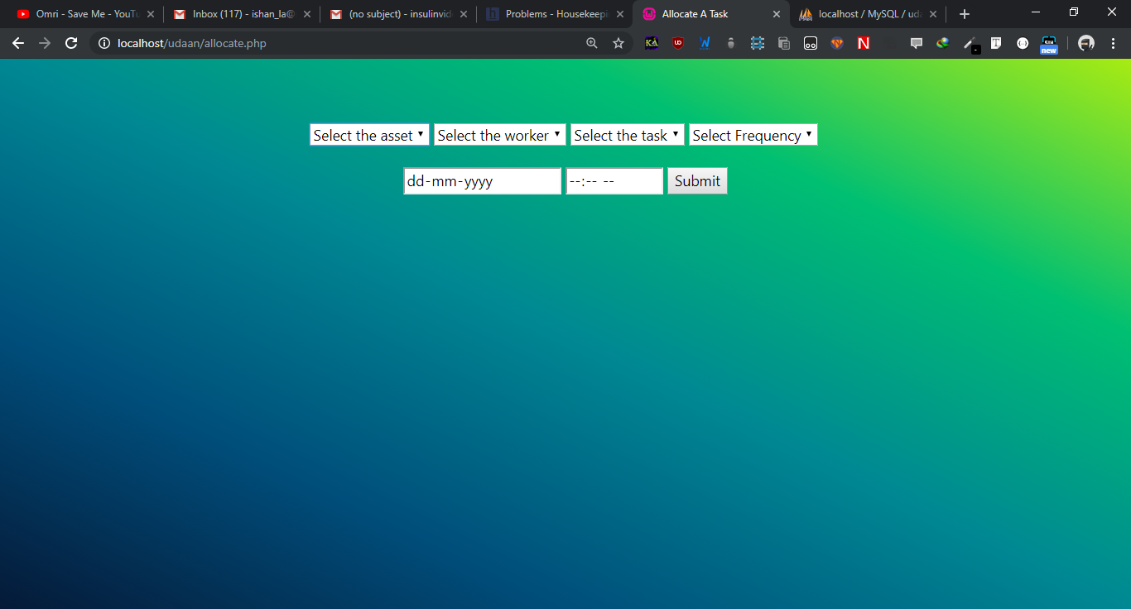

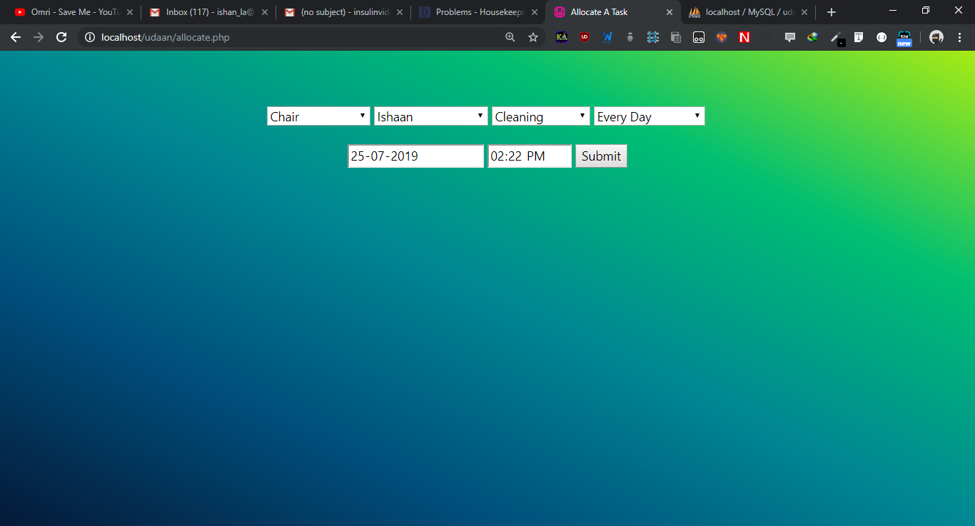

Now select the date and deadline of the work.

Click on submit