**Assignment 3**

Create a database named college

Create a table name student in college database with following structure

roll,name,class,marks,age with respective datatypes.

Insert at least 5 rows in the table.

Delete the entry of roll number 4

Update the marks of roll number 3

Give additional grace marks of 0.5 to all students.

Truncate the table

Insert the data again using multi-insert statement.

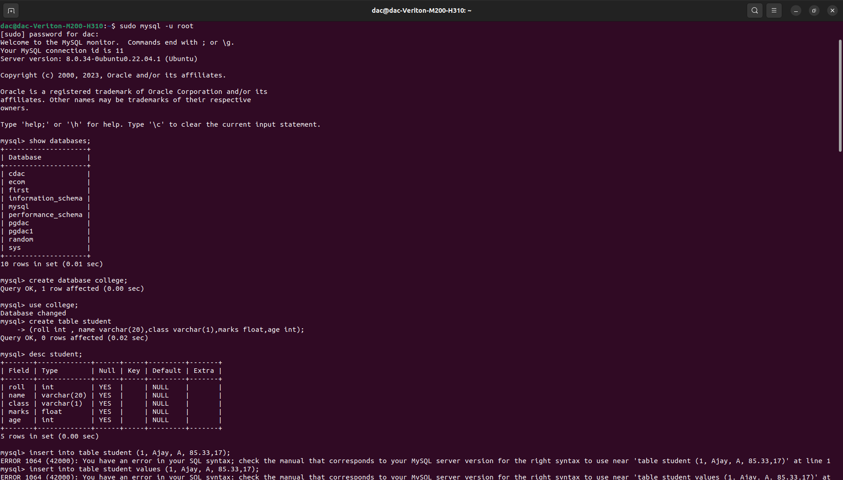



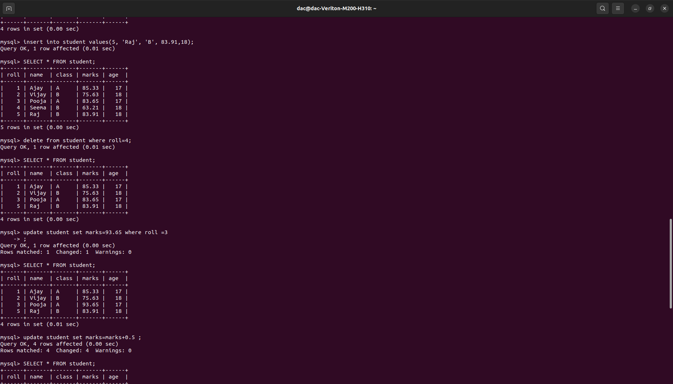

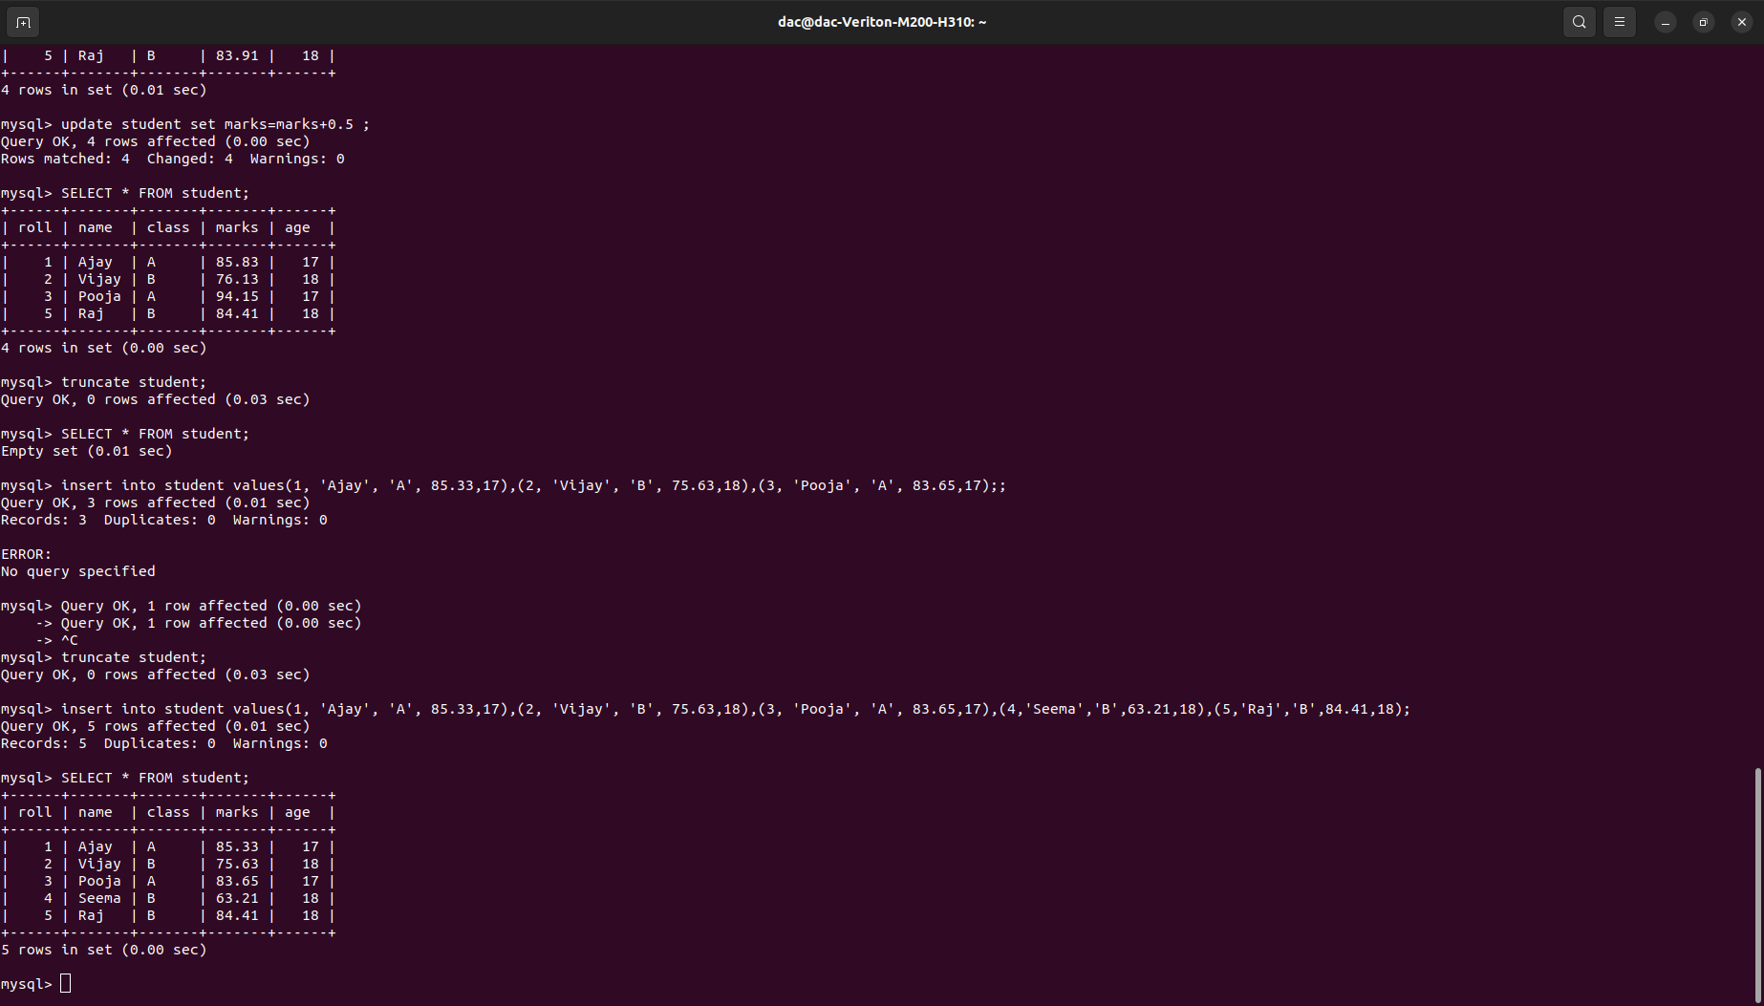

Queries:

sudo mysql -u root

create database college;

use college;

desc student;

insert into student values(1, 'Ajay', 'A', 85.33,17);

insert into student values(2, 'Vijay', 'B', 75.63,18);  
 insert into student values(3, 'Pooja', 'A', 83.65,17);

insert into student values(4, 'Seema', 'B', 63.21,18);

insert into student values(5, 'Raj', 'B', 83.91,18);

delete from student where roll=4;  
update student set marks=93.65 where roll =3

-> ;

update student set marks=marks+0.5 ;

SELECT * FROM student;

truncate student;

insert into student values(1, 'Ajay', 'A', 85.33,17),(2, 'Vijay', 'B', 75.63,18),(3, 'Pooja', 'A', 83.65,17),(4,'Seema','B',63.21,18),(5,'Raj','B',84.41,18);

SELECT * FROM student;

ac@dac-Veriton-M200-H310:~$ sudo mysql -u root

[sudo] password for dac:

Welcome to the MySQL monitor. Commands end with ; or \g.

Your MySQL connection id is 11

Server version: 8.0.34-0ubuntu0.22.04.1 (Ubuntu)

Copyright (c) 2000, 2023, Oracle and/or its affiliates.

Oracle is a registered trademark of Oracle Corporation and/or its

affiliates. Other names may be trademarks of their respective

owners.

Type 'help;' or '\h' for help. Type '\c' to clear the current input statement.

mysql> show databases;

+--------------------+

| Database |

+--------------------+

| cdac |

| ecom |

| first |

| information_schema |

| mysql |

| performance_schema |

| pgdac |

| pgdac1 |

| random |

| sys |

+--------------------+

10 rows in set (0.01 sec)

mysql> create database college;

Query OK, 1 row affected (0.00 sec)

mysql> use college;

Database changed

mysql> create table student

-> (roll int , name varchar(20),class varchar(1),marks float,age int);

Query OK, 0 rows affected (0.02 sec)

mysql> desc student;

+-------+-------------+------+-----+---------+-------+

| Field | Type | Null | Key | Default | Extra |

+-------+-------------+------+-----+---------+-------+

| roll | int | YES | | NULL | |

| name | varchar(20) | YES | | NULL | |

| class | varchar(1) | YES | | NULL | |

| marks | float | YES | | NULL | |

| age | int | YES | | NULL | |

+-------+-------------+------+-----+---------+-------+

5 rows in set (0.00 sec)

mysql> insert into table student (1, Ajay, A, 85.33,17);

ERROR 1064 (42000): You have an error in your SQL syntax; check the manual that corresponds to your MySQL server version for the right syntax to use near 'table student (1, Ajay, A, 85.33,17)' at line 1

mysql> insert into table student values (1, Ajay, A, 85.33,17);

ERROR 1064 (42000): You have an error in your SQL syntax; check the manual that corresponds to your MySQL server version for the right syntax to use near 'table student values (1, Ajay, A, 85.33,17)' at line 1

mysql> insert into student values (1, Ajay, A, 85.33,17);

ERROR 1054 (42S22): Unknown column 'Ajay' in 'field list'

mysql> insert into student values(1, Ajay, A, 85.33,17);

ERROR 1054 (42S22): Unknown column 'Ajay' in 'field list'

mysql> insert into student

-> values(1, Ajay, A, 85.33,17);

ERROR 1054 (42S22): Unknown column 'Ajay' in 'field list'

mysql>

mysql> insert into student values(1, 'Ajay', 'A', 85.33,17);

Query OK, 1 row affected (0.00 sec)

mysql> SELECT * FROM student;

+------+------+-------+-------+------+

| roll | name | class | marks | age |

+------+------+-------+-------+------+

| 1 | Ajay | A | 85.33 | 17 |

+------+------+-------+-------+------+

1 row in set (0.00 sec)

mysql> insert into student values(2, 'Vijay', 'B', 75.63,18);

Query OK, 1 row affected (0.01 sec)

mysql> SELECT * FROM student;

+------+-------+-------+-------+------+

| roll | name | class | marks | age |

+------+-------+-------+-------+------+

| 1 | Ajay | A | 85.33 | 17 |

| 2 | Vijay | B | 75.63 | 18 |

+------+-------+-------+-------+------+

2 rows in set (0.00 sec)

mysql> insert into student values(3, 'Pooja', 'A', 83.65,17);

Query OK, 1 row affected (0.00 sec)

mysql> SELECT * FROM student;

+------+-------+-------+-------+------+

| roll | name | class | marks | age |

+------+-------+-------+-------+------+

| 1 | Ajay | A | 85.33 | 17 |

| 2 | Vijay | B | 75.63 | 18 |

| 3 | Pooja | A | 83.65 | 17 |

+------+-------+-------+-------+------+

3 rows in set (0.00 sec)

mysql> insert into student values(4, 'Seema', 'B', 63.21,18);

Query OK, 1 row affected (0.00 sec)

mysql> SELECT * FROM student;

+------+-------+-------+-------+------+

| roll | name | class | marks | age |

+------+-------+-------+-------+------+

| 1 | Ajay | A | 85.33 | 17 |

| 2 | Vijay | B | 75.63 | 18 |

| 3 | Pooja | A | 83.65 | 17 |

| 4 | Seema | B | 63.21 | 18 |

+------+-------+-------+-------+------+

4 rows in set (0.00 sec)

mysql> insert into student values(5, 'Raj', 'B', 83.91,18);

Query OK, 1 row affected (0.01 sec)

mysql> SELECT * FROM student;

+------+-------+-------+-------+------+

| roll | name | class | marks | age |

+------+-------+-------+-------+------+

| 1 | Ajay | A | 85.33 | 17 |

| 2 | Vijay | B | 75.63 | 18 |

| 3 | Pooja | A | 83.65 | 17 |

| 4 | Seema | B | 63.21 | 18 |

| 5 | Raj | B | 83.91 | 18 |

+------+-------+-------+-------+------+

5 rows in set (0.00 sec)

mysql> delete from student where roll=4;

Query OK, 1 row affected (0.01 sec)

mysql> SELECT * FROM student;

+------+-------+-------+-------+------+

| roll | name | class | marks | age |

+------+-------+-------+-------+------+

| 1 | Ajay | A | 85.33 | 17 |

| 2 | Vijay | B | 75.63 | 18 |

| 3 | Pooja | A | 83.65 | 17 |

| 5 | Raj | B | 83.91 | 18 |

+------+-------+-------+-------+------+

4 rows in set (0.00 sec)

mysql> update student set marks=93.65 where roll =3

-> ;

Query OK, 1 row affected (0.00 sec)

Rows matched: 1 Changed: 1 Warnings: 0

mysql> SELECT * FROM student;

+------+-------+-------+-------+------+

| roll | name | class | marks | age |

+------+-------+-------+-------+------+

| 1 | Ajay | A | 85.33 | 17 |

| 2 | Vijay | B | 75.63 | 18 |

| 3 | Pooja | A | 93.65 | 17 |

| 5 | Raj | B | 83.91 | 18 |

+------+-------+-------+-------+------+

4 rows in set (0.01 sec)

mysql> update student set marks=marks+0.5 ;

Query OK, 4 rows affected (0.00 sec)

Rows matched: 4 Changed: 4 Warnings: 0

mysql> SELECT * FROM student;

+------+-------+-------+-------+------+

| roll | name | class | marks | age |

+------+-------+-------+-------+------+

| 1 | Ajay | A | 85.83 | 17 |

| 2 | Vijay | B | 76.13 | 18 |

| 3 | Pooja | A | 94.15 | 17 |

| 5 | Raj | B | 84.41 | 18 |

+------+-------+-------+-------+------+

4 rows in set (0.00 sec)

mysql> truncate student;

Query OK, 0 rows affected (0.03 sec)

mysql> SELECT * FROM student;

Empty set (0.01 sec)

mysql> insert into student values(1, 'Ajay', 'A', 85.33,17),(2, 'Vijay', 'B', 75.63,18),(3, 'Pooja', 'A', 83.65,17);;

Query OK, 3 rows affected (0.01 sec)

Records: 3 Duplicates: 0 Warnings: 0

ERROR:

No query specified

mysql> Query OK, 1 row affected (0.00 sec)

-> Query OK, 1 row affected (0.00 sec)

-> ^C

mysql> truncate student;

Query OK, 0 rows affected (0.03 sec)

mysql> insert into student values(1, 'Ajay', 'A', 85.33,17),(2, 'Vijay', 'B', 75.63,18),(3, 'Pooja', 'A', 83.65,17),(4,'Seema','B',63.21,18),(5,'Raj','B',84.41,18);

Query OK, 5 rows affected (0.01 sec)

Records: 5 Duplicates: 0 Warnings: 0

mysql> SELECT * FROM student;

+------+-------+-------+-------+------+

| roll | name | class | marks | age |

+------+-------+-------+-------+------+

| 1 | Ajay | A | 85.33 | 17 |

| 2 | Vijay | B | 75.63 | 18 |

| 3 | Pooja | A | 83.65 | 17 |

| 4 | Seema | B | 63.21 | 18 |

| 5 | Raj | B | 84.41 | 18 |

+------+-------+-------+-------+------+

5 rows in set (0.00 sec)

mysql> ^C

mysql> desc college;

ERROR 1146 (42S02): Table 'college.college' doesn't exist

mysql> desc student;

+-------+-------------+------+-----+---------+-------+

| Field | Type | Null | Key | Default | Extra |

+-------+-------------+------+-----+---------+-------+

| roll | int | YES | | NULL | |

| name | varchar(20) | YES | | NULL | |

| class | varchar(1) | YES | | NULL | |

| marks | float | YES | | NULL | |

| age | int | YES | | NULL | |

+-------+-------------+------+-----+---------+-------+

5 rows in set (0.00 sec)

mysql> show tables;

+-------------------+

| Tables_in_college |

+-------------------+

| student |

+-------------------+

1 row in set (0.00 sec)

mysql> select * from student;

+------+-------+-------+-------+------+

| roll | name | class | marks | age |

+------+-------+-------+-------+------+

| 1 | Ajay | A | 85.33 | 17 |

| 2 | Vijay | B | 75.63 | 18 |

| 3 | Pooja | A | 83.65 | 17 |

| 4 | Seema | B | 63.21 | 18 |

| 5 | Raj | B | 84.41 | 18 |

+------+-------+-------+-------+------+

5 rows in set (0.00 sec)

mysql> alter student set roll primary key;

ERROR 1064 (42000): You have an error in your SQL syntax; check the manual that corresponds to your MySQL server version for the right syntax to use near 'student set roll primary key' at line 1

mysql> alter table student set roll primary key;

ERROR 1064 (42000): You have an error in your SQL syntax; check the manual that corresponds to your MySQL server version for the right syntax to use near 'set roll primary key' at line 1

mysql> alter table student modify roll primary key;

ERROR 1064 (42000): You have an error in your SQL syntax; check the manual that corresponds to your MySQL server version for the right syntax to use near 'primary key' at line 1

mysql> alter table student modify roll primarykey;

ERROR 1064 (42000): You have an error in your SQL syntax; check the manual that corresponds to your MySQL server version for the right syntax to use near 'primarykey' at line 1

mysql> alter table student modify primarykey roll;

ERROR 1064 (42000): You have an error in your SQL syntax; check the manual that corresponds to your MySQL server version for the right syntax to use near 'roll' at line 1

mysql> alter table student modify primarykey (roll);

ERROR 1064 (42000): You have an error in your SQL syntax; check the manual that corresponds to your MySQL server version for the right syntax to use near '(roll)' at line 1

mysql>

mysql> alter table student modify primary key (roll);

ERROR 1064 (42000): You have an error in your SQL syntax; check the manual that corresponds to your MySQL server version for the right syntax to use near 'primary key (roll)' at line 1

mysql> alter table student add primary key (roll);

Query OK, 0 rows affected (0.04 sec)

Records: 0 Duplicates: 0 Warnings: 0

mysql> desc student;

+-------+-------------+------+-----+---------+-------+

| Field | Type | Null | Key | Default | Extra |

+-------+-------------+------+-----+---------+-------+

| roll | int | NO | PRI | NULL | |

| name | varchar(20) | YES | | NULL | |

| class | varchar(1) | YES | | NULL | |

| marks | float | YES | | NULL | |

| age | int | YES | | NULL | |

+-------+-------------+------+-----+---------+-------+

5 rows in set (0.00 sec)

mysql> select sum(marks) from student;

+-------------------+

| sum(marks) |

+-------------------+

| 392.2300033569336 |

+-------------------+

1 row in set (0.00 sec)

mysql> select avg(marks) from student;

+-------------------+

| avg(marks) |

+-------------------+

| 78.44600067138671 |

+-------------------+

1 row in set (0.00 sec)

mysql> select avg(age) from student;

+----------+

| avg(age) |

+----------+

| 17.6000 |

+----------+

1 row in set (0.00 sec)

mysql> select min(marks) from student;

+------------+

| min(marks) |

+------------+

| 63.21 |

+------------+

1 row in set (0.00 sec)

mysql> select max(marks) from student;

+------------+

| max(marks) |

+------------+

| 85.33 |

+------------+

1 row in set (0.00 sec)

mysql> select count(roll) from student;

+-------------+

| count(roll) |

+-------------+

| 5 |

+-------------+

1 row in set (0.00 sec)

mysql> select count from student;

ERROR 1054 (42S22): Unknown column 'count' in 'field list'

mysql> select count() from student;

ERROR 1064 (42000): You have an error in your SQL syntax; check the manual that corresponds to your MySQL server version for the right syntax to use near ') from student' at line 1

mysql> select count(roll) from student;

+-------------+

| count(roll) |

+-------------+

| 5 |

+-------------+

1 row in set (0.00 sec)

mysql> select count(*) from student;

+----------+

| count(*) |

+----------+

| 5 |

+----------+

1 row in set (0.00 sec)

mysql> alter table student

-> drop primary key;

Query OK, 5 rows affected (0.05 sec)

Records: 5 Duplicates: 0 Warnings: 0

mysql> desc student;

+-------+-------------+------+-----+---------+-------+

| Field | Type | Null | Key | Default | Extra |

+-------+-------------+------+-----+---------+-------+

| roll | int | NO | | NULL | |

| name | varchar(20) | YES | | NULL | |

| class | varchar(1) | YES | | NULL | |

| marks | float | YES | | NULL | |

| age | int | YES | | NULL | |

+-------+-------------+------+-----+---------+-------+

5 rows in set (0.00 sec)

mysql> alter table student drop constraint roll;

ERROR 3940 (HY000): Constraint 'roll' does not exist.

mysql> alter table student drop constraint NULL roll;

ERROR 1064 (42000): You have an error in your SQL syntax; check the manual that corresponds to your MySQL server version for the right syntax to use near 'NULL roll' at line 1

mysql> alter table student drop constraint NULL from roll;

ERROR 1064 (42000): You have an error in your SQL syntax; check the manual that corresponds to your MySQL server version for the right syntax to use near 'NULL from roll' at line 1

mysql> select * from student;

+------+-------+-------+-------+------+

| roll | name | class | marks | age |

+------+-------+-------+-------+------+

| 1 | Ajay | A | 85.33 | 17 |

| 2 | Vijay | B | 75.63 | 18 |

| 3 | Pooja | A | 83.65 | 17 |

| 4 | Seema | B | 63.21 | 18 |

| 5 | Raj | B | 84.41 | 18 |

+------+-------+-------+-------+------+

5 rows in set (0.00 sec)

mysql> select * from student group by class

-> ;

ERROR 1055 (42000): Expression #1 of SELECT list is not in GROUP BY clause and contains nonaggregated column 'college.student.roll' which is not functionally dependent on columns in GROUP BY clause; this is incompatible with sql_mode=only_full_group_by

mysql> select * from student order by marks;

+------+-------+-------+-------+------+

| roll | name | class | marks | age |

+------+-------+-------+-------+------+

| 4 | Seema | B | 63.21 | 18 |

| 2 | Vijay | B | 75.63 | 18 |

| 3 | Pooja | A | 83.65 | 17 |

| 5 | Raj | B | 84.41 | 18 |

| 1 | Ajay | A | 85.33 | 17 |

+------+-------+-------+-------+------+

5 rows in set (0.00 sec)

mysql> select * from student order by marks desc;

+------+-------+-------+-------+------+

| roll | name | class | marks | age |

+------+-------+-------+-------+------+

| 1 | Ajay | A | 85.33 | 17 |

| 5 | Raj | B | 84.41 | 18 |

| 3 | Pooja | A | 83.65 | 17 |

| 2 | Vijay | B | 75.63 | 18 |

| 4 | Seema | B | 63.21 | 18 |

+------+-------+-------+-------+------+

5 rows in set (0.00 sec)

mysql> select name from student group by class;

ERROR 1055 (42000): Expression #1 of SELECT list is not in GROUP BY clause and contains nonaggregated column 'college.student.name' which is not functionally dependent on columns in GROUP BY clause; this is incompatible with sql_mode=only_full_group_by

mysql> select name from student where class='A' group by class;

ERROR 1055 (42000): Expression #1 of SELECT list is not in GROUP BY clause and contains nonaggregated column 'college.student.name' which is not functionally dependent on columns in GROUP BY clause; this is incompatible with sql_mode=only_full_group_by

mysql> select COUNT(roll) from student GROUP BY class;

+-------------+

| COUNT(roll) |

+-------------+

| 2 |

| 3 |

+-------------+

2 rows in set (0.00 sec)

mysql> select COUNT(roll) as CCP from student GROUP BY class;

+-----+

| CCP |

+-----+

| 2 |

| 3 |

+-----+

2 rows in set (0.00 sec)

mysql> select COUNT(roll) from student GROUP BY class having marks>80;

ERROR 1054 (42S22): Unknown column 'marks' in 'having clause'

mysql> select COUNT(roll) from student GROUP BY class having marks > 80 ;

ERROR 1054 (42S22): Unknown column 'marks' in 'having clause'

mysql> select COUNT(roll) from student GROUP BY class having count(roll) > 2 ;

+-------------+

| COUNT(roll) |

+-------------+

| 3 |

+-------------+

1 row in set (0.00 sec)

mysql> select * from student order by marks;

+------+-------+-------+-------+------+

| roll | name | class | marks | age |

+------+-------+-------+-------+------+

| 4 | Seema | B | 63.21 | 18 |

| 2 | Vijay | B | 75.63 | 18 |

| 3 | Pooja | A | 83.65 | 17 |

| 5 | Raj | B | 84.41 | 18 |

| 1 | Ajay | A | 85.33 | 17 |

+------+-------+-------+-------+------+

5 rows in set (0.00 sec)

mysql> select name from student where name like 'P%' ;

+-------+

| name |

+-------+

| Pooja |

+-------+

1 row in set (0.00 sec)

mysql> select name from student where name like '__j%' ;

+-------+

| name |

+-------+

| Vijay |

| Raj |

+-------+

2 rows in set (0.00 sec)

mysql> select name from student where name like '____a' ;

+-------+

| name |

+-------+

| Pooja |

| Seema |

+-------+

2 rows in set (0.00 sec)

mysql> select * from student where marks between 60 and 80 ;

+------+-------+-------+-------+------+

| roll | name | class | marks | age |

+------+-------+-------+-------+------+

| 2 | Vijay | B | 75.63 | 18 |

| 4 | Seema | B | 63.21 | 18 |

+------+-------+-------+-------+------+

2 rows in set (0.00 sec)

mysql> select * from student where roll in (3,5) ;

+------+-------+-------+-------+------+

| roll | name | class | marks | age |

+------+-------+-------+-------+------+

| 3 | Pooja | A | 83.65 | 17 |

| 5 | Raj | B | 84.41 | 18 |

+------+-------+-------+-------+------+

2 rows in set (0.01 sec)

mysql> select * from student where roll notin (3,5) ;

ERROR 1064 (42000): You have an error in your SQL syntax; check the manual that corresponds to your MySQL server version for the right syntax to use near 'notin (3,5)' at line 1

mysql> select * from student where roll not in (3,5) ;

+------+-------+-------+-------+------+

| roll | name | class | marks | age |

+------+-------+-------+-------+------+

| 1 | Ajay | A | 85.33 | 17 |

| 2 | Vijay | B | 75.63 | 18 |

| 4 | Seema | B | 63.21 | 18 |

+------+-------+-------+-------+------+

3 rows in set (0.00 sec)

mysql> insert into student value(6,NULL,'A',88.22,17);

Query OK, 1 row affected (0.00 sec)

mysql> select * from student;

+------+-------+-------+-------+------+

| roll | name | class | marks | age |

+------+-------+-------+-------+------+

| 1 | Ajay | A | 85.33 | 17 |

| 2 | Vijay | B | 75.63 | 18 |

| 3 | Pooja | A | 83.65 | 17 |

| 4 | Seema | B | 63.21 | 18 |

| 5 | Raj | B | 84.41 | 18 |

| 6 | NULL | A | 88.22 | 17 |

+------+-------+-------+-------+------+

6 rows in set (0.00 sec)

**Assignment No. 4**

D→Create a database named college

D→Create a table name student in college database with following structure

roll,name,class,marks,age with respective datatypes.

Apply the following MySQL clause to this table.

Creating, Altering, Dropping Constraints

Aggregate Functions: SUM(), AVG(), COUNT(), MAX(), MIN(), COUNT(), Group By, Having

Clause

Using Like, Distinct, Order By, Between...And

Comparing Nulls, Using IN/Not-In