WAGENIUS
AI-Powered WhatsApp Business Automation
A plain-language guide for business owners — no tech background needed

1. What is WAGENIUS?
WAGENIUS is an AI-powered WhatsApp business platform. It talks to your customers, drafts your campaigns, and helps your team reply in seconds — all from one simple screen, without anyone on your team needing to be "technical."
At its core, an AI assistant is built into the platform from day one — reading every incoming message the moment it lands, answering common questions instantly, and making sure a real person is only pulled in when it truly matters. Think of it as giving your business a tireless, always-on team member who never sleeps, never gets tired of repeating the same answer, and hands off smoothly to your staff whenever a human touch is needed.

AI at the Heart of WAGENIUS
LIVE NOW Instant AI Replies, Day or Night
The built-in AI reads and answers common customer questions the moment they arrive — even outside business hours — and hands the chat to a real person whenever it's needed.
LIVE NOW AI-Drafted Message Content
Describe what you want to say, and AI writes a ready-to-use message for you.
COMING SOON Smart Reply Suggestions for Your Team
AI prepares ready-made reply options for your agents to send in a single tap.
COMING SOON AI-Made Campaigns — Text, Images & Video
Describe a campaign in one line and AI creates the message, image, video, and brochure to go with it.

Think of it like this: instead of one shop-owner typing messages to customers one by one on a personal phone, WAGENIUS gives the business a proper AI-assisted control room. From one screen, the business can:
- Let AI answer routine customer questions instantly, any time of day
- Chat with customers live, with AI support built in
- Keep an organized address book of every customer who has messaged them
- Send the same message (an offer, a reminder, an update) to hundreds or thousands of customers at once
- See who opened, replied to, or ignored a message
- Know exactly how much each message costs, so there are no billing surprises
Everything happens on WhatsApp itself — the app your customers already use every day. They don't need to download anything new.

2. The Main Parts of WAGENIUS
WAGENIUS is organized into simple sections. Here is what each one does and why it matters for the business.

Contacts — The Customer Address Book
What it does: Every person who messages the business on WhatsApp is automatically saved here, with their name, phone number, and any notes or labels ("tags") the team adds — for example "VIP", "Repeat Buyer", or "Lead from Instagram". The business can also upload a list of existing customers (from a spreadsheet) to bring them in.
Why it helps you: Nobody's contact gets lost in someone's personal phone. The whole team sees the same, up-to-date customer list, even if a staff member leaves.

Customer Groups — Sending to the Right People
What it does: The business can build named groups of customers for a specific purpose — for example "Diwali Sale Customers" or "Customers from Delhi". A group can be built by picking customers manually, importing a list, or by a saved filter (like "everyone tagged VIP").
Why it helps you: Instead of messaging everyone every time, the business can speak to the right audience — which means better results and fewer customers getting annoyed by irrelevant messages.

Message Templates — Ready-Made, Pre-Approved Messages
What it does: Before a business can send bulk WhatsApp messages, WhatsApp's parent company (Meta) requires the message to be reviewed and approved in advance — this is a WhatsApp rule for every business, not something WAGENIUS adds. WAGENIUS lets the team write these messages (with images, videos, buttons like "Order Now" or "Call Us"), submit them for approval, and track whether WhatsApp has approved, rejected, or is still reviewing them.
Why it helps you: This keeps the business compliant with WhatsApp's rules automatically, and gives the team a library of ready-to-use, professional messages instead of writing one from scratch every time.

Campaigns — Sending One Message to Many Customers
What it does: A campaign is simply: pick an approved message, pick a customer group, and hit send (right away or scheduled for later). WAGENIUS then sends it out and tracks, customer by customer, whether it was delivered, read, replied to, or failed.
Why it helps you: This is how a business runs a sale announcement, a festival greeting, a payment reminder, or a re-engagement push to old customers — to thousands of people at once, with a clear report of what worked.
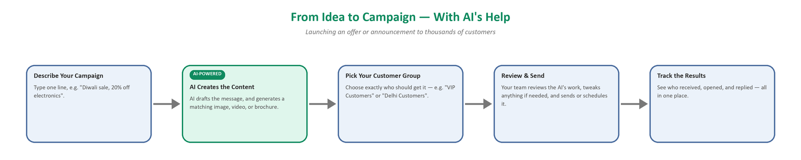
How a campaign moves from idea to results — the highlighted step is AI-assisted content creation.

Live Chat Inbox — Talking to Customers in Real Time
What it does: This is the day-to-day chat screen, similar to WhatsApp itself. Every customer conversation lands here. A staff member (an "agent") can reply directly, see the customer's full history, and assign a conversation to themselves or a teammate. WAGENIUS already includes a built-in AI assistant that can automatically answer common customer questions right away — and if the question is too complex, or the customer specifically asks for a human, the conversation is automatically handed over to a real staff member.
Why it helps you: Customers get an instant reply even outside working hours, staff aren't overwhelmed by repetitive questions, and no conversation gets missed or forgotten.
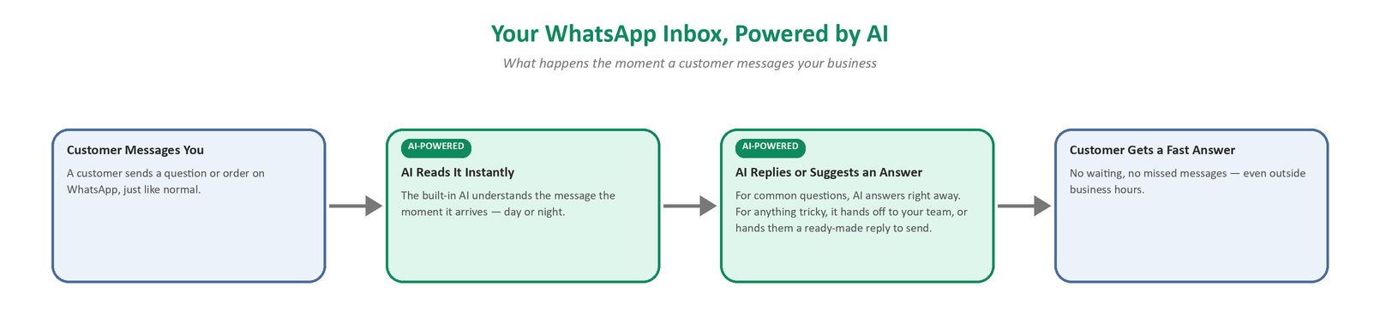
What happens the moment a customer sends a message — the highlighted steps are AI-powered.

Team Members & Roles
What it does: The business owner (Admin) can add staff accounts and decide what each person is allowed to do — for example, a "Support Agent" only handles chats, while a "Campaign Manager" can also send bulk campaigns.
Why it helps you: This keeps things organized and safe as a team grows — everyone sees only what they need to, and the owner stays in control.

Pricing & Cost Tracking
What it does: WhatsApp charges businesses per conversation, based on rules Meta sets. WAGENIUS keeps track of these rates and shows the estimated cost of campaigns before they're sent.
Why it helps you: No surprise bills — the business always knows roughly what a campaign will cost before committing to it.

3. How a New Business Gets Set Up on WAGENIUS
WAGENIUS is built so that many different businesses can each run their own private, separate WhatsApp operation on the same platform — one business never sees another business's customers, chats, or campaigns.
Today, bringing a new business onto WAGENIUS follows these steps:
- The business registers an official WhatsApp Business Account with Meta (this is a one-time WhatsApp requirement for any company that wants to send bulk business messages, not a WAGENIUS-specific step).
- The business's WhatsApp number is connected to their own private WAGENIUS workspace.
- The WAGENIUS team creates the business owner's Admin login.
- The Admin logs in, adds their team members, and sets each person's role.
- The business imports its existing customer list (if it has one) or simply lets it build up naturally as customers message in.
- The business is ready to build templates and launch its first campaign.
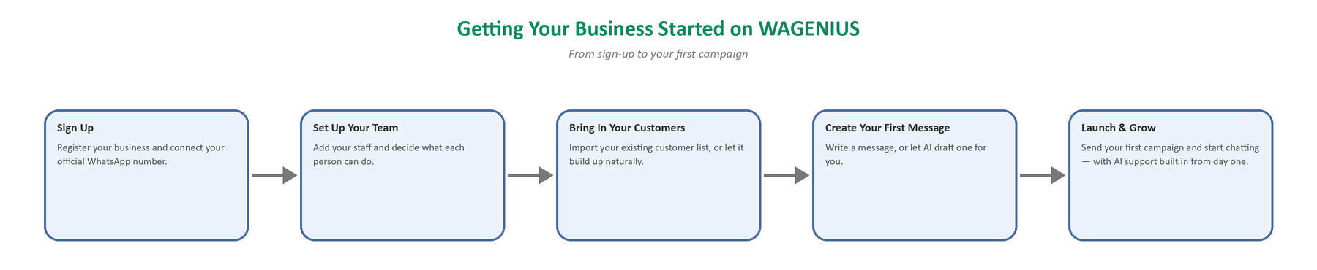
The journey from signing up to launching your first AI-assisted campaign.

CURRENT STATUS: Right now, step 3 (creating the Admin login) is done by the WAGENIUS team on request. A fully self-service "Sign Up" page — where a new business can register itself, connect its own WhatsApp number, and start immediately without waiting on anyone — is one of the planned upgrades. It's listed in the next section.

4. Additional Features We Can Add — Making It Smarter with AI
WAGENIUS already has a working AI assistant inside the Live Chat Inbox (described in Section 2) that can auto-reply to customers and hand off to a human when needed. Below are further AI-powered upgrades that build on top of that foundation.

4.1 Smart Reply Suggestions for Agents
Today's AI can reply to customers automatically on its own. This new feature adds a second, softer mode: whenever a customer sends a message, the AI instantly prepares 2-3 suggested replies and shows them to the human agent — the agent can tap one to send it instantly, tweak it first, or ignore it and type their own reply.
- Agents reply much faster, especially to common questions ("Is this in stock?", "What's the price?", "Where's my order?")
- The business keeps a human in control of every message, while still getting AI-level speed
- New or less experienced staff sound just as professional and consistent as the best agent on the team
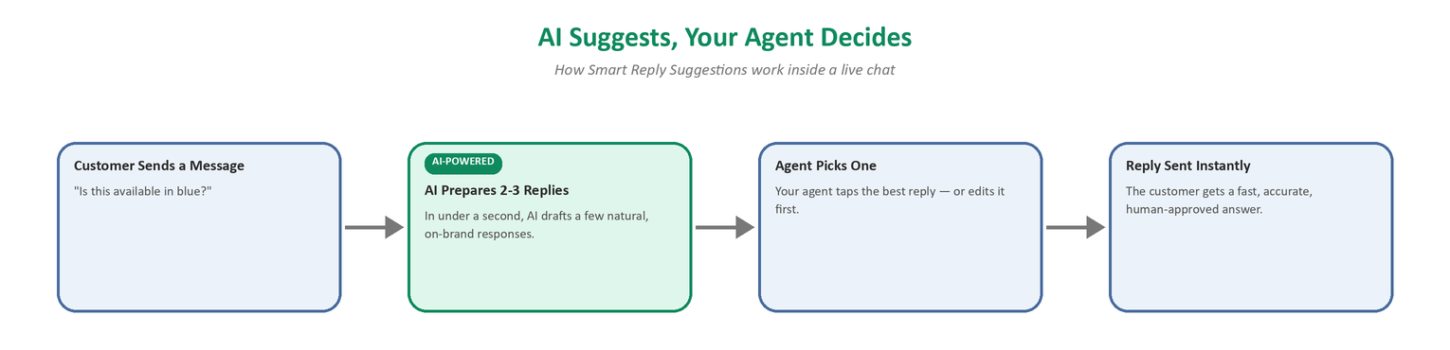
How Smart Reply Suggestions work inside a live chat.

4.2 AI-Generated Campaign Content (Text, Images, Videos & Brochures)
Today, AI can already help write the text of a message template. This upgrade extends that same idea to a full campaign package: the team simply describes what the campaign is about (e.g. "Diwali sale, 20% off electronics"), and the AI generates a matching message, a promotional image or short video, and even a simple product brochure/document — all ready to review, tweak, and send.
- No need to hire a designer or writer for every single campaign
- Campaigns go out faster and look more professional
- The team can launch more campaigns (festivals, restocks, reminders) because creating them takes minutes instead of days

4.3 A Smarter, More Configurable Chatbot
The existing auto-reply AI can be trained specifically on each business's own information — their products, prices, store hours, FAQs, and policies — so it answers accurately as that business, not with generic answers. It can also be set to work only during off-hours, only for certain types of questions, or in the customer's own language.
- Every customer gets an accurate, on-brand answer, any time of day
- The business decides exactly how much the chatbot is allowed to handle on its own
- Works naturally in the customer's preferred language

4.4 A Few More AI Ideas Worth Considering
- AI Conversation Summaries — a one-line summary at the top of each chat so an agent picking up a conversation instantly knows what's going on, without reading the whole history
- AI Campaign Insights — plain-English explanations of campaign results ("This campaign did well with customers tagged VIP, but poorly on weekends") instead of raw numbers
- Voice Note Understanding — automatically converting a customer's voice note into text so agents (and the AI) can read and respond to it
- Automatic Translation — customers can message in their own language, and staff can reply in theirs, with WAGENIUS translating both ways

4.5 Self-Service Sign-Up for New Businesses
A public "Get Started" page where a brand-new business can sign up on its own, connect its WhatsApp number, and set up its account immediately — without waiting for anyone to set it up manually. This turns WAGENIUS from a platform that is set up business-by-business into one that any business can join instantly, on its own.

5. Quick Summary
Feature | In One Line
Contacts | One organized address book for every customer.
Customer Groups | Send the right message to the right people.
Message Templates | Pre-approved, ready-to-send messages with images, videos, and buttons.
Campaigns | Send one message to thousands of customers and track the results.
Live Chat Inbox | Real-time chat with customers, backed by a built-in AI assistant.
Team & Roles | Add staff and control what each person can do.
Pricing Tracking | Know the cost of a campaign before sending it.
(New) Smart Reply Suggestions | AI hands agents ready replies to send in one tap.
(New) AI Campaign Content | AI creates text, images, video, and brochures for campaigns.
(New) Smarter Chatbot | AI trained on each business's own products and policies.
(New) Self-Service Sign-Up | Any business can join and set up its own account instantly.

In short: WAGENIUS already turns WhatsApp into a full customer communication system for a business today — and the features above are the next steps to make it faster, smarter, and easier for any new business to join.

