1. Install **Python** 3.8. 5

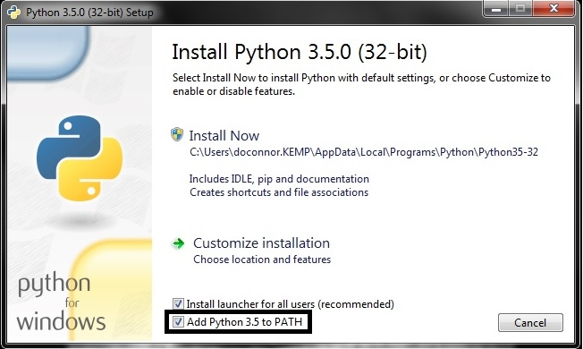

1. Install Visual Studio Code

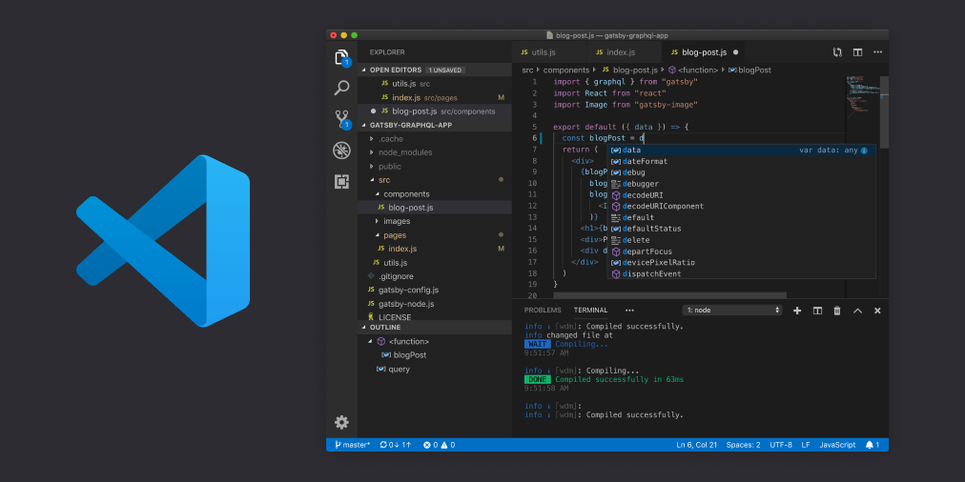

1. Open **cmd** command Prompt
2. pip install django

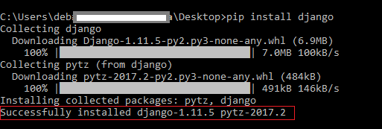

1. pip install pandas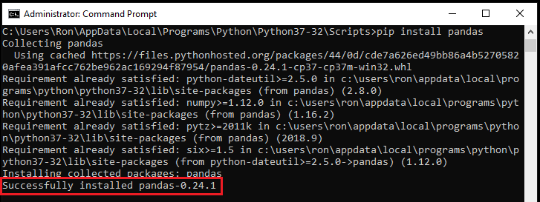
2. pip install matplotlib

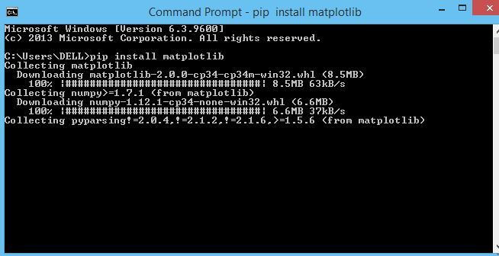

4) click on in bottom left and then click on settings

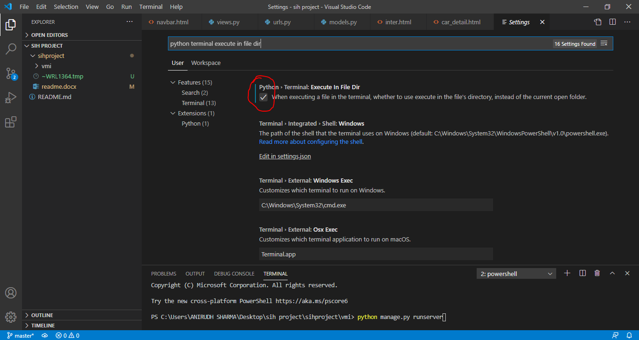and search for python terminal execute in file dir and check it as shown

5) open vmi directory in command line and run:

python manage.py runserver

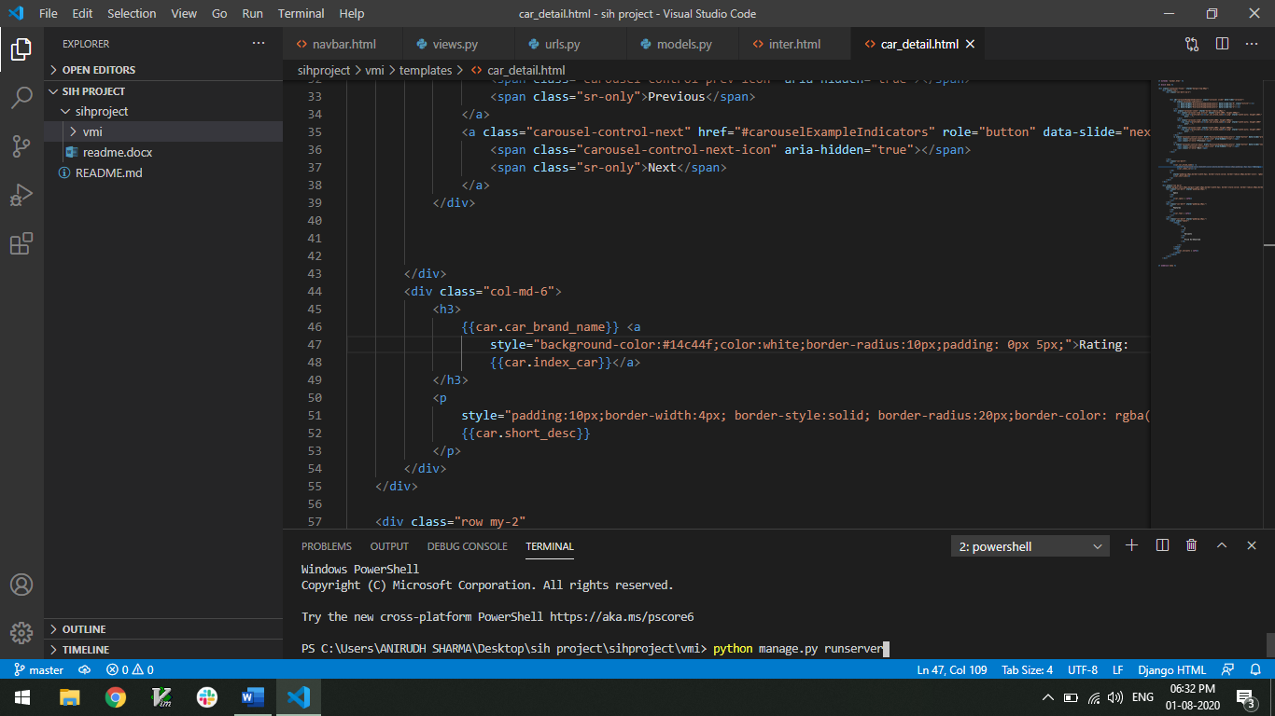 then ctrl+left click on localhost url to view website

remember to run the command in vmi directory.