Workflow diagram for data processing
Master mandi dataset
- Monthly datasets scraped from Agmarknet (old website) as xls files (features shown below from a randomly taken month) (all months follow the same features and naming conventions)
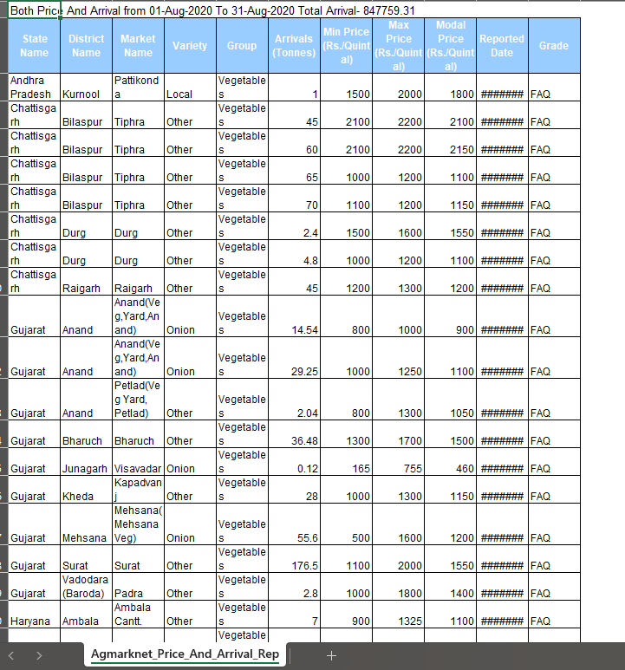
- Merged all monthly xls files into one parquet file (file type made to handle large datasets). Total rows = 1,265,726. Has exactly the same rows as all xls files combined (skipping the first metadata row in every xls file using skiprows=1). Combined all varieties to have a bigger dataset (higher avg. accuracy as more values to train the model on). Removed variety column, group column, min price column, max price column, and grade column.
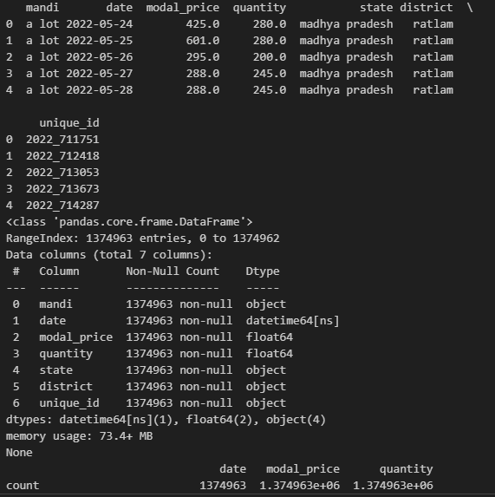
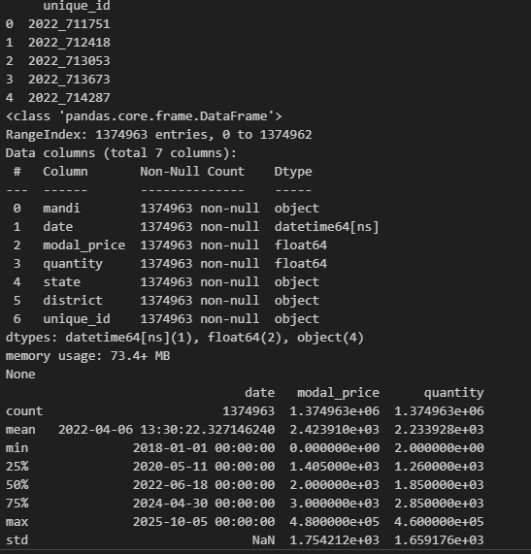

- Added rows so that the parquet file has rows for every mandi (1629 mandis) for every day (2557 days) (reindexing) to calculate % missing values, sorted by date, then mandi, then district, then state

