Workflow diagram for data processing
Master mandi dataset
- Monthly datasets scraped from Agmarknet (old website) as xls files (features shown below from a randomly taken month) (all months follow the same features and naming conventions)
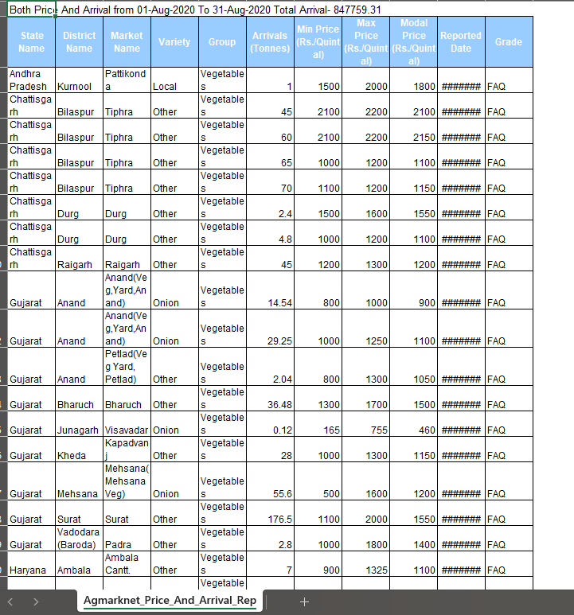
- Merged all monthly xls files into one parquet file (file type made to handle large datasets). Total rows = 1,265,726. Has exactly the same rows as all xls files combined (skipping the first metadata row in every xls file using skiprows=1)
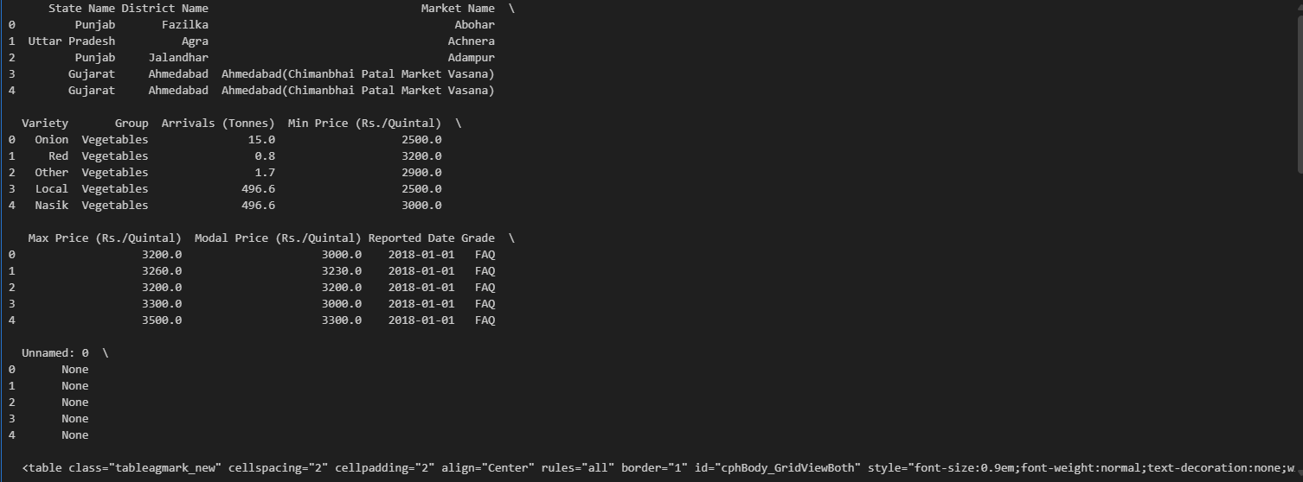
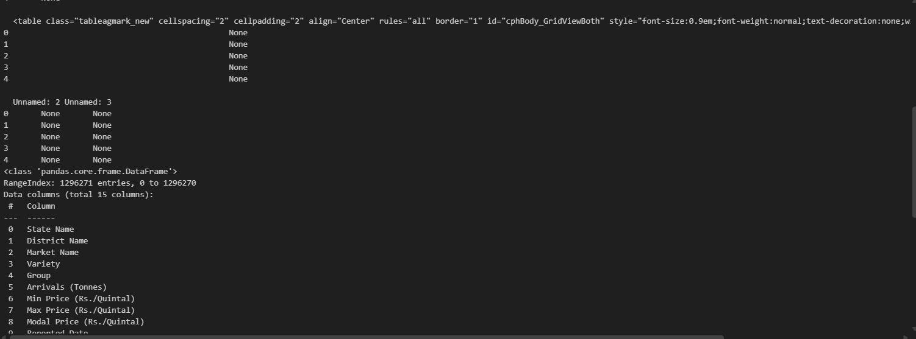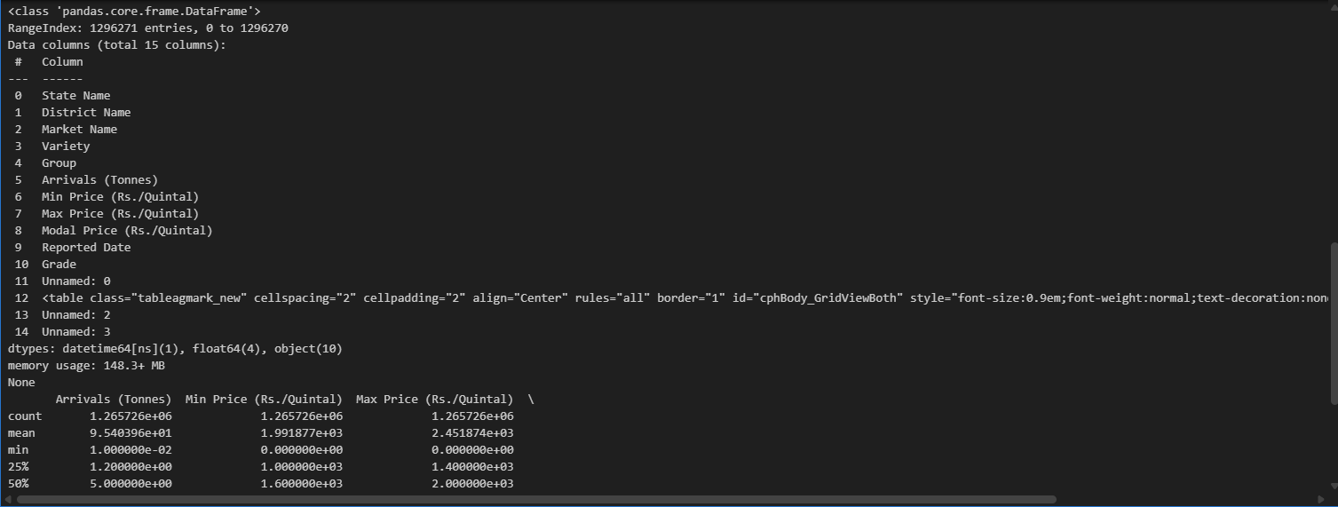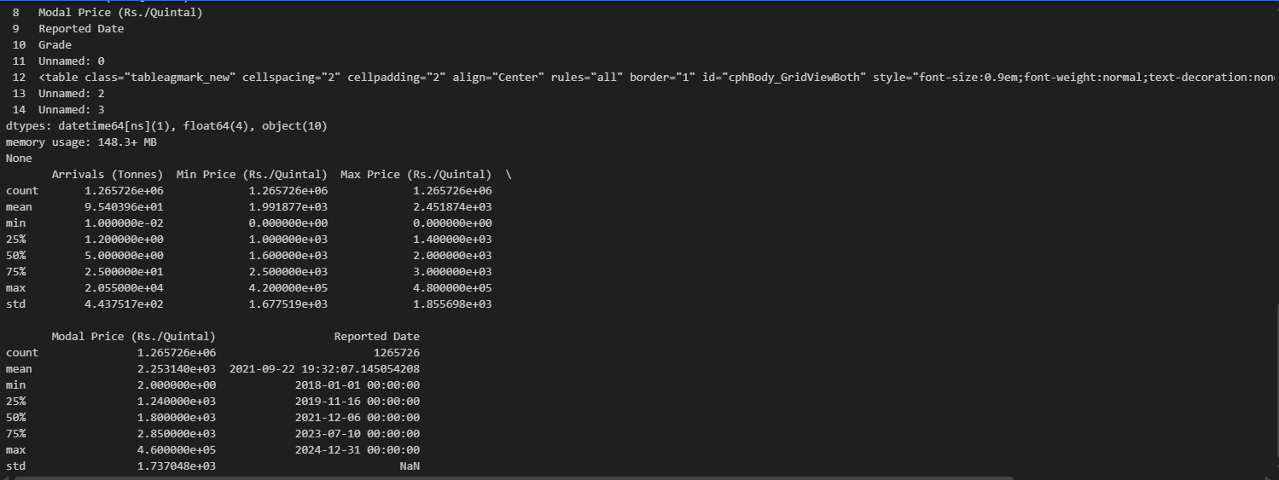
- Checked the dataset for the different onion varieties
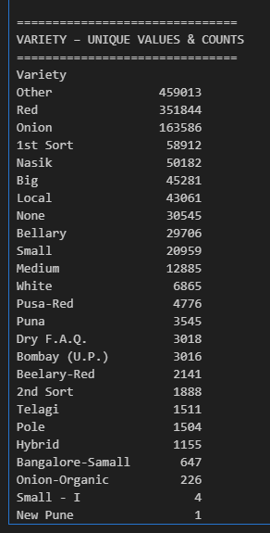
- Since there are 3 dominating varieties, I will be making 3 different datasets from those varieties; as instructed by the professors.
  - All 3 parquet files have the same data architecture (columns). So I will only be showing the count of rows of each parquet file (Onions, Red, Other respectively) (all the counts are the same as the image above).
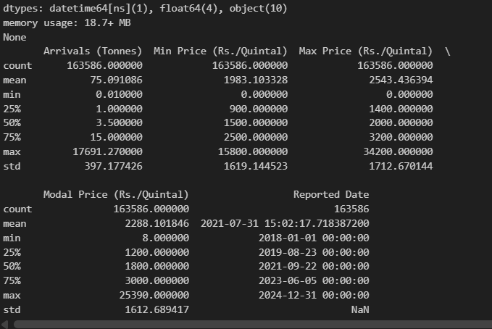
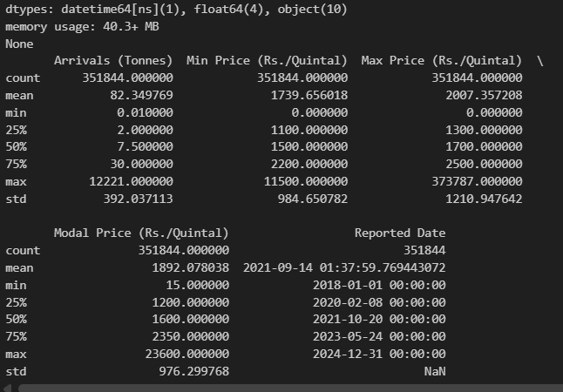
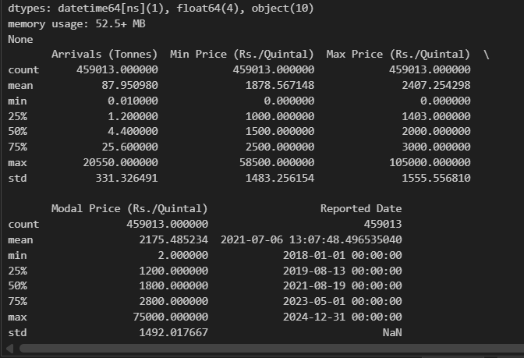
- Finding the % missing values based on the total number of possible rows (1629 mandis X 2557 days = 4,165,353 rows), the missing % for Onions, Red, and Other are 96.073%, 91.553%, and 88.991% respectively.
  - Indicating an avg. of 28.48 datapoints per mandi per year. Will not be enough values to show any time-series trend, much less any volatility in prices
- This is much higher as compared to approx. 72% missing values when considering the cumulative rows of all varieties.

