**NATURAL LANGUAGE PROCESSING**

**TASK 2**

**DATE – 06/12/19**

**ISHAAN TIWARI**

**17BCE0751**

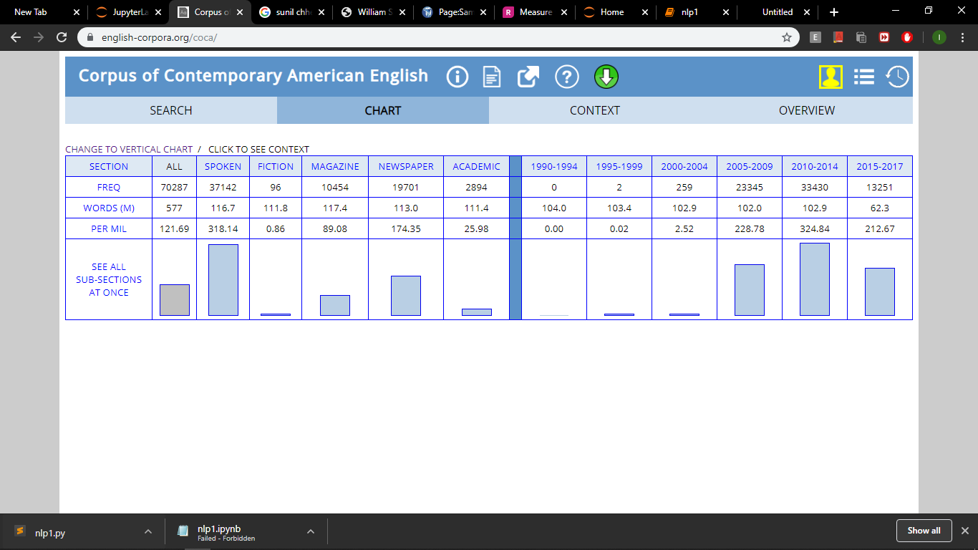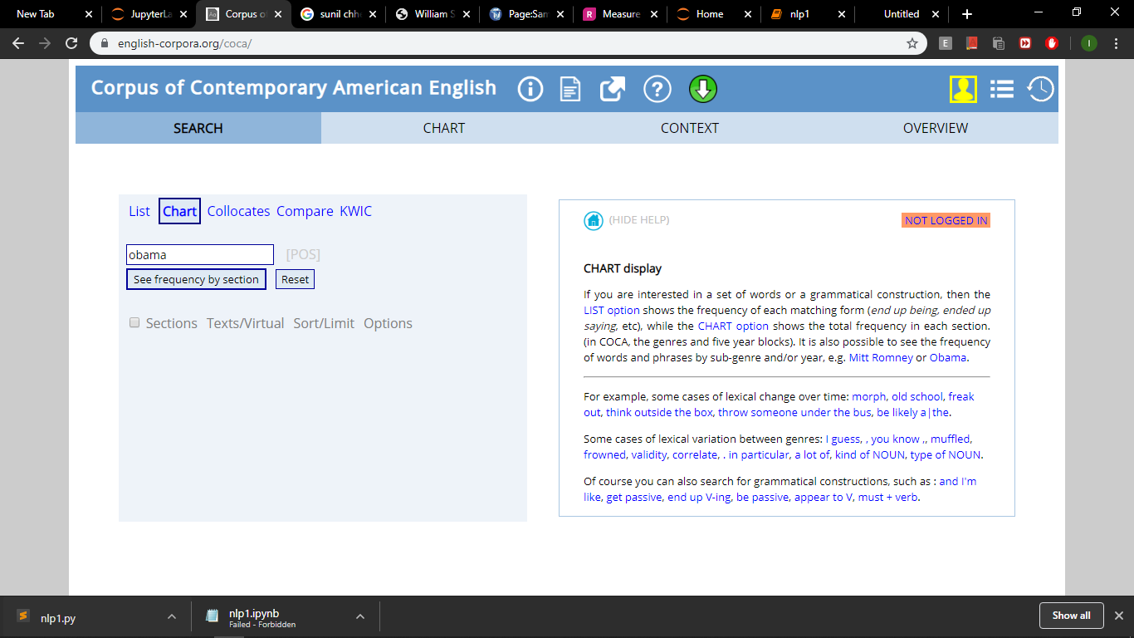**KEYWORD – “OBAMA**”

**CHART**

* The number **of hits** on the word Obama **– 70287**
* The mode of media through which the term was spread **the most** was – **SPOKEN**
* And the time period of **most frequency** is **2005-2009 & 2010-2014 as was Barak Obama’s office term duration.**