Assignment 1

Scientific Programming

Isha Borgaonkar   
Student Number: 24209758

Here I coded, compiled and run both programs in C on Sciprog. I am attaching output of both programs, screenshot of code which is done on Sciprog as well as code of .c File.

**Output of Program Q1.stub and Q2.stub**

The input for Q1.stub file is the data points which are in the Assignment1 file.

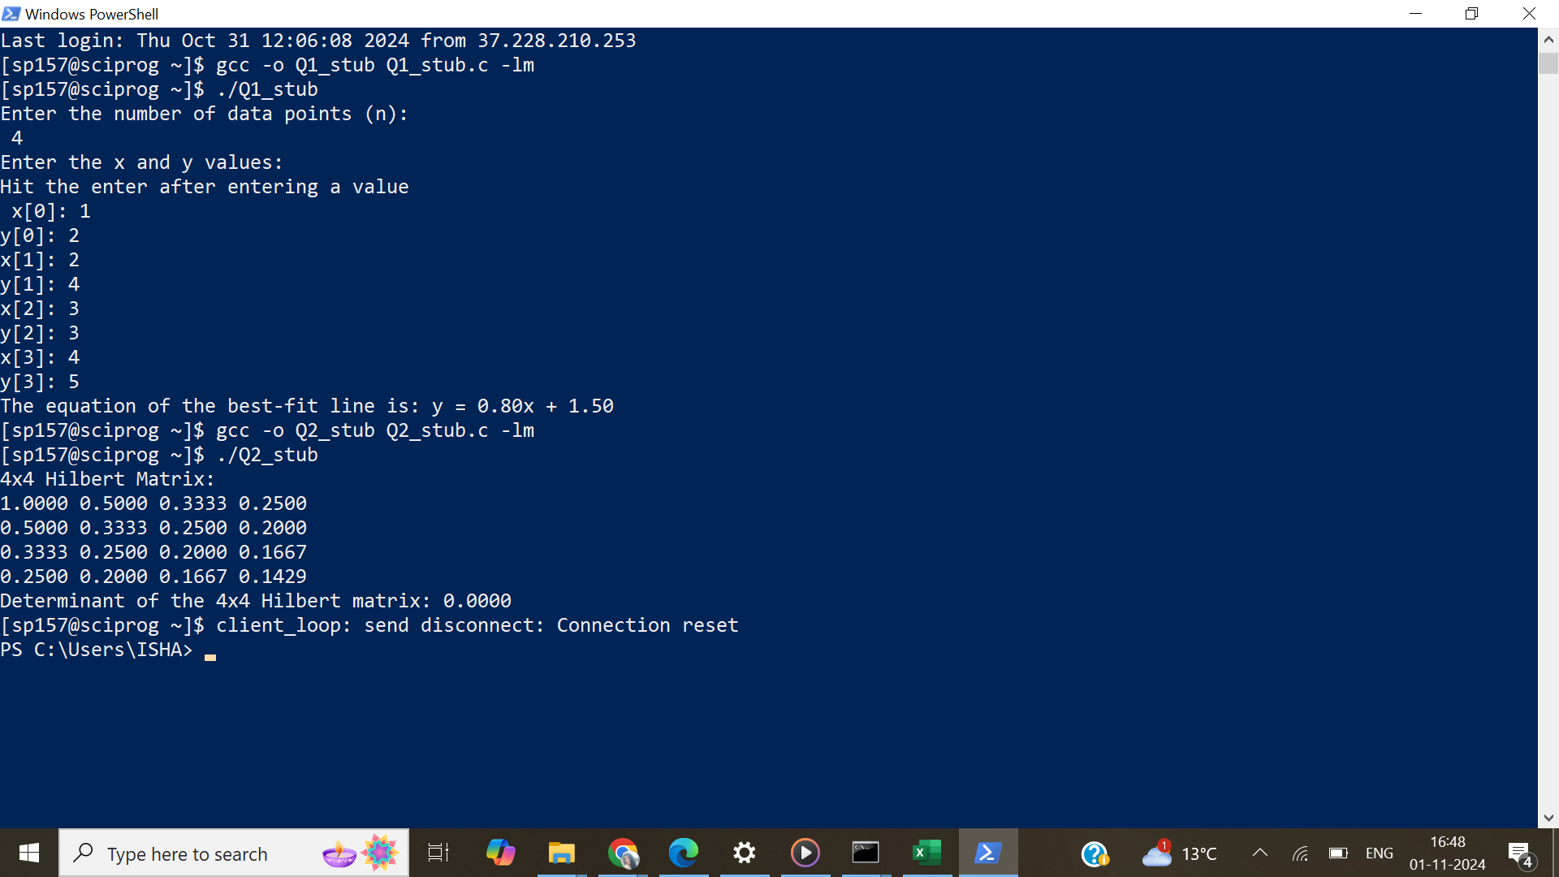

Q1.Stub.c File sciprog

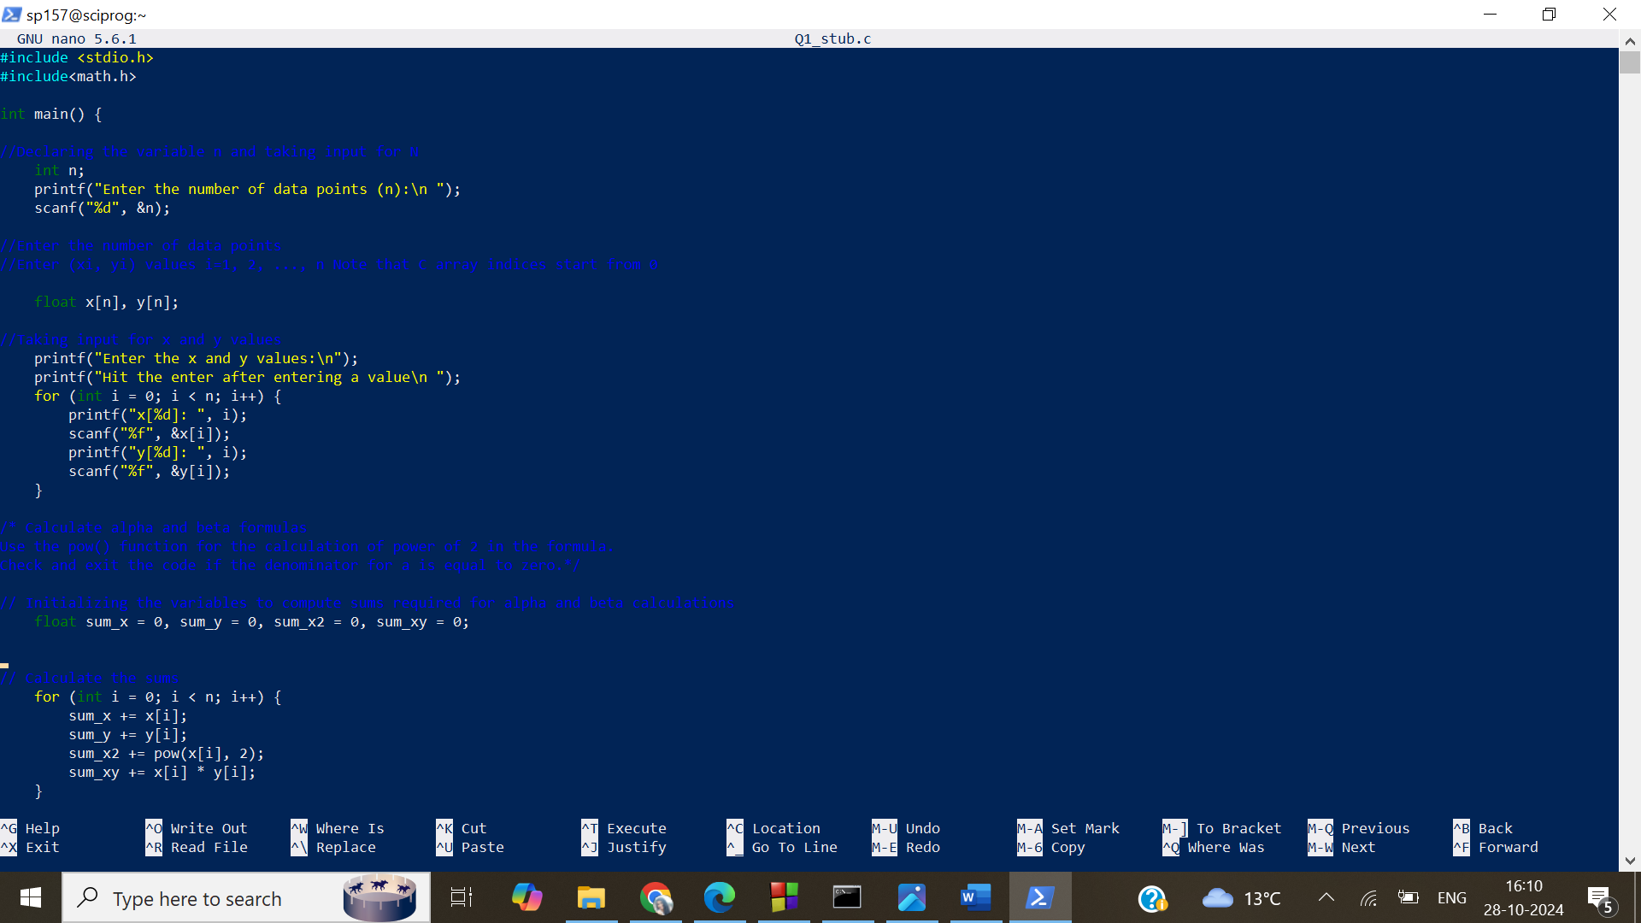

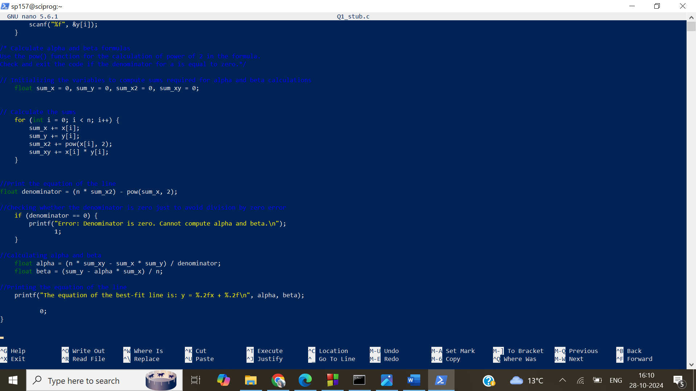

Q1.Stub.c File on sciprog

