**Problem - Need for ShopSmart**

ShopSmart is intent on giving its audience a realistic and affordable shopping experience. That being said the need for ShopSmart is realistic for those who are averagly spending more money and potentially have a lack of time when it comes to grocery shopping. To think, let’s imagine Melissa who is a single mother of five children who works as an accountant at one of the big fours. She is someone who likes to plan out her day, is organized, and prides herself on being someone who is environmentally conscious.

However, in the manner that Melissa is currently shopping, we can see her behaviors are not aligned with who she is. For someone who plans her day out a few days before, she is erratic when she buys groceries as she often doesn’t remember what her children want. This forces her to spend money on food and then potentially throw it out as her children are extremely picky, which makes her throw out food without meaning too. It’s obvious that Melissa has a lack of product awareness, continuously is wasting food, and is wasting her well-earned money. However, with the help of ShopSmart Melissa will be able to plan her grocery list as well as show her which retailer will be the best option for her. She’ll also be able to get various recommendations on the app that our AI functions believe her kids may end up liking. This idea of overconsumption is a standard for America, therefore we want to be able to reduce that and try to resolve the overarching problem.

**Our Solution**

What we believe is the best solution for this specific problem is our application: ShopSmart. As outlined in the first paragraph above, we want to reduce the need for overconsumption so we are innovating an app that aims to gamify the shopping experience by streamlining the grocery shopping selection process, offering smart shopping lists, and offering personalized recommendations all within an extremely user-friendly interface. Our features such as price comparison, access to previous reviews, personalized recommendation homepage, guarantee you the best price for all of your grocery needs. We will be able to utilize various forms of AI to find what products will be the best for your needs especially if you are living with little ones who are picky and going through various changes. ShopSmart overall wants to create a more organized way to shop for your grocery needs, and we plan to save our customers the maximum amount of money,

**Why Does ShopSmart Stand Out?**

1. Target Audience and Personalization

ShopSmart recognizes that the one-size-fits-all approach needs to be updated in grocery shopping by strategically targeting Students and budget-conscious shoppers. The platform ensures its marketing and content are personalized to resonate with each demographic. This approach enables a more engaging and relevant shopping experience for users.

2. Real-time Price Comparisons

A standout feature of ShopSmart is its real-time price comparison functionality. This cutting-edge feature empowers users by instantly comparing prices of the same product across different stores. This saves valuable time and enables shoppers to make informed decisions, ensuring they secure the best possible deals on their purchases. ShopSmart sets itself apart by prioritizing transparency and empowering users to make informed decisions.

3. Exclusive Offers and Discounts

Utilizing user data and shopping history, ShopSmart goes beyond conventional practices by offering personalized and exclusive deals and discounts. The platform enhances user satisfaction by tailoring promotions to individual preferences and behaviors.

4. Nutritional Information

ShopSmart takes a step further by providing users with detailed nutritional information. This includes calorie content and allergen alerts, promoting informed and healthier choices. By integrating nutritional data into the shopping experience, ShopSmart addresses students' evolving needs and preferences.

5. All-in-One Solution

ShopSmart aspires to be the ultimate solution for grocery shoppers. Acting as a one-stop shop, the platform enables users to compare prices and deals across various stores, ensuring they obtain the best value for their purchases. This comprehensive approach simplifies the shopping process and positions ShopSmart as an indispensable tool for those seeking convenience and savings in their grocery shopping endeavors.

**USE CASE DIAGRAM**

The ShopSmart use case diagram shows how customers and store owners interact with the ShopSmart Application.

For customers, the primary use cases are:

* Searching for products
* Comparing product prices
* Accessing deals and discounts
* Reviewing grocery expenditures
* Providing and reading product reviews

For store owners, the primary use cases are:

* Creating and managing product listings
* Setting prices
* Offering deals
* Identifying top-selling products

The use case diagram shows how these different use cases interact with each other to provide a complete and seamless shopping experience for customers.

For example, a customer can start by searching for a product on the ShopSmart storefront. Once they have found a product they are interested in, they can compare prices across different stores to find the best deal. The customers can also read and write product reviews. The app user also has an upvote for their favorite product, which can provide insights to identify the top-selling products.

Store owners can make this shopping experience even better by creating accurate and informative product listings, setting competitive prices, and offering attractive deals.

Overall, the ShopSmart use case diagram shows how the ShopSmart application provides a valuable service to customers and store owners.

**PROTOTYPE**

**LANDING PAGE**

The app is designed to enhance the shopping experience by providing a structured and cost-effective way to manage grocery shopping, especially for individuals like Melissa, who are seeking an organized and mindful approach to purchasing groceries.

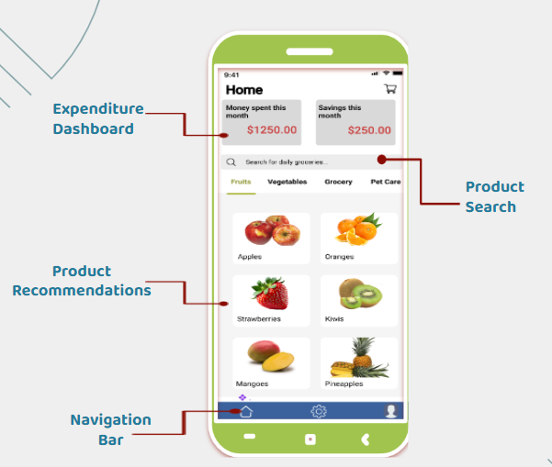

Here are the components in the prototype:

1. **Expenditure Dashboard:** This section of the app displays financial data related to the user's shopping activities. It shows the amount of money spent in the current month and the savings achieved, providing a quick and clear financial overview.
2. **Product Search:** This feature allows users to quickly search for products. The search bar is prominently placed at the top, and there are also category tabs (Fruits, Vegetables, Grocery, Pet Care) that can help in filtering the search results according to different sections of the store.
3. **Product Recommendations:** Below the search bar, there are product recommendations which will be personalized for the user. This section showcases various food items (Apples, Oranges, Strawberries, Kiwis, Mangoes, Pineapples) with images and possibly prices, simplifying the selection process.
4. **Navigation Bar:** At the bottom of the interface is a navigation bar, which is a common feature in apps that allows users to navigate through different sections of the app efficiently. It generally includes icons representing different functionalities of the app.

**PRICE COMPARISON**

The app focuses on the feature that allows users to compare prices for a specific product across different retailers.

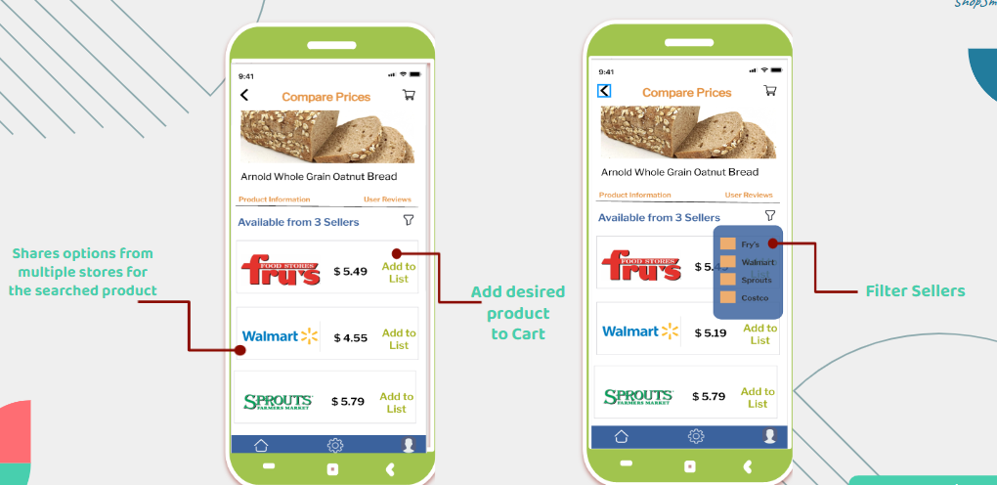

1. **Price Comparison Feature:** Both screens are titled "Compare Prices" at the top, indicating that this section of the app is dedicated to comparing the cost of items across various stores. The product being compared in this example is "Arnold Whole Grain Oatnut Bread."
2. **Product Information and User Reviews:** There are two tabs under the product image: 'Product Information' and 'User Reviews.' These tabs suggest that the user can access detailed descriptions of the product and read reviews from other customers to make an informed decision.
3. **Seller Options:** The main feature displayed here is the list of different sellers offering the product, along with their respective prices. On the left screen, three sellers are listed: Fry's, Walmart, and Sprouts, each with a button to "Add to List," for creating a shopping list or for later reference. On the right screen, we see the same sellers but with an added functionality that appears to allow the user to filter which sellers to display.
4. **Add to Cart Functionality:** The right screen also has a shopping cart icon with a plus sign, which allows the user to add the desired product directly to their shopping cart for purchase.

These screens demonstrate the app's functionality to assist users like Melissa in finding the best prices for their grocery items, hence aligning with their goal of organized and cost-effective shopping. The interface appears intuitive and focused on saving the user money by providing an easy comparison of prices at a glance.

**SHOPPING CART SECTION**

Below image shows prototype of a shopping cart feature within a mobile application for the ShopSmart app.

1. **Shopping Cart Contents:** The section titled "Your Cart" lists all the products that the user has added to their shopping cart. Each item in the list shows the product name, a thumbnail image, the price, and buttons to adjust the quantity of each item.
2. **Total Spend and Savings:** At the bottom of the cart, there is a summary of the total cost, labeled as "Subtotal," which includes an estimate of the total spending with taxes. Additionally, it displays the total amount saved, indicating that the app may apply discounts or compare prices to ensure the user is getting a good deal.

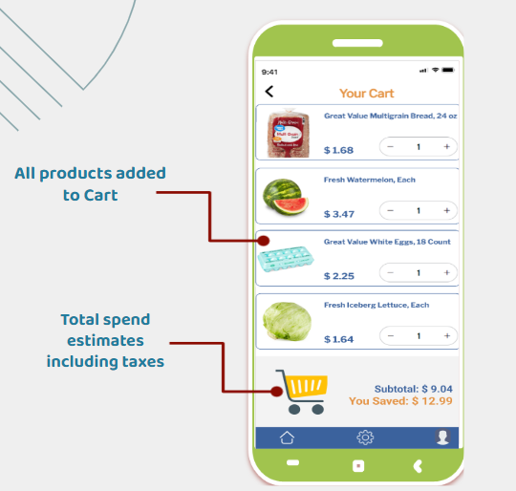

This screen is designed to give users a clear and concise overview of the items they are planning to purchase, along with the cost and savings, before they proceed to checkout. The interface seems user-friendly, with the essential information and controls readily accessible, supporting the app’s aim to make grocery shopping more organized and economical.

**DEALS & REVIEWS SECTION**

The below image displays two screens from a mobile application, each offering different functionalities that enhance the shopping experience:

1. **Catered Discounts (Left Screen):** This screen is titled "Flash Coupons" and appears to provide users with a variety of discount vouchers and promotional codes that they can apply to their purchases. The discounts are from well-known retailers such as Costco, Walmart, and Fry's Food Stores, suggesting that the app aggregates deals from multiple sources. Each offer is presented with a significant visual cue, like the "25% OFF" banner, and includes a specific code ("NEW10") that can presumably be used at checkout to obtain a discount.

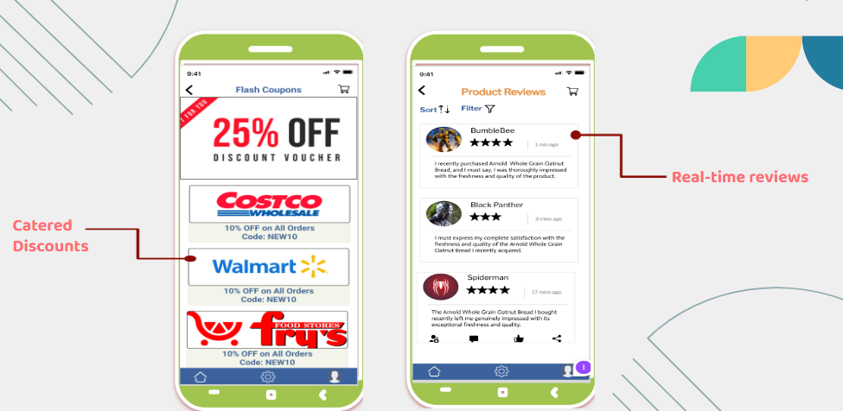

1. **Real-time Reviews (Right Screen):** The second screen, titled "Product Reviews," shows a list of user-generated reviews for a product. The reviews can be sorted and possibly filtered, as indicated by the sort and filter icons at the top. Each review includes the username, a star rating, a timestamp indicating when it was written, and the review text itself. This function would allow users to read up-to-date feedback from other customers about a product's quality and suitability before making a purchase.

Both screens are part of a cohesive system designed to provide users with a way to save money through discounts and make informed decisions based on the experiences of other shoppers. The interface is designed to be clear and accessible, with straightforward navigation to ensure a user-friendly experience within the ShopSmart app.

**LOGIN & PROFILE CREATION**

The image shows three screens from a mobile application, likely the ShopSmart app, each related to user account management and security:

1. **Login Screen (Leftmost Screen):** This is a standard login interface where users can enter their email and password to access their account. The presence of "Forgot password" and "Sign up" options indicates that users can recover their password or create a new account if they don't already have one. The login process is labeled as "Easy Login," suggesting that the app emphasizes a straightforward, hassle-free sign-in experience.

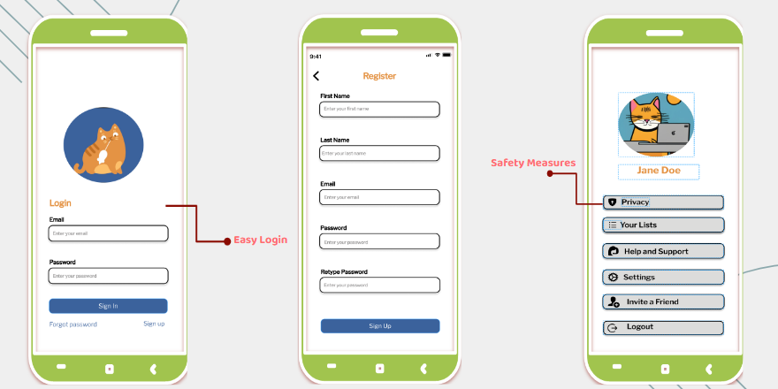

1. **Registration Screen (Center Screen):** This screen is for new users to register for an account. It provides fields for entering one's first name, last name, email, password, and a password retype for confirmation. The presence of multiple fields indicates a thorough registration process aimed at capturing essential user information.
2. **Account/Safety Measures Screen (Rightmost Screen):** This screen displays what appears to be an account profile section where safety and privacy are highlighted. The user's avatar and name ("Jane Doe") are displayed, along with several menu options related to account management and privacy, such as "Privacy," "Your Lists," "Help and Support," "Settings," "Invite a Friend," and "Logout." This suggests a user-centric design with a focus on personalized settings and security features.

Collectively, these screens show the steps a user would take to start using the app, from signing up to managing their account, with a clear emphasis on ease of use and privacy measures.

**MOSCOW ANALYSIS**

Utilizing MOSCOW analysis in the creation of our shopping assistant product plays a crucial role in aligning our efforts with the key elements that drive user satisfaction and project success. By dividing features into Must-haves, Should-haves, Could-haves, and Won't-haves, we ensured that our team prioritizes critical functionalities like price comparison, estimated spending, and deals/discounts. These features are essential for improving the overall shopping experience for our users and achieving the core goals of our product. This systematic approach not only helps us allocate resources efficiently but also allows us to adapt to evolving requirements, effectively manage stakeholder expectations, and mitigate potential risks. Our goal is to create a strong and customer-focused shopping assistant. By utilizing MOSCOW analysis, we can ensure that our development efforts are carefully planned and geared towards providing the highest level of value to our users. This approach also allows us to adapt to changing needs as our product evolves.

Our shopping assistant app offers a robust and essential set of “Must-have” features designed to elevate the user's shopping experience. By enabling users to easily compare prices from local stores, the app focuses on efficiency and cost-effectiveness. Real-time updates and information help users make informed decisions. Additionally, with the app's estimated spending calculation, including taxes, users can have full transparency in budget management. The integration of Deals and Discounts also adds value by providing cost-saving opportunities, creating a well-rounded shopping experience that caters to users' financial needs.

Aside from the necessary elements, the app will also provide a range of "Should-Have" functions that will enhance user participation and contentment. With Product Reviews included, users can rely on peer input to make knowledgeable purchasing decisions, promoting reliability and trust in the app. The Monthly Spend Dashboards give users a comprehensive overview of their spending habits, assisting in budget management. Additionally, the integration of AI-powered Product Recommendations utilizes cutting-edge technology to suggest tailored options, elevating user convenience. Together, these features create a user-friendly interface that not only streamlines the shopping experience but also offers a customized approach to cater to individual preferences and behaviors.

In terms of additional functionalities in the future phases, the app could boast a variety of features that users will find useful. These include but are not limited to Food content, nutrition facts, calorie information, a convenient store filter for comparison purposes, expiration dates, language translation, and an integrated shopping list. These features work together to create a seamless and personalized experience for the user, simplifying the shopping process and catering to their unique preferences and habits.

**BUSINESS MODEL**

Central to our strategy lies a dynamic revenue model focused on catering to the needs of our users. Our carefully crafted revenue model aims to achieve sustainable growth and unparalleled benefits for both users and stakeholders.

Through our subscription model, users can enjoy a hassle-free shopping experience and gain access to unique features and tailor-made recommendations. Our Premium Subscription for Business Insights also provides businesses with invaluable market information, equipping them with data-driven strategies to outshine their competitors. This subscription-based system not only fosters user loyalty but also promotes a mutually beneficial relationship, setting the stage for the long-term success of our app.

Our app sets itself apart by offering unparalleled features that enhance the user experience and foster an active marketplace. By tapping into the power of crowdsourced data, our platform brings users together and leverages collective wisdom to make smarter shopping decisions. With localized deals and offers, both consumers and retailers benefit from a mutually beneficial arrangement that elevates the overall experience. These ultimately would be profitable for us.

Through targeted in-app advertising, businesses gain an effective channel to reach their target audience and amplify the impact of their marketing strategies. The app's dynamic ecosystem thrives on strategic partnerships and commissions with retailers and grocery chains, creating a win-win situation for all parties involved.

Our grand vision surpasses a simple app; our goal is to revolutionize the market and transform the way people shop. We strive to create a dynamic marketplace that empowers businesses to flourish and delights users with a seamless and intelligent shopping experience. This unwavering vision drives us to continuously adapt and cater to ever-changing demands, ensuring a rewarding experience for all involved in the retail ecosystem.

**Future Challenge**

As ShopSmart embarks on its journey to revolutionize the grocery shopping experience, several challenges loom on the horizon. The first challenge lies in maintaining the accuracy and currency of data across diverse local stores for real-time price comparison, deals, and discounts. The dynamic nature of local store data introduces the risk of discrepancies that could undermine user satisfaction. To counter this, the development team must implement automated systems capable of regular updates and verification of pricing information. Establishing partnerships with local stores for direct data feeds becomes crucial to ensure a continuous and accurate flow of real-time information, ultimately enhancing the reliability of the price comparison feature.

The complexity of developing and fine-tuning AI algorithms for personalized product recommendations presents another significant challenge. This complexity stems from the necessity to accurately discern and adapt to user preferences, providing recommendations that align seamlessly with individual tastes and needs. To mitigate this challenge, ShopSmart must conduct extensive user profiling and behavior analysis. The implementation of machine learning models capable of continuous learning from user interactions becomes imperative. Regular refinement of these algorithms based on user feedback and evolving market trends is necessary to ensure that the AI-driven recommendations meet and exceed user expectations.

Meanwhile, the third challenge to protecting user data privacy and security arises in features such as spending dashboards and AI-driven insights, which require a meticulous approach to encryption and transparent data usage policies. It is essential to clearly communicate data use policies to users and to obtain explicit consent. Regular audits and updates of security measures are necessary to stay in line with evolving data protection standards and maintain user trust.

Additionally, the challenge of language translation and localization arises, especially when introducing features like language translation for a broader user base. Accurate translations of not just the interface but also product details become essential for a seamless user experience. Collaborating with language experts, implementing user-friendly translation systems, and consistently updating translations based on user feedback and changes in local languages are vital steps to address this challenge successfully. In the face of these challenges, ShopSmart remains steadfast in its commitment to providing a secure, accurate and user-centric shopping partner.

**Timeline for next step**

ShopSmart will continue to grow in the future and will follow 5 phases. In the initial phase, the focus is on implementing core functions, including the development of a real-time price comparison engine, the ability to calculate estimated spending, and the integration of trading and discount modules. The next phases emphasize enhancing the user experience by integrating product reviews, monthly consumption dashboards, and beginning to integrate AI algorithms for personalized recommendations. Then, the functionality is expanded to include features such as food content, nutritional content, and language translation. After that, prioritize optimization based on user feedback to ensure that the application is refined and seamless. The final phase involves preparing for future challenges, studying progress, evaluating scalability, and laying the groundwork for ShopSmart to become a comprehensive, adaptable grocery shopping solution.