**Q1.**

**Code:**

package Q_01;  
import javax.swing. *;  
public class Que_01 {  
 public static void main(String[] args) {  
 JFrame myWindow;  
 myWindow = new JFrame();  
 myWindow.setSize(800, 600);  
 myWindow.setTitle("Welcome to Java");  
 myWindow.setVisible(true);  
 }  
  
}

**Output:**

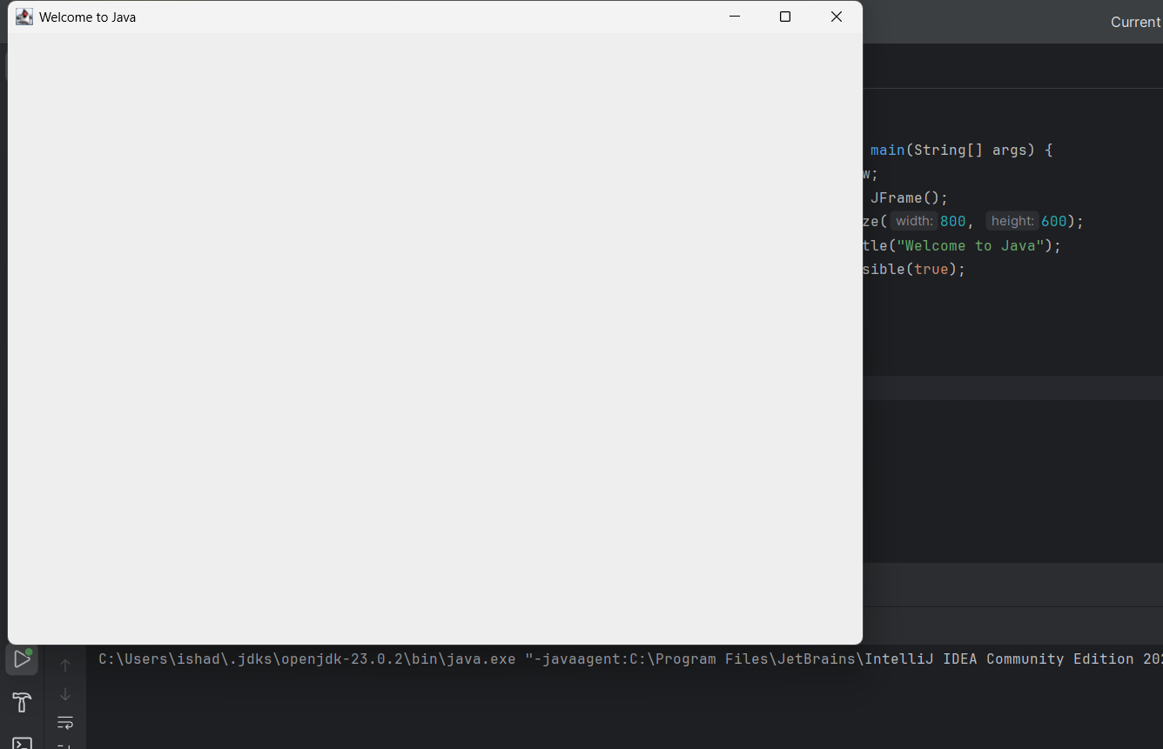

**Q02.**

**Code:**

package Q_02;  
import javax.swing. *;  
import java.util.Scanner;  
  
public class Que_02 {  
 public static void main(String[] args) {  
 Scanner scanner = new Scanner(System.*in*);  
 String firstName;  
 System.*out*.print("Enter your first name: ");  
 firstName = scanner.next();  
 String lastName;  
 System.*out*.print("Enter your last name: ");  
 lastName = scanner.next();  
 scanner.close();  
  
 String fullName = firstName + " " + lastName;  
  
 JFrame frame;  
 frame = new JFrame(fullName);  
 frame.setSize(400, 300);  
 frame.setVisible(true);  
 }  
}

**Output:**

**Q03.**

**Code:**

package Q_03;  
import java.util.Scanner;  
  
public class Que_03{  
 public static void main(String[] args) {  
 Scanner scanner = new Scanner(System.*in*);  
 System.*out*.print("Enter first name: ");  
 String firstName = scanner.next();  
 System.*out*.print("Enter middle name: ");  
 String middleName = scanner.next();  
 System.*out*.print("Enter last name: ");  
 String lastName = scanner.next();  
 scanner.close();  
  
 String fullName = firstName + " " + middleName.substring(0,1) + ". " + lastName;  
  
 System.*out*.println("Full Name: " + fullName);  
 }  
}

**Output:**

**Q04**.

**Code:**

package Q_04;  
import java.util.Date;  
import java.text.SimpleDateFormat;  
public class Que_04 {  
 public static void main(String[] args) {  
 Date today;  
 SimpleDateFormat sdf;  
 today = new Date();  
 sdf = new SimpleDateFormat("dd MMMM yyyy");  
 System.*out*.println(sdf.format(today));  
 }  
}

**Output:**

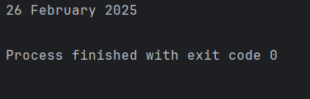

**Q05.**

**Code:**

package Q_05;  
import java.util.Date;  
import java.text.SimpleDateFormat;  
public class Que_05 {  
 public static void main(String[] args) {  
 Date today;  
 SimpleDateFormat sdf;  
 today = new Date();  
 sdf = new SimpleDateFormat("EEEE, MMMM dd, yyyy");  
 System.*out*.println(sdf.format(today));  
 }  
}

**Output:**



**Q06.**

**Code:**

package Q_06;  
import javax.swing. *;  
import java.util.Scanner;  
  
public class Que_06{  
 public static void main(String[] args) {  
 Scanner scanner = new Scanner(System.*in*);  
 System.*out*.print("Enter the width in pixels: ");  
 int W = scanner.nextInt();  
  
 System.*out*.print("Enter the height in pixels: ");  
 int H = scanner.nextInt();  
  
 System.*out*.print("Enter the frame title: ");  
 String frameTitle = scanner.next();  
  
 scanner.close();  
  
 JFrame frame;  
 frame = new JFrame(frameTitle);  
 frame.setSize(W, H);  
 frame.setVisible(true);  
  
 }  
}

**Output:**

**Q07.**

**Code:**

package Q_07;  
import javax.swing.*;  
import java.text.SimpleDateFormat;  
import java.util.Date;  
  
public class Que_07 {  
 public static void main(String[] args) {  
 Date now = new Date();  
  
 SimpleDateFormat timeFormat = new SimpleDateFormat("hh:mm:ss a");  
  
 String currentTime = timeFormat.format(now);  
  
 JFrame frame = new JFrame(currentTime);  
 frame.setSize(500,300);  
 frame.setVisible(true);  
 }  
}

**Output**:

**Q08.**

**Code:**

package Q_08;  
import java.util.Scanner;  
  
public class Que_08{  
 public static void main(String[] args) {  
 Scanner scanner = new Scanner(System.*in*);  
 System.*out*.print("Enter a string with a single exclamation mark: ");  
 String input = scanner.nextLine();  
 scanner.close();  
  
 int index = input.indexOf('!');  
  
 if (index != -1) {  
 String before = input.substring(0, index).trim();  
 String after = input.substring(index + 1).trim();  
  
 System.*out*.println(before);  
 System.*out*.println(after);  
 }  
 else {  
 System.*out*.println("Error. No exclamation mark found in the input");  
 }  
 }  
}

**output:**

**Q09.**

**Code:**

package Q_09;  
import java.util.Scanner;  
  
public class Que_09{  
 public static void main(String[] args) {  
 Scanner scanner = new Scanner(System.*in*);  
 System.*out*.print("Enter a string: ");  
 String input = scanner.nextLine();  
 scanner.close();  
  
 System.*out*.println(input.length());  
 System.*out*.println(input.charAt(0));  
 System.*out*.println(input.charAt(input.length() - 1));  
 }  
}

**Output:**

**Q10**.

**Code:**

package Q_10;  
import java.util.Scanner;  
  
public class Que_10{  
 public static void main(String[] args) {  
 Scanner scanner = new Scanner(System.*in*);  
 System.*out*.print("Enter an odd-length word: ");  
 String word = scanner.next();  
 scanner.close();  
  
 int length = word.length();  
  
 if (length % 2 == 1) {  
 int middleIndex = length / 2;  
 System.*out*.println(word.charAt(middleIndex));  
 }  
 else {  
 System.*out*.println("Error. The word doesn't have odd number of characters.");  
 }  
 }  
}

**Output:**

**Q11**.

**Code:**

package Q_11;  
import java.util.Scanner;  
  
public class Que_11 {  
 public static void main(String[] args) {  
 Scanner scanner = new Scanner(System.*in*);  
 System.*out*.print("Enter your first name: ");  
 String firstName = scanner.next();  
 System.*out*.print("Enter your middle name: ");  
 String middleName = scanner.next();  
 System.*out*.print("Enter your last name: ");  
 String lastName = scanner.next();  
 scanner.close();  
  
 System.*out*.println(lastName + ", " + firstName + " " + middleName.charAt(0) + ".");  
 }  
}

**Output:**

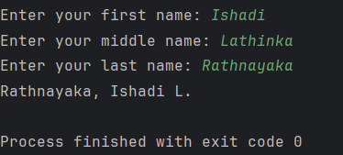

**Q12**.

**Code:**

package Q_12;  
import javax.swing.*;  
  
public class Que_12 {  
 public static void main(String[] args) {  
  
 JFrame frame = new JFrame();  
 frame.setSize(300, 200);  
 frame.setTitle("My First Frame");  
 frame.setLocation(100, 50);  
 frame.setDefaultCloseOperation(JFrame.*EXIT_ON_CLOSE*);  
 frame.setVisible(true);  
 }  
}

**Output:**

