**Lab worksheet 5: Repetition Statements**

**Q_01.**

**Code:**

package Q_01;  
public class Que_01 {  
 public static void main(String[] args) {  
 int number = 10;  
 while (number <= 49){  
 System.*out*.print(number + " ");  
  
 if(number %10 == 9){  
 System.*out*.println();  
 }  
 number = number + 1;  
 }  
 }  
}

**Output:**

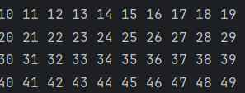

**Q_02.**

**Code:**

package Q_02;  
  
import java.util.Scanner;  
  
public class Que_02 {  
 public static void main(String[] args) {  
 Scanner scanner = new Scanner(System.*in*);  
 int num;  
  
 do{  
 System.*out*.print("Enter a Num: ");  
 num = scanner.nextInt();  
  
 if(num>=0){  
 int digit = *digitCount*(num);  
 System.*out*.println(num + " has "+ digit + " digits");  
  
 }  
  
 }while(num>=0);  
  
  
  
 }  
  
 private static int digitCount(int num) {  
  
  
 int count = 0;  
 while (num > 0) {  
 num = num / 10;  
 count++;  
 }  
 return count;  
 }}

**Output:**

**Q_03.**

package Q_03;  
  
import java.util.Scanner;  
  
public class Q_03 {  
 public static void main(String[] args) {  
 Scanner input = new Scanner(System.*in*);  
 int N;  
  
 System.*out*.print("Enter N: ");  
 N = input.nextInt();  
  
 for (int i = 1; i <= 10; i++) {  
 int result = N * i;  
 System.*out*.println(N + " x " + i + " = " + result);  
 }  
  
 input.close();  
 }  
}

**Output:**

**Q_04.**

**Code:**

package Q_04;  
import java.util.Scanner;  
  
public class Que_04 {  
 public static void main(String[] args) {  
 Scanner input = new Scanner(System.*in*);  
  
 System.*out*.print("Enter the number of rows: ");  
 int row = input.nextInt();  
 int space = row - 1;  
 int asterisk = 1;  
  
 for (int i = 0; i < row; i++) {  
  
 for (int j = 0; j < space; j++) {  
 System.*out*.print(" ");  
 }  
  
 for (int k = 0; k < asterisk; k++) {  
 System.*out*.print("*");  
 }  
  
 System.*out*.println();  
  
 asterisk += 2;  
 space--;  
 }  
  
 input.close();  
 }  
}

**Output:**

**Q_05.**

**Code:**

package Q_05;  
  
import java.util.Scanner;  
  
public class Que_05 {  
 public static void main(String[] args) {  
 Scanner input = new Scanner(System.*in*);  
 System.*out*.print("Enter a word: ");  
 String word=input.nextLine();  
  
 if(*isPalindrome*(word)){  
 System.*out*.print("The given word is palindrome: ");  
 }else{  
 System.*out*.print("The given word is not palindrome: ");  
 }  
  
 }  
 public static boolean isPalindrome(String word) {  
 String reverseWord = "";  
 for(int i=word.length()-1; i>=0; i--){  
 reverseWord = reverseWord + word.charAt(i);  
  
 }  
 return word.equals(reverseWord);  
}}

**Output:**



**Q_06.**

**Code:**

package Q_06;  
import java.util.Random;  
import java.util.Scanner;  
public class Que_06 {  
 public static void main(String[] args) {  
 Scanner input = new Scanner(System.*in*);  
 Random random = new Random();  
  
 int secretNumber = random.nextInt(100) + 1;  
 int guess;  
 int attempts = 0;  
  
 System.*out*.println("Welcome to the number guessing game!");  
  
 do {  
 System.*out*.print("Enter your quess(1-100) : ");  
 guess = input.nextInt();  
 attempts++;  
  
  
 if (guess > secretNumber) {  
 System.*out*.println("Higher");  
 } else if (guess < secretNumber) {  
 System.*out*.println("Lower");  
  
 }else{  
 System.*out*.println("Congratulation you guessed the secret number correctly in "+ attempts + " attempts" );  
 }  
  
 }while(guess!=secretNumber);  
  
  
}}

**Output:**

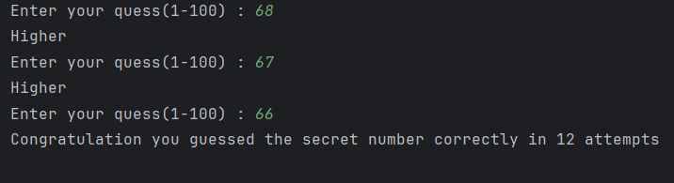

**Q_07.**

**Code:**

package Q_07;  
import java.util.Scanner;  
  
public class Que_7 {  
 public static void main(String[] args) {  
 Scanner input = new Scanner(System.*in*);  
  
 System.*out*.print("Enter the sentence: ");  
 String sentence = input.nextLine();  
  
 System.*out*.print("Enter the word to replace: ");  
 String wordToReplace = input.nextLine();  
  
 System.*out*.print("Enter the replacement word: ");  
 String replacementWord = input.nextLine();  
  
 String modifiedSentence = *replaceWord*(sentence, wordToReplace, replacementWord);  
 System.*out*.print("Modified sentence: " + modifiedSentence);  
  
 input.close();  
 }  
  
 private static String replaceWord(String sentence, String wordToReplace, String replacementWord) {  
 String[] words = sentence.split(" ");  
 for (int i = 0; i < words.length; i++) {  
 if (words[i].equalsIgnoreCase(wordToReplace)) {  
 words[i] = replacementWord;  
 }  
 }  
 return String.*join*(" ", words);  
 }  
}

**Output:**

