****Spotify – Recommendations to Reduce Song Skipping**

Marketing Models

Columbia University in the City of New York

***Abstract:*** *Spotify is one of the top consumer-preferred music streaming platforms. They are known for providing recommendations to the consumers with the latest, relevant, and consumer-preferred songs. Although, as the data reveals, a lot of users skip the songs while being recommended in a playlist. Some skip early, some late while some not at all. Being data scientists, we dived deeper into knowing the reasons behind a song being skipped and provide possible recommendations for Spotify to make their users love songs more and skip less.*

1. **Goal of the Project:** Build and estimate a model to predict the user’s skipping behaviour and derive managerial insights for Spotify. Specifically, answering the question - how can Spotify reduce user-skipping!
2. **Data Description:**

The provided dataset (a simplified subset of Spotify AI challenge) consisted of 9 acoustic features of songs and 2 target variables – ‘early skip’ and ‘late skip’. The meaning of the features is as follows:

1. **Duration**: Duration or length of the song in seconds
2. **Acousticness:** The confidence measure of how natural acoustic sounds it consists of. Lower acousticness means higher electric sounds. 1.0 represents high confidence the track is acoustic
3. **Danceability:** The extent of how suitable a track is for dancing based on a combination of musical elements including tempo, rhythm stability, beat strength, and overall regularity. A value of 1.0 means most danceable
4. **Energy:** A measure from 0.0 to 1.0 representing a perceptual measure of intensity and activity. Typically, energetic tracks feel fast, loud, and noisy
5. **Instrumentalness:** Measure of whether a track contains no vocals. “Ooh” and “aah” sounds are treated as instrumental in this context. Rap or spoken word tracks are clearly “vocal”. 1.0 indicates greater likelihood that the track contains no vocal content
6. **Liveliness:** Detection of the presence of an audience in the recording. Higher liveliness representing increased probability that the track was performed live
7. **Loudness:** Overall loudness of the track in decibels (dB). is the quality of a sound that is the primary psychological correlate of physical strength (amplitude). Values typical range between -60 and 0 db
8. **Tempo:** It is the speed or pace of a given piece derived directly from the average beat duration in bpm (beats per minute)
9. **Valence:** A measure from 0.0 to 1.0 describing the musical positiveness conveyed by a track
10. **Early:** If song was skipped early or not. 1 indicating early skip while 0 could mean either a late skip or no skip
11. **Late:** If song was skipped late or not. 1 indicating late skip while 0 indicating no skip.

*Note: ‘1’ in Early column had ‘1’ in late column as well*

1. **Feature Engineering:** To account for redundancy in ‘Early’ and ‘Late’ column. A new column was created named as ‘Skip_speed’ by adding both columns. ‘0’ indicating ‘No skip’, ‘1’ indicating ‘late skip’ and ‘2’ indicating ‘early skip’.
2. **Modelling:**

Firstly, the trained dataset was scaled and test set was scaled on the train’s mean and standard deviation.

* 1. **3 classes Multi-class classifier**

First aim was to find the best classifier with highest accuracy or least loss on the hold-out test set.

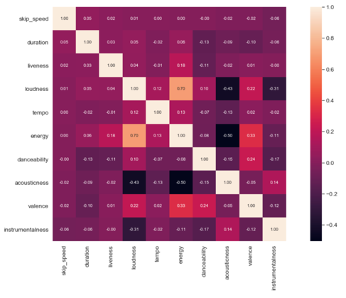

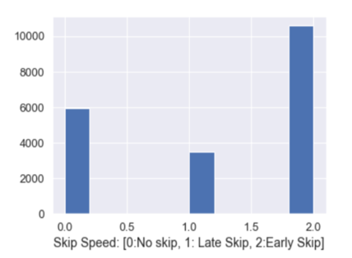

*Figure 1 Class frequencies in the dataset*

*Figure 2 Correlation plot*

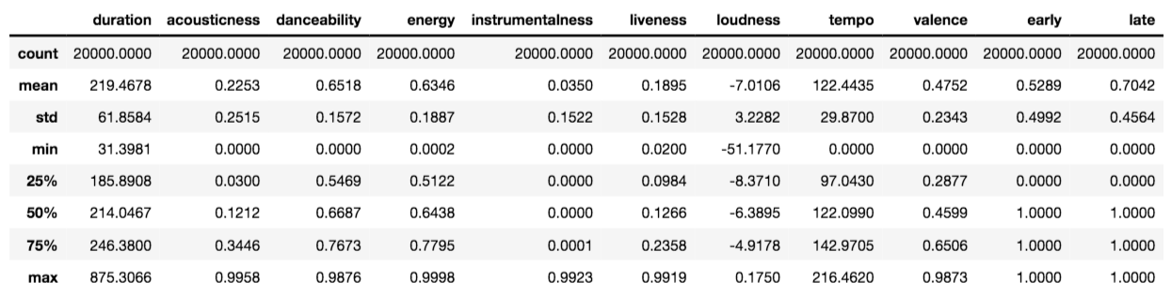

*Figure 3 Summary Statistics*

1. Dataset was imbalanced.
2. No strong correlation with skip speed was observed for any of the song features. Although, loudness and acousticness as well as energy and acousticness were highly negatively correlated.
   1. **Metric for models**

**Log loss *(Logarithmic loss)* or Categorical Cross Entropy loss** was chosen as the best metrics to evaluate the classifier. Unlike acccuracy which just measures ‘yes’s or ‘no’s, log loss takes into account the uncertainty of the prediction based on how much it varies from the actual label. Thus, giving a more nuanced view into the performance of the model.

* 1. **Multinomial Logistic Regression:** It is the simplest Machine Learning Model and provides high interpretabiliy of feature importances for every target class. Multinomial log loss on hold out test set was 0.99345.

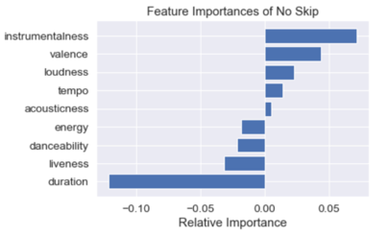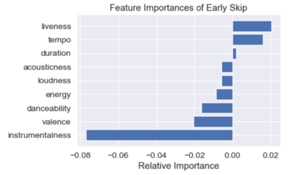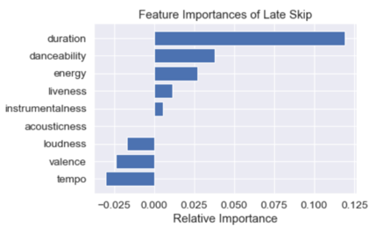

*Figure 3. Feature importance for each class for multinomial regression*

**4.3.1 Interpretations:**

* Lack of vocals (high instrumentalness) in song reduce skipping, especially early skipping significantly
* Positivity (high valence) in song makes the user listen song without skipping
* Long duration songs lead to high number of late skips indicating that user tend to skip the song after a certain time of listening
* Liveliness lead to early skipping of songs – implying that as soon as user identifies that song is not original or there is ‘noise’ of audience, user tends to skip the song.
* Loudness being positively correlated with ‘No skip’ and negatively correlated with both the ‘early’ and ‘late’ skips indicate that louder the song, lesser the chances of user to skip it
* Danceability is negatively correlated to both the ‘no skip’ and ‘early skip’ while highly positively correlated to ‘late skip’ implying that high danceability makes the user skip the song although late
* Energy is negatively correlated to both the ‘no skip’ and ‘early skip’ while highly positively correlated to ‘late skip’ implying that high energy songs makes the user skip the song although late
* High tempo in song lead to more early skips and lesser late skips
* Acousticness has relatively the least affect on user’s skipping behaviour
  1. **Decision and Gradient Boosting Trees:** Trees are one of the best interpretable Machine Learning models. For the 3 class multi-class classification using decision tree, it was tuned through cross – validation by finding the best values of max_depth, ccp_alpha (complexity parameter), criterion and splitter

Performance of Neural network and ensemble trees increased from 53% to 72% when changing from 3 class classifier to 2 class classifier. It showed that it is better and more reliable to first classify if the song will be skipped at all or not and make first level of recommendations and then conditioned on being skipped, creating another classifier if a song will be skipped early or late.

4.4.1 **Skip V/s No-skip Classifier**

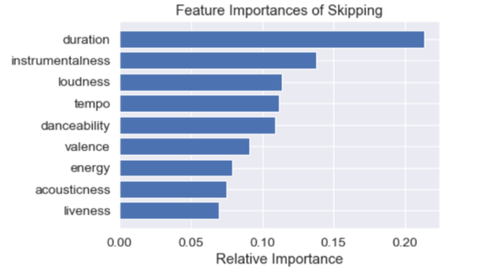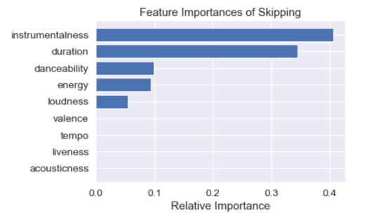

*Figure 4. Feature importance for Skip – No Skip classifier: GradientBoosting*

*(Ensemble of 100 decision trees)*

*Figure 5. Feature importance for Skip – No Skip classifier: Decision Tree (single tree)*

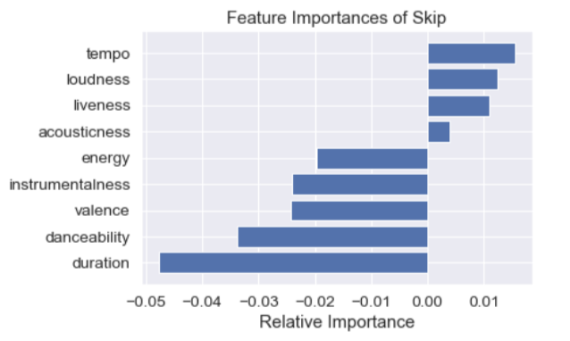

*Figure 8. Feature importance for Skip – No Skip classifier: Logistic Regression- Elasticnet*

**Interpretation:**

* Length of songs increases chances of skipping
* Lack of vocals (high instrumentalness) increases chances of skipping
* Loudness increases chances of skipping
* Danceability increase chances of skipping



*Figure 6. Skip – No Skip classifier*

*Decision Tree*

4.4.2 **Early Skip V/s Late skip Classifier**

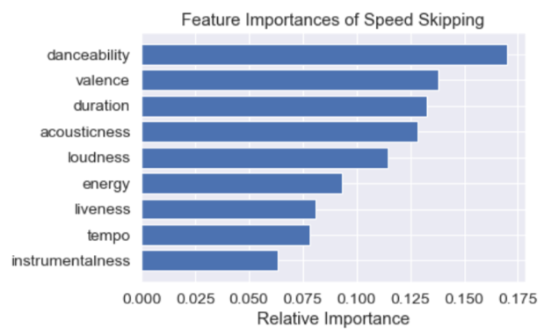

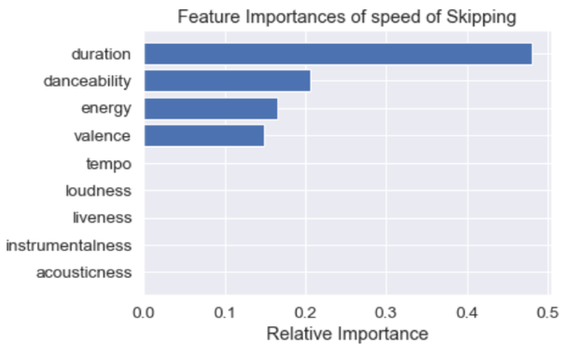

*Figure 8. Feature importance for Early Skip – Late Skip classifier: Decision Tree (single tree)*

*Figure 7. Feature importance for Early Skip – Late Skip classifier: GradientBoosting*

*(Ensemble of 100 decision trees)*

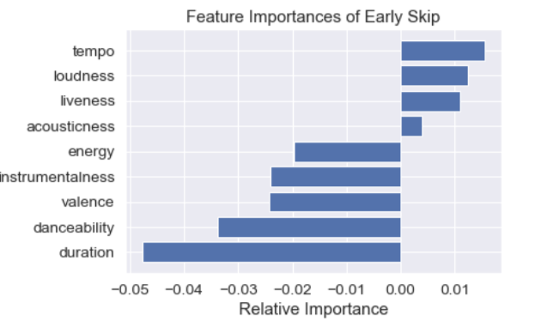

*Figure 8. Feature importance for Early Skip – Late Skip classifier: Logistic Regression- Elasticnet*

**Interpretation:**

* Length of songs increases speed of skipping
* Danceability increases speed of skipping
* Valence increases speed of skipping
* Energy (High intensity and activity) in songs increase the speed of skipping



*Figure 5. Early Skip – Late Skip classifier*

*Decision Tree*

* 1. **Modelling Summary:**

|  |  |  |  |
| --- | --- | --- | --- |
| **Method** | **No skip: Early Skip : Late Skip classifier**  **Log – Loss Accuracy** | **Skip : No-skip classifier**  **Log – Loss Accuracy** | **Early Skip : Late Skip Classifier**  **Log – Loss Accuracy** |
| **Multinomial Logistic**  **Regression (Elasticnet)** | 0.99345 0.5386 | 0.99286 0.5382 | 0.55483 0.75660 |
| **SVM** | 0.99449 0.5392 | 0.99444 0.5402 | 0.55528 0.75604 |
| **Neural Network** | 0.99554 0.53820 | 0.59901 0.71146 | 0.55804 0.75660 |
| **Decision Tree** | 0.99591 0.5366 | 0.99522 0.5408 | 8.42644 0.75603 |
| **Gradient Boosting** | 0.99575 0.538 | 0.99518 0.5374 | 8.51472 0.75348 |

Results show that 3 class classifiers perform poorly as compared to 2 separate classifiers. The reason is that 3 classes are not exactly equivalent. A song being skipped or not skipped is about if a listener loved it or hated it, while a song being skipped early or late is about how soon the listener dislikes or get bored of the song. The classes in a multiclass classifier are assumed to be equivalent or equidistant from each other which is not applicable here.

Hence, we move to find best classifiers both for **‘Skip-No Skip’** as well as for **‘Early skip-Late Skip’.** Binary classifiers were found to not only produce much improved results but also provide better visualization and interpretration for making business recommendations. Hence, our final predictor will first use Neural Network model to predict whether the given song will be skipped or not and then use the logistic regression to predict the speed of skipping (early or late skipping) conditioned on the song being skipped. Important thing to note here is that, in case of

**Skip-No Skip’** classifier, neural network outperforms all other classifiers. Whereas in case of **Early skip-Late Skip’** classifier, all classifiers are improved to similar extent. Given the high computational power required by SVM, low interpretability of Neural Network and simplicity of logistic regression, we chose the latter to form 2nd layer of predictor.

Input song ( 9 features )

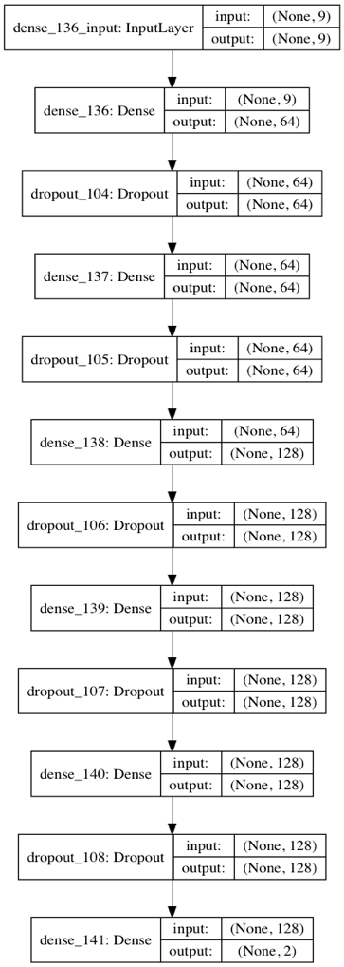

Input song ( 9 features )

**[ Probability of Not skipping , Probability of Skipping ]**

* 1. **Recommendations to Reduce Skipping:**

As decision trees are inherently classifiers, log-loss which makes them calculate probabilties doesn’t perform well as their metric. From the decision tree splits and feature importances above, following are our top recommendations for spotify:

* If danceability of a song is less then instrumentalness shouldn’t exceed beyond a limit. It implies that if there aren’t musical elements in the song including tempo, rhythm stability, beat strength, and overall regularity, then person tend to skip if even vocals are missing beyond a certain level. It makes logical sense as well, when a person doesn’t find any interesting music, beats or rhythm then she/he should find lyrics to dwell in else person skips it.

Therefore, a playlist can be created such that to maintain entertainment and reduce monotonicity, a lyrical song is followed by an instrumental song of genre of user’s preferences or mood.

* Both the danceability and instrumentalness should be high to ensure no skipping. It implies that if vocals are lacking beyond a certain level, then song should be highly danceable i.e. should have strong tempo, rhythmic stability, beat strength and overall regularity for the person to keep listening.
* In both the above cases, if duration of song exceeds beyond certain level then person will skip the song. It kind of shows that after a certain period of time, person gets bored of listening the same song and has enjoyed every element of the song. Therefore, to avoid it, in the mash-ups and spotify curated mood playlists, especially those which listeners listen and choose to like or dislike, should not have complete songs rather only till certain length. So that, as soon as the person starts getting bored of listening one song, the next song is played automatically without person having to skip the song which reduces customer satisfaction.
  1. **Reccommendations to Delay Skipping:**
* If duration of song is less but danceability is more, then person tends to skip song early. To keep person hooked for longer, the danceability should be proportional to length. In other words, for relatively shorter songs, danceability should be less. It makes intuitive sense as well. Danceable song are quickly chosen by listeners – ‘to listen or to not listen’ or rather ‘to dance on or not’ but other songs have to be listened to make a decision. The reason is danceable songs can be liked or disliked merely by beats, vibes and rhythm while other songs have to be given time.

This implies that while recommending songs to user, recommended danceable songs should be user’s choice – either through previous history or previous interests while ‘experiment’ can be done with non-danceable song, as user would have to ‘listen’ to the new song to decide if to skip or not.

* If song has low energy level, then duration should be within a range. This implies that if a song has low energy level and duration extends beyond a limit, then listener tend to skip the song early. In other words, low energy songs can hook a listener till a certain limit, beyond which user tend to skip it.

This implies that while recommending new or out of the box latest low energy

* If song has high energy levels, then it should have high valence i.e. positivity too.