1. **Data Manipulation:**

Provided data contained null values and unnecessary columns. Hence, to correct that:

1. Removed Column ‘Phone’
2. Imputed (substituted) mean values for Nan in numeric columns
3. Imputed (substituted) mode values for Nan in categorical columns
4. **Data Exploration:**

Data for the churn prediction is highly imbalanced as the TARGET = ‘1’ value is only 12.5% of the total values, whereas TARGET = ‘0’ is the remaining 87.5% values. Hence the dataset needs to resampled using SMOTE technique.

Using SMOTE ration = 0.5, we get resampled dataset for modelling having 43.6% values for TARGET = ‘1’ and remaining 56.4% for TARGET = ‘0’.

1. **Models:**

Have solved the classification problem using below mentioned classifier models:

1. Default models
2. Hyperparameter tuning of models using Randomized Search

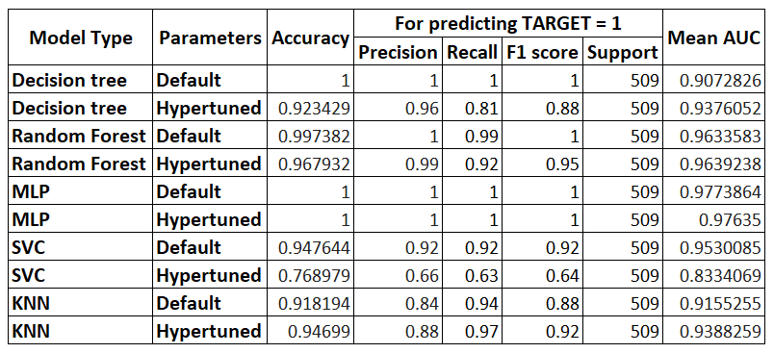

**Observations:**

1. On carrying out hyperparameter tuning on the classifier models, accuracy when compared to their default models has remained same for MLP classifier but reduced for all the rest models. This is because when we do hyperparameter tuning, we restrict the parameters to a certain boundary. In default state, the models work better in most of the cases.
2. **Stacking:**

Emsembled predictions of 3 of the classifier models: DT, RF and SVC. Have used DT, RF and SVC as stacking classifiers as well. Below are the results for the same:

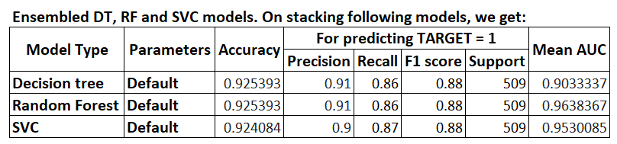

**Observations:**

1. On carrying out stacking on the emsembled predictions of the models, accuracy when compared to their default individual models has reduced for all the models. But compared to their hypertuned models, their accuracy score is comparable.
2. We carry out stacking for better prediction of models compared to their individual models.
3. **Suggestions:**

For better prediction results, we can do the following:

1. Vary the values for Hyperparameter tuning
2. Vary the SMOTE ratio
3. Try using other models like Gradient Boosting, etc
4. Can use Grid search technique while hypertuning
5. Try other combinations of Ensembled models