**Name: Ishani Udaykant Shah**

**Instructions:**

* Used the data file: WorldClassicMoviesRentals.csv, which is a dataset on the World Classic Movie Rentals history.
* For questions 3-7, imported the csv file to Tableau and answered the questions.

Questions

1. Use the attached data file: WCM Movie Rentals.csv. Examine the column names (you can Load the file in Excel to examine. The column names are self-explanatory. For each of the columns listed below, identify the column as a measure or a dimension:

|  |  |  |
| --- | --- | --- |
|  | **Column** | **Measure or Dimension?** |
| 1 | Year | Dimension |
| 2 | Quarter | Dimension |
| 3 | Month | Dimension |
| 4 | Country | Dimension |
| 5 | StateOrProvince | Dimension |
| 6 | Revenue | Measure |
| 7 | Quantity | Measure |

1. The data in the WCM Movie Rentals.csv file is generated from a database that has the star schema as shown below. Write an SQL query that can generate this data cube from the database (order matters!). *Note also that in the fact table of the star schema, each row is at the day-store level; in the csv file, each row is at the month-state level.*

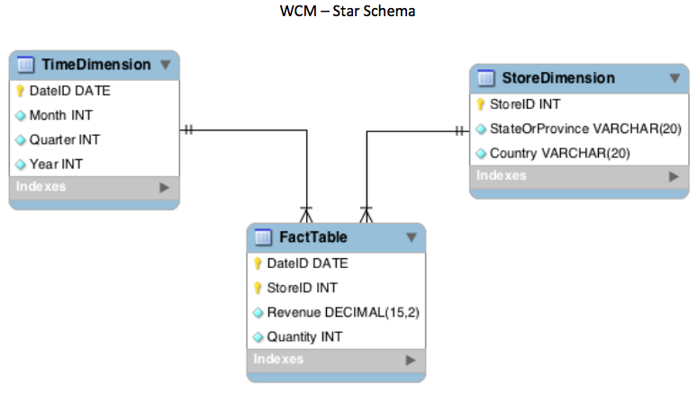

**Answer:**

Select T.Year, T.Quarter, T.Month, S.Country, S.StateOrProvince,

Sum(F.Revenue) as Revenue, Sum(F.Quantity) as Quantity

From FactTable F

Left join StoreDimension S

On F.StoreID = S.StoreID

Left join TimeDimension T

On F.DateID = T.DateID

Group by 1,2,3,4,5

Order by 1 asc,2 asc,3 asc;

Please use Tableau to answer the questions 3-7:

1. Which year generated the highest revenue?

**Ans: 2008**

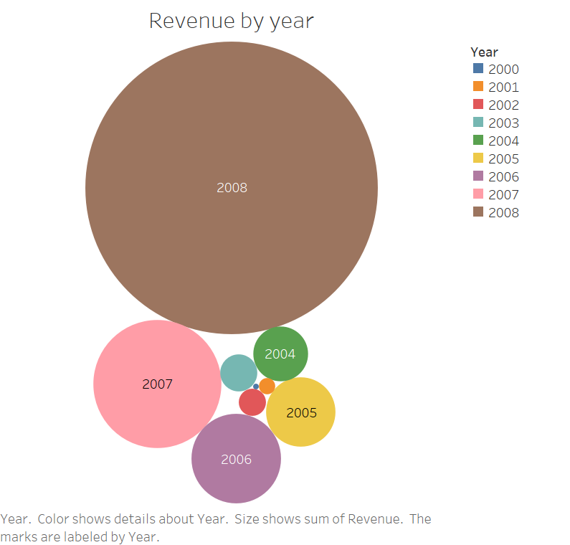

1. In 2008, which month generated the highest revenue and which month generated the lowest?

**Ans: Lowest revenue: February & Highest revenue: December**

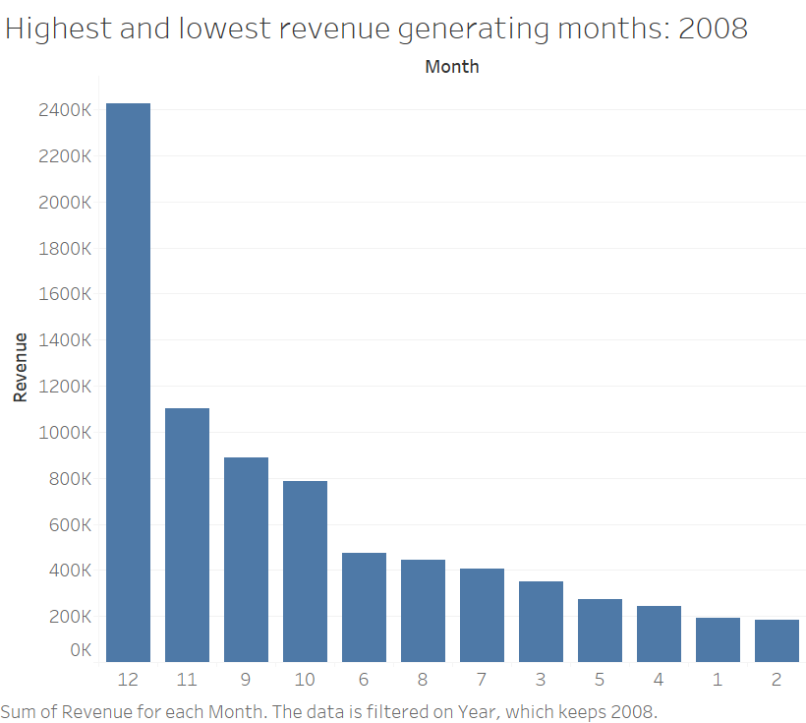

1. Show the revenue by month in country: “US” and year: 2006 and 2007. Do you find a similar seasonality in revenue in these two years?

**Ans: Yes, we can observe similar seasonality trend for year 2006 & 2007 in US**

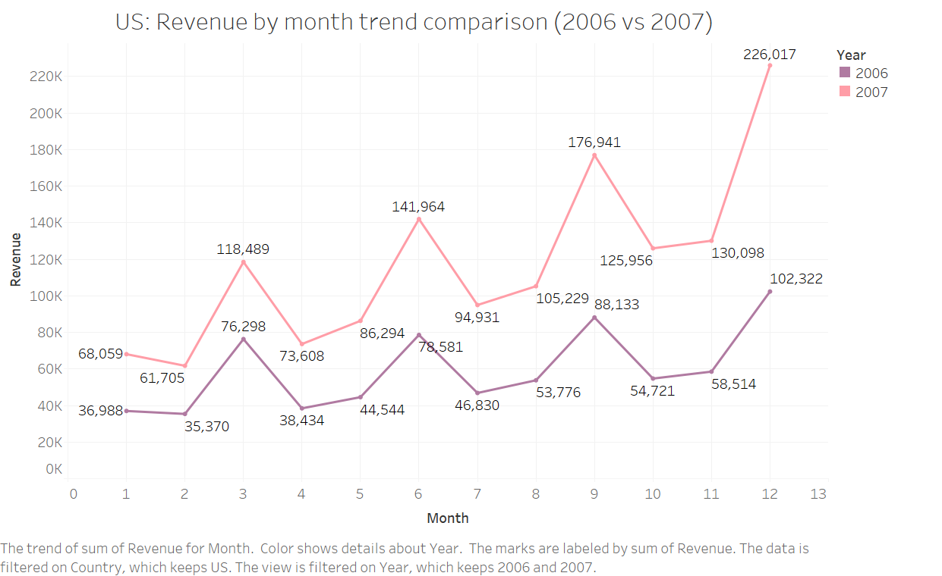

1. Which three states/provinces generated the highest revenue in the first two quarters of 2007?

**Ans: Top 3 states/provinces: California, Texas, New York**

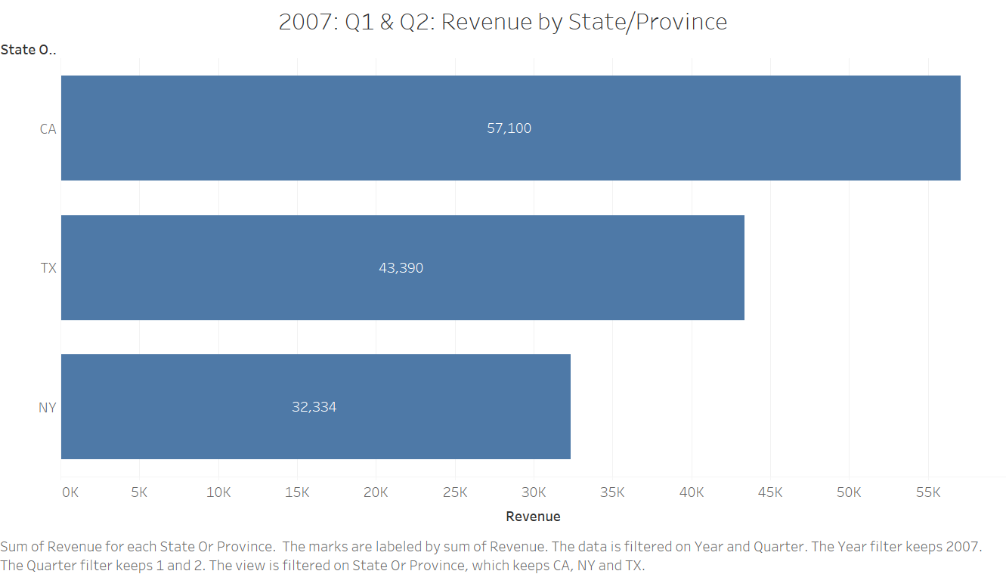

1. Please provide a map of US (mainland) showing the revenues for each state. The graph should allow managers to see easily and clearly the revenues comparison for each state.

[NOTE, due to space constraints, it will be difficult to show numbers for every state].

**Ans:**

