**Assignment: React Project Assignment (ChocoPedia)**

Introduction

In this assignment, you will exercise the usage of react concepts

Objective

This assignment will help you master the following concepts:

* React
* React Router
* Redux
* Redux Saga
* Immerjs

Prerequisites

Not Applicable.

Supporting Data Files

Problem Statement

**ChocoPedia**

online web application that provides details of different brands and their chocolates

Develop a react application that provides following features

* Home Page
* Login
* Signup
* List all brands
* Brand Detail and its chocolates
* List all chocolates
* Chocolate detail
* Search chocolates by name and display results

Note: All screen shots have URL info. Use URL info to create routing rules to power navigation in the application

**Mock Api :** <https://github.com/baluragala/mock-chocolate-collection-api>

This api contains all the mock data for the below project, follow the setup instructions on git. Mock api is based on a tool called JSON sever, you can explore more about this at <https://github.com/typicode/json-server>

Concepts to be used:

* Next generation JS syntaxes
* React Router for navigation
* Redux for state management
* Redux Saga as middleware
* immerjs for immutable data structures

**Home Page:**

This is the landing page of the application

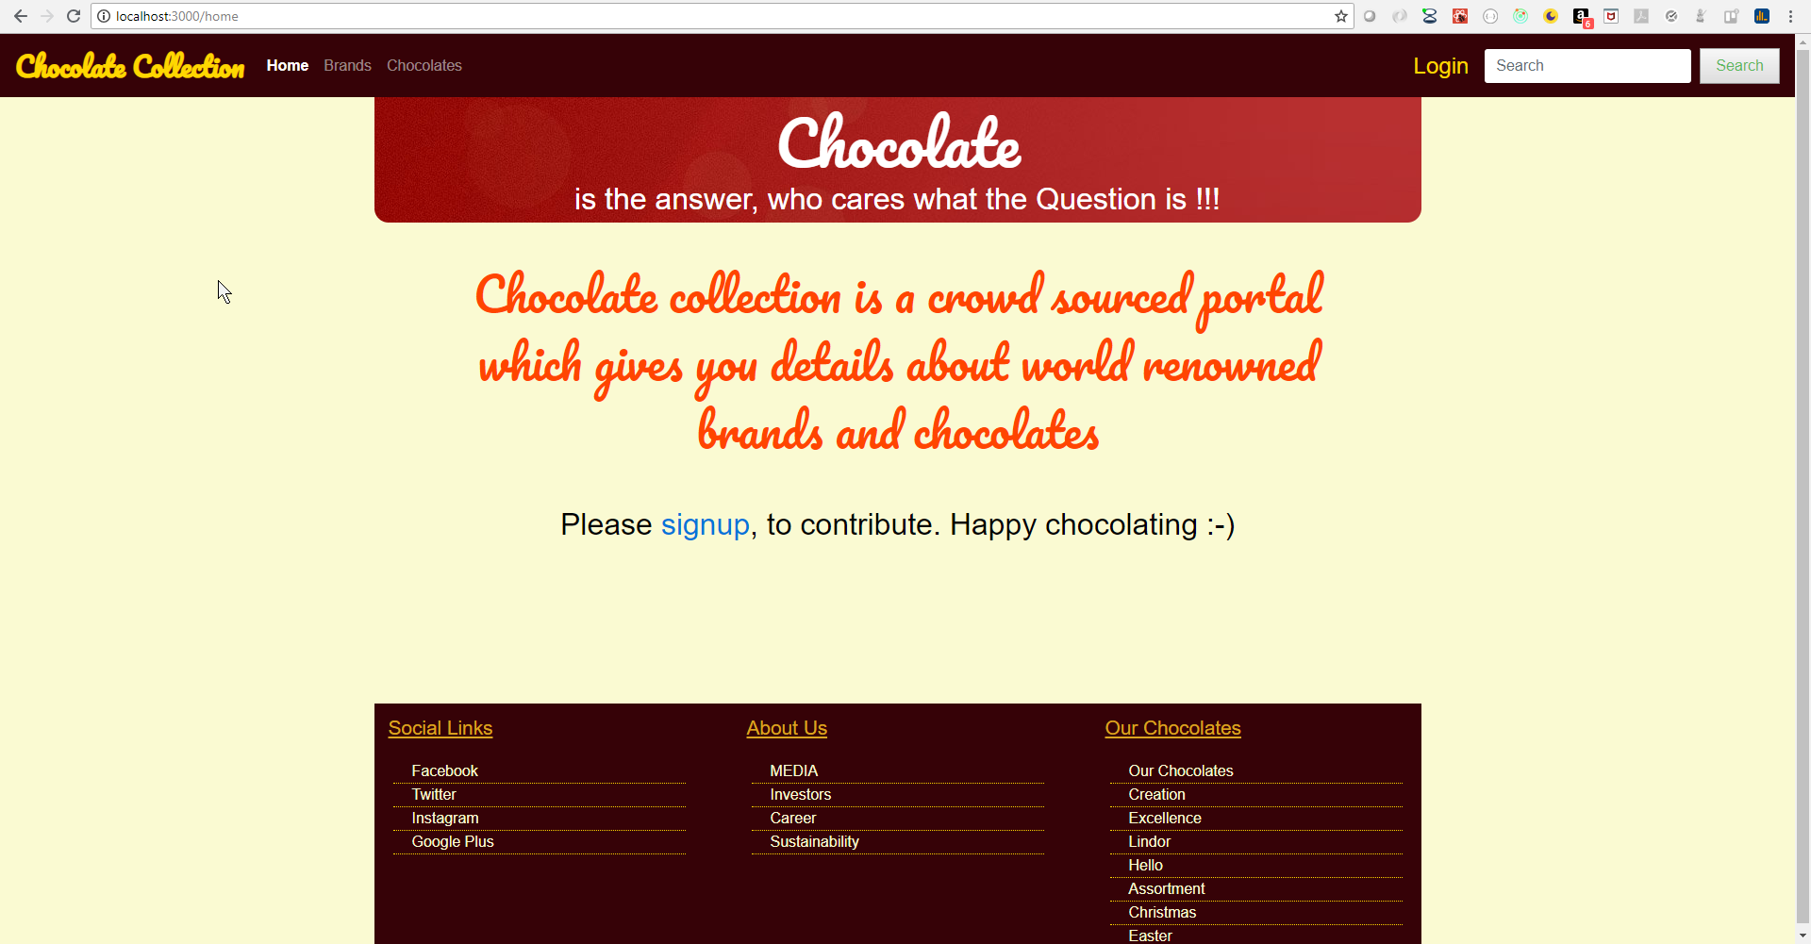

**Brands Page:**

This page lists all brands, user can click on any brand to navigate to brand detail page

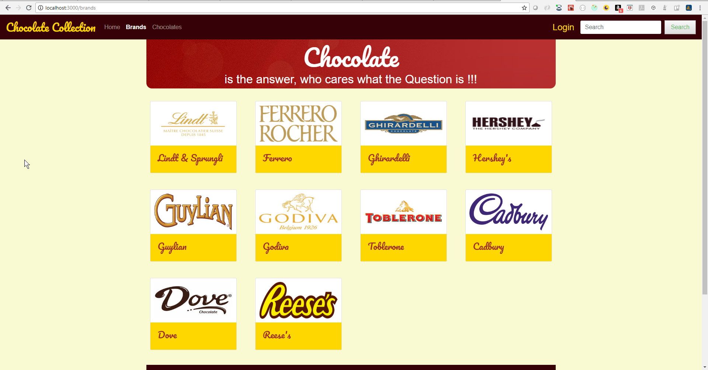

**Brand Detail Page:**

This page shows the details about the selected brand. Details about brand are pulled from api using the brand id. You can get selected brand id using route params

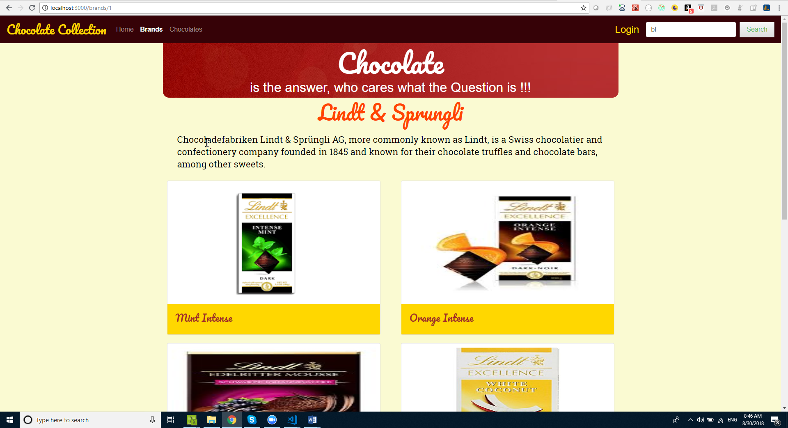

**Chocolate List Page:**

This page lists all chocolates irrespective of brand, user can click on any chocolate to navigate to chocolate detail page

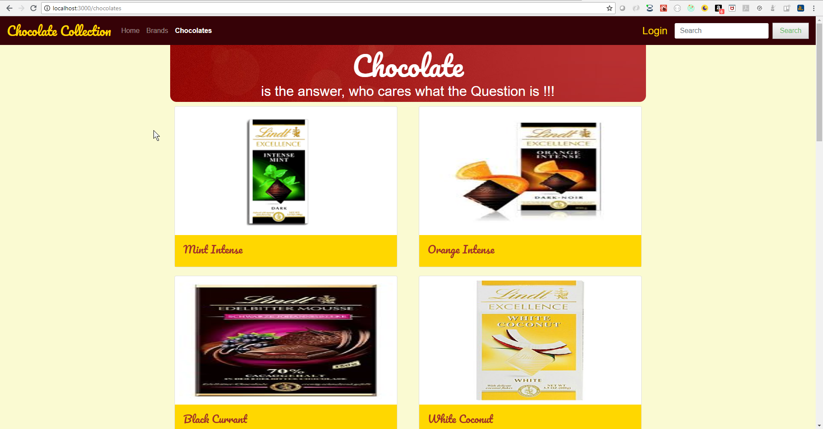

**Chocolate Detail Page:**

This page shows the details about the selected chocolate. Details about chocolate are pulled from api using the chocolate id.

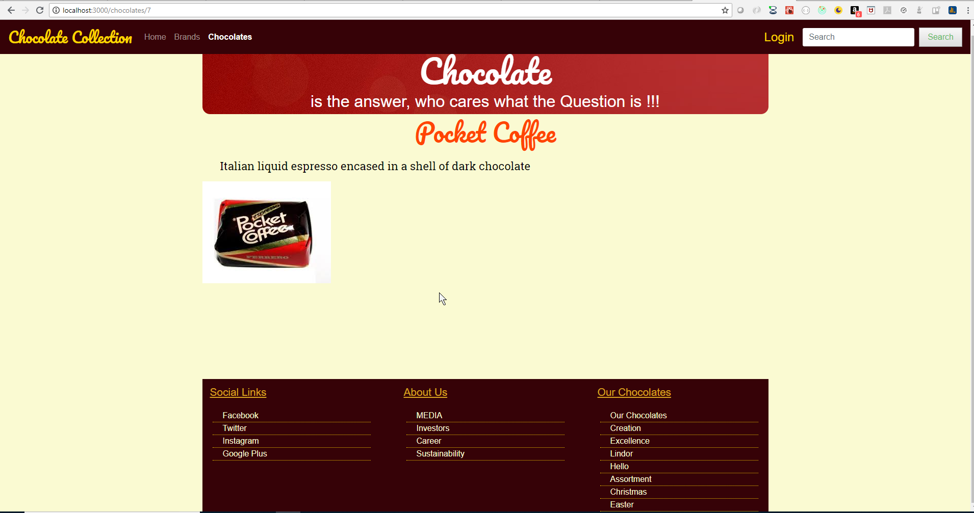

**Login Page:**

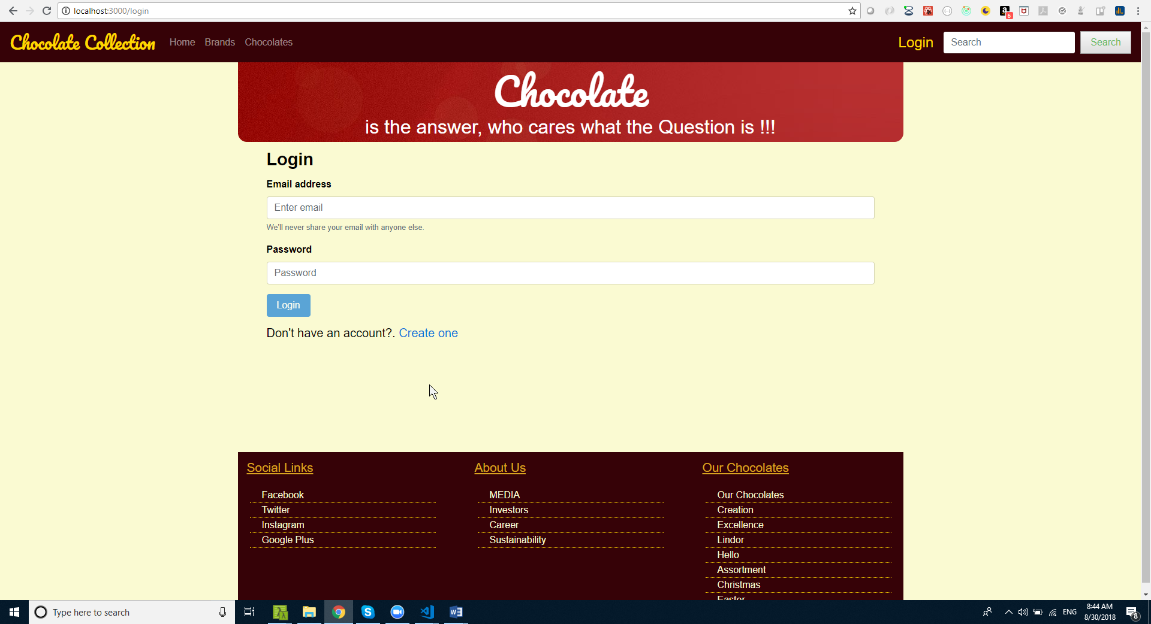

**Signup Page:**

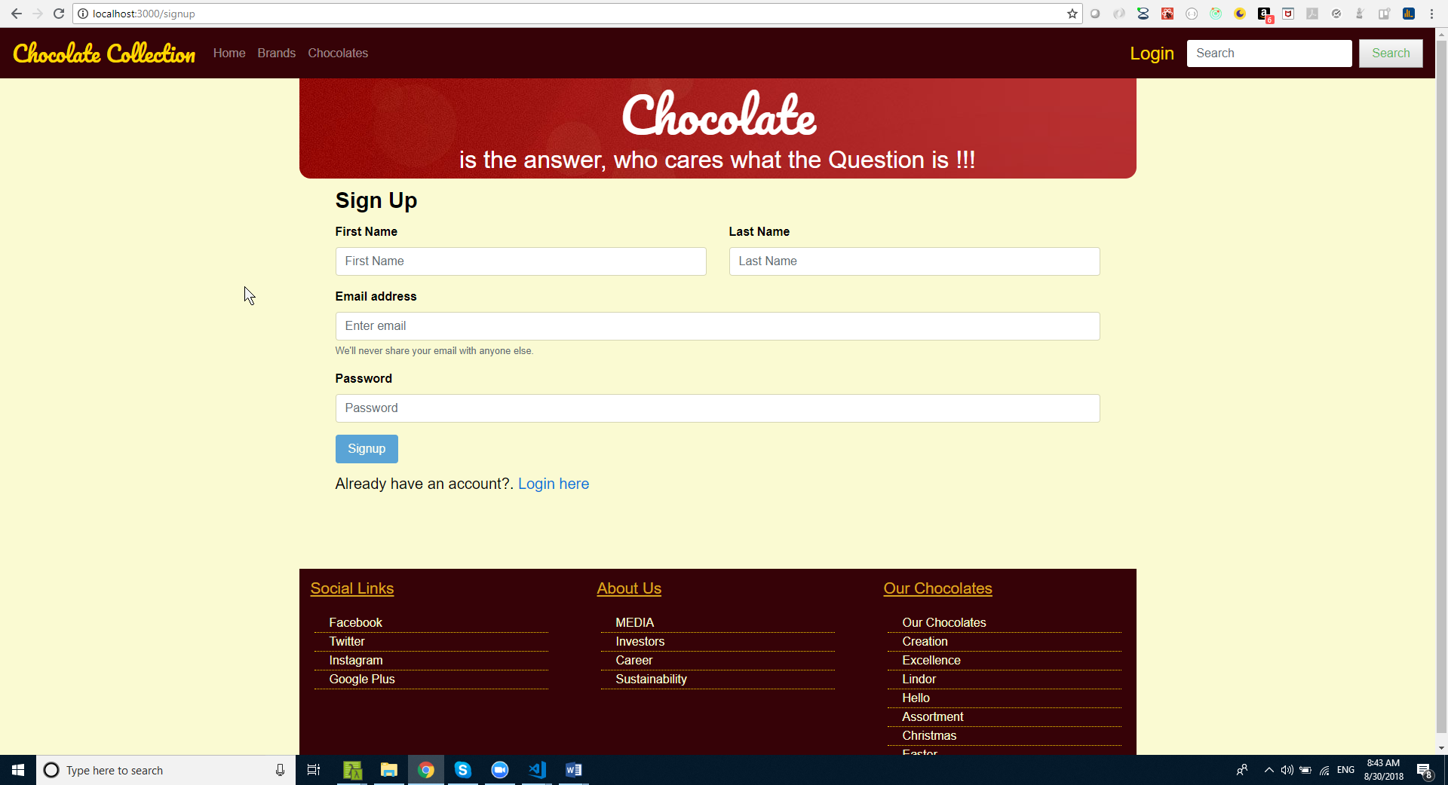

**Search Results Page:**

Using the search box on the navigation user can search chocolates by name. User enter search param into search box and the click search button. When no results yielded for search the show “No results found”

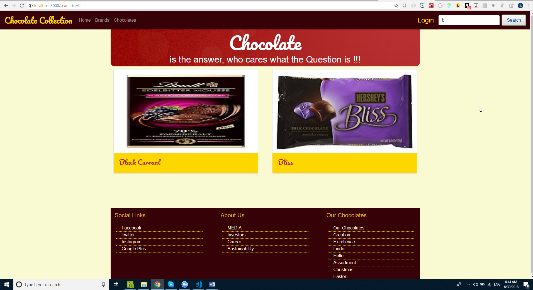

Expected output

Working react single page application as per requirements

Approximate Time to Complete Task

600 minutes