MATHS

Q1. Find the factors for each of the following numbers by multiplication. (2×2=4)

- 28

- 15

Q2. Find the factors for each of the following by division. (2×2=4)

- 16

- 64

Q3. Find the prime factors. Use the factor tree method. (2×3=6)

- 105

- 210

- 462

Q4. Find the HCF of :- (2×2=4)

- 48

- 120

Q5. Write the first six multiples for the numbers given below :- (1×2=2)

- 3

- 12

Q6. Write the divisions as fractions. (1×2=2)

- 4÷5

- 3÷4

Q7. Solve the following. (2×2=4)

- 3/7 + 1/7

- 7/12 – 4/12

Q8. Simplify. (2×2=4)

a) 5/12 + 2/3 – 5/6

b) 6 - 2
_{ଷ}

Q9. Multiply. (2×3=6)

a) 4/9 × 3/8
b) 8/9 × 27/28
c) 4/5 × 10/14

Q10. Fill in the blanks. (1×4=4)
a) 3/5 × ___ = 1
c) ___ × 6/7 = 1

b) 5/7 × ___ = 1

d) ___ × 24/25 = 1

Q11. Write the next three decimals. (1×4=4)

- 4.6 , 4.7 , ____ , ____ , ____

- 3.9 , 4.0 , ____ , ____ , ____

- 1.1 , 1.2 , ____ , ____ , ____

- 6.2 , 6.3 , ____ , ____ , ____

Q12. Write the fractions and decimal for each of the following. (1×4=4)

- If 25 squares out of 100 are shaded ______ .

- If 9 squares out of 10 are shaded ______ .

- If 89 squares out of 100 are shaded ______ .

- If 345 squares out of 1000 are shaded ______ .

Q13. Complete the pa erns. (1×2=2)

- 8 , 17 , 26 , ____ , ____ , ____

- 4,9,16,25,____,____,____

Q14. Draw the lines of symmetry for each of the following. (1×2=2)

a) b)
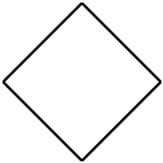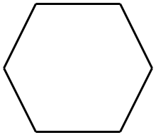

Q15. Complete the symmetrical shapes. (1×2=2)

a) ∑ b)
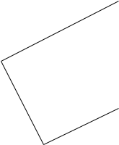

Q16. Solve (2×3=6)

- The product of HCF and LCM of two numbers is 9072. If one of the numbers is 72 , find the other number.

- The product of a number and 4/5 is 16 , find the number.

c) The cost of one bucket to a fair is Rs. 70.25. Find the cost of 9 buckets.

