Department of Computer Science
ENGR498 Engineering Seminar
[Academic Year / Semester]
AI-Based Smart Glove for Selected ASL Sign Recognition
with Personalized Multilingual Speech Output

Role | Name | Email | Phone
Submitted by | [Student Name] | [Student Email] | [Phone Number]
Supervisor | [Supervisor Name] | [Supervisor Email] | [Phone Number]
Faculty Dean | [Faculty Dean Name] | [Faculty Dean Email] | [Phone Number]
Final Year Project Report Draft

Abstract
Communication is a daily challenge for people who cannot rely on spoken language in every situation. While sign language is expressive and complete, not everyone around the user understands it, which creates a communication gap in classrooms, clinics, public places, and daily interactions. This project proposes an AI-based smart glove prototype that recognizes a selected vocabulary of ASL-inspired hand signs and converts them into personalized multilingual phrase output through a mobile application.
The system combines wearable hardware, embedded sensing, machine learning, real-time communication, and a mobile user interface. Five flex sensors are physically installed on the glove and connected to an Arduino Nano 33 BLE Rev2. The Arduino reads normalized finger-bending values and streams them through USB serial in the order index, middle, ring, pinky, and thumb. For the final prototype, the machine learning model focuses on the three primary sensing channels: index, middle, and ring. This design choice supports a stable selected-sign recognition workflow while keeping the prototype reliable, focused, and suitable for final year project demonstration.
A Random Forest classifier was trained using a balanced dataset of 1000 samples across five labels: REST, YES, WHERE, FEEL, and NAME. The final model achieved 99.6% held-out accuracy, with 249 correct predictions out of 250 test samples. A Python live predictor and WebSocket bridge receive the Arduino stream, apply the trained model, enforce a REST-based state machine, and send gesture events as JSON packets to an Expo React Native mobile application. The mobile app displays the detected gesture, translated phrase, selected language, active profile, system state, and gesture history. Text-to-speech support is implemented through Expo Speech, although emulator TTS reliability remains a limitation.
The final prototype demonstrates a complete end-to-end pipeline: glove sensors to Arduino, Arduino to Python AI inference, Python to WebSocket, and WebSocket to the mobile app. The project is not presented as a full ASL translator. Instead, it is accurately framed as a selected-sign recognition system with personalized multilingual speech output, with full ASL grammar, motion-based signs, BLE phone deployment, and expanded vocabulary planned as future work.

Table of Contents
Abstract ................................................................ 2
List of Figures ......................................................... 4
List of Tables .......................................................... 4
List of Abbreviations ................................................... 4
Acknowledgements ........................................................ 5
Chapter 1: Introduction ................................................. 6
1.1 Objectives .......................................................... 6
1.2 Scope ............................................................... 7
1.3 Purpose ............................................................. 7
1.4 Technologies Used ................................................... 7
1.5 Problem Statement ................................................... 8
1.6 Proposed Solution ................................................... 8
Chapter 2: Software and System Specifications ........................... 9
2.1 Functional and Conceptual Study ..................................... 9
2.2 Functional Requirements ............................................. 9
2.3 Non-Functional Requirements ......................................... 10
2.4 UML Use Case Diagram ................................................ 10
2.5 Use Case Narrative Tables ........................................... 11
Chapter 3: System Design ................................................ 13
3.1 Overall Architecture ................................................ 13
3.2 Hardware Design ..................................................... 13
3.3 Firmware and Calibration Design ..................................... 14
3.4 AI Model Design ..................................................... 15
3.5 Recognition State Machine ........................................... 15
3.6 Mobile Application Design ........................................... 16
3.7 Data Design ......................................................... 16
Chapter 4: Implementation ............................................... 16
4.1 Hardware Implementation ............................................. 16
4.2 Arduino Firmware Implementation ..................................... 16
4.3 Dataset Collection and Model Training ............................... 16
4.4 Python Live Prediction .............................................. 16
4.5 WebSocket Bridge Implementation ..................................... 17
4.6 Mobile App Implementation ........................................... 17
4.7 Final Demo Implementation Flow ...................................... 19
Chapter 5: Testing ...................................................... 20
5.1 Hardware Testing .................................................... 20
5.2 Model Evaluation .................................................... 20
5.3 Live Integration Testing ............................................ 21
5.4 Gesture Testing Notes ............................................... 21
5.5 Limitations Observed During Testing ................................. 22
Chapter 6: Conclusions and Future Works ................................. 23
6.1 Conclusion .......................................................... 23
6.2 Future Work ......................................................... 23
References .............................................................. 23

List of Figures
- Figure 1: Final Smart Glove System Pipeline
- Figure 2: Hardware Sensing Layout
- Figure 3: Use Case Overview
- Figure 4: AI Model Development Workflow
- Figure 5: Recognition State Machine
- Figure 6: Mobile Dashboard Screenshot Placeholder
- Figure 7: Gesture History Screenshot Placeholder
- Figure 8: Python Bridge Terminal Screenshot Placeholder
- Figure 9: Training Report Screenshot Placeholder

List of Tables
- Table 1: List of Abbreviations
- Table 2: Technology Stack
- Table 3: Functional Requirements
- Table 4: Non-Functional Requirements
- Table 5: Hardware Pin Mapping
- Table 6: Use Case - Detect and Speak a Gesture
- Table 7: Use Case - Manage Personalized Phrases
- Table 8: Use Case - Run Live AI Bridge
- Table 9: Data Organization Summary
- Table 10: Final Dataset Distribution
- Table 11: Model Evaluation Summary
- Table 12: Integration Testing Summary
- Table 13: Gesture Testing Notes

List of Abbreviations
Abbreviation | Meaning
AI | Artificial Intelligence
ASL | American Sign Language
BLE | Bluetooth Low Energy
CSV | Comma-Separated Values
FYP | Final Year Project
ML | Machine Learning
REST | Neutral hand state used by the recognition state machine
TTS | Text-to-Speech
UI | User Interface
USB | Universal Serial Bus
WS | WebSocket
Table 1: List of Abbreviations

Acknowledgements
I would like to express my sincere appreciation to my supervisor for the guidance, feedback, and encouragement provided during the development of this project. Their support helped shape the technical direction and academic presentation of the system.
I also extend my appreciation to the Department of Computer Science and the faculty members who supported this academic journey. Finally, I thank my family, friends, and everyone who encouraged me while I faced hardware instability, calibration challenges, software integration issues, and final demonstration preparation.

Chapter 1: Introduction
People who cannot rely on spoken language may face difficulty expressing basic needs, emotions, names, questions, or responses when the people around them do not understand sign language. Sign language is a complete and natural language; however, communication can become limited when there is no interpreter or when the other person has no sign language knowledge.
This project addresses this communication gap through a wearable smart glove prototype. The glove captures finger-bending patterns using flex sensors, classifies selected signs using a machine learning model, and sends the recognized phrase to a mobile application. The mobile app then displays the output, stores gesture history, supports multiple languages, and attempts to speak the phrase using text-to-speech.
The project went through several practical engineering stages, including hardware calibration, sensor noise diagnosis, soldering improvements, dataset collection, model training, live prediction, WebSocket integration, and mobile app development. The final system is a working prototype focused on selected ASL-inspired signs rather than full ASL translation.
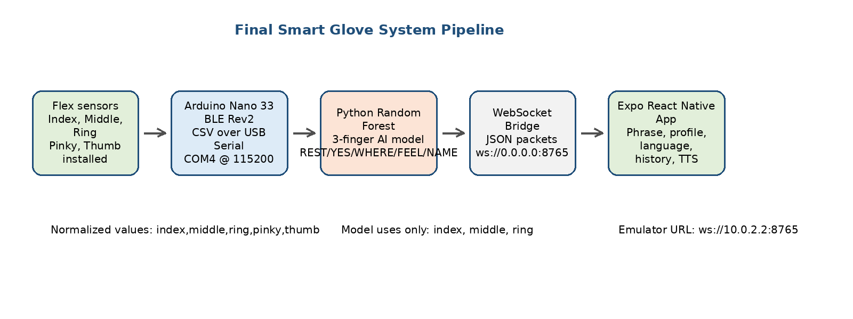
Figure 1: Final Smart Glove System Pipeline

1.1 Objectives
The main objective of this project is to design and implement a smart glove prototype that can recognize selected hand signs and convert them into useful phrase output through a mobile application. The project combines hardware sensing, embedded systems, machine learning, real-time communication, and mobile development.
- Build a wearable glove using flex sensors to capture finger bending.
- Read and normalize sensor values using an Arduino Nano 33 BLE Rev2.
- Train a machine learning model capable of recognizing selected signs from real glove data.
- Use the most stable sensor channels for reliable recognition instead of forcing unreliable hardware channels into the model.
- Create a Python live prediction and WebSocket bridge to connect hardware inference to the app.
- Develop an Expo React Native mobile app to display gestures, phrases, language, profile, and history.
- Support personalized phrase output and multilingual display in English, Arabic, and French.
- Document technical limitations clearly and propose realistic future improvements.

1.2 Scope
The scope of this project is a functional prototype for selected ASL-inspired sign recognition. The system recognizes a limited vocabulary composed of REST, YES, WHERE, FEEL, and NAME. These signs are selected because they can be represented using the stable finger-bending patterns available from the glove prototype.
The glove physically contains five flex sensors. However, the final AI model uses only index, middle, and ring because these three channels were the most stable during testing. Pinky and thumb remain installed and streamed by Arduino, but they are ignored by the final model because their readings were noisy and less reliable. This is a deliberate engineering decision that improves final demo stability.
The system does not implement full ASL grammar, continuous signing, hand motion tracking, facial expression recognition, or sentence-level interpretation. These areas are treated as future work.

1.3 Purpose
The purpose of the project is to demonstrate how a wearable assistive technology system can translate selected finger gestures into understandable phrase output. The system is designed for educational and prototype purposes, showing a complete end-to-end pipeline from sensor data to AI prediction to mobile interface.
The project also demonstrates an important practical engineering concept: when hardware is imperfect, the solution should not depend on unrealistic assumptions. Instead of forcing five noisy sensors into the final model, the project uses the three reliable sensors and clearly documents the limitation. This makes the prototype more stable, honest, and academically defensible.

1.4 Technologies Used
Layer | Technology | Purpose in the Project
Hardware controller | Arduino Nano 33 BLE Rev2 | Reads analog flex sensor values and streams normalized CSV output.
Sensors | Flex Sensor Linear 2.2 inch | Measures finger bending for each glove finger.
Firmware | Arduino C/C++ | Implements analog reading, smoothing, calibration, percent conversion, and serial output.
AI / ML | Python, scikit-learn Random Forest | Trains and runs the selected-sign classification model.
Model storage | joblib | Saves and loads the trained model artifact.
Communication | USB Serial COM4 and WebSocket | Connects Arduino readings to Python and Python predictions to the mobile app.
Mobile app | Expo React Native with TypeScript | Provides dashboard, phrase display, profiles, settings, history, and TTS integration.
Local app storage | SQLite / local persistence | Stores history, profile, settings, and phrase-related information.
Speech output | Expo Speech | Attempts to speak translated phrases through the app.
Table 2: Technology Stack

1.5 Problem Statement
People who depend on sign language may not always be understood by others, especially when the listener has no sign language background. This creates barriers in daily communication, emergency situations, education, and social interactions. Traditional solutions such as human interpreters are useful but not always available.
From an engineering perspective, building a wearable sign-recognition system is challenging because sensor readings are affected by glove material, wire strain, calibration quality, finger cross-talk, and inconsistent bending patterns. The challenge is not only to classify ideal hand positions, but also to create a reliable prototype using real noisy hardware.

1.6 Proposed Solution
The proposed solution is an AI-based smart glove that recognizes a selected vocabulary of signs and sends the result to a mobile application. Flex sensors capture finger bending, Arduino converts the readings into normalized percentages, Python applies a trained Random Forest model, and a WebSocket bridge sends the result to the Expo React Native app.
The app displays the detected sign and phrase, tracks system state, supports multiple languages and user profiles, and saves detections in history. The system uses a REST-based state machine to prevent repeated accidental outputs and to ensure that the user returns to a neutral hand position before making the next sign.

Chapter 2: Software and System Specifications
This chapter defines the functional and non-functional requirements of the Smart Glove system. Unlike a traditional software-only application, this project includes hardware sensing, firmware, AI inference, WebSocket communication, and mobile application features. Therefore, the specifications cover both embedded and software components.

2.1 Functional and Conceptual Study

Functional Study
The Smart Glove system begins by reading finger flex values from the glove. The Arduino converts each sensor reading into a normalized percentage and sends a five-column CSV stream. Python receives this stream, extracts the stable three-finger feature vector, predicts the label using the trained model, and sends the accepted result to the mobile app.
The mobile app provides a user-friendly interface where the detected gesture and phrase are displayed. It also includes profiles, selected language, phrase customization, history, settings, and training/future-work screens. The final demonstration uses WebSocket mode because the Android emulator cannot reliably demonstrate BLE mode.

Conceptual Study
Conceptually, the system is divided into five layers: sensing, embedded processing, AI inference, communication bridge, and mobile output. Each layer has a clear responsibility. The sensing layer captures physical finger movement. The embedded layer normalizes and streams values. The AI layer classifies gestures. The bridge layer converts predictions into app-friendly JSON messages. The mobile layer presents the output and stores history.
This layered structure makes the system easier to test and debug. For example, hardware can be tested using Arduino Serial Monitor, the AI can be tested using the local live predictor, and app integration can be tested using the WebSocket bridge.

2.2 Functional Requirements
ID | Requirement | Description
FR1 | Read finger sensor values | The Arduino shall read five analog flex sensor channels: index, middle, ring, pinky, and thumb.
FR2 | Normalize readings | The firmware shall output sensor values as normalized percentages in CSV order.
FR3 | Run AI prediction | The Python model shall classify selected signs using index, middle, and ring values.
FR4 | Detect REST state | The system shall detect REST before accepting the next gesture.
FR5 | Send gesture event | The WebSocket bridge shall send accepted predictions as JSON packets to the app.
FR6 | Display detected gesture | The mobile app shall display the gesture label and translated phrase.
FR7 | Support profiles and phrases | The app shall support user profiles and customizable phrase output.
FR8 | Support multilingual display | The app shall support English, Arabic, and French phrase output.
FR9 | Store history | The app shall save detected gestures in a history screen.
FR10 | Provide speech output | The app shall attempt to speak phrases using text-to-speech where supported.
Table 3: Functional Requirements

2.3 Non-Functional Requirements
Category | Requirement | Explanation
Reliability | Use stable sensor channels | The final model uses index, middle, and ring to improve live demo reliability.
Responsiveness | Near real-time prediction | The system should detect gestures with low delay using serial streaming and WebSocket updates.
Maintainability | Layered architecture | Firmware, AI scripts, bridge, and app are separated for easier debugging and future upgrades.
Usability | Clear mobile dashboard | The app should show connection status, system state, detected gesture, phrase, and history.
Robustness | REST state machine | The recognition logic should reduce repeated accidental speech by requiring return to REST.
Scalability | Expandable vocabulary | The dataset/model design should allow adding more gestures in future iterations.
Portability | Emulator and phone path | WebSocket supports emulator demo; BLE can be used later on a real phone.
Transparency | Clear limitation statement | The system must be presented as selected sign recognition, not full ASL translation.
Table 4: Non-Functional Requirements

2.4 System Workflow

The Smart Glove system follows a real-time recognition workflow. First, the user wears the glove and performs one of the selected ASL-inspired gestures. The flex sensors capture the bending level of the fingers and send analog readings to the Arduino Nano 33 BLE Rev2. The Arduino normalizes these readings and streams them through USB serial as comma-separated values.

The Python application receives the serial data and extracts the selected input features used by the machine learning model. A trained Random Forest classifier predicts the gesture based on the incoming finger-bending pattern. After a gesture is recognized with sufficient confidence, the result is sent through a WebSocket bridge to the mobile application.

The mobile application displays the detected gesture, shows the corresponding phrase, stores the detection in the history screen, and supports speech output using text-to-speech when available. This workflow allows the prototype to convert selected hand gestures into readable and spoken phrases in real time.

Chapter 3: System Design
This chapter explains the structural design of the Smart Glove system, including hardware layout, data flow, AI workflow, communication design, and app data organization.

3.1 Overall Architecture
The architecture is designed as an end-to-end assistive technology prototype. The glove senses finger movement and sends normalized values to the computer. The Python layer performs AI prediction and communicates results to the mobile app. The app provides the visible and audible output layer for the user.
Final demo pipeline: Glove sensors -> Arduino Nano 33 BLE Rev2 -> USB Serial COM4 -> Python Random Forest model -> WebSocket bridge -> Android emulator/mobile app -> displayed phrase + history + speech when TTS is available.

3.2 Hardware Design
The hardware layer uses flex sensors connected as voltage dividers. Each finger has a flex sensor connected to an analog pin through a resistor network. The Arduino Nano 33 BLE Rev2 reads the analog values using 12-bit resolution and outputs percentage values. The physical glove includes all five finger sensors, but the final AI model focuses on the stable three fingers.

Figure 2: Hardware Sensing Layout
Finger | Arduino Pin | Status in Final Model | Reason
Index | A0 | Used | Stable enough for final model after hardware fixes.
Middle | A1 | Used | Strong and useful bending signal.
Ring | A2 | Used | Useful for differentiating FEEL, WHERE, and NAME.
Pinky | A3 | Ignored by model | Physically installed but unstable/noisy during final testing.
Thumb | A4 | Ignored by model | Physically installed but often high/noisy during final testing.
Table 5: Hardware Pin Mapping

3.3 Firmware and Calibration Design
The Arduino firmware reads the five analog inputs and outputs a CSV stream in the exact order index, middle, ring, pinky, thumb. The firmware uses smoothing and calibration values to convert raw analog readings into percentage values. The Serial baud rate is 115200, and the output stream is designed to be easy for Python to parse.
The final stage of development revealed that sensor quality was affected by long wires, breadboard noise, shared rails, exposed copper, and strain from the glove. Hardware improvements such as direct soldering, shorter wiring, stable power/ground paths, and filtering capacitors improved stability. The final project report should clearly state that reliable sensing was a major engineering challenge and that the final model was designed around the most stable channels.
Serial output rule: Arduino Serial Monitor, Python live predictor, and Python WebSocket bridge cannot use COM4 at the same time. Only one program can own the serial port.

3.4 AI Model Design
The AI model was developed using Python and scikit-learn. The final model is a Random Forest classifier trained on real glove readings. The model file is stored as smart-glove-ai/models/asl_3finger_model.joblib. The final dataset is data/smart_glove_asl_words_v3_clean.csv.
The final AI model uses three features: index, middle, and ring. It ignores pinky and thumb even though Arduino continues streaming them. This avoids unstable predictions caused by noisy hardware channels.
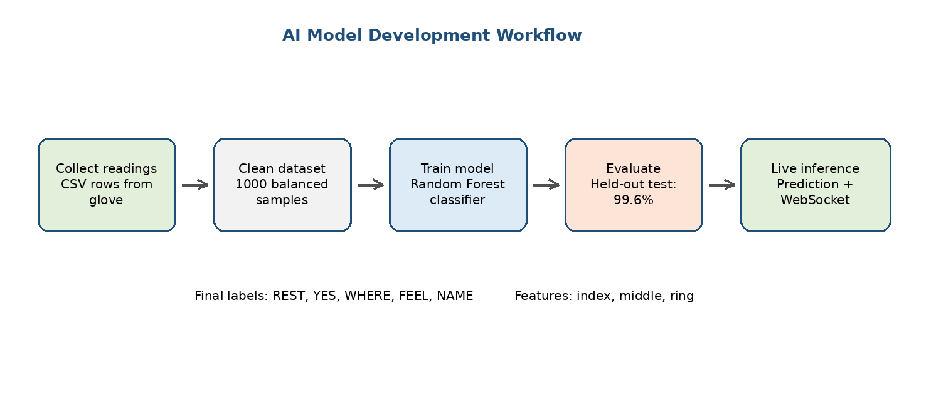
Figure 4: AI Model Development Workflow

3.5 Recognition State Machine
The live system uses a REST-based state machine. This prevents repeated output while the user is still holding a gesture. The system first waits for REST, then accepts one gesture, sends the output, and enters Waiting for REST until the hand returns to a neutral position.
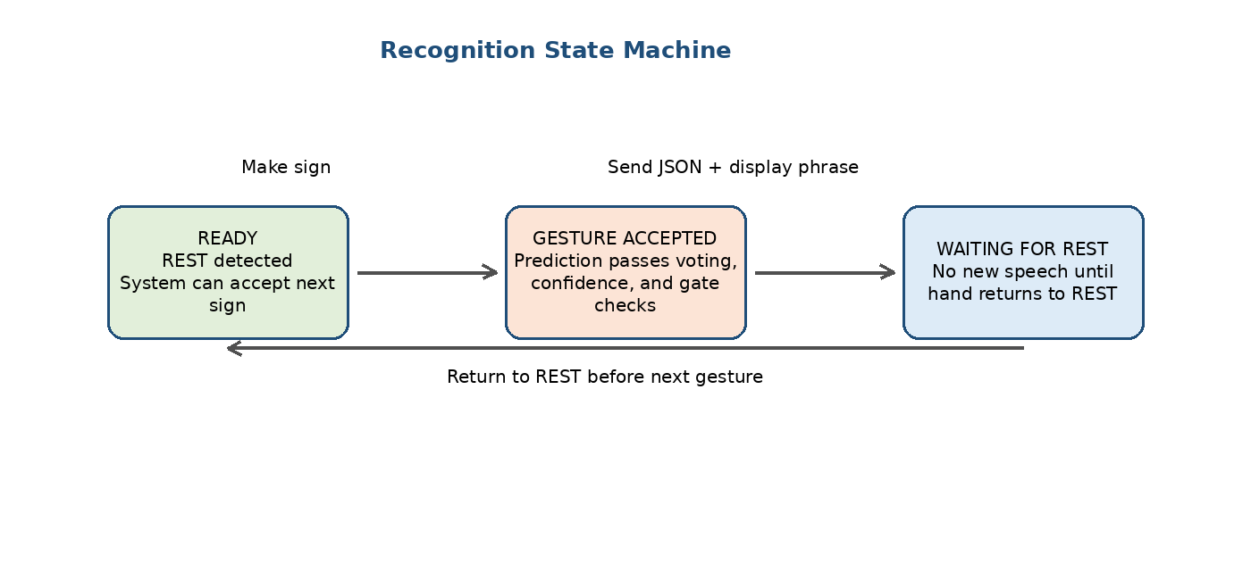
Figure 5: Recognition State Machine

3.6 Mobile Application Design
The mobile application is built with Expo React Native and TypeScript. It receives WebSocket messages from the Python bridge and updates the interface in real time. The app includes a dashboard, gesture display, phrase display, system state card, profile management, language setting, phrase editor, history, settings, and training/future-work screen.
The app supports English, Arabic, and French phrase display. It also calls Expo Speech for text-to-speech output. During emulator testing, TTS was not fully reliable because the emulator sometimes failed to bind to the TTS engine. This is documented as an emulator limitation, not an AI model failure.

3.7 Data Design
The project uses two main kinds of data: machine learning data and mobile app data. The machine learning data is collected as CSV rows from the glove, cleaned, balanced, and used to train the classifier. The mobile app data includes profiles, phrase mappings, language preferences, and gesture history stored locally.
Data Area | Stored Information | Purpose
ML dataset | Label, index, middle, ring, pinky, thumb | Training and evaluating the sign recognition model.
Model artifact | Random Forest model and feature list | Live prediction using the same features used during training.
App profile | Active user/profile settings | Personalized phrase output.
Phrase mappings | Default/custom phrases per label and language | Translate labels into user-friendly messages.
Gesture history | Detected label, phrase, timestamp, confidence | Evidence of detected signs and user review.
Table 9: Data Organization Summary

Chapter 4: Implementation
This chapter describes how the system design was translated into a working prototype. The implementation includes the glove hardware, Arduino firmware, Python AI scripts, WebSocket bridge, and Expo React Native mobile application.

4.1 Hardware Implementation
The glove was built using five flex sensors attached to the fingers. Each sensor was wired to an analog input on the Arduino Nano 33 BLE Rev2. The project experienced realistic hardware problems, including sensor range differences, weak pinky and thumb readings, cross-talk between fingers, unstable breadboard connections, and wire strain caused by glove movement.
After diagnosis, the final direction was to improve wiring stability and base the AI model on the strongest channels. The index, middle, and ring sensors produced the most useful patterns for the selected vocabulary. Pinky and thumb remained physically installed but were excluded from final inference.

4.2 Arduino Firmware Implementation
The firmware continuously reads the sensor values, applies smoothing, converts values to calibrated percentages, and outputs CSV rows. The output order is fixed as index, middle, ring, pinky, thumb. This fixed order is critical because the Python scripts depend on it.
The firmware also supports calibration commands and status output during development. For the final demo, the Python bridge forces the Arduino into CSV mode so that raw numeric values are available for prediction.
CSV example: A row such as 0,100,78,0,100 means index=0, middle=100, ring=78, pinky=0, thumb=100. The model uses only [0,100,78].

4.3 Dataset Collection and Model Training
The final dataset was collected from the real glove and cleaned into a balanced five-label dataset. The model was trained using only index, middle, and ring values. This reflects the actual final hardware state and avoids misleading results from unstable pinky and thumb readings.
Label | Samples
FEEL | 200
NAME | 200
REST | 200
WHERE | 200
YES | 200
Total | 1000
Table 10: Final Dataset Distribution

4.4 Python Live Prediction
The Python live predictor loads the trained model, opens the Arduino serial port, reads CSV values, extracts the index-middle-ring feature vector, and predicts the gesture. A debug mode can be used to show raw input values, predictions, and confidence values.
The older local predictor is useful for quick recognition testing without the mobile app. The final demo uses the mobile WebSocket bridge.

4.5 WebSocket Bridge Implementation
The WebSocket bridge connects the hardware/AI layer to the mobile app. It opens COM4, loads the trained model, receives Arduino CSV values, predicts labels, applies REST logic, and sends JSON messages to connected mobile clients. The bridge sends two important message types: system_state and gesture_detected.
The bridge was improved to force CSV mode, detect status mode, show raw serial lines in debug mode, retry when CSV is silent, and use a more responsive voting style similar to the old predictor.
Final bridge command: mobile_ws_bridge.py --mode live --port COM4 --model asl_3finger_model.joblib --debug
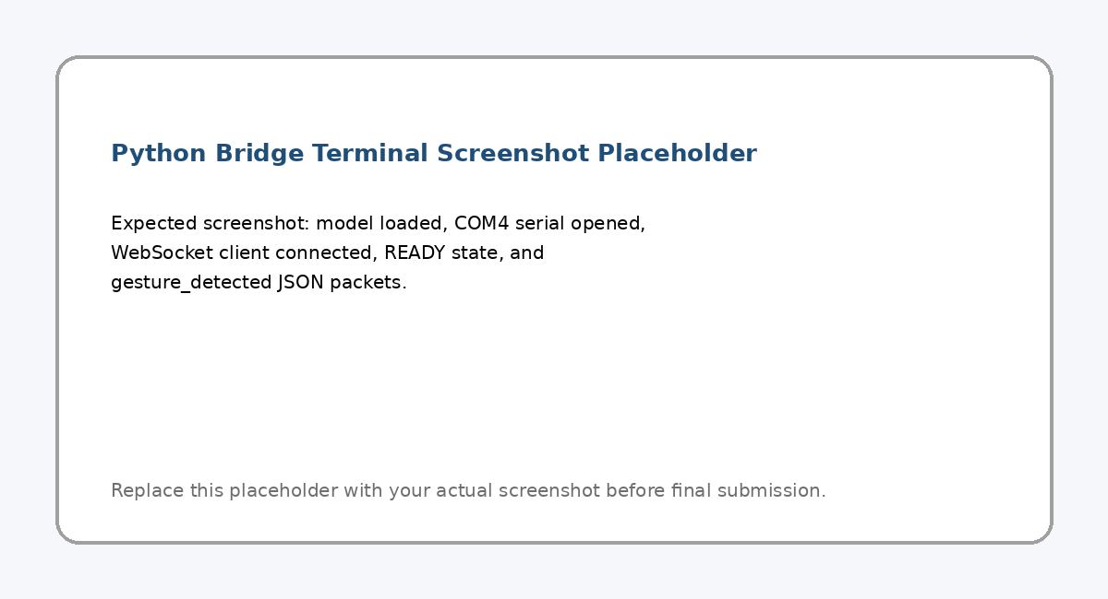
Figure 8: Python Bridge Terminal Screenshot Placeholder

4.6 Mobile App Implementation
The mobile app was implemented using Expo React Native with TypeScript. It includes a polished dashboard for the final demonstration. The app receives JSON packets from the Python bridge and updates the UI with the detected gesture, phrase, confidence, system state, active profile, and selected language.
The app includes screens for profiles, phrase editing, settings, history, and training/future work. It also supports multilingual output in English, Arabic, and French. For the emulator demo, the app uses WebSocket Demo Mode and connects to ws://10.0.2.2:8765.
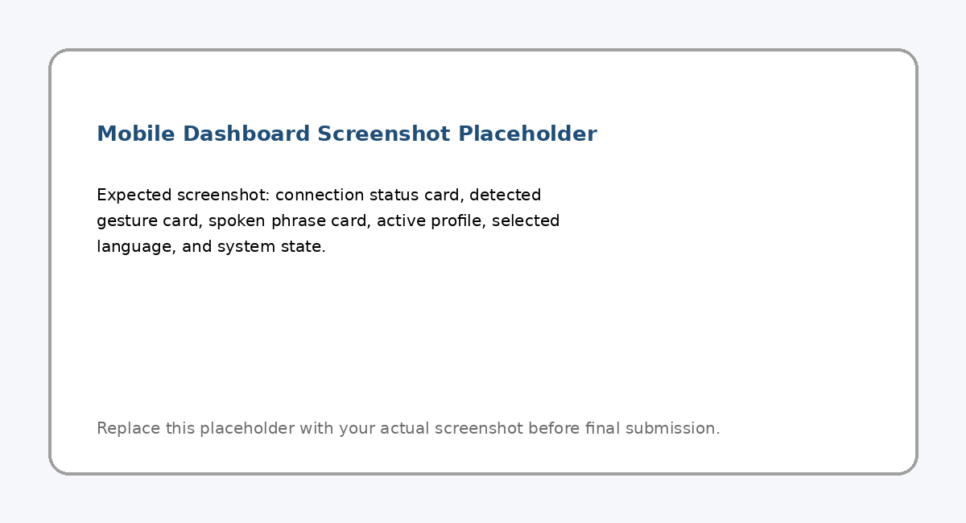
Figure 6: Mobile Dashboard Screenshot Placeholder
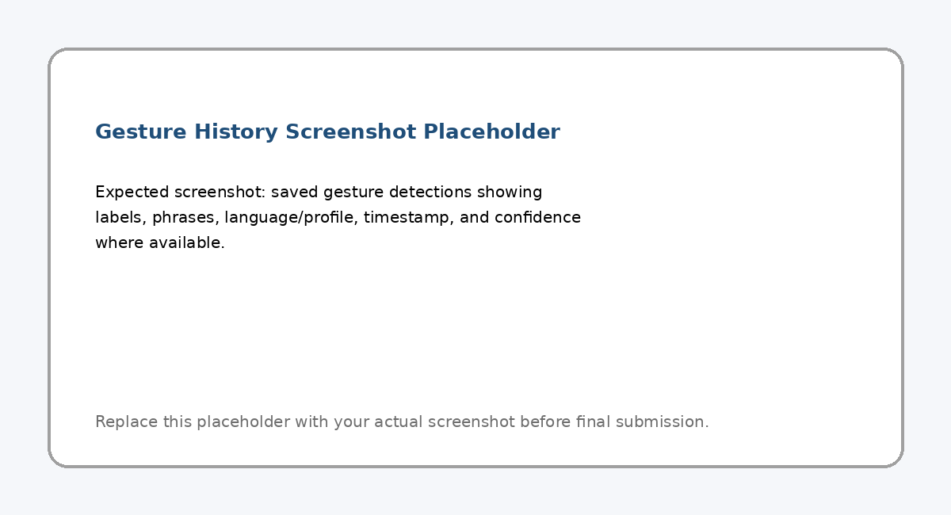
Figure 7: Gesture History Screenshot Placeholder

4.7 Final Demo Implementation Flow
The recommended final demo flow is designed for stability. It avoids unnecessary recalibration or retraining and focuses on the strongest working signs.
- Close Arduino Serial Monitor so COM4 is free.
- Run the Python WebSocket bridge in live mode.
- Open the Android emulator app.
- Enter WebSocket Demo Mode.
- Connect the app to ws://10.0.2.2:8765.
- Wait for READY / REST state.
- Perform FEEL, then return to REST.
- Wait for READY again.
- Perform WHERE, then return to REST.
- Wait for READY again.
- Perform NAME, then open history to show saved detections.

Chapter 5: Testing
Testing was performed at multiple levels: hardware readings, model evaluation, live prediction, WebSocket connection, mobile app reception, and final demo flow. Since the system includes hardware and software, testing focused not only on accuracy but also on reliability during live usage.

5.1 Hardware Testing
Hardware testing focused on whether each finger sensor produced usable readings. Index, middle, and ring became the final stable channels. Pinky and thumb remained physically installed but were not reliable enough for final AI inference. Testing also confirmed that breadboard wiring, long wires, exposed copper, and strain from the glove affected sensor stability.
- Arduino COM4 serial communication was confirmed.
- CSV streaming from Arduino was confirmed.
- Index, middle, and ring values were usable for selected signs.
- Pinky and thumb were identified as unreliable for final model features.
- Soldering, wire shortening, stable power/ground routing, and filtering were recommended for improved readings.

5.2 Model Evaluation
The final model was evaluated on a held-out test set. The model achieved 99.6% accuracy, with 249 correct predictions out of 250. Only one YES sample was predicted as WHERE. This result shows that the selected three-finger model is strong for the final limited vocabulary.
Metric / Label | Result
Model type | Random Forest classifier
Features | index, middle, ring
Labels | REST, YES, WHERE, FEEL, NAME
Dataset size | 1000 balanced samples
Held-out test accuracy | 99.6%
Correct predictions | 249 / 250
FEEL | 50 / 50
NAME | 50 / 50
REST | 50 / 50
WHERE | 50 / 50
YES | 49 / 50
Table 11: Model Evaluation Summary

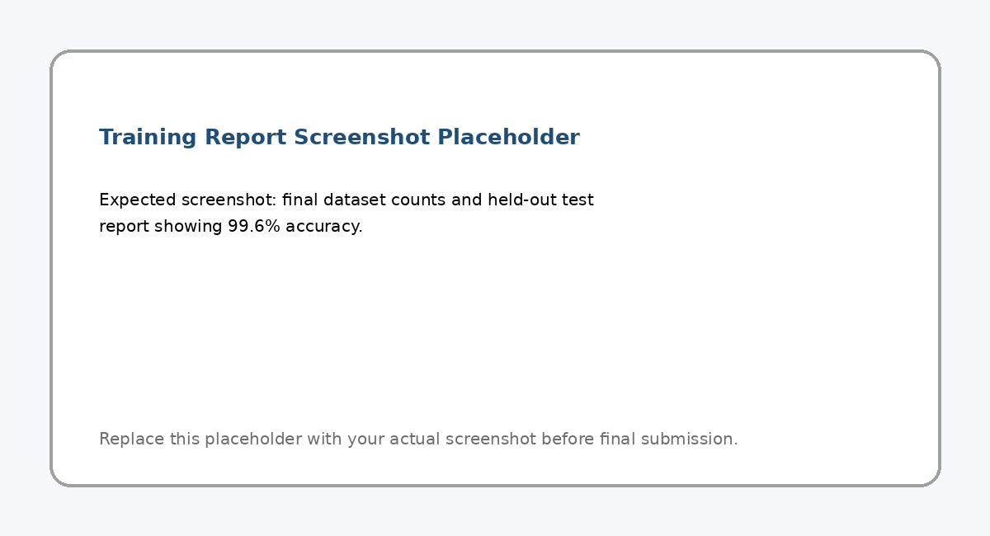
Figure 9: Training Report Screenshot Placeholder

5.3 Live Integration Testing
Live integration testing confirmed that the complete pipeline can run from Arduino to app. The bridge successfully loaded the model, opened COM4, accepted a WebSocket client, detected READY/REST state, and transmitted gesture_detected JSON packets for accepted signs.
Test Area | Expected Result | Status
Serial connection | Python opens COM4 at 115200 baud | Passed
CSV parsing | Bridge reads index,middle,ring,pinky,thumb rows | Passed
Model loading | asl_3finger_model.joblib loads successfully | Passed
Feature extraction | Bridge uses index, middle, ring only | Passed
REST state | System sends READY/system_state packets | Passed
Gesture detection | FEEL/WHERE/NAME can be accepted live | Passed
WebSocket app connection | Mobile client connects to bridge | Passed
Mobile display | App displays gesture/phrase/state/history | Passed
TTS on emulator | App speaks phrase using Expo Speech | Partially passed / emulator risk
Table 12: Integration Testing Summary

5.4 Gesture Testing Notes
The final demo should focus on the most stable signs. FEEL, WHERE, NAME, and REST are the strongest live labels. YES can work when the glove reads a true fist pattern across index, middle, and ring, but it is less stable if the glove produces only an index-only bend.
Gesture | Target Three-Finger Pattern | Demo Notes
REST | index low, middle low or tolerated drift, ring low | Required before each accepted gesture.
FEEL | index low, middle high, ring medium/high | Strong demo label; avoid pushing ring fully to 100 if possible.
WHERE | middle high and ring very high | Can be accepted even if index remains low after gate patch.
NAME | ring very high, middle low | Works well but may leave ring high afterward.
YES | index high, middle high, ring high | Use only if the glove reads a real fist pattern.
Table 13: Gesture Testing Notes

5.5 Limitations Observed During Testing
- The system recognizes selected signs only and does not translate full ASL grammar.
- Pinky and thumb are physically installed but excluded from final AI inference due to noisy readings.
- The Android emulator may not reliably play TTS audio even when the app receives correct predictions.
- Fast movement between signs can reduce reliability if the system has not returned to REST.
- Only one program can use COM4 at a time; Arduino Serial Monitor must be closed when Python is running.
- Hardware quality depends strongly on wiring stability, soldering, strain relief, and sensor placement.

Chapter 6: Conclusions and Future Works

6.1 Conclusion
This project successfully demonstrates a working AI-based smart glove prototype for selected ASL-inspired sign recognition with personalized multilingual phrase output. The system integrates wearable flex sensors, Arduino serial streaming, a Python Random Forest model, a WebSocket bridge, and an Expo React Native mobile application.
The final model uses the three most stable sensors - index, middle, and ring - and recognizes five labels: REST, YES, WHERE, FEEL, and NAME. The balanced final dataset contains 1000 samples, and the held-out evaluation achieved 99.6% accuracy. Live testing confirmed that the system can send predictions from the glove to the mobile app, where they are displayed and saved in history.
The project is academically valid because it demonstrates a complete engineering pipeline and honestly documents hardware limitations. Instead of claiming to be a full ASL translator, the system is correctly framed as a selected-sign recognition prototype. This makes the project more professional, realistic, and defensible.

6.2 Future Work
Future improvements can build on the current prototype and address the limitations identified during development and testing.
- Improve hardware reliability by fully soldering all sensor connections, shortening analog wires, adding strain relief, and using filtering capacitors per finger.
- Restore reliable five-finger inference after pinky and thumb readings become stable enough for training.
- Expand the vocabulary beyond REST, YES, WHERE, FEEL, and NAME.
- Add movement-based signs using an IMU or motion tracking because many real ASL signs depend on movement, not only finger bending.
- Deploy BLE communication directly to a real Android phone instead of relying on USB serial and WebSocket emulator mode.
- Improve text-to-speech reliability using a real phone and language-specific TTS engines.
- Add two-glove support for signs requiring both hands.
- Explore on-device TinyML inference on the Arduino for lower latency and reduced dependency on a laptop.
- Add user-specific calibration profiles to adapt the glove to different hand sizes and bending styles.
- Collect larger datasets from multiple users to improve generalization.

References
[1] Arduino Documentation, Arduino Nano 33 BLE Rev2 technical documentation.
[2] scikit-learn Documentation, Random Forest Classifier.
[3] Expo Documentation, React Native and Expo Speech.
[4] React Native Documentation, Mobile application development.
[5] Project implementation files and experimental logs collected during Smart Glove FYP development.

