

Department of Computer Science
ENGR498 Engineering Seminar
Fall 2024-2025

Veterinary Clinic

 | Name | Email | Phone
Submitted by | Mira Fattal | mira.fattal1@gmail.com | 70267669
Supervisor | Eng. Ahmad Trad | a.trad@cityu.edu.lb | 70306002
Faculty Dean | Dr. Hiba Al Sheikh | h.sheikh@cityu.edu.lb | 03171847

Abstract
Veterinary clinics often face challenges in managing large volumes of data related to patient health records, treatment outcomes, clinic performance, and operational efficiency. Moreover, pet owners need a reliable way to access their pet's medical history, while veterinarians require a system that helps them streamline workflows and make data-driven decisions. Without the right tools, clinics struggle to optimize resources, track patient progress, and ensure seamless communication between clients and medical professionals. This project introduces a Veterinary Clinic Analytics Dashboard—a comprehensive, data-driven platform designed to address these challenges. The dashboard offers valuable insights into clinic performance, patient demographics, treatment outcomes, and operational efficiency, all powered by advanced data analytics. It also includes a user-friendly client portal where pet owners can view their pet’s medical history, including vaccine records, medication usage, and surgeries. Veterinarians and clinic staff are provided with tools to track appointments, manage patient data, and optimize their services, improving overall clinic operations. The website contains several key components: Patient Health Records: Detailed reports on demographics, treatments, and recovery outcomes. Client Portal: A personalized interface where pet owners can view their pets’ medical history, receive reminders for vaccinations, and access relevant treatment details. Doctor's Dashboard: An interface for veterinarians to manage patient data, track ongoing treatments, and access analytics-driven insights on treatment effectiveness and patient progress. Patients receive more personalized and timely care, as veterinarians can predict outcomes and tailor treatments based on past data. Pet owners are empowered with transparency and access to their pet’s health information, creating a stronger trust between them and the clinic. Veterinarians are equipped with data-driven insights to optimize care, streamline workflows, and ensure better patient outcomes. From a technical perspective, the platform is going to be built using modern web technologies like Angular for the front-end and C# for the back-end. In terms of business benefits, the dashboard leads to improved decision-making by providing actionable insights, enhances client satisfaction by offering transparency, and increases operational efficiency by identifying bottlenecks in clinic workflows. It also supports revenue growth by highlighting areas for optimization and improving patient retention. Overall, the platform bridges the gap between pet care providers and clients, while offering powerful tools for data analysis, performance tracking, and operational improvement.

Table of Contents
Abstract i
Table of Contents iii
List of Figures iv
List of Tables vi
List of Abbreviations vii
Acknowledgements viii
Chapter 1: Introduction 1
1.1 Objectives 1
1.2 Scope 2
1.3 Purposes 2
1.4 Technologies used 3
1.5 Problem statement 4
1.6 solution 4
Chapter 2: Software Specifications 7
2.1 Functional And conceptual study 7
2.2 functional requirements 8
2.3 non-functional requirements 9
2.4 uml use case diagram 10
2.5 use case narrative tables 13
Chapter 3: System Design 19
3.1 Entity relationship diagram 19
Chapter 4: Implementation 23
4.1 Introduction 23
4.2 System Implementation Overview 23
4.3 Owner Screens 24
4.4 Doctor/Clinic screens 28
4.5 Mobile screens 40
Chapter 5: Testing 45
5.1 Testing Screens 45
Chapter 6: Conclusions and Future Works 47
6.1 Conclusion 47
6.2 Future work 47

List of Figures
Figure 1: UML Diagram 12
Figure 2: UML Activity Diagram for Clients 12
Figure 3: UML Activity Diagram for Doctors 13
Figure 4: Appointment System ER 19
Figure 5: Animal Records ER 20
Figure 6: Ratings and Invoices ER 20
Figure 7: Adoption System ER 21
Figure 8: Meal Tracking System ER for Mobile 21
Figure 9: Welcome page for Owners 24
Figure 10: View Services on the Website 25
Figure 11: Give Ratings 25
Figure 12: Book Appointments 26
Figure 13: Confirmation Message 26
Figure 14: List of Pets displayed for Adoption 27
Figure 15: Fill an Adoption Questionnaire 27
Figure 16: View Services the clinic provides 28
Figure 17: Login Page 28
Figure 18: Doctor's Dashboard 29
Figure 19: Appointments Dashboard 29
Figure 20: Doctor's Schedule 30
Figure 21: Pets for Adoption 30
Figure 22: Approve or Reject Questionnaires 31
Figure 23: Review Questionnaires 31
Figure 24: Pet Table 32
Figure 25: Search Functionality 32
Figure 26: Doctor's book Appointment 33
Figure 27: Pet Details 33
Figure 28: Add X-ray Images 34
Figure 29: Edit Pets 34
Figure 30: Edit Owner Details 35
Figure 31: Medical History 35
Figure 32: Add a medical history 36
Figure 33: Vaccination History 36
Figure 34: Add Vaccination 37
Figure 35: Lab Results 37
Figure 36: Add an animal with a new owner or an existing owner 38
Figure 37: Horse Table 38
Figure 38: Invoices 39
Figure 39: Review Ratings 39
Figure 40: Login Page 40
Figure 41: Welcome Page 41
Figure 42: Services Page 41
Figure 43: Meal Tracking Page 42
Figure 44: Book Appointment Page 42
Figure 45: Check medical history of the animal 43
Figure 46: Lab Results 43
Figure 47: View Pets for Adoption 44
Figure 48: Fill Questionnaire 44
Figure 49: Form 1, Submit button is disabled 45
Figure 50: Form 2 45
Figure 51: Form 3 46
Figure 52: Form 4 46

List of Tables
Table 1: Add Medical History Use Case 14
Table 2: Approving Questionnaires Use Case 15
Table 3: Fill Questionnaires Use Case 16
Table 4: Log in Use Case 17
Table 5: Delete Medical Record Use Case 18

List of Abbreviations
If appropriate, list any abbreviations used in the thesis.
- ER: Entity Relationship.
- CRUD: create, read, update and delete.

Acknowledgements

First and foremost, I am deeply grateful to Allah (SWT) for granting me the strength, patience, and guidance to complete this project. Without His blessings and mercy, none of this would have been possible.
I would like to extend my sincere gratitude to my supervisor, for their invaluable guidance, constructive feedback, and constant encouragement throughout this journey. Their expertise and insights have been instrumental in shaping the direction and success of this project.
I would also like to express my heartfelt thanks to Dr. Hiba Al Sheikh, the Dean of our Faculty, for their unwavering support and for fostering an environment that inspires academic growth and innovation.
To everyone who has supported me along the way, I am truly grateful.

Introduction
Managing a veterinary clinic involves multiple complex operations, from scheduling appointments and maintaining medical records to handling pet adoptions and client interactions. Traditional methods often result in inefficiencies, errors, and a lack of streamlined workflows. This project aims to design and develop a comprehensive veterinary clinic management system that integrates various functionalities into a unified platform. With role-based access for doctors, and clients, the system ensures secure and efficient management of appointments, medical histories, adoption processes, and clinic revenues. The solution also enhances user experience by providing clients with convenient access to services and promoting better collaboration among clinic staff.

Objectives
The primary objective of this project is to design and implement a user-friendly veterinary clinic management system that streamlines operations and enhances user experience for both staff and pet owners. The system aims to provide role-based authentication and authorization, ensuring secure access for doctors, and clients. It will enable efficient scheduling and management of appointments, allowing doctors to collaborate seamlessly.
Doctors will be empowered to maintain accurate medical records, vaccinations and lab results for pets and horses. They will efficiently manage animal records, appointment bookings, and invoicing. The system also simplifies the pet adoption process through a streamlined questionnaire and approval mechanism, ensuring an organized and transparent approach.
Additionally, the platform will provide clients with easy access to services such as booking appointments, viewing adoption information, filling out questionnaires, and rating the clinic’s services. Finally, the system will generate insightful revenue reports for the clinic through dynamic chart visualizations and facilitate seamless CRUD operations for managing appointments, invoices, medical records, and adoption data.

Scope
The veterinary clinic management system caters to two primary user roles: Doctors, and Clients (Pet or Horse Owners), each with secure authentication and role-based access control. It offers features for appointment scheduling, viewing, and management, enabling smooth collaboration between doctors, and clients. Doctors can update medical histories, vaccination records, and lab results, ensuring accurate and accessible information for pets and horses. They are also equipped to add new pets or horses, link them with their respective owners, manage invoices, and facilitate appointment bookings.
The system also includes a dynamic pet adoption platform, allowing clients to browse pets available for adoption, fill out questionnaires, and await approval from doctors. Additionally, the platform generates revenue reports in monthly, and yearly formats, presented with clear visual chart representations. Nurses and doctors can efficiently perform CRUD operations on animals, appointments, invoices, and adoption data. Furthermore, the system provides clients with a rating feature to share feedback on the clinic’s services, enhancing overall user satisfaction.

Purposes
The veterinary clinic management system is designed to address the inefficiencies and challenges associated with traditional manual processes in veterinary clinics. These outdated methods often lead to errors, delays, and poor customer experiences. By integrating appointment scheduling, medical records, pet adoption processes, and invoicing into a single platform, the system aims to streamline workflows and enhance operational efficiency.
It promotes better communication and collaboration between doctors, and clients by providing role-specific functionalities that cater to their unique needs. Clients benefit from a user-friendly interface that simplifies booking appointments, exploring adoption options, and sharing feedback on services. Additionally, the system empowers clinic staff with real-time access to revenue reports and historical appointment data, enabling informed, data-driven decision-making. Robust authentication and role-based access controls ensure data security and integrity, making the system a reliable and efficient solution for veterinary clinics.

Technologies used
- Frontend Development (Angular): a powerful front-end framework developed by Google, is used to build the web application’s user interface. It provides a robust and scalable architecture, enabling the development of dynamic, single-page applications with enhanced performance. Angular’s component-based structure ensures maintainability and reusability, while its built-in features like two-way data binding, dependency injection, and state management simplify development. The framework also offers seamless integration with backend APIs, ensuring smooth data communication and real-time updates for veterinarians and pet owners.
- Frontend Development (Flutter): For mobile application development, Flutter, Google’s UI toolkit, is utilized to create a cross-platform app that delivers a native-like experience on both Android and iOS. Flutter’s widget-based architecture allows for highly customizable and responsive UI designs, ensuring a seamless user experience across different devices. The framework’s hot reload feature accelerates development by enabling real-time code changes without restarting the application. By leveraging Flutter’s efficient rendering engine, the mobile app offers smooth animations, quick interactions, and an intuitive interface for pet owners.
- Backend Development (.NET Core (C#)): The backend of the application is built using .NET Core, a high-performance, cross-platform framework developed by Microsoft. .NET Core provides a secure and scalable environment for handling business logic, processing requests, and managing authentication and authorization. The framework supports RESTful API development, enabling efficient communication between the frontend and database. With its built-in dependency injection, asynchronous programming model, and strong security features, .NET Core ensures a reliable and optimized backend architecture.
- Database Management: To ensure secure and efficient data storage, Microsoft SQL Server is used as the relational database management system. It provides robust data integrity, high availability, and optimized query performance, allowing clinics to manage large volumes of patient records, appointments, and medical histories effectively. With advanced indexing, stored procedures, and transaction management, SQL Server supports seamless data retrieval and updates, ensuring veterinarians and pet owners can access accurate, up-to-date information.
These technologies work in unison to deliver a secure, scalable, and efficient veterinary clinic management system with a modern user experience.

Problem statement
Veterinary clinics often face significant challenges in managing their daily operations due to reliance on traditional manual processes. These methods are prone to inefficiencies, errors, and delays in critical tasks like scheduling appointments, maintaining medical records, handling pet adoptions, and managing invoices. The lack of a unified platform for communication and data sharing between doctors, nurses, and clients often results in poor user experiences, missed appointments, and operational bottlenecks. Additionally, securely managing sensitive information, such as medical histories and clinic revenue, becomes increasingly difficult without a modern, robust system in place.

solution
The proposed veterinary clinic management system is a comprehensive platform designed to streamline and automate the clinic’s operations. By leveraging modern technologies like Angular, Flutter, .NET Core (C#), and Microsoft SQL Server, the system integrates key functionalities into a user-friendly application. It offers secure role-based access for doctors, and clients, ensuring each user can perform their specific tasks efficiently.
The system simplifies appointment scheduling, maintains accurate medical records, supports seamless pet adoption processes, and generates insightful revenue reports. For clients, it provides an intuitive interface for booking appointments, filling out adoption questionnaires, and rating services. By centralizing these features, the solution enhances collaboration, reduces operational errors, and improves overall user satisfaction while ensuring data security and integrity.

Software Specifications
The Software Specifications chapter defines the key requirements and design principles that shape the development of the veterinary clinic management system. It outlines both the functional and conceptual aspects of the system, ensuring clarity in its structure and behaviour. This chapter provides a detailed functional study, describing the system’s core features and how they interact to meet user needs. Additionally, it includes a conceptual study, offering insights into the underlying system architecture and data flow.
To further illustrate system functionality, use case diagrams and descriptions are presented, showcasing various user interactions and workflows. These specifications serve as a foundation for the system’s implementation, ensuring alignment with user expectations and technical feasibility.

Functional And conceptual study

Functional Study:
The veterinary clinic management system is designed to optimize essential clinic operations by automating workflows and improving efficiency. The system provides role-based authentication to ensure secure access for doctors, and clients. Key functionalities include appointment scheduling, medical record management, and pet adoption handling. Each user role has tailored access to specific features, ensuring seamless task execution. Additionally, the system enhances clinic operations by offering a feedback system for clients, allowing them to rate services and provide valuable insights. A revenue tracking module displays financial performance through dynamic charts, helping clinic staff monitor earnings. The system also supports comprehensive CRUD (Create, Read, Update, Delete) operations for managing appointments, invoices, and animal records, ensuring accurate and up-to-date information storage.

CONCEPTUAL STUDY:
The veterinary clinic management system is designed as an all-in-one digital solution to modernize and streamline clinic operations. The platform incorporates two main user roles: doctors, and clients. Each role interacts with the system through an intuitive and user-friendly interface, ensuring secure and efficient execution of tasks.

The conceptual framework of the system focuses on improving communication between clinic staff and clients, reducing manual errors, and providing real-time data insights for informed decision-making. The adoption process and client interaction features enhance user engagement, while the system’s backend architecture ensures scalability and data security. By integrating these core functionalities, the system aims to improve operational efficiency, elevate patient care, and enhance the overall user experience.

functional requirements
Functional requirements define the specific operations and features that the veterinary clinic management system must provide to meet user needs. These requirements ensure seamless workflow automation, covering aspects such as authentication, appointment scheduling, medical record management, and adoption processing.

Authentication and Role Management:
• Secure user login for doctors, and clients.
• Role-based permissions to ensure access is granted only to authorized functionalities.

Appointment Management:
- View available services and book appointments (clients).
- Doctors and nurses can manage appointment schedules (add, view).

Animal Management:
- Add, edit, and delete pet/horse records.
- Maintain medical history, vaccination, X-ray images, and lab results for animals.
- The system can flag lab results as normal or abnormal based on the result.

Adoption System:
- View pets available for adoption (clients).
- Fill out adoption questionnaires (clients).
- Doctors can review, approve, or reject adoption requests.

Feedback System:
- Clients can rate the clinic after receiving services.
- Doctors can view aggregated ratings to evaluate feedback.

Revenue and Reports:
- Generate dynamic revenue charts (monthly, yearly).
- Doctors and nurses can view financial performance metrics.

non-functional requirements
Non-functional requirements define the quality attributes and constraints that the system must meet, ensuring its overall performance and user satisfaction. These requirements focus on factors like security, reliability, and maintainability. Security ensures the system protects data and prevents unauthorized access. Reliability ensures the system consistently performs as expected, minimizing downtime or failures. Maintainability focuses on the ease of updating, modifying, or troubleshooting the system to ensure long-term functionality and adaptability.

Security:
- Encrypted user credentials to ensure data confidentiality.
- Role-based access control to protect sensitive operations like CRUD activities on records.

Performance:
- The system must handle a big amount of concurrent users accessing features like booking, viewing schedules, or managing records.
- Quick response time for viewing medical records, schedules, or adoption data (less than 3 seconds).

Reliability:
- The system should have an availability of 99.9%, ensuring minimal downtime.
- Scheduled backups of all records (daily).

Maintainability:
- Implement real-time validation on all forms to ensure users provide required inputs before submission.
- Highlight invalid fields with red borders or warning icons to guide users.
- Provide success/error feedback after an action, such as "Appointment booked successfully" or "Failed to save data. Please try again."

uml use case diagram
The following UML diagram illustrates the system's structure, highlighting the relationships and interactions between various components, including users, features, and functionalities. It provides a comprehensive overview of how the system is designed to handle key processes and ensure efficient management of the veterinary clinic's operations.
- Actors:
- Owner: A registered user who can fill out adoption questionnaires and interact with their pet's data.
- Doctor: A veterinary professional who adds medical history, approves/rejects adoption questionnaires, and manages vaccination/lab records.
- Use Cases for Owner:
- Sign in: Owners can sign in, enhancing security in the system.
- Filling Adoption Questionnaires: Owners can submit adoption applications for pets they wish to adopt.
- Providing Feedback: Owners can rate the clinic/services provided by the clinic staff.
- Booking Appointments: Owners can easily book appointments for their associated animals.
- Use Cases for Doctor:
- Sign in: Doctors can sign in, enhancing security in the system.
- Adding Medical History: Doctors add or update a pet's medical history, including diagnosis, treatments, and other relevant health records.
- Managing Animal Records: Doctors can create, update and delete animal records within the system.
- Approving Adoption Questionnaires: Doctors review and either approve or reject adoption applications based on the questionnaire responses.
- Vaccination/Lab Results/ X-ray Images: Doctors can add or update an animal’s vaccination history and related records.
- Schedule: Doctors can view their appointments and daily agenda.
- Appointment: Doctors can book new appointments.
- Adoption: Doctors can add new pets for adoption.
- Ratings: The staff can view ratings submitted by owners.
- Viewing Revenue Chart: Doctors view the clinic's revenue performance over time.
Adding Invoices: Doctors/Nurses can add, update or delete invoices.

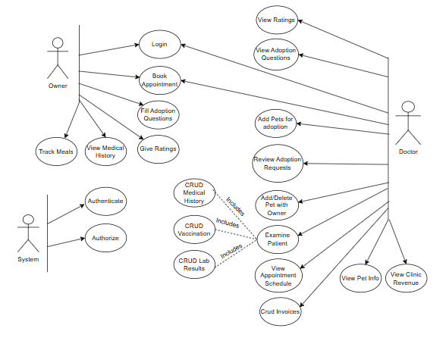
Figure 1: UML Diagram

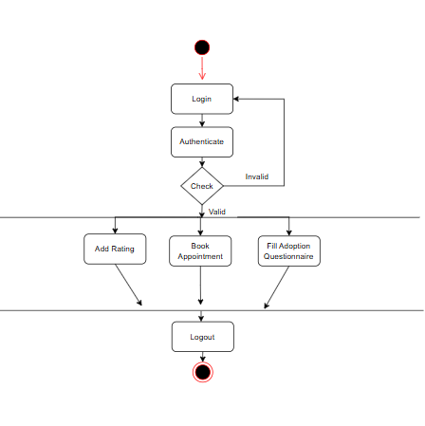
Figure 2: UML Activity Diagram for Clients

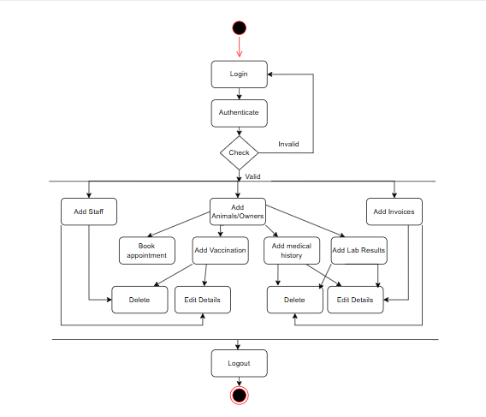
Figure 3: UML Activity Diagram for Doctors

use case narrative tables
Here are some examples (not all) of the use cases narrative tables:

Field | Details
Use Case Name | Adding Medical History
Actors | Doctor
Description | This use case allows a doctor to add medical records, such as surgery details, diagnosis, and other treatments for a specific pet.
Preconditions | - The pet must already be registered in the system.  - The Doctor must be logged in.
Postconditions | - The new medical history is stored in the system and linked to the corresponding pet.
Trigger | The Doctor selects the "Add Medical History" option for a pet.
Primary Flow | 1. The Doctor logs into the system.  2. The system verifies the credentials.  3. The Doctor selects a pet from the database.  4. The Doctor inputs the medical details.  5. The system validates the input.  6. The system stores the new medical record.
Alternative Flows | Invalid Input:  - If any required field is missing or invalid, the system prompts the Doctor to correct it.
Frequency of Use | Frequently, as medical history is regularly updated.
Assumptions | - The Doctor inputs accurate data.  - The system has sufficient storage for medical records.
Special Requirements | - Data should be stored securely and comply with privacy policies.
Table 1: Add Medical History Use Case

Field | Details
Use Case Name | Approving Adoption Questionnaires
Actors | Doctor
Description | This use case allows a doctor to review and approve or reject adoption questionnaires submitted by Guests/Owners.
Preconditions | - A completed questionnaire must exist in the system.  - The Doctor must be logged in.
Postconditions | - The questionnaire is marked as approved or rejected, and the Guest/Owner is notified by the doctor.
Trigger | The doctor selects a questionnaire for review.
Primary Flow | 1. The Doctor logs into the system.  2. The system verifies the credentials.  3. The Doctor selects a submitted questionnaire from the list.  4. The Doctor reviews the responses.  5. The Doctor chooses to approve or reject the application.  6. The system updates the questionnaire status.
Alternative Flows | Request for More Information:  - The Doctor may request additional details from the Guest/Owner if required.
Frequency of Use | Occasionally, based on submitted questionnaires.
Assumptions | - The doctor has sufficient information to make an informed decision.  - The system provides a clear review interface.
Special Requirements | - Ensure confidentiality of the information.
Table 2: Approving Questionnaires Use Case

Field | Details
Use Case Name | Filling Adoption Questionnaires
Actors | Guest/Owner
Description | This use case allows a Guest/Owner to fill out a questionnaire as part of the adoption process for a pet.
Preconditions | - The Guest/Owner must be logged into the system.  - The pet must be listed as available for adoption.
Postconditions | - The completed questionnaire is saved in the system and awaits review by a doctor.
Trigger | The Guest/Owner selects a pet and opts to fill out the adoption questionnaire.
Primary Flow | 1. The Guest/Owner logs into the system.  2. The system verifies the credentials.  3. The Guest/Owner views the list of adoptable pets.  4. The Guest/Owner selects a pet and opens the questionnaire.  5. The Guest/Owner completes and submits the questionnaire.  6. The system stores the completed form and awaits the doctor’s review.
Alternative Flows | Incomplete Questionnaire:  - If required fields are not filled, the system prompts the Guest/Owner to complete the form.
Frequency of Use | Occasionally, as it depends on the adoption interest.
Assumptions | - The Guest/Owner has internet access.  - The system ensures form fields are user-friendly.
Special Requirements | - Provide validation for mandatory fields.
Table 3: Fill Questionnaires Use Case

Field | Details
Use Case Name | Logging into the System
Actors | Doctor, Guest/Owner
Description | This use case allows both doctors and owners to log into the system to access their respective features and information.
Preconditions | - The actor must have a valid account in the system.  - The system must be accessible and operational.
Postconditions | - The actor successfully logs in and is directed to their respective dashboard (doctor or client).
Trigger | The actor selects the login option and enters their credentials.
Primary Flow | 1. The actor navigates to the login page.  2. The system prompts the actor to enter their username and password.  3. The actor enters valid credentials.  4. The system verifies the credentials and grants access if they are correct.  5. The actor is directed to their respective dashboard (doctor or client).
Alternative Flows | Invalid Credentials:  - If the actor enters incorrect credentials, the system prompts them to re-enter their username/password.
Frequency of Use | Frequently, as doctors and clients must log in to access their accounts regularly.
Assumptions | - The actor has internet access and a device capable of accessing the system.
Special Requirements | - The system must securely store passwords using encryption.
Table 4: Log in Use Case

Field | Details
Use Case Name | Deleting a Medical Record
Actors | Doctor
Description | This use case allows a doctor to delete an animal’s medical record from the system, usually in case of data errors or unnecessary records.
Preconditions | - The doctor must be logged into the system.  - The medical record must exist in the system.
Postconditions | - The selected medical record is permanently deleted from the system.
Trigger | The doctor selects a medical record and opts to delete it.
Primary Flow | 1. The doctor logs into the system.  2. The system verifies the doctor's credentials.  3. The doctor accesses the animal’s medical records.  4. The doctor selects the medical record to be deleted.  5. The system prompts the doctor to confirm the deletion.  6. The doctor confirms the deletion.  7. The system deletes the medical record and confirms successful removal.
Alternative Flows | Cancellation of Deletion:  - If the doctor cancels the deletion, the system does not delete the record and returns the doctor to the medical records page.
Frequency of Use | Rarely, as deletion is typically done only when necessary.
Assumptions | - The doctor has the required permissions to delete medical records.
Special Requirements | - The system must confirm the deletion action with a prompt to avoid accidental deletions.
Table 5: Delete Medical Record Use Case

System Design
This chapter provides an overview of the architectural and structural components of the veterinary clinic management system. This chapter outlines the design process, including the use of Entity Relationship Database system to represent system workflows and interactions. It highlights the planned functionality, user roles, and the flow of data across different modules.

Entity relationship diagram
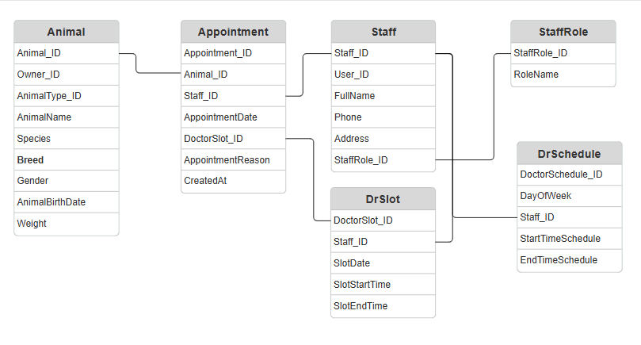
Figure 4: Appointment System ER
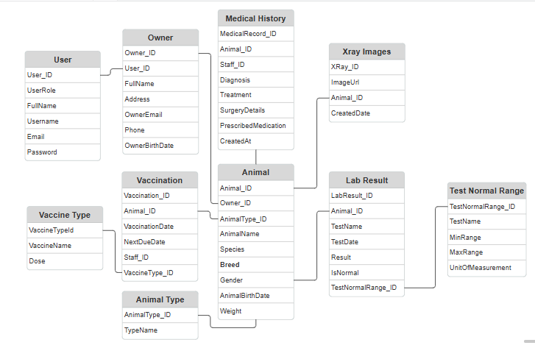
Figure 5: Animal Records ER

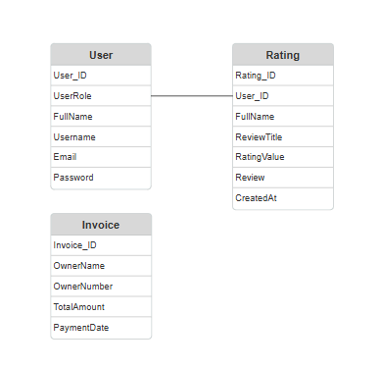
Figure 6: Ratings and Invoices ER

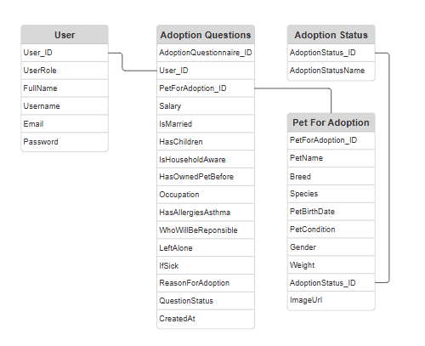
Figure 7: Adoption System ER
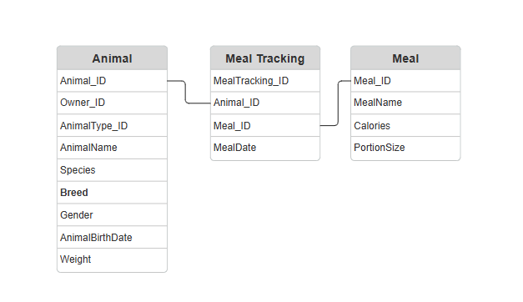
Figure 8: Meal Tracking System ER for Mobile

Implementation
The Implementation chapter details the practical development of the veterinary clinic management system, focusing on how the design was translated into a working application.

Introduction
The veterinary clinic management platform is designed to streamline operations and provide essential functionalities for doctors, nurses, and pet owners. It displays an intuitive dashboard where users can access features such as appointment scheduling, medical records management, and invoicing. The platform also provides detailed adoption information, allowing pet owners to view available pets and submit adoption questionnaires. Doctors can review and update medical histories, vaccinations, lab results, and X-ray images. They can manage animal records, book appointments, and add invoices. Additionally, pet owners can rate the clinic, view services, and book appointments, ensuring a user-friendly experience for all stakeholders.

System Implementation Overview
In this system, the workflow is designed to provide a seamless experience for animal owners and staff. It starts with the user interface built using Angular, which ensures an intuitive and responsive front-end. The front-end facilitates easy navigation through the system, allowing animal owners to access and fill out forms such as adoption questionnaires and book appointments, while also enabling staff to manage records and interact with the data efficiently. Angular’s components and services are used to structure the workflow, handling the communication between the user interface and the back-end services.
The back-end of the system follows a 3-layer architecture consisting of the repository, service, and controller layers. The repository layer is responsible for direct interaction with the database, abstracting the data access logic and ensuring that queries are executed efficiently. The service layer acts as a business logic layer, where the system's core functionalities, such as form validation, record creation, and data processing, are handled. It communicates between the controller and repository layers. Finally, the controller layer exposes RESTful API endpoints that are consumed by the front-end, ensuring a smooth flow of data between the system’s components. This structured approach provides scalability and maintainability to the system, as each layer is independently managed and can be updated without affecting the others.
To ensure a mobile-friendly experience, the system integrates with Flutter, allowing for cross-platform mobile development. The mobile application ensures that animal owners have access to key features, such as filling out questionnaires and tracking pets’ meals, from their mobile devices. They can view their animal’s medical history. I have integrated more meaningful features in the mobile for animal owners as it is easier for them to access their mobile to view medical history, vaccinations’ next due dates and track meals for their animals. Whereas, in the website I have integrated more options and use cases for the doctor. Flutter’s single codebase and ability to compile for both iOS and Android allow for a consistent user experience across all devices, enhancing accessibility and engagement.
The addition of a meal tracking system for animal owners is a crucial feature for the system. This feature allows pet owners to record and monitor the meals provided to their pets, ensuring that they are following a suitable diet and meeting the pet’s nutritional needs. Data is entered through the front-end interface and stored securely in the back-end. This meal tracking system helps promote better care for the pets and provides valuable insights to owners.

Owner Screens
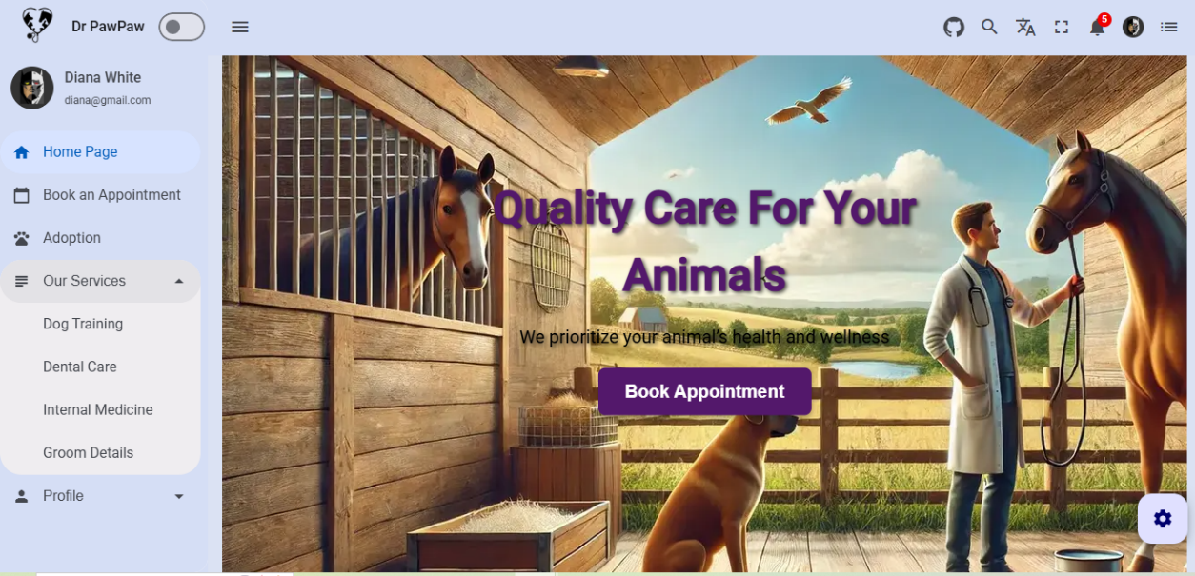
Figure 9: Welcome page for Owners
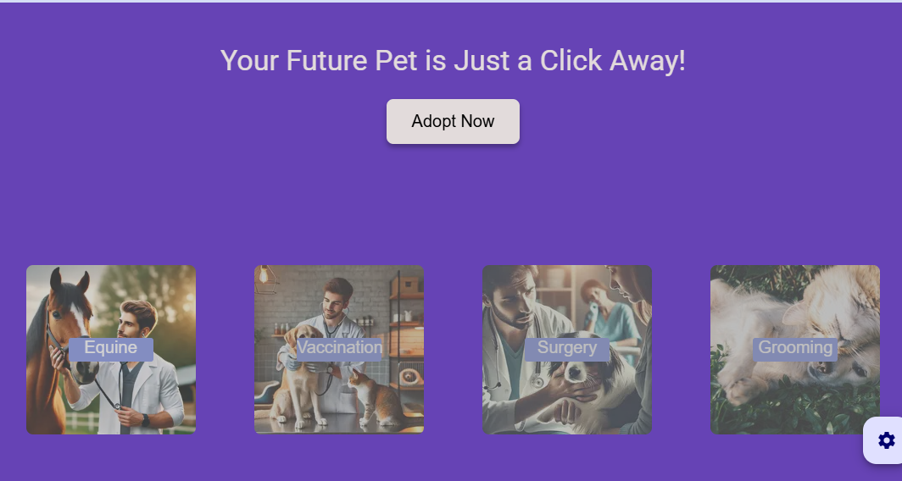
Figure 10: View Services on the Website
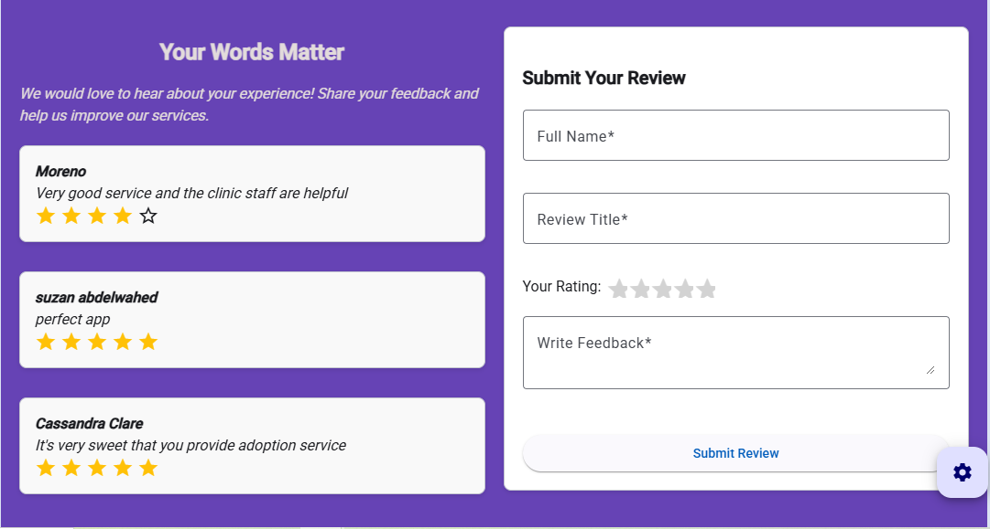
Figure 11: Give Ratings
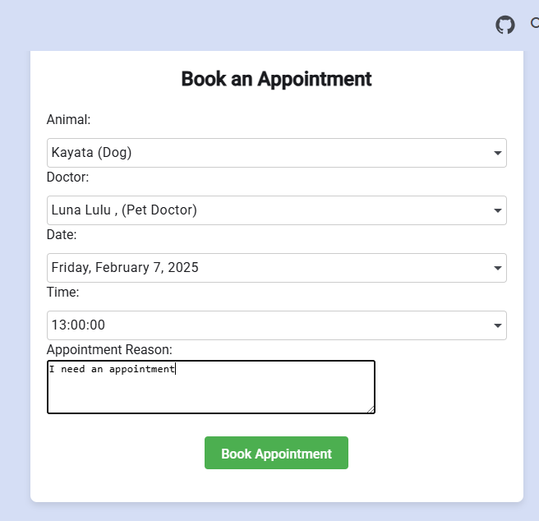
Figure 12: Book Appointments


Figure 13: Confirmation Message
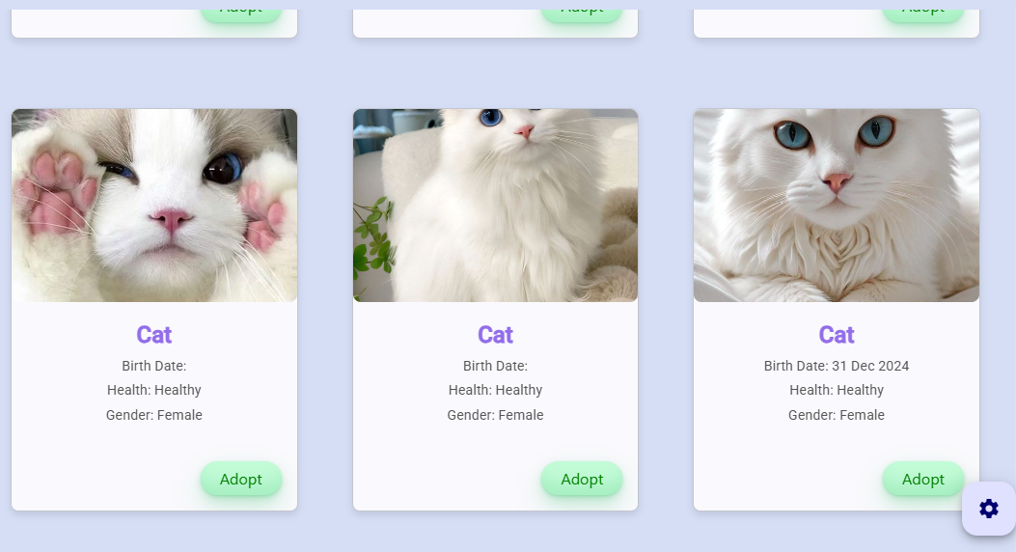
Figure 14: List of Pets displayed for Adoption

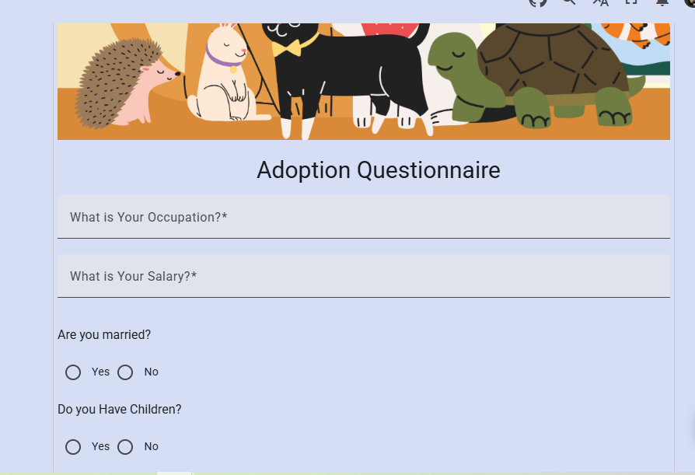
Figure 15: Fill an Adoption Questionnaire
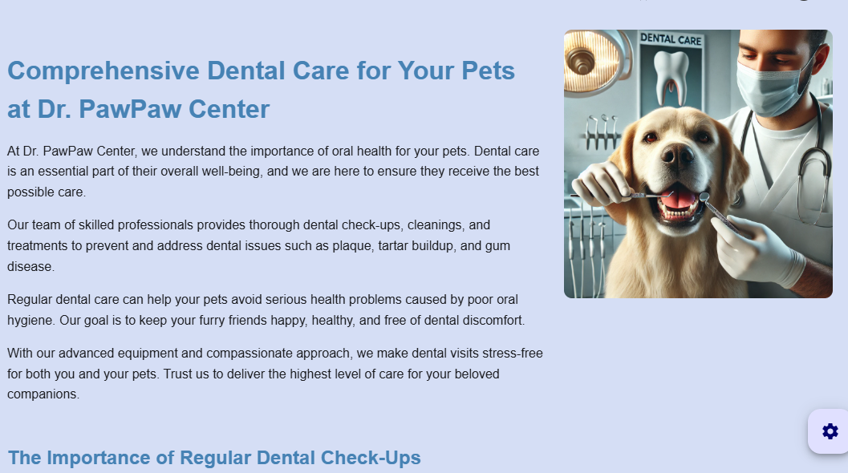
Figure 16: View Services the clinic provides

Doctor/Clinic screens
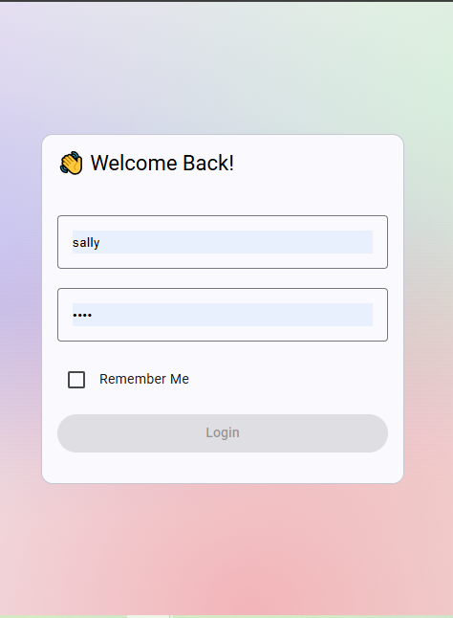
Figure 17: Login Page
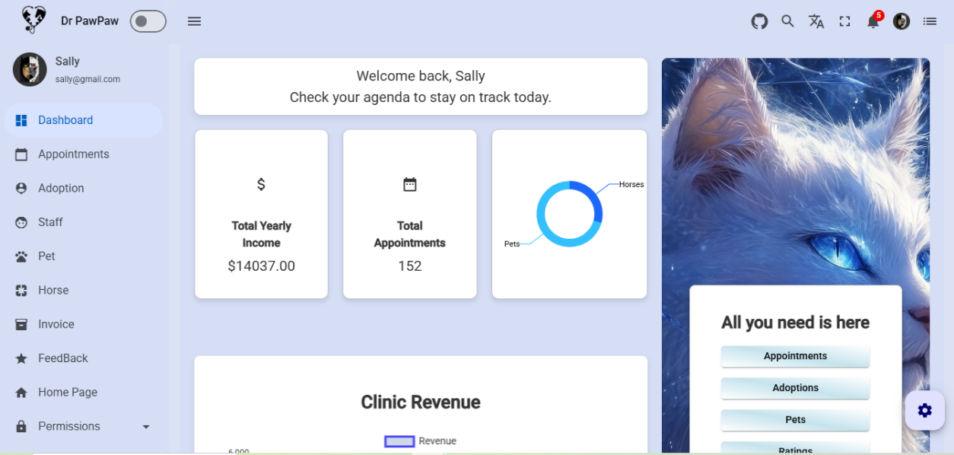
Figure 18: Doctor's Dashboard

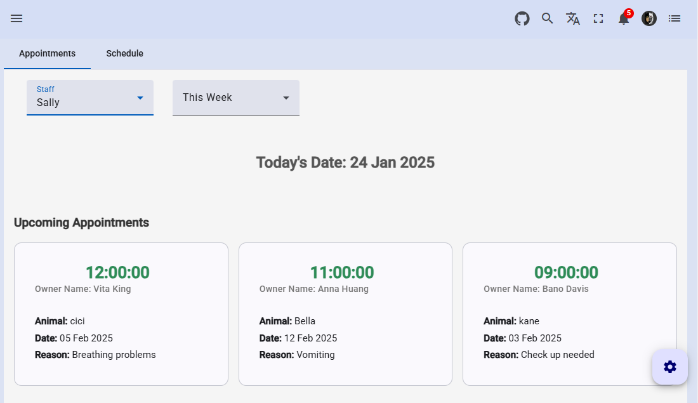
Figure 19: Appointments Dashboard
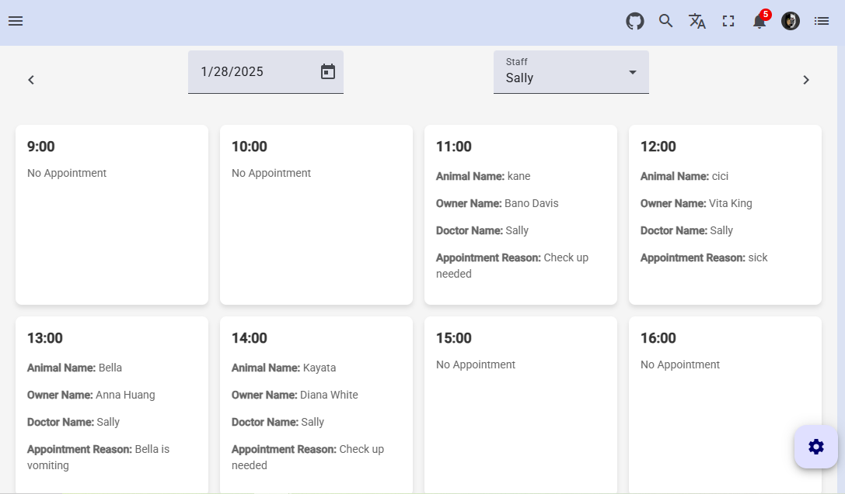
Figure 20: Doctor's Schedule

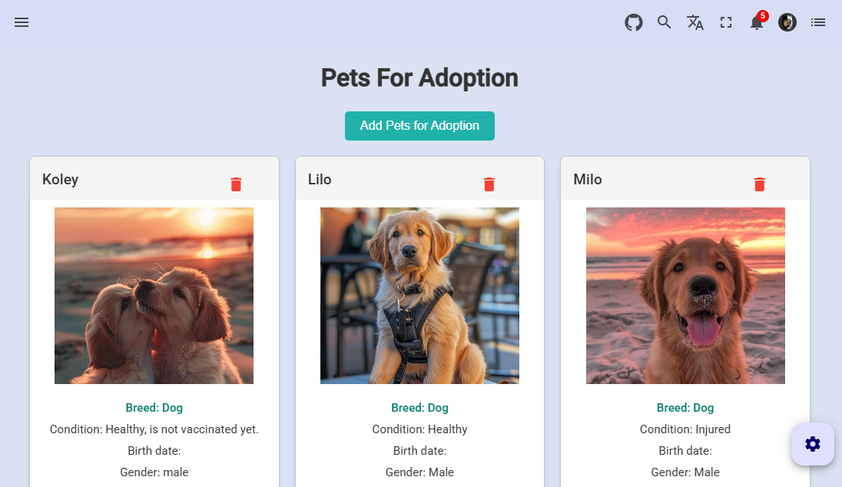
Figure 21: Pets for Adoption
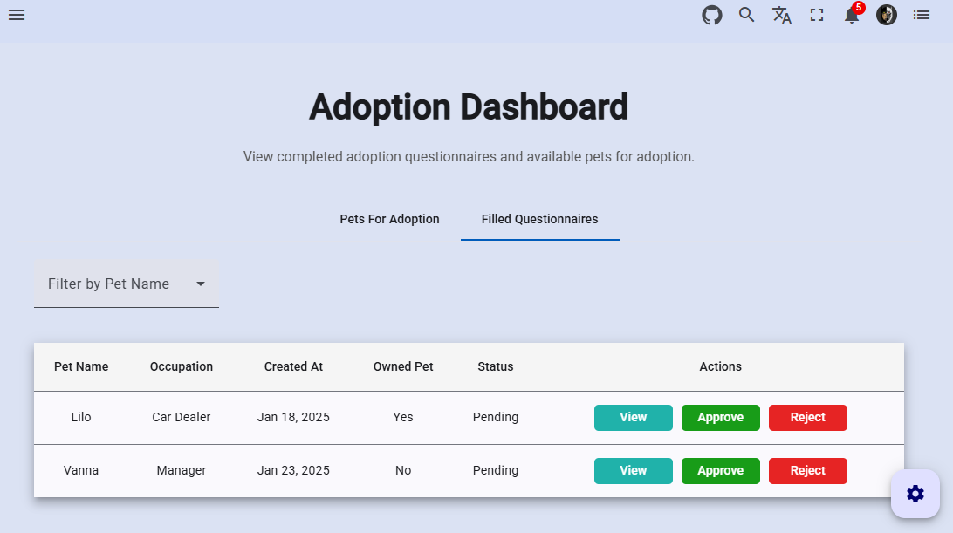
Figure 22: Approve or Reject Questionnaires

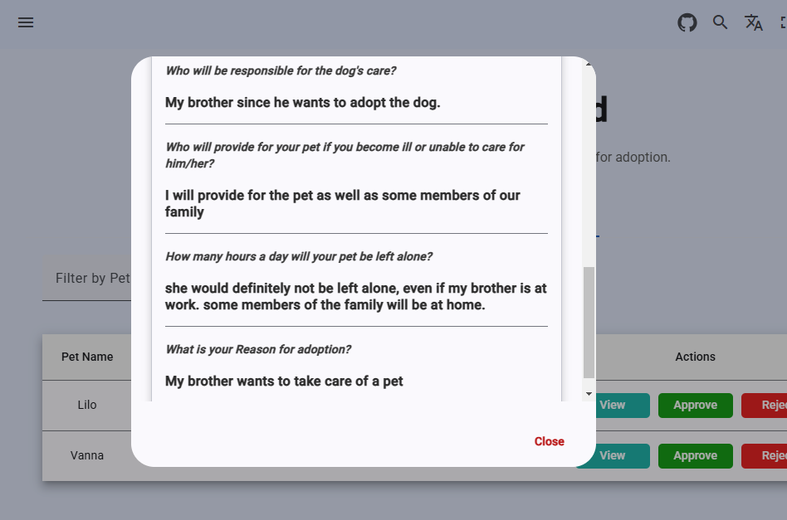
Figure 23: Review Questionnaires
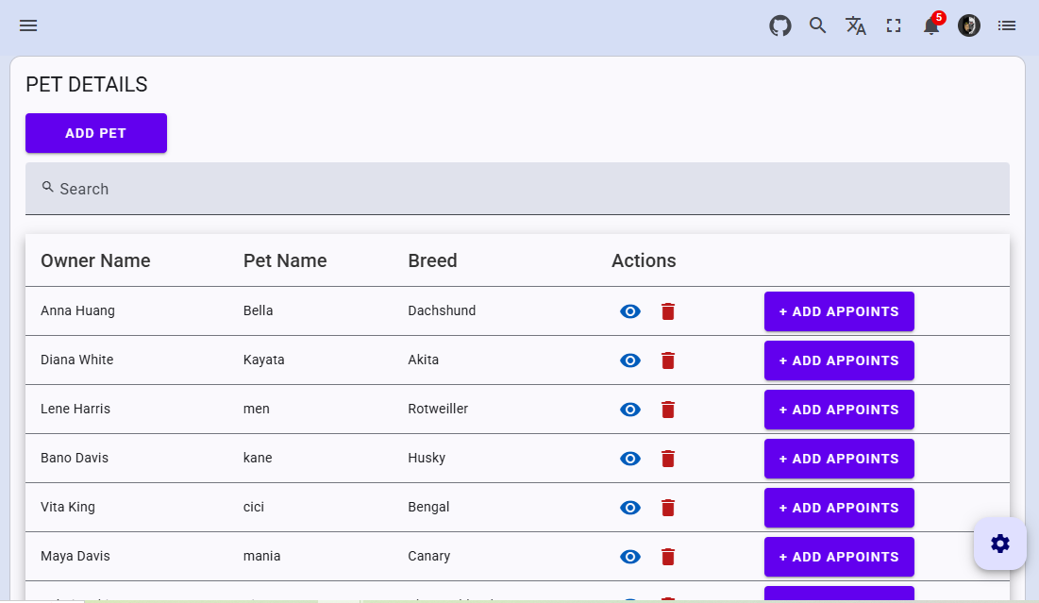
Figure 24: Pet Table

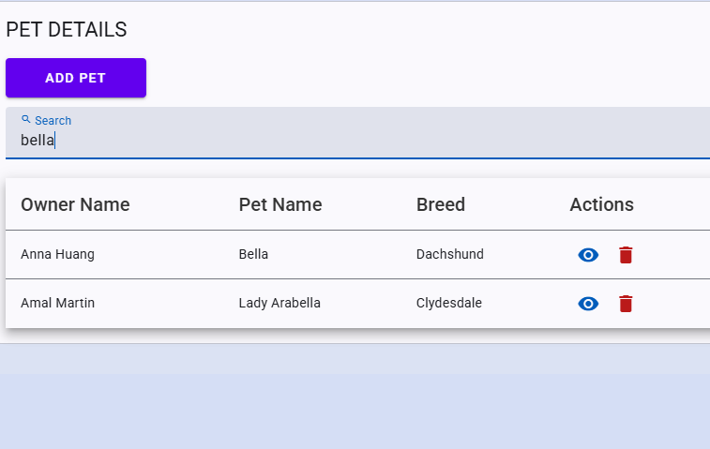
Figure 25: Search Functionality

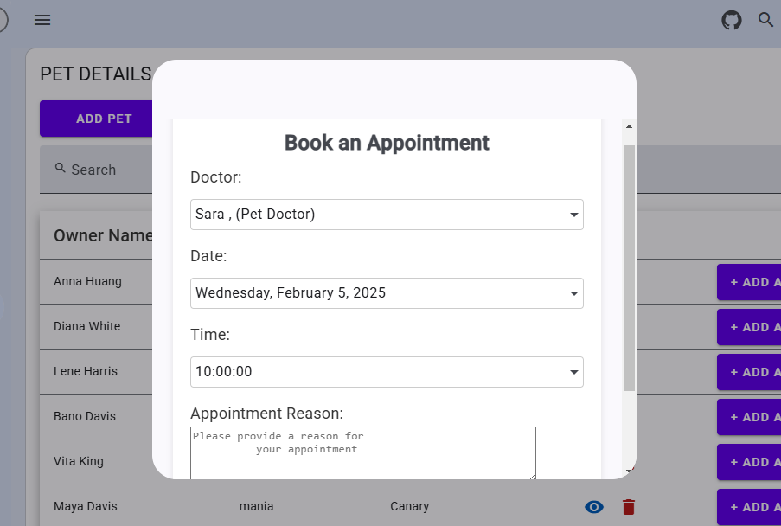
Figure 26: Doctor's book Appointment

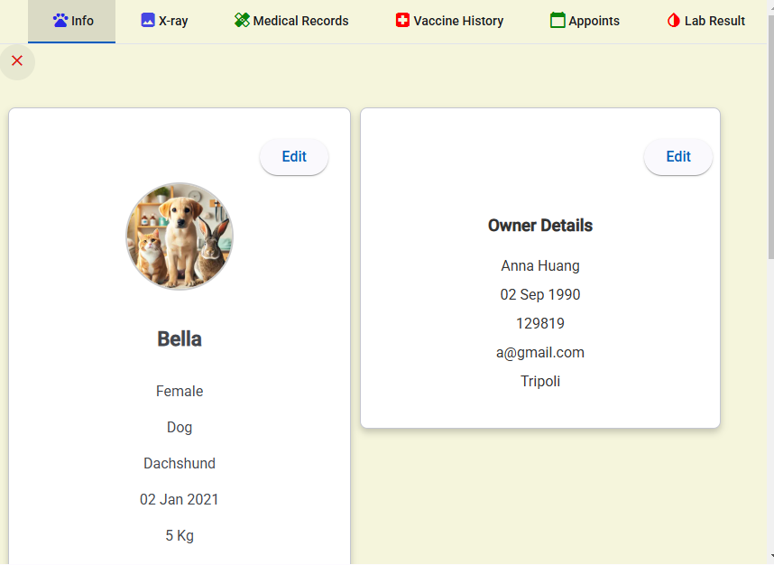
Figure 27: Pet Details
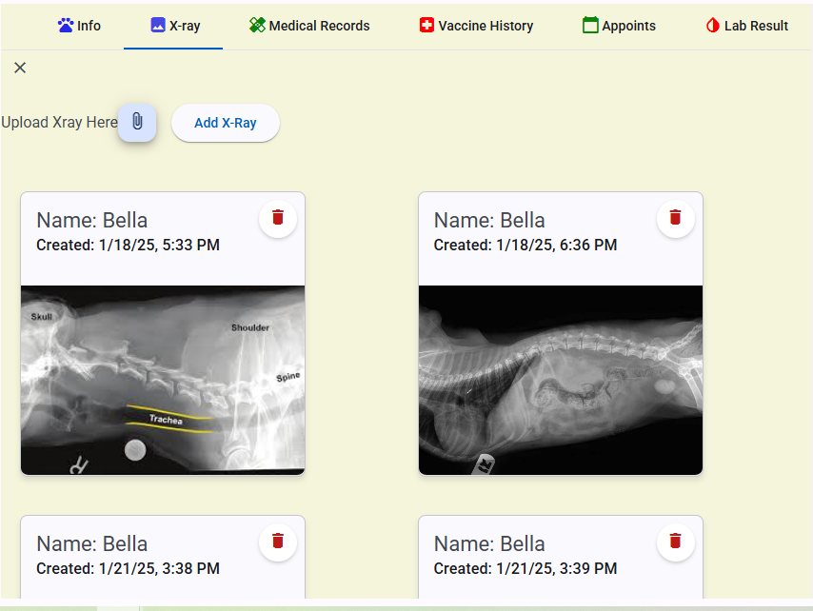
Figure 28: Add X-ray Images

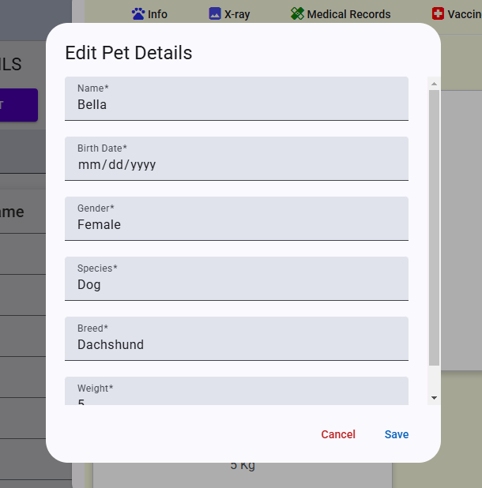
Figure 29: Edit Pets
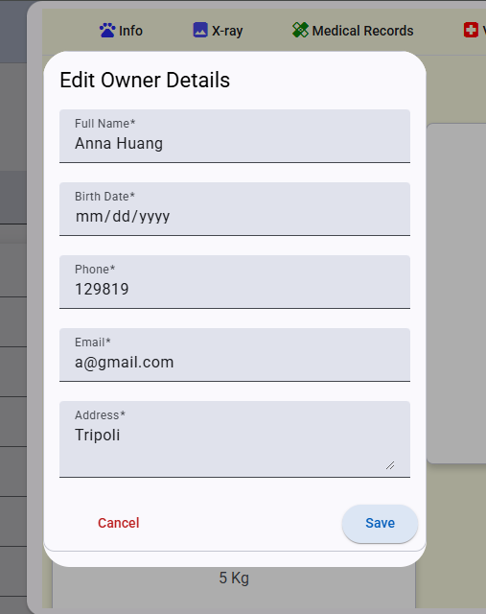
Figure 30: Edit Owner Details

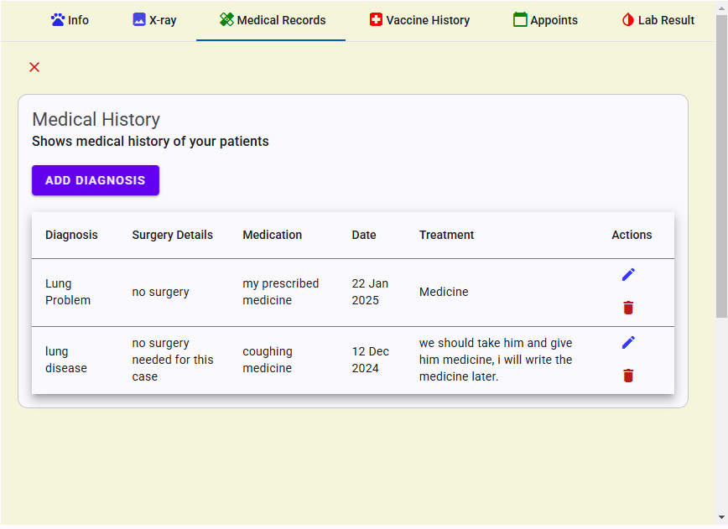
Figure 31: Medical History
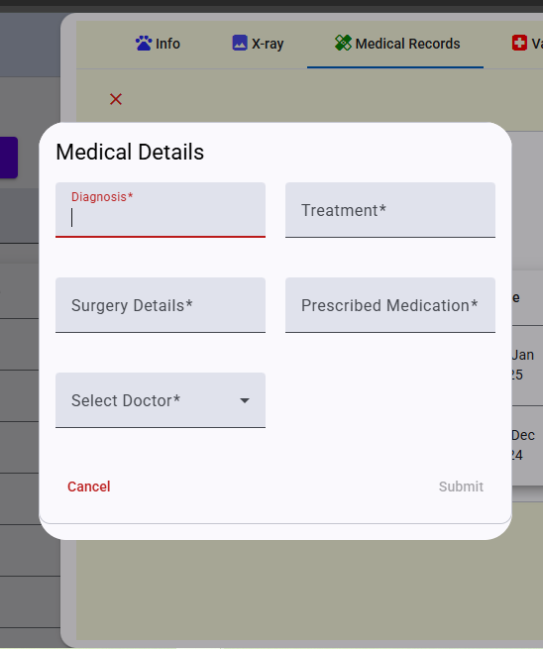
Figure 32: Add a medical history

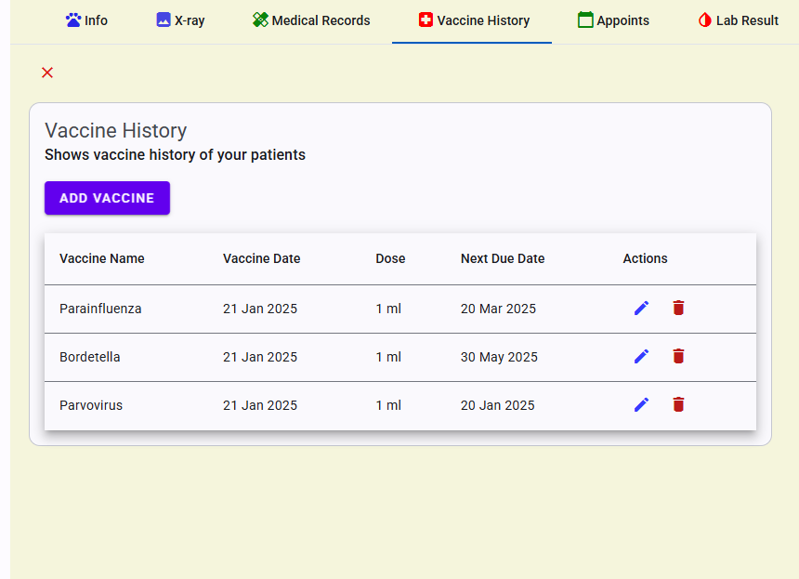
Figure 33: Vaccination History
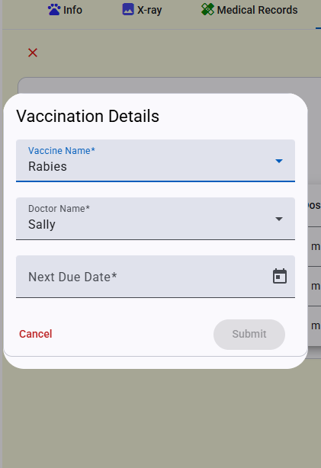
Figure 34: Add Vaccination

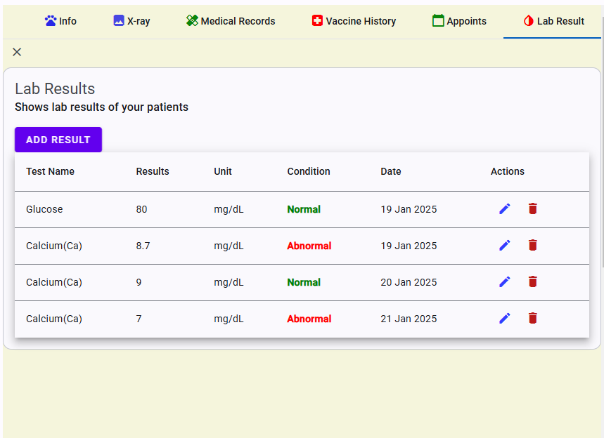
Figure 35: Lab Results
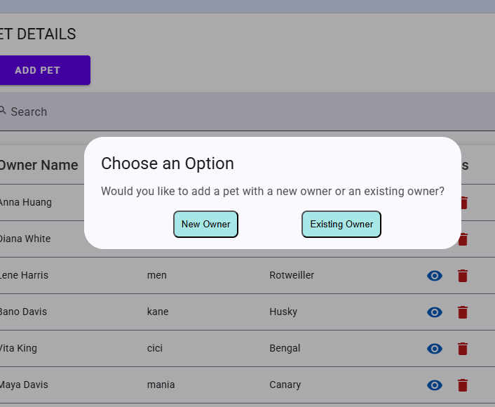
Figure 36: Add an animal with a new owner or an existing owner

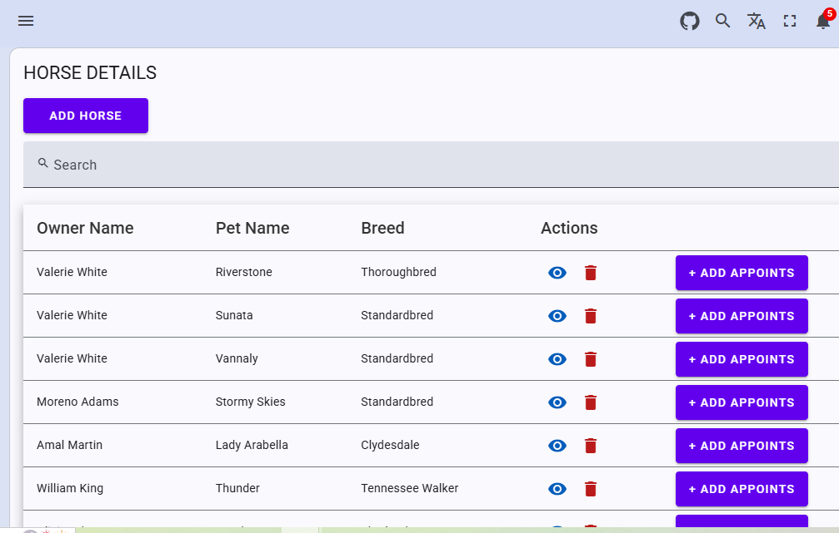
Figure 37: Horse Table
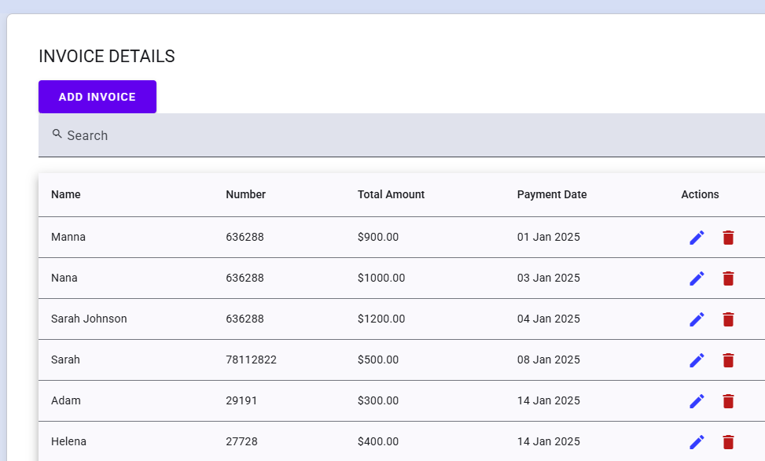
Figure 38: Invoices

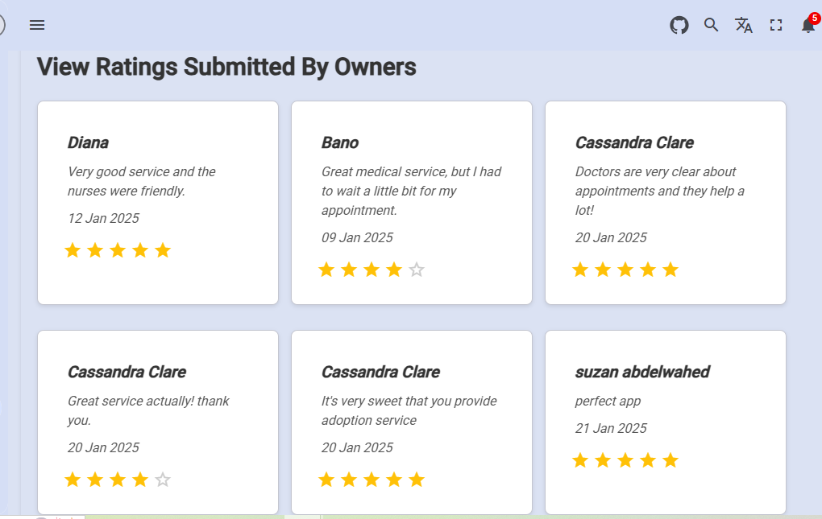
Figure 39: Review Ratings

Mobile screens
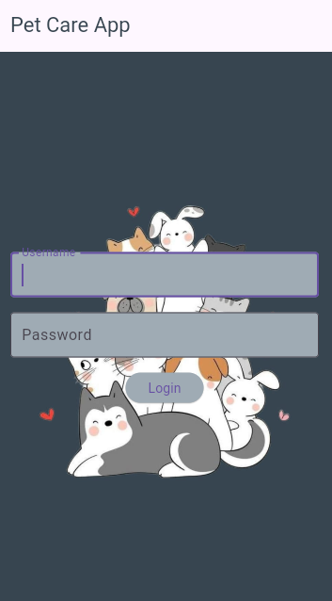
Figure 40: Login Page

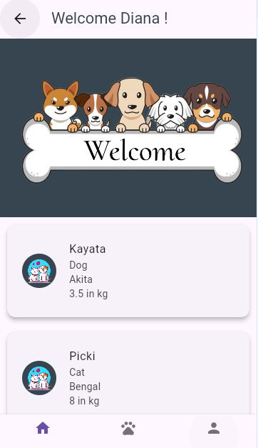
Figure 41: Welcome Page

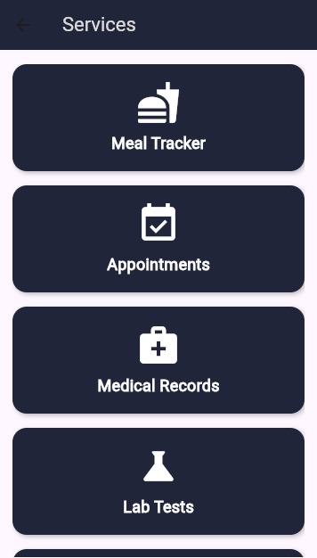
Figure 42: Services Page

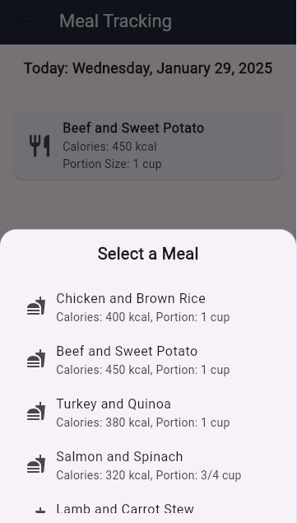
Figure 43: Meal Tracking Page
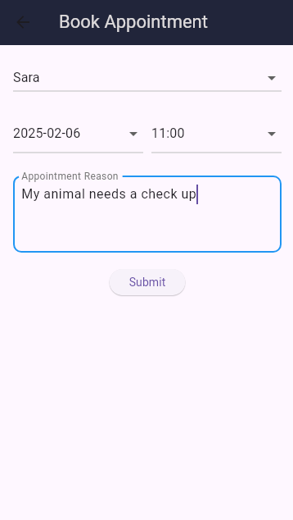
Figure 44: Book Appointment Page
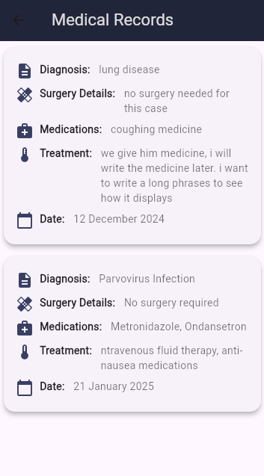
Figure 45: Check medical history of the animal
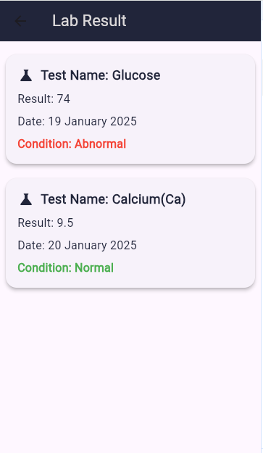
Figure 46: Lab Results
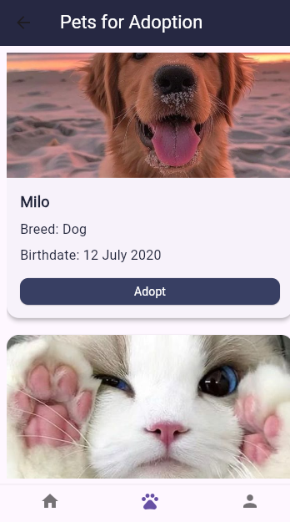
Figure 47: View Pets for Adoption
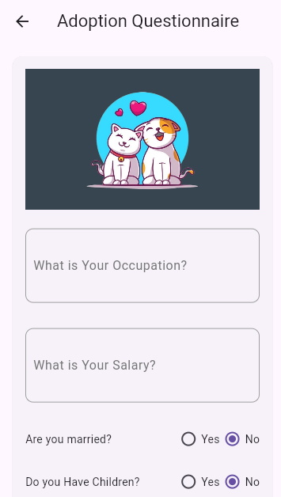
Figure 48: Fill Questionnaire

Testing
Testing ensures that the system functions correctly and enforces data integrity.

Testing Screens
Users can’t submit forms if not all required fields are filled:
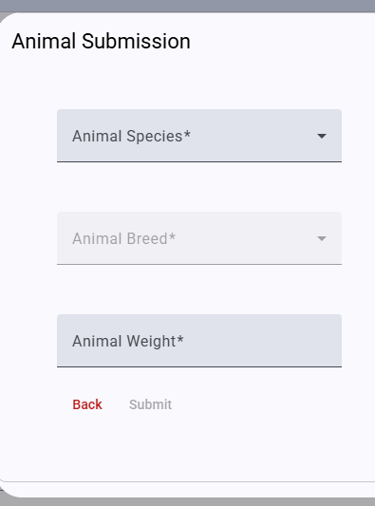
Figure 49: Form 1, Submit button is disabled
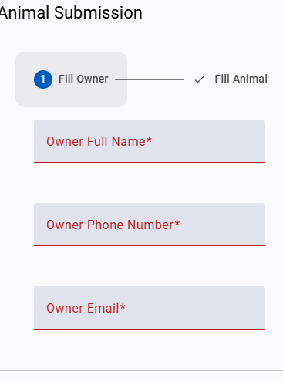
Figure 50: Form 2
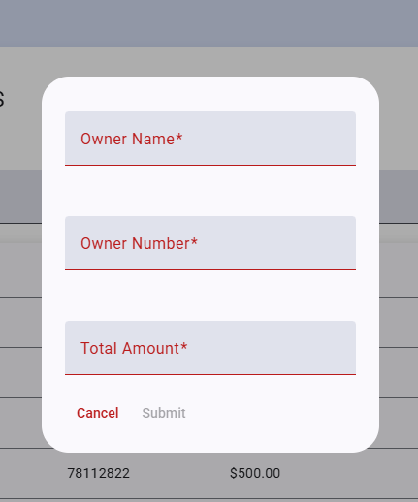
Figure 51: Form 3
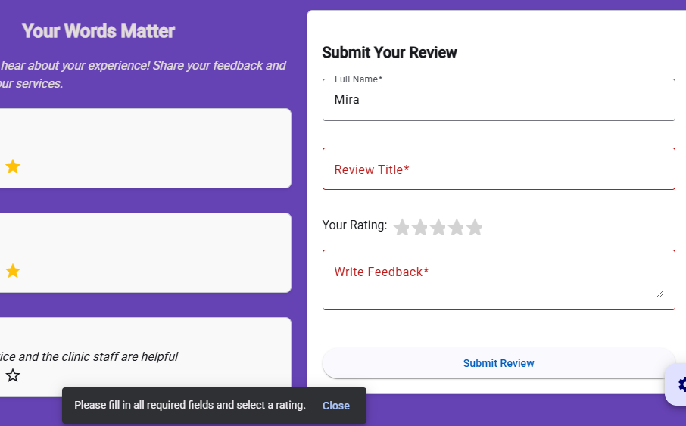
Figure 52: Form 4

Conclusions and Future Works

Conclusion
The veterinary clinic management system successfully addresses the challenges faced by veterinary clinics in managing daily operations. By integrating features such as appointment scheduling, medical record management, pet adoption, invoicing, and role-based access control, the system enhances efficiency and ensures a seamless user experience for doctors, nurses, and pet owners. The platform's secure authentication mechanisms and dynamic features provide a reliable, user-friendly solution for clinic operations. Overall, the system demonstrates its potential to improve workflow, reduce errors, and offer a better experience for all users involved.

Future work
Future enhancements to the system could include the integration of automated reminders and notifications for appointments to improve client engagement and reduce missed appointments. A telemedicine feature could be introduced to enable virtual consultations between pet owners and veterinarians, expanding the clinic's accessibility. Additionally, advanced data analytics could be implemented to provide deeper insights into clinic performance, patient care trends, and customer satisfaction. These improvements would further enhance the system's functionality and its value to veterinary clinics.

