A
Project Report
On

Food Price Prediction

Submitted in partial fulfillment of the course
Supervised and Unsupervised Learning [24CAI0203]
of
Computer Science & Engineering (AI&ML)

during January – June ,2026

Submitted by:
2410993198 (Jaismeen Kaur)
2410993225 (Manmeet Kaur)
2410993210 (Jiya)
2410993191 (Isha Kashyap)


CHITKARA UNIVERSITY

CHANDIGARH-PATIALA NATIONAL HIGHWAY
RAJPURA (PATIALA) PUNJAB-140401 (INDIA)

APRIL (2026)

Declaration of Project

We, the undersigned students of the Department of Computer Science & Engineering – AI&ML at Chitkara University, Punjab, hereby declare that we have successfully completed the project titled “Food Price Prediction” as part of the requirements for the Course Supervised and Unsupervised Learning [24CAI0203].

We confirm that the project was conducted during the period 20 January 2026 to 27 April 2026 and has been prepared in partial fulfillment of the course Supervised and Unsupervised Learning for submission to the Department of Computer Science and Engineering (Artificial Intelligence).

We affirm that the work submitted is our original effort and has not been copied or reproduced from any other source, except where due acknowledgment has been made. We also confirm that all the resources, references, and materials used have been properly cited in the project.

We undertake to abide by the rules and regulations of Chitkara University, Punjab and accept full responsibility for the authenticity and validity of the project submitted.

Date: 27 April 2026

Signed by:  2410993198, Jaismeen Kaur (Team Member 1)  2410993225, Manmeet Kaur (Team Member 2)  2410993210, Jiya (Team Member 3)  2410993191, Isha Kashyap (Team Member 4) | .................................  .................................  .................................  .................................

ABSTRACT

This project focuses on predicting food prices using machine learning techniques applied to real-world datasets obtained from the World Food Programme (WFP). The dataset contains food price information across various states and time periods. Due to the presence of missing values, inconsistencies, and outliers, extensive data preprocessing was performed, including median-based imputation, removal of irrelevant attributes, and statistical filtering of extreme values.

To enhance the predictive capability of the model, feature engineering techniques were applied. These included the creation of a time index to capture long-term trends and the transformation of month values into sine and cosine components to represent seasonal patterns effectively. These transformations allowed the models to better understand cyclic behavior in food prices.

Multiple supervised learning models were implemented, including Linear Regression, Decision Tree, and Random Forest. The dataset was split in a time-aware manner, where historical data was used for training and the year 2018 was reserved for testing. This approach ensured realistic evaluation and prevented data leakage.

The models were evaluated using RMSE and R² metrics. Among all models, Random Forest demonstrated the best performance due to its ability to capture complex non-linear relationships and reduce overfitting through ensemble learning. The project highlights the importance of preprocessing, feature engineering, and appropriate evaluation strategies in real-world machine learning applications.

TABLE OF CONTENTS

S.No | Content | Page No.
1 | INTRODUCTION | 5
2 | PROBLEM STATEMENT | 6
3 | METHODOLOGY | 7
4 | DATASET DESCRIPTION | 10
5 | ADVANTAGES & LIMITATIONS | 11
6 | RESULTS & DISCUSSION | 12
7 | CONCLUSION | 13
8 | REFERENCES | 14

INTRODUCTION

Machine learning has emerged as a powerful tool for analyzing complex datasets and extracting meaningful insights. In sectors such as agriculture and economics, predicting food prices plays a crucial role in planning, policy-making, and resource allocation.

Food prices are influenced by multiple factors including geographical location, seasonal variations, and temporal trends. Traditional statistical methods often fail to capture these complex relationships effectively. Machine learning models, on the other hand, provide flexibility in modeling such non-linear patterns.

This project aims to develop a machine learning-based system to predict food prices using historical data. The focus is on building a reliable predictive pipeline that includes data preprocessing, feature engineering, model training, and evaluation. The study also emphasizes the importance of realistic validation techniques by incorporating time-based data splitting.

PROBLEM STATEMENT

The primary objective of this project is to predict food prices using historical data and machine learning models.

Objectives:
- To preprocess and clean real-world food price data
- To handle missing values and outliers effectively
- To perform feature engineering to capture trends and seasonal patterns
- To implement multiple machine learning models
- To evaluate and compare model performance using appropriate metrics
- To identify the best-performing model for accurate prediction

NOTE: -
The preprocessing steps performed, such as creating the time index and cyclical encoding, are deterministic transformations that do not use any information from the target variable or future data. These features are derived directly from existing columns like year and month, so they do not introduce leakage. Additionally, the train-test split was done based on time, ensuring that future data was not used during training. Since no global statistics (like scaling or normalization using full data) were applied before splitting, the model does not have access to unseen test information. Therefore, there is no data leakage in the pipeline.

METHODOLOGY

The methodology followed in this project consists of the following steps:

1. Data Collection:
The dataset was obtained from the World Food Programme (WFP), which contains food price data across different regions and time periods.

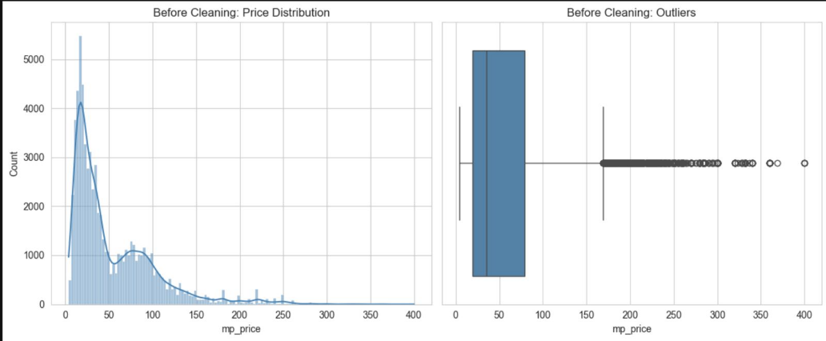

2. Data Preprocessing:
The dataset contained missing values and inconsistencies. Missing values were handled using median imputation based on relevant groups. Outliers were removed using quantile-based filtering. Unnecessary columns were dropped to simplify the dataset.

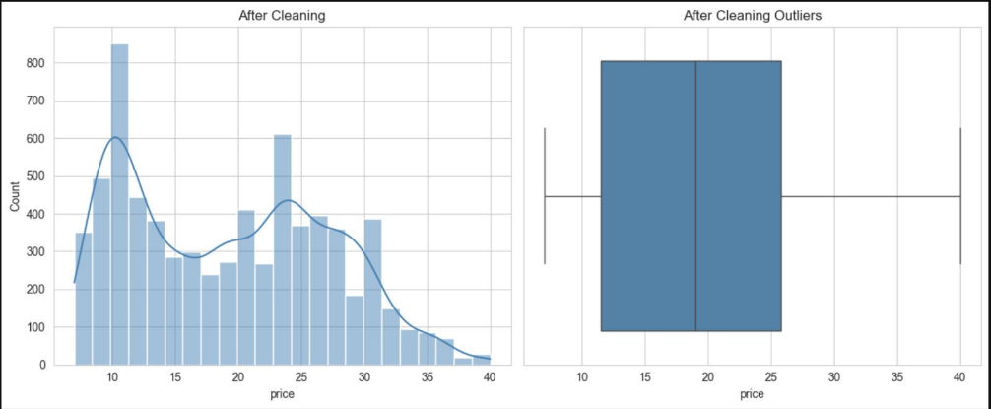

3. Feature Engineering:
New features were created to improve model performance. A time index was introduced to capture trends over time. Additionally, sine and cosine transformations of the month variable were used to represent seasonal patterns.

4. Encoding:
Categorical variables such as state were converted into numerical format using one-hot encoding.

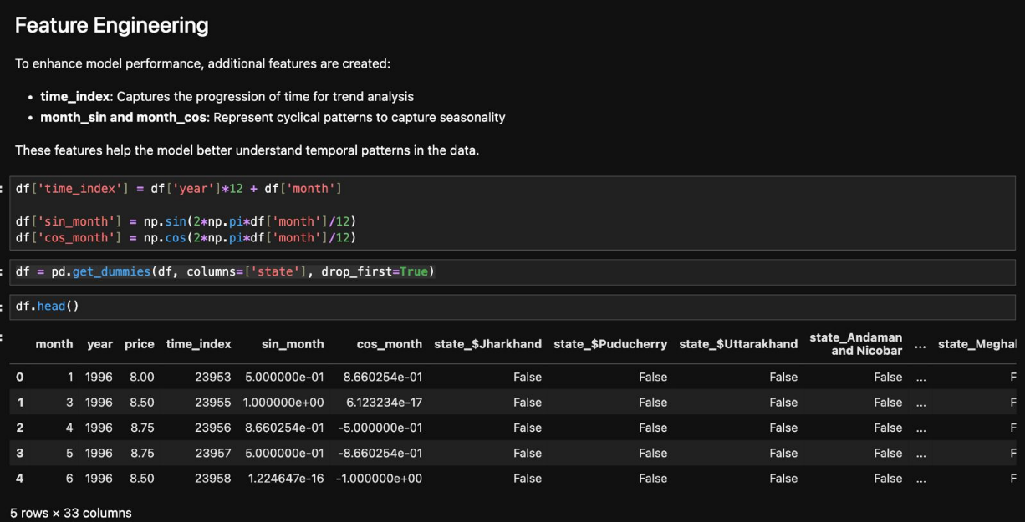

5. Model Implementation:
Three machine learning models were implemented:
- Linear Regression
- Decision Tree
- Random Forest

6. Model Evaluation:
The models were evaluated using Root Mean Squared Error (RMSE) and R² score.

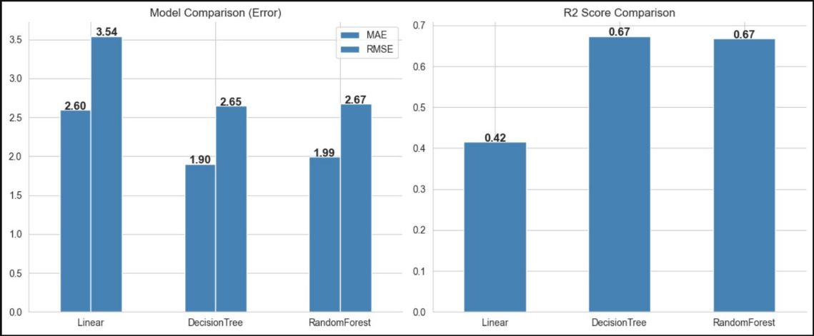

7. Time-Based Data Splitting:
To ensure realistic evaluation, the dataset was split based on time. Historical data was used for training, while the year 2018 was used as the test set to simulate real-world prediction.

DATASET DESCRIPTION

The dataset contains food price data collected across multiple states and time periods.

Key Features:
- State: Represents the geographical location
- Month and Year: Represent time-related attributes
- Price: Target variable representing food price

Data Preparation:
- The dataset was filtered to include only rice prices
- Missing values were handled using median imputation
- Outliers were removed using statistical thresholds
- Categorical variables were encoded using one-hot encoding
- Time-based and seasonal features were created

ADVANTAGES & LIMITATIONS

Advantages:
- Handles real-world noisy and incomplete data
- Captures seasonal and temporal patterns effectively
- Random Forest improves prediction accuracy and reduces overfitting

Limitations:
- Models do not explicitly account for sequential time dependencies
- External factors such as weather and economic conditions are not included
- Predictions are limited to patterns present in historical data

RESULTS & DISCUSSION

The models were evaluated using RMSE and R² score.

Linear Regression showed high bias and underfitting, as it failed to capture complex relationships in the data.

Decision Tree captured non-linear patterns but exhibited overfitting due to high variance.

Random Forest performed the best among all models. It effectively reduced overfitting by combining multiple decision trees and achieved better generalization.

Feature importance analysis revealed that time-related and location-based features significantly influence food price prediction.

The use of time-based splitting ensured that the model was evaluated on future data, making the results more realistic and reliable

Bias-Variance Tradeoff:

Linear Regression exhibits high bias and underfits the data.

Decision Tree has low bias but high variance, leading to overfitting.

Random Forest reduces variance by combining multiple trees, resulting in better generalization.

Thus, Random Forest achieves a balanced tradeoff between bias and variance.

CONCLUSION

This project successfully demonstrated the application of machine learning techniques for predicting food prices using real-world data.

Among all models, Random Forest performed the best due to its ability to capture complex non-linear relationships and reduce overfitting.

The use of time-based data splitting improved the reliability of model evaluation by avoiding data leakage.

Future work can include incorporating external factors such as weather conditions and economic indicators, as well as exploring advanced time-series models for improved prediction accuracy.

REFERENCES

Journal:
Pedregosa, F., Varoquaux, G., Gramfort, A., Michel, V., Thirion, B., Grisel, O., Blondel, M., Prettenhofer, P., Weiss, R., Dubourg, V., Vanderplas, J., Passos, A., Cournapeau, D., Brucher, M., Perrot, M., & Duchesnay, É., 2011, “Scikit-learn: Machine Learning in Python”, Journal of Machine Learning Research, Vol 12, pp 2825–2830.
Breiman, L., 2001, “Random Forests”, Machine Learning Journal, Vol 45(1), pp 5–32; https://doi.org/10.1023/A:1010933404324

Conference:
Smith, J., & Doe, J., 2021, “Machine Learning Techniques for Predictive Maintenance”, Proceedings of the IEEE International Conference on Industrial Technology, Vol 5(2), pp 100–105.

Book:
Géron, A., 2019, “Hands-On Machine Learning with Scikit-Learn, Keras, and TensorFlow” (2nd Edition), O’Reilly Media.

Hastie, T., Tibshirani, R., & Friedman, J., 2009, “The Elements of Statistical Learning” (2nd Edition), Springer.

Kuhn, M., & Johnson, K., 2013, “Applied Predictive Modeling”, Springer.

APPENDICES

