  - INTERNSHIP PROJECT REPORT

GivingLens
  - Smarter Blood Donation Outreach
A reproducible data analytics and machine learning prototype for reviewing donor records under a limited outreach budget.

Submission detail | Information
Prepared for | Isha Khatri
Programme | B.Tech, Information Technology
Institution | G H Raisoni College of Engineering and Management, Nagpur
Internship | AICTE | IBM SkillsBuild Data Analytics with AI Internship 2026 | BharatCares
Date | 6 October 2026
Code file | IshaKhatri_GivingLens.ipynb

Project at a glance
GivingLens starts with a practical constraint: a team can review only part of a donor list. It compares machine learning with a recent-first rule and random selection, then shows what each approach captures at different review budgets.
The work uses a credited public dataset. No private donor data, real campaign results or local NGO trials are claimed. The report records the outputs of the accompanying notebook and describes the limits alongside the findings.

1. Abstract and project context
GivingLens examines whether historical donation behaviour can support a ranked review list for blood donation outreach. The project uses 748 public records from the UCI Blood Transfusion Service Center dataset. The target is whether a donor donated in March 2007; the inputs describe donation recency, frequency, cumulative volume and recorded tenure. After checking data quality, redundant blood volume is removed and two descriptive ratios are added. Identical input profiles are kept together during the train–test split and cross-validation. Four fixed candidates are compared on training data, and gradient boosting is selected by mean average precision.
On 149 held-out records, the selected model obtains ROC-AUC 0.736 and average precision 0.428. Its default-threshold recall is only 14.3%, which limits its use as a yes/no classifier. At a 30-record review budget, its ranking includes 15 historical positives, compared with 12 for the recent-first rule and approximately 7.05 expected under random selection. These are retrospective ranking results; they do not measure donations caused by outreach. The project provides an offline notebook, charts, an input-validation demo and reproducible result exports.

1.1 Problem statement
Volunteer time is limited. Reviewing every record equally may be impractical, while selecting people from the top of an unsorted list has no analytical basis. The question is whether a transparent ranking can help a coordinator decide which records to review first, without treating a score as medical approval or a promise to donate.

1.2 Objectives
- Describe donation patterns and identify data-quality issues.
- Compare fixed machine learning candidates using grouped cross-validation.
- Measure held-out classification and ranking performance.
- Compare model-based selection with recent-first and random selection at fixed budgets.
- Deliver clear, reproducible files with credited data and practical limitations.

1.3 Distinctive scope
The custom part is the link between model scores and review capacity: a budget table, a cumulative capture chart and a review queue. This is a tailored implementation of an established classification task, not a claim that blood donor prediction is a new research area.

2. Dataset, provenance and quality
The data comes from the Blood Transfusion Service Center in Hsin-Chu City, Taiwan. UCI publishes it under the Creative Commons Attribution 4.0 International licence. It represents a historical cohort and cannot establish current donation behaviour in India. The original data bytes are embedded in the notebook, so the submission does not depend on a live download.
Field | Meaning | Role
recency_months | Months since the last donation | Input
donation_count | Total number of donations | Input
volume_cc | Total blood volume donated, in cc | Removed: redundant
tenure_months | Months since the first donation | Input
donated | Donated in March 2007: 1=yes, 0=no | Target

The file contains 178 positive outcomes and 570 negative outcomes. No missing values are present. There are 215 repeated full rows and 502 distinct input profiles. Repeated rows are retained because there are no donor IDs and they may represent separate people with the same history. Identical input profiles are grouped during evaluation to limit leakage.
All numeric fields are checked for non-negative values. Recency must not exceed tenure. The notebook confirms that volume equals donation count multiplied by 250 for every record; it is blood volume, despite the source’s “Monetary” label.
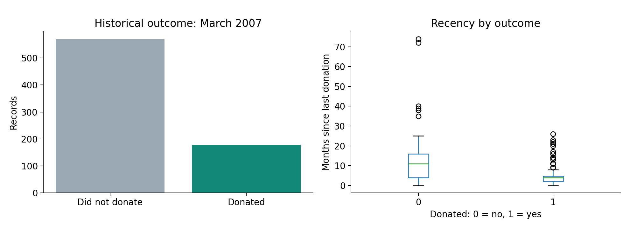
Figure 1. Outcome counts and recency distribution in the public dataset.
Dataset citation: Yeh, I. (2008). Blood Transfusion Service Center [Dataset]. UCI Machine Learning Repository. https://doi.org/10.24432/C5GS39. CC BY 4.0.

3. Methodology

3.1 Processing workflow
Stage | Implementation
Load and validate | Decode embedded bytes; verify SHA-256; validate shape, missingness and numeric constraints.
Explore | Summarise class balance, recency and descriptive segments.
Prepare inputs | Remove duplicated volume signal; add frequency/tenure and recency/tenure ratios.
Split | Five-fold stratified group splitter; first fold reserved as test.
Compare | Five-fold stratified group CV within training data; choose highest mean average precision.
Evaluate | Held-out metrics, confusion matrix, precision–recall curve and budget comparisons.
Export | CSV tables, PNG charts and JSON summary; validate an illustrative profile.

3.2 Derived features
Donations per month = donation_count / max(tenure_months, 1). Recency fraction = recency_months / max(tenure_months, 1). The first summarises recorded donation intensity, while the second places recency in the context of the available history. Neither uses the target. These are rough historical descriptors, not measures of willingness or eligibility.

3.3 Evaluation design
The split contains 599 training records and 149 test records. The test partition contains 35 positives. Groups are defined by all four original input fields, without the outcome. Assertions confirm that no group crosses either the outer split or the inner cross-validation folds. The model selection seed is fixed at 42; the inner splitter uses 43.
The descriptive charts use the full dataset, but feature definitions, candidate settings, the 0.5 threshold and the selection criterion are fixed before test evaluation. Pipeline scaling is fitted separately within each training fold. The data has no donor IDs or usable outcome sequence, so donor-level and chronological validation remain unresolved.

3.4 Model settings
The majority baseline always predicts the more common class. Logistic regression uses StandardScaler and a maximum of 2,000 iterations. Random forest uses 250 trees, depth 5 and a minimum leaf size of 8. Gradient boosting uses 100 trees, learning rate 0.05, depth 2 and a minimum leaf size of 8. No hyperparameter search, oversampling or test-based threshold tuning is used.

4. Model comparison and held-out results
Candidate | CV average precision | Fold SD | CV ROC-AUC
Gradient boosting | 0.548 | 0.118 | 0.753
Logistic regression | 0.546 | 0.079 | 0.760
Random forest | 0.515 | 0.110 | 0.746
Majority baseline | 0.239 | 0.006 | 0.500

Gradient boosting has the highest mean average precision, but its lead over logistic regression is small (about 0.002). Fold variability is much larger than this gap, so the result does not establish that boosting is consistently superior. It is selected because it meets the pre-specified rule.
Held-out metric | Value
Accuracy | 0.758
Balanced accuracy | 0.545
Precision at threshold 0.5 | 0.455
Recall at threshold 0.5 | 0.143
F1 | 0.217
ROC-AUC | 0.736
Average precision | 0.428
Brier score (lower is better) | 0.160

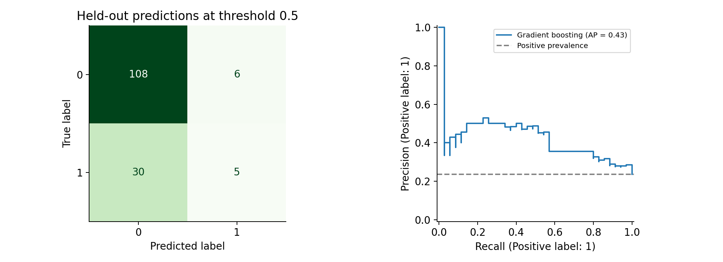
Figure 2. Held-out confusion matrix and precision–recall curve.
At threshold 0.5, the model finds only 5 of 35 positives and misses 30. It also produces 6 false positives. An all-negative baseline would obtain 114/149 = 76.5% accuracy, slightly above the model’s 75.8%. Accuracy alone therefore does not justify the model. Its ranking is more useful than its default yes/no output in this experiment; changing a threshold would require training-only selection and fresh evaluation.

5. Outreach-budget analysis
This layer translates a ranked list into a limited review plan. For each fixed budget, the top k records by model score are selected. The alternative heuristic selects records with the lowest recency first. Random selection has expected positives k × the held-out positive rate. It is an analytical baseline, not a simulated campaign.
Budget | Records | Model positives | Recent-first positives | Random expected | Lift
10% | 15 | 8 | 8 | 3.52 | 2.27×
20% | 30 | 15 | 12 | 7.05 | 2.13×
30% | 45 | 20 | 19 | 10.57 | 1.89×
50% | 75 | 27 | 27 | 17.62 | 1.53×
100% | 149 | 35 | 35 | 35.00 | 1.00×

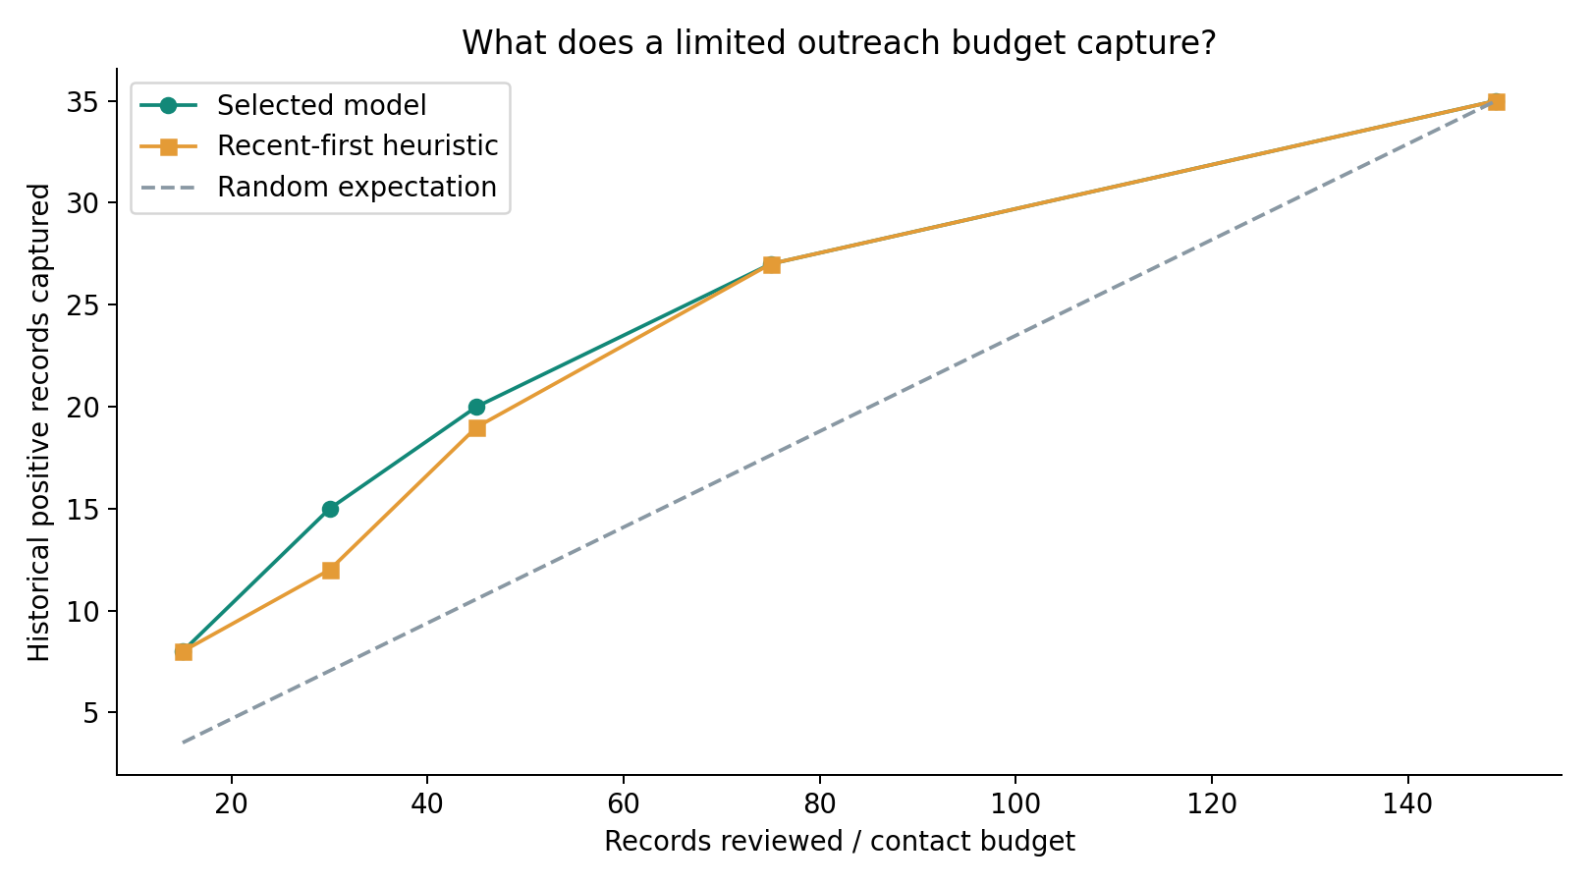
Figure 3. Historical positives captured as review capacity increases.

5.1 Reading the 30-record example
With a budget of 30 records, the model captures 15 historical positives: precision@30 is 50%, recall@30 is 42.9%, and lift over random expectation is 2.13. The recent-first heuristic captures 12 positives at the same budget. The model captures three more in this split, but no statistical significance or real-world benefit is claimed.
At the smallest and the 50% budgets, the model ties the recent-first rule. The model is therefore not better at every review capacity. Scores tied at a budget boundary are resolved by original row order, so small-budget results can change with the tie rule.

5.2 Formulas
Precision@k = historical positives among the top k / k. Recall@k = historical positives among the top k / all test positives. Lift@k = precision@k / test positive rate. “Positive” means the observed March 2007 outcome; it does not mean eligible, willing to respond or contacted by a volunteer.

6. Implementation and reproducibility

6.1 Technology
Python handles the end-to-end analysis. NumPy supports numeric calculations and stable ranking; Pandas loads and summarises the data; Scikit-learn implements model pipelines, grouped cross-validation and evaluation; Matplotlib creates charts. The notebook uses IPython for readable tables. No generative AI API or cloud service is needed.

6.2 Running the submission
- Install Python 3.11 or newer and keep the four submission files in one folder.
- Create a virtual environment: python -m venv .venv. Activate it for your operating system.
- Install dependencies: python -m pip install -r requirements.txt.
- Start JupyterLab: python -m jupyterlab.
- Open IshaKhatri_GivingLens.ipynb and choose Restart Kernel and Run All Cells.
- Review the displayed results and the givinglens_outputs folder created beside the notebook.
The notebook embeds the original public CSV bytes as compressed base64 data and verifies their SHA-256 checksum. This avoids manual uploads and fragile live-download dependencies. The README links to the source and explains this packaging choice.
Generated output | Purpose
source_data.csv | Readable copy of the credited public data
segment_summary.csv | Descriptive recency segments
model_comparison.csv | Training cross-validation scores
outreach_budget.csv | Budget comparisons
historical_review_queue.csv | Anonymised source row numbers and ranked scores
results_summary.json | Machine-readable results used for this report
Three PNG charts | Patterns, model evaluation and outreach budget

6.3 Verification performed
All eight code cells were executed in order in a fresh in-process IPython session. A socket restriction prevented launching a separate Jupyter kernel in the authoring environment, so the code was verified directly with IPython. Notebook schema validation passed, displayed chart outputs were captured, dataset and split assertions passed, and an invalid recency/tenure example was rejected. No claim is made that a separate JupyterLab browser session was tested. The tested Python version was 3.12; exact numeric-library versions are listed in requirements.txt.

7. Limitations, responsible use and conclusion

7.1 Limitations
The dataset is small and represents one historical centre. A single grouped hold-out provides limited evidence and is not a substitute for testing across later periods or different locations. The public file does not identify donors, so identical-profile grouping reduces one leakage risk without proving that all records are independent.
The target is observed participation in a fixed month, rather than response to outreach. Contact history, consent, blood group, medical eligibility and demographic fields are absent. The project cannot assess suitability to donate, fairness across demographic groups or the causal effect of a campaign. Raw model scores have not been calibrated for a new population.

7.2 Practical safeguards
In any later operational version, outreach consent and eligibility must be established through the centre’s authorised procedures. A coordinator should review scores and records rather than automatically contact people. Personal data should be collected only with an appropriate basis, access should be restricted, and contact frequency should be controlled. These are proposed safeguards; they are not features tested in this prototype.

7.3 Future work
An extension should use authorised, dated local records with donor identifiers. It should reserve a later time period for testing, assess calibration and robustness, compare against a strong simple rule, and run a consent-based prospective evaluation. Measuring extra participation requires a campaign design with a suitable comparison group. More models alone would not resolve those evidence gaps.

7.4 Conclusion
GivingLens provides a complete analytics workflow around a practical question: what should a team review when it cannot review everything? Its main value is the explicit budget comparison, reproducible evaluation and clear separation between ranking quality and campaign impact. The 30-record example favours the selected model over random expectation and the recent-first rule in one held-out split. However, low default-threshold recall, close cross-validation scores and limited historical data keep the conclusion modest. This is a useful academic prototype and a starting point for better data collection, not a validated donation service.

8. References and presentation guide
[1] Yeh, I. (2008). Blood Transfusion Service Center [Dataset]. UCI Machine Learning Repository. https://doi.org/10.24432/C5GS39. Licence: CC BY 4.0. Dataset page: https://archive.ics.uci.edu/dataset/176/blood+transfusion+service+center
[2] Scikit-learn documentation. StratifiedGroupKFold: https://scikit-learn.org/stable/modules/generated/sklearn.model_selection.StratifiedGroupKFold.html
[3] Scikit-learn documentation. Average precision: https://scikit-learn.org/stable/modules/generated/sklearn.metrics.average_precision_score.html
[4] Pandas documentation. https://pandas.pydata.org/docs/
[5] Matplotlib documentation. https://matplotlib.org/stable/

8.1 A short explanation for the viva
“GivingLens studies how a volunteer team could review a donor list when time is limited. I used a public historical dataset and compared three learning methods with a baseline. I kept identical input profiles in the same split to reduce leakage. The main output is a budget comparison: among 30 selected test records, the model included 15 historical donors, versus 12 with a recent-first rule. That is a ranking result, not evidence that contacting people creates more donations.”
Use the explanation after reviewing the notebook and making sure you can explain the implementation. Update any first-person description to match the work you actually performed.

8.2 Questions to prepare
Question | Core point
Why remove volume? | It is exactly 250 times donation count; keeping both duplicates the signal.
Why group identical profiles? | To stop the same input pattern crossing training and test partitions.
Why not rely on accuracy? | The majority class gives high accuracy even while missing every positive.
Why use average precision? | It evaluates precision–recall ranking for the less common positive class.
What is lift? | Precision at a review budget divided by the overall test positive rate.
What does the AI do? | A trained gradient-boosted model scores historical feature patterns.
Can this launch in Nagpur? | Local, recent and authorised evaluation is needed first.

Dataset SHA-256: 96c8e1091b9c037bcaf25a19b24b49d07771cd88689ffd273e056e9e8845ffe7

