Cal State Apply:

HS Attended: Enhance the User Experience and Search (CS-233)

**Sign-Off**

|  |  |  |  |
| --- | --- | --- | --- |
| Organization | Role | Person | Date |
| The California State University | Enrollment Management Services | April Grommo, Angela Williams |  |
| The California State University | Common Management Systems | DaMonique Sampson |  |

Contents

Summary/Overview – High School Attended 1

Current State 1

Required Changes to High School Search and User Experience 2

Graduated Label on High School Attended tile 14

Out of Scope 14

Tracking 14

Applications Impacted 14

Non-Functional Requirements 14

Cycles Impacted 14

Milestones/Time Criticality 15

# Summary/Overview – High School Attended

## Current State

Many applicants are manually entering their school name on the High School Attended tile. Manually entered schools don’t result in a match to a CEEB code which has downstream impacts on data quality and processing. Additionally, an unknown school will also force an applicant to manually enter high school coursework and complete A-G matching.

## Required Changes to High School Search and User Experience

**1. Search by Country**

To add a new high school, applicants will first select a Country from the drop-down menu. Country will default to United States. Once country is selected, applicants can then search by:

* State
* City
* Zip code
* CEEB code

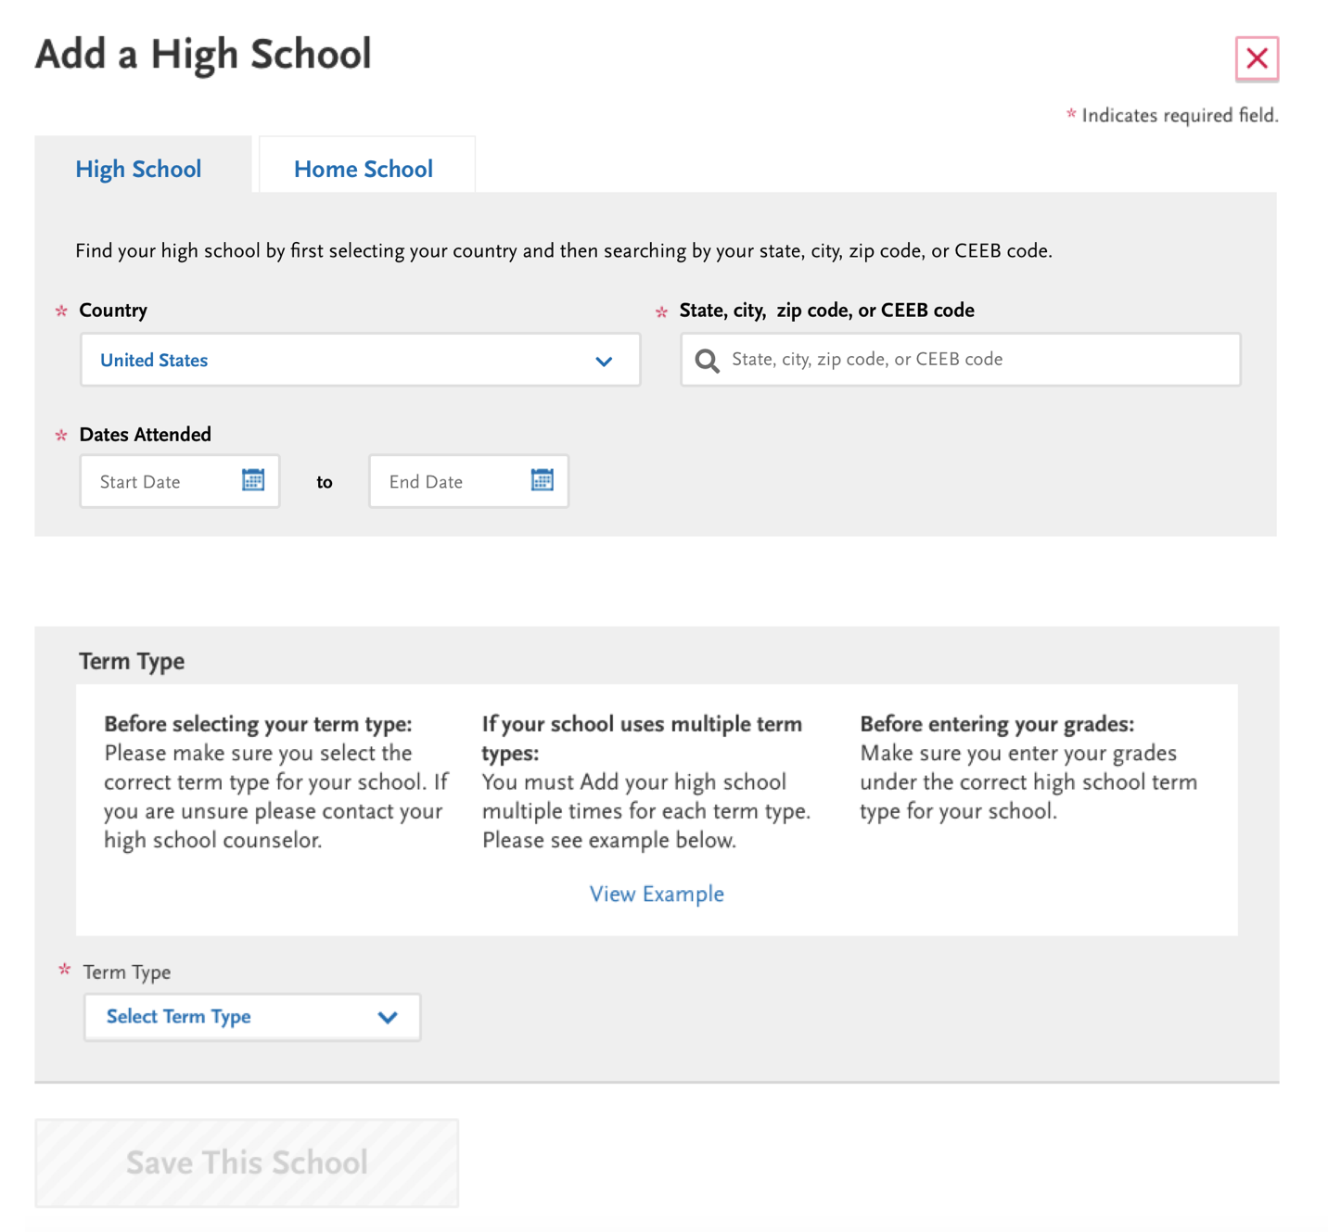

2. **US High Schools** > **Searching by City or State**

After applicants type in at least 2 letters, matching states and cities will be suggested. Applicants can choose one of the suggestions under States or Cities.

Note: If there are no suggested states, the state section won’t appear. Similarly if there are no suggested cities, the city section won’t appear.

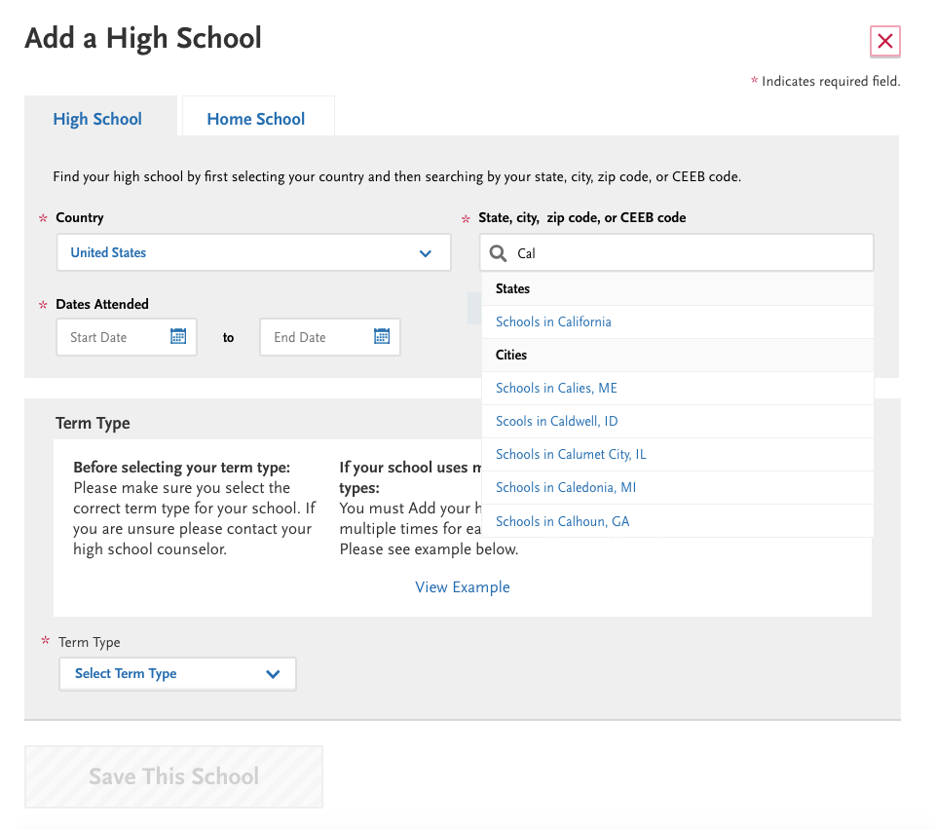

3. **US High Schools** > **Results list for City or State Search**

A search results list will be displayed to applicants who select a suggested city or state. Schools will be sorted alphabetically in the results list.

Search results heading will say either “Schools in [City, State]” or “Schools in [State]” based on what the applicant selected from the suggestions.

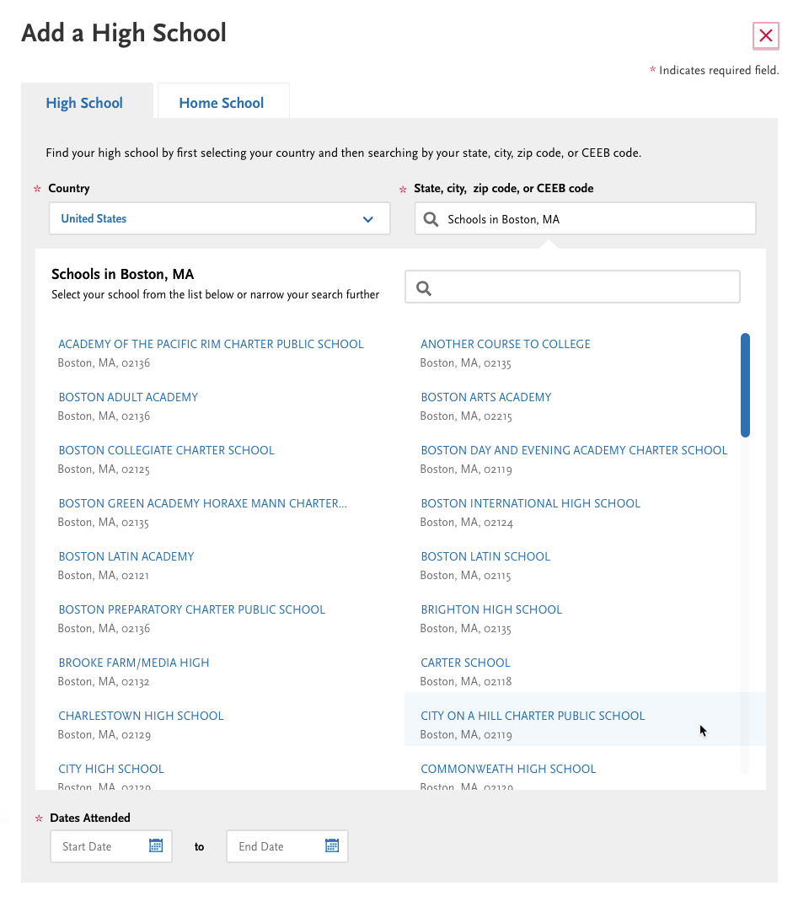

**4. Narrowing Search Results**

Applicants can further narrow their search results by using the High School name field in the search results. The High School name field will conduct a search within the existing results.

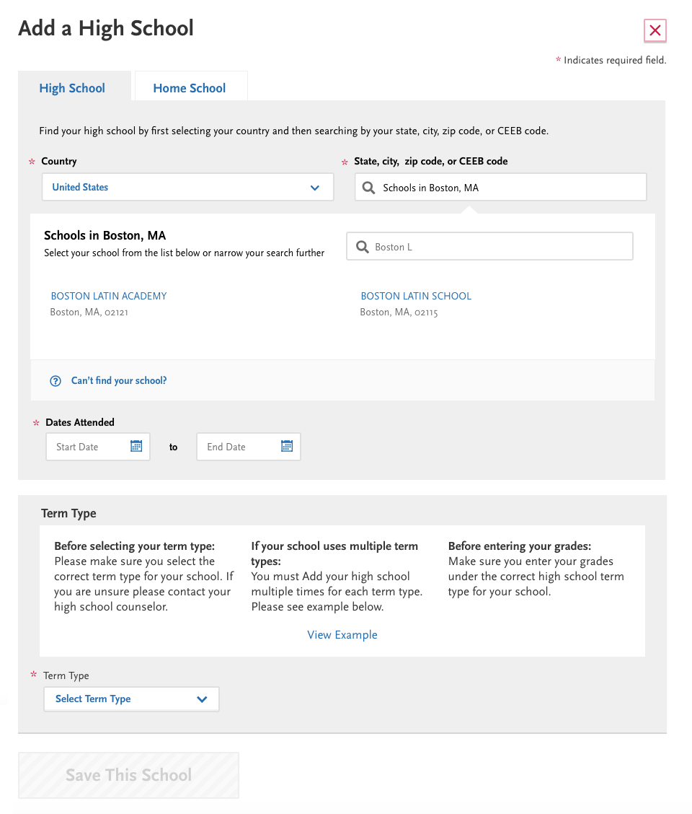

5. **US High Schools > Search by zip code or CEEB code**

If applicants enter at least 2 numbers in the search field, matching zip codes and CEEB codes will be displayed as suggestions. The suggestions will be separated into two sections – Zip Codes and CEEB Codes.

The name of the school will be displayed next to the CEEB code to help applicants select their school.

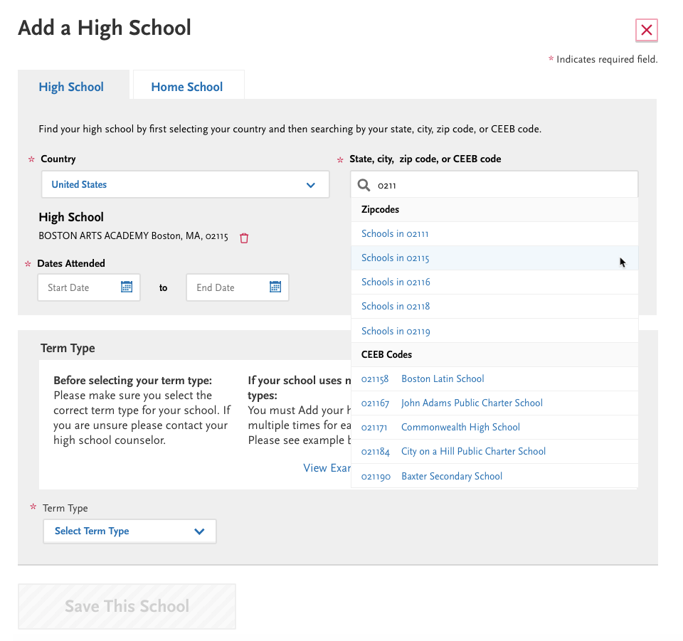

6a. **US High Schools > Results list for Zip Code**

A search results list will be displayed to applicants who select a suggested zip code. Schools will be sorted alphabetically in the results list.

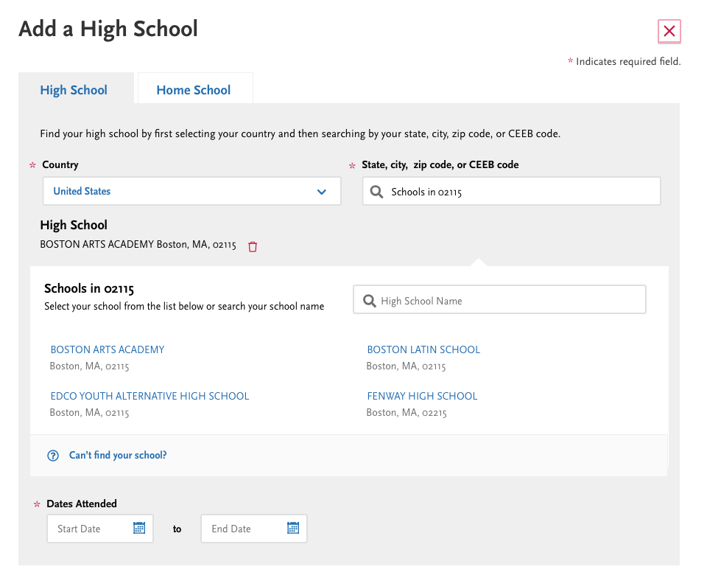

6b. **US High Schools > Results list for CEEB Code**

A search results list will be displayed to applicants who select a suggested CEEB code. A singled matching school will be displayed.

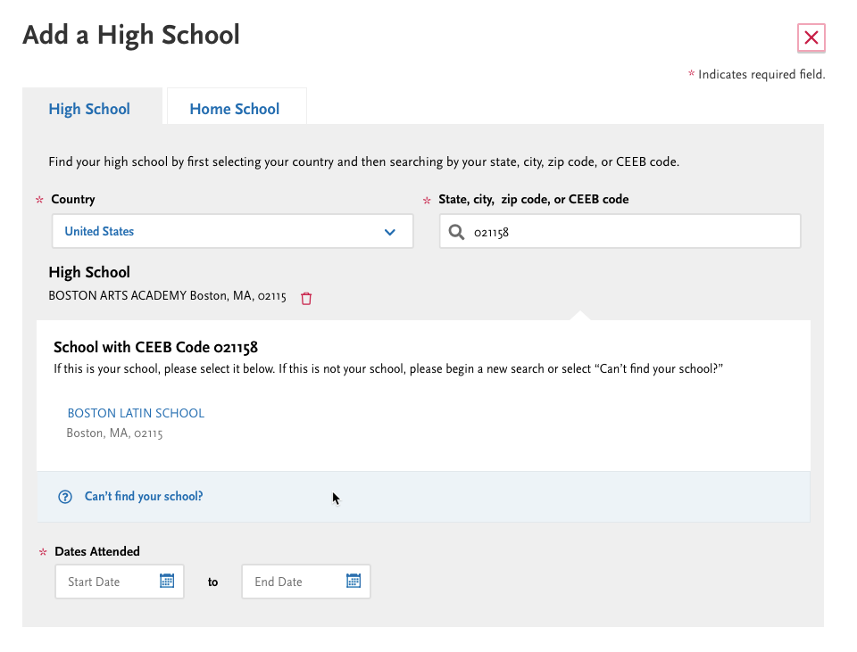

**7.** **US High Schools > Selected School**

Applicant can select a high school from the results list. Once a school is selected, the school name, city, state and zip code will display under the “High School” heading.

Applicants can delete a school by clicking the Trash Can icon. When a school is deleted, the last search results screen will be displayed again.

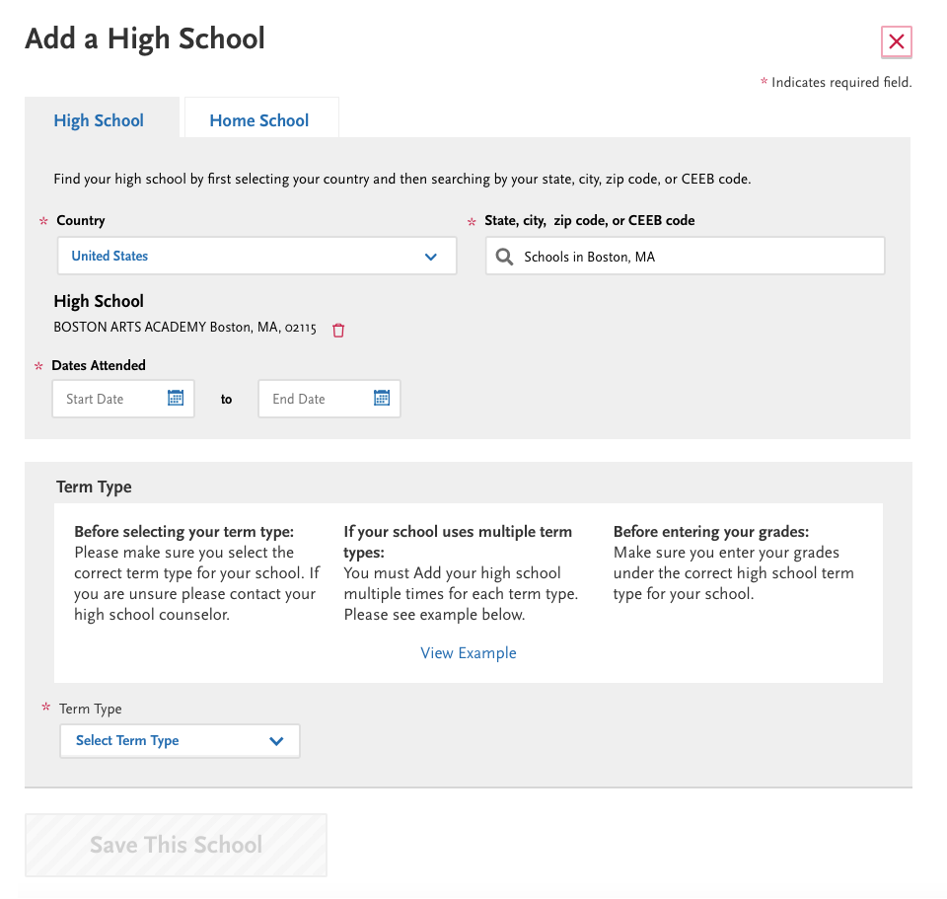

8. **US High Schools > Can’t find your school**

For applicants who can’t find their school through searching, they can select “Can’t find your school” from the search results list. “Can’t find your school” will display at the end of the results list.

Applicants will then manually enter state, city and school.

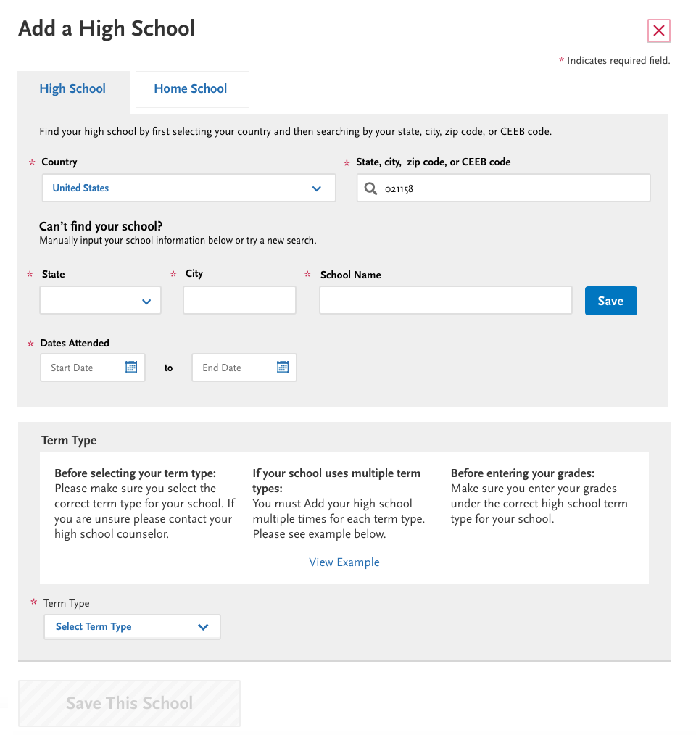

Existing validation will be used for manually entered schools. State and City will be required before School name can be entered.

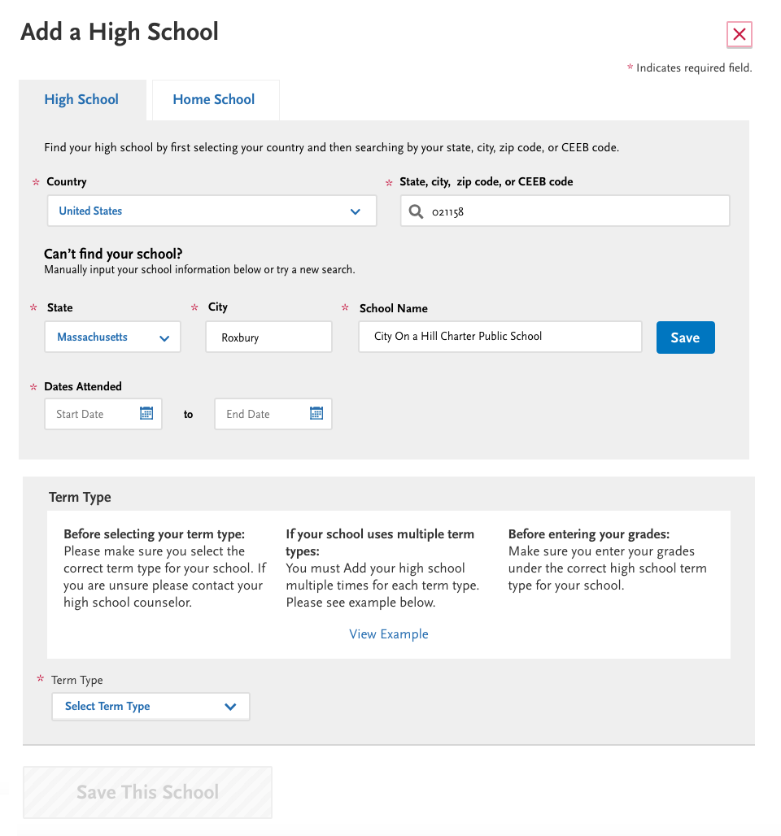

**9. Verification of Manually Entered School**

When applicants click Save on a manually entered school, a search will be conducted to see if a similar school exists in the HS lookup. A search will be conducted:

* First, a search will be run in the city the applicant entered.
* When there are no matches within the entered city, a search will be run within the state.

Any matches will be presented in a Verify Your School modal. Suggested schools will appear before the manually entered school. Note: more than one suggestion can appear in the modal.

If there are no suggested schools in the city or state, the modal won’t appear.

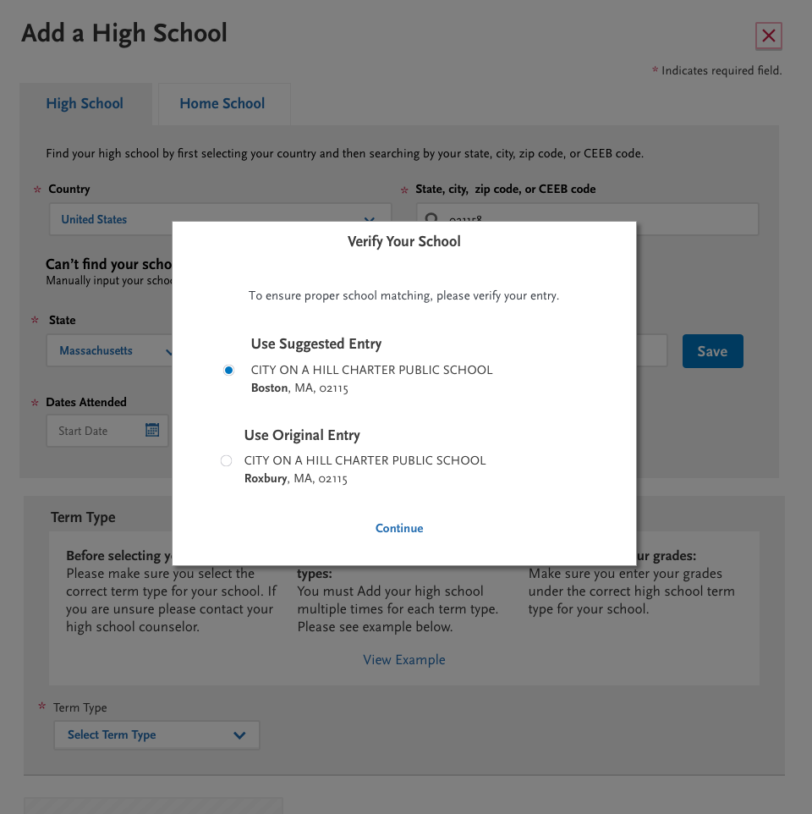

Once applicants select a suggested school from the Verify Your School modal, the state, city and school name fields will be updated.

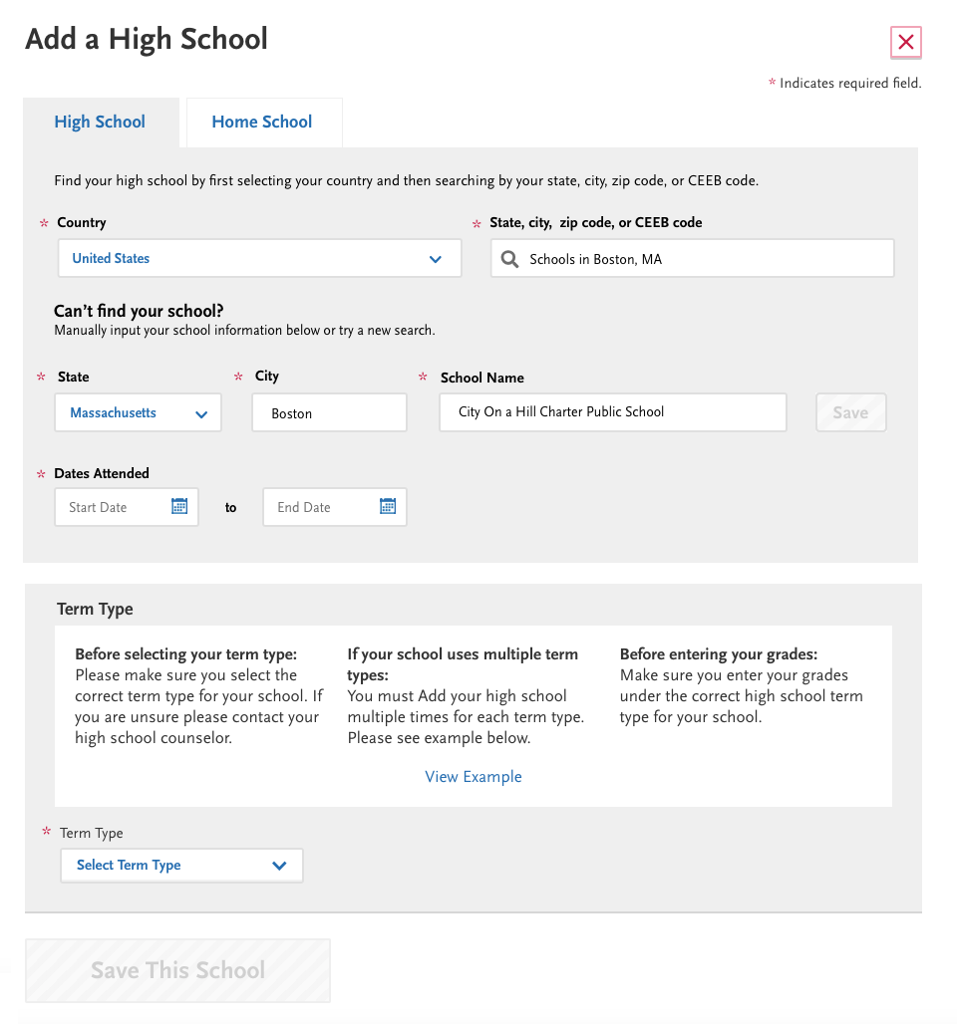

**10. Non-US Search**

For non-US high schools, applicants will limit their search first by country and then search by state, city, postal code or CEEB. Applicants can then select from search results or manually enter their school.

For all countries except the US, an option for “Can’t find your school?” will be displayed at the bottom of the search. This will allow applicants to manually enter a high school when there isn’t data for their country.

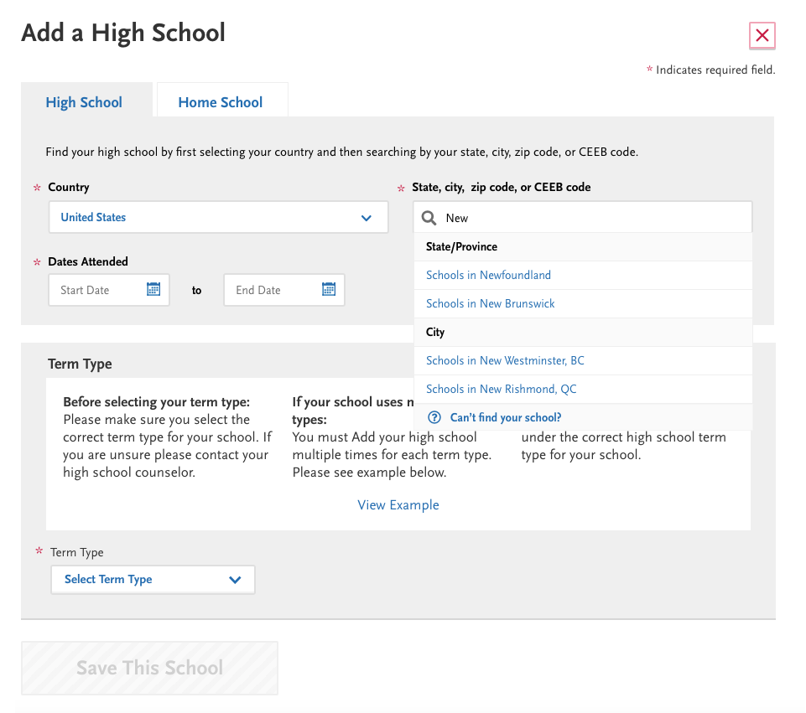

## 

**11. Editing a High School from High Schools Attended**

Users can edit their school by clicking the edit button from the High Schools Attended tile.

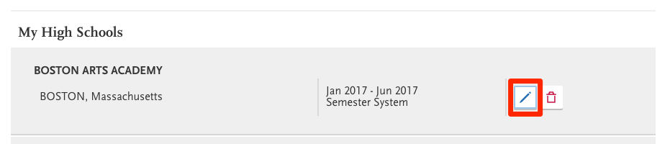

For high schools selected from search results, only Dates Attended and Term Type are editable after the high school is added. Fields (country and state/city/zip/CEEB) will be grayed out and HS can’t be deleted.

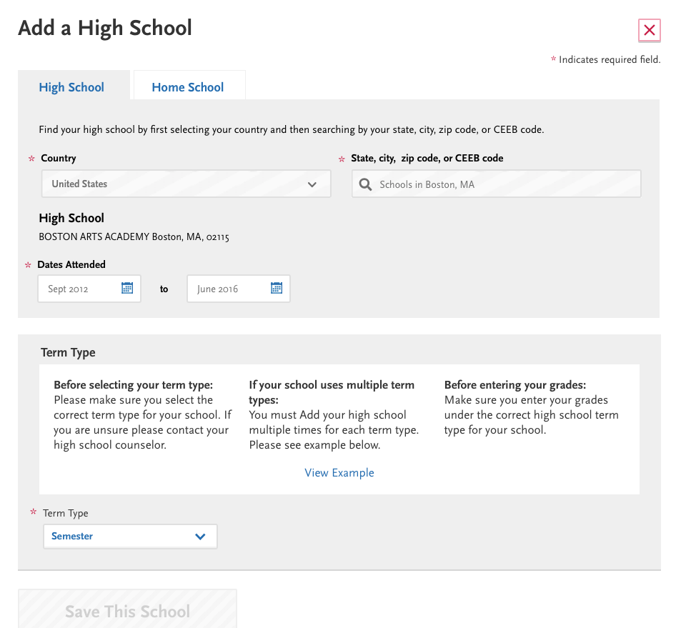

For manually entered high schools, only Dates Attended and Term Type are editable after the high school is added. All other fields will be grayed out.

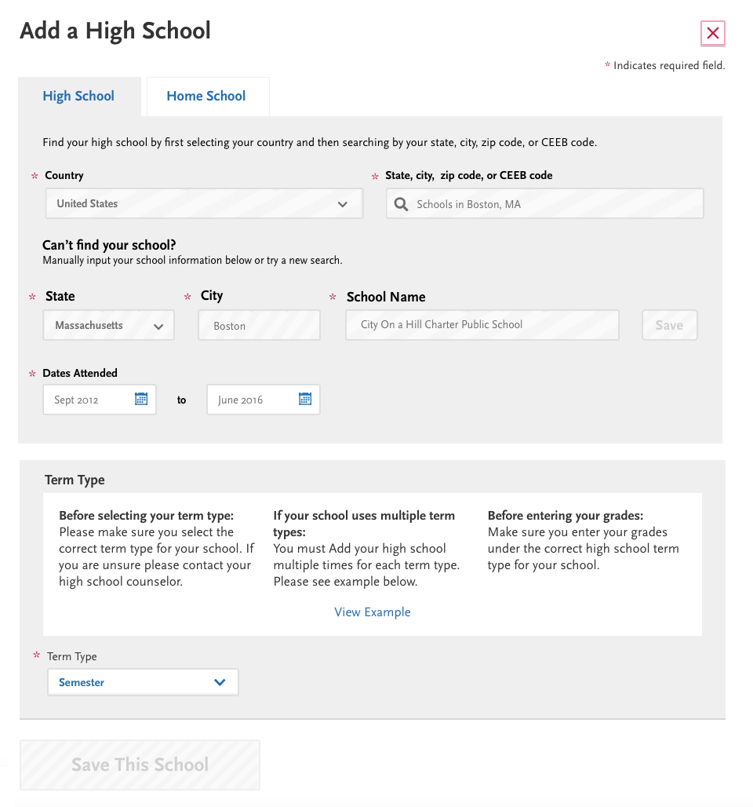

## Graduated Label on High School Attended tile

* Remove the Graduated label next to the high school name. This column that currently shows Graduated label will be removed from the tile.
* Note: this change will not impact Graduation Status – this data will still be collected and exported to WebAdMIT.

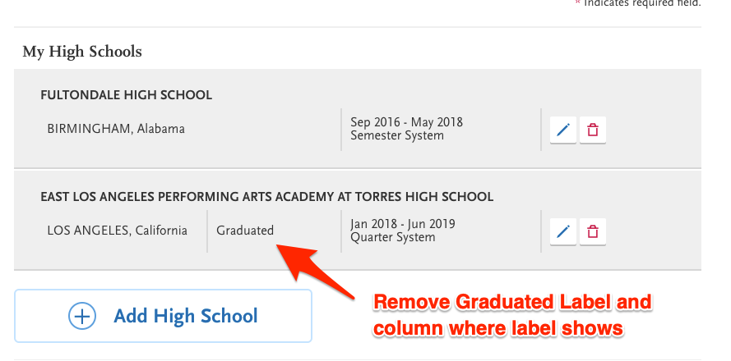

# Out of Scope

* Changes to WebAdMIT

# Tracking

This enhancement request is being tracked as [CS-233](https://liaison-intl.atlassian.net/browse/CS-233) for purposes of initial discovery, estimation, and prioritization.

# Applications Impacted

* Applicant Portal

# Non-Functional Requirements

Meets WCAG 2.0 Level AA compliance

# Cycles Impacted

Apply to the 2020-2021 (and future) Cal State Apply applications.

# Milestones/Time Criticality

Release for new cycle which launches on October 1, 2019