Caused by a SARS-COV-2 corona virus. First identified in Wuhan, Hubei, China. Earliest reported symptoms reported in November 2019. First cases were linked to contact with the Huanan Seafood Wholesale Market, which sold live animals. On 30 January the WHO declared the outbreak to be a Public Health Emergency of International Concern

here we uploaded the data of corona infected people from various countries from day to day in the form of the data representation feb to mar

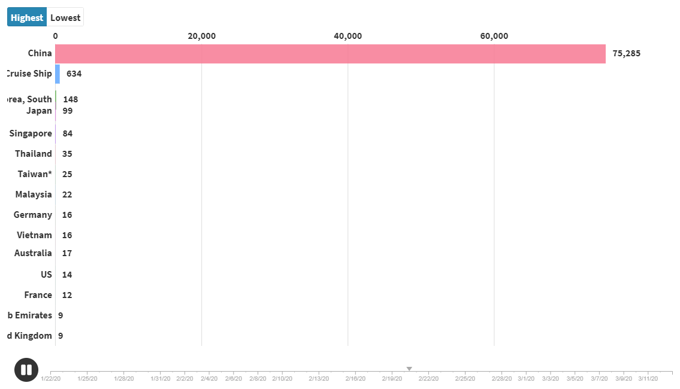

You can go through the link for the analysis review of the corona infercted people all over the world an exponential growth in the major countries like china , Italy and south korea.

Link :

<https://app.flourish.studio/story/217122/edit>