ANALYSIS OF ALGORITHMS (AOA)
PROJECT REPORT
Algorithm Analysis and Problem Solving Toolkit

Submitted by | Isha Kumawat
Roll No. | 24EJCCA087
Class/Section | CSAI (B section)
Subject | Analysis of Algorithms
Academic Year | 2026–27
Submission Deadline | 20 September 2026

Submitted as part of the academic requirements for the subject
Analysis of Algorithms

1. Introduction
This project presents an integrated Algorithm Analysis and Problem Solving Toolkit based on the algorithms covered in the supplied AOA laboratory material. The toolkit provides a menu-driven interface through which the user can execute sorting, graph, dynamic programming, greedy, and backtracking problems.

2. Objectives
- Implement the algorithms covered in the AOA laboratory experiments.
- Provide one menu-driven program instead of isolated executions.
- Understand the working and application of different algorithmic paradigms.
- Observe outputs for sorting, graph, optimization, and backtracking problems.
- Provide a reusable C++ implementation suitable for demonstration and viva.

3. Project Modules
Module | Algorithm | Concept | Purpose
1 | Quick Sort | Divide and Conquer | Sort an array using a pivot and recursive partitioning.
2 | Merge Sort | Divide and Conquer | Divide an array, recursively sort halves, and merge them.
3 | Topological Ordering | Graph / Indegree | Find a valid ordering of vertices of a DAG.
4 | Transitive Closure (Warshall) | Dynamic Programming | Determine reachability between vertex pairs.
5 | 0/1 Knapsack | Dynamic Programming | Maximize profit under a capacity constraint.
6 | Dijkstra | Greedy | Find shortest paths from one source with non-negative weights.
7 | Floyd | Dynamic Programming | Find shortest distances between every pair of vertices.
8 | Prim | Greedy | Construct a minimum-cost spanning tree.
9 | Kruskal | Greedy | Construct an MST by selecting edges in increasing weight order.
10 | Travelling Salesman Problem | Dynamic/Recursive formulation in supplied lab | Find a minimum-cost tour visiting every city once and returning to the start.
11 | N-Queens | Backtracking | Place N queens so that no two attack each other.

4. Algorithm Details

Quick Sort
Select a pivot, partition smaller elements before it and larger elements after it, then recursively process both subarrays.
Complexity: Best/Average: O(n log n); Worst: O(n²).

Merge Sort
Divide the array into two halves, recursively sort both halves, then merge the sorted halves.
Complexity: O(n log n).

Topological Ordering
Calculate indegrees, enqueue vertices with indegree 0, process them, and reduce the indegrees of adjacent vertices. If fewer than n vertices are processed, a cycle exists.
Complexity: O(V²) for the adjacency-matrix implementation.

Warshall
For every intermediate vertex k, update reachability from i to j when i can reach k and k can reach j.
Complexity: O(V³).

0/1 Knapsack
Build a DP table. For each item and capacity, choose the better of including or excluding the item when it fits.
Complexity: O(nW).

Dijkstra
Start the source at distance 0, repeatedly select the unvisited minimum-distance vertex, and relax its adjacent vertices.
Complexity: O(V²) with the matrix implementation.

Floyd
Use every vertex as an intermediate vertex and update every pair if the route through that vertex is shorter.
Complexity: O(V³).

Prim
Start from a vertex and repeatedly choose the minimum-weight edge joining a visited vertex to an unvisited vertex.
Complexity: O(V²) with the matrix implementation.

Kruskal
Sort all edges by weight and add an edge when it does not create a cycle, using disjoint-set operations.
Complexity: O(E log E) due to edge sorting.

TSP
The supplied lab material uses recursive exploration of unvisited cities, adds the return edge, and retains the minimum tour cost.
Complexity: O(n!) in the supplied recursive approach.

N-Queens
Place a queen row by row, checking column and diagonal safety. If no safe position exists, backtrack.
Complexity: Exponential/backtracking; exact running time depends on n.

5. Software and Hardware Requirements
Software: C++ compiler (g++/MinGW or an IDE such as Code::Blocks, Dev-C++, Visual Studio, or VS Code).
Operating system: Windows/Linux/macOS.
Hardware: Any standard computer capable of compiling C++ programs.

6. How to Run the Project
- Save the source file as AOA_Algorithm_Toolkit.cpp.
- Compile it using a C++ compiler. For example: g++ AOA_Algorithm_Toolkit.cpp -o aoa_toolkit
- Run the executable: ./aoa_toolkit on Linux/macOS or aoa_toolkit.exe on Windows.
- Select an option from 1–11 and enter the required input.
- Choose option 12 to exit.

7. Sample Test Cases
Module | Sample Input | Expected Output
Quick Sort | 5 | 50 20 10 40 30 | 10 20 30 40 50
Merge Sort | 38 27 43 3 9 82 10 | 3 9 10 27 38 43 82
Topological Ordering | Matrix from supplied experiment | 0 1 2 3 4 (one valid order)
0/1 Knapsack | Weights: 2,1,3,2,4; Profits: 12,10,20,15,18; Capacity: 7 | Maximum Profit = 47
Dijkstra | 5-vertex matrix; source 0 | Distances: 0, 10, 50, 30, 60
Floyd | 4-vertex weighted matrix | 0 5 8 9 / INF 0 3 4 / INF INF 0 1 / INF INF INF 0
Prim | 4-vertex matrix | Minimum Cost = 19
Kruskal | 4-vertex matrix | Minimum Cost = 19
TSP | 4-city matrix: 0 10 15 20 / 10 0 35 25 / 15 35 0 30 / 20 25 30 0 | Minimum Travelling Cost = 80
N-Queens | n = 4 | Two standard 4-Queens solutions are printed.

8. Program Output Evidence
The following pages show the verified Windows PowerShell outputs of the menu-driven AOA Algorithm Toolkit for the test cases used in this project.

1. Quick Sort
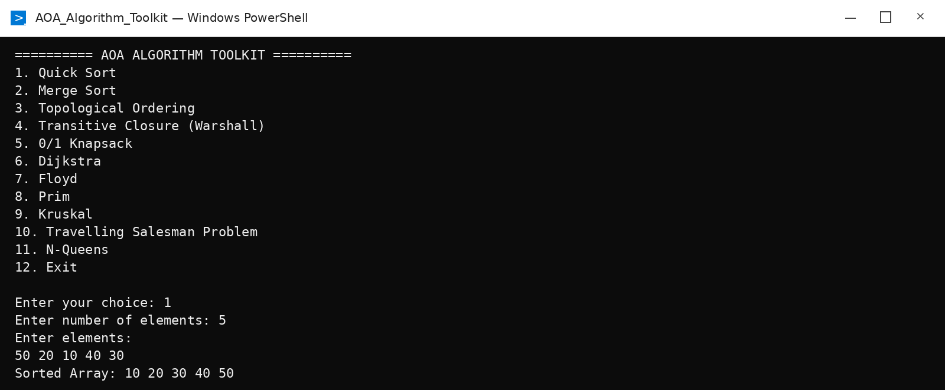

2. Merge Sort
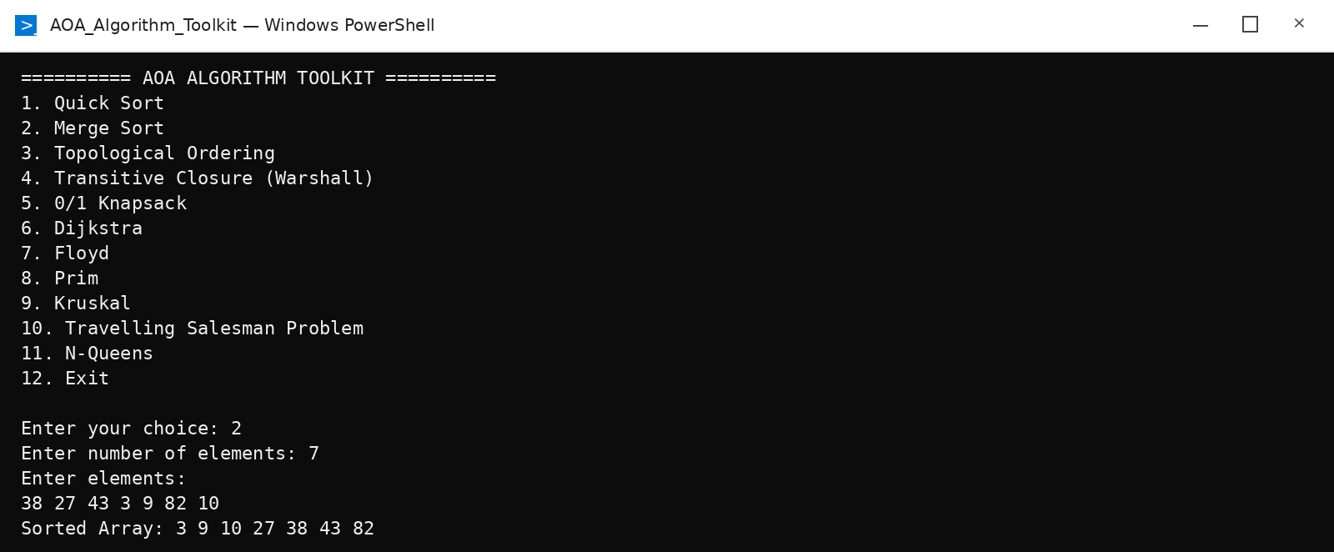

3. Topological Ordering
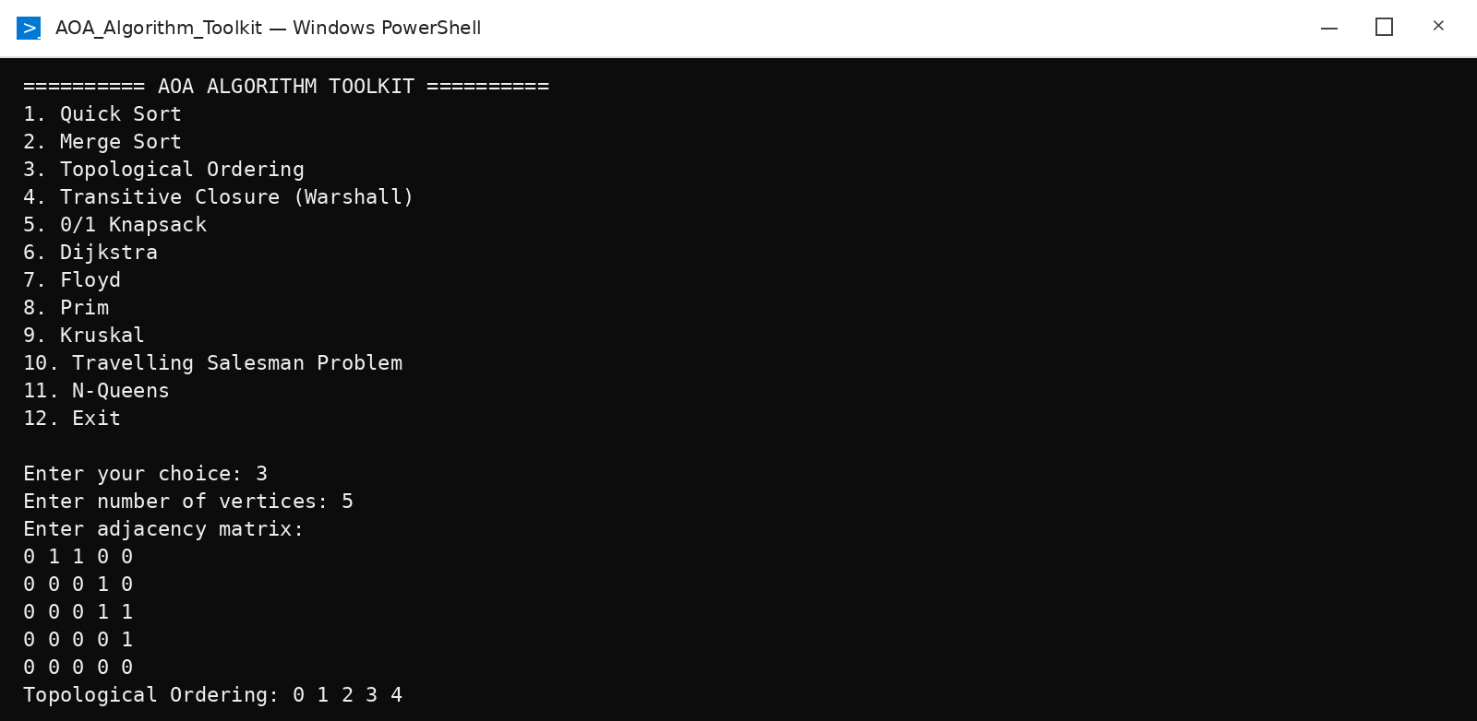

4. Transitive Closure (Warshall)
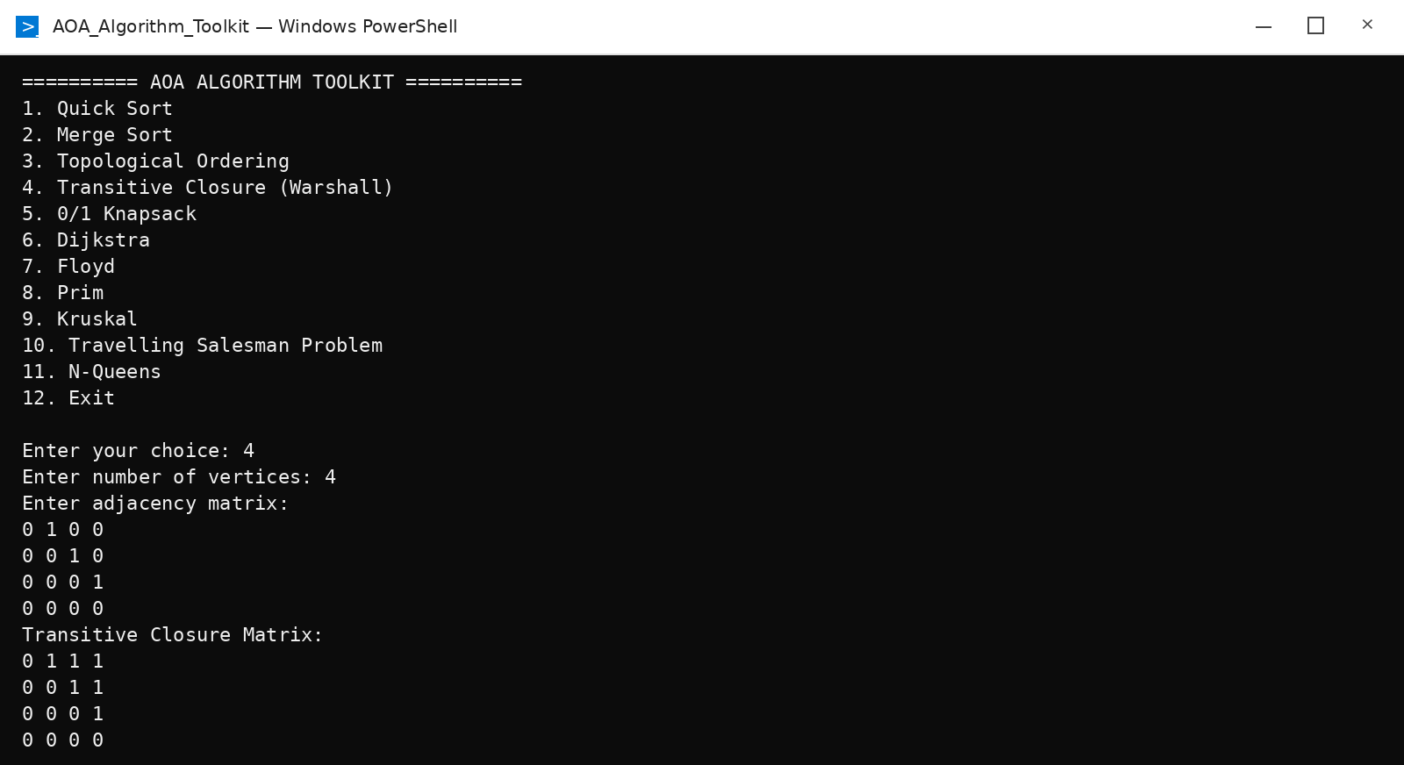

5. 0/1 Knapsack
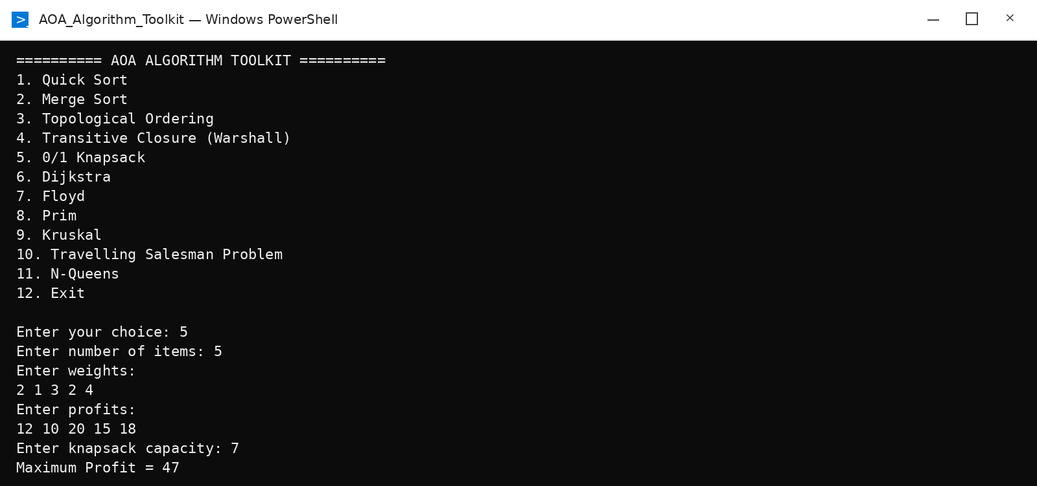

6. Dijkstra
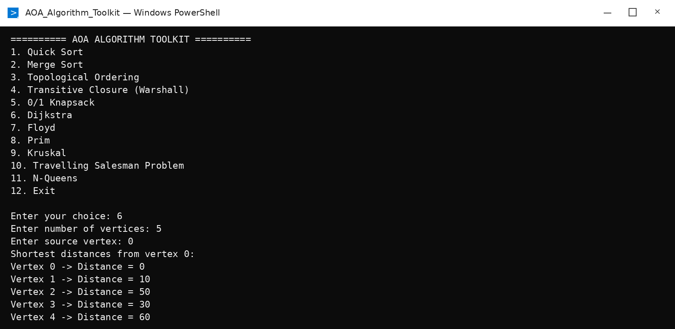

7. Floyd
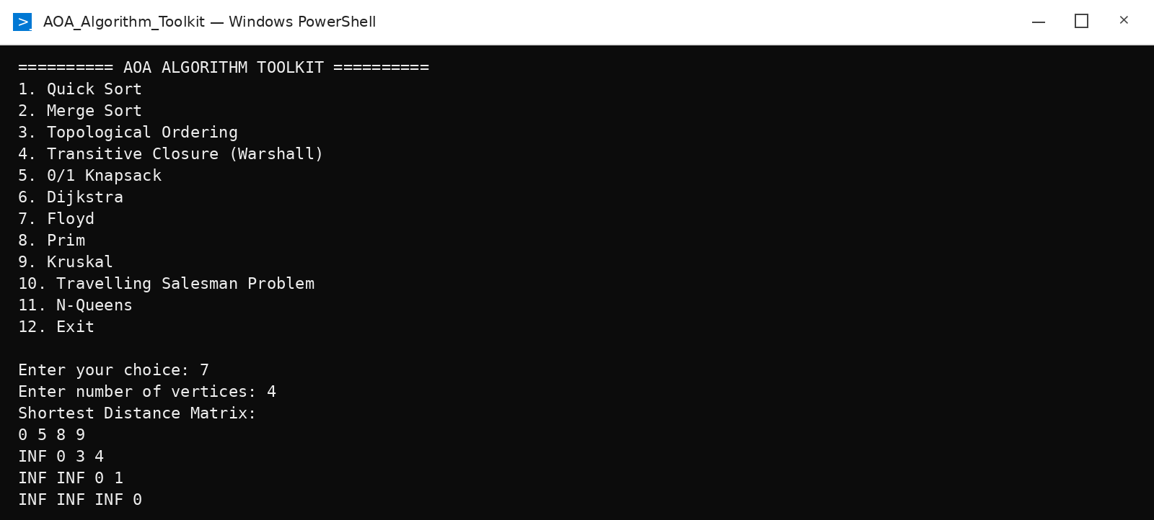

8. Prim
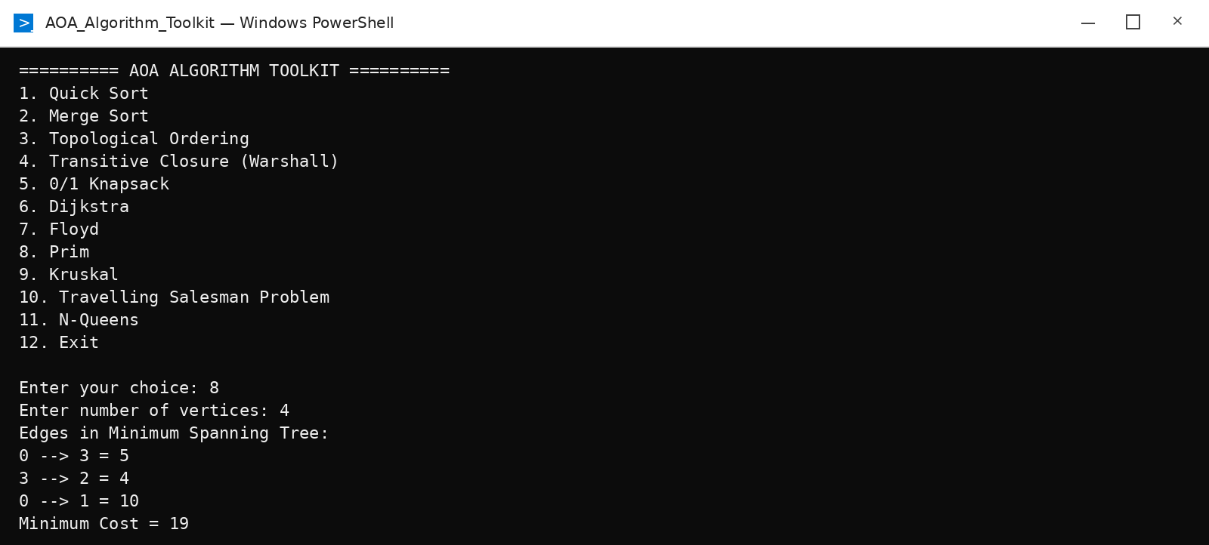

9. Kruskal
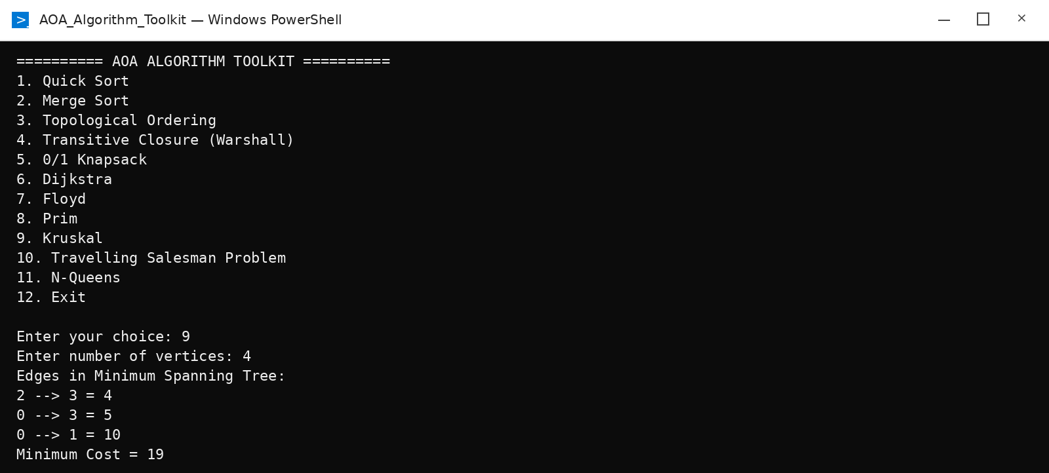

10. Travelling Salesman Problem
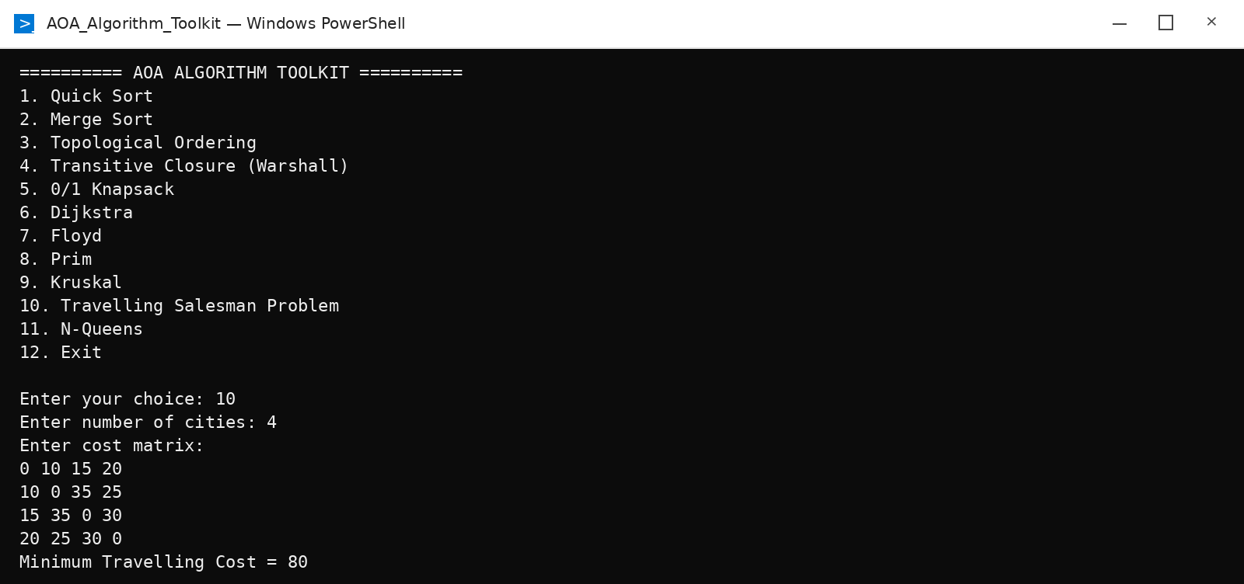

11. N-Queens
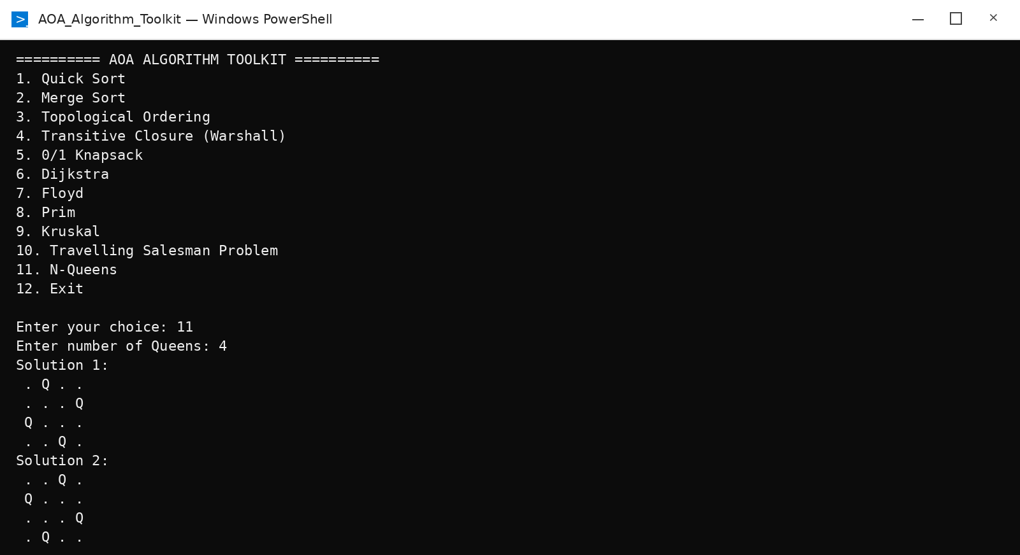

9. Conclusion
The project integrates the supplied AOA laboratory algorithms into a single menu-driven toolkit. It demonstrates multiple algorithmic paradigms—Divide and Conquer, Greedy methods, Dynamic Programming, Graph algorithms, and Backtracking—through executable C++ modules. The project can be extended later with graphical visualization, runtime comparison, and file-based input.

10. Viva Preparation – Important Questions
What is an algorithm?
A finite sequence of well-defined steps used to solve a problem.
What is Divide and Conquer?
Divide the problem into smaller subproblems, solve them recursively, and combine their results.
Quick Sort vs Merge Sort?
Quick Sort partitions around a pivot; Merge Sort divides into halves and merges sorted halves.
What is a DAG?
A Directed Acyclic Graph; topological ordering is possible only for a DAG.
What is indegree?
The number of incoming edges of a vertex.
What is Dynamic Programming?
A method that solves overlapping subproblems and stores their results to avoid repeated computation.
Dijkstra condition?
The supplied experiment specifies non-negative edge weights.
Dijkstra vs Floyd?
Dijkstra is single-source shortest path; Floyd computes shortest distances for every pair.
Prim vs Kruskal?
Prim grows an MST from visited vertices; Kruskal selects globally smallest edges while avoiding cycles.
What is backtracking?
A search technique that builds a solution step-by-step and reverses choices when a partial solution cannot lead to a valid solution.
What is N-Queens?
Place N queens on an N×N board with no shared row, column, or diagonal.

11. Note on Source Material
The project structure and algorithm descriptions are based on the supplied AOA experiment materials. The supplied TSP experiment labels its aim as Dynamic Programming but its provided program uses recursive enumeration with a visited array; this integrated project preserves that supplied approach rather than silently replacing it.

