**Selling and buying used books**

The app idea conditioned based on the demand for used books to cater the audience who are looking for different books. Bibliophiles who are looking for creating a space and want their precious books to find a new home, or the students who are looking for books to buy semester books and sell old books because they cannot carry books which might not come in use later and old book store owners.

For every idea, their is a requirement of extensive research

1. Target Audience Research
2. Competitors Analysis- strategy
3. Problem statement
4. Benefits for users
5. Wireframes

**Target Audience**

1. To understand Target audience, I will have to do

Primary research - asking questions to prospect users to have direct data of the target.

Secondary research- extracting insights from other sources.

In the process of defining the different types of users so as to solidify various features that we will be adding to the application, we create user personas based on questionnaires.

Questions

1. Name, Occupation, Marriage status.
2. Educational Background
3. Which are the more preferred books- old or new books or borrowed
4. Do you prefer to buy from stores or online?
5. Which online ecommerce sites do you prefer.Why do you like to shop from there only.
6. Which offline store do you prefer
7. What are your book choice mostly
8. What do you prefer: keeping the book you read as a memory or selling or donating to the person in need.
9. Have you ever used any bookstore app? Why do you like to shop from it?

Type of users I have listed out are Avid readers, Parents of school students and toddlers, Old book shop owners, College Students.

Users can be divided based on the mode of books buying and selling books and the type of books they like

I have created personas of target Users I might be targeting for the App.

User Personas

Avid readers

**Assumptions**

Name- Shweta

Age- 25

Location - Chandigarh

Occupation- MA English

Marriage status- Married

Goals- 1. Read 100 books in one year

Background- Shweta is a bibliophile. She has an MA english degree. Naturally She has read more than 500 books so far. She uses Amazon to buy books and her house is filled with books so whenever she gets time she feels like selling the old books. She goes to the old books market to sell the books and it is difficult to get a good price on the books. It depends on the store owner to name the price and she has to sell it because she went there to sell it and she cannot take them back home. And if she finds a good book there she buys from there at the same time.

Insights-

1. Amazon is trusted site to buy books
2. She goes with hedonic purchase

Persona 2

Name - Neeta

Age- 40

Location- Rajasthan

Occupation- Homemaker

Marriage Status- Married

Goals- 1. Good upbringing of kids

Background- Neeta is a mother to 2 boys. Her elder son is in 9th grade and younger is in 5th grade. She uses the books of elder son for younger son every time. But sometimes, the syllabus changes so she has to buy new books. There is no plan to keep old books at home. The only option she gets is to sell the books to kabadiwala because book stores offer very less selling price. She wishes there is a better option to sell the books.

Insights

1. Throwing the books for kabaddi vala
2. Market book store provide less selling price

Persona 3

Name- Aditya

Age- 17

Location- Punjab

Occupation- Student

Goals-1. Getting a good college

Background- Aditya is a commerce student. He is a good student. He has completed his senior secondary school this year and waiting for the results to start applying he knows he will get a good college. He wants to sell his commerce books and he is planning to buy CA books for studying during college period. He is planning to buy a second hand book because higher education books are expensive and he doesn't want to become a burden on his family

Persona 4

Name- Khwaab

Age- 35

Location- Chandigarh

Occupation- Bookstore owner

Background- Khwaab is a bookstore store owner in Chandigarh market. He has taken over his father’s bookstore. His daily footfall is 10 people avg per day. And 50 on peak days. He wants to expand the business.

Insights

1. Expansion of business

Persona 5

Name - Shine

Age- 22

Location- Indore

Occupation- college students

Background- Shine is an electrical engineering student. He usually buys the books and sells his books in the books market. Sometimes he cannot find the book in the market and in the library as wells. Then he has no option but to buy it from Amazon or a big store where no second hand books are available. Those months become financially difficult considering he is middle class and he has to travel everyday from home to college by bus.

Insights

1. He is in contact with a small books market.

Target age group - 15-45 years

Problem statement

Considering the above problems I will conclude my problem statement

*‘ People do not have access of books they need at affordable prices’*

**Mission**

To make all kinds of books available for everyone at any time. To help the students who can’t afford expensive new books, get used books which are in a readable condition and rated in the same manner. Make books accessible and affordable.

My competitors are

1. Bookchor
2. Olx
3. Reusebooks
4. Kitabay
5. Metrol- education app

After examining my competitors, i have come up with the following wireframes

I have used draw.io for the wireframes and exported the images here as jpeg files

App design

So it is a multi sided platform where there is a buy and a seller

A buyer

1. Will login and browse through the categories
2. Will search for the required book
3. Should be able to buy books.
4. Should get the package delivered on time.
5. Should be able to return the package if considered defected easily

A seller

1. Should be able to set an appealing ad.
2. Should be able to get the price which is deserved
3. Should get a good screen time in front of the buyer.

I have created a case diagram to give an overview of the system

I have added numbers to differentiate the paths from each other. The dotted lines are to depict the used cases through the used case.

I have made an assumption of using a logistic partner to pick up a book from the seller and checking given specifications and then tagging the product at the same time to be delivered to the buyer.

Here, there is a need for a small pickup and dispatch centre to have a continuous flow of work. Once the customer base improves, the need to have more logistics partners will increase.

**User Story**

Buyer

Step 1-Login and authentication

1. Create an account via google or facebook. You can also do a normal signup
2. Verify phone no. and email address
3. Give access for location
4. User is directed to the home page to search for the books.
5. User can choose the categories of books on the top or the screen

Step 2- feed

1. Search through the books
2. Tap on the book user desires.
3. Choose the seller
4. Check the profile of seller

Step 3- Payment

1. Add the book to cart or to wishlist
2. Check the address of the seller, give a call to the seller or email.
3. Use the payment mode to pay for the book and checkout
4. Once the payment is done you will get the notification
5. Seller will get a notification

Step 4- Get the parcel

Disclaimer- I am considering the price of books to be reduced based on the quality. The selling price shall be provided to the seller.

**Seller story**

Step 1- seller profile

1. Choose the option to sell from menu
2. Fill the details of book, edition, pages, binding etc
3. Upload MRP tag.
4. Upload 4 Images
5. Add description

Step 2- selling

1. Once an order is placed. User will get a notification
2. The offer can be rejected if the order is not valuable but it will debar the seller to sell for 4 months(Assumption).

Step3- Give the product

1. Give the product to the delivery guy to pick up the parcel and get it checked.
2. 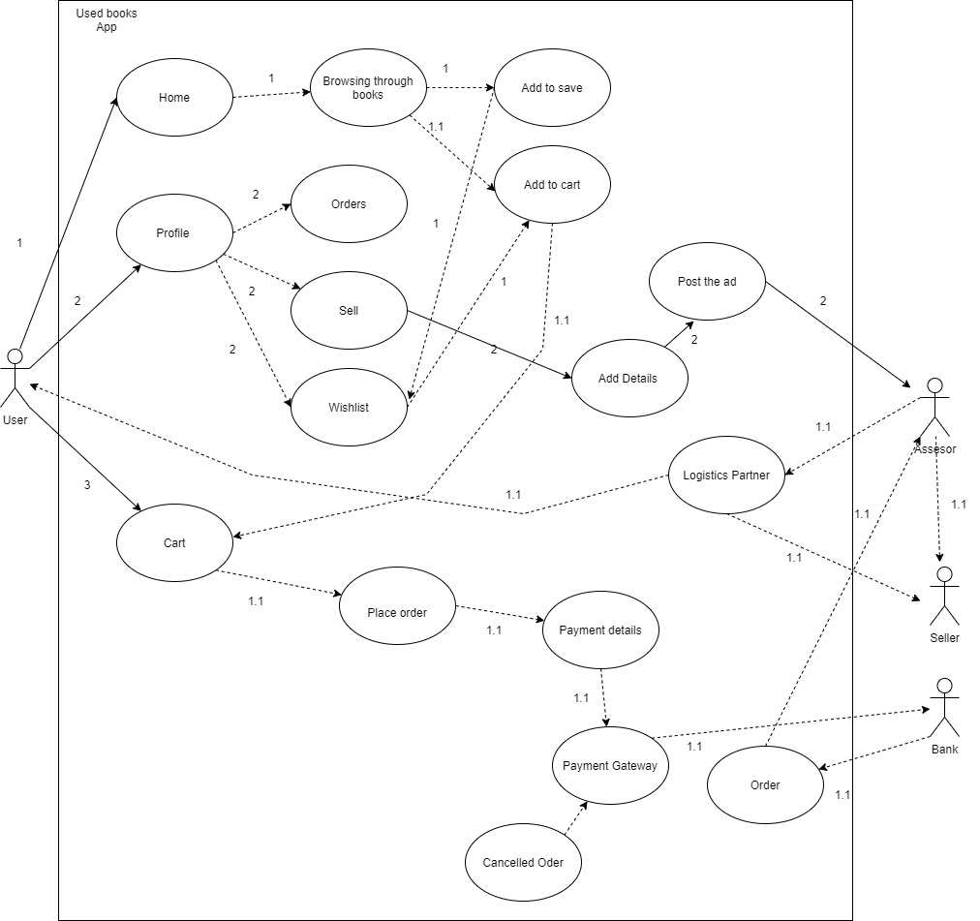Wait for the transfer of the amount.

Wireframes

Step 1 login and Authentication 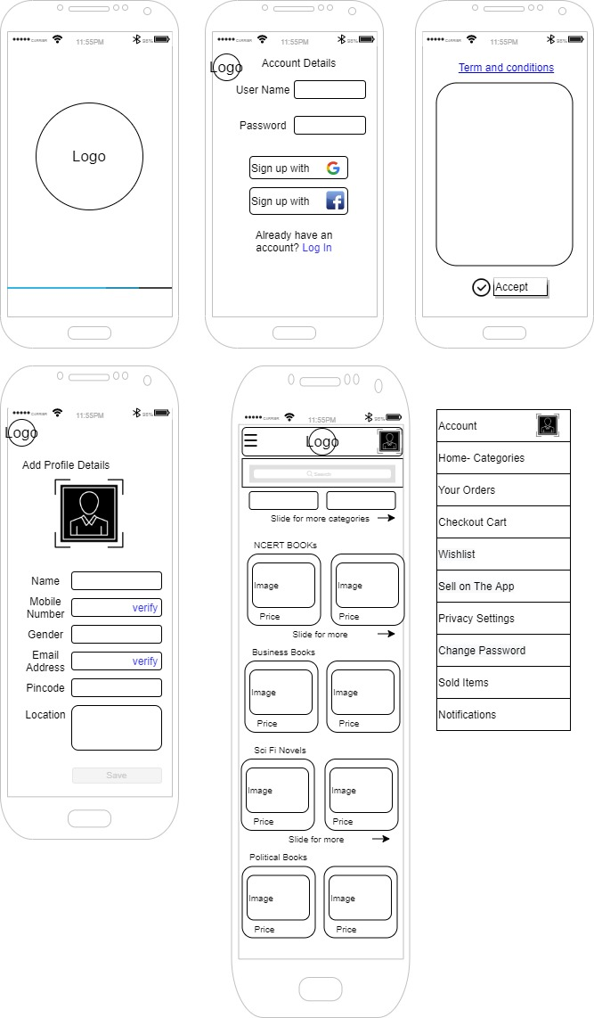

Step 2 onboarding

1.The profile section will ask questions that might not interest a user and it might bounce back the user. So there can be a skip option to go directly to the home screen and browse and once the desired book is found the user can fill in the detail when they have to checkout.

The categories will help the user to have more options.

2.We can also read the kind of books the user chooses so that we can recommend the books later to improve the chances of hedonics purchases.

3.The menu shall have contact information for the app customer care no.



Step3- Browsing

In browsing it is required that the user feel that everything is of their interest so that they don’t get bored. If the user is a student, the books shall be more related to their education

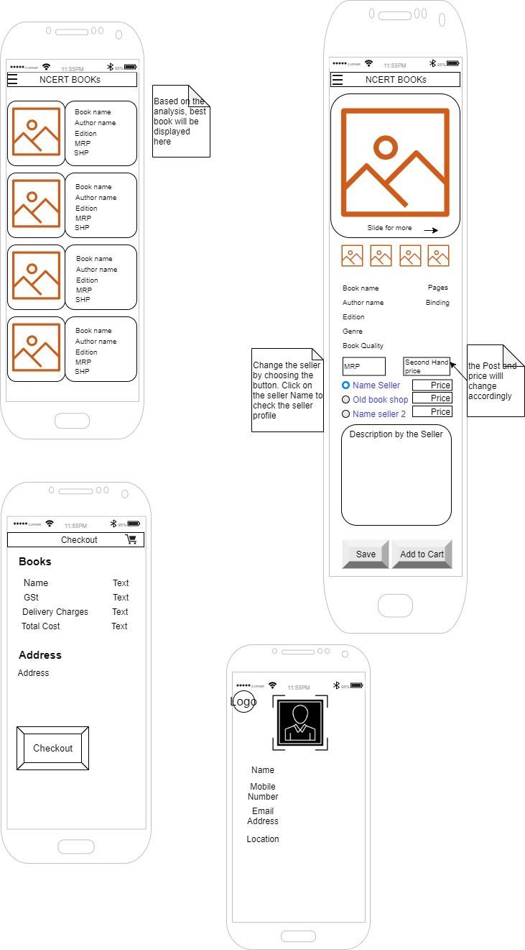

Step 4- Checkout

**Seller Side**

Step 1- Choosing selling from the menu. Step 2- Filling in details and posting the ad.

Seller should be able to make a good appealing ad post for attracting customers. So it is important to specify an image size for the seller to post clear photo.

Both Buyer and Seller shall be able to see orders in the Account section.

This app needs to be user friendly because it will cater to tier 2 tier 3 cities.

Seller should be able to make a good appealing ad post for attracting customers. So it is important to specify an image size for the seller to post clear photo.

Both Buyer and Seller shall be able to see orders in the Account section.

This app needs to be user friendly because it will cater to tier 2 tier 3 cities.

