ShopEZ Backend Web API using Microservices

Backend Technical Documentation
Batch Code: Batch 3
Submitted By:
Isha Landge
Under the Guidance of:
Narasimha Sir
Program:
Cognizant uGE_Dot Net FSD (Angular)

Acknowledgement
I would like to express my sincere gratitude to Narasimha Sir for his continuous guidance, encouragement, and support throughout the development of the ShopEZ Backend Application.
His valuable mentoring and technical insights helped me understand the concepts of ASP.NET Core Web API, Microservices Architecture, JWT Authentication, API Gateway, and Backend Testing in a practical manner.
I would also like to thank Cognizant uGE_Dot Net FSD (Angular) Program for providing the learning platform and technical resources required for completing this project successfully.
I am equally thankful to all open-source contributors whose tools, frameworks, libraries, and documentation played an important role in the successful implementation of this project.
Finally, I express my gratitude to everyone who directly or indirectly supported me during the development and testing of this application.

Abstract
The ShopEZ Backend Web API using Microservices is a distributed backend application developed using ASP.NET Core Web API and Microservices Architecture to provide a scalable, secure, and modular e-commerce backend system.
The application consists of independently deployable microservices including:
- Auth Service
- Product Service
- Order Service
- API Gateway using Ocelot
The system implements:
- JWT Authentication
- Role-Based Authorization
- Product Management
- Order Management
- API Gateway Routing
- Microservice Communication
The backend uses:
- Entity Framework Core
- Dapper ORM
- SQL Server
- Swagger
- Postman
- xUnit Testing
- Moq Mocking Framework
The project follows a service-oriented architecture where each microservice handles specific business responsibilities independently, improving scalability, maintainability, fault isolation, and deployment flexibility compared to traditional monolithic systems.
Comprehensive API testing and backend unit testing were performed to validate:
- Authentication workflows
- Product CRUD operations
- Order processing
- Authorization control
- Stock management
- Exception handling
- Microservice communication
The project successfully demonstrates the implementation of a modern secure e-commerce backend system using microservices architecture.

Table of Contents
- Introduction
- Problem Statement – Issues in Existing System
- Proposed System
3.1 Auth Service
3.2 Product Service
3.3 Order Service
3.4 API Gateway
- Tech Stack Details
- Setup & Prerequisites
5.1 SQL Server Connection
5.2 Project Running Validation
- Database Design
6.1 Users Table
6.2 Orders Table
6.3 OrderItems Table
6.4 Products Table
- System Design
7.1 Overall Architecture Diagram
- Auth Service API Testing
8.1 User Registration
8.2 User Login
8.3 Admin Login
8.4 Change User Role
8.5 Get User Profile
8.6 Get All Users
- Product Service API Testing
9.1 Create Product
9.2 Get All Products
9.3 Get Product By ID
9.4 Update Product
9.5 Delete Product
9.6 Reduce Product Stock
9.7 Restore Product Stock
- Order Service API Testing
10.1 Create Order
10.2 Insufficient Stock Validation
10.3 Get Order By ID
10.4 Invalid Order ID Validation
10.5 My Orders
10.6 Get All Orders
10.7 Delete Order
10.8 User Cancel Own Order
- Ocelot API Gateway Configuration
- xUnit Testing and Mocking
12.1 Product Service Testing
12.2 Order Service Testing
12.3 Authentication Service Testing
12.4 Overall Backend Testing Summary
- Authorization Matrix
- Dockerization & Containerization
- Conclusion
- Future Scope

Project Overview
ShopEZ is a full-stack microservices-based e-commerce platform developed for luxury home décor products. The backend system is designed using ASP.NET Core Web API and Microservices Architecture to provide scalability, modularity, and secure API communication.
The application consists of three independent backend microservices — Auth Service, Product Service, and Order Service — integrated through an Ocelot API Gateway. All APIs are secured using JWT Bearer Authentication with Role-Based Authorization to differentiate Admin and Customer access levels.
MicroServices | Port | Responsibility
API Gateway (Ocelot) | 7070 | Request routing, authentication middleware, unified API access
Auth Service | 7182 | User registration, login, JWT generation, role management
Product Service | 7210 | Product CRUD operations, inventory management, stock control
Order Service | 7238 | Order placement, order retrieval, cancellation, order management

1. Introduction
The E-Commerce Microservices Backend System is a distributed backend application developed using ASP.NET Core Web API and Microservices Architecture. The project is designed to provide secure authentication, product management, and order processing functionalities through independently deployable microservices.
The system follows a service-oriented architecture where each microservice handles a specific business responsibility. Communication between the client and backend services is managed through an API Gateway.
The backend consists of:
- Auth Service (Dapper)
- Product Service (Entity Framework Core)
- Order Service (Entity Framework Core)
- API Gateway (Ocelot)
The application uses JWT Authentication and Role-Based Authorization to secure APIs and manage access control.

2. Problem Statement – Issues in Existing System
Traditional monolithic e-commerce applications face multiple challenges as the system grows.

Issues in Existing System
- Tight Coupling
All functionalities are connected in a single application, making development and maintenance difficult.
- Difficult Deployment
Even small modifications require redeploying the complete application.
- Scalability Problems
The entire application must scale together even if only one module experiences high traffic.
- Reduced Maintainability
Large codebases become difficult to debug and manage.
- Poor Fault Isolation
Failure in one module may affect the entire application.
- Limited Technology Flexibility
Using different technologies for different modules becomes difficult.

3. Proposed System
The proposed system uses Microservices Architecture where each service is independently developed

Microservices Included

1. Auth Service
Responsible for:
The Auth Service handles:
- User Registration
- User Login
- JWT Token Generation
- Role Management
- Users Profile Retrieval
Technology Used:
- ASP.NET Core Web API
- Dapper
- SQL Server

2. Product Service
Responsible for:
The Product Service handles:
- Product Management
- Product CRUD Operations
- Stock Management
- Product Retrieval
Technology Used:
- ASP.NET Core Web API
- Entity Framework Core
- SQL Server

3. Order Service
Responsible for:
• Order Creation
• Order Retrieval
• Order Cancellation
• Order Management
Technology Used:
- ASP.NET Core Web API
- Entity Framework Core
- SQL Server

4. API Gateway
Acts as the centralized entry point for all APIs.
Responsibilities:
- Request Routing
- Authentication Validation
- Service Communication
- Endpoint Exposure
Technology Used:
- Ocelot API Gateway

4 Tech Stack
Technology | Purpose
ASP.NET Core Web API | Backend Development
C# | Programming Language
SQL Server | Database
Entity Framework Core | ORM for Product & Order Services
Dapper | Lightweight ORM for Auth Service
JWT Authentication | Secure Authentication
Ocelot | API Gateway
Docker | Containerization
Docker Compose | Multi-container Orchestration
Swagger | API Documentation
Postman | API Testing
Git & GitHub | Version Control
Visual Studio 2022 | IDE
Microservices Architecture | Distributed Backend Design

The project includes:
- Secure JWT Authentication
- Product Management
- Order Processing
- API Gateway Routing
- Role-Based Authorization
- Microservices Communication
The system provides better scalability, maintainability, and modularity compared to monolithic architecture. Setup & Prerequisites
  - SQL Server Connection Before initiating any API tests: the SQL Server connection must be established. The connection string in the project configuration should reference the correct server name. Failure to establish this connection will result in all database-related endpoints being unavailable.

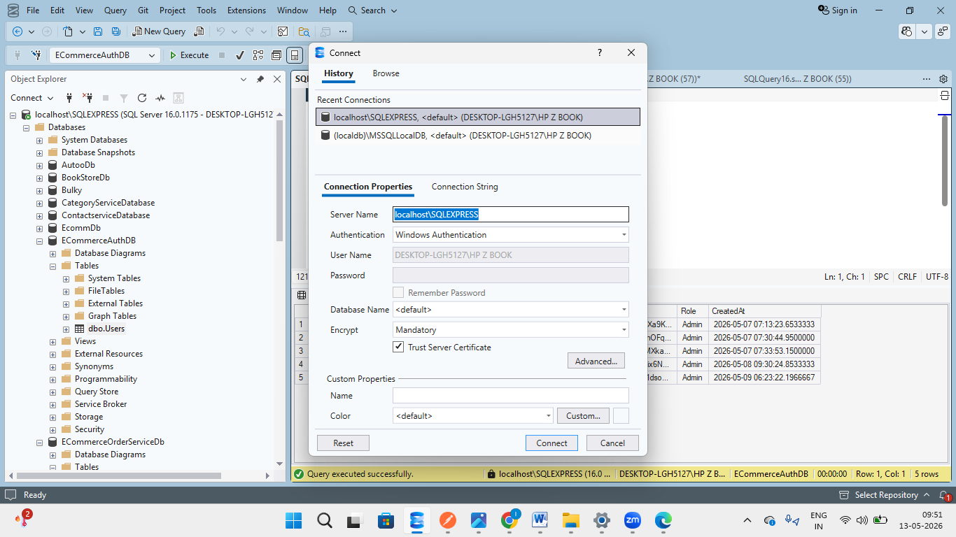
Figure1.1— SQL Server connection configured successfully.
  - Project Not Running — Common Pre-Test Error A frequent mistake during testing is attempting to call API endpoints while the application is not running. If the project has not been started in Visual Studio (or the equivalent IDE), Postman will return a connection-refused error. Always ensure the project is running before executing any requests.

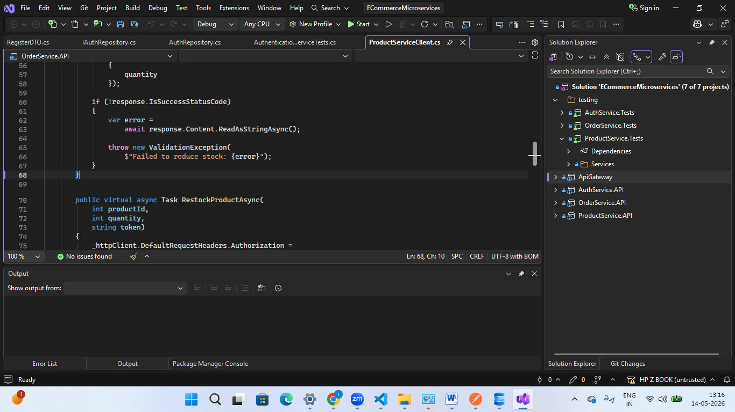

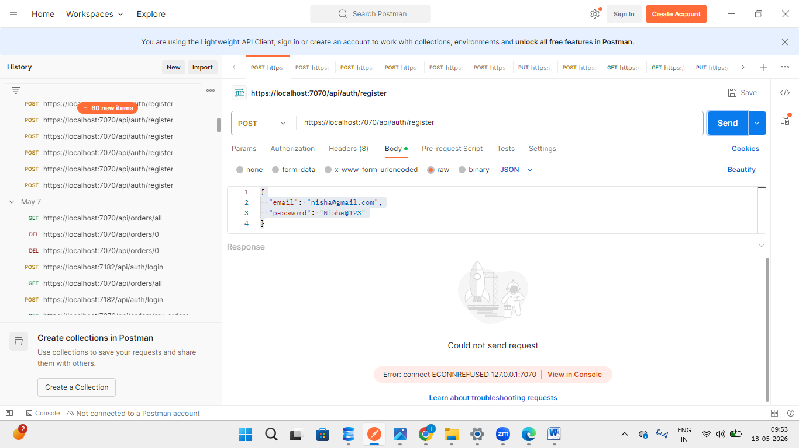
Figure1.2 — Error observed when the project is not running and Postman tries to reach an endpoint

My SQL Table Structure :

Users Table
The Users table stores all registered users of the application. Whenever a new user registers through the Auth Service, the user details are inserted into this table. The stored data is later used for authentication, authorization, and profile management during login and other secured operations.
This table is managed by the Auth Service using Dapper ORM and SQL Server.

Purpose of Users Table
The Users table is responsible for:
- Storing registered user information
- Managing authentication details
- Supporting JWT-based login functionality
- Managing user roles (Admin/User)
- Controlling role-based authorization

Columns in Users Table
Column Name | Description
Id | Primary Key of the user table. Each user is assigned a unique ID automatically.
Email | Stores the registered email address of the user. This email is used during login authentication.
PasswordHash | Stores the hashed version of the user's password for security purposes. Plain text passwords are never stored in the database.
Role | Defines the role of the user such as Admin or User.
CreatedAt | Stores the date and time when the user account was created.

Role Management
Initially, there is only one Admin user in the system:
ishalandge234@gmail.com
The Admin has special privileges such as:
- Promoting users to Admin role
- Demoting Admins back to User role
- Managing system-level operations
All newly registered users are assigned the User role by default.

Security Implementation
To improve security:
- Passwords are stored as hashed values using password hashing algorithms.
- Plain text passwords are never saved in the database.
- JWT Authentication is used after successful login.
- Role-based authorization is implemented to restrict access to protected endpoints.

Database Screenshot
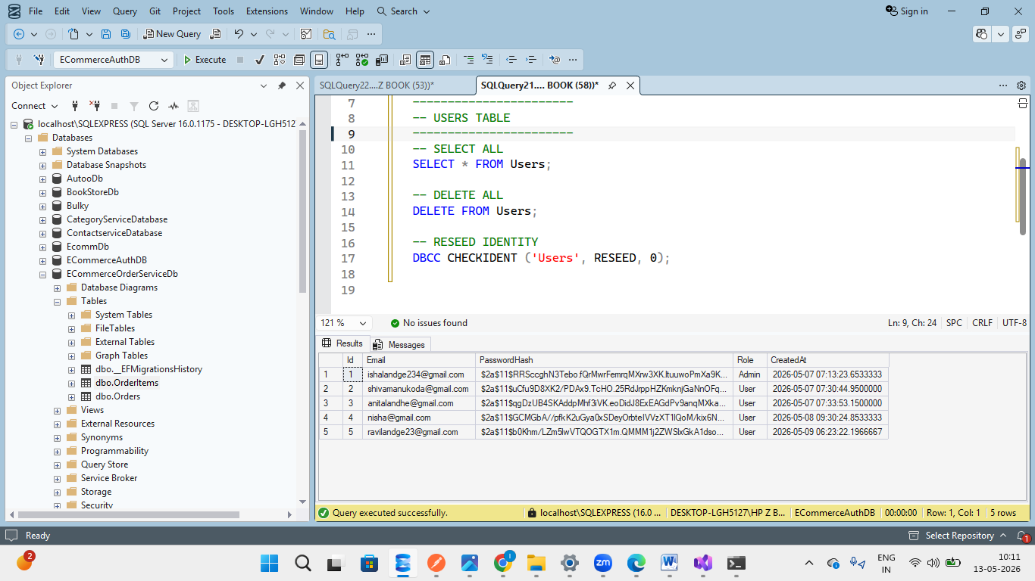
Figure: Users table in ECommerceAuthDB database showing registered users and roles.

OrderItems Table
The OrderItems table stores the detailed information of products associated with each order placed by customers. Whenever a customer places an order, the ordered products along with their quantity and pricing details are stored in this table.
This table acts as a bridge between the Orders table and the Products table, helping maintain a proper relationship between orders and products in the system.
The table is managed by the Order Service using Entity Framework Core and SQL Server.

Purpose of OrderItems Table
The OrderItems table is responsible for:
- Storing products included in each order
- Maintaining quantity information for ordered products
- Preserving product price at the time of purchase
- Supporting order history functionality
- Creating relationship between Orders and Products

Columns in OrderItems Table
Column Name | Description
OrderItemId | Primary Key of the OrderItems table. Each order item is assigned a unique ID automatically.
OrderId | Foreign Key referencing the Orders table. Identifies which order the product belongs to.
ProductId | Foreign Key referencing the Products table. Identifies the ordered product.
ProductName | Stores the name of the product at the time the order was placed.
UnitPrice | Stores the price of a single product unit during the order.
Quantity | Stores the quantity of the product ordered by the customer.

Relationship Management
The OrderItems table maintains relationships between:
- Orders Table
- Products Table
One Order can contain multiple products, therefore:
- One-to-Many relationship exists between Orders and OrderItems.
- One Product can appear in multiple orders.

Business Logic Implemented

Snapshot Pricing
The UnitPrice is stored separately in the OrderItems table so that future product price changes do not affect old orders.
Example:
If a product price changes from ₹24,999 to ₹29,999, previously placed orders will still show the original purchase price.

Quantity Tracking
The Quantity column helps track how many units of a product were purchased in a particular order.

Order History
The table helps generate complete order history for customers and admins.

Security & Data Integrity
To maintain data consistency:
- Foreign key relationships are used.
- Product IDs must exist in the Products table.
- Order IDs must exist in the Orders table.
- Quantity validation is performed before creating an order.

Database Screenshot
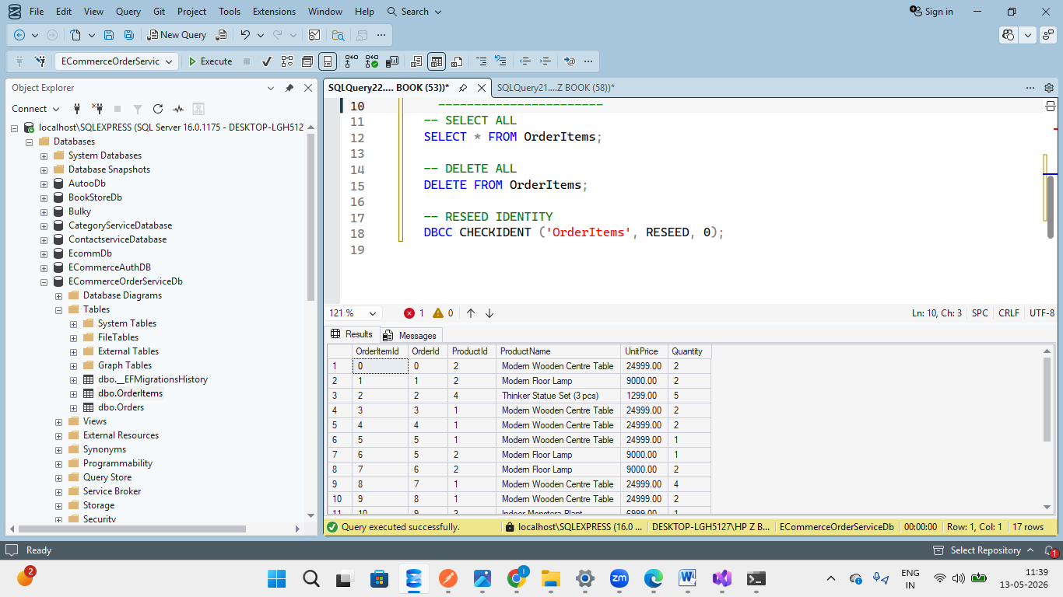
Figure: OrderItems table in EcommerceOrderServiceDb showing products associated with customer orders.

Orders Table
The Orders table stores all order-related information generated when customers place orders in the application. Every successful order created through the Order Service is stored in this table along with details such as the user who placed the order, total order amount, order status, and order date.
This table acts as the main transactional table for the order management system.
The table is managed by the Order Service using Entity Framework Core and SQL Server.

Purpose of Orders Table
The Orders table is responsible for:
- Storing customer order information
- Tracking order status
- Maintaining order history
- Managing order cancellation
- Supporting customer and admin order retrieval
- Maintaining transactional records

Columns in Orders Table
Column Name | Description
OrderId | Primary Key of the Orders table. Each order is assigned a unique ID automatically.
UserId | Stores the ID of the user who placed the order.
OrderDate | Stores the date and time when the order was placed.
TotalAmount | Stores the total amount of the order calculated from all ordered products.
IsDeleted | Indicates whether the order is soft deleted or active.
Status | Represents the current status of the order such as Order Placed or Cancelled.

Business Logic Implemented

Order Creation
Whenever a customer places an order:
- Order details are saved in the Orders table.
- Corresponding products are stored in the OrderItems table.
- Product stock is reduced automatically.

Total Amount Calculation
The TotalAmount field is automatically calculated based on:
TotalAmount = UnitPrice × Quantity
for all products included in the order.

Order Cancellation
Customers or Admins can cancel orders using:
PUT /api/orders/{id}/cancel
When an order is cancelled:
- Order status changes to "Cancelled"
- Product stock may be restored
- Order history remains preserved

Soft Delete Functionality
The IsDeleted column is used for soft delete implementation.
Values:
- 0 → Active Order
- 1 → Deleted Order
This approach helps preserve order history instead of permanently removing records from the database.

Relationship Management
The Orders table has relationships with:
- Users Table
- OrderItems Table
Relationships:
- One User can place multiple Orders.
- One Order can contain multiple OrderItems.

Security & Data Integrity
To maintain data consistency:
- UserId must exist in the Users table.
- Orders cannot be created with invalid products.
- Stock validation is performed before order creation.
- JWT authentication is required for placing orders.

Database Screenshot
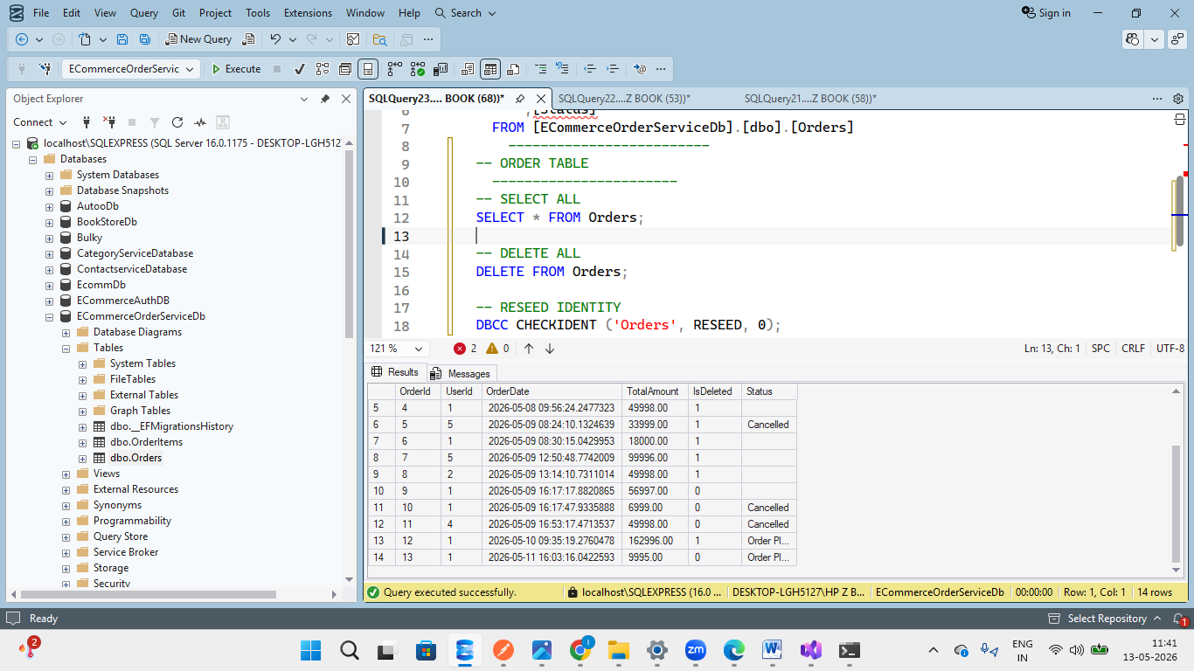
Figure: Orders table in EcommerceOrderServiceDb showing customer orders and their statuses.

Products Table
The Products table stores all product-related information available in the e-commerce application. Every product displayed to customers is maintained in this table along with details such as product name, description, pricing, stock quantity, category, and image path.
This table is managed by the Product Service using Entity Framework Core and SQL Server.
The Product Service handles all CRUD operations related to products including adding, updating, deleting, restocking, and retrieving products.

Purpose of Products Table
The Products table is responsible for:
- Storing product information
- Managing product inventory
- Maintaining stock availability
- Supporting product search and retrieval
- Categorizing products
- Managing product images
- Supporting admin product management operations

Columns in Products Table
Column Name | Description
Id | Primary Key of the Products table. Each product is assigned a unique ID automatically.
Name | Stores the name of the product.
Description | Stores detailed information about the product.
Price | Stores the selling price of the product.
Stock | Stores the available quantity of the product.
IsDeleted | Indicates whether the product is active or soft deleted.
CreatedAt | Stores the date and time when the product was created.
UpdatedAt | Stores the latest update timestamp for the product.
ImageUrl | Stores the image path or image URL of the product.
Category | Stores the category to which the product belongs.
Product Categories
Products are organized into categories for easier product management and customer browsing.
Example Categories:
- Furniture
- Lighting
- Decorative Items
- Kitchen & Dining
- Planters

Business Logic Implemented

Product Creation
Admins can add new products using:
POST /api/products
Only users with Admin role are authorized to perform this operation.

Product Update
Admins can update existing products using:
PUT /api/products/{id}
The UpdatedAt field is automatically updated whenever product details are modified.

Product Deletion
Products are managed using soft delete functionality.
Instead of permanently deleting product data:
- IsDeleted = 1 indicates deleted product
- IsDeleted = 0 indicates active product
This helps preserve historical order records.

Stock Management
The Product Service provides stock management APIs:

Reduce Stock
PUT /api/products/{id}/stock/reduce
Used during order placement to reduce available inventory.

Restock Product
PUT /api/products/{id}/stock/restock
Used by Admins to increase product inventory.

Relationship Management
The Products table is connected with:
- OrderItems Table
Relationship:
- One Product can appear in multiple order items.
- Product information is referenced during order creation.

Security & Authorization
The following security measures are implemented:
- Only Admin users can add, update, delete, or restock products.
- JWT Authentication is required for protected product APIs.
- Role-Based Authorization restricts unauthorized access

Database Screenshot
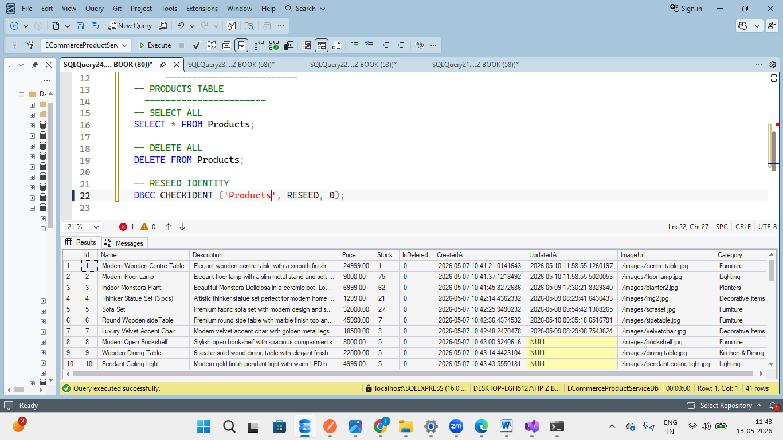
Figure: Products table in EcommerceProductServiceDb showing product details, stock information, and categories.

5. System Design

5.1 Overall Architecture Diagram
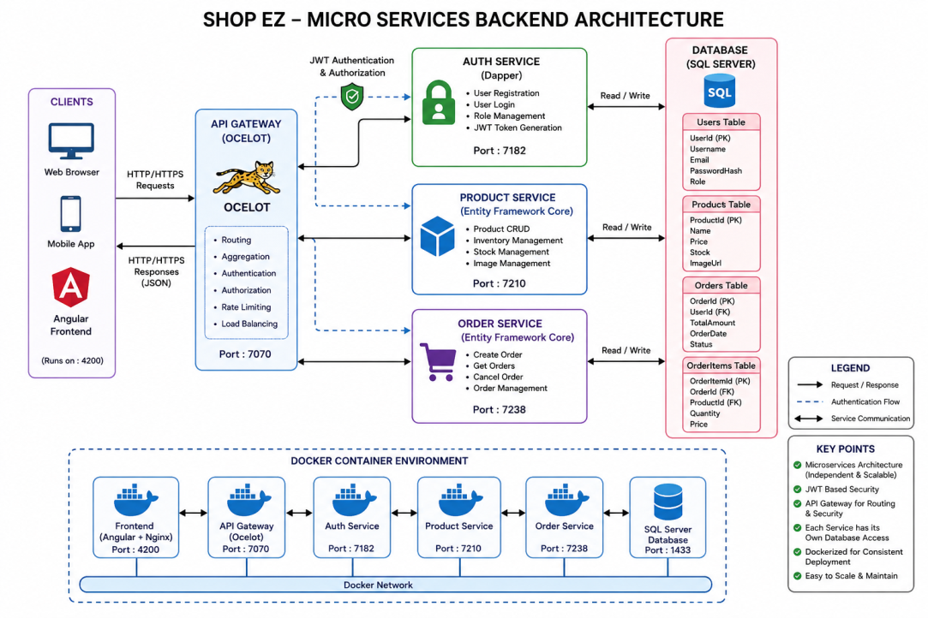

My Postman Testing for every Service :
Auth Service
The Auth Service is responsible for user authentication, JWT token generation, profile management, and role-based authorization. All API test cases were executed using Postman through the API Gateway endpoint.
Both successful and unsuccessful test scenarios were validated to ensure proper authentication flow, security implementation, validation handling, and correct HTTP response codes.

Authentication Flow
User Login
|
v
API Gateway
|
v
Auth Service
|
Validate Credentials
|
Generate JWT Token
|
Return JWT Token
|
Frontend Stores Token

For Auth Service : Swagger Endpoints:
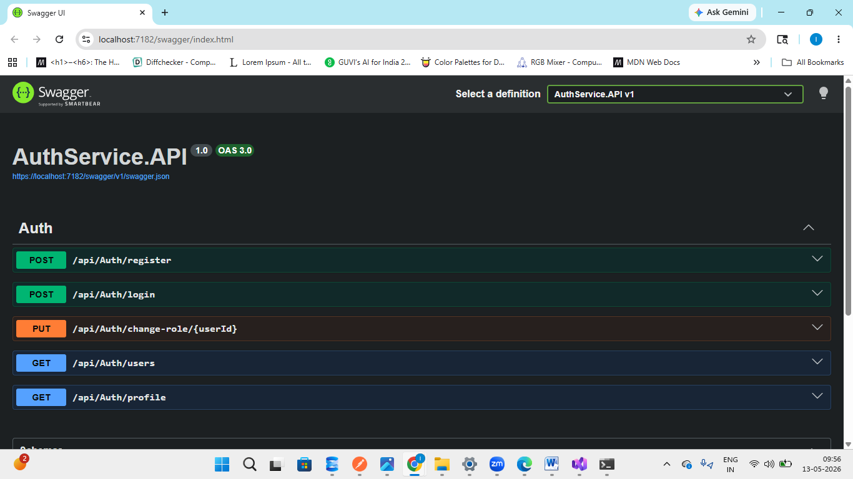
User registration:
Method | Endpoint | Description | Access
POST | /api/Auth/register | Register new user | Public

1) User Registration
A new user account is created by submitting a valid email and password through the registration endpoint. During registration, the password is securely hashed using BCrypt before being stored in the database.

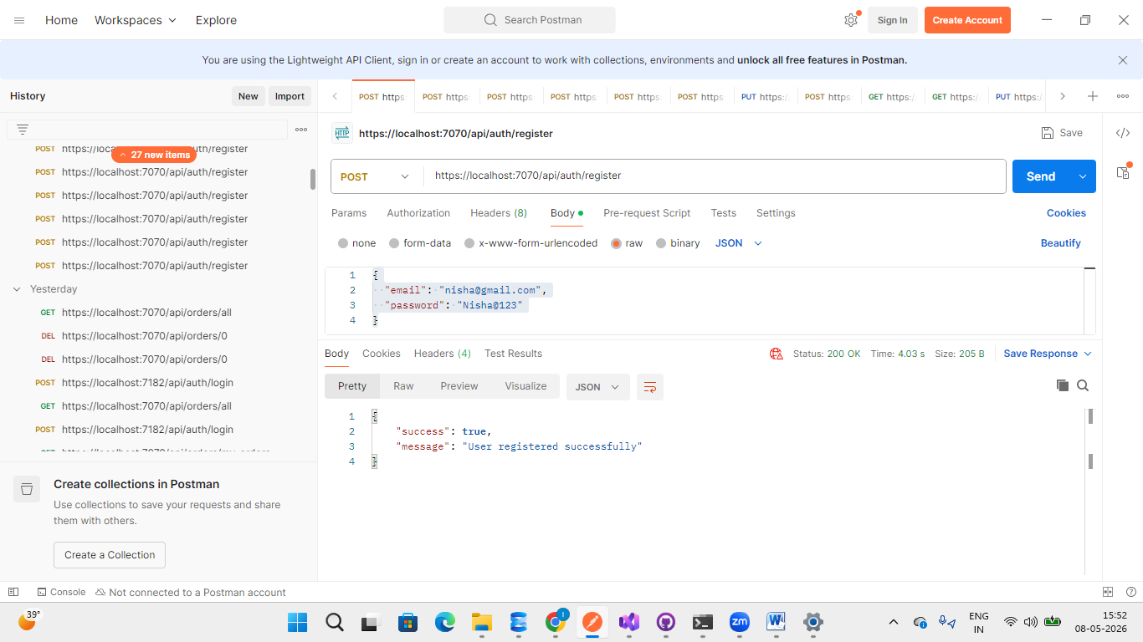
Fig – Successful user registration response
2)If user already exists : Attempting to register with an already-existing email triggers a conflict response, preventing duplicate accounts in the system.
PASSED – Duplicate email correctly rejected
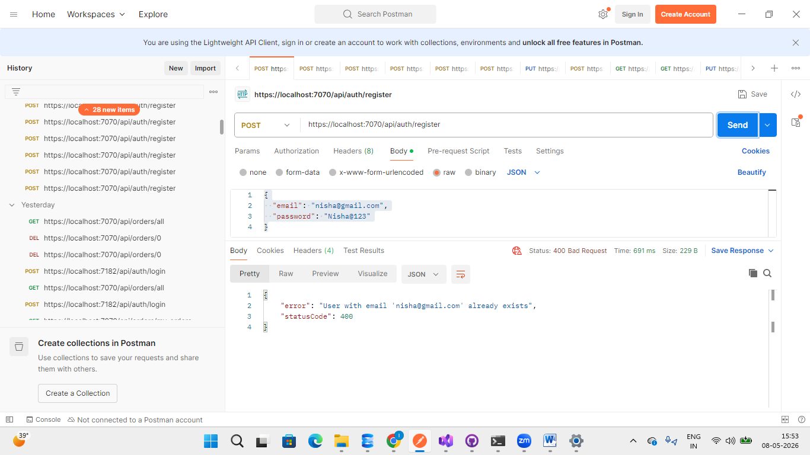

Registration Validation Testing
During user registration, validation checks are implemented to ensure that users provide valid input data before account creation.
If the user enters:
- an invalid email format
- or a password that does not satisfy the required password policy
then the system returns a validation error response with the appropriate HTTP status code 400 Bad Request.
The password policy includes:
- Minimum required length ie 6
- Uppercase letter
- Lowercase letter
- Numeric value
These validations help improve application security and maintain proper user data integrity.
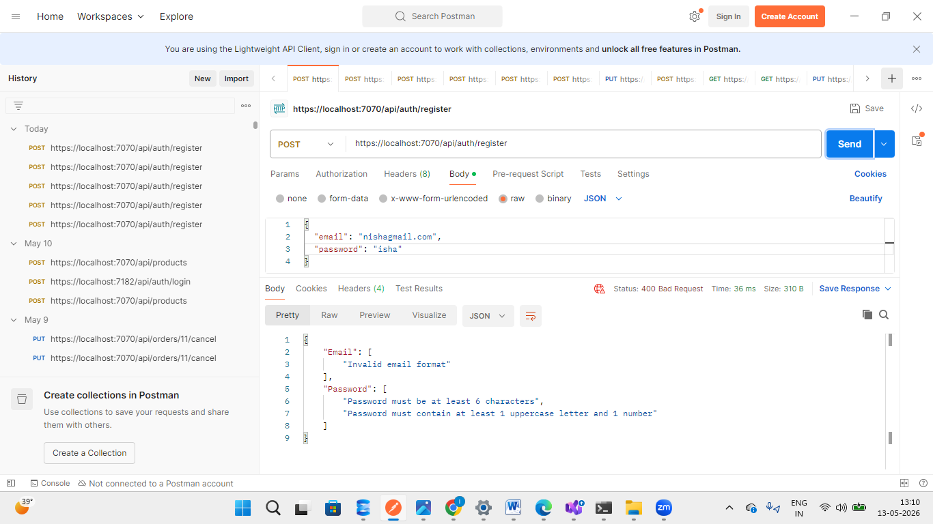
User login:
This test case validates the successful authentication functionality of the Auth Service when valid login credentials are provided.
If the user enters the same email address and password used during registration, the system authenticates the user successfully and generates a JWT token.
The generated JWT token is later used to access protected APIs such as product management and order-related endpoints.

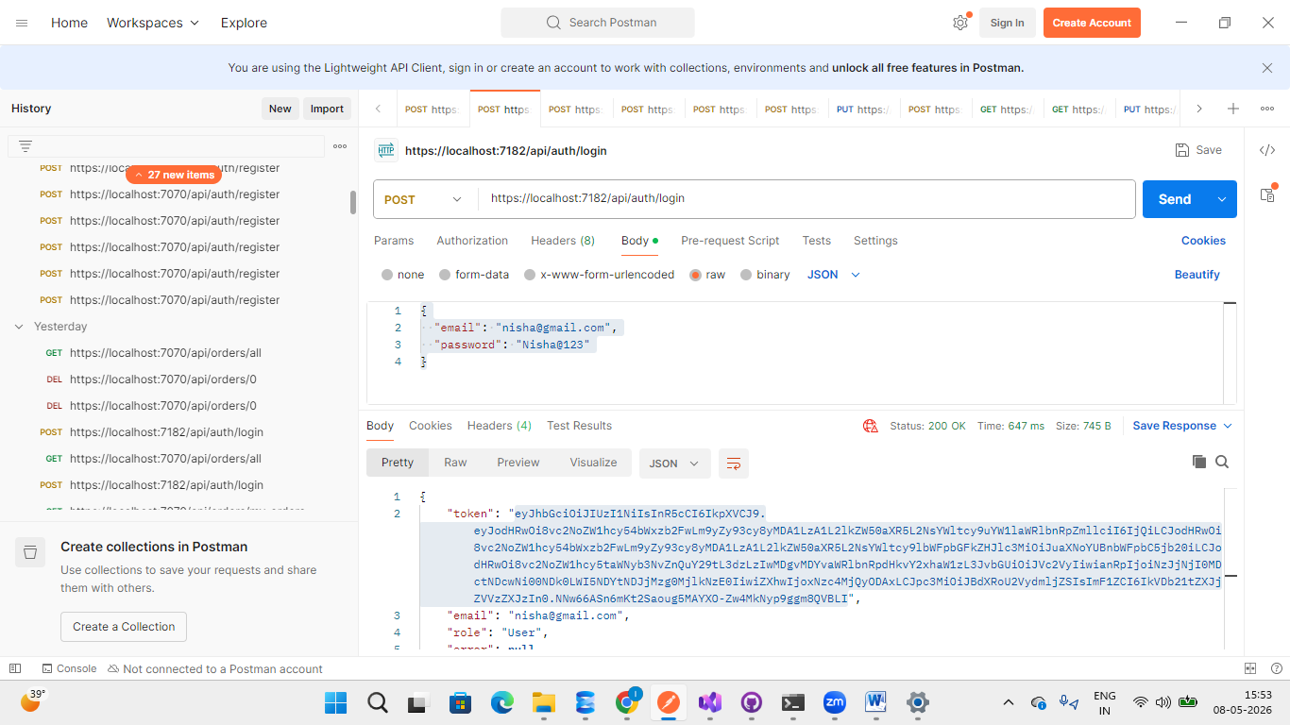

Invalid Login Credential Testing
This test case validates the login authentication functionality of the Auth Service when incorrect credentials are provided.
If the user attempts to log in using:
- an unregistered email address
- or an incorrect password
then the system denies access and returns an Unauthorized response.
This validation ensures that only users with valid registered credentials can access protected resources and receive JWT tokens.

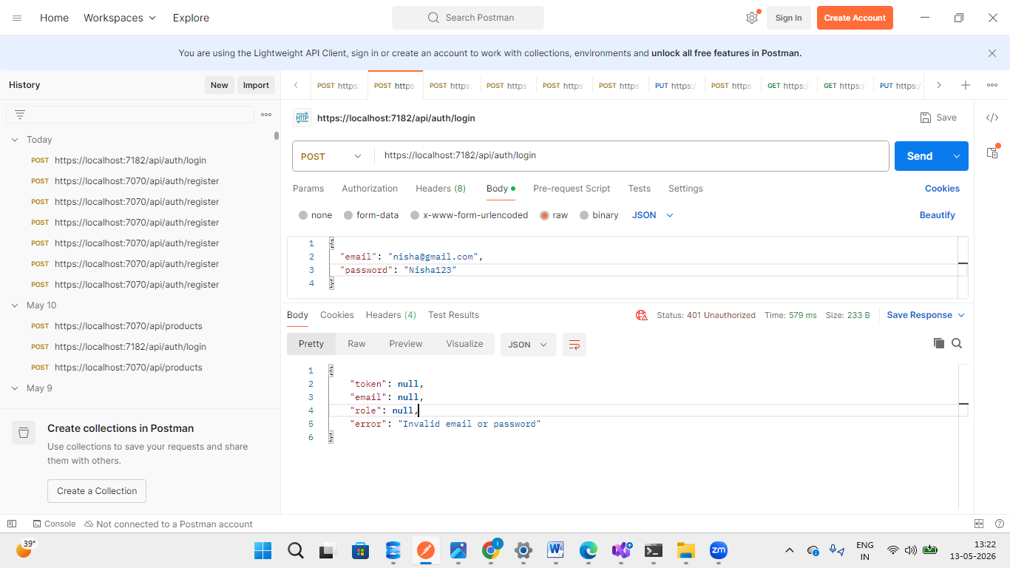

Admin Login Testing
In this application, Admin users are not required to register manually through the registration endpoint.
An Admin account is already preconfigured in the database using seeded data during application setup. Therefore, the Admin can directly log in using the predefined credentials.
This approach helps maintain better security and prevents unauthorized users from creating Admin accounts through public registration APIs.

Seeded Admin Account
The system contains a default Admin account stored in the Users table during database initialization.
The Admin account has special privileges such as:
- Managing products
- Viewing all orders
- Promoting or demoting users
- Accessing protected admin endpoints

Admin Authentication Flow
Instead of registering:
- Admin directly logs in using seeded credentials.
- Auth Service validates the credentials.
- A JWT token with Admin role claims is generated.
- The Admin token is used to access protected APIs.

Security Advantage
This implementation ensures:
- Public users cannot self-register as Admins
- Role escalation is prevented
- Admin access remains controlled and secure
- Only authorized Admin users can manage the system
A valid JWT token with Admin role is generated upon successful authentication.
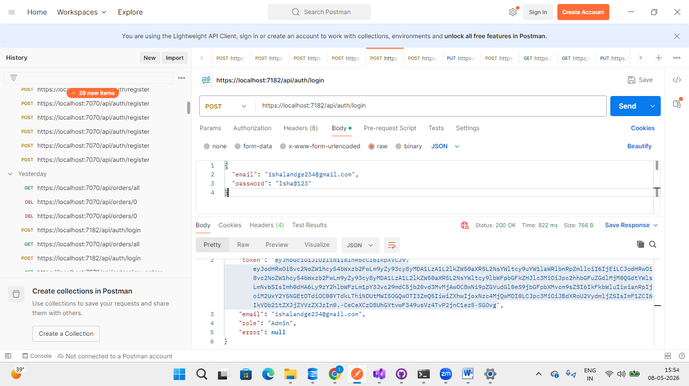
Figure: Successful Admin login using seeded database credentials.

Change User Role Testing
Method | Endpoint | Description | Access
PUT | /api/Auth/change-role/{userId} | Change User Role | Admin
The Change Role endpoint allows the Admin to manage user roles within the application. Using this functionality, the Admin can:
- Promote a User to Admin
- Demote an Admin back to User
Whenever a role is updated, the corresponding changes are immediately reflected in the Users table of the database.
This functionality is protected using Role-Based Authorization to ensure that unauthorized users cannot modify user roles.

Access Control
Only the seeded Super Admin account has permission to perform role management operations.
Other Admin users created later in the system are restricted from accessing this functionality.
This additional restriction helps maintain stricter control over administrative privileges and prevents unauthorized role escalation.

Business Logic Implemented
The following logic is implemented in the Auth Service:
- Only the seeded Admin can change roles
- Users can be promoted from User → Admin
- Admins can be demoted from Admin → User
- Role updates are saved directly in the database
- Unauthorized users receive access denied responses

Database Update
After successful role modification:
- The Role column in the Users table is updated automatically.
- Changes are reflected immediately in future JWT tokens generated for that user.
Example:
Before Role Change:
Role = User

After Role Change:
Role = Admin

Security Validation
The system ensures:
- Normal users cannot access this endpoint
- Newly promoted Admins cannot manage roles
- Only the seeded Admin has complete role management authority
- JWT authentication is mandatory

Expected Responses
Scenario | Expected Result
Seeded Admin changes role | 200 OK
Normal Admin tries to change role | 403 Forbidden
User tries to access endpoint | 403 Forbidden
Invalid User ID | 404 Not Found

Purpose of This Functionality
This functionality helps:
- Maintain secure admin control
- Prevent unauthorized privilege escalation
- Manage system administrators safely
- Enforce strict role-based access control

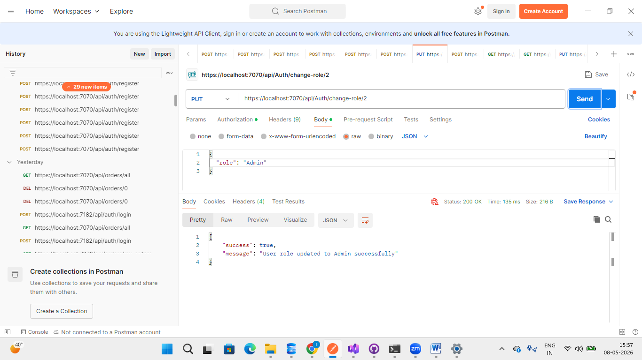
Updated database : 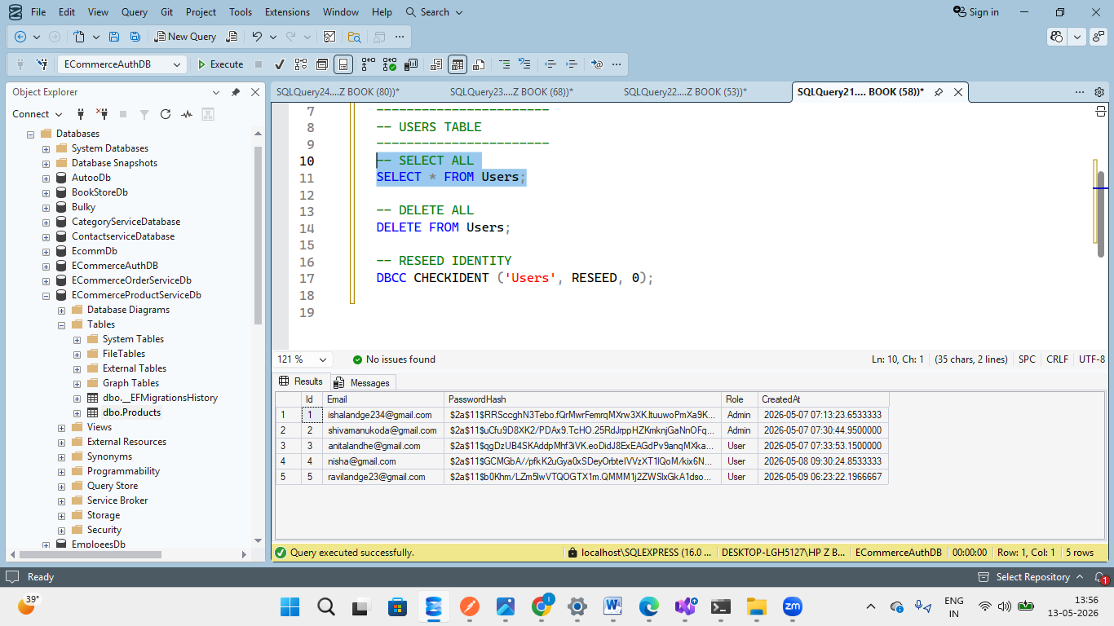
Figure: Role change operation performed by the seeded Admin account with database role update.

2) Demote: Changed the role of User 2 from Admin to User. Only the seeded Admin can perform this action and a valid Admin JWT token is required.
JSON Body:
{
"role": "User"
}
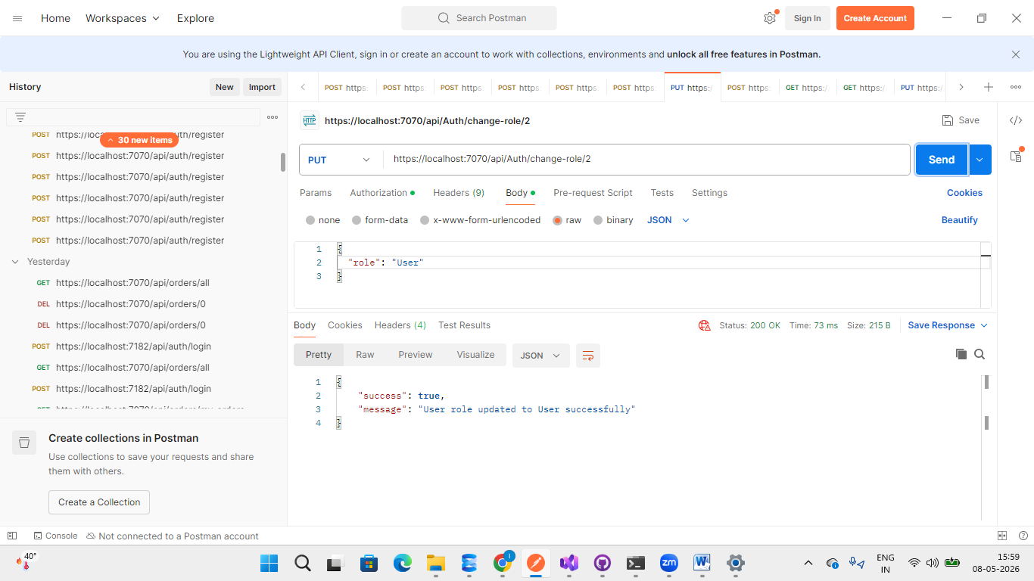
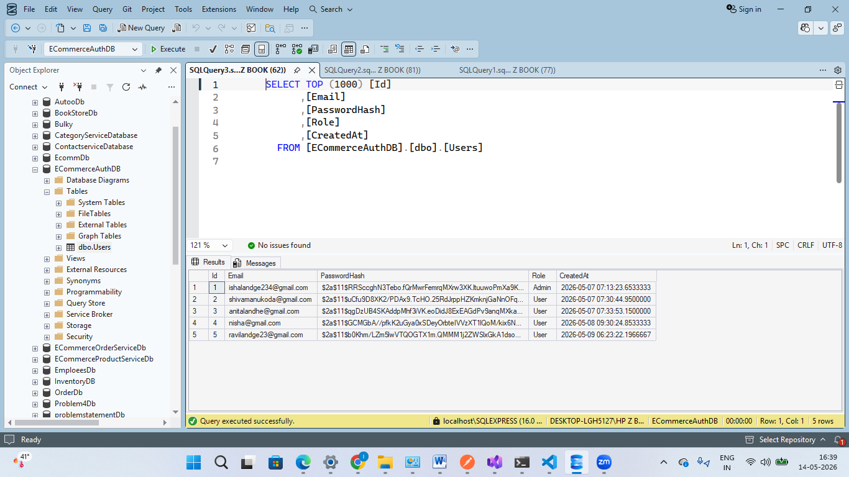
Figure: Seeded Admin successfully demoting an Admin back to User role with database update.

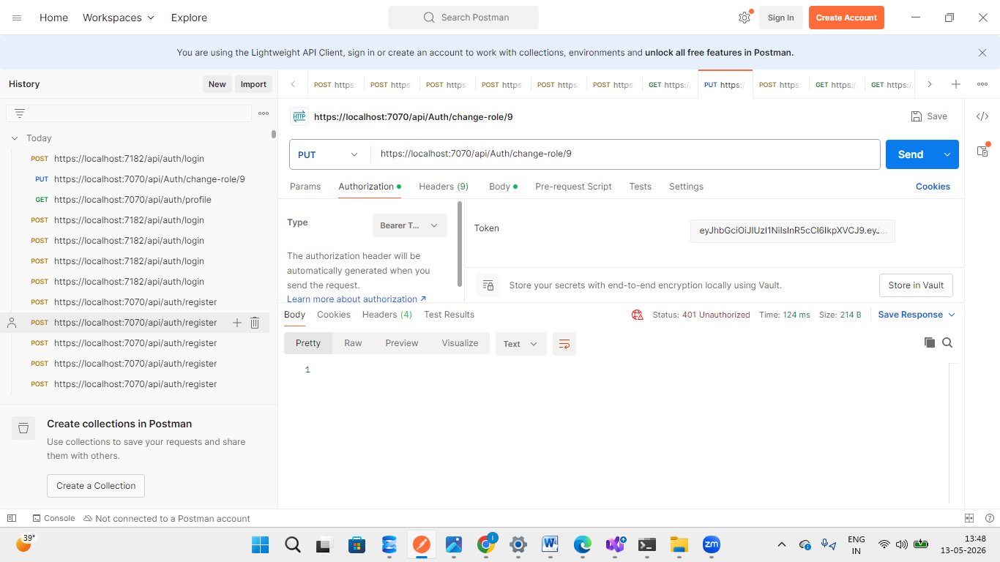
Fig :If the JWT token is invalid, expired, old, or belongs to a normal User instead of the seeded Admin, the system returns 401 Unauthorized.

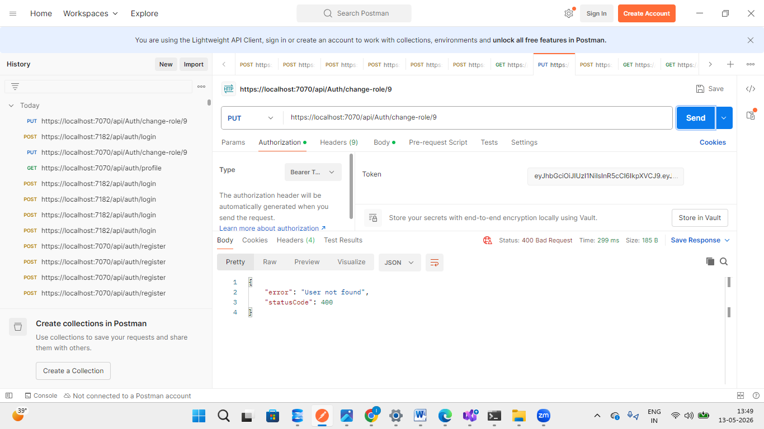
4)If the Admin tries to change the role of a user that does not exist in the database, the system returns 400 Bad Request with the message "User not found".

Get User Profile Testing
Method | Endpoint | Description | Access
GET | /api/Auth/profile | Get Logged-In User Profile | Authenticated User

The Get Profile endpoint is a protected endpoint used to retrieve the details of the currently logged-in user.
This endpoint extracts the user information from the JWT token and returns details such as:
- Email
- User Role
It also confirms that the user has successfully accessed a protected API endpoint using valid authentication.

Purpose of This Endpoint
This endpoint is mainly used to:
- Verify JWT authentication
- Identify the currently logged-in user
- Retrieve user role information
- Test protected route access

JWT Authentication Requirement
A valid JWT token must be provided in the Authorization header to access this endpoint.
If:
- the token is missing
- invalid
- expired
- or incorrect
then the system returns:
401 Unauthorized

Successful Response
When a valid JWT token is provided, the system returns the logged-in user's details.
Example Response:
{
"email": "nisha@gmail.com",
"role": "User",
"message": "This is a protected endpoint"
}

Functionality Verified
The following functionalities were verified during testing:
- JWT token validation
- Protected endpoint authorization
- User identity extraction from token claims
- Role retrieval from JWT token
- Secure API access

Security Validation
The endpoint ensures:
- Only authenticated users can access the endpoint
- Unauthorized users are blocked
- JWT token claims are correctly validated
- Protected API routes remain secure

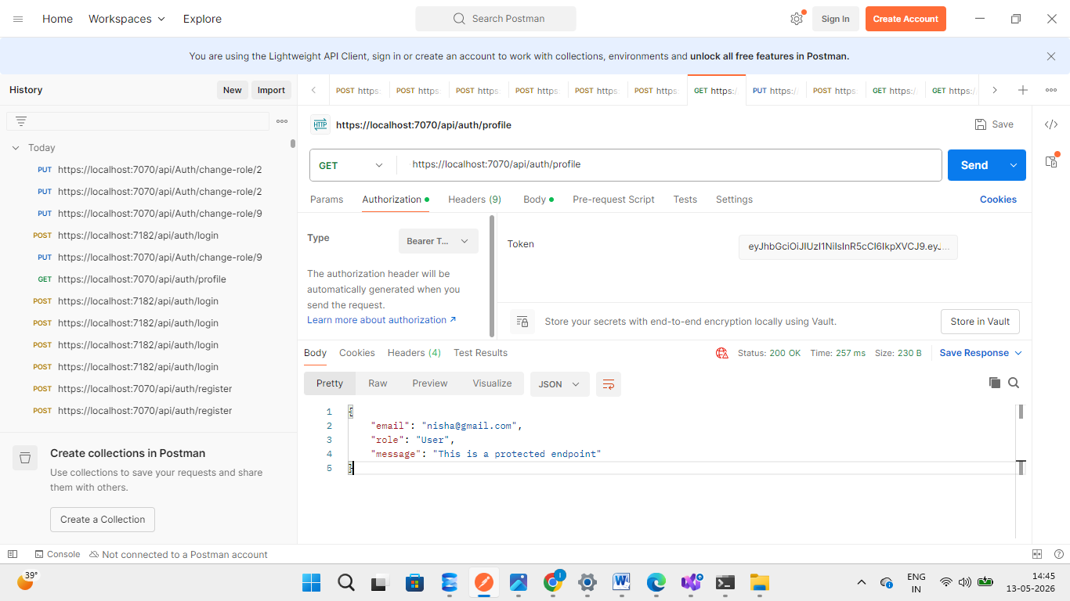Figure: Successful access to the protected profile endpoint using a valid JWT token.

Get All Users Testing
METHOD | EndPoint | Description | Access
GET | /api/Auth/users | Get All Users | Admin
The Get All Users endpoint allows the Admin to retrieve the details of all registered users available in the system.
This is a protected Admin-only endpoint and requires a valid Admin JWT token for access.
The endpoint returns user-related details such as:
- User ID
- Email
- User Role
- Registration details

Access Control
- Only Admin users can access this endpoint.
- Normal users are not authorized.
- A valid Admin JWT token is required.
If the JWT token is missing, invalid, expired, or belongs to a normal user, the system returns:
401 Unauthorized

Purpose of This Endpoint
This endpoint is used to:
- View all registered users
- Manage users in the system
- Verify user roles
- Support admin-level user management operations

Functionality Verified
The following functionalities were verified during testing:
- Admin authorization
- JWT token validation
- Retrieval of all registered users
- Protected endpoint access

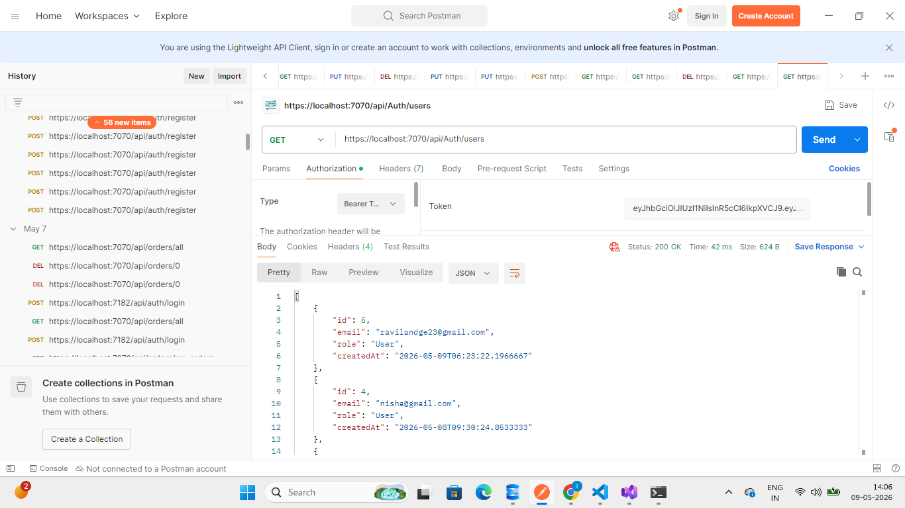
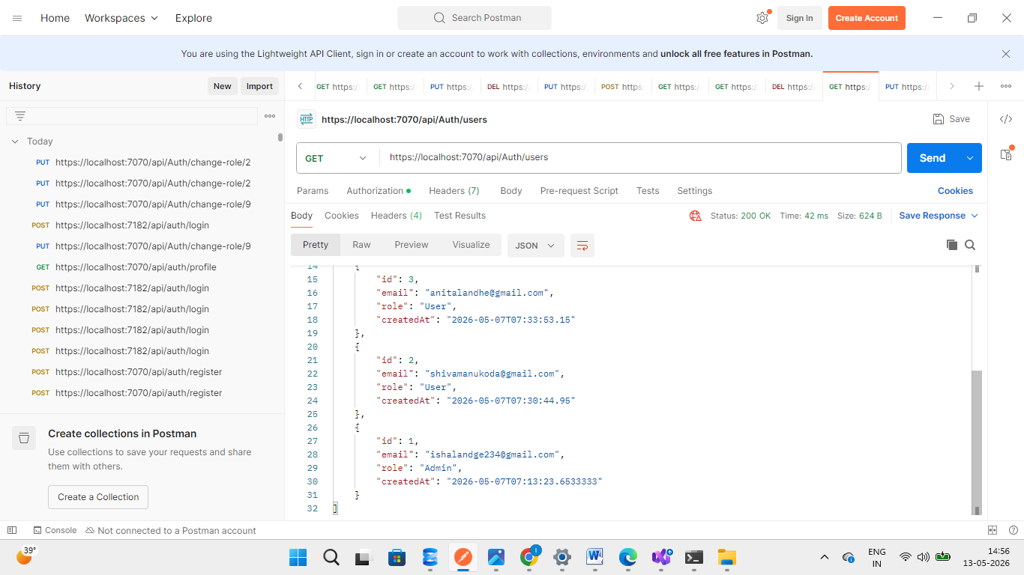
Figure: Admin successfully retrieving all registered users using a valid JWT token.

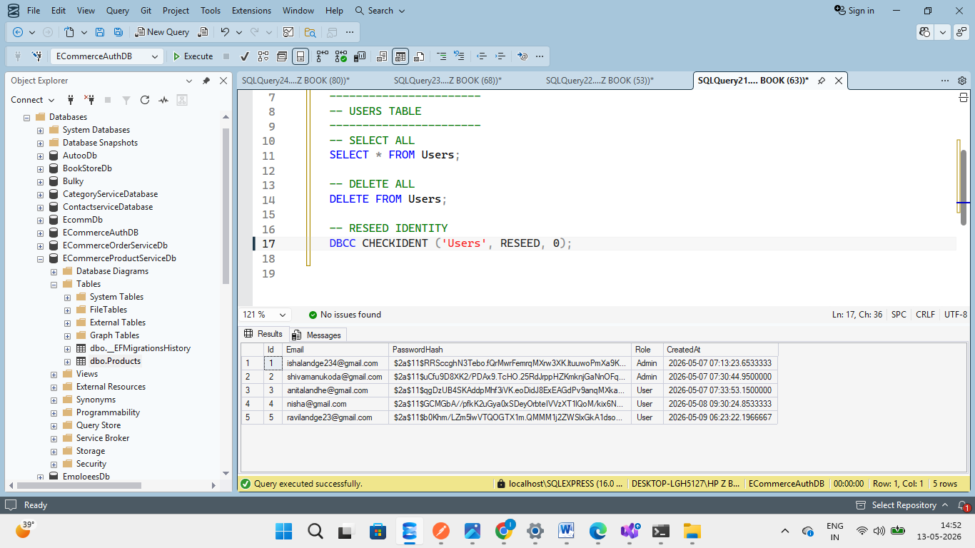
Fig:This endpoint fetches all users currently registered and stored in the database.

Product service
Product Service Endpoints using Swagger:
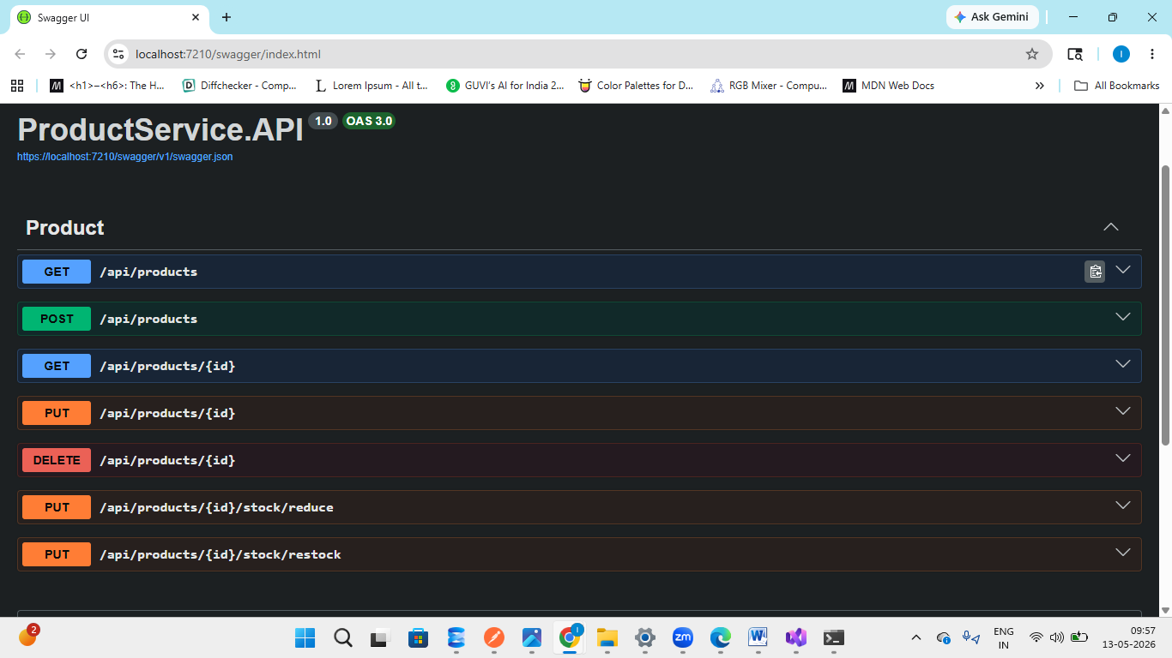

Create Product Testing
Method | Endpoint | Description | Access
POST | /api/products | Add new product | Admin
The Create Product endpoint is used to add new products to the Products database.
This is a protected Admin-only endpoint, which means only users with a valid Admin JWT token can create products. Normal users are not authorized to access this functionality.
The product details are sent in JSON format through the request body.

Authorization Requirement
- Only Admins can create products.
- A valid Admin JWT token is required.
- If a normal user or invalid token is used, the system returns: 401 Unauthorized

Steps in Postman
Select Body → Raw → JSON

JSON Request Body
{
"name": "Tulip Flower Vase",
"description": "Ceramic flower vase with artificial tulip flowers.",
"price": 1299,
"stock": 19,
"category": "Decorative Items",
"imageUrl": "/images/flower vase.jpg"
}

Functionality Verified
The following functionalities were verified during testing:
- Admin authorization
- JWT token validation
- Product creation
- Database insertion
- JSON request handling
- Product category storage
- Image URL storage

Database Update
After successful product creation:
- The new product is stored in the Products table.
- Product stock and category details are saved in the database.

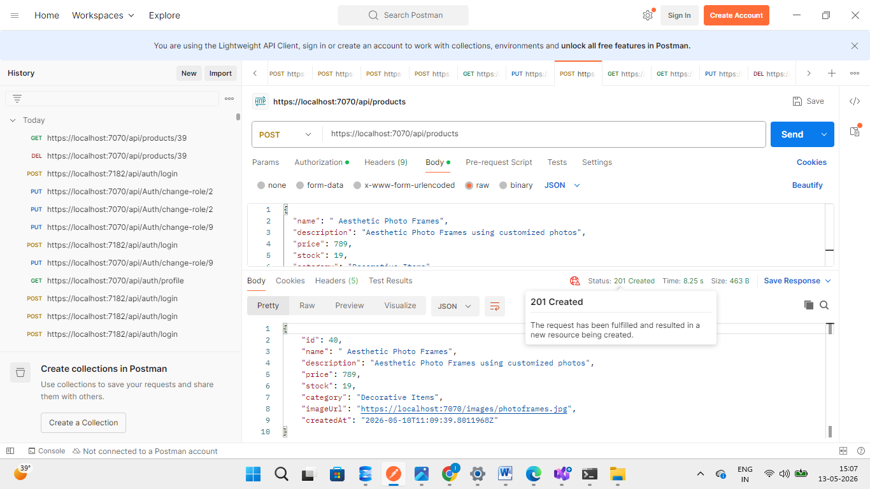
Figure: Admin successfully creating a new product using a valid JWT token.

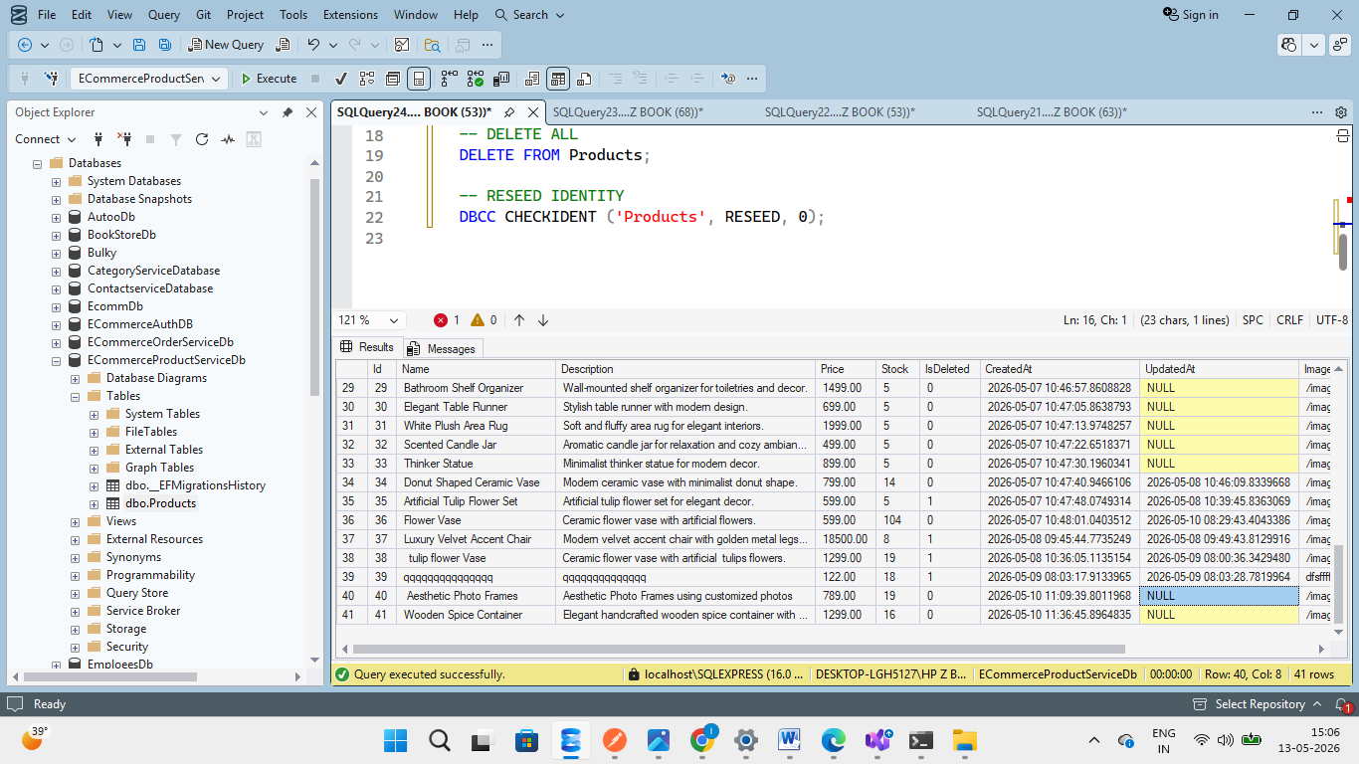
Fig :The value is currently showing NULL because the product has not been updated yet after creation.

Get All Products Testing
Method | Endpoint | Description | Access
GET | /api/products | Get all products | Public
The Get All Products endpoint is used to retrieve product details from the Products database.
This endpoint is publicly accessible, which means no authentication or JWT token is required. Any user can view products without logging into the application.
Pagination is implemented in this endpoint, therefore initially only the first 10 products are loaded and displayed per request.

Key Features
- No authorization required
- Publicly accessible endpoint
- Loads first 10 products initially
- Pagination support implemented
- Fetches product details from the database

Pagination Functionality
To improve performance and optimize data loading, pagination is implemented.
The endpoint initially returns:
- First 10 available products
Additional products can be fetched through pagination requests.

Functionality Verified
The following functionalities were verified during testing:
- Product retrieval from database
- Public API accessibility
- Pagination implementation
- Product data loading
- Response handling

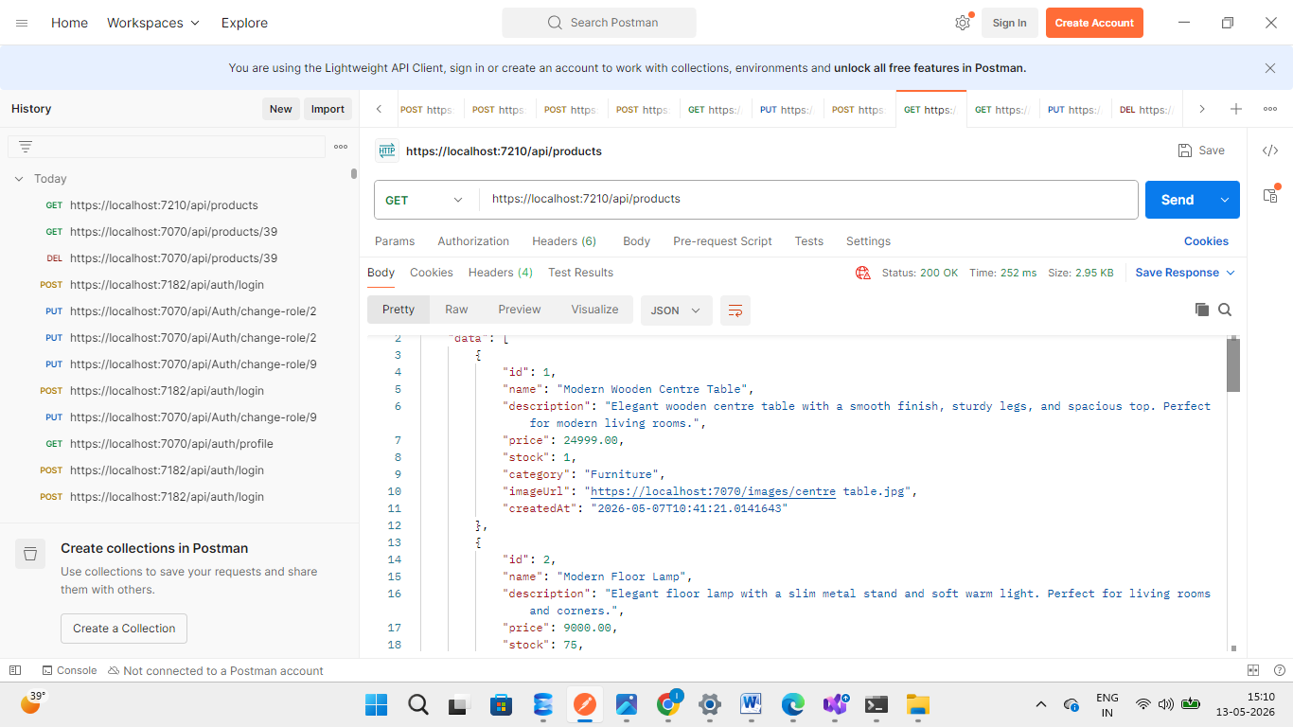
Figure: Successfully retrieving the first 10 products without authentication using pagination.

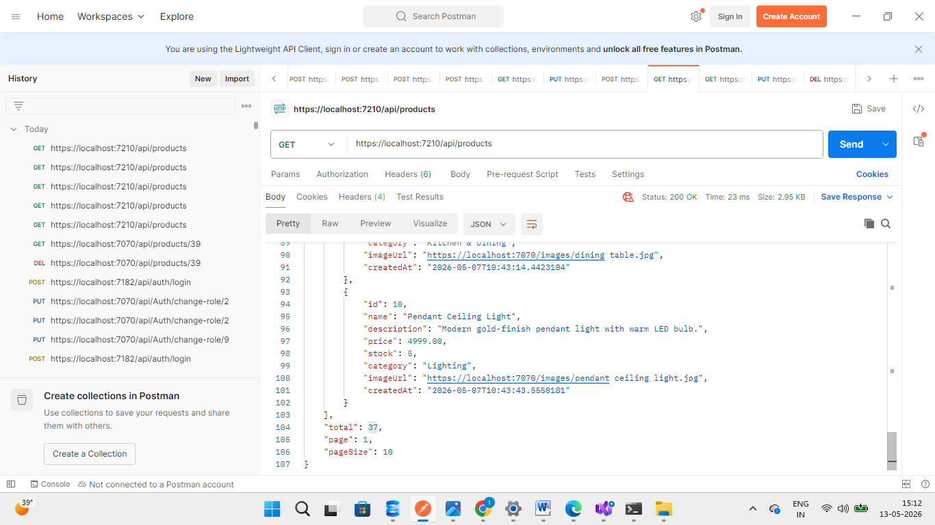

Get Product By ID Testing
Method | Endpoint | Description | Access
GET | /api/products/{id} | Get product by ID | Public
The Get Product By ID endpoint is used to fetch a single product record from the Products database using its unique product identifier.
This endpoint is publicly accessible, therefore no authentication or JWT token is required.
The API returns complete details of the selected product such as:
- Product Name
- Description
- Price
- Stock
- Category
- Image URL
- Created Date

Purpose of This Endpoint
This endpoint is used to:
- Retrieve a specific product
- View detailed product information
- Fetch product data using product ID
- Display product details to users

Functionality Verified
The following functionalities were verified during testing:
- Product retrieval by ID
- Database fetching
- Product detail response
- Public endpoint accessibility
- JSON response handling

Sample Response
{
"data": {
"id": 5,
"name": "Sofa Set",
"description": "Premium fabric sofa set with modern design and soft cushions.",
"price": 32000,
"stock": 13,
"category": "Furniture",
"imageUrl": "https://localhost:7070/images/sofaset.jpg",
"createdAt": "2026-05-07T10:42:25"
}
}

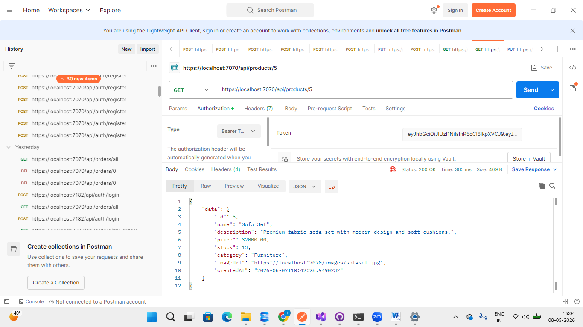
Figure: Successfully fetching product details using product ID.

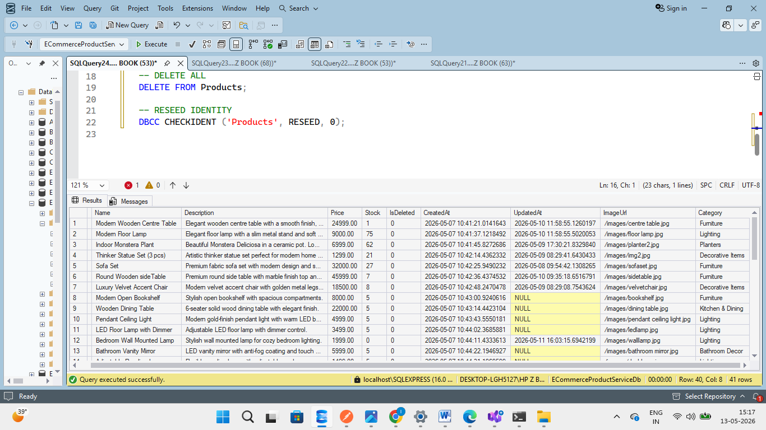
Figure :Since the product details are fetched using the Product ID, the retrieved product can be cross-verified directly from the Products table in the database.

Update Product By ID Testing
Method | Endpoint | Description | Access
PUT | /api/products/{id} | Update product | Admin
The Update Product By ID endpoint is used to modify the details of an existing product using its unique product identifier.
This is a protected Admin-only endpoint, therefore only users with a valid Admin JWT token are authorized to update product details.
The endpoint updates the selected product information in the Products database.

Authorization Requirement
- Only Admin users can access this endpoint.
- A valid Admin JWT token is required.
- Normal users are not authorized to perform product updates.
If an invalid or missing token is provided, the system returns:
401 Unauthorized

JSON Request Body
{
"name": "Luxury Velvet Accent Chair",
"description": "Modern velvet accent chair with golden metal legs and soft cushioning. Perfect for living rooms and lounges.",
"price": 18500,
"stock": 8,
"category": "Decorative Items",
"imageUrl": "/images/velvet-chair.jpg"
}

Functionality Verified
The following functionalities were verified during testing:
- Product update by ID
- Admin authorization
- JWT token validation
- Database update operation
- JSON request handling
- Product detail modification

Database Update
After successful update:
- Product ID 7 is updated in the Products table.
- Modified details are immediately reflected in the database.

Sample Response
{
"success": true,
"message": "Product updated successfully"
}

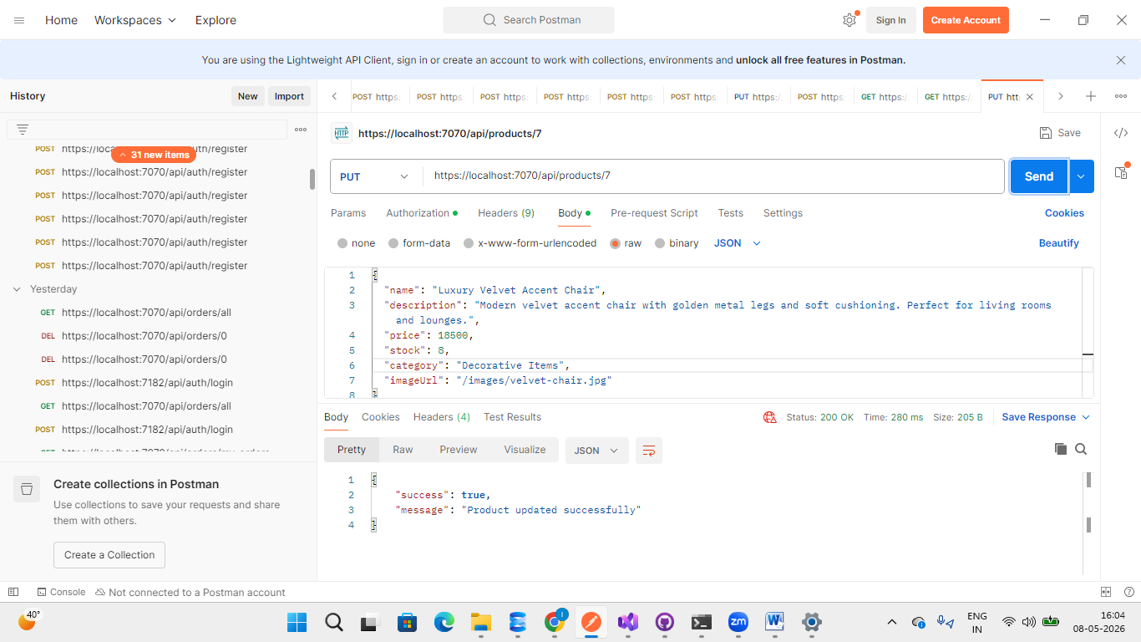
Figure: Admin successfully updating Product ID 7 using a valid JWT token

The updated product details can be verified using both the Get Product By ID and Get All Products endpoints. The changes are also successfully reflected in the Products database table, as shown in the attached screenshots.
Get All Products 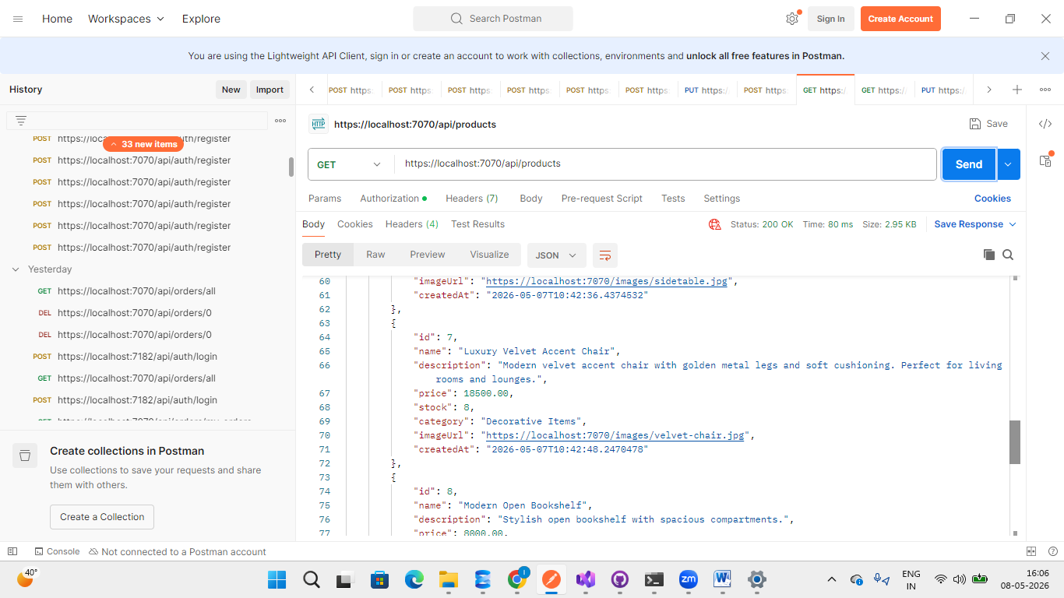
Fig:The updated product details can be verified using the Get Product By ID endpoint as well as directly from the Products table in the database using the Product ID. 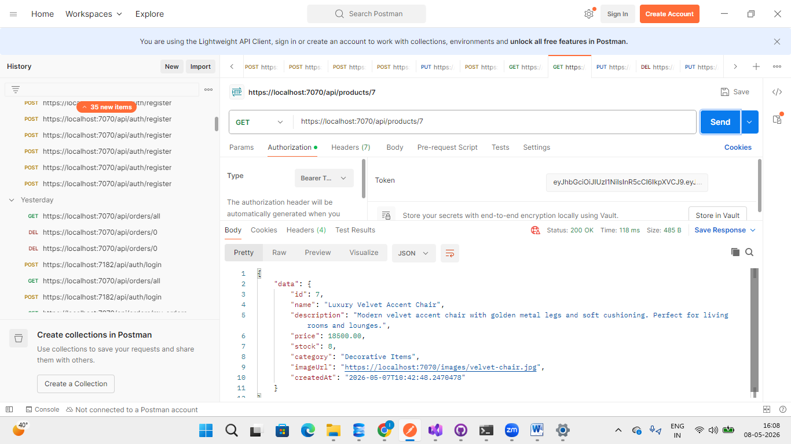
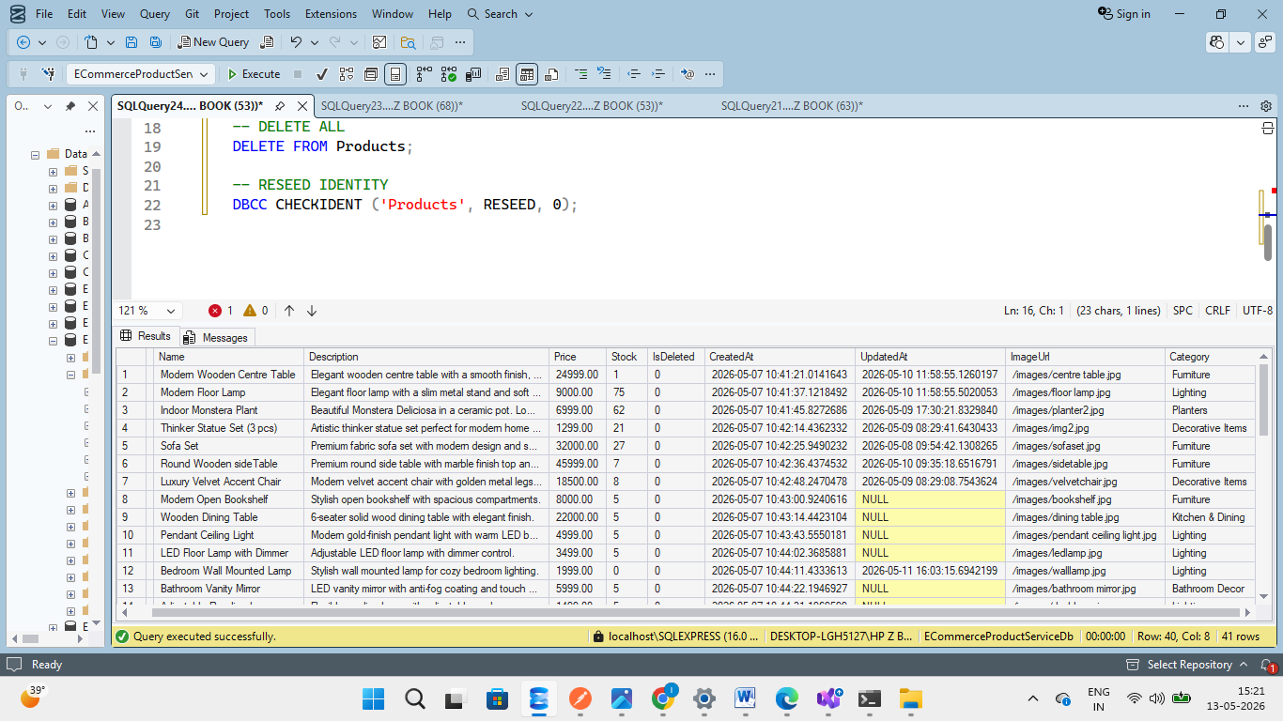
Fig: The updated product details can also be verified directly from the Products table in the database using the Product ID.

Delete Product By ID Testing
Method | Endpoint | Description | Access
DELETE | /api/products/{id} | Delete product | Admin

The Delete Product By ID endpoint is used to remove a product from the application using its unique product identifier.
This is a protected Admin-only endpoint, therefore only users with a valid Admin JWT token are authorized to delete products.
Instead of permanently removing the product from the database, the system performs a soft delete by updating:
IsDeleted = 1
This helps preserve product history and maintain database consistency.

Authorization Requirement
- Only Admin users can access this endpoint.
- A valid Admin JWT token is required.
- Normal users are not authorized to delete products.
If an invalid or missing token is provided, the system returns:
401 Unauthorized

Functionality Verified
The following functionalities were verified during testing:
- Product deletion by ID
- Admin authorization
- JWT token validation
- Soft delete implementation
- Database update operation

Database Update
After successful deletion:
- The product is marked as deleted in the database.
- The IsDeleted column is updated from 0 to 1.
The product is no longer shown in active product listings
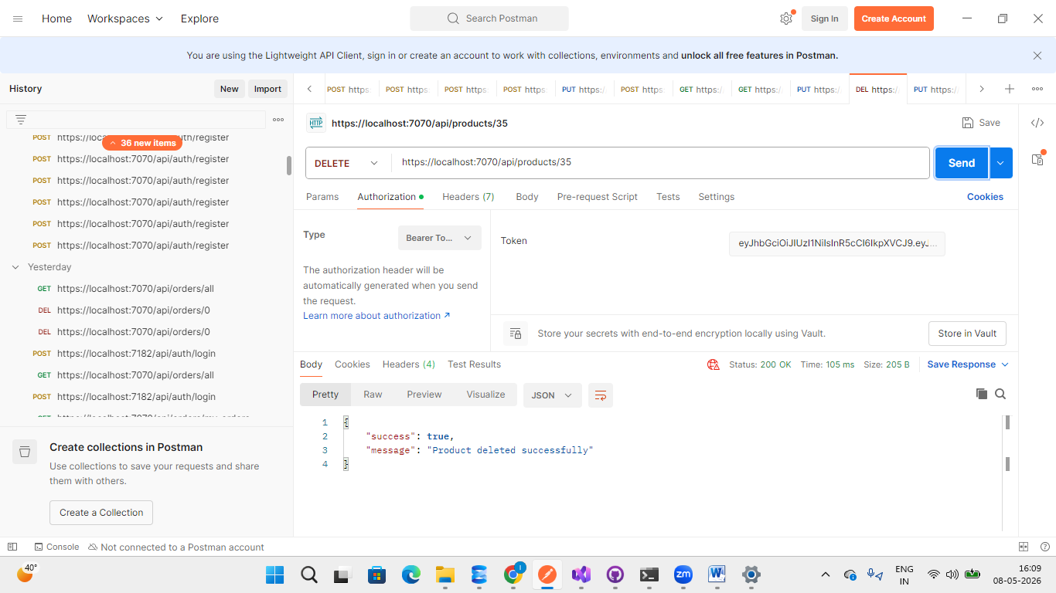
Figure: Admin successfully deleting a product by updating the IsDeleted flag to 1 in the database.

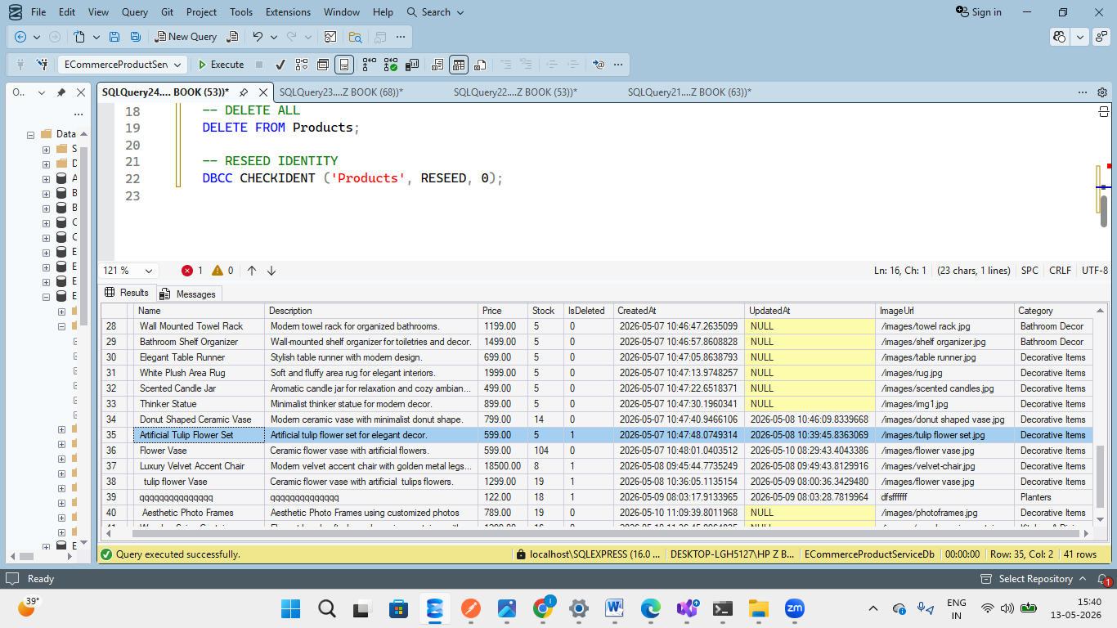

Fig: The deleted product can be cross-verified using the Get Product By ID endpoint, where the IsDeleted field is updated to 1 in the database.
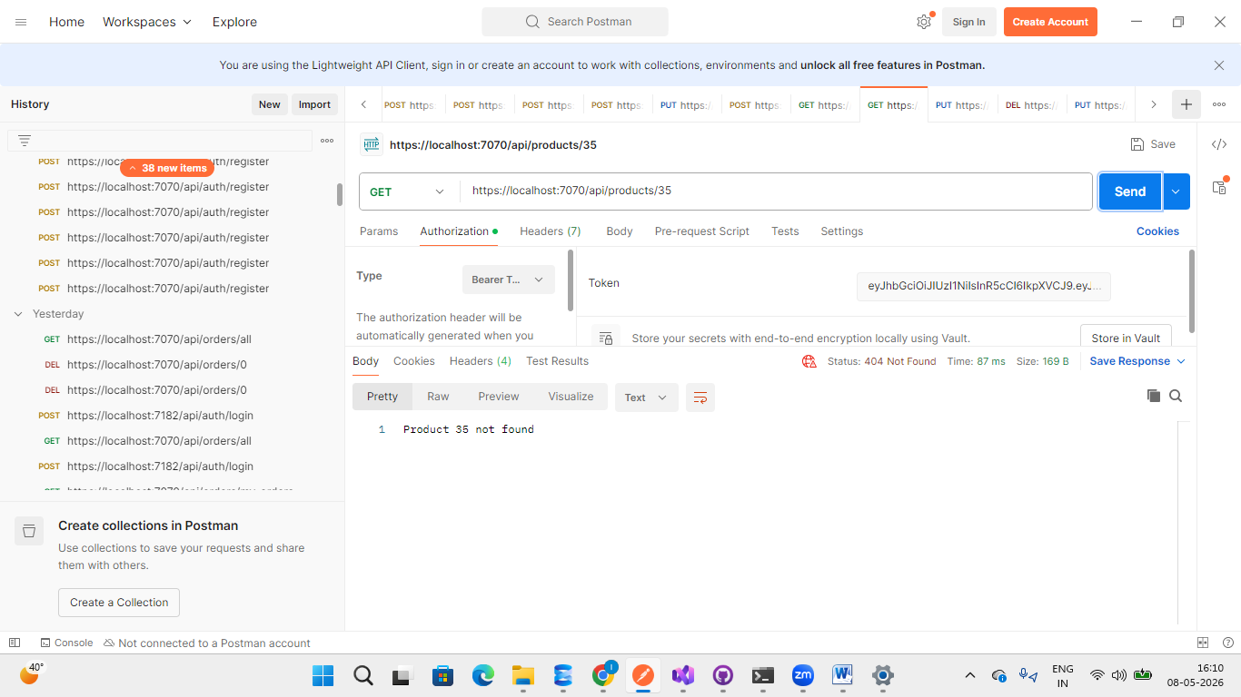
Get Product By ID : Removes a product from the catalog by ID. The deletion is verified by attempting to fetch the same product ID afterward, which returns a not-found response.

Reduce Product Stock Testing
Method | Endpoint | Description | Access
PUT | /api/products/{id}/stock/reduce | Reduce product stock | Internal Service/Admin
The Reduce Stock endpoint is used to decrease the available stock quantity of a product in the Products database.
This is a protected Admin-only endpoint, therefore only users with a valid Admin JWT token are authorized to perform stock reduction operations.
In this test case:
- Product ID 34 initially had 5 items in stock.
- The stock quantity was reduced by 1.
- After successful execution, the stock became 4.

Authorization Requirement
- Only Admin users can access this endpoint.
- A valid Admin JWT token is required.
If an invalid or missing token is provided, the system returns:
401 Unauthorized

JSON Request Body
{
"quantity": 1
}

Functionality Verified
The following functionalities were verified during testing:
- Stock reduction
- Admin authorization
- JWT token validation
- Database stock update
- Quantity validation

Database Update
Before Stock Reduction:
Stock = 5
After Stock Reduction:
Stock = 4
The updated stock value is immediately reflected in the Products table.

Verification
The updated stock quantity can be cross-verified using:
- Get Product By ID endpoint
- Get All Products endpoint
- Database table screensho

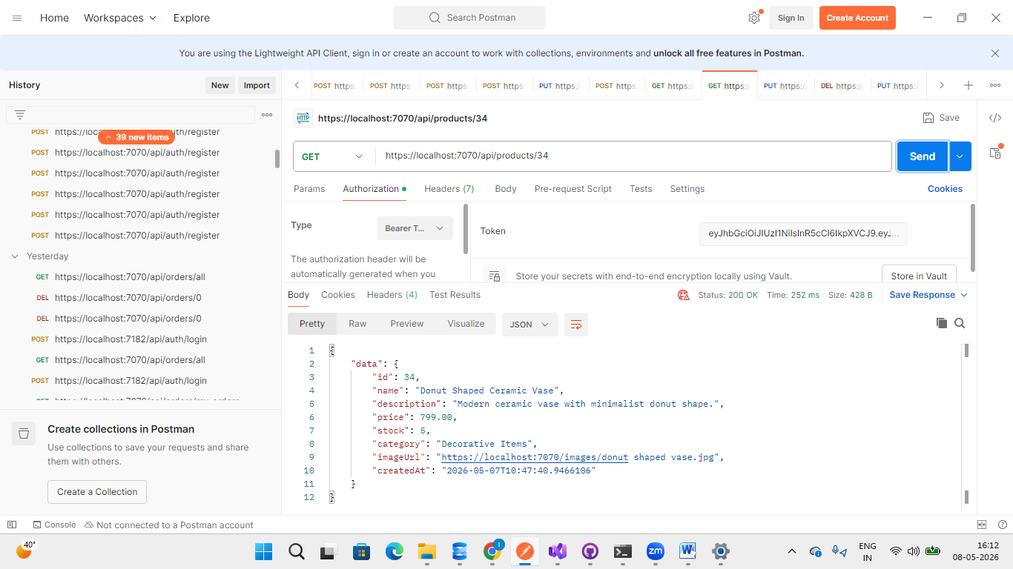
Before stock reduction, Product ID 34 had 5 items available in stock, as verified using the Get Product By ID endpoint.
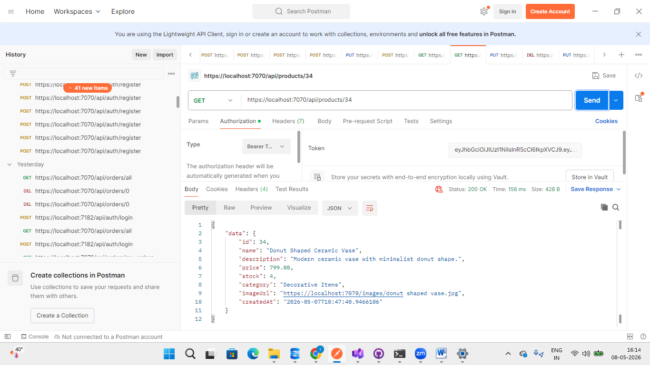
Figure: Admin successfully reducing Product ID 34 stock quantity using a valid JWT token.now it has only 4 product as we reduced the stock by one

Restore Product Stock Testing
Method | Endpoint | Description | Access
PUT | api/products / {id} /stock/restock | Restores the product stock | Internal Service/Admin
The Restore Stock endpoint is used to increase the available stock quantity of a product in the Products database.
This is a protected Admin-only endpoint, therefore only users with a valid Admin JWT token are authorized to restore product stock.
In this test case:
- Product ID 34 stock was restored by 10 items.
- The updated stock quantity is successfully reflected in the database.

JSON Request Body
{
"quantity": 10
}

Functionality Verified
The following functionalities were verified during testing:
- Product stock restoration
- Admin authorization
- JWT token validation
- Database stock update
- Quantity increment operation

Verification
The updated stock quantity can be cross-verified using the Get Product By ID endpoint.
After restoring stock, Product ID 34 stock increased successfully and is reflected in the response.


Before restoring the stock, Product ID 34 had 4 items available in stock.

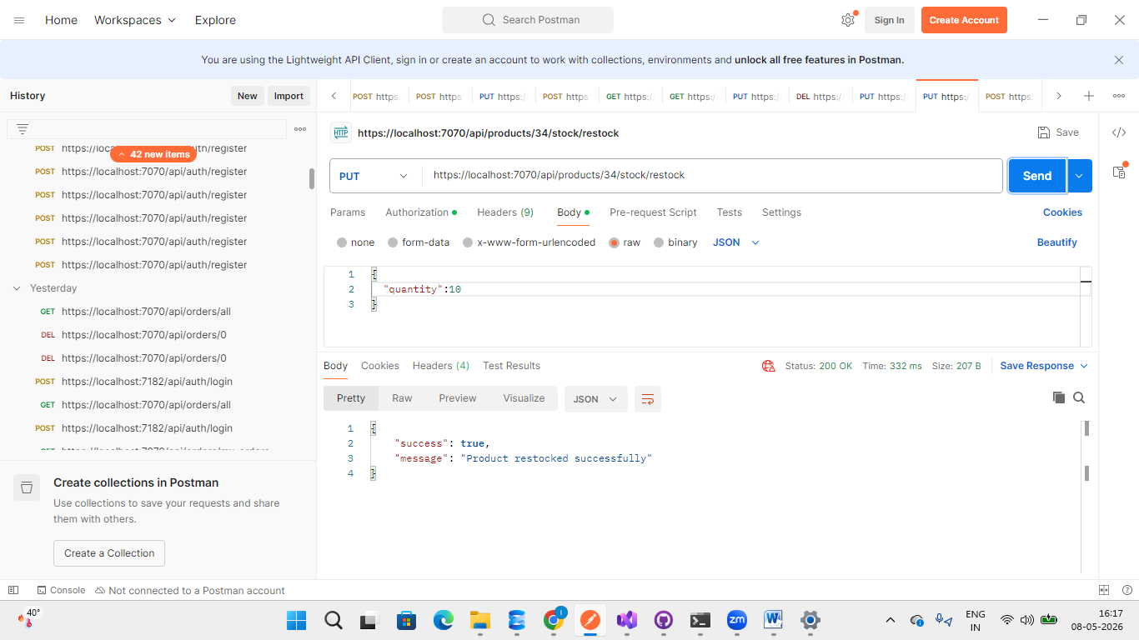
We added 10 more items to the product stock using the Restore Stock endpoint.
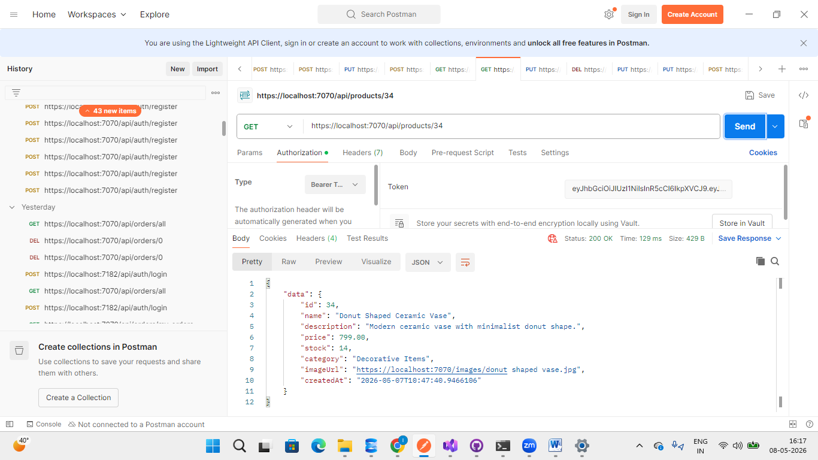
After restoring the stock quantity, Product ID 34 now has 14 items available in stock.

Order services :
Order Flow
Customer Places Order
|
v
API Gateway
|
v
Order Service
|
Validate Product
|
Check Product Stock
|
Create Order
|
Update Product Stock
|
Return Order Response

Swagger API Endpoint for Order Service
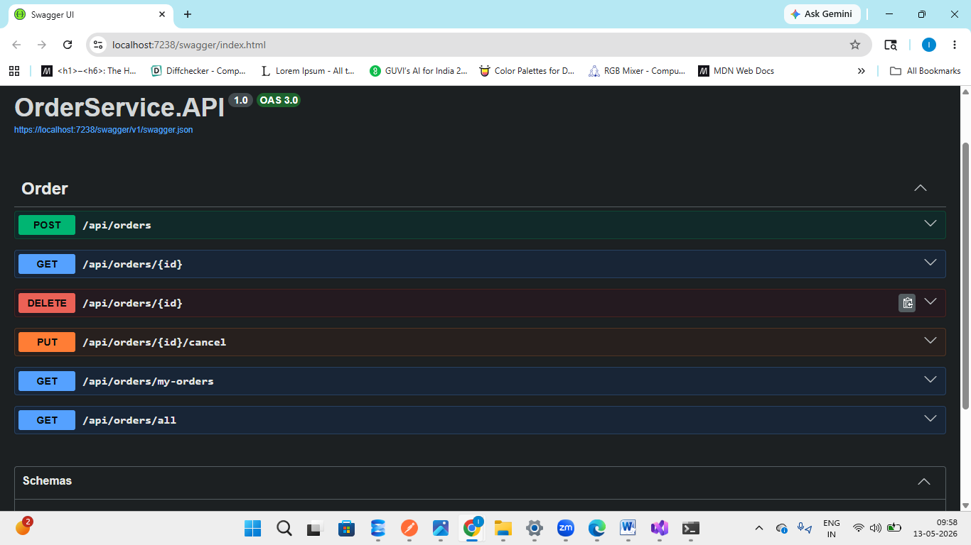

Create Order Testing
Method | Endpoint | Description | Access
POST | /api/orders | Create order | Customer
The Create Order endpoint is used to place a new order for products available in the application.
This is a protected endpoint, therefore a valid JWT token is required to place an order. The Order Service validates the product, checks stock availability, calculates the total amount, and stores the order details in the database.

JSON Request Body
{
"items": [
{
"productId": 1,
"quantity": 2
}
]
}

Functionality Verified
The following functionalities were verified during testing:
- JWT token validation
- Order creation
- Product validation
- Stock availability check
- OrderItems creation
- Total amount calculation
- Database insertion

Database Update
After successful order creation:
- Order details are stored in the Orders table.
- Ordered products are stored in the OrderItems table.
- Product stock is automatically reduced.

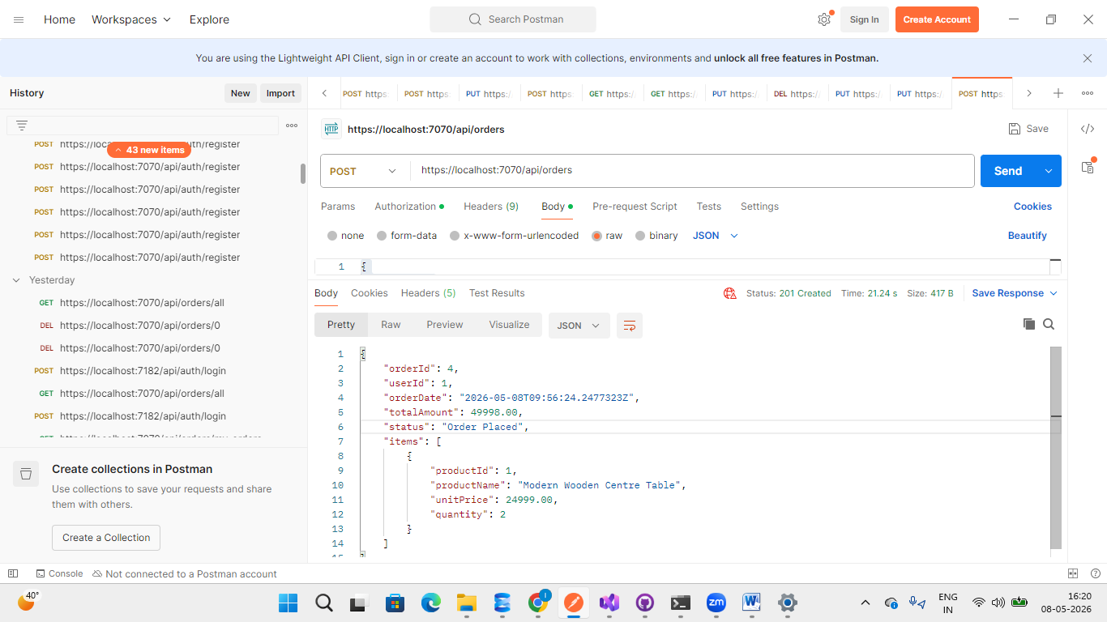
Figure: Successfully retrieving orders of the logged-in user using JWT token authentication.

Insufficient Stock Validation Testing
This test case validates the stock availability check during order creation.
If the user tries to place an order with a quantity greater than the available product stock, the system rejects the request and returns a validation error.
In this test case:
- The user attempted to order 200 quantities of Product ID 1.
- The available stock was lower than the requested quantity.
- Therefore, the order was not created.

Request Body
{
"items": [
{
"productId": 1,
"quantity": 200
}
]
}

Expected Response
400 Bad Request

Error Response
{
"error": "Insufficient stock for Modern Wooden Centre Table"
}

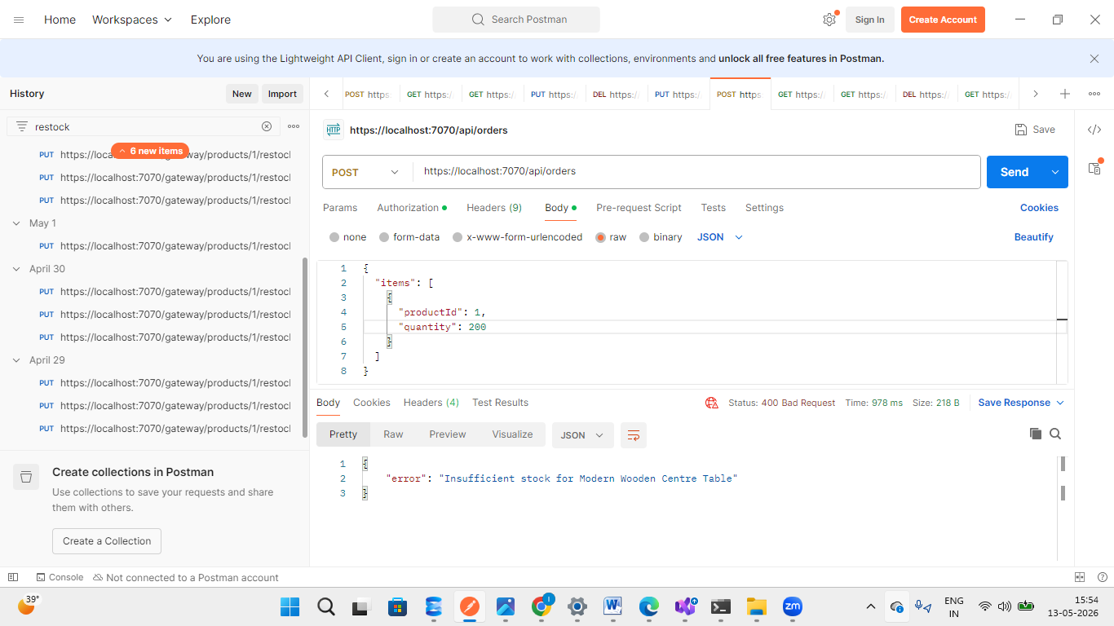
Figure: Order creation failed due to insufficient product stock availability.

Get Order By ID Testing
Method | Endpoint | Description | Access
GET | /api/orders/{id} | Get order by ID | Owner/Admin
The Get Order By ID endpoint is used to retrieve details of a specific order using its unique Order ID.
This is a protected Admin-only endpoint, therefore only users with a valid Admin JWT token are authorized to access it.
Unlike the My Orders endpoint, which returns orders of the currently logged-in user, this endpoint allows the Admin to fetch any specific order directly using the Order ID.

Authorization Requirement
- Only Admin users can access this endpoint.
- A valid Admin JWT token is required.

Functionality Verified
The following functionalities were verified during testing:
- Order retrieval by ID
- Admin authorization
- JWT token validation
- Database order fetching

Invalid Order Validation
If the specified Order ID does not exist, the system returns:
404 Not Found
Response:
{
"error": "Order not found"
}

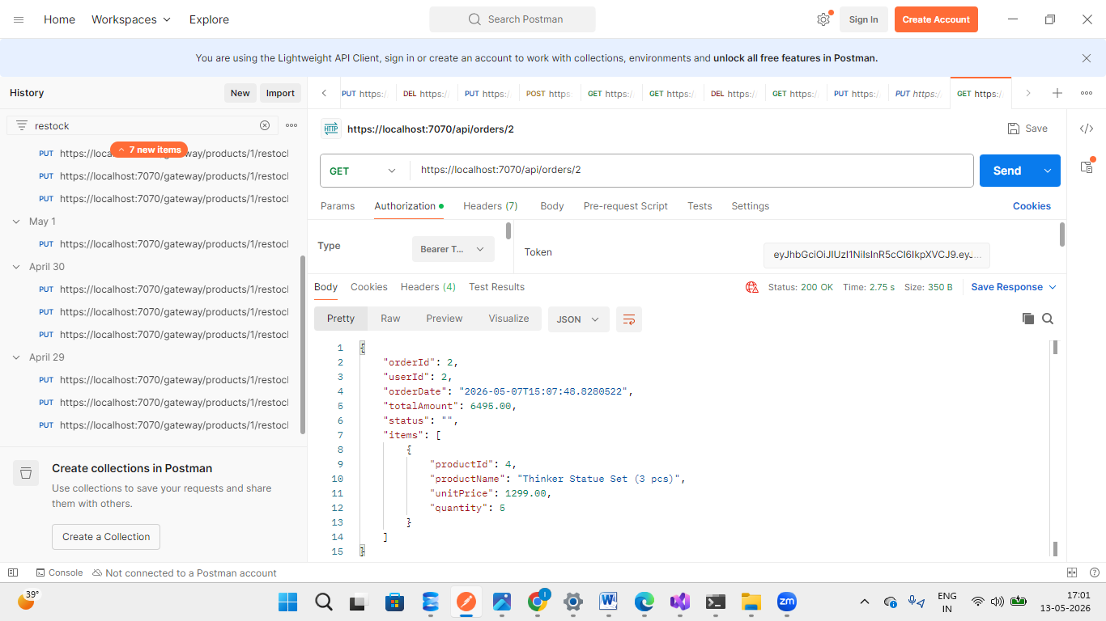Figure: Admin successfully retrieving a specific order using Order ID and a valid JWT token.

Invalid Order ID Testing
If the Admin tries to fetch an order using an Order ID that does not exist in the database, the system returns an error response.
This validation ensures that only valid existing orders can be retrieved.

Example Endpoint
GET /api/orders/200

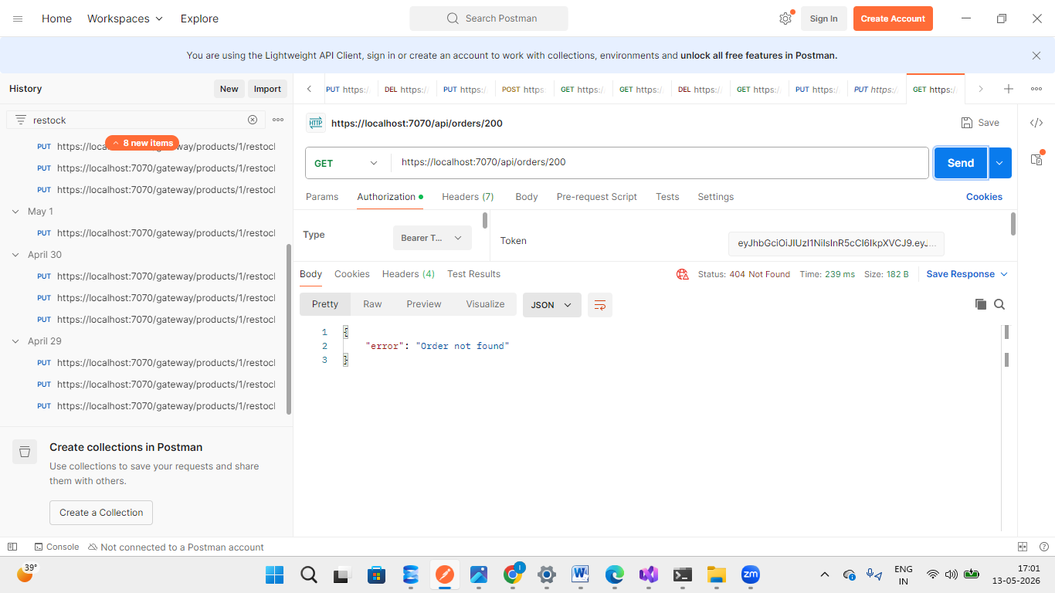
Figure: System returning "Order not found" response for an invalid Order ID.

My Orders Testing
Method | Endpoint | Description | Access
GET | /api/orders/my-orders | Get logged-in user orders | Customer
The My Orders endpoint is used to fetch order details of the currently logged-in user.
This endpoint extracts the User ID from the JWT token and returns only the orders belonging to that specific user.
Users cannot view orders of other users, ensuring secure and role-based order access.

JWT Functionality
The endpoint:
- Extracts User ID from JWT token claims
- Filters orders based on logged-in user
- Returns only that user's order history

Security Validation
The system ensures:
- Users can access only their own orders
- JWT authentication is mandatory
- Unauthorized users cannot access order history

Expected Response
200 OK

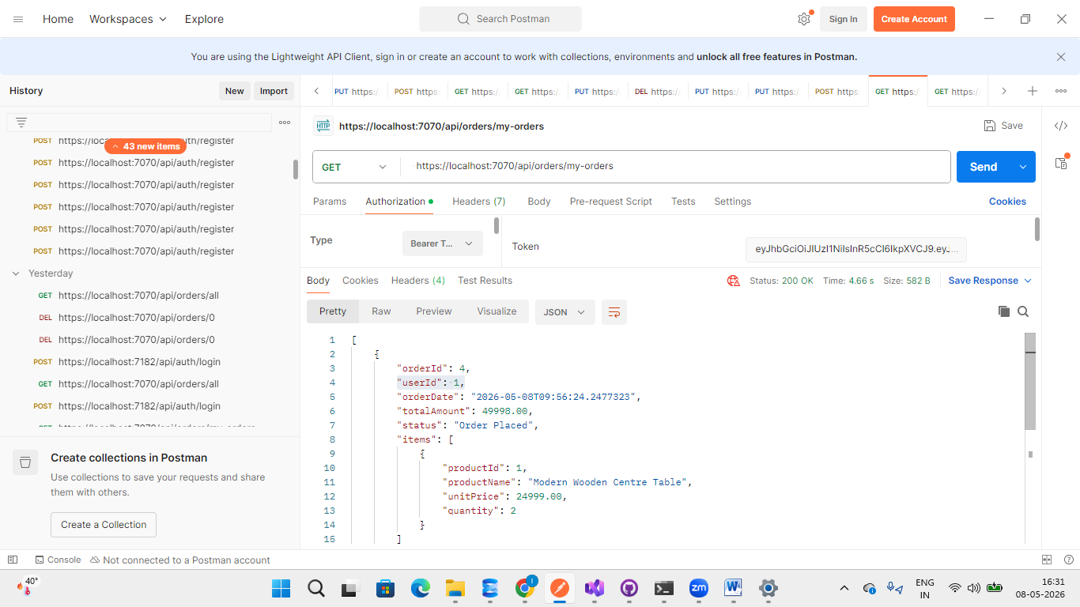

Get All Orders Testing
Method | Endpoint | Description | Access
GET | /api/orders/all | Get all orders | Admin
The Get All Orders endpoint is used to retrieve all orders available in the system.
This is a protected Admin-only endpoint, therefore only users with a valid Admin JWT token are authorized to access it.
The endpoint returns complete order details of all users stored in the Orders database.

Authorization Requirement
- Only Admin users can access this endpoint.
- A valid Admin JWT token is required.
- Normal users are not authorized to view all orders.
If an invalid, expired, or missing token is provided, the system returns:
401 Unauthorized

Functionality Verified
The following functionalities were verified during testing:
- Admin authorization
- JWT token validation
- Retrieval of all orders
- Protected endpoint access
- Database order fetching

Purpose of This Endpoint
This endpoint is mainly used by Admins to:
- Monitor all customer orders
- Manage order records
- View complete order history
- Track order activity in the system

Figure: Admin successfully retrieving all orders using a valid JWT token.
: 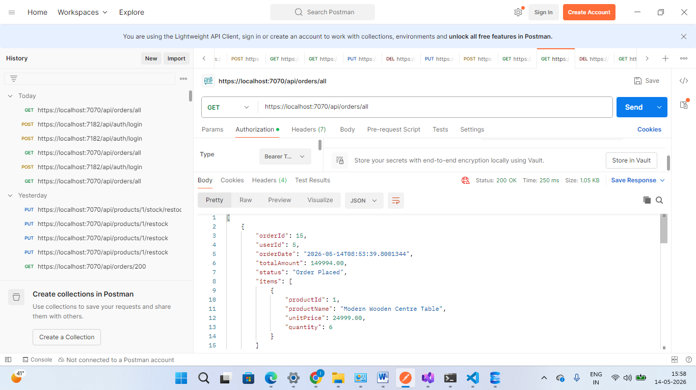

Delete Order Testing
Method | Endpoint | Description | Access
DELETE | /api/orders/{id} | Delete order | Admin
The Delete Order endpoint is used to remove an order from the system using its unique Order ID.
This is a protected Admin-only endpoint, therefore only users with a valid Admin JWT token are authorized to delete orders.
In this test case, Order ID 3 was successfully deleted from the database by the Admin.

Endpoint
DELETE /api/orders/{id}
Example:
DELETE /api/orders/3

Authorization Requirement
- Only Admin users can access this endpoint.
- A valid Admin JWT token is required.
If an invalid or missing token is provided, the system returns:
401 Unauthorized

Functionality Verified
The following functionalities were verified during testing:
- Order deletion by ID
- Admin authorization
- JWT token validation
- Database order removal
- Protected endpoint access

Sample Response
{
"message": "Order deleted successfully"
}

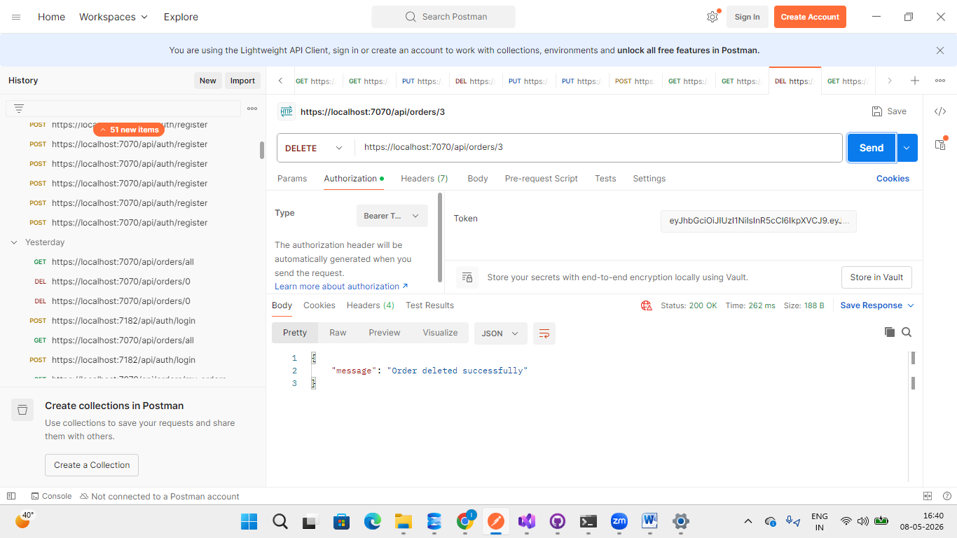
Figure: Admin successfully deleting Order ID 3 using a valid JWT token.

User can Cancle Own Order Testing
Method | Endpoint | Description | Access
PUT | /api/orders/{id}/cancel | Cancel existing order | Customer
The Delete Order endpoint also allows users to delete their own orders using a valid JWT token.
In this test case:
- A new user was registered.
- The user logged into the application.
- The JWT token generated during login was copied and used for authentication.
- The user created an order using the following JSON data:
{
"items": [
{
"productId": 1,
"quantity": 2
}
]
}
- Using the My Orders endpoint, the user fetched their order details.
- The Order ID from the response was copied.
- The same Order ID was used to delete the order successfully.

JWT Functionality
The system extracts the User ID from the JWT token and ensures that users can delete only their own orders.
Users are not authorized to delete orders belonging to other users.

Functionality Verified
The following functionalities were verified during testing:
- User authentication
- JWT token validation
- Order creation
- My Orders retrieval
- Order deletion by owner
- Secure user-based authorization

Security Validation
The system ensures:
- Users can delete only their own orders
- JWT authentication is mandatory
- Unauthorized access is restricted

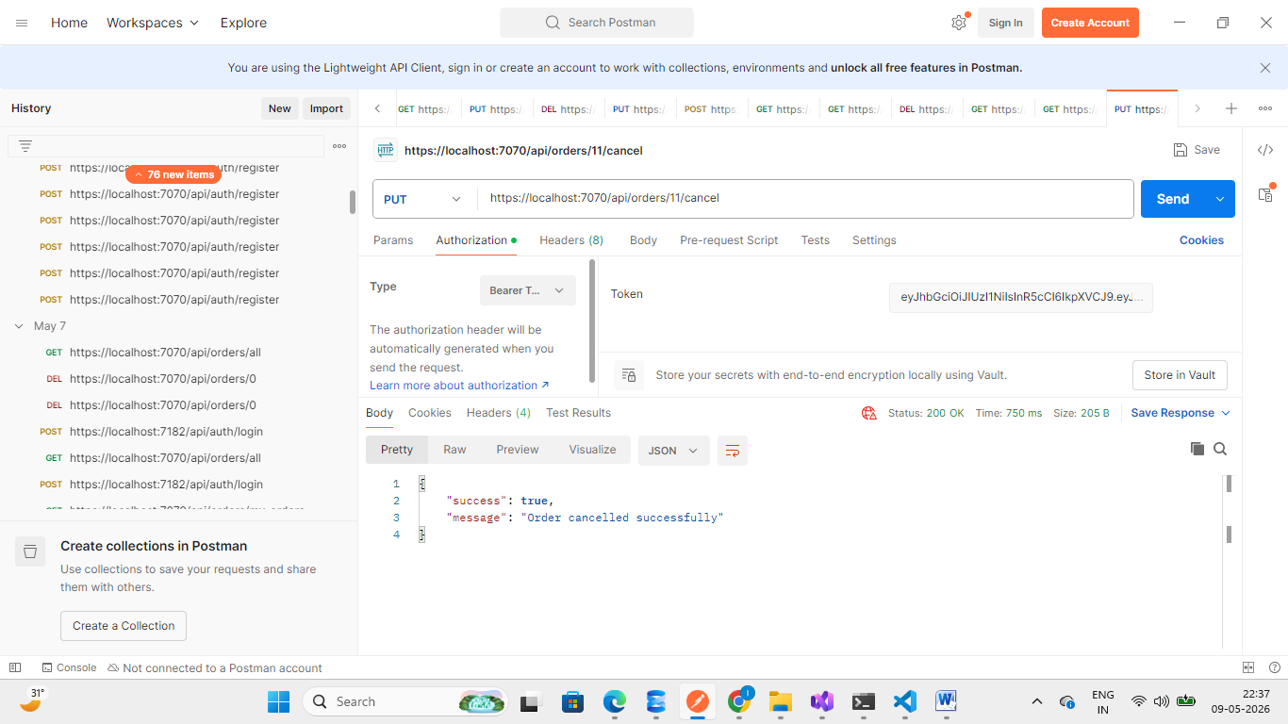
Figure: User successfully deleting their own order using a valid JWT token
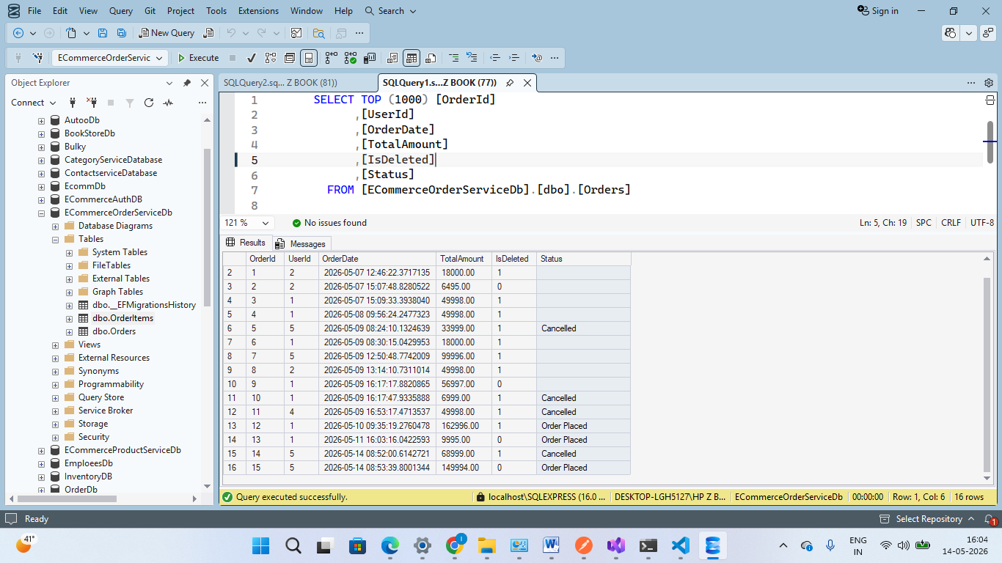
When a user cancels their order, the updated order status is immediately reflected in the Orders table in the database.

Ocelot .json
{
"Routes": [
{
"DownstreamPathTemplate": "/images/{everything}",
"DownstreamScheme": "http",
"DownstreamHostAndPorts": [
{
"Host": "productservice",
"Port": 8080
}
],
"UpstreamPathTemplate": "/images/{everything}",
"UpstreamHttpMethod": [ "GET" ]
},

{
"DownstreamPathTemplate": "/api/Auth/{everything}",
"DownstreamScheme": "http",
"DownstreamHostAndPorts": [
{
"Host": "authservice",
"Port": 8080
}
],
"UpstreamPathTemplate": "/api/Auth/{everything}",
"UpstreamHttpMethod": [ "GET", "POST", "PUT", "DELETE" ]
},

{
"DownstreamPathTemplate": "/api/products",
"DownstreamScheme": "http",
"DownstreamHostAndPorts": [
{
"Host": "productservice",
"Port": 8080
}
],
"UpstreamPathTemplate": "/api/products",
"UpstreamHttpMethod": [ "GET", "POST", "PUT", "DELETE" ]
},

{
"DownstreamPathTemplate": "/api/products/{everything}",
"DownstreamScheme": "http",
"DownstreamHostAndPorts": [
{
"Host": "productservice",
"Port": 8080
}
],
"UpstreamPathTemplate": "/api/products/{everything}",
"UpstreamHttpMethod": [ "GET", "POST", "PUT", "DELETE" ]
},

{
"DownstreamPathTemplate": "/api/orders",
"DownstreamScheme": "http",
"DownstreamHostAndPorts": [
{
"Host": "orderservice",
"Port": 8080
}
],
"UpstreamPathTemplate": "/api/orders",
"UpstreamHttpMethod": [ "GET", "POST", "PUT", "DELETE" ],
"AuthenticationOptions": {
"AuthenticationProviderKey": "Bearer",
"AllowedScopes": []
}
},

{
"DownstreamPathTemplate": "/api/orders/{everything}",
"DownstreamScheme": "http",
"DownstreamHostAndPorts": [
{
"Host": "orderservice",
"Port": 8080
}
],
"UpstreamPathTemplate": "/api/orders/{everything}",
"UpstreamHttpMethod": [ "GET", "POST", "PUT", "DELETE" ],
"AuthenticationOptions": {
"AuthenticationProviderKey": "Bearer",
"AllowedScopes": []
}
}
],

"GlobalConfiguration": {
"BaseUrl": "http://apigateway:8080"
}
}

XUnit Testing AND Mocking

Product Service Testing:

Technologies Used
Technology | Purpose
xUnit | Unit testing
Moq | Repository mocking
Arrange-Act-Assert | Test structure
Coverlet | Code coverage

Tested Features

CRUD Operations
- Get all products
- Get product by ID
- Create product
- Update product
- Delete product

Inventory Management
- Reduce stock after order placement
- Restock product inventory

Validation & Exception Testing
- Product not found validation
- Insufficient stock validation
- Empty product list handling

Repository Mocking
- Mocked repository methods using Moq
- Verified repository method execution using Verify()

Product Service Test Coverage
Area | Coverage
CRUD Operations | ✅
Business Logic | ✅
Stock Management | ✅
Validation Testing | ✅
Exception Handling | ✅

Order Service Testing

Technologies Used
Technology | Purpose
xUnit | Unit testing
Moq | Service and repository mocking
HttpClient Mocking | External API testing
Moq.Protected | Mock HttpMessageHandler
Arrange-Act-Assert | Test structure

Tested Features

Order Management
- Create order
- Cancel order
- Delete order
- Get order by ID
- Get orders by user
- Get all orders

External API Communication
- Product validation
- Product availability check
- Stock deduction
- Product restocking

Security & Authorization
- Unauthorized order deletion
- Unauthorized order cancellation

Validation & Exception Testing
- Product not found
- Insufficient stock
- Already cancelled order
- Unauthorized access
- Invalid order operations

HttpClient Mocking

Tested Scenarios
- Product API success response
- Product API not found response
- Stock deduction API failure
- Product restock API failure

Tools Used
- HttpClient
- HttpMessageHandler
- Moq.Protected

Order Service Test Coverage
Area | Coverage
Order Workflow | ✅
Business Logic | ✅
HttpClient Communication | ✅
Validation Testing | ✅
Authorization Testing | ✅
Exception Handling | ✅

Authentication Service Testing

Technologies Used
Technology | Purpose
xUnit | Unit testing
Moq | Repository mocking
JWT Testing | Authentication validation
Arrange-Act-Assert | Test structure

Tested Features

Authentication Testing
- User registration
- Duplicate user validation
- Login success
- Invalid credentials handling
- JWT token generation

Authorization Testing
- Change user role
- Invalid role validation
- Admin self-demotion prevention
- Get all users

Validation & Exception Testing
- User not found
- Invalid role assignment
- Repository update failure

Repository Mocking
- Mocked database repository methods
- Verified user creation and role updates

Authentication Service Test Coverage
Area | Coverage
User Registration | ✅
Login & JWT | ✅
Role Management | ✅
Validation Testing | ✅
Authorization Logic | ✅
Exception Handling | ✅

Overall Backend Testing Summary

Overall Testing Features
- Implemented unit testing for all backend microservices
- Used xUnit and Moq for backend testing
- Tested service-layer business logic independently
- Implemented repository mocking
- Added validation and exception testing
- Implemented HttpClient mocking for microservice communication
- Verified authorization and role-based access control

Overall Coverage Summary
Service | Coverage
Product Service | CRUD + inventory + validation
Order Service | Workflow + HttpClient + authorization
Auth Service | Authentication + authorization + JWT

Benefits Achieved
- Improved backend reliability
- Reduced runtime bugs
- Validated business logic
- Secured role-based operations
- Verified microservice communication
- Improved maintainability
- Increased application stability

Authservice
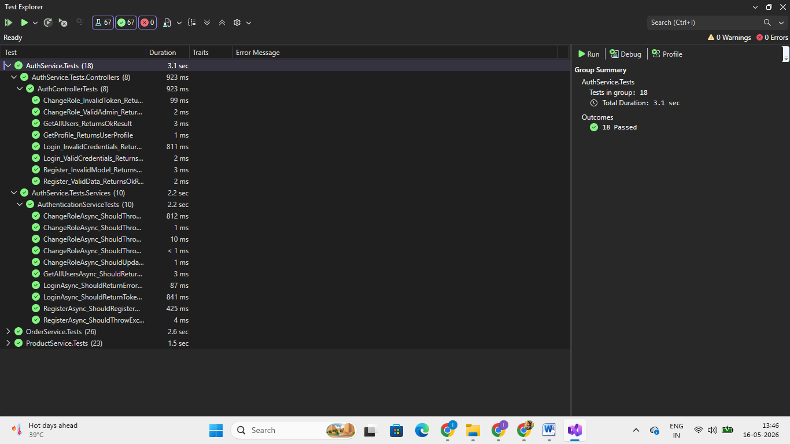
Product service and productserviceclient:
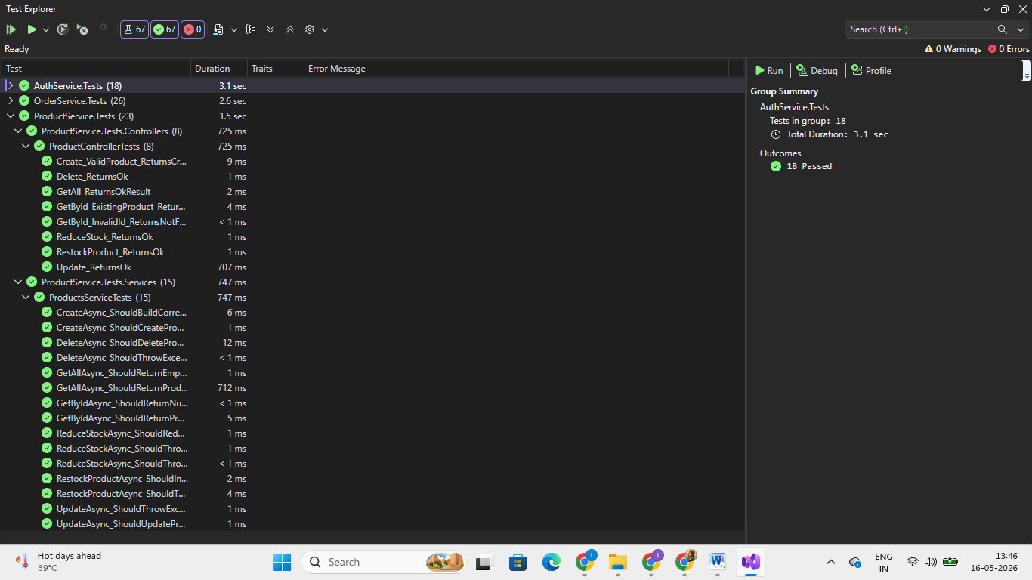

Orderservice testing:
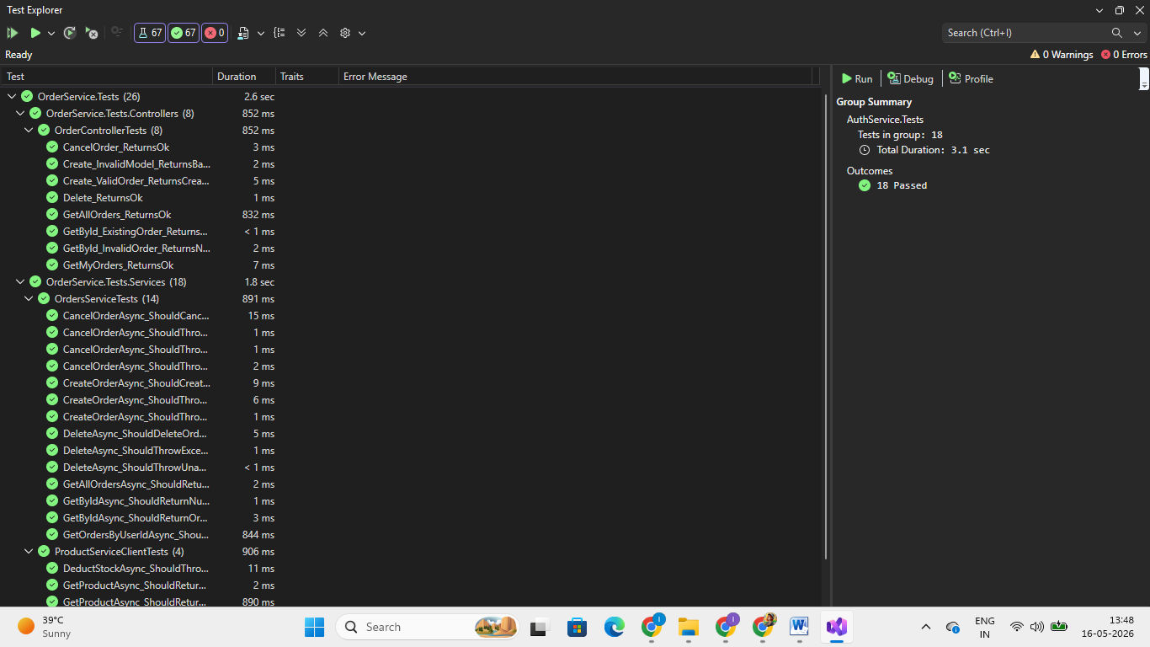

7. Authorization Matrix
Endpoint | Anonymous | Customer | Admin
POST /api/Auth/register | Yes | Yes | Yes
POST /api/Auth/login | Yes | Yes | Yes
GET /api/products | Yes | Yes | Yes
POST /api/products | No | No | Yes
PUT /api/products/{id} | No | No | Yes
DELETE /api/products/{id} | No | No | Yes
POST /api/orders | No | Yes | Yes
GET /api/orders/my-orders | No | Yes | No
GET /api/orders/all | No | No | Yes
PUT /api/Auth/change-role/{userId} | No | No | Yes

14. Dockerization & Containerization

14.1 Overview
The complete ShopEZ Backend Microservices Application was Dockerized to simplify deployment, improve scalability, and maintain environment consistency.
The backend architecture includes the following Docker containers:
- API Gateway (Ocelot)
- AuthService
- ProductService
- OrderService
- SQL Server Database

14.2 Docker Compose Orchestration
Docker Compose was used to orchestrate all backend services and manage:
- Container networking
- Port mappings
- Service dependencies
- Persistent storage

14.3 Docker Networking
Docker networking enabled communication between services using container names instead of localhost.
Example service names:
- authservice
- productservice
- orderservice
- sqlserver
- apigateway

14.4 Benefits of Dockerization
- Simplified deployment
- Consistent runtime environment
- Easier microservice management
- Production-style architecture
- Improved scalability

14.5 Docker Commands Used
- docker compose build
- docker compose up
- docker compose down
- docker compose logs
- docker ps

13. Conclusion
The E-Commerce Microservices Backend System successfully demonstrates the implementation of a secure and scalable distributed backend architecture using ASP.NET Core Web API.

14. Future Scope

Possible Future Enhancements
- Add Cart Service
- Payment Gateway Integration
- Kubernetes Orchestration
- Redis Caching
- RabbitMQ Integration
- Email Notifications
- CI/CD Pipeline
- Monitoring & Logging
- Cloud Deployment using Azure or AWS

