KAAYA ORGANICS
Digital Marketing Analytics Report
Executive Marketing Audit & 90-Day Growth Plan
Reporting period: 1–30 September 2026 (30-day snapshot)
Prepared for: Founder & Leadership Team
Prepared by: Growth & Performance Marketing
Date: 18 October 2026
A full-funnel read on traffic quality, engagement and conversion — with the three highest-leverage moves for the next quarter.

Confidential — prepared from a representative synthetic sample dataset for portfolio / interview review.

1. Executive Summary
Kaaya Organics closed the 30 days to 30 September 2026 with 299,000 website sessions, 7,358 orders and ₹1.46 crore (14,596,800) in revenue. That is a blended conversion rate of 2.46% at an average order value (AOV) of ₹1,984. Paid media absorbed ₹18.10 lakh and returned ₹43.22 lakh of attributed revenue — a blended return on ad spend (ROAS) of 2.39x and return on investment (ROI) of 139%. At headline level the programme is profitable and growing.
The averages, however, hide a structural problem. Roughly two-thirds of the paid budget is being spent on the two least efficient channels in the portfolio. Paid Social and Display together consume ₹11.90 lakh (66% of ad spend) yet return only 1.21x and 0.69x respectively — Display is actively losing money, burning ₹2.10 lakh to recover ₹1.44 lakh. Meanwhile the channels that convert best — Email at 6.8% and Referral at 3.8% — are the least funded, together accounting for just 7.7% of sessions. Growth is being bought at the wrong end of the funnel.
Underneath that, the on-site funnel leaks hardest at the point of highest intent. Of 185,000 product-page views, only 41,860 visitors add to cart, and of the 19,435 who begin checkout, just 7,358 complete — a 37.9% checkout completion rate. Recovering even a third of that leak would be worth more than any single channel change available to us.
Headline performance — 30 days to 30 Sep 2026
SESSIONS  2,99,000  8 sources | ORDERS  7,358  blended CR 2.46% | REVENUE  1.46 Cr  ₹1,45,96,800 | AD SPEND  18.10 L  3 paid channels | BLENDED ROAS  2.39x  ROI 139%
The three growth hacks in this report
1. Reallocate the paid budget. Move ~₹8.0 lakh out of Display and the weakest Paid Social placements into Paid Search and cart-abandonment retargeting — where we already know the audience converts.
2. Fix the checkout. Cut friction on the highest-intent step (one-page checkout, UPI-first, trust signals) to lift checkout completion from 37.9% toward 48%, the single largest revenue lever on the site.
3. Scale the owned lifecycle engine. Build email/SMS flows and a structured referral loop to grow the two best-converting channels from 7.7% of sessions toward 12%.
Modelled together, these three moves represent roughly ₹55–75 lakh of incremental revenue over a comparable 30-day period at current spend levels. Sections 8 and 9 detail the assumptions and the 90-day sequence.

2. Scope, Method & How to Read This Report
This audit analyses one 30-day window (1–30 September 2026) of website and campaign data for the Kaaya Organics D2C store. It covers eight traffic sources and the three paid channels that carry media spend, and traces a five-stage purchase funnel from session to order.
All metrics are computed from a single channel-level dataset (sessions, bounce rate, conversion rate, AOV, media spend, impressions and clicks) held in the appendix. Nothing in this report is estimated beyond that dataset; every ratio — CTR, CPC, CPA, ROAS, ROI — is derived arithmetically from it.
Definitions used throughout
Metric | Definition
CTR | Click-through rate — clicks ÷ impressions
CPC | Cost per click — media spend ÷ clicks
CPA | Cost per acquisition — media spend ÷ orders
ROAS | Return on ad spend — attributed revenue ÷ media spend
ROI | (Attributed revenue − media spend) ÷ media spend
Bounce rate | Share of sessions that end without interaction
AOV | Average order value — revenue ÷ orders

A note on the data
The dataset in this report is a representative synthetic sample built to mirror the shape of a mid-size Indian D2C skincare brand — seasonality, channel economics and funnel drop-offs are realistic, but the numbers are illustrative. It is intended to demonstrate analytical method and executive communication, not to state Kaaya Organics' actual trading results.

3. Traffic Sources — Where the Audience Comes From
Organic Search is the backbone of the acquisition mix, delivering 92,000 sessions (30.8% of traffic) at the lowest cost of any meaningful channel. Paid Social (58,000 sessions) and Paid Search (46,000) follow, together contributing a further third of traffic. The remainder is spread across Direct, Display, Organic Social, Email and Referral.
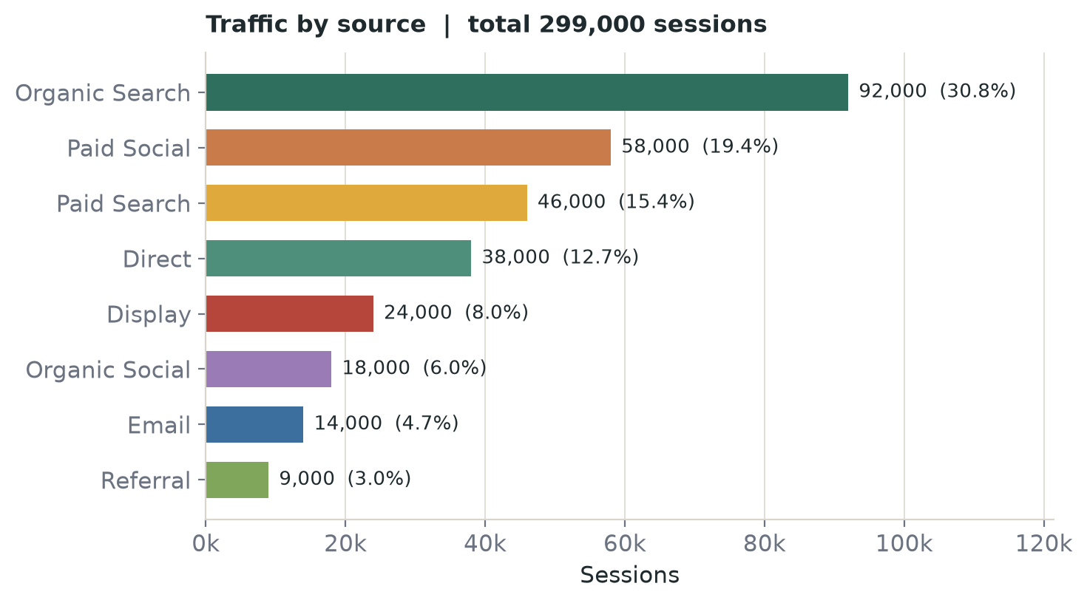
Figure 1 — Sessions by source, 30 days to 30 Sep 2026.
The mix matters more than the totals. The two channels with the weakest downstream economics — Paid Social and Display — together account for 82,000 sessions (27.4%) and ₹11.90 lakh of spend. The two strongest converters, Email and Referral, contribute just 23,000 sessions (7.7%). Traffic volume and traffic value are pointing in opposite directions, which is the central tension this audit addresses.
Traffic source summary
Channel | Sessions | Share | Bounce | Conv. rate | Orders | Revenue
Organic Search | 92,000 | 30.8% | 41% | 2.6% | 2,392 | ₹44,25,200
Paid Social | 58,000 | 19.4% | 68% | 1.2% | 696 | ₹11,83,200
Paid Search | 46,000 | 15.4% | 48% | 3.1% | 1,426 | ₹29,94,600
Direct | 38,000 | 12.7% | 35% | 3.4% | 1,292 | ₹26,48,600
Display | 24,000 | 8.0% | 81% | 0.4% | 96 | ₹1,44,000
Organic Social | 18,000 | 6.0% | 72% | 0.9% | 162 | ₹2,59,200
Email | 14,000 | 4.7% | 22% | 6.8% | 952 | ₹21,89,600
Referral | 9,000 | 3.0% | 44% | 3.8% | 342 | ₹7,52,400
Table 1 — Traffic, engagement and output by source.

4. Engagement — Bounce Rate as a Quality Signal
The site-wide bounce rate is 50.8%, but the channel spread runs from 22% (Email) to 81% (Display) — a 59-point gap that tells us far more about traffic quality than the blended figure does.
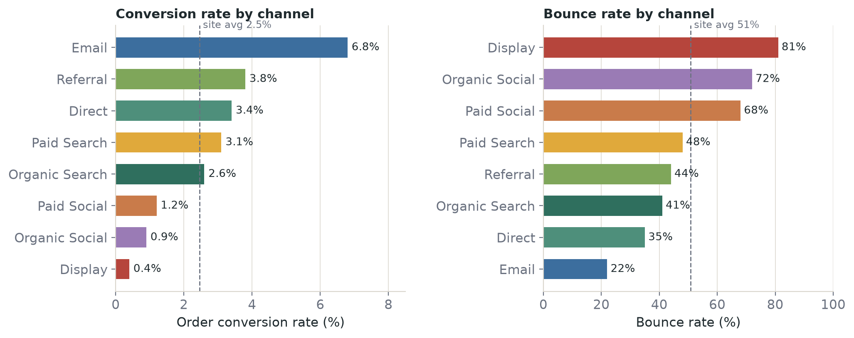
Figure 2 — Conversion rate (left) and bounce rate (right) by channel.
Channels that acquire an audience with existing intent behave very differently from those that interrupt one. Email (22%), Direct (35%) and Organic Search (41%) sit well below the site average, while Display (81%), Organic Social (72%) and Paid Social (68%) sit far above it. High bounce is not automatically bad — a first-touch awareness visit may legitimately bounce — but when it is combined with a low conversion rate it becomes evidence that the traffic is the wrong traffic.
The pattern to watch
Bounce rate and conversion rate are inversely related across almost every channel. Display and Organic Social pair the highest bounce rates (81%, 72%) with the lowest conversion rates (0.4%, 0.9%). Email pairs the lowest bounce (22%) with the highest conversion (6.8%). The lesson: buy fewer, better-matched clicks rather than more cheap ones.

5. Conversion Rate — Output by Channel
Blended conversion is 2.46%, but that average conceals a five-fold spread. Email converts at 6.8%, Referral at 3.8% and Direct at 3.4%; at the other end, Organic Social manages 0.9% and Display 0.4%. The channels above the site average are exactly the ones we are under-investing in.
Channel | Sessions | Orders | Conv. rate | AOV | Revenue | Revenue / session
Email | 14,000 | 952 | 6.8% | ₹2,300 | ₹21,89,600 | ₹156
Referral | 9,000 | 342 | 3.8% | ₹2,200 | ₹7,52,400 | ₹84
Direct | 38,000 | 1,292 | 3.4% | ₹2,050 | ₹26,48,600 | ₹70
Paid Search | 46,000 | 1,426 | 3.1% | ₹2,100 | ₹29,94,600 | ₹65
Organic Search | 92,000 | 2,392 | 2.6% | ₹1,850 | ₹44,25,200 | ₹48
Paid Social | 58,000 | 696 | 1.2% | ₹1,700 | ₹11,83,200 | ₹20
Organic Social | 18,000 | 162 | 0.9% | ₹1,600 | ₹2,59,200 | ₹14
Display | 24,000 | 96 | 0.4% | ₹1,500 | ₹1,44,000 | ₹6
Table 2 — Conversion output ranked by conversion rate. Revenue-per-session (right column) is the cleanest single measure of channel value.
Revenue per session sharpens the picture further. Email generates ₹156 of revenue for every session it sends; Referral ₹84; Direct ₹70. Paid Social, despite being our second-largest source of traffic, returns just ₹20 per session and Display ₹6. When a channel's cost per click (Section 7) is a multiple of what a session is worth, no amount of volume will make it work.

6. Conversion Funnel — Where the Drop-Off Happens
Tracing the journey from session to order localises the single biggest opportunity on the site. The funnel narrows gradually at the top and then collapses at the bottom.
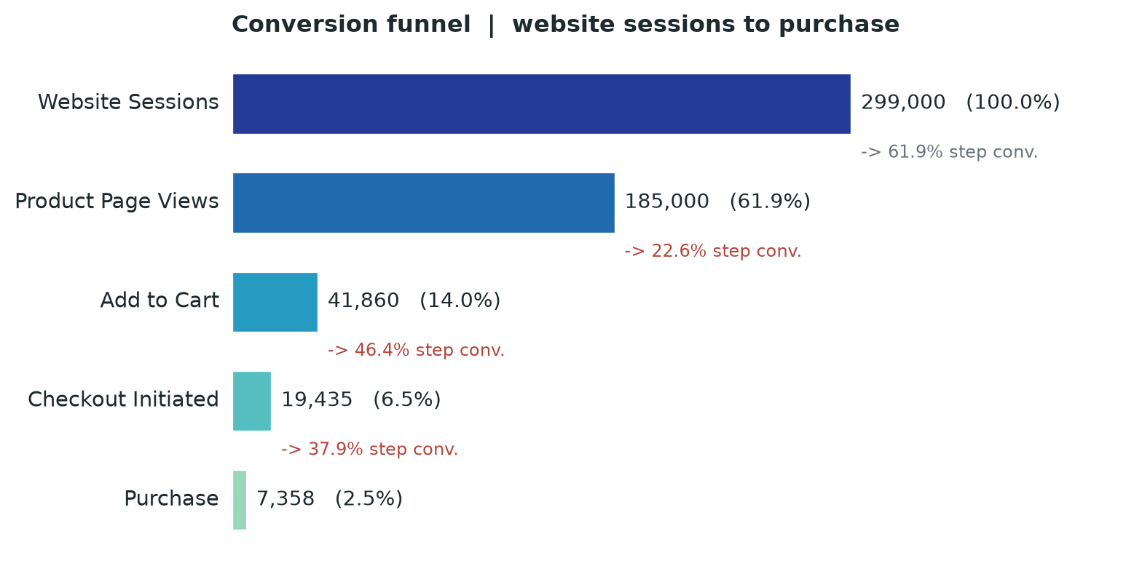
Figure 3 — Site-wide conversion funnel, session to purchase.
Funnel stage | Entered | % of sessions | Step conversion | Drop-off
Website Sessions | 2,99,000 | 100.0% | — | —
Product Page Views | 1,85,000 | 61.9% | 61.9% | 38.1%
Add to Cart | 41,860 | 14.0% | 22.6% | 77.4%
Checkout Initiated | 19,435 | 6.5% | 46.4% | 53.6%
Purchase | 7,358 | 2.5% | 37.9% | 62.1%
Table 3 — Stage-by-stage funnel performance.
Two steps carry almost all of the loss. Product-to-cart converts at just 22.6% — the merchandising and product-page job. More importantly, checkout-to-purchase converts at only 37.9%, meaning roughly six in ten shoppers who have already committed to buy abandon at the final step. This is the highest-intent, highest-value traffic on the entire site, and we are losing the majority of it to friction, payment failures or price/trust hesitation at the last moment.
Why this is the priority
A shopper who reaches checkout has already chosen a product and decided to pay. Recovering them requires no additional media spend. Lifting checkout completion from 37.9% to 48% would add roughly 1,960 orders and ₹38.9 lakh in revenue in a comparable period — with essentially no incremental acquisition cost. No channel optimisation comes close to that leverage.

7. Paid Media Efficiency — CTR, CPC, CPA and ROI
The three paid channels tell three very different stories. Paid Search is a profitable workhorse, Paid Social is an expensive experiment running at scale, and Display is a structural loss.
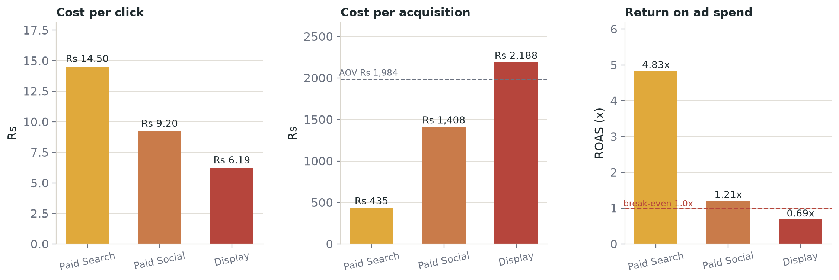
Figure 4 — Cost per click, cost per acquisition and return on ad spend by paid channel.
Metric | Paid Search | Paid Social | Display | Blended
Media spend | 6.20 L | 9.80 L | 2.10 L | 18.10 L
Impressions | 7,80,000 | 97,00,000 | 1,21,00,000 | 2,25,80,000
Clicks | 42,760 | 1,06,500 | 33,900 | 1,83,160
CTR | 5.48% | 1.10% | 0.28% | 0.81%
CPC | ₹14 | ₹9 | ₹6 | ₹10
Orders | 1,426 | 696 | 96 | 2,218
CPA | ₹435 | ₹1,408 | ₹2,188 | ₹816
ROAS | 4.83x | 1.21x | 0.69x | 2.39x
ROI | 383% | 21% | -31% | 139%
Table 4 — Paid media efficiency. Display is loss-making (ROAS below 1.0x).
Paid Search earns ₹4.83 for every rupee spent, at a ₹435 CPA that sits comfortably below AOV. Paid Social returns only ₹1.21 per rupee at a ₹1,408 CPA — it is not yet recovering its cost once fulfilment and margin are considered. Display returns ₹0.69 per rupee: a ₹2,188 CPA against a ₹1,984 AOV means every Display order is sold below the cost of acquiring it. In aggregate, Paid Social and Display account for 66% of spend but deliver only 31% of paid revenue.
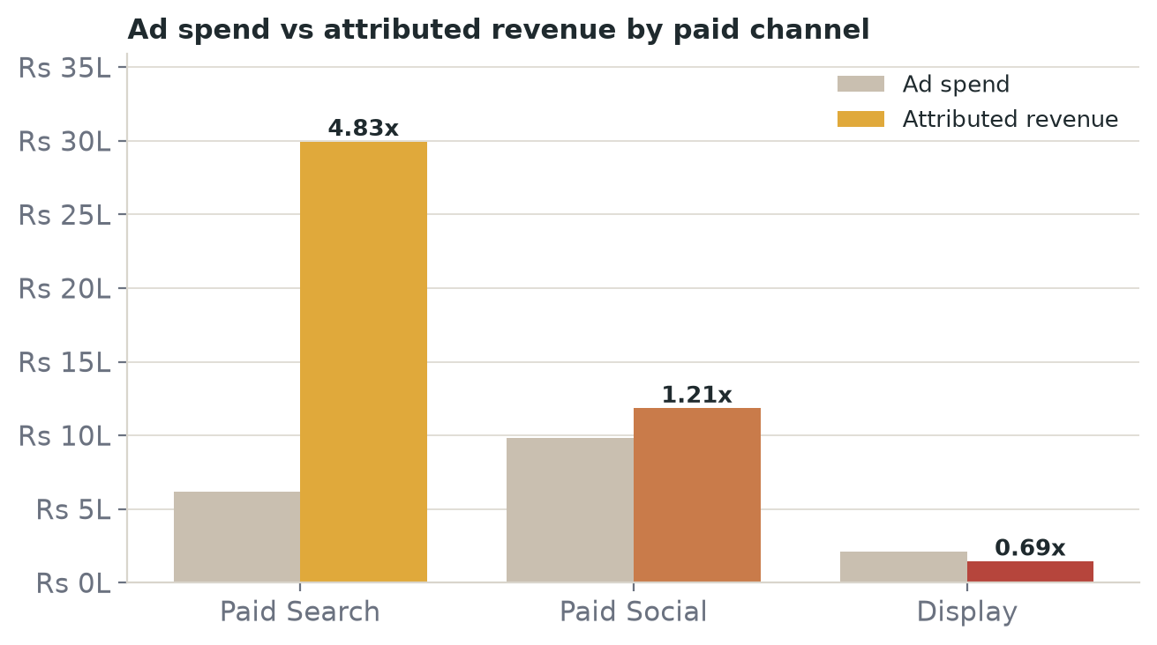
Figure 5 — Media spend versus attributed revenue by paid channel.
Budget verdict
Display should be paused immediately — it is destroying ₹66,000 of value in the period analysed. Paid Social should be held at a hard 1.5x blended ROAS floor and restructured toward retargeting and high-intent audiences before any further scaling. The freed budget belongs in Paid Search and retargeting, where incremental rupees still clear a profit.

8. Growth Tactics — Three Optimization Hacks
HACK 01
Reallocate ₹8 lakh of paid budget to the channels that already convert
The fastest available win is not to spend more but to spend better. Display (₹2.10 lakh, 0.69x) should be paused outright, and Paid Social (₹9.80 lakh, 1.21x) reduced and rebuilt around retargeting and lookalikes of purchasers rather than broad cold audiences. Combined, that frees roughly ₹8.0 lakh.
Redeploy it where the audience has demonstrated intent: scale Paid Search on the brand and high-intent non-brand terms that already return 4.83x, and fund a dedicated cart- and browse-abandonment retargeting programme. Even at a conservative 2.4x — half of Paid Search's current efficiency — ₹8.0 lakh redeployed returns approximately ₹19.2 lakh in revenue, versus the ₹1.6 lakh the same money returns through Display today.
Owner: Performance Marketing · Timeframe: Weeks 1–2 · KPI: blended paid ROAS from 2.39x toward 3.0x
HACK 02
Fix the checkout and recover the highest-intent traffic on the site
Checkout-to-purchase converts at 37.9% — the weakest step in the funnel and the most expensive leak, because this traffic has already decided to buy. The fix is operational, not creative: a single-page, mobile-first checkout; UPI and wallet options promoted above card; guest checkout by default; transparent shipping and delivery promises shown before payment; and clear trust signals (returns, authenticity, secure-payment badges) at the point of hesitation.
Lifting completion from 37.9% to 48% — a realistic target for a friction-removal programme on this step — adds roughly 1,960 orders and ₹38.9 lakh of revenue in a comparable period, at no incremental media cost. The second priority is the product-to-cart step (22.6%), where better product imagery, reviews and bundle offers can move the middle of the funnel.
Owner: Product & CRO · Timeframe: Weeks 2–6 · KPI: checkout completion ≥ 48%, overall CR from 2.46% toward 3.0%
HACK 03
Scale the owned lifecycle engine — email, SMS and referral
Email is the single best-converting channel on the site (6.8%, ₹156 revenue per session) and Referral the second-most efficient (₹84 per session), yet together they drive only 7.7% of sessions. These are channels we control, with no rising CPC and no auction risk.
Build a structured lifecycle programme: a welcome and first-purchase flow, browse- and cart-abandonment sequences, a post-purchase reorder cadence tuned to a consumable product, and a two-sided referral offer (give-₹150, get-₹150) triggered at the moment of highest satisfaction. Growing Email and Referral from 7.7% to 12% of sessions — 12,800 additional sessions at current channel conversion — is worth roughly ₹21.9 lakh in revenue per period, and it compounds as the list grows.
Owner: CRM & Lifecycle · Timeframe: Weeks 3–12 · KPI: owned channels to 12% of sessions; email revenue share doubled
Combined modelled impact
Growth hack | Primary lever | Incremental revenue (per 30 days)
1. Budget reallocation | ₹8.0 L moved to Paid Search + retargeting | ≈ ₹19.2 L
2. Checkout fix | Checkout completion 37.9% → 48% | ≈ ₹38.9 L
3. Owned lifecycle | Email + Referral 7.7% → 12% of sessions | ≈ ₹21.9 L
Table 5 — Individually modelled impact. The three levers overlap (Hack 2 lifts conversion on traffic Hack 3 also grows), so a realistic combined range is ₹55–75 lakh rather than the simple ₹80 lakh sum.
9. Recommended 90-Day Action Plan
The sequence matters. Fix the budget and the checkout first — both are high-certainty and fast — then compound the gains with the owned lifecycle engine.
Phase | Focus | Actions | Success measure
Weeks 1–2 | Stop the leak | Pause Display; cap Paid Social at a 1.5x ROAS floor; launch cart-abandonment retargeting | Blended paid ROAS → 2.8x
Weeks 2–6 | Fix the funnel | One-page mobile checkout; UPI-first payment; guest checkout; trust signals at payment | Checkout completion ≥ 48%
Weeks 3–12 | Build the engine | Welcome, abandonment, reorder flows; two-sided referral programme | Owned channels → 12% of sessions
Weeks 6–12 | Scale what works | Reinvest proven budget into Paid Search; test product-page merchandising to lift add-to-cart | Overall CR → 3.0%; ROAS → 3.0x
Table 6 — Sequenced 90-day plan.
What we are explicitly not recommending
We are not recommending an increase in total media budget this quarter. Every rupee of the modelled upside above comes from reallocation, conversion-rate improvement and owned channels — not from more spend. Only once the checkout leak is closed and Paid Search is absorbing the reallocated budget efficiently should absolute spend be revisited.
Risks and dependencies
The checkout and lifecycle work depends on product and engineering capacity; the referral programme needs margin headroom on the incentive; and Paid Search scaling will face diminishing marginal ROAS as spend grows, which is why the model assumes 2.4x on reallocated budget rather than the current 4.83x. Each assumption is testable within the 90-day window.

Appendix A — Full Channel Dataset
Channel | Sessions | Bounce | Conv. rate | Orders
Organic Search | 92,000 | 41% | 2.6% | 2,392
Direct | 38,000 | 35% | 3.4% | 1,292
Paid Search | 46,000 | 48% | 3.1% | 1,426
Paid Social | 58,000 | 68% | 1.2% | 696
Email | 14,000 | 22% | 6.8% | 952
Organic Social | 18,000 | 72% | 0.9% | 162
Referral | 9,000 | 44% | 3.8% | 342
Display | 24,000 | 81% | 0.4% | 96
Table A1 — Traffic and conversion by source.
Channel | AOV | Revenue | Media spend | CPA | ROAS
Organic Search | ₹1,850 | ₹44,25,200 | — | — | —
Direct | ₹2,050 | ₹26,48,600 | — | — | —
Paid Search | ₹2,100 | ₹29,94,600 | ₹6,20,000 | ₹435 | 4.83x
Paid Social | ₹1,700 | ₹11,83,200 | ₹9,80,000 | ₹1,408 | 1.21x
Email | ₹2,300 | ₹21,89,600 | — | — | —
Organic Social | ₹1,600 | ₹2,59,200 | — | — | —
Referral | ₹2,200 | ₹7,52,400 | — | — | —
Display | ₹1,500 | ₹1,44,000 | ₹2,10,000 | ₹2,188 | 0.69x
Table A2 — Revenue and paid economics. Paid metrics shown only where media spend exists.
Appendix B — Glossary
Term | Meaning
AOV | Average order value = revenue ÷ orders
CTR | Click-through rate = clicks ÷ impressions
CPC | Cost per click = media spend ÷ clicks
CPA | Cost per acquisition = media spend ÷ orders
ROAS | Return on ad spend = attributed revenue ÷ media spend (gross)
ROI | Return on investment = (revenue − spend) ÷ spend (net of media)
Revenue per session | Revenue ÷ sessions — the value of a single visit by source
Step conversion | Percentage of users advancing from one funnel stage to the next

Prepared by Growth & Performance Marketing · Kaaya Organics Digital Marketing Analytics Report · Reporting period 1–30 September 2026 · Built on a representative synthetic sample dataset.

