Software Requirements
Specification
for
Study planner and partner
finder system
Version 1.0 approved
Prepared by
Isham S. (0039-BSCS-24)
Fatima N. (0097-BSCS-24)
Rameen U. (0067-BSCS-24)

15th November 2025
(This project was completed as part of a 3-member group in our Software Engineering course. My contributions included documentation, SRS sections, and design work.)

Copyright © 1999 by Karl E. Wiegers. Permission is granted to use, modify, and distribute this document.

Software Requirements Specification for Study planner and partner finder system

Table of Contents

Table of Contents ii Revision History ii 1. Introduction 1
1.1 Purpose..............................................................................................................................................1
1.2 Document Conventions.....................................................................................................................1 1.3 Intended Audience and Reading Suggestions...................................................................................1 1.4 Product Scope...................................................................................................................................1
1.5 References.........................................................................................................................................1

2. Overall Description 2
2.1 Product Perspective...........................................................................................................................2
2.2 Product Functions.............................................................................................................................2
2.3 User Classes and Characteristics......................................................................................................2
2.4 Operating Environment.....................................................................................................................2
2.5 Design and Implementation Constraints...........................................................................................2
2.6 User Documentation.........................................................................................................................2
2.7 Assumptions and Dependencies.......................................................................................................3

3. External Interface Requirements 3
3.1 User Interfaces..................................................................................................................................3
3.2 Hardware
Interfaces..........................................................................................................................3
3.3 Software Interfaces...........................................................................................................................3
3.4 Communications Interfaces..............................................................................................................3

4. System Features 4
4.1 System Feature 1...............................................................................................................................4
4.2 System Feature 2 (and so on)............................................................................................................4

5. Other Nonfunctional Requirements 4
5.1 Performance Requirements...............................................................................................................4
5.2 Safety Requirements.........................................................................................................................5
5.3 Security Requirements......................................................................................................................5
5.4 Software Quality Attributes..............................................................................................................5
5.5 Business Rules..................................................................................................................................5

6. Other Requirements 5

Appendix A: Glossary 5

Appendix B: Analysis Models 5

Appendix C: To Be Determined List 6

Revision History
Name | Date | Reason For Changes | Version
- | - | Initial Approved Version | 1.0

1.Introduction
1.1Purpose
This Software Requirements Specification (SRS) document defines the complete requirements for the Study Planner and Partner Finder System. It includes system behavior, functional and nonfunctional requirements, interfaces, constraints, and detailed features of the system. This SRS describes the entire product.
1.2Document Conventions




Requirements are labeled as REQ-X.Y.

Priorities: High (H), Medium (M), Low (L).
Bold text indicates key elements.
All diagrams referenced are conceptual.
1.3Intended Audience and Reading Suggestions




Developers & Designers: Focus on Sections 2, 3, 4.
Testers: Focus on functional requirements in Section 4.
Project Managers: Review Sections 1, 2, and 5.
End-users / Clients: Overview in Sections 1 and 2.
1.4Product Scope
The system is a web-based application that helps students:
Plan their study schedules intelligently
Generate auto-timelines from deadlines Track academic progress with analytics Find suitable study partners using a matching algorithm Communicate via an in-built chat system The goal is to improve productivity,
collaboration, and learning outcomes.
1.5References
No prior documents were used in preparing this SRS

2.Overall Description
2.1Product Perspective
The system is a standalone web application with four modules:
- Smart Study Planner
- Partner Finder
- Real-time Chat
- Admin Panel
It includes a database, REST API backend, and browser-based frontend.
2.2Product Functions
User registration & authentication
Creation and management of study plans
Automatic schedule generation
Task tracking & progress analysis
Partner matching using multi-factor algorithm
Chat & collaboration
Admin monitoring & user management
Chat Database
A conceptual diagram showing the major modules and how they relate is included below:
















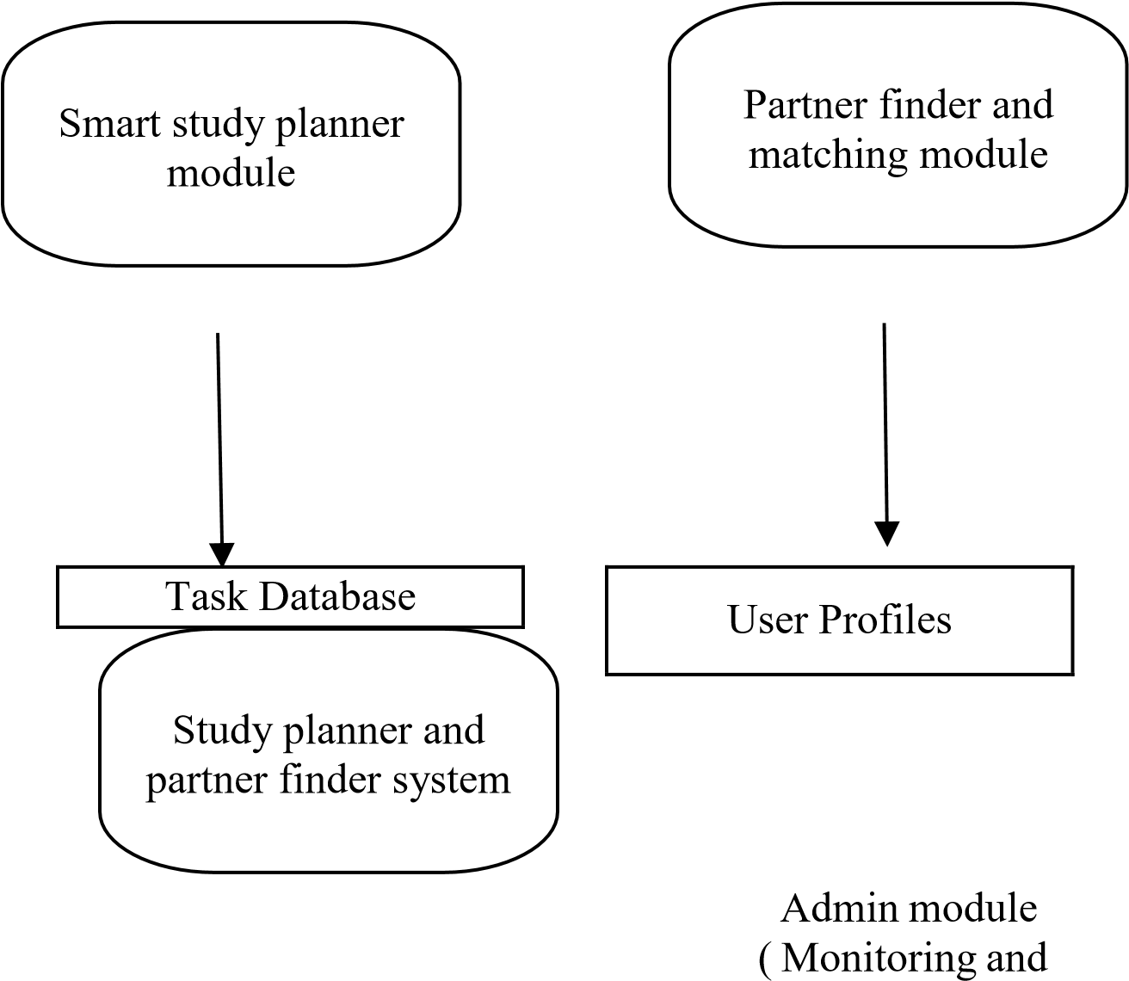
Management)
Real

-

time

chat

and

collaboration

module

2.3User Classes and Characteristics
User Type | Characteristics | Access Level
Student | Basic computer skills | Can create plans, match
 |  | partners
Study Partner | Same as student | Collaborative tasks, chat
Admin | Technical knowledge | Full control, moderation
2.4Operating Environment
OS: Windows, macOS, Linux
Browser: Chrome, Firefox, Safari
Backend: Node.js / Django Database: PostgreSQL / MySQL
2.5Design and Implementation Constraints
Must use relational database
Must support mobile-responsive UI
Must support secure login (JWT or session-based) Real time chat requires WebSockets
2.6User Documentation
Online user manual
FAQs
Walkthrough tutorial In app tooltips
2.7Assumptions and Dependencies
Users have internet access
Browser supports JavaScript
Notifications depend on SMTP or push notification service

3.External Interface Requirements
3.1User Interfaces
Clean, responsive UI
Dashboard with schedule, tasks, analytics
Partner matching screen
Chat window with live typing indicator
3.2Hardware Interfaces
No special hardware required.
3.3Software Interfaces
Database connection
Email server
WebSocket server for real-time chat
3.4Communications Interfaces
HTTPS for secure communication
WebSocket for chat SMTP for notifications

4.System Features
4.1System Feature: Smart Study Planner
4.1.1Description & Priority A scheduling assistant that creates intelligent study plans. Priority: High
4.1.2Stimulus/Response Sequences
- User enters subjects, deadlines, study hours.
- System analyzes workload.
- System generates optimized schedule.
- User updates tasks; system updates analytics.
4.1.3Functional Requirements
REQ-1.1: The system shall allow users to enter subjects, tasks, and deadlines.
REQ-1.2: The system shall automatically generate a study schedule using prioritization logic.
REQ-1.3: The system shall reschedule missed tasks.
REQ-1.4: The system shall display analytics, including daily hours, completion rate, and weak subjects.
REQ-1.5: The system shall send reminders for upcoming deadlines.
4.2System Feature: Partner Finder & Matching
4.2.1Description & Priority Matches students based on multiple parameters. Priority: High
4.2.2Stimulus/Response Sequences
- User completes profile (subjects, levels, availability).
- System calculates match score.
- Recommended partners are displayed.
- User may send a collaboration request.
4.2.3Functional Requirements
REQ-2.1: The system shall collect user preferences and study habits.
REQ-2.2: The system shall calculate match score using weighted criteria.
REQ-2.3: The system shall show partner suggestions based on match score.
REQ-2.4: The system shall notify users of new partner requests.
REQ-2.5: The system shall allow users to accept/decline partner requests.
4.3System Feature: Real-time Chat & Collaboration
4.3.1Description & Priority
Provides messaging and shared study space.

Priority: Medium
4.3.2Stimulus/Response Sequences
- Users accept match request.
- Chat screen opens.
- Users exchange messages in real time.
- Users share notes, schedules, and updates.
4.3.3Functional Requirements
REQ-3.1: The system shall support real-time messaging.
REQ-3.2: The system shall show online/offline status.
REQ-3.3: The system shall allow sharing of schedules and tasks. REQ3.4: The system shall store chat history.
4.4System Feature: Admin Management
4.4.1Description & Priority Ensures system integrity and content moderation. Priority:

Medium
4.4.2Functional Requirements
REQ-4.1: Admin can view all users.
REQ-4.2: Admin can remove inappropriate users. REQ4.3: Admin can view system statistics.

5.Other Nonfunctional Requirements
5.1Performance Requirements
The system shall handle 500+ concurrent users.
Auto-scheduling algorithm shall generate a plan within 5 seconds. Chat messages shall appear within 1 second.
5.2Safety Requirements
System shall prevent data loss during power or server failure. Regular backups must be maintained.
5.3Security Requirements
All passwords must be encrypted.
Two-factor authentication (optional).
Chat data must be secured using encryption.
5.4Software Quality Attributes
Usability: Simple UI for students Reliability: 99% uptime

Maintainability: Modular code
Portability: Works on all major browsers

5.5Business Rules
Users must verify their email before using advanced features. Misuse of chat can lead to account suspension.

6.Other Requirements
Database must support relational integrity.
System should support future mobile app expansion.

7.Appendix A: Glossary
Match Score: Numerical value representing partner compatibility
Task: A study-related activity with a defined deadline Analytics: A breakdown of performance indicators

8.Appendix B: Analysis Models
Use Case Diagrams
Class Diagrams
Sequence Diagrams
Collaborative Diagrams
Detailed Use Case, Sequence, Activity, and DFD diagrams are available in a separate document.

9.Appendix C: To Be Determined List
AI complexity level for auto-scheduling
Push notification service provider

