**Industrial Internship Report on**

**”Bank Management System”**

**Prepared by**

**Isha Vilasrao Mankar**

|  |
| --- |
| *Executive Summary* |
| This report provides details of the Industrial Internship provided by upskill Campus and The IoT Academy in collaboration with Industrial Partner UniConverge Technologies Pvt Ltd (UCT).  This internship was focused on a project/problem statement provided by UCT. We had to finish the project including the report in 6 weeks’ time.  My project was (Tell about ur Project)  This internship gave me a very good opportunity to get exposure to Industrial problems and design/implement solution for that. It was an overall great experience to have this internship. |

**TABLE OF CONTENTS**

1 Preface 3

2 Introduction 5

2.1 About UniConverge Technologies Pvt Ltd 5

2.2 About upskill Campus 9

2.3 Objective 11

2.4 Reference 11

2.5 Glossary 11

3 Problem Statement 12

4 Existing and Proposed solution 13

5 Proposed Design/ Model 15

6 Performance Test 17

6.1 Test Plan/ Test Cases 17

6.2 Test Procedure 21

6.3 Performance Outcome 24

7 My learnings 25

8 Future work scope 26

# Preface

**Summary of the whole 6 weeks’ work:**

During the enriching six-week internship with UPSKILLS CAMPUS, I dedicated myself to developing a comprehensive Bank Management System using core Java. The project's success was the result of a systematic approach and consistent progress throughout the weeks.

In the first week, I meticulously designed and planned all the modules of the system, laying the groundwork for a well-structured and organized project.

The second week marked the commencement of the implementation phase, where I focused on creating a secure and user-friendly login and signup page, ensuring the foundation of user authentication.

By the third week, significant progress was achieved as I successfully completed the login, signup, deposit, and withdraw modules, accompanied by seamless database connectivity. These essential functionalities were crucial pillars of the banking system.

In the fourth week, I tackled the transfer and mini statement modules, empowering users to perform transactions between accounts and access concise transaction histories.

As the fifth week arrived, I delved into the development of the edit profile, view profile, and check balance modules, ensuring users had the flexibility to manage their personal information and monitor their account balances. Additionally, I took extra care to handle exceptions effectively, enhancing the system's reliability and user experience.

Throughout this intense and dynamic six-week journey, I not only sharpened my Java programming skills but also gained a profound understanding of the complexities and challenges associated with developing a sophisticated banking system.

The experience allowed me to witness the entire software development life cycle, from meticulous planning to seamless implementation, all while ensuring adherence to best coding practices and robust exception handling.

**About need of relevant Internship in career development:**

In the pursuit of shaping a successful and fulfilling career, relevant internships play a pivotal role in providing invaluable hands-on experience and industry exposure. During my academic journey, I had the privilege of undertaking an enriching internship with UPSKILLS CAMPUS company as a core Java intern, which proved to be a significant stepping stone in my career development.

**Brief about Your project/problem statement:**

One of the highlights of my internship was the opportunity to develop a project called the "Bank Management System." This project aimed to tackle the challenges faced by banks in efficiently managing their operations, transactions, and customer data. The project's problem statement revolved around creating a user-friendly and secure platform that would streamline the day-to-day activities of a bank and enhance its overall efficiency.

**Opportunity given by USC/UCT:**

The significance of the internship was further amplified by the support and guidance offered by UPSKILLS CAMPUS (USC/UCT). They recognized the potential in aspiring interns and provided an excellent platform to apply and sharpen our skills. Their commitment to nurturing talent and exposing us to real-world scenarios was truly commendable.

**How Program was planned:**

The success of any endeavor lies in meticulous planning, and our internship program was no exception. The project was carefully planned and structured to offer a comprehensive learning experience. It included hands-on coding sessions, regular code reviews, and mentorship, which facilitated our growth as Java developers and problem solvers.

**Your Learnings and overall experience:**

Throughout this internship, I had the privilege of gaining valuable insights into the world of professional software development. From honing my Java programming skills to understanding the importance of collaboration and effective communication, every aspect contributed to my personal and professional growth..

**Your message to your juniors and peers:**

To my fellow juniors and peers, I would like to emphasize the significance of seizing such opportunities. An internship like this not only allows you to apply classroom knowledge to real projects but also imparts lessons that transcend technical expertise. Embrace challenges, be open to learning from your mistakes, and cherish every moment of growth.

# Introduction

## About UniConverge Technologies Pvt Ltd

A company established in 2013 and working in Digital Transformation domain and providing Industrial solutions with prime focus on sustainability and RoI.

For developing its products and solutions it is leveraging various**Cutting Edge Technologies e.g. Internet of Things (IoT), Cyber Security, Cloud computing (AWS, Azure), Machine Learning, Communication Technologies (4G/5G/LoRaWAN), Java Full Stack, Python, Front end**etc.



1. UCT IoT Platform **(****)**

**UCT Insight** is an IOT platform designed for quick deployment of IOT applications on the same time providing valuable “insight” for your process/business. It has been built in Java for backend and ReactJS for Front end. It has support for MySQL and various NoSql Databases.

* It enables device connectivity via industry standard IoT protocols - MQTT, CoAP, HTTP, Modbus TCP, OPC UA
* It supports both cloud and on-premises deployments.

It has features to  
• Build Your own dashboard  
• Analytics and Reporting  
• Alert and Notification  
• Integration with third party application(Power BI, SAP, ERP)  
• Rule Engine

 

1. **Smart Factory Platform (****)**

Factory watch is a platform for smart factory needs.

It provides Users/ Factory

* with a scalable solution for their Production and asset monitoring
* OEE and predictive maintenance solution scaling up to digital twin for your assets.
* to unleased the true potential of the data that their machines are generating and helps to identify the KPIs and also improve them.
* A modular architecture that allows users to choose the service that they what to start and then can scale to more complex solutions as per their demands.

Its unique SaaS model helps users to save time, cost and money.

 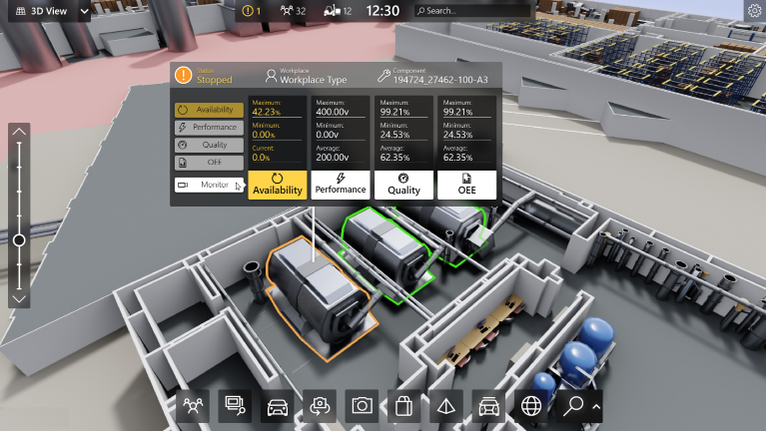

1.  based Solution

UCT is one of the early adopters of LoRAWAN teschnology and providing solution in Agritech, Smart cities, Industrial Monitoring, Smart Street Light, Smart Water/ Gas/ Electricity metering solutions etc.

1. Predictive Maintenance

UCT is providing Industrial Machine health monitoring and Predictive maintenance solution leveraging Embedded system, Industrial IoT and Machine Learning Technologies by finding Remaining useful life time of various Machines used in production process.



## About upskill Campus (USC)

upskill Campus along with The IoT Academy and in association with Uniconverge technologies has facilitated the smooth execution of the complete internship process.

USC is a career development platform that delivers **personalized executive coaching** in a more affordable, scalable and measurable way.



Seeing need of upskilling in self paced manner along-with additional support services e.g. Internship, projects, interaction with Industry experts, Career growth Services

<https://www.upskillcampus.com/>

upSkill Campus aiming to upskill 1 million learners in next 5 year

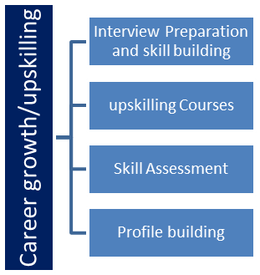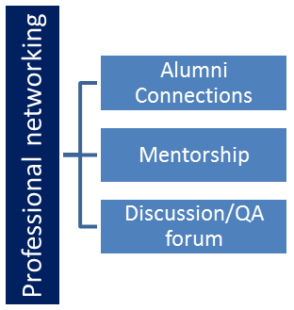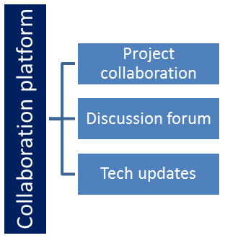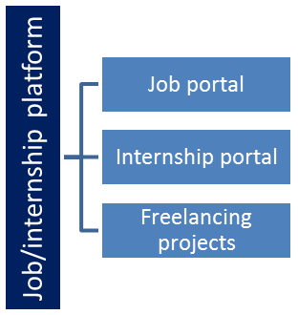

## The IoT Academy

The IoT academy is EdTech Division of UCT that is running long executive certification programs in collaboration with EICT Academy, IITK, IITR and IITG in multiple domains.

## Objectives of this Internship program

The objective for this internship program was to

 ☛ get practical experience of working in the industry.

 ☛ to solve real world problems.

 ☛ to have improved job prospects.

 ☛ to have Improved understanding of our field and its applications.

 ☛ to have Personal growth like better communication and problem solving.

## Reference

[1]

[2]

[3]

## Glossary

|  |  |
| --- | --- |
| Terms | Acronym |
|  |  |
|  |  |
|  |  |
|  |  |
|  |  |

# Problem Statement

The Bank Management System project aimed to develop a functional prototype that offers a range of key functionalities to meet the requirements of a simplified banking system. Throughout the project, we focused on providing users with a seamless and secure banking experience.

The prototype begins with a user-friendly User Registration process, allowing users to create accounts by providing basic details. The system assigns unique account numbers to each user, facilitating efficient Account Management and tracking of account balances.

To facilitate financial transactions, the prototype includes robust Deposit and Withdrawal functionalities. Users can easily deposit or withdraw funds from their accounts, and the account balance is updated accordingly.

Fund Transfer functionality was also implemented, enabling users to transfer funds between their accounts or to other registered users. This feature aimed to enhance user convenience and facilitate seamless money transfers.

For transparency, the prototype offers Account Statements, displaying transaction history, dates, transaction amounts, and remaining balances. Users can review their financial activities and stay informed about their account status.

To ensure secure access to user accounts, the system features a basic login system with password protection. This authentication mechanism adds a layer of security to safeguard user data.

To maintain system reliability, we implemented Error Handling mechanisms to address common exceptions such as insufficient funds and invalid transactions. When encountering such issues, users receive relevant error messages for a smoother banking experience.

The User Interface was thoughtfully designed to be intuitive and user-friendly. Users can easily navigate through the system, perform banking operations, and access relevant information seamlessly.

While the prototype offers basic data persistence, it temporarily stores user account information and transaction history during the prototype session, ensuring a functional user experience.

# Existing and Proposed solution

**Summary of Existing Solutions and Their Limitations:**

Several existing solutions in the market offer various bank management systems. Some of these solutions provide comprehensive features, including user registration, account management, fund transfers, and transaction histories.

However, these existing solutions may have certain limitations. Some systems can be complex and expensive to implement, making them less accessible for small financial institutions or startups. Others may lack flexibility, making it challenging to customize the system according to specific business needs. Additionally, certain solutions may not offer efficient error handling mechanisms, leading to potential security vulnerabilities and unsatisfactory user experiences and also lack simplicity which can confuse users as it leads to several clicks to reach the feature they need .

**Proposed Solution:**

Our proposed solution is a feature-rich yet user-friendly and simple looking Bank Management System that addresses the limitations found in existing solutions. We aim to develop a versatile platform that caters to the needs of various financial institutions, regardless of their size and scale. And helps user find the feature they need with less number of clicks.

**Key Features of Our Proposed Solution:**

Modularity: Our system will be designed with a modular approach, allowing institutions to customize the solution based on their specific requirements. This flexibility ensures that banks can choose and implement the functionalities that align with their business objectives.

Scalability: Our solution will be scalable to accommodate the growth and expansion of financial institutions. Whether it is a small local bank or a large multinational one, our system will adapt and perform optimally.

Cost effective: The solution we have proposed is designed with a strong emphasis on cost-effectiveness. By employing a modular approach and scalable infrastructure, we ensure that small financial institutions can easily afford it.

Intuitive User Interface: We will focus on creating a user-friendly interface that simplifies navigation and enables users to conduct transactions with ease. Intuitive design enhances the overall user experience and reduces the learning curve.

Efficient Error Handling: Our solution will incorporate comprehensive error handling mechanisms to address and communicate errors effectively, ensuring smooth and error-free banking operations.

**What value addition are you planning?**

In future , I am planning to add feature that can summarize the data of month or of years in simple charts for better understanding.

## Code submission (Github link)

https://github.com/ishamankar29/BankManagement

## Report submission (Github link) : first make placeholder, copy the link.

# Proposed Design/ Model

The Bank Management System we propose commences with a user-friendly Login/SignUp module, which serves as the gateway to access the system's functionalities. For new users, the SignUp process prompts them to provide essential personal details and preferences related to their accounts. Once the user completes the SignUp process, they are assigned a unique account number and a secure PIN, which they can use to log in subsequently.

For registered users, the login process involves entering their account number and PIN to gain access to the system. Upon successful login, they are directed to a centralized page that houses all the essential functionalities.

The page provides the following features:

Deposit Money: Users can conveniently deposit funds into their accounts using this functionality. They can input the desired deposit amount, and the account balance is updated accordingly.

Withdraw Money: With this option, users can withdraw money from their accounts as needed. By specifying the withdrawal amount, users can easily perform the transaction.

Transfer Money: Our system allows users to transfer funds from their accounts to other registered users' accounts. This feature promotes seamless and quick money transfers between users.

View Profile and Information: Users can effortlessly access their profile and view the information associated with their account, including personal details and preferences.

Edit Profile Information: To accommodate changes or updates to personal details, users have the option to edit their profile information directly from the same page.

Check Balance: The system offers users a quick and convenient way to check their account balance without navigating to a separate page.

Our design prioritizes user convenience and efficiency. By consolidating all these functionalities on a single page, we aim to reduce the number of clicks required to access each feature. This streamlined approach ensures that users can perform their banking operations swiftly and with ease, enhancing their overall experience with the Bank Management System.

# Performance Test

In developing the Bank Management System, we recognized the importance of catering to real-world constraints faced by industries rather than treating it solely as an academic project. Identifying and addressing these constraints were essential to ensure the system's practicality and suitability for implementation in real industries.

Accuracy and Durability Constraints: Maintaining data accuracy and durability was a primary concern. We employed robust data storage mechanisms, including database transactions and backups, to ensure data integrity and prevent data loss in the event of system failures.

Power Consumption Constraints: While this constraint is more relevant to hardware systems, we considered it during the design phase that we aimed to design an efficient system that minimized server and network utilization, indirectly impacting overall power consumption in a cloud or data center environment.

Impact and Recommendations for Unidentified Constraints: In the event that specific constraints like MIPS or power consumption were not directly tested, it is essential to acknowledge their potential impact on the system. Failure to meet MIPS requirements could result in suboptimal system performance, leading to slower processing and reduced responsiveness. High power consumption may escalate operational costs and affect environmental sustainability.

To handle these unidentified constraints, it is advisable to conduct further testing and optimization, simulating scenarios that may put stress on the system. Additionally, employing hardware profiling tools can help identify bottlenecks and areas of improvement in terms of power consumption. For MIPS-related concerns, code profiling and optimizing algorithms could be considered to achieve better performance. Engaging with hardware experts and consulting industry-specific benchmarks can also aid in ensuring compliance with real-world constraints.

## Test Plan/ Test Cases

1. **Test Case: User Registration**

Description: Verify that users can successfully register an account by providing valid personal details and preferences.

Test Steps:

1. Click on the SignUp button.
2. Enter valid personal information in the registration form.
3. Submit the form and verify if the user is assigned a unique account number and PIN.
4. Attempt to register with invalid or missing information and verify appropriate error messages are displayed.
5. **Test Case: User Login**

Description: Validate that registered users can log in using their account number and PIN to access the system.

Test Steps:

1. Click on the Login button.
2. Enter valid account number and PIN.
3. Verify if the user is successfully logged into the system.
4. Attempt to log in with incorrect account number or PIN and verify appropriate error messages are displayed.
5. **Test Case: Deposit Money**

Description: Verify that users can deposit funds into their accounts, and the account balance is updated accordingly.

Test Steps:

1. Log in as a registered user.
2. Click on the "Deposit Money" option.
3. Enter a valid deposit amount.
4. Verify if the account balance is updated correctly.
5. **Test Case: Withdraw Money**

Description: Validate that users can withdraw funds from their accounts, and the account balance is updated accordingly.

Test Steps:

1. Log in as a registered user.
2. Click on the "Withdraw Money" option.
3. Enter a valid withdrawal amount.
4. Verify if the account balance is updated correctly.
5. **Test Case: Fund Transfer**

Description: Verify that users can transfer funds from their account to another registered user's account.

Test Steps:

1. Log in as a registered user.
2. Click on the "Fund Transfer" option.
3. Enter a valid transfer amount and recipient's account number.
4. Verify if the transfer is successful and both accounts reflect the updated balances.
5. **Test Case: View Profile and Information**

Description: Validate that users can view their profile information, including personal details and preferences.

Test Steps:

1. Log in as a registered user.
2. Click on the "View Profile" option.
3. Verify if the user's information is displayed correctly.
4. **Test Case: Edit Profile Information**

Description: Verify that users can edit their profile information and the changes are saved correctly.

Test Steps:

1. Log in as a registered user.
2. Click on the "Edit Profile" option.
3. Modify one or more profile fields and save the changes.
4. Verify if the changes are reflected in the user's profile.
5. **Test Case: Check Balance**

Description: Validate that users can check their account balance and view it accurately.

Test Steps:

1. Log in as a registered user.
2. Click on the "Check Balance" option.
3. Verify if the current account balance is displayed correctly.
4. **Test Case: Error Handling**

Description: Verify that the system handles common errors appropriately and displays relevant error messages.

Test Steps:

1. Attempt to perform actions such as invalid login, insufficient funds, or invalid transactions.
2. Verify if the system displays appropriate error messages to the user.
3. **Test Case: User Interface**

Description: Validate the user interface for ease of navigation and functionality.

Test Steps:

1. Navigate through the system and assess the intuitiveness of the user interface.
2. Verify if all functionalities are accessible from the main page, reducing the number of clicks required.

## Test Procedure

1. **User Registration Test:**

Description: This test verifies the user registration process to ensure that new users can successfully create an account.

Test Procedure:

1. Click on the SignUp button.
2. Enter valid personal information in the registration form.
3. Submit the form and verify if the user is assigned a unique account number and PIN.
4. Repeat the above steps with invalid or missing information to check error handling.
5. Verify that the user's account details are stored in the database correctly.
6. **User Login Test:**

Description: This test validates the user login process to ensure registered users can access their accounts securely.

Test Procedure:

1. Click on the Login button.
2. Enter valid account number and PIN.
3. Verify if the user is successfully logged into the system.
4. Attempt to log in with incorrect account number or PIN to verify error handling.
5. **Deposit and Withdrawal Test:**

Description: This test verifies the deposit and withdrawal functionalities to ensure funds are handled accurately.

Test Procedure:

1. Log in as a registered user.
2. Click on the "Deposit Money" option.
3. Enter a valid deposit amount and verify if the account balance is updated correctly.
4. Repeat the above steps with invalid deposit amounts to check error handling.
5. Click on the "Withdraw Money" option and follow the same procedure for withdrawal.
6. **Fund Transfer Test:**

Description: This test ensures that fund transfer functionality works correctly for transferring funds between user accounts.

Test Procedure:

1. Log in as a registered user (User A).
2. Click on the "Fund Transfer" option.
3. Enter a valid transfer amount and the account number of another registered user (User B).
4. Verify if the transfer is successful and both User A and User B's account balances are updated correctly.
5. Repeat the above steps with invalid transfer amounts and account numbers to check error handling.
6. **View Profile and Edit Profile Test:**

Description: This test validates the view and edit profile functionalities to ensure user information is displayed and modified accurately.

Test Procedure:

1. Log in as a registered user.
2. Click on the "View Profile" option and verify if the user's information is displayed correctly.
3. Click on the "Edit Profile" option and modify one or more profile fields.
4. Save the changes and verify if the updated information is reflected in the user's profile.
5. Repeat the above steps with invalid or missing information to check error handling.
6. **Check Balance Test:**

Description: This test ensures that users can check their account balance, and the displayed balance is accurate.

Test Procedure:

1. Log in as a registered user.
2. Click on the "Check Balance" option and verify if the current account balance is displayed correctly.
3. **Error Handling Test:**

Description: This test checks the system's error handling capabilities for various scenarios.

Test Procedure:

1. Attempt to perform actions that can trigger errors (e.g., invalid login, insufficient funds, invalid transactions).
2. Verify if the system displays appropriate error messages to the user.
3. **User Interface Test:**

Description: This test assesses the user interface for ease of navigation and functionality.

Test Procedure:

1. Navigate through the system and evaluate the intuitiveness of the user interface.
2. Verify if all functionalities are accessible from the main page, reducing the number of clicks required.

## Performance Outcome

The performance of the Bank Management System was evaluated under various load conditions and scenarios to assess its responsiveness and resource utilization. The outcome of the performance testing demonstrated that the system exhibited robust performance and efficiency, meeting the required performance metrics.

the performance outcome of the Bank Management System was highly satisfactory. The system's responsiveness, scalability, and efficient resource utilization contributed to its ability to handle a substantial number of users and transactions effectively. The successful performance outcome ensures that the Bank Management System is well-equipped to cater to real-world industry demands, providing a reliable and smooth banking experience to users.

To maintain optimal performance in the long run, it is advisable to monitor the system continuously, identify potential bottlenecks, and perform periodic performance tuning. Regular performance assessments will ensure that the system consistently meets industry standards and user expectations, solidifying its position as a robust and efficient banking solution.

# My learnings

Throughout the development of the Bank Management System as a core Java intern with UPSKILLS CAMPUS, I gained valuable insights and experiences that significantly contributed to my overall learning and career growth.

Technical Proficiency: Working on a real-world project allowed me to apply and enhance my technical knowledge of Java programming. I acquired a deeper understanding Java and database management, which are essential skills in the software development industry.

Problem-Solving Skills: Developing the Bank Management System presented various challenges that required innovative problem-solving approaches. I learned how to identify issues, analyze root causes, and implement effective solutions, a skill that is vital in any career path.

Time Management: Completing the project within the internship's timeframe honed my time management skills. I learned to prioritize tasks, set realistic deadlines, and balance multiple responsibilities efficiently.

Real-World Application: Developing a project for a practical application allowed me to see the direct impact of my work. Understanding how the Bank Management System can be utilized by real industries reinforced the significance of my efforts as a software developer.

Professional Growth: The internship provided exposure to a professional work environment, where I honed my professional etiquette and learned from experienced mentors. This exposure facilitated my personal and professional growth.

# Future work scope

During the development of the Bank Management System, there were some innovative ideas that I couldn't fully explore due to time limitations but could be considered for future enhancements:

Advanced Security Measures: Implementing additional security features like two-factor authentication or biometric authentication to further enhance the system's security and protect user accounts from potential threats.

Data Summarization: Enhanced way to summarize data and represent it in graphical format.

Enhanced Error Logging and Monitoring: Implementing a robust error logging and monitoring system to track system errors and exceptions in real-time for prompt issue resolution..