# Trip Booking Application

1. Admin Panel ([admin@gmail.com](mailto:admin@gmail.com) && Admin@123)

🡺**Server-Side Searching**

**🡺Server-Side Pagination**

**🡺Loader**

**🡺Action Sheet: (**add new trip , delete trip , cancel**)**

🡺 **TabStrip** (Dashboard, All Trip, Booked trip data)

🡺 Login Module:

Email Id (TextBox with Validation)

Password (TextBox with Validation)

🡺 Add New Trip / Edit Trip /Delete Trip

Trip Type: International or domestic (radio button)

Trip Name: (ComboBox)

Date: (**DatePicker**)

Time: (**DateTimePicker**)

Days: (TextBox)



Image: **(Image Upload)**

Price: (TextBox)



Available seat: (TextBox) Validation: Initial Seat >= Available Seat



Initial Seat: (Text Box)

Description (**Kendo Editor**)



1. User Dashboard

🡺**Menu**: (Purchase trip , logout)

🡺 Login Module:

Email Id (TextBox with Validation)

Password (TextBox with Validation)

🡺 Register Module

Username (TextBox with Validation)

Email Id (TextBox with Validation)

Password (TextBox with Validation)

🡺 Wizard View

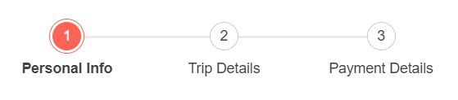

1. Personal Info

User first fill out all the personal information.

First name (TextBox with Validation)

Last name (TextBox with Validation)

Gender (radio button) (TextBox with Validation)

Address (TextBox with Validation)

1. Add Trip Details

After the personal Information, User click on next button to redirect to the Add Trip details.

There is 3 dropdown which are associated with each other.

First Dropdown 🡪 Type of the Trip(International or Domestic)

Second Dropdown 🡪 According to the type of the trip user select, fetch all the available trip name to second Dropdown.

Third Dropdown🡪 According to the second dropdown, show all the Available date of that trip.

Enter Total no. of the Member

Price (Price per Member) 🡪 Automatically fetch when user select Trip name.

1. Payment Details

After filling all the details of the Trip, user need to pay the total amount of the trip.

Card number (**MaskedTextBox**)

CVV number (**MaskedTextBox**)

Card holder name