RENTKARO

Enrollment Numbers - 22103105, 22103095, 22103107
Name - Vansh Agarwal, Gaurav Chandra, Akshat Singh



MAY 2025

SUBMITTED IN PARTIAL FULFILLMENT OF THE DEGREE OF
BACHELOR OF TECHNOLOGY
IN
COMPUTER SCIENCE ENGINEERING

 | TABLE OF CONTENTS
Chapter No. | Topics | Page No.
Chapter - 1 | Introduction
 | 1.1 Platform Overview…………………………………….……. | 9
 | 1.2 Early Methods of PG Booking……………………………… | 9-10
 | 1.3 The Shift to Digital Platforms……………………………….. | 10
 | 1.4 The Need for RentKaro Project………………………………. | 11
 | 1.5 Historical Insights shaping RentKaro…………………………. | 12-13
 | 1.6 Challenges Overcomed By RentKaro…………………………. | 13-17
 | 1.7 How RentKaro Operates without Payment System and Maps… | 17-18
Chapter – 2 | Modelling and Implementation Detail
 | 2.1 Sequence Diagram……………………………………………… | 19
 | 2.2 UML Diagram…………………………………………………… | 20
 | 2.3 ER Diagram……………………………………………………… | 20
Chapter - 3 | Requirement Analysis and Solution Approach
 | 3.1 User Authentication and Profile Management………………… | 21
 | 3.2 PG Search and Booking System…………………………...…... | 21-22
 | 3.3 Recommendation System using ML……………………………  3.4 Property Owner/Host Management……………………………..  3.5 Contact and Support Facility…………………………………….  3.6 Scalability and Performance……………………………………..  3.7 Security Considerations…………………………………………  3.8 Future Enhancements…………………………………………… | 22  22-23  23  24  24-25  25-26
Chapter - 4 | Results
 | 4.1 Enhanced User Experience ……...……….……………………... | 27
 | 4.2 Property Management Efficiency…….…………………………. | 28
 | 4.3 Scalability and Performance …………………….………………  4.4 Security and Data Protection……………………………………..  4.5 Machine Learning Integration…………………………………… | 28-29  29  30
Chapter-5 | Literature Survey
 | 5.1 Topic Used for Implementing Project…………………………… | 31-32
 | 5.2 Summary of Research Paper………………………………….…. | 32-33
Chapter – 6 | Testing | 34-42
Chapter – 7 | Conclusion | 43
Chapter – 8 | Future Work | 44-45
Chapter – 9 | References | 46

DECLARATION

We hereby declare that this submission is our own work and that, to the best of my knowledge and belief, it contains no material previously published or written by another person nor material that has been accepted for the award of any other degree or diploma from the university or other institutes of higher learning, except where due acknowledgment has been made in the text.

Place: JIIT Noida Signature:
Date: 08/05/2025 Name: Vansh Agarwal, Gaurav Chandra, Akshat Singh
Enrollment No: 22103105, 22103095, 22103107

CERTIFICATE

This is to certify that the work titled "RentKaro" submitted by " Vansh Agarwal, Gaurav Chandra, Akshat Singh " is in partial fulfillment for the award of the degree of B.Tech program of Jaypee Institute of Information Technology, Noida has been carried out under my supervision. This work has not been submitted partially or wholly to any other University or Institute for the award of this or any other degree or diploma.

Signature of Supervisor
Name of Supervisor: Ritika Chaudhary
Designation: Assistant Professor
Date: 08 May 2025

ACKNOWLEDGEMENT

It is our proud privilege to release the feelings of our gratitude to several persons who helped us directly or indirectly to conduct this developmental project work. We express our heartfelt indebtedness and owe a deep sense of gratitude to our project supervisor Ritika Chaudhary for her sincere guidance and inspiration in completing this project. This project consumed a substantial amount of hard work, dedication, and familiarization with new concepts but still, the implementation would not have been possible without the meticulous and efficient guidance of Ritika Ma'am, our supervisor who constantly provided her support, suggestions, and encouragement. We also thank our friends who have more or less contributed to the preparation of this project report. We will always be indebted to them. This study has indeed helped us to explore more knowledgeable avenues related to our topic and we are sure it will help us in the future.

Signature:
Name: Vansh Agarwal, Gaurav Chandra, Akshat Singh
Enrollment No: 22103105, 22103095, 22103107
Date: 08 May 2025
SUMMARY

The RentKaro Website is a streamlined platform designed to connect tenants with PG accommodations efficiently. It offers essential features to enhance the user experience and ensure seamless interaction between tenants and PG owners. The website leverages machine learning to provide intelligent recommendations and facilitate decision-making.

Key Features
- Login Page:
  - A secure login page for both tenants and PG owners ensures user authentication and personalized access.
- Tenant Registration:
  - New users can register by providing basic details such as name, contact information, and accommodation preferences.
  - Registration allows tenants to save preferences and receive personalized recommendations.
- PG Searching and Booking:
  - Tenants can search for PGs using various filters such as location, budget, gender preference, and amenities.
  - Booking requests can be initiated directly through the platform, simplifying the process.
- Sentiment Analysis using User Reviews:
  - Automatically evaluates and scores user reviews for each property using AI-powered sentiment analysis to enhance trust and decision-making.

Machine Learning Models Used:
- K-Means Clustering:
  - Groups PGs based on factors like location, price range, and amenities to recommend the most relevant options to tenants.
- Regression Model:
  - Predicts rent trends or costs based on factors such as location, demand, and facilities, helping tenants make informed financial decisions.
- Sentiment Analysis Model:
- Analyzes user reviews using a fine-tuned DistilBERT model to generate sentiment scores, helping tenants gauge the overall satisfaction and trustworthiness of each property.

Purpose and Benefits
- Personalized Experience: Machine learning models ensure tailored suggestions, making the platform more user-centric.
- Transparency: Detailed PG listings and direct contact with owners enhance trust and clarity.
- Convenience: Combines registration, search, booking, and communication in a single platform.
The RentKaro website represents an innovative approach to simplifying PG accommodation, leveraging technology to address user needs efficiently.

SIGNATURE OF STUDENT SIGNATURE OF SUPERVISOR
Vansh Agarwal 22103105 DATE 08 May 2025
Gaurav Chandra 22103095
Akshat Singh 22103107

INTRODUCTION

Platform Overview
The evolution of Paying Guest (PG) accommodations has been shaped by the growing needs of students, professionals, and urban migrants. Historically, the process of finding suitable accommodations was informal and largely dependent on personal networks, word of mouth, and offline advertisements. With the advent of technology and the rise of digital platforms, PG booking has undergone significant transformation. The RentKaro project draws upon this historical context to create a modern, efficient, and user-friendly platform that addresses the shortcomings of traditional PG booking methods.

Early Methods of PG Booking
1. Informal Networking
In the early days, PG accommodations were typically found through:
- Recommendations from friends, family, or colleagues.
- Notices posted on college boards, community centres, or local stores.
- Personal visits to neighbourhoods in search of available accommodations.
While these methods were straightforward, they were often time-consuming and lacked transparency. Potential tenants had limited choices and often had to compromise on their preferences.
2. Classified Ads
- Newspapers and magazines became a popular medium for advertising PG accommodations.
- Listings included basic details such as location, rent, and contact information.
- While this expanded visibility, it lacked interactivity and real-time updates, often leading to outdated or irrelevant information.
3. Local Real Estate Brokers
- Real estate agents and brokers acted as intermediaries, connecting tenants with PG owners.
- While they simplified the process, their services came at a cost, often requiring brokerage fees from both tenants and owners.

The Shift to Digital Platforms
The advent of the internet brought about a paradigm shift in how PG accommodations were discovered and booked. With increasing internet penetration and the rise of smartphones, the traditional methods began to give way to digital solutions.
1. Online Classifieds
Platforms like Craigslist and OLX introduced the concept of online PG listings, allowing owners to reach a broader audience. However:
- These platforms lacked features tailored specifically for PG seekers.
- The absence of filters, reviews, and secure communication posed challenges for users.
2. Specialized PG Portals
The mid-2010s saw the emergence of specialized websites and apps focused on rental and PG accommodations. These platforms offered:
- Search filters for budget, location, and amenities.
- Verified listings for increased trust.
- Online booking options, reducing dependency on brokers.
Examples include NestAway, ZoloStays, and NoBroker, which began addressing the specific needs of urban migrants.
The Need for the RentKaro Project

Despite the advancements in PG booking platforms, several challenges remain that the RentKaro project seeks to address:
1. Lack of Personalization
Existing platforms often provide a generic list of options without understanding individual preferences, leading to suboptimal recommendations. RentKaro integrates AI-driven personalization to recommend PGs based on user preferences.
2. Limited Community Interaction
While some platforms facilitate owner-tenant communication, few offer tools for tenants to interact with fellow residents. RentKaro fosters community building by enabling connections among tenants within the same PG.
3. Inconsistent Information
Many listings on current platforms lack updated or accurate details, resulting in wasted time and effort for tenants. RentKaro ensures verified and regularly updated listings for a seamless experience.
4. Accessibility Challenges
Some platforms focus primarily on large cities, neglecting smaller towns and regions where PG demand is also significant. RentKaro aims to cater to users across diverse locations, ensuring inclusivity.
5. High Costs
Brokerage fees and hidden charges remain a concern for tenants and owners. RentKaro eliminates the need for intermediaries, offering a cost-effective solution for all users.

Historical Insights Shaping RentKaro

The history of PG booking highlights the evolution from manual, time-intensive processes to efficient digital solutions. RentKaro builds upon this history by combining the strengths of existing platforms with innovative features that address persistent gaps:
- Evolution of User Expectations:
  - Users today demand personalized, real-time, and hassle-free services.
  - RentKaro incorporates these expectations through its intelligent recommendation engine and intuitive interface.
- Technological Advancements:
  - The integration of artificial intelligence, geolocation services, and secure payment gateways aligns with modern technological trends.
  - These advancements ensure a superior user experience, setting RentKaro apart from its predecessors.
- Community-Centric Approach:
  - Unlike traditional platforms that focus solely on transactions, RentKaro emphasizes community building and tenant satisfaction.

The history of PG booking underscores the need for continuous innovation to meet the evolving demands of urban living. From informal word-of-mouth recommendations to sophisticated digital platforms, each phase has contributed to shaping the RentKaro project. By addressing the shortcomings of previous systems and leveraging cutting-edge technology, RentKaro aspires to redefine the PG booking experience, making it more accessible, personalized, and efficient for tenants and owners alike. This project represents the next logical step in the journey of PG accommodations, rooted in history but designed for the future.

In recent years, the demand for convenient and affordable accommodation has increased significantly, particularly among students and working professionals. Urban migration and the pursuit of better opportunities have made it essential to have a reliable platform for finding and managing paying guest (PG) accommodations. The RentKaro PG Recommendation Website is designed to address these needs by providing a user-friendly, feature-rich platform that simplifies the process of finding, comparing, and managing PG accommodations.

RentKaro aims to bridge the gap between PG seekers and owners by offering personalized recommendations, seamless communication, and a streamlined tenant registration process. By leveraging modern web technologies and data-driven insights, the platform ensures users find accommodations that match their preferences and budget while empowering PG owners to connect with potential tenants efficiently.
RentKaro emerges as a comprehensive digital solution specifically designed to transform the Paying Guest (PG) accommodation ecosystem, addressing the complex challenges faced by students, young professionals, and migrant workers in urban India.

Challenges Overcomed By RentKaro
The RentKaro PG Recommendation Website focuses on solving historical challenges related to PG accommodation using a streamlined, user-friendly platform. While the platform does not include features such as payment systems or maps, it compensates by emphasizing efficient communication, reliable information, and tenant-owner engagement. Below is an explanation of how RentKaro overcomes the challenges while considering its current scope.

1. Limited Accessibility and Visibility
Challenge:
Traditionally, finding PGs involved relying on word of mouth, local classifieds, or brokers. These methods were time-consuming and offered limited choices.
RentKaro’s Solution:
- Centralized Listings: RentKaro provides a centralized platform where owners can list their PG accommodations with detailed descriptions, photos, and contact details.
- Search and Filter Features: Users can easily browse PGs by location name (e.g., city, locality), budget, and amenities, simplifying the discovery process.
- Owner Contact Integration: The platform provides direct contact information for owners, ensuring seamless communication.

2. Lack of Verified Information
Challenge:
PG seekers often dealt with incomplete or misleading information, such as hidden costs or misrepresentation of facilities.
RentKaro’s Solution:
- Detailed Property Descriptions: Owners are required to provide comprehensive details, including rent, deposit, amenities, and rules.
- Image Uploads: Listings include multiple images to give tenants a clear idea of the property before making contact.
- Listing Verification: Admins review all listings for completeness and authenticity, ensuring reliability.

3. Time-Consuming Manual Processes
Challenge:
Traditional methods required tenants to visit multiple properties physically, wasting significant time and effort.
RentKaro’s Solution:
- Comprehensive Profiles: RentKaro allows tenants to view all necessary property details in one place, reducing the need for initial physical visits.
- Owner Communication: Tenants can directly contact owners through the platform to clarify questions or arrange viewings, streamlining decision-making.

4. Dependency on Brokers
Challenge:
Tenants historically relied on brokers, leading to increased costs and limited control over the selection process.
RentKaro’s Solution:
- Broker-Free Model: RentKaro connects tenants directly with owners, eliminating the need for intermediaries.
- Transparent Listings: With clear rent and deposit information, tenants can avoid brokerage fees and negotiate directly with owners.

5. Lack of Personalization
Challenge:
Traditional platforms or methods provided generic options, making it difficult for tenants to find accommodations tailored to their preferences.
RentKaro’s Solution:
- Search Filters: Tenants can narrow down results by specifying their requirements, such as room type, gender-specific accommodations, and amenities like food or Wi-Fi.
- Recommendations: While not automated through AI, RentKaro offers categorized suggestions (e.g., “Budget-Friendly,” “Near Colleges,” “Shared Spaces”) based on user inputs.

6. Inefficient Communication Channels
Challenge:
Coordination between tenants and owners was often cumbersome, relying on slow or indirect methods like third-party communication or phone calls.
RentKaro’s Solution:
- Direct Contact Information: Owners list their contact details, allowing tenants to reach out instantly via calls or messages.
- Tenant Coordination Features: Once a booking is confirmed, tenants can engage with co-residents via external communication methods facilitated by shared group information.

7. Understanding User Sentiment
Challenge:
Potential tenants often struggle to assess the true quality of accommodations due to biased listings or lack of genuine feedback.
RentKaro’s Solution:
- AI-Powered Sentiment Analysis: Automatically analyzes tenant reviews to generate sentiment scores, offering an unbiased overview of user satisfaction.
- Enhanced Decision-Making: Helps users quickly identify trustworthy and high-rated properties based on authentic experiences.

8. High Costs for Owners
Challenge:
PG owners often had to pay hefty fees to brokers or advertising platforms to find tenants.
RentKaro’s Solution:
- Free or Low-Cost Listings: RentKaro offers owners a straightforward listing process at minimal or no cost.
- Cost-Free Communication: Owners and tenants interact without any platform-imposed charges, making it an economical solution for both parties.

9. Post-Move-In Support
Challenge:
Traditional methods of booking PGs rarely included post-move-in support, leaving tenants without avenues to address issues like maintenance or disputes.
RentKaro’s Solution:
- Complaint Escalation: Tenants can report issues directly to owners or via the platform's basic support system, ensuring accountability.
- Feedback Mechanism: Both owners and tenants can share feedback, fostering transparency and encouraging quality improvements.

How RentKaro Operates Without Payment Systems or Maps
While payment systems and maps are common features in many platforms, RentKaro compensates for their absence with the following strategies:
No Payment Systems
- Direct Payments: Tenants and owners handle rent and deposits offline, maintaining simplicity in transactions.
- Platform Focus: By focusing on connecting users rather than handling transactions, RentKaro minimizes operational complexity and potential disputes.
No Maps
- Search by Location: Tenants can search for PGs by entering locality or city names.
- Descriptive Listings: Owners include specific addresses or landmarks in property descriptions, providing sufficient detail for offline navigation

The RentKaro PG Recommendation Website overcomes historical challenges by simplifying the tenant-owner interaction, ensuring accurate and reliable information, and offering essential tools for an efficient PG booking experience. While it does not include features like payment gateways or maps, its focus on verified listings, transparent communication, and streamlined processes makes it a valuable resource for both tenants and PG owners. This project embodies a practical approach to addressing long-standing issues in the PG accommodation sector while maintaining ease of use and affordability.

Modelling and Implementation Details

Sequence Diagram:

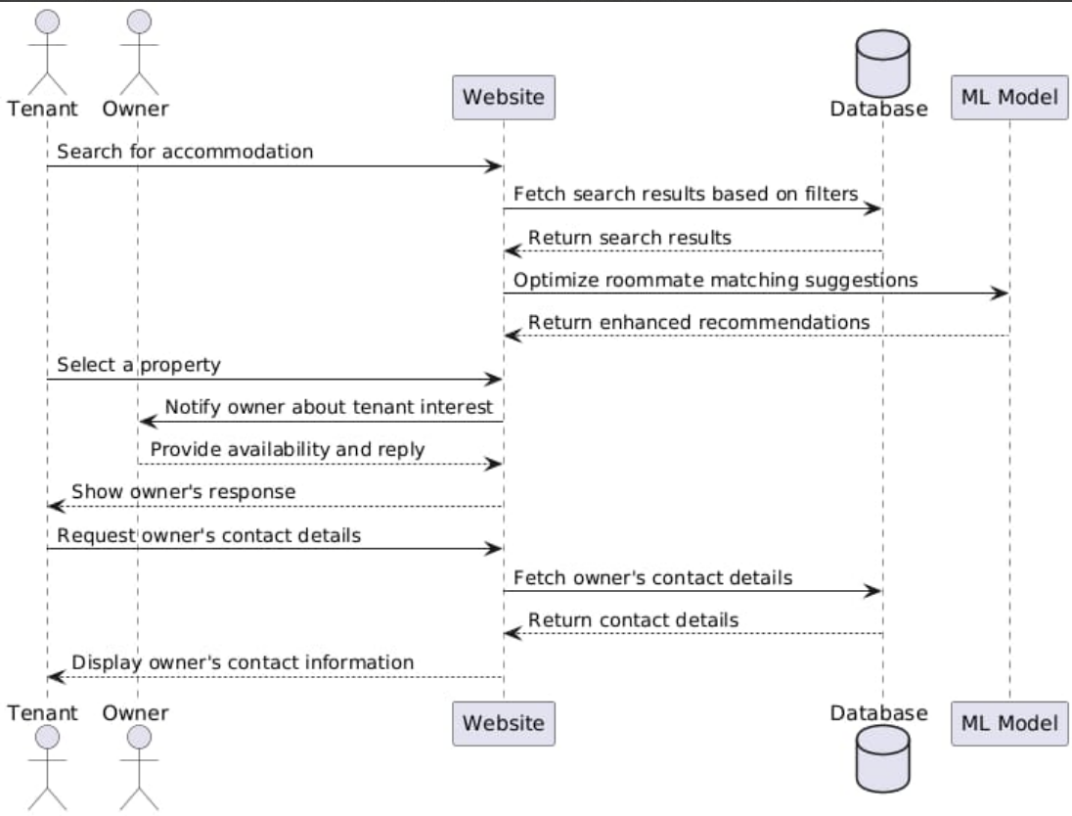

UML Diagram:
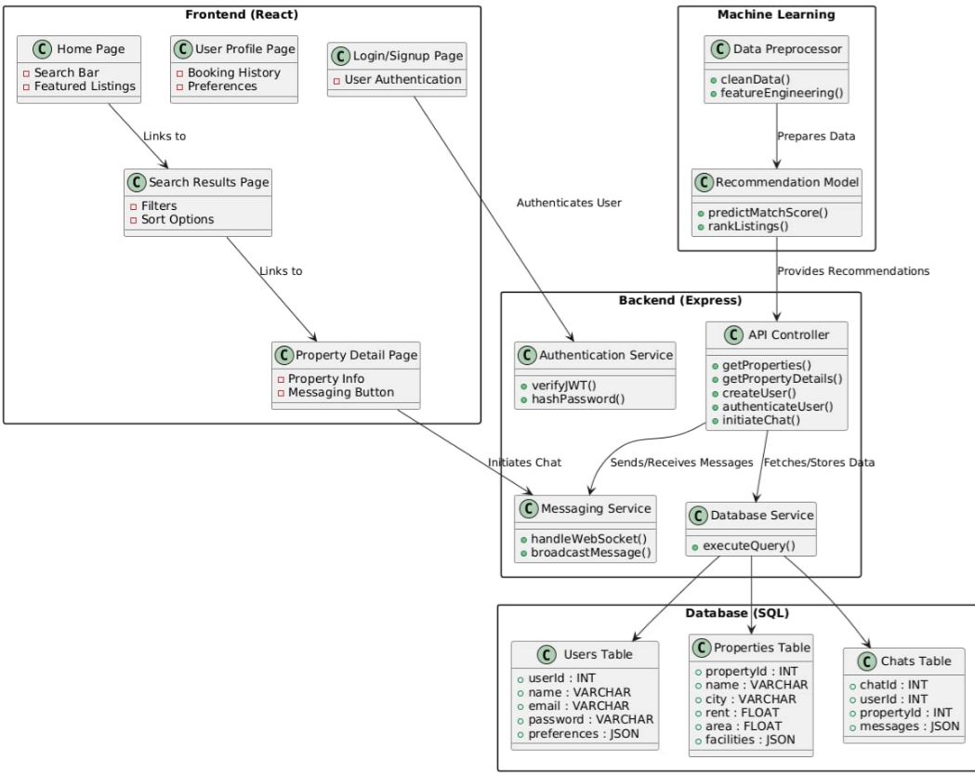
ER Diagram:

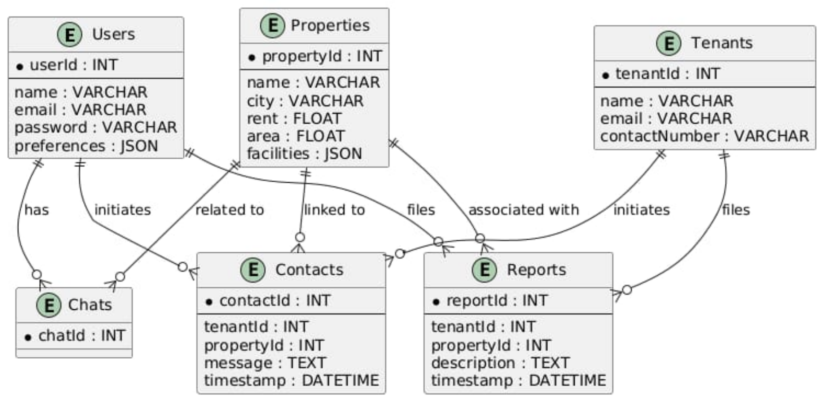
Requirement Analysis and Solution Approach

Based on the previously provided features of the RentKaro platform, we can break down the solution approach into different components that address specific business needs, technical requirements, and user experience objectives. Below is the solution approach along with the associated requirements:
1. User Authentication and Profile Management
Solution Approach:
- Implement a secure registration and login system for both tenants and property owners. The authentication process will support multiple login methods such as email/password and OTP verification for enhanced security.
Use JWT (JSON Web Tokens) or OAuth for secure session management and handling user states.

Requirements:
Frontend: Login/Registration forms with validation and social media login options.
Backend: User authentication APIs (RESTful services) to handle sign-up, login, and session management.
Database: Tables for storing user data (tenants, property owners), login credentials (passwords hashed), and session tokens.
Security: Password hashing (e.g., bcrypt) and OTP-based login system.
Tools: Node.js with Express or Django for handling authentication.

2. PG Search & Booking System
Solution Approach:
A search engine that allows tenants to filter PGs based on parameters such as location, price range, amenities, and available facilities.
Property details will include images, descriptions, rental prices, and contact details for owners.
Integrate an inquiry or booking system where tenants can submit booking requests or directly contact property owners.

Requirements:
Frontend: Search bar, filters (e.g., location, amenities, price), property listing pages, and detailed property view pages.
Backend:
APIs for searching PGs (with filtering capabilities).
APIs for submitting booking requests or inquiries to property owners.
Database: Tables for storing PG details (location, price, amenities, owner info).
Tools: Elasticsearch for optimizing search functionality.

3. Recommendation System using ML (K-Means Clustering, Regression and Sentiment Analysis)
Solution Approach:
Use K-Means Clustering for grouping tenants based on preferences, location, and budget to suggest PGs most likely to match their needs.
Regression models will predict the likely PG prices based on various factors such as location, size, and amenities, allowing for dynamic pricing adjustments.
Sentiment Analysis Uses a fine-tuned DistilBERT model to analyze tenant reviews and assign sentiment scores, enhancing recommendations by factoring in user satisfaction and trust.

Requirements:
Data: Collect tenant interaction data (search history, preferences) and PG characteristics (location, amenities, price) and user-generated reviews .
Backend:
Implement machine learning models (K-Means and Regression) in Python (using libraries like scikit-learn) and Sentiment Analysis using Transformers (Hugging Face) in Python.
APIs to integrate the models with the website for real-time predictions and suggestions.
Tools: Python with scikit-learn and Hugging Face Transformers for model building, and Flask or FastAPI for integrating models into the backend.

4. Property Owner/Host Management
Solution Approach:
Property owners can manage their PG listings via a dashboard that allows them to add new properties, update existing listings, and view booking requests or inquiries.
Owners can also manage availability and pricing dynamically.
Requirements:
Frontend: Admin panel for property owners with options to add/edit property details, view booking requests, and track property status.
Backend:
APIs for adding, editing, and deleting property listings.
APIs for viewing property statistics (e.g., number of bookings, inquiries).
Database: Tables to store property listing data, owner details, and booking status.
Security: Admin-level access control for property owners.

5. Contact and Support Facility
Solution Approach:
Integrate a contact form for general inquiries, support tickets, or customer service requests.
A help center with FAQs, troubleshooting guides, and live chat support.
Requirements:
Frontend: Contact form for general inquiries and a knowledge base for FAQs.
Backend: APIs for managing user inquiries and generating support tickets.
Database: Table to store support tickets and their statuses.
Tools: Integration with third-party customer support platforms (e.g., Zendesk) for ticket management.

6. Scalability and Performance
Solution Approach:
Ensure that the platform is scalable to handle a growing number of tenants, property owners, and PG listings.
Implement caching strategies (e.g., Redis) to speed up data retrieval.
Use load balancing to distribute traffic and ensure high availability.
Requirements:
Frontend: Optimized page loads, lazy loading for images and data.
Backend: Use load balancers (e.g., Nginx) and implement caching mechanisms to reduce server load.
Database: Indexing on frequently queried fields (e.g., location, price) for faster data retrieval.
Tools: Cloud services (AWS, Azure) for scaling, Redis for caching.

7. Security Considerations
Solution Approach:
Implement data encryption for sensitive information (e.g., passwords, payment details).
Use role-based access control (RBAC) to ensure that only authorized users (admins, property owners, tenants) can access their respective data.

Requirements:
Frontend: Secure login process (e.g., HTTPS, Two-factor authentication) and access control for sensitive pages.
Backend: Implement encryption (e.g., SSL/TLS) and use JWT for secure communication.
Database: Store hashed passwords (e.g., bcrypt) and sensitive data in encrypted form.
Tools: Use OAuth and JWT for secure authentication.

8. Future Enhancements
Solution Approach:
Map Integration: Integrate Google Maps or other map services to visually display PG locations.
Payment Gateway: Integrate a payment gateway (e.g., Stripe, Razorpay) for handling bookings and deposits.
Mobile App: Develop a mobile application for tenants and property owners to access the platform on the go.
Requirements:
Frontend: Integration with a map API for PG location.
Backend: APIs to handle payment transactions and interact with the mobile app.
Tools: Google Maps API, Stripe for payments, React Native for mobile app development.

The solution approach focuses on creating a user-friendly, secure, and scalable platform that integrates advanced machine learning features for personalized recommendations, provides real-time messaging capabilities, and ensures smooth property management for owners. With the outlined requirements, the platform can evolve to meet growing user needs and implement additional features as the business expands.

Results

RentKaro, designed as an online platform for finding and booking PG accommodations, has been built with a strong technical foundation, integrating user-centered design, machine learning algorithms, and robust security protocols. Below is a detailed analysis of the outcomes and features based on the solution approach outlined earlier:

1. Enhanced User Experience:
PG Search and Booking System:
The core functionality of RentKaro lies in its search and booking system. Tenants can filter available PGs based on critical parameters such as location, budget, amenities, and property size. This functionality is powered by backend services that retrieve data from a well-structured relational database where PG listings are indexed to allow fast search operations.
Users experience an intuitive search process, which allows them to enter key criteria and see results within seconds. The results are dynamically updated based on the filters, and tenants can easily access detailed pages with more in-depth information about each PG, such as rent details, amenities, property images, and contact information for owners.
Recommendation System:
RentKaro integrates machine learning algorithms like K-Means Clustering and Regression models to enhance the search experience. The K-Means algorithm groups tenants into clusters based on their preferences (e.g., location, budget, amenities), while the regression model predicts the likely rental price for a property based on tenant demand and property characteristics.
Through clustering, the platform learns tenant preferences and suggests PGs that align with their historical search patterns, ensuring that tenants are presented with relevant options. This not only improves user engagement but also reduces the time spent on the platform by showing them relevant properties from the start.

2. Property Management Efficiency:
Owner Dashboard:
The property owner dashboard is designed to give property owners full control over their listings. They can manage multiple PGs, update property details, change pricing, or adjust availability based on demand or seasonality.
The dashboard includes analytics features, where property owners can track key metrics such as the number of views for their listings, the number of inquiries, and the booking rate over time.
This feature streamlines the property management process by reducing the need for manual updates or third-party tools.
Dynamic Pricing:
The dynamic pricing feature allows property owners to adjust rental prices based on market conditions, demand, and tenant behavior. The system leverages the regression model to predict price fluctuations and recommends price adjustments based on these insights. For example, during high-demand periods (e.g., holidays or academic session starts), the platform suggests price increases for property owners, helping them capitalize on market trends.

3. Scalability and Performance:
System Performance:
RentKaro is designed with scalability in mind, to handle increasing numbers of users and PG listings. The platform can seamlessly scale both horizontally (adding more servers) and vertically (upgrading server capacity) to handle spikes in traffic.
To ensure fast response times, the platform uses database indexing and query optimization techniques to speed up search and booking requests. For instance, indexing fields like `location`, `price`, and `availability` enables the database to quickly return relevant PG listings.
Caching mechanisms using Redis are integrated into the backend to store commonly accessed data, reducing the load on the database and improving page load times. The use of content delivery networks (CDNs) for serving static assets such as images and property details further boosts performance.
Load Balancing:
RentKaro employs load balancing strategies to distribute incoming traffic evenly across multiple servers. This ensures high availability and reliability, especially during periods of high traffic.
The use of cloud infrastructure allows RentKaro to scale dynamically, using services such as AWS Elastic Load Balancer to route traffic to the most optimal server based on real-time demand.

4. Security and Data Protection:
Data Encryption and Secure Communication:
All sensitive information, including user credentials and payment details, is encrypted using industry-standard encryption algorithms such as AES-256. This ensures that all user data is stored securely, making it nearly impossible for unauthorized entities to access sensitive information.
SSL/TLS protocols are implemented to secure all communications between the client (user’s browser) and the server, ensuring that all data transferred over the platform is encrypted in transit.
Password Hashing and Authentication:
User passwords are hashed using encrypt before being stored in the database. This ensures that even if the database is compromised, passwords are not exposed.
The JWT-based authentication system ensures that each user session is securely managed, and session tokens are refreshed periodically to prevent unauthorized access.
Role-Based Access Control (RBAC):
The system employs role-based access control (RBAC), ensuring that different users (e.g., tenants, property owners, administrators) have access only to the data relevant to their roles. For example, a property owner can only manage their own properties, while tenants cannot access other tenants' data.
5. Machine Learning Integration:
K-Means Clustering:
K-Means clustering has been successfully integrated into the platform to segment tenants based on their preferences and behaviors. The system continuously analyzes tenant interactions, such as searches, clicks, and bookings, to create user profiles. These profiles are then used to recommend properties that closely match their preferences.
As more data is collected from tenants, the model improves, ensuring more accurate recommendations over time.
Regression Model for Price Prediction:
The regression model uses historical data to predict rental prices for PGs based on location, size, amenities, and other factors. This helps property owners set competitive prices and adjust rent dynamically.
The model continuously learns from new booking and pricing data, refining its predictions for more accurate price recommendations.
Sentiment Analysis for Review Insights:
A fine-tuned DistilBERT model is integrated to perform sentiment analysis on tenant reviews, converting textual feedback into quantifiable sentiment scores. These scores help highlight trustworthy, high-quality properties and flag potentially problematic listings. By incorporating sentiment into the recommendation logic, the platform offers more transparent and experience-driven suggestions, enhancing trust and decision-making for future tenants.

Topic Used for Implementing the Project

Frontend Development
- React.js: Enables a dynamic and responsive user interface.
- Tailwind CSS: Provides a utility-first CSS framework for creating visually appealing and responsive designs.
Backend Development
- Express.js: Manages API requests and serves as the core backend framework.
- SQL Database: Stores and manages data related to users, properties, and tenants efficiently.
Machine Learning
- Roommate Matching: Utilizes an AI-driven model to suggest compatible roommates based on user preferences and attributes.
- Property Ranking: Analyzes property data to rank accommodations by rent, facilities, and other factors.
- Sentiment-Based Property Scoring: Incorporates sentiment analysis of user reviews using a fine-tuned DistilBERT model to assess tenant satisfaction, enhancing property rankings with authentic, experience-driven insights.
Authentication and Security
- Aadhar Verification: Ensures secure and verified user registration, promoting trust within the platform.
- Data Protection: Implements encryption techniques to safeguard sensitive information.
Other Key Topics
- RESTful APIs: Facilitates seamless communication between the frontend and backend components.
- Data Preprocessing: Processes raw data to ensure compatibility with ML models.
- Database Normalization: Optimizes the SQL database for efficient data storage and retrieval.
- Scalability: Designed to accommodate future growth in users and property listings

Summaries of the Research Papers:

1. LeKeDe: Online Rental System:
Purpose: LeKeDe is an Android-based online rental platform connecting renters and owners for products like furniture, cars, books, and more. It addresses the demand for affordable renting solutions versus purchasing.
Key Features:
  - Allows users to upload, view, and rent items.
  - Facilitates communication via email, phone, or in-person meetings.
  - Incorporates Google Firebase for data storage and security.
  - Target Audience: Individuals preferring rentals over purchases, especially students and professionals relocating to new cities.
Future Scope:
  - Location-based filtering using Google Maps.
  - Recommendation systems for better suggestions.
  - Validity extension for rental agreements.
Impact:
Promotes efficient use of resources and provides an eco-friendly, cost-effective alternative to ownership.

2. Tenouse: AI-based Intimation of H`ouses for Tenants, Landlords, and Others:
Purpose:
Tenouse is an AI-powered platform designed to connect tenants, landlords, and property seekers without intermediaries, ensuring secure and efficient transactions.
Key Features:
Machine Learning models for house classification and price prediction.
  - Recommendation system using Apriori algorithms.
  - Sentiment analysis for personalized suggestions and premium features.
  - Match score calculation to ensure relevant property listings.
  - Chatbots and a mobile app for user convenience.
Innovation:
Reinforces fair transactions by eliminating brokers, introducing secure payment methods, and using AI to match preferences.
Human Welfare:
Includes donation campaigns to support the homeless, enhancing social responsibility.
Future Scope:
  - Enhanced data analysis for better matching.
Features to facilitate property buying and selling.
  - Improved chatbot intelligence.
Both papers emphasize leveraging technology to simplify and optimize rental and housing processes while promoting sustainability and user convenience.

Testing

- Landing Page of RentKaro

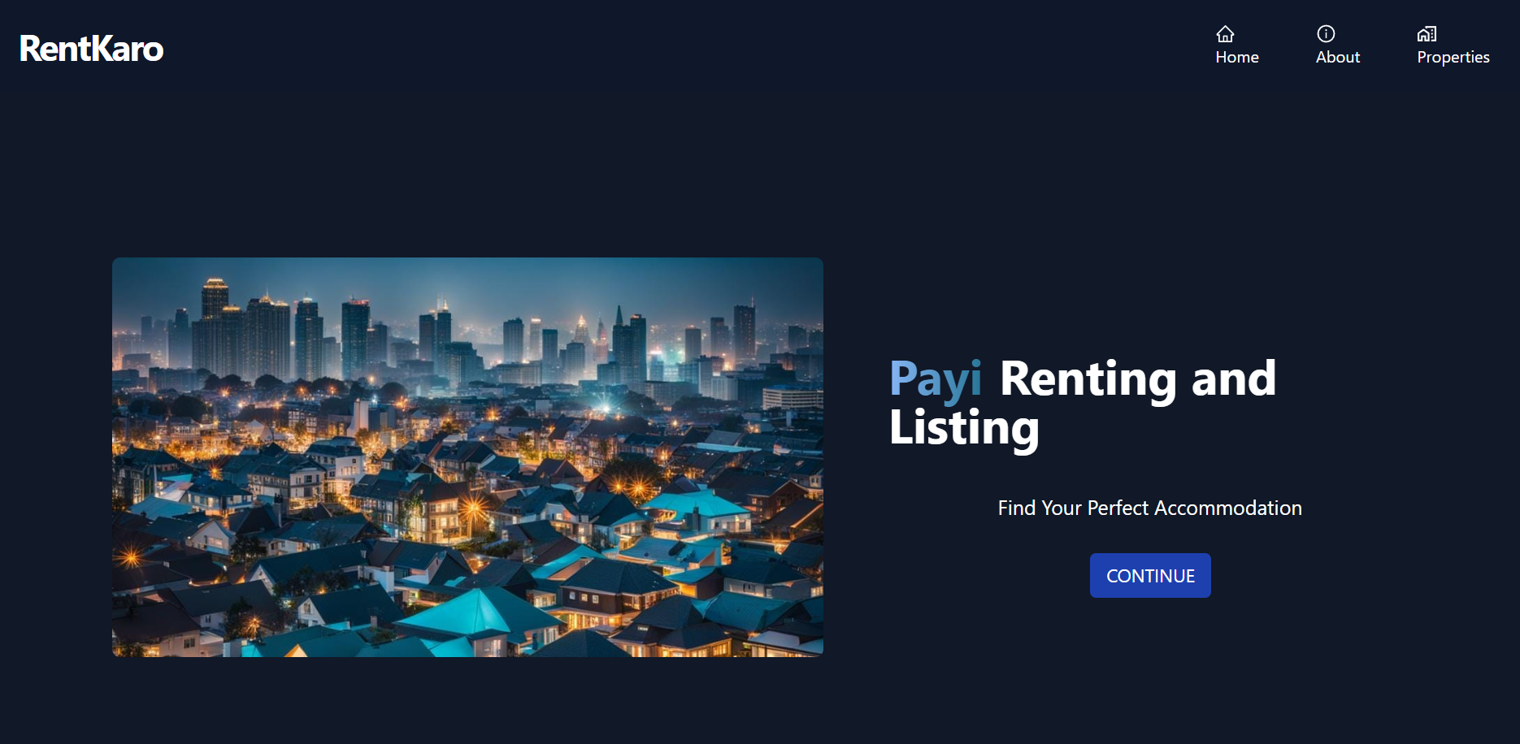

- SignUp Page
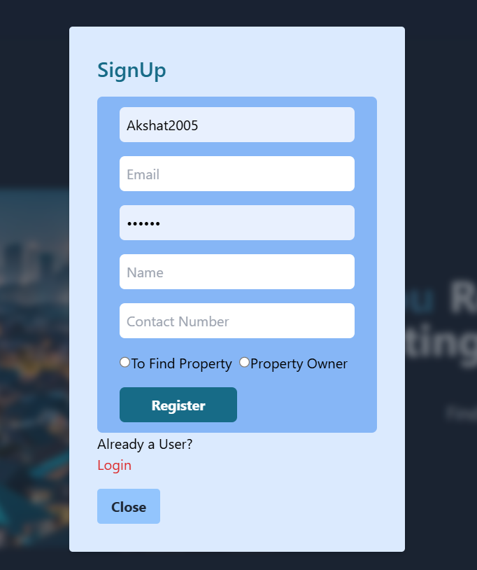

- Login Page

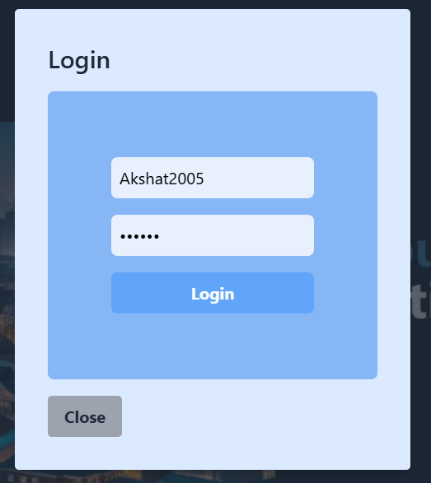
- List Properties

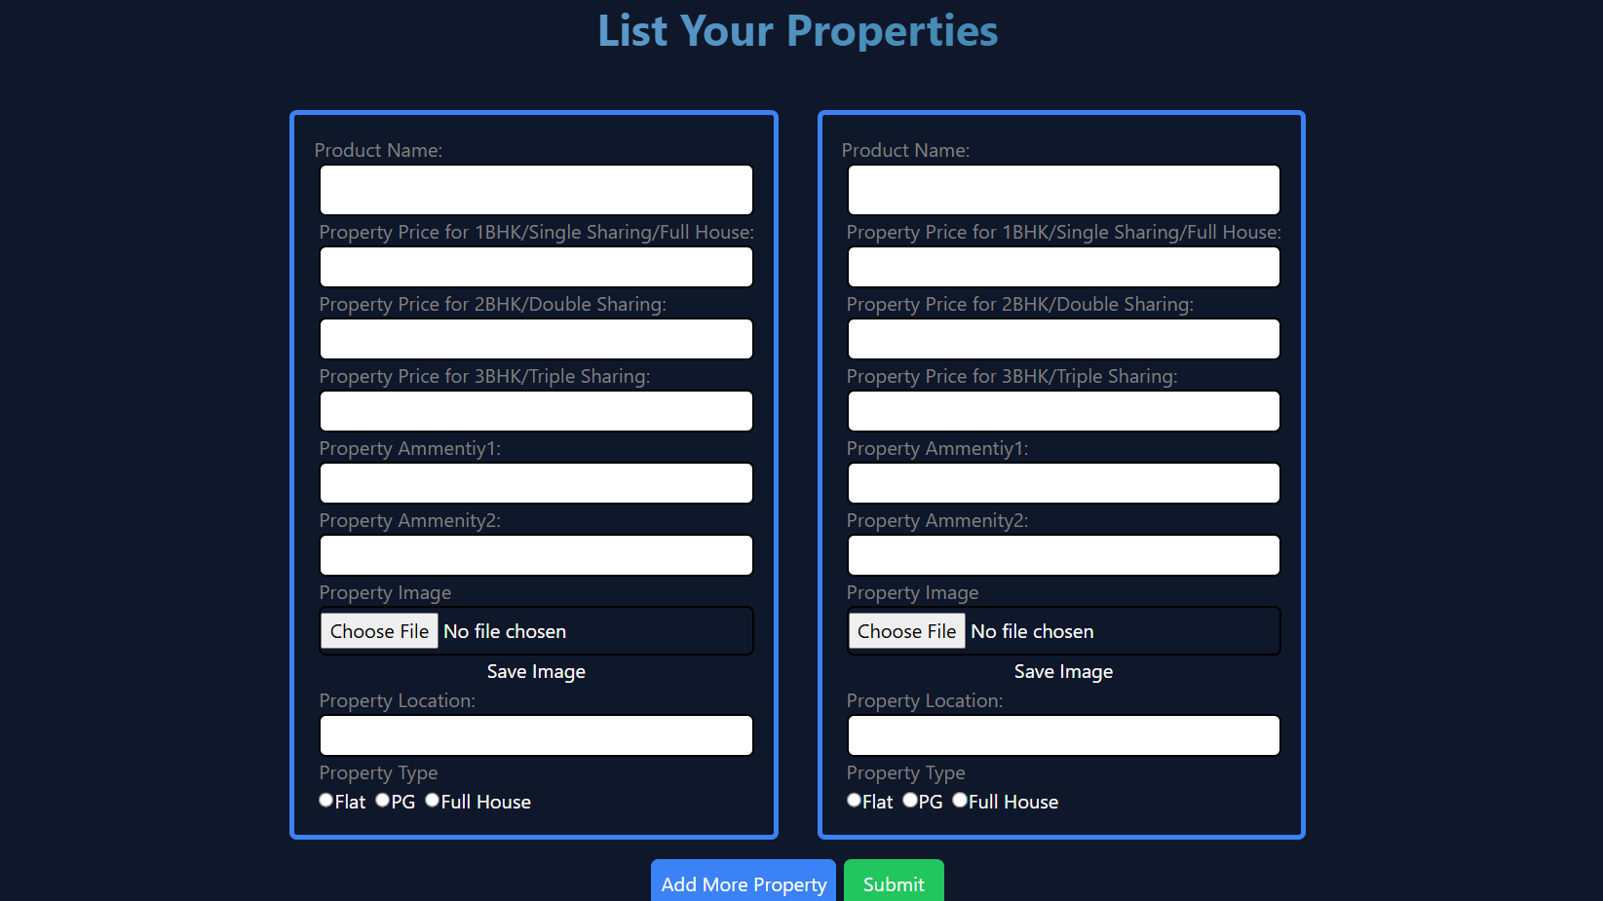

- Find Properties

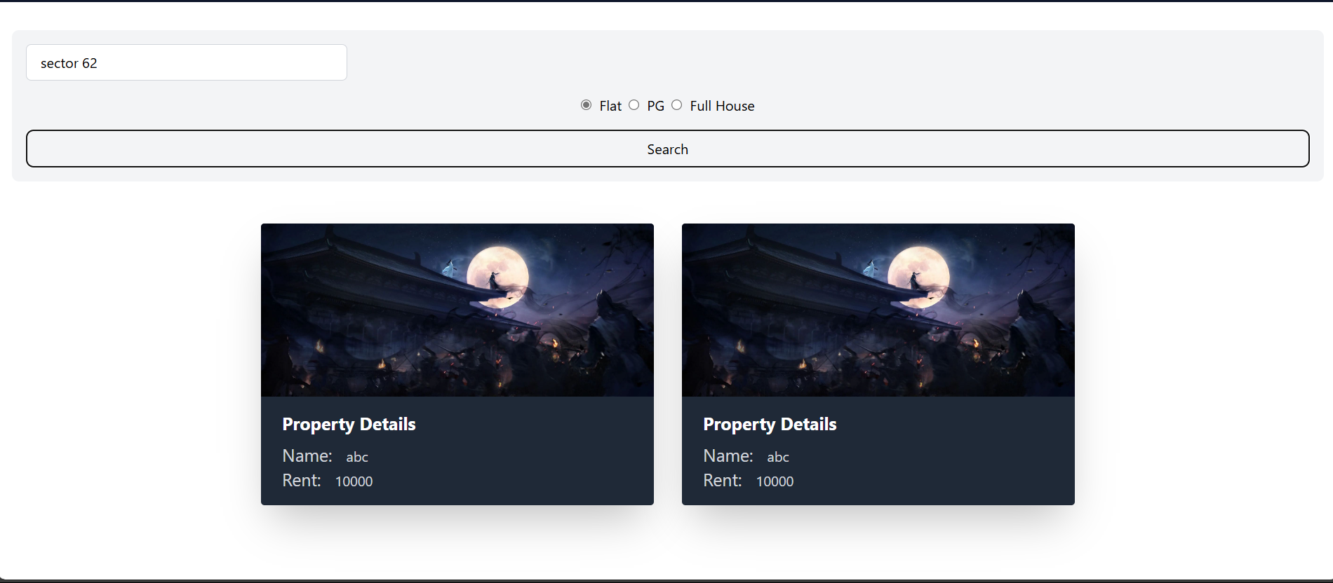
- Property Window

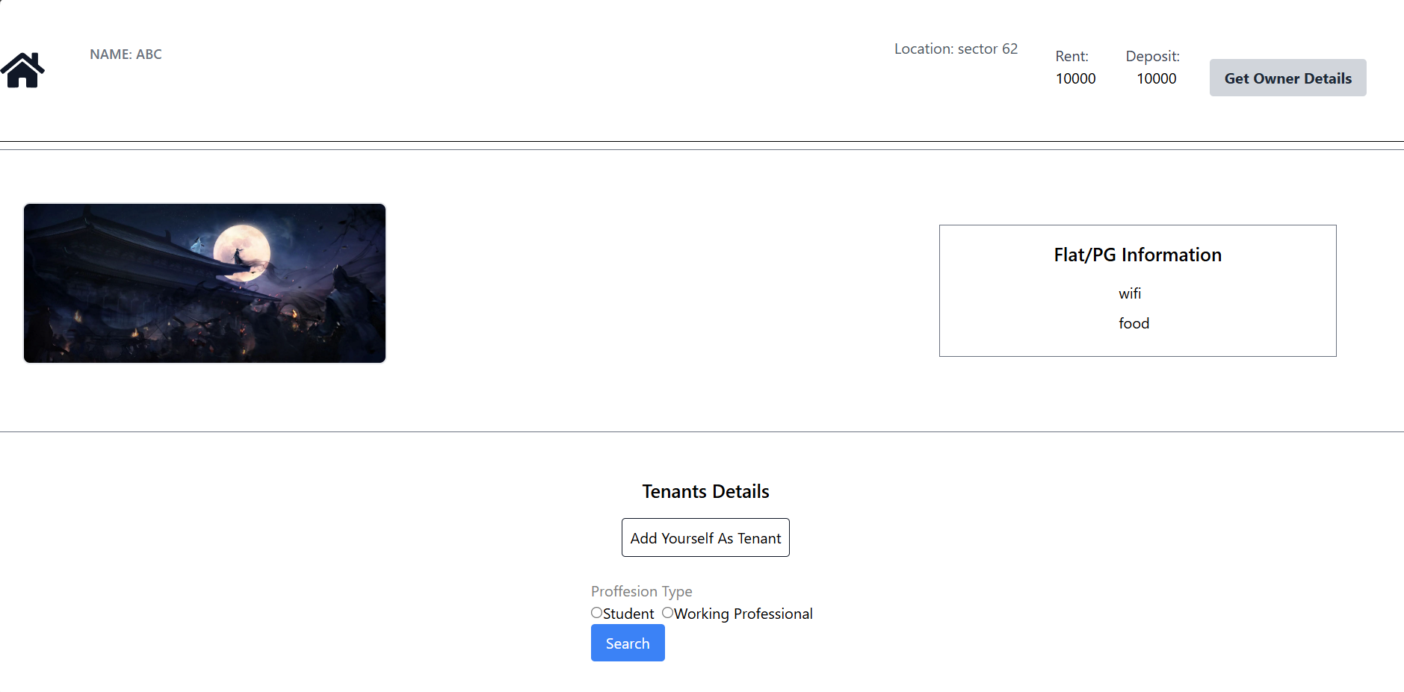

- Add Tenant Section
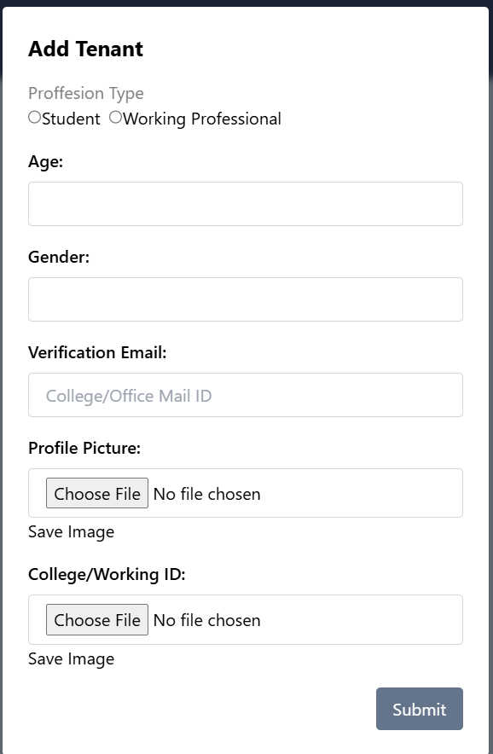

- Tenant Section
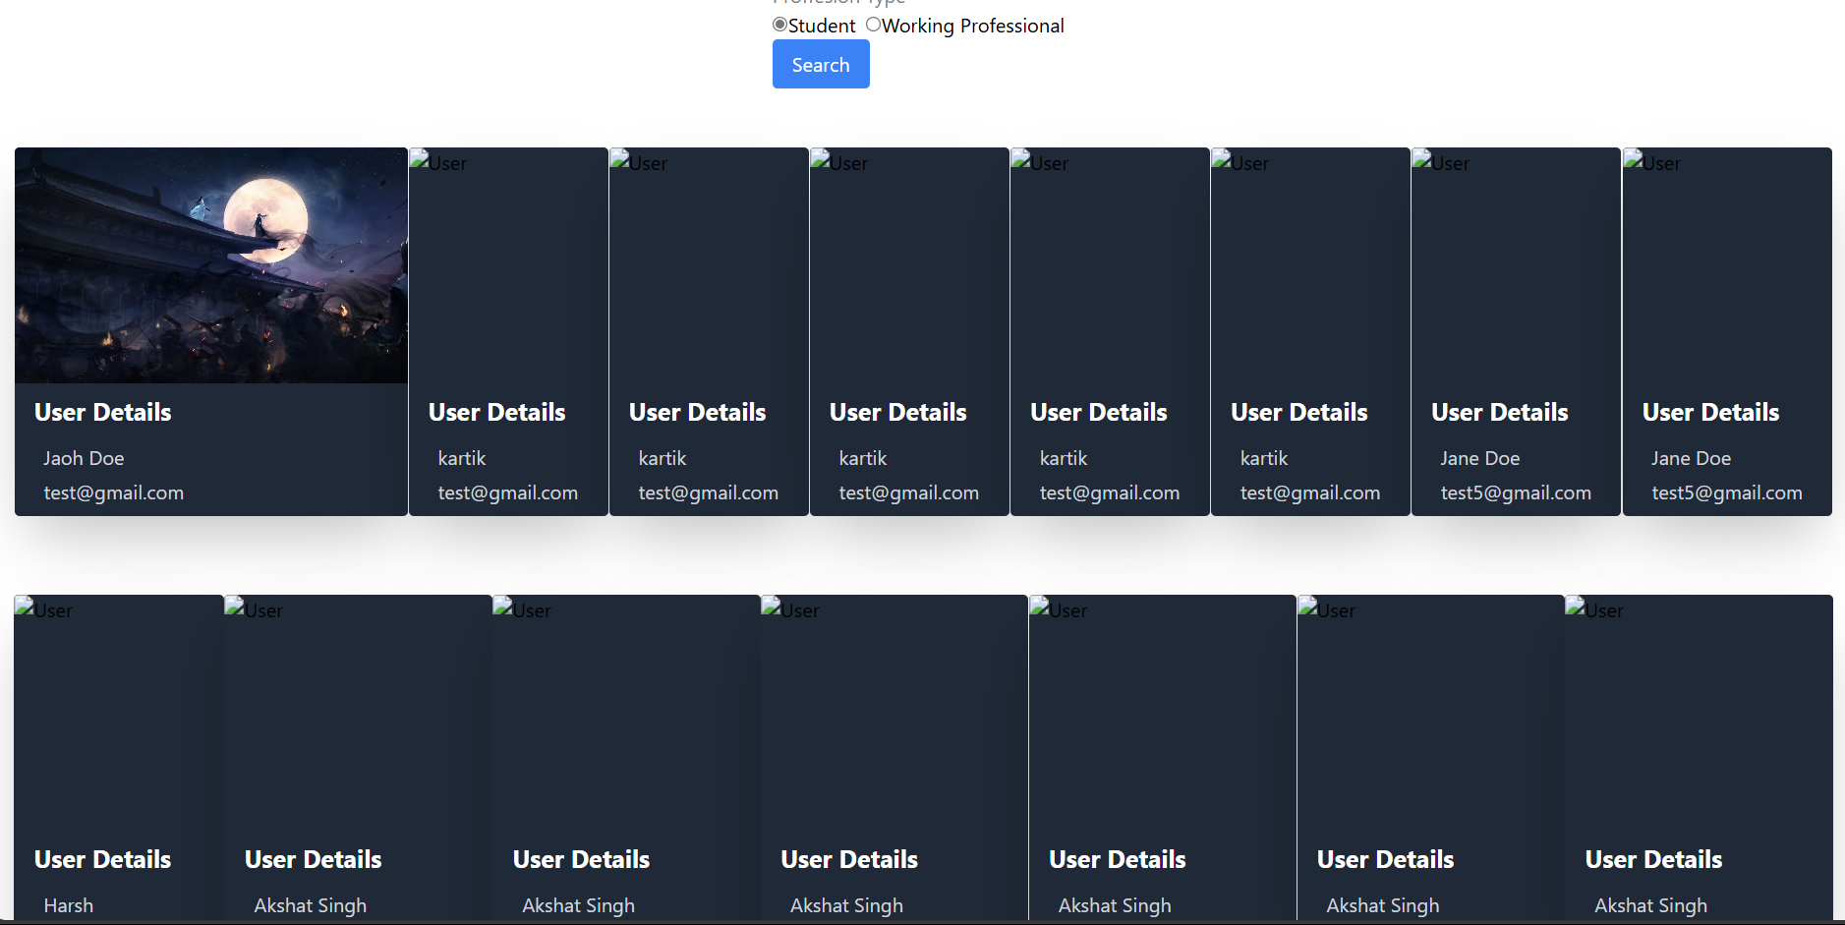

- Contact and Report Tenant

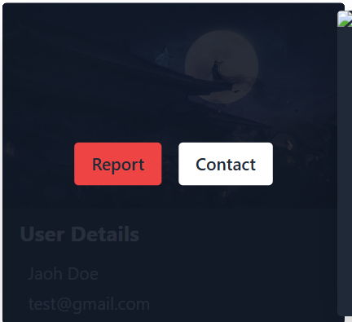
- Report Section

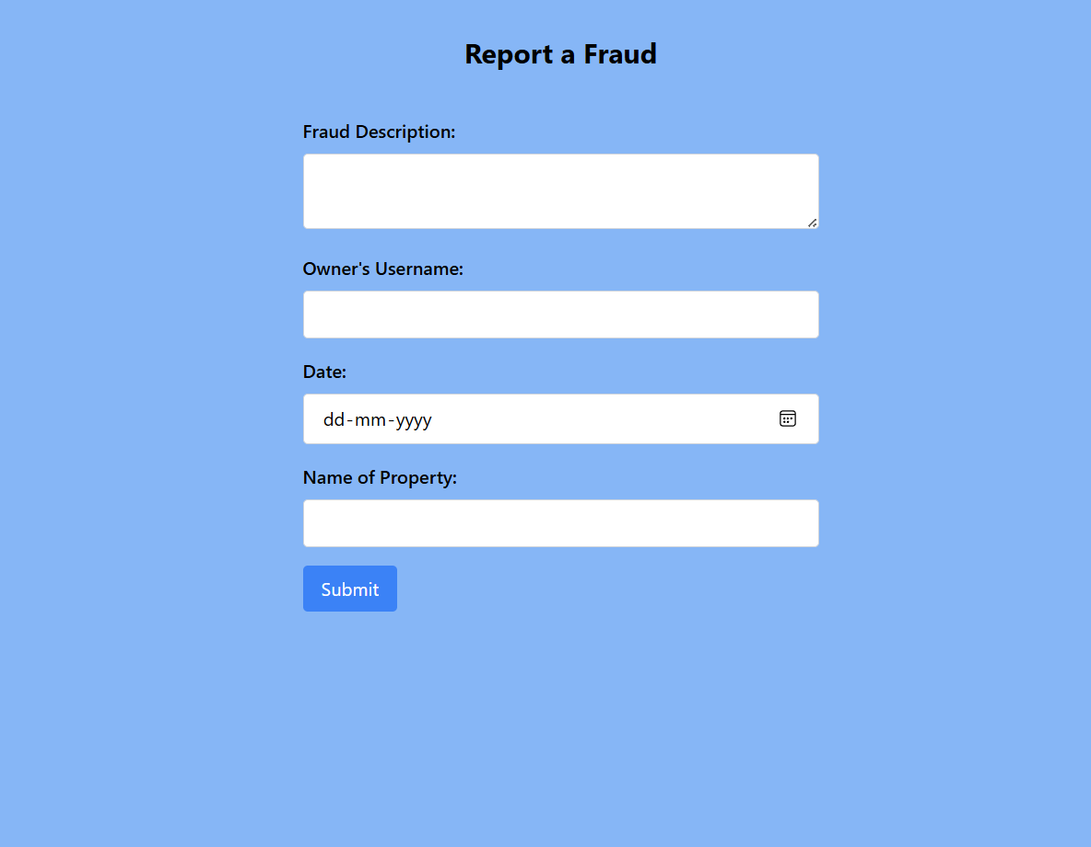

- SQL Database Tables

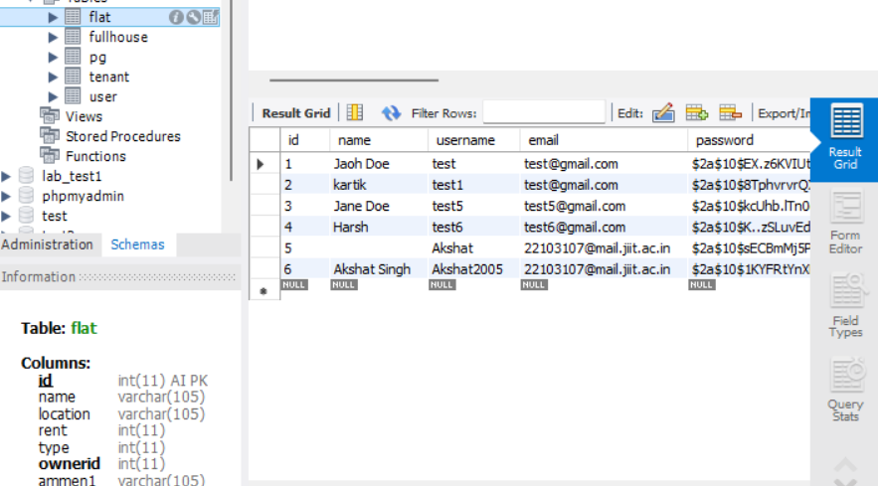
- Clustering Property

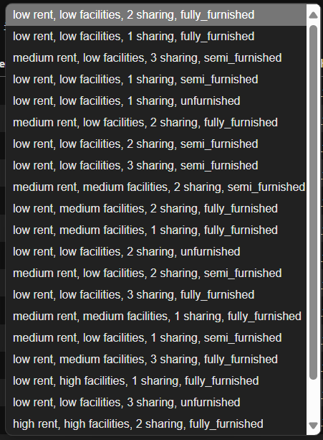
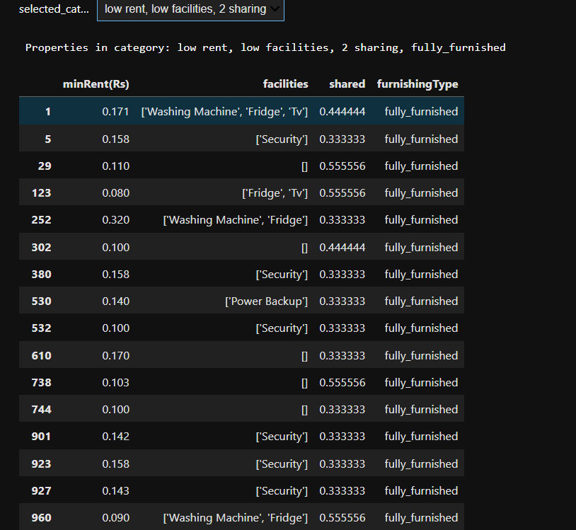
- Ranking Properties

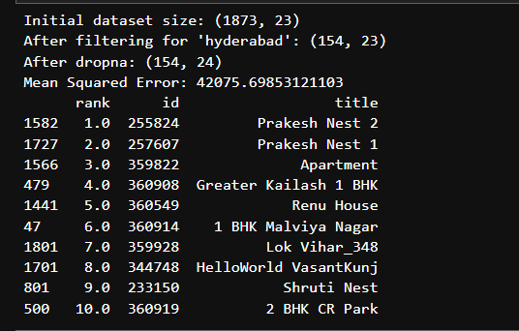

- Dataset

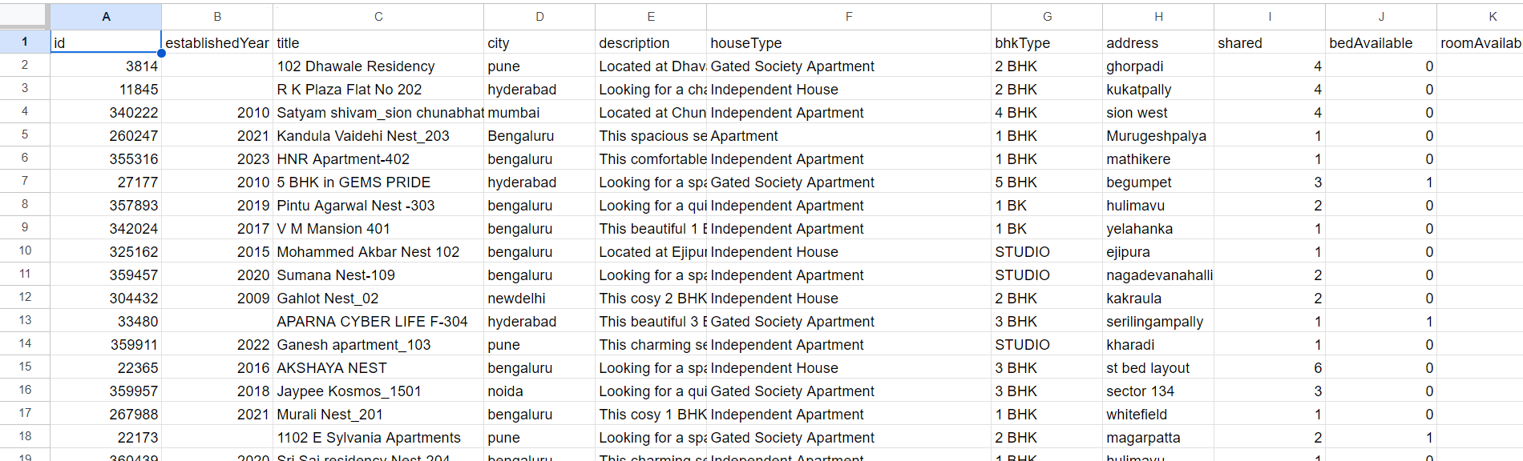

Conclusions

Based on the results outlined above, several key conclusions can be drawn:
1. Successful Platform Implementation:
RentKaro has successfully met its objectives by creating a platform that is not only easy to use but also efficient for property owners. The integration of machine learning-based recommendation systems and dynamic pricing features has enhanced both the tenant and property owner experience.
2. User-Centric Design:
The platform’s design focuses heavily on **user experience** by providing intuitive search filters, detailed property pages, real-time communication tools, and personalized recommendations. This has made it easier for tenants to find the PGs that suit their needs while providing property owners with tools to optimize their listings.
3. Scalability and Performance:
RentKaro is well-equipped to handle growth in user traffic, with load balancing, database optimizations, and caching strategies ensuring the platform performs well even during peak usage. These strategies contribute to a highly responsive system, which is crucial for maintaining a seamless user experience.
4. Robust Security Features:
By implementing strong encryption, authentication, and access control mechanisms, RentKaro ensures that user data is secure and protected. This is crucial for building trust among users and property owners, especially in a platform that handles sensitive information.
5. Machine Learning Enhancements:
The integration of machine learning algorithms has been highly effective in improving recommendations and price predictions. As more data is collected, the platform will continue to improve, providing even more personalized experiences for tenants and dynamic pricing for property owners.
Future Work

While RentKaro has achieved significant milestones, several areas present opportunities for further development. These enhancements can ensure the platform remains competitive and relevant in the future:

1. Payment Integration:
Online Payment Systems: Integrating a secure payment gateway (e.g., Stripe or Razorpay) would allow tenants to complete bookings directly through the platform. This would simplify the booking process and ensure secure financial transactions.
Subscription Models: RentKaro could offer subscription models for property owners, providing them with additional features such as promotional listings or access to analytics tools.

2. Mobile Application:
RentKaro’s reach can be extended with the development of a mobile app for both iOS and Android. A mobile application can offer tenants and property owners a more convenient and personalized experience, including push notifications for new inquiries, booking confirmations, and property availability updates.

3. Enhanced Machine Learning:
Further improvements to the recommendation system could involve the use of deep learning to create more sophisticated models that better understand tenant behavior and preferences. For example, by using neural networks, RentKaro could better predict tenant choices by analyzing patterns in unstructured data (e.g., text reviews).

4. Interactive Map Integration:
Integrating Google Maps or a similar mapping service would allow tenants to view PG locations in real time and find nearby amenities (e.g., markets, transport, schools). This would be particularly beneficial for tenants who prioritize location when choosing accommodations.

5. Customer Support:
Implementing a chatbot to assist users with common inquiries can enhance customer support. The chatbot can answer questions, guide tenants through the booking process, and provide recommendations based on user queries.

References

1. Aggarwal, C. C. (2016). Recommender Systems: The Textbook. Springer.
2. Badr, M. A., & Hassan, A. M. (2019). “Machine Learning Techniques for Personalized Recommendations.” Journal of Computing Science and Engineering.
3. Shostack, A. (2014). Threat Modeling: Designing for Security. Wiley.
4. Stallings, W. (2018). Cryptography and Network Security: Principles and Practice. Pearson.
5. Thomas, P. (2016). Database Design and Relational Theory: Normal Forms and All That Jazz. O'Reilly Media.
6. Bell, D. (2015). Building Scalable Web Applications with Microservices. Packt Publishing.
7. Krug, S. (2014). Don't Make Me Think: A Common Sense Approach to Web Usability. New Riders.
8. https://www.ijert.org/research/lekede-online-rental-system-IJERTV8IS100213.pdf
9. https://www.irjet.net/archives/V8/i7/IRJET-V8I7192.pdf
10. https://ijcrt.org/papers/IJCRT2104681.pdf

