#### **“BuliWear (Business Web App)”**



**A MINOR PROJECT REPORT**

**Submitted in partial fulfillment of the requirement of the degree of**

**MASTER OF COMPUTER APPLICATIONS (MCA)**

**MCA-306 (2022-2023)**

**Guided by: Submitted by:**

**Ms. Ratnalata Gupta Abhishek Buliwal**

**Ishan Jaiswal**

**SHRI VAISHNAV INSTITUTE OF MANAGEMENT, INDORE**

**APPROVED BY AICTE, NEW DELHI & AFFILIATED TO DAVV, INDORE and RGPV, Bhopal (M.P) UGC-NAAC ACCREDITED ‘A’ GRADE INSTITUTE**

**Approval**

The Minor project entitled **“BuliWear (Web App)”** submitted by **Abhishek Buliwal (0807CA211001) and Ishan Jaiswal (0807CA211026) Rajiv Gandhi Proudyogiki Vishwavidyalaya (RGPV), Bhopal of MCA III** Semester is approved for the partial fulfillment of the requirement of degree of **Master of Computer of Applications (MCA)**.

**Internal Examiner External Examiner**

**Head, DOCS Director**

**Acknowledgement**

First and foremost, we would like to express our gratitude to our Mentor, **Ms. Ratnalata Gupta**, who was a continual source of inspiration. She pushed us to think imaginatively and urged us to do this Minor Project without hesitation. Her vast knowledge, extensive experience, and professional competence in Web Development enabled us to successfully accomplish this project.

This endeavor would not have been possible without her help and supervision. We could not have asked for a finer mentor in our project. This initiative would not have been a success without the contributions of each and every individual. We were always there to cheer each other on, and that is what kept us together until the end.

I’d like to thank **Shri Vaishnav Institute of Management, Indore** for providing me with the opportunity to work on the project (**BuliWear**). Last but not least, I would like to express my gratitude to my faculty members and friends for their invaluable assistance, and I am deeply grateful to everyone who has contributed to the successful completion of this project.

**Submitted by:**

**Abhishek Buliwal**

**Ishan Jaiswal**

**Table of Contents Page No.**

**Approval II**

**Acknowledgement III**

1. **Problem Investigation 6**
   1. **Introduction**
   2. **Limitation of Current System**
   3. **Aim and Objectives**

1. **System Analysis 7-12**
   1. **Information Gathering 7**
   2. **Feasibility Study 8**
   3. **Data flow Diagram 9-11**
      1. **User DFD 9-10**
      2. **Admin DFD 11**
   4. **Hardware and Software Requirements 12**
2. **System Design 13-17**
   1. **UML Diagram 15**
   2. **ER Diagram 16**
   3. **Data Tables 17**
3. **Tool Used 18-20**
   1. **Front End and Back End 19**
   2. **MERN Stack 20**
4. **Testing 21-23**

**5.1 Testing Table 22-23**

1. **Implementation 24-28**
   1. **Forms Layout 24**
      1. **Home Page 25**
      2. **Sign In Page 26**
      3. **Sign Up Page 27**
      4. **After login 28**
2. **Conclusion 29-30**
   1. **Salient Features of System 29**
   2. **Limitation of System 30**
   3. **Scope of future Enhancements**
3. **Bibliography 31**
4. **Research Paper**
5. **Problem Investigation**

This chapter gives an overview about the introduction, aim and objectives, background and operation environment of the system.

**1.1 INTRODUCTION**

Whether you provide products or services, an online website is an alternative location to sell them. You can reach clients that are in another town or country just by simply having a web presence. With our busy lifestyles we are reverting to browsing online – gone are the days where hours are spent in physical shops checking out products.

**1.2 LIMITATION OF CURRENT SYSTEM**

As in todays world all of us use internet to buy and sell goods and hence in this era we must have an online presence in any form. As Business can get very benefits from getting online because they will no longer have limitation to reaching its target audience.

**1.3 AIM AND OBJECTIVE**

BuliWear Business web app will help our business to reach our target audience and grow our business by making our store available to everyone and anywhere at any time. This will also increase our customer base and make our online presence more worth.

1. **System Analysis**

Systems analysis is the process by which an individual (s) studies a system such that an information system can be analyzed, modeled, and a logical alternative can be chosen. Systems analysis projects are initiated for three reasons: problems, opportunities, and directives.

**2.1 Information Gathering**

Managing information involves gathering and distributing necessary information and assimilating them on the project management activities and processes. The information gathering techniques are repeated processes that are used to create and organize data across different kinds of sources. There are four types of information gathering techniques as follows:

Brainstorming: This method is used to get a list of all project lists. All ideas are generated with the help of a facilitator through an open discussion and mass interviewing techniques. Commonly, the brainstorming technique can be done during a scheduled meeting with peers, individual brainstorming or even at an informal meeting.

Delphi Technique: This technique in project management requires the presence of a facilitator that gives out questionnaires to solicit different ideas. The responses are summarized and re-circulated to the participants.

Root cause analysis: One of the information gathering techniques is the root cause analysis. It is used in identifying problems and its underlying causes thus developing a preventive action.

Interviewing: Stakeholders, participants and experts are interviewed to identify risks.

**2.2 Feasibility Study**

The objective of feasibility study is to determine whether or not the proposed system is feasible. The feasibility is determined in terms of three aspects. These are: -

1. **Technical Feasibility -** In this, one has to test whether the system can be developed using existing technology or not. We have used HTML, CSS as front end and PHP, SQL as back end. It is evident that necessary hardware and software are available for development and implementation of proposed system. We acquired the technical knowledge of working in HTML and CSS, and then only we have started designing our project.
2. **Operational Feasibility -** Operational feasibility refers to the measure of solving problems with the help of a new proposed system. It helps in taking advantage of the opportunities and fulfills the requirements as identified during the development of the project. It takes care that the management and the users support the project.
3. **Economic Feasibility -** This assessment typically involves cost/benefit analysis of the project, helping organizations determine the viability, cost and benefits associated with a project before financial resources are allocated.

**2.3 DATA FLOW DIAGRAM**

* It is a simple graphical formalism that can be used to represent a system in terms of input data to the system, various processing carried out on this data, and the output data is generated by this system.
* The data flow diagram (DFD) is one of the most important modeling tools. It is used to model the system components.

**2.3.1 User**

**Level 0**

**It is also known as a context diagram**. It's designed to be an abstraction view, showing the system as a single process with its relationship to external entities. It represents the entire system as a single bubble with input and output data indicated by incoming/outgoing arrows.

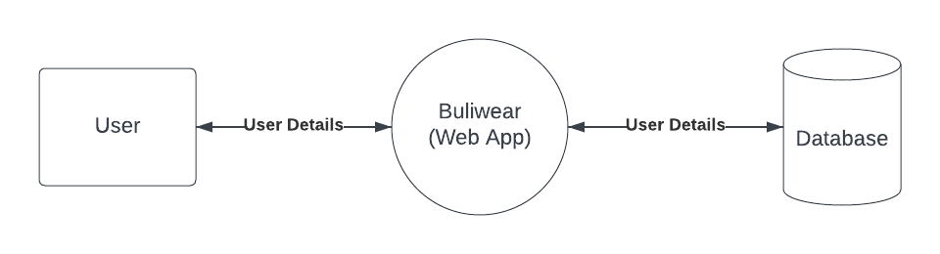

Fig 2.1 USER level 0 data flow diagram

**Level 1**

As described previously, context diagrams (level 0 DFDs) are diagrams where the whole system is represented as a single process. A level 1 DFD **notates each of the main sub-processes that together form the complete system**. We can think of a level 1 DFD as an “exploded view” of the context diagram.

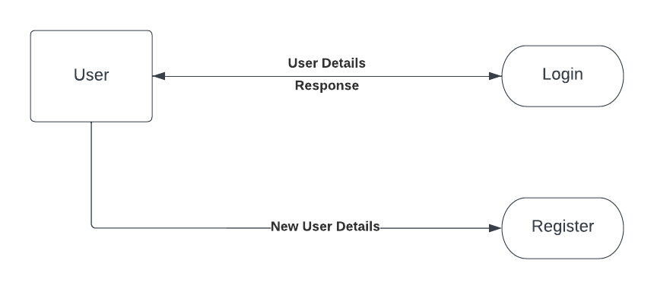

Fig 2.2 USER level 1 data flow diagram

**2.3.2 Admin**

**Level 0**

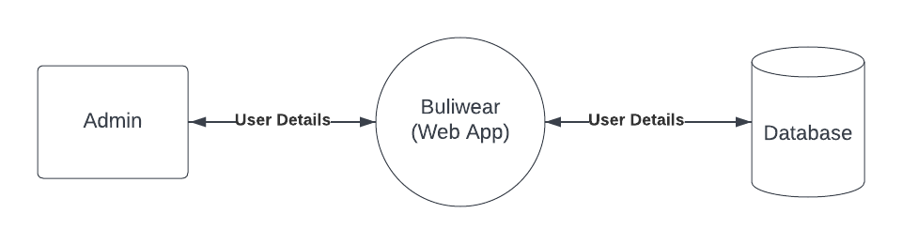

Fig 2.3 Admin level 0 data flow diagram

**Level 1**

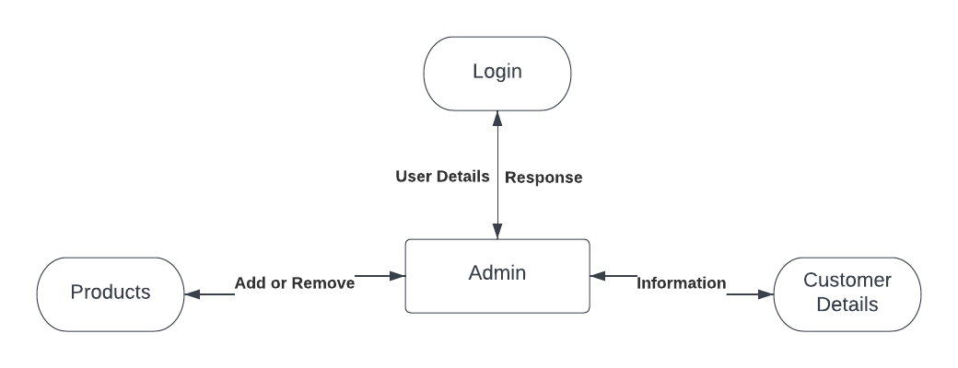

Fig 2.4 Admin level 1 data flow diagram

**2.4 Hardware and Software Requirements**

**HARDWARE INTERFACES: -**

* Memory minimum of 2 GB RAM
* Hard disk of 1 GB
* Processor – Pentium 4 or higher
* Stable Internet Connection

**SOFTWARE INTERFACES: -**

* Web Technologies – Node JS, React JS
* Database – MongoDB
* Operating System – 7/8/10/11
* Installation – React, MongoDB Compass
* Setup – Node Module

**3.System Design**

The purpose of System Design is to create a technical solution that satisfies the functional requirements for the system. At this point in the project lifecycle there should be a Functional Specification, written primarily in business terminology, containing a complete description of the operational needs of the various organizational entities that will use the new system. The challenge is to translate all of this information into Technical Specifications that accurately describe the design of the system, and that can be used as input to System Construction.

Many organizations look at System Design primarily as the preparation of the system component specifications; however, constructing the various system components is only one of a set of major steps in successfully building a system. The preparation of the environment needed to build the system, the testing of the system, and the migration and preparation of the data that will ultimately be used by the system are equally important. In addition to designing the technical solution, System Design is the time to initiate focused planning efforts for both the testing and data preparation activities

This phase consists of the following processes:

* Prepare for System Design, where the existing project repositories are expanded to accommodate the design work products, the technical environment and tools needed to support System Design are established, and training needs of the team members involved in System Design are addressed.
* Define Technical Architecture, where the foundation and structure of the system are identified in terms of system hardware, system software, and supporting tools, and the strategy is developed for distribution of the various system components across the architecture.
* Define System Standards, where common processes, techniques, tools, and conventions that will be used throughout the project are identified in an attempt to maximize efficiencies and introduce uniformity throughout the system.
* Create Physical Database, where the actual database to be used by the system is defined, validated, and optimized to ensure the completeness, accuracy, and reliability of the data.
* Prototype System Components, where various components of the solution may be developed or demonstrated in an attempt to validate preliminary functionality, to better illustrate and confirm the proposed solution, or to demonstrate “proof-of-concept.”
* Produce Technical Specifications, where the operational requirements of the system are translated into a series of technical design specifications for all components of the system, setting the stage for System Construction.

The following chart illustrates all of the processes and deliverables of this phase in the context of the system development

lifecycle

**3.1 UML Diagram**

A use case diagram is a graphical depiction of a user's possible interactions with a system. A use case diagram shows various use cases and different types of users the system has and will often be accompanied by other types of diagrams as well. The use cases are represented by either circles or ellipses.

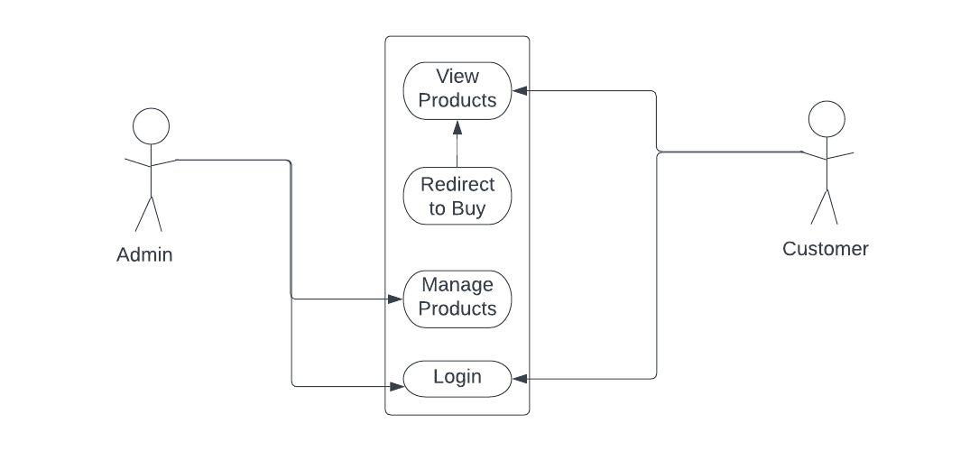

Fig 3.4 Use Case Diagram

**3.2 ER Diagram**

An Entity Relationship Diagram is a diagram that represents relationships among entities in a database. It is commonly known as an ER Diagram. An ER Diagram in DBMS plays a crucial role in designing the database. Today’s business world previews all the requirements demanded by the users in the form of an ER Diagram. Later, it's forwarded to the database administrators to design the database.

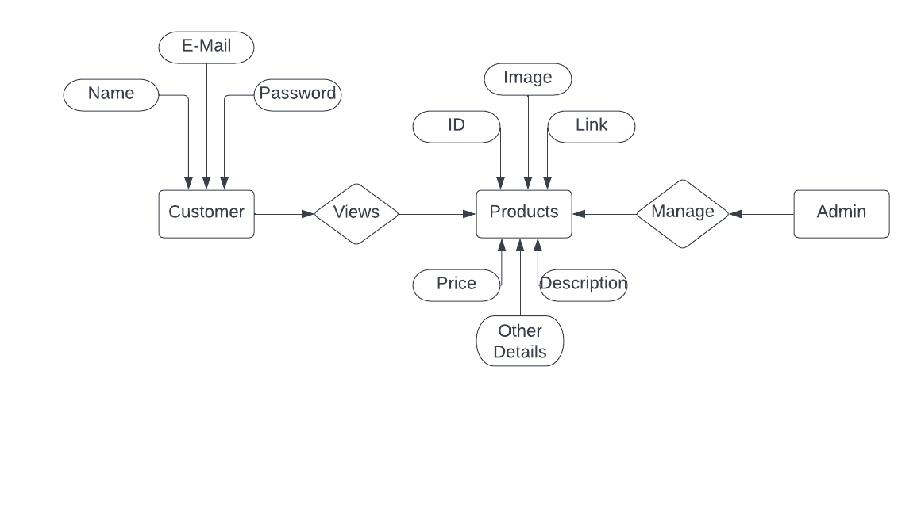

Fig 3.5 Entity Relationship Diagram

**3.3 Data Table**

A table is a collection of related data held in a table format within a database. It consists of columns and rows. In relational databases, and flat file databases, a table is a set of data elements using a model of vertical columns and horizontal rows, the cell being the unit where a row and column intersect.

**Table: 3.1 Products**

|  |  |  |
| --- | --- | --- |
| **Field** | **Type** | **Description** |
| id | String | ID of a product |
| Name | String | Name of the product |
| Details | String | Product Details |
| Description | String | Description about Product |
| Price | Number | Price of the Product |
| link | String | Buying link of Product |
| size | String | Size of the Product |

**Table: 3.2 User Details**

|  |  |  |
| --- | --- | --- |
| **Field** | **Type** | **Description** |
| Name | String | Name of User |
| Email | String | Email of User |
| Password | Password | Encrypted Password |
| Admin | Boolean | Is user Admin or not |

**4.Tools Used**

A software or a programming tool is a set of computer programs that are used by the developers to create, maintain, debug, or support other applications and programs. Software development tools are simply tools (generally software themselves) that programmers practice to create other software. For Example - language libraries, code editors, debuggers, etc. Any software deploy tool that enables a programmer to build stable software matching the needs or goals of a customer is placed into this category.

In other words, the selection of software engineering tools to be used in its development process can completely shape or break a project. Once the targeted ecosystem and programming language(s) are chosen, and the requirements and end goals are also well-enough understood, the next task is starting the work of a software development project is to choose the tools that will be utilized throughout the process. It's also important to be knowledgeable of the types of tools that are available for employment, their benefits, and the implications for using them.

**Tools and Technologies we used**

MongoDB, Express, React JS and Node JS (MERN Stack) as in Backend and Frontend has been used to develop this Project (Web APP). We have also used Softwares like Visual Studio code which helped us to write code efficiently and quickly.

As we have used VS Code with some extenuations which increases our productivity. We also have used Git for version controlling which help our team member to update our code easily by just pushing the code on git repository once we made any changes on our code.

**4.1 Front End and Back End**

System architectures are broken down into front end and back-end components for a variety of purposes. The most common is in software and web development to break down projects in terms of required skills. The front-end aspect of a project is usually handled by professionals such as web designers while the back end is handled by engineers and developers.

Front end and back end can also be used to describe situations where the customer has access to one view and employees have access to another. Front end components are customer facing while rights to the back end are exclusively for authenticated users.

**4.2 What is the MERN stack?**

MERN stands for MongoDB, Express, React, Node, after the four key technologies that make up the stack.

* MongoDB - document database
* Express - Node.js web framework
* React - a client-side JavaScript framework
* Node - the premier JavaScript web server

Express and Node make up the middle (application) tier. Express.js is a server-side web framework, and Node.js is the popular and powerful JavaScript server platform. Regardless of which variant you choose, ME(RVA)N is the ideal approach to working with JavaScript and JSON, all the way through.

**React.js front end**

The top tier of the MERN stack is React.js, the declarative JavaScript framework for creating dynamic client-side applications in HTML. React lets you build up complex interfaces through simple components, connect them to data on your back-end server, and render them as HTML.

**Express.js and Node.js server tier**

The next level down is the Express.js server-side framework, running inside a Node.js server. Express.js bills itself as a “fast, unopinionated, minimalist web framework for Node.js,” and that is indeed exactly what it is. Express.js has powerful models for URL routing (matching an incoming URL with a server function), and handling HTTP requests and responses.

**MongoDB database tier**

If your application stores any data (user profiles, content, comments, uploads, events, etc.), then you’re going to want a database that’s just as easy to work with as React, Express, and Node.

That’s where MongoDB comes in: JSON documents created in your React.js front end can be sent to the Express.js server, where they can be processed and (assuming they’re valid) stored directly in MongoDB for later retrieval. Again, if you’re building in the cloud, you’ll want to look at Atlas. If you’re looking to set up your own MERN stack, read on!

**5.Testing**

Web app testing, or web testing, is a software testing practice that helps ensure the quality and functionalities of the app according to the requirements. Web testing must detect all underlying issues, such as functional discrepancies, security breaches, integration problems, environmental issues, or traffic stress before it is delivered.

**Functional vs. Non-functional Testing**

The goal of utilizing numerous testing methodologies in your development process is to make sure your software can successfully operate in multiple environments and across different platforms. These can typically be broken down between functional and non-functional testing. Functional testing involves testing the application against the business requirements. It incorporates all test types designed to guarantee each part of a piece of software behaves as expected by using uses cases provided by the design team or business analyst. These testing methods are usually conducted in order and include:

* Unit testing
* Integration testing
* System testing
* Acceptance testing

Non-functional testing methods incorporate all test types focused on the operational aspects of a piece of software. These include:

* Performance testing
* Security testing
* Usability testing
* Compatibility testing

The key to releasing high quality software that can be easily adopted by your end users is to build a robust testing framework that implements both functional and non-functional software testing methodologies.

**Table: 5.1 Testing**

|  |  |  |  |  |
| --- | --- | --- | --- | --- |
| **S.NO** | **Test Case** | **Expected Result** | **Actual Result** | **Result** |
| 1 | Enter the URL | should get Home page | Home page Displayed | Pass |
| 2 | Click About us option | should get About us page | About us page displayed | Pass |
| 3 | Click Contact us option | Should get Contact page | Contact page displayed | Pass |
| 4 | Click Product option | should get Product page | Product page  displayed | Pass |
| 5 | Click Sign Up option | should get Sign Up Page | Sign Up page Displayed | Pass |
| 6 | Click Sign In option | should get Sign In Page | Sign In page Displayed | Pass |
| 7 | Click Sign Up and enter Name, Email and Password | Register and will be redirected to Sign In page | Sign In page Displayed | Pass |
| 8 | Click Sign In and enter Email and Password | Sign In and redirect to Home page | Home page displayed | Pass |
| 9 | Go to product page and select product and Buy | Redirect to specific product page | Redirected successfully | Pass |
| 10 | Click on logout | Session should be out and main page should be displayed | Session is out | Pass |

**6. Implementation**

Implementation is the process that actually yields the lowest-level system elements in the system hierarchy (system breakdown structure). System elements are made, bought, or reused. Production involves the hardware fabrication processes of forming, removing, joining, and finishing, the software realization processes of coding and testing, or the operational procedures development processes for operators' roles. If implementation involves a production process, a manufacturing system which uses the established technical and management processes may be required.

**6.1 Forms layout**

**6.1.1 Home Page**

For a Web user, the home page is the first Web page that is displayed after starting a Web browser like Netscape's Navigator or Microsoft's Internet Explorer. The browser is usually preset so that the home page is the first page of the browser manufacturer.

The term may also refer to the start page shown in a web browser when the application first opens. Usually, the home page is located at the root of the website's domain or subdomain. For example, if the domain is http://example.com , the home page is likely located at www.example.com/ .

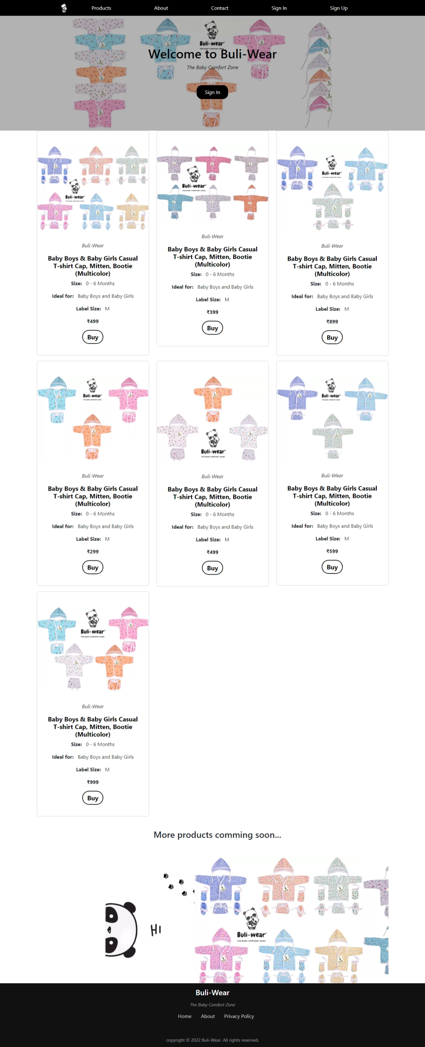



Fig 6.1 Home Page

**6.1.2 Sign In Page**

Sign In Page is very common among any type of secured applications and its widely used on the internet for authenticating the user before presenting the secured pages of the web applications. For example, to use Facebook you have to get authenticated by the Facebook before they give you access to their platform. The user authentication is done through a special web page called Login Page. The Login page asks you to enter your credentials which is then validated by the application and after successful validation you are presented with the secured part of the application.

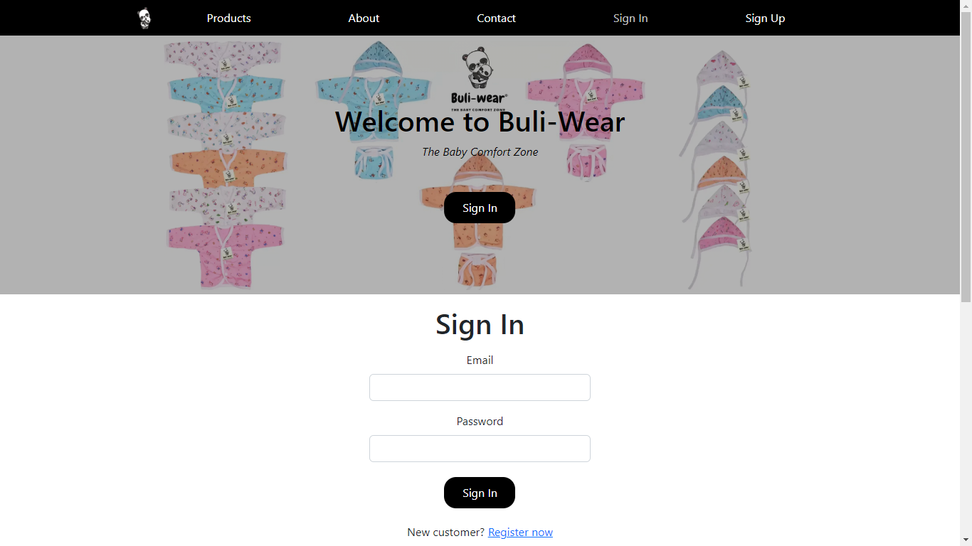

Fig 6.2 Sign In Page

**6.1.3 Sign Up Page**

A signup page (also known as a registration page) enables users and organizations to independently register and gain access to your system. It is common to have multiple signup pages depending on the types of people and organizations you want to register. In this article you will learn about the different types of signup pages, how to configure them and related functionality. Global Administrator access is required to create and modify signup pages.

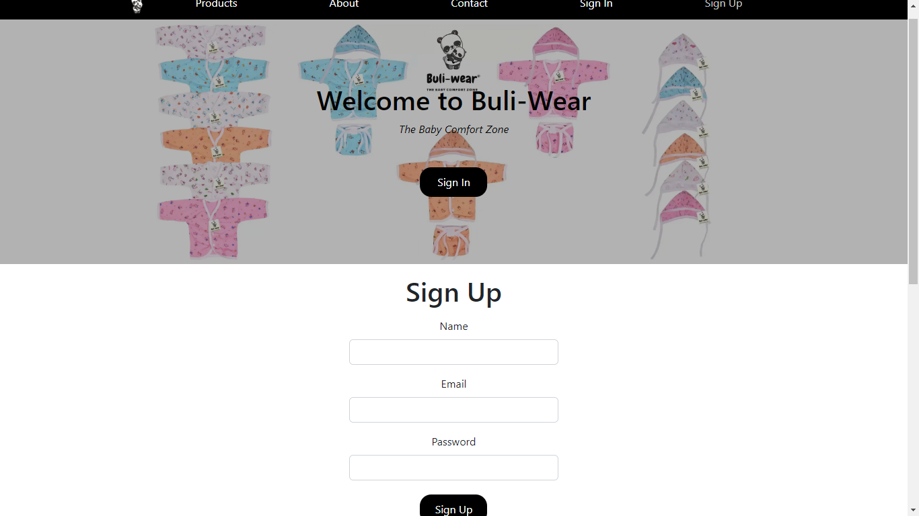

Fig 6.3 Sign Up Page

**6.1.4 After Login**

After user has successfully logged in on this platform his/her name will be displayed on the Navigation Bar instead of Sign In and Sign UP. And also user’s name will be displayed on Hero Image with Greeting text.

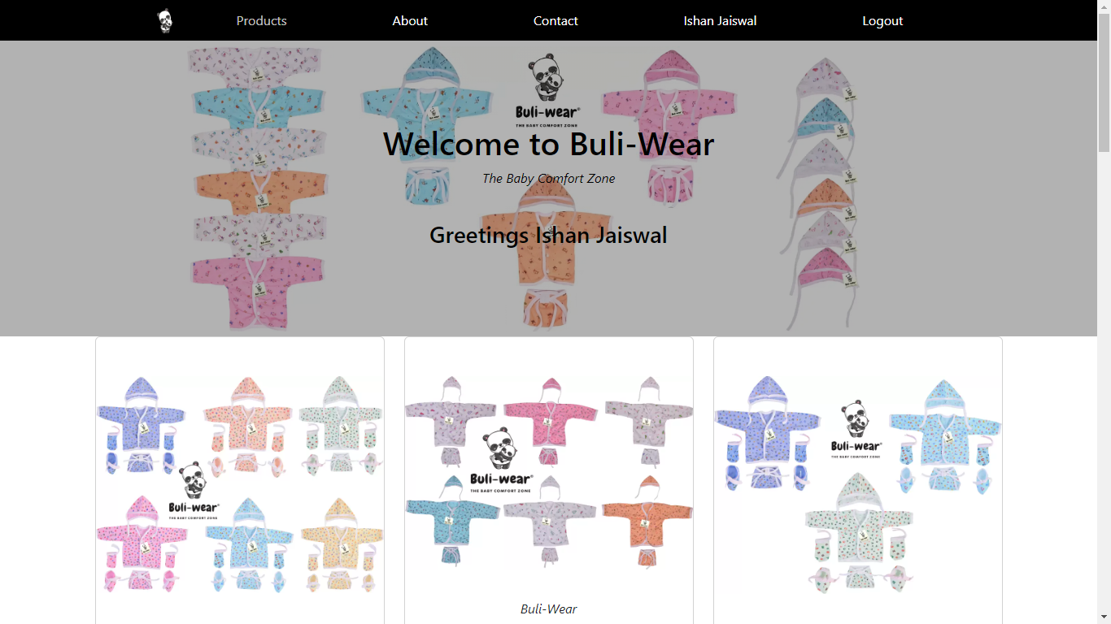



Fig 6.4 After Login

**7. Conclusion**

**7.1 Salient Features of System**

* This Business website will make online presence of BuliWear.
* Now customers can reach our platform anytime and anywhere.
* This will increase our customer reach and help BuliWear to grow faster.
* All the official products will be listed on this application.
* As it is an official website and hence it will be safe and secure for all of the customers and all of there details will be kept secure.
* By this platform our customers and contact us by using Contact Form available on the Portal.
* As our customers will login on our web app we will get their information like Name and Email which can help us to acquire more data which can help us to know more about our customers and help us to manage our product relevantly.
  1. **Limitations of System**

This app does have many features but there are some limitations too: -

* As it is a basic Business web app it has some basic features only.
* It is dependent on many node module and sometime it may cause errors.
* Accessing this application will require internet connection.
* Our system doesn’t provide automatic back up of data.

**7.3 Scope of Future Enhancements**

As this app is our first version there are many features we can add on our platform which we do have plans of: -

Some of them are:

* More enhanced user dashboard
* Full checkout system for buying products
* Visual enhancement.
* And few minor changes

**8. Bibliography**

[www.reactjs.org](https://reactjs.org/)

[www.nodejs.org/](https://nodejs.org/en/)

<www.mongodb.com/>

[www.w3schools.com](http://www.w3schools.com)

[www.tutorialpoint.com](http://www.tutorialpoint.com)

[https://www.academia.edu](https://www.academia.edu/67179046/Comprehensive_Study_of_MERN_Stack_Architecture_Popularity_and_Future_Scope)

**9. Research Papers**

[www.researchgate.net](https://www.researchgate.net/publication/361465446_Application_using_MERN_Stack)

[https://www.academia.edu/](https://www.academia.edu/67179046/Comprehensive_Study_of_MERN_Stack_Architecture_Popularity_and_Future_Scope)