Data:

A thorough exploration of the data, similar to what is presented in labs. What are the distributions of the features? How do these features correlate with the target?

After some data cleaning, for example, filling Null values with the mean value and separating categorical data into indicator variables. This was done by following industry standards and concepts learned from class. We came up with the following graphs to do some data analysis and see how the features correlate with the target.

The image below shows some simple statistics about the numerical data that we had. We can see the mean, standard deviation, minimum, and maximum values with all the ˆinterquartile ranges for the questions.

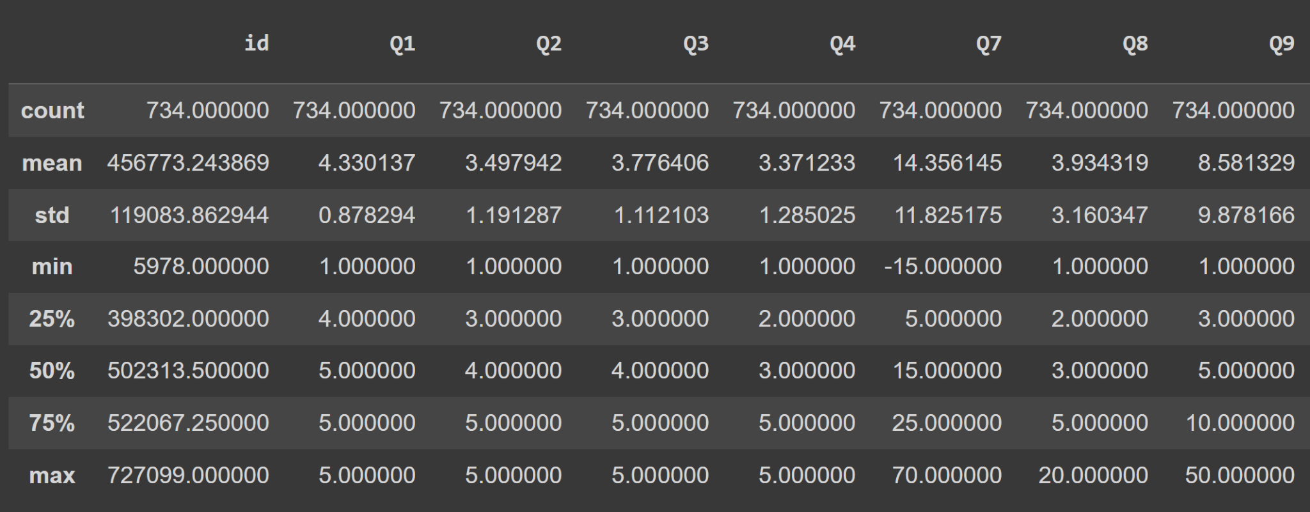

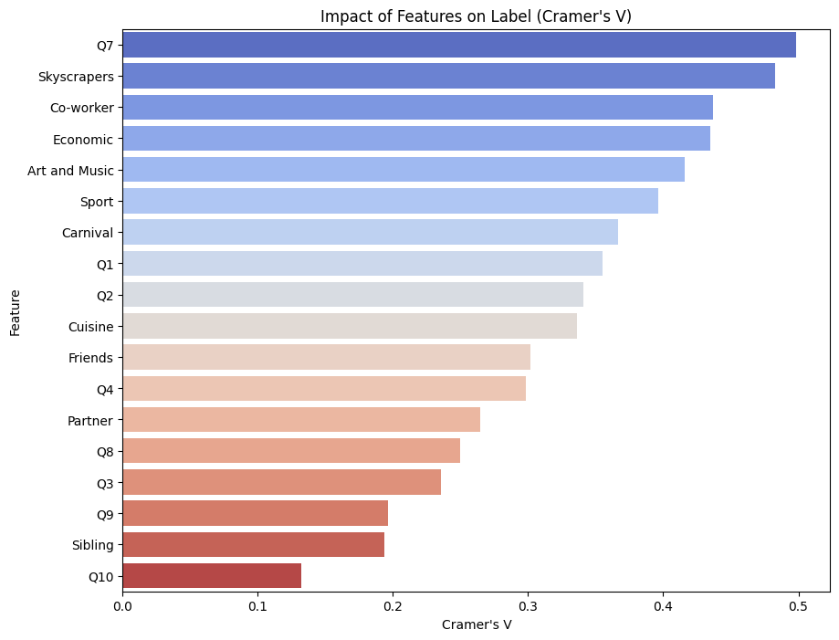
The graph above shows how each of the question's features correlates with the city label. We used the Cramer’s V test which is a measurement for chi-square. The range for this value is from 0 to 1. 1 being that it highly correlates with the label. From the graph above, we can see that the Cramer’s V test value ranges from 0.1 to 0.5. Even though none of the features have a high value like 0.9, we still need to consider these features as they are our questions on the survey. We can see that question 7 highly correlates with the city label with the value being around 0.5. This means that temperature is one of the factors that should be used to distinguish what the city is. We also can see that skyscrapers and Co-worker variables correlate with the city label. This means that we need to consider questions 6 and 5 into our model as well and we can’t remove the other options that were part of these questions as this will skew the model and will not contain the full picture about the entire question even though they might have less correlation to the city label. Questions 1 and 2 are in the middle for how it correlates to the city label with values being around 0.3. These questions can help to decide what the city is some meaning full capacity but not as much as question 7. We can see that question 10 does not correlate to the data well with a value of 0.12. This is because this question has words as a response and not a number so it is hard to find a correlation for it. This discovery lead to us changing the way

We will see later on in this text why we have included it in our model and input features.

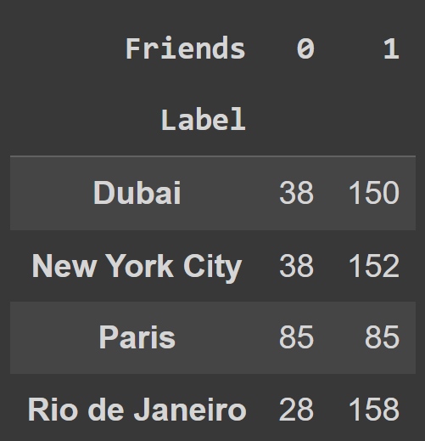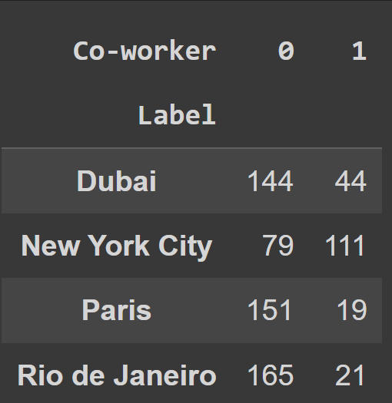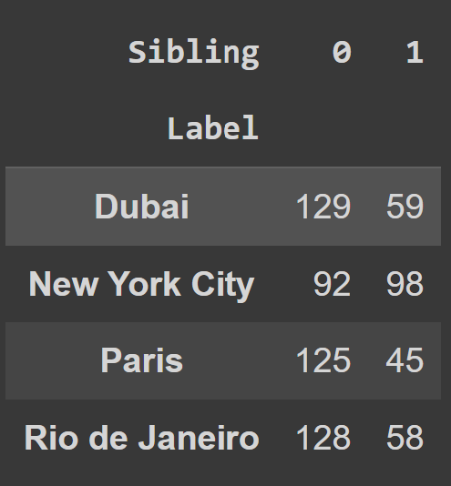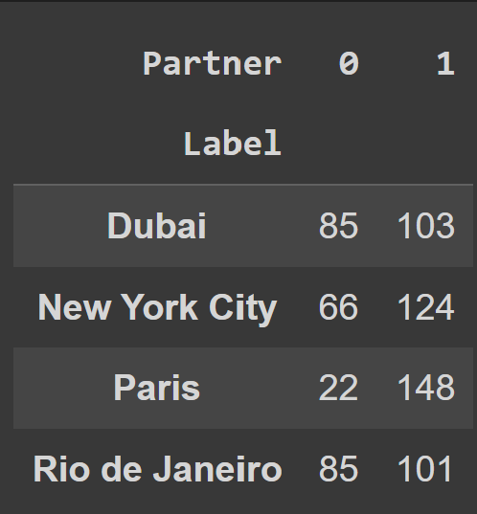

Next, we will talk about the 4 images seen above. They relate to question 5. 1 relates to the answer selection that they would take that option to that city and 0 means that they would not. For friends, we can see that around 150 users have selected to take their friends to Dubai, New York, and Rio. Paris has considerably low value for friends. For co-workers, we can see that a lot of users (high amount) have selected to take their co-workers to New York (111) compared to any other city. The other cities have a very low amount for this option. For siblings, we do not gain much information about this option as they are all around the same values except that New York has a slightly higher amount that they would take their siblings. For partners, we can see that Paris has the highest amount that users who will take their partners there. These trends in data can help us predict what city it will be for our model.
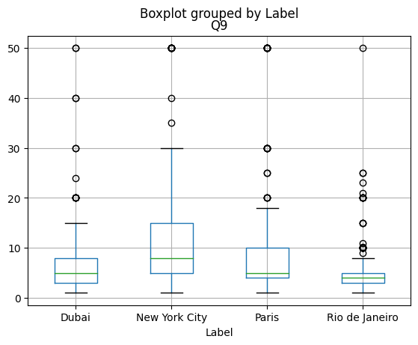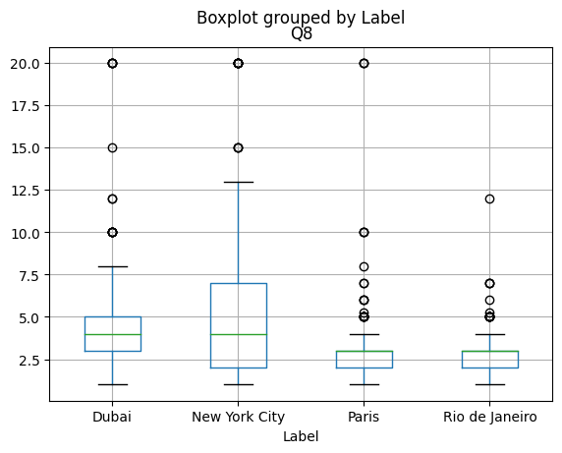

Next, we are going to talk about questions 8 and 9. We can see that these 2 questions have similar trends, especially for New York from the graphs above. New York can be seen to have the largest variance in data for these 2 questions. We can see that Dubai has the second-highest median for both questions. For question 9, Paris has the 2nd highest variance of data. Rio has the smallest amount of variance in both questions. We can also see that Rio has a lot of outliers in the data. We can see that the relevant numbers for question 9 are from 1 to 30 and for question 8 it is from 1 to 13 with New York showing this. In the data exploration stage, we found some values that do not make sense. Later on in this report, we will see what we did to fix them.

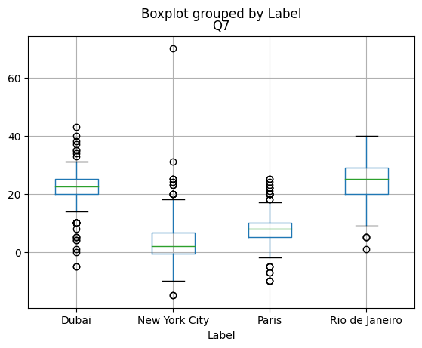
Now, we are going to talk about q7 using the graph above, which was the question that most correlated with the city label. We can see that Dubai and Rio have high temperatures compared to the other 2 cities which makes sense. This is because New York and Paris get cold in the winter (January). We see that Dubai has a lot of outliers which we also saw in our data exploration stage. We will see later, how we fixed them in the report.

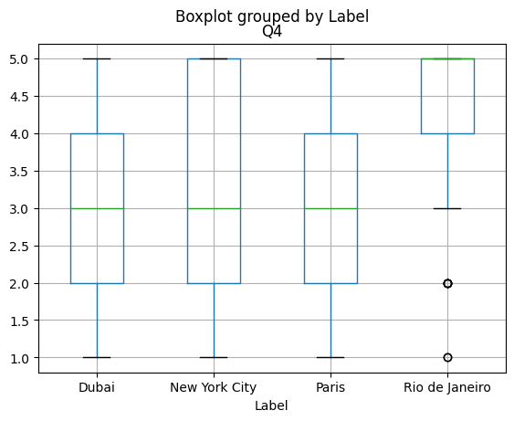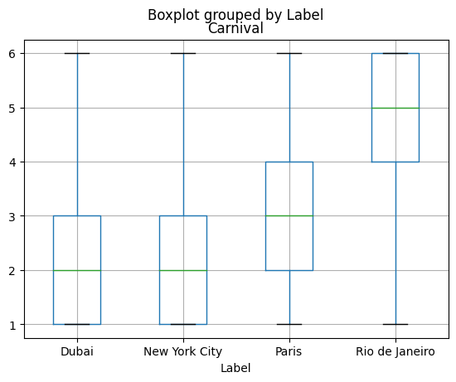

Now, we are going to talk about Q4 using the graph above, We can see that Rio has a low variance of data saying that it has a lot of street parties. This correlates with the graph that is next to it saying that Rio has a lot of Carnivals from question 6. From, domain knowledge, this is true which is why many users selected high for these 2 questions for Rio. The next thing to point out is that New York has a large amount of variance for question 4 and has a max value being 5. This shows that New York also has a lot of parties but not as much as Rio and the value for Carnivals for New York is very low. While a city may have a large number of parties, they might not necessarily have the party type of carnival in the city. This is true in the case of New York based on domain knowledge. Dubai also shows that they don’t have a lot of carnivals in the city.

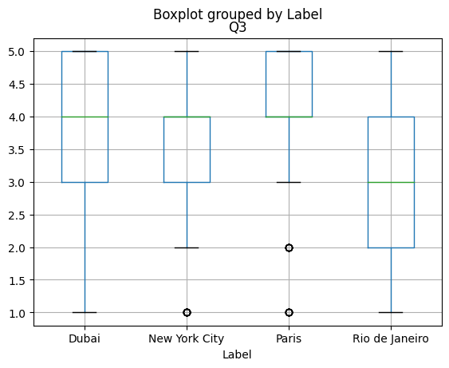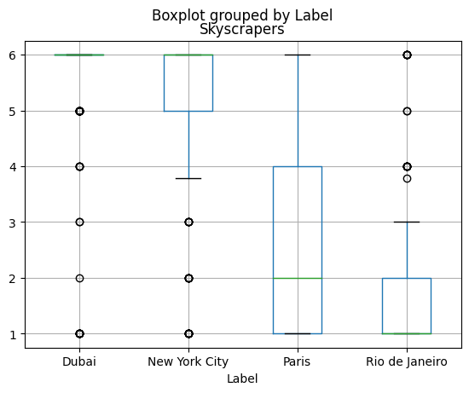

Next, we are going to talk about question 3 and question 6 rankings of skyscrapers using the graphs above. Question 3 talks about architectural uniqueness. We can see that users have selected the ranking for Dubai to have a lot of skyscrapers (median: 6) for question 6. The remaining order is as follows, New York (median as 6 but has variance in data), Paris (median: 2), and lastly Rio (median: 1). For question 3, we can see that Paris has the highest blend of different architectural uniqueness. The variance of data is less compared to Dubai in question 3. We can also see a high variance of data in question 3 for Rio but the median is on the lower side with having value of 3. These trends in data can help us determine which city will be predicted in our model. Furthermore, in the correlation graph, we saw that skyscrapers highly correlated with the city label.

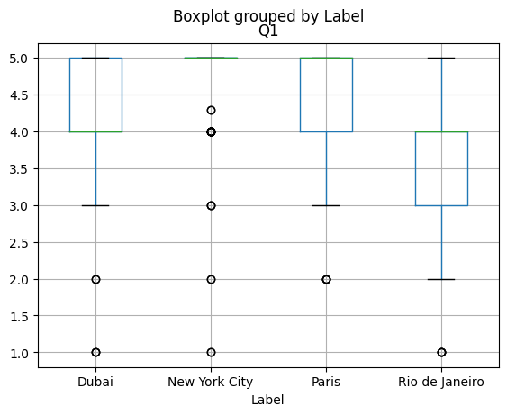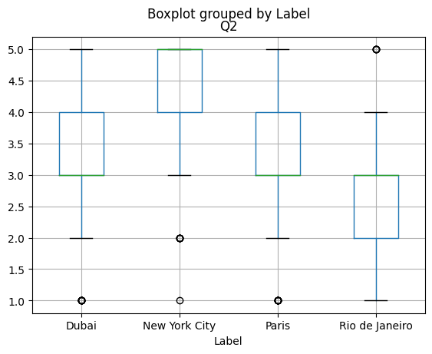

Next, we are going to talk about questions 1 and 2 using the graphs above. Question 1 shows how popular a city is and question 2 shows the potential for viral moments. We can see that for question 1, New York has the highest value in this question with no variance in data. This relates to question 2 as New York also has the highest value in this question. If a city is generating more viral moments, the city will be more popular based on domain knowledge. In the case of Paris, it is hard to tell because Paris is a city that a lot of people would go to even if there was not a lot of viral moments from there. Paris is one of the most touristy cities that people go to. We can see that Rio does not perform highly in these 2 questions with median and min values much lower compared to the other cities. The variance of data is also on the lower side. For question 1, the median is 4 and the minimum is 2 for Rio. For question 2, the median is 3 and the minimum is 1 for Rio.

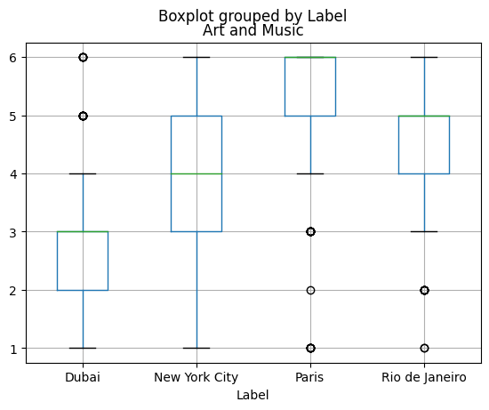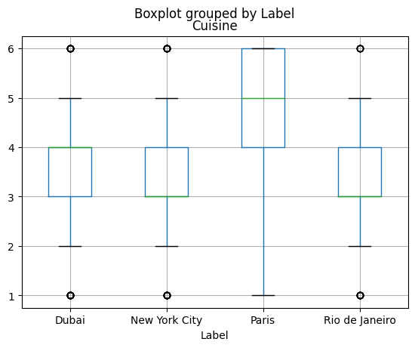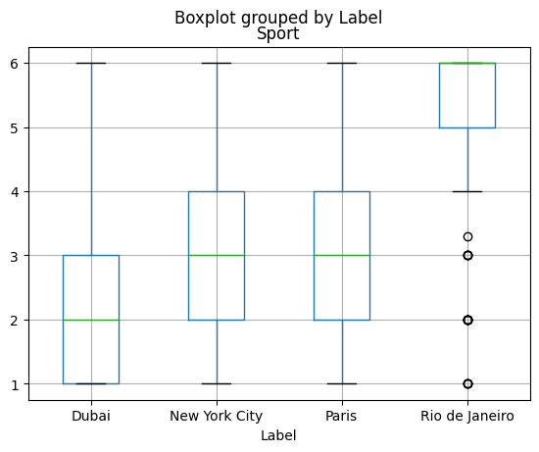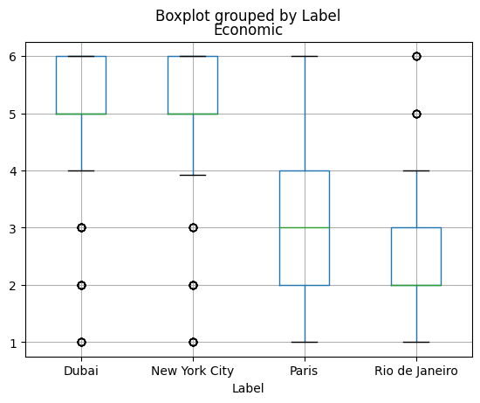

Our final discussion about data will be about question 6, using the 4 remaining ranking features using the graphs above. We can see that Paris has high values for cuisine and Art options. Art and music has a median of 6 and cuisine has a median of 5 for Paris. This is probably because France is known for its food and Paris has a large art museum. The next 2 for Art and Music is Rio (median: 5) and New York respectively (median: 4). This could be because Rio is popular for Latin American music with the carnivals and New York has Broadway and art galleries that are famous. For cuisine, the other cities don’t tell much as they are all similar. We can see that for sports, Rio has the highest median of 6. This could be because they are well-known for soccer. Dubai has the lowest median of value 2 in sports. The final criterion for this question that will be discussed is economic. We can see that New York and Dubai have high medians of value 5. This is probably because New York is known for its stock exchange and Dubai is going very fast pace economic development. Rio has the lowest median value of 2 for economic because it is not as economically talked about in the media as much as the other cities. This is based on domain knowledge of the cities.

A clear and logical determination of how you determined your input features, with convincing logical or empirical evidence justifying your choice. Important features are not overlooked (e.g., not removed for “ease”):

For our models, we included all questions that were answered in the survey and removed the ID column from the given data. For the numerical questions, we did not have to change how the data looked like except for normalizing them so that all of them were on one scale. For question 5, we represented this type of data using indicator variables for each of the options in this question (Partner, Friends, Siblings, Co-worker). These are separated into 4 different input features. For question 6, we separated all of the options into separated features where the value for them is the ranking number by the user. For question 10, we made 4 different bags of words that represent word connotations for each of the 4 different cities.

In total, this gives 21 input features for the model (more about this can be seen in the upcoming texts). To come up with what input features are important for the model, we used existing knowledge of these places that some members have (can be considered as domain knowledge) and did some statistical research into the data given.

For question 10, we decided to include this feature (4 different bags of words) in our models because of some domain-level knowledge about these cities. One way to easily identify a city is by using certain words that describe the city. People have certain connotations about how and what the city looks like. We can take into account this bias in our model that people have to give the correct label for that city. Also, some members have visited or are from the cities that are in the list to predict. This means that they will mostly know what words to put in the bag of words for the cities to give the highest chance of giving the correct prediction. We still take this question into our model even though it had the least correlation with the city label because of the reasons above. This is the logical evidence for having Question 10 as our input feature.

For the rest of the questions, we used trends and patterns that we saw in our data exploration stage. To make, the report concise and clear, we will not talk about what patterns and trends, we saw here again as this can be seen using the graphs above. The general idea is that we took input features that have a high correlation with the city label and took questions for our input features that have a trend in the data that can help us distinguish the cities. The trends and patterns are the empirical evidence justifying the choice of the questions to have as our input features.

A clear description of the way(s) that you are representing the data in your models:

Column Name (From clean_dataset) | Representation in our model
id | Removed from our model
Q1 | We normalized the values of Q1 so that they are in the range of -1 to 1.
Q2 | We normalized the values of Q2 so that they are in the range of -1 to 1.
Q3 | We normalized the values of Q3 so that they are in the range of -1 to 1.
Q4 | We normalized the values of Q4 so that they are in the range of -1 to 1.
Q5 | We used indicator variables to represent each of the options available to us in the multi select question.
 | Partner - Indicator Variable, 1 means selected, 0 means not selected.
 | Friends - Indicator Variable, 1 means selected, 0 means not selected.
 | Siblings - Indicator Variable, 1 means selected, 0 means not selected.
 | Co-worker - Indicator Variable, 1 means selected, 0 means not selected.
Q6 | We divide each of the
Skyscrapers
Normalized the values given to us, in case of a null value, it was replaced by the mean of the distribution
Art and Music
Normalized the values given to us, in case of a null value, it was replaced by the mean of the distribution
Sport
Normalized the values given to us, in case of a null value, it was replaced by the mean of the distribution
Carnival
Normalized the values given to us, in case of a null value, it was replaced by the mean of the distribution
Cuisine
Normalized the values given to us, in case of a null value, it was replaced by the mean of the distribution
Economic
Normalized the values given to us, in case of a null value, it was replaced by the mean of the distribution
Q7 | We restrict our values to be only in the range of -20 to 70. Values above maxi will be assigned the value of maxi, and values under mini will be assigned the values of mini  Null values are assigned the values of the average of the training set.  After scaling the input and dealing with Null values, it is then normalized.
Q8 | We restrict our values to be only in the range of 1 to 20. Values above maxi will be assigned the value of maxi, and values under mini will be assigned the values of mini  Null values are assigned the values of the average of the training set.  After scaling the input and dealing with Null values, it is then normalized.
Q9 | We restrict our values to be only in the range of 1 to 50. Values above maxi will be assigned the value of maxi, and values under mini will be assigned the values of mini  Null values are assigned the values of the average of the training set.  After scaling the input and dealing with Null values, it is then normalized.
Q10 | 4 Bag of words are created for each city, within each Bag of words the follow occurs:  For each sentence in the dataset, a vector is generated by transforming the sentence to lowercase, removing punctuation, and marking the presence of words from a predefined Bag of Words (BoW) with ones in a corresponding binary vector.  The average of this binary vector is calculated, reflecting the proportion of BoW words in the sentence. This mean value is then assigned to a new column associated with the sentence, serving as a feature for further analysis.

A clear description of how you are splitting your data into various sets:

To split our data into training, validation and testing, we first group the entire data by the label value (city). The aim to do this is to ensure that a similar proportion of each label is being represented in our final dataset. Think of this as splitting the data into 4 different tables, each table representing one city.

Once done, shuffle each respective table and then, 50% of each table will be for the training set, 40% will be for the validation set and 10% will be for the test set.

We are aware that there is another test set that exists, which we will be graded on it. However, we are splitting our data into a test set for internal testing.

We did this to avoid the 3 pitfalls of splitting the data which are: Inadequate Sample Size, Data Leakage and Improper Shuffle or Sorting.

Model:

A description of the model(s) that you are evaluating/exploring. We are expecting a thorough exploration of at least 3+ family of models, even if you don’t ultimately use those models. We are looking for:

– How you are applying these models. You don’t need to reiterate what the models are and how they work. Instead, we’re looking for a description of the choices you are making to apply the model to this task.

For each model we evaluated, we used a sanitized version of the data, this means that we took the data and cleaned it to be numerical. Along with this, the model sanitized the data based on each column independently, this allowed the model to maintain the questions contexts and ensure that all sanitization does not interfere with the data integrity of all other columns. The sanitization is explained more in depth for each column in the model choice and hyperparameters section.

The first model we chose to evaluate is the KNN model. In this model, we use the sanitized data, and iterate over different values of the hyper parameter K to check which value would give us the highest possible validation accuracy.

The second model we chose to use is the Decision Tree model. In this model, we use the sanitized data, and again iterate over different choices of max_depth and min_sample_size to see which combination of these hyperparameters output the best validation accuracy that we can get with our choice of hyper parameters.

The third model we chose to use is the Logistic Regression model. In this model, we use the sanitized data, and iterate over different max_iter hyperparameters to find the best overall validation accuracy. Given this validation accuracy we print out the corresponding weight vector and bias vector related to the combination of the best hyperparameters.

The fourth model we chose to use is the Neural Network model. In this model, we choose to use a 2-layer neural network, and we use the sanitized data, and iterate over different values of the hidden unit hyperparameter to find the best overall validation accuracy. Given this validation accuracy, we print out the corresponding weight vectors and bias vectors related to the number of hidden units used in the hidden layer that returns the best validation accuracy.

After running all these models, we chose to use the model that gave the best validation accuracy, with the hyperparameters, weights, and bias that returned the best validation accuracy.

In our final model, we used a Neural Network as it gave the best validation accuracy, with hidden units = 21. This model was found to give our group the best training accuracy, the best validation accuracy, and the overall best test accuracy on a training set, validation set, and test set that we saw overall in the models that we evaluated.

Model Choice and Hyperparameters:

How you are determining what model(s) to use in your final pred.py, as well as an exploration of hyperparameters. We are looking for:

– A convincing explanation of how you ensured that the evaluation metrics for various models are comparable (i.e., are you using a consistent test set?)

To ensure that these evaluation metrics were comparable, our group decided to sanitize the data equally and shuffle the data into a training, validation, and test set. This would ensure that the models were being fitted and tuned with the same training and validation sets each time and that the models were getting tested with the same test set each time. This made it easier to compare the evaluation metrics of the different models we tested, as they used the same datasets each time to make predictions. No model was given a different data set, and all data points underwent the same sanitization process.

Specifically, to ensure that all data in our training set is consistent, our model independently undergoes sanitization on each of the ten original questions. Going through the first four questions, our model recognizes that the responses are numerical and that the range of answers is between 1 and 5. But suppose there is a row that did not answer one of the questions, rather than delete the entire row of data, as this could potentially remove helpful information for the model in later questions. In that case, the model chooses to input a neutral value into that row, which is the mean response of the column. This ensures that the overall distribution of answers is unchanged and does not favour one specific answer. This is why the model does not choose to input 1 or 5, as this would skew the model towards a specific direction of answers and make it infer that more of the survey answers trend towards a specific direction, which introduces bias into the model, which inflates the frequency of the response for 1 and 5 as well. To ensure no particular bias in the dataset for these first four questions.

For Question 5, our group took a different approach; since the survey asks for a person to select multiple options as Partner, Friends, Siblings, and Co-workers, the model answer can not be quantified here. Instead, our model chooses to split the answers to the column into four new columns, including the possible answers to the question and which person the person taking the survey would want to travel with. If the column in Q5 contained a Partner, Friends, Siblings, or Co-worker as a string, then the model would write a 1 in the corresponding column related to one of these answers and 0 otherwise. The model would then drop the column associated with Q5 entirely as the data of Q5 is extracted into four new columns. For this question, the model does not input the average of the column if there are no answers. Instead, this implies that the person most likely does not want to travel with anyone to the corresponding city, so the model inputs 0 instead of 1. This keeps consistency with the context of the question, as it ensures that it is not assumed that even if no one wanted to travel with someone, they would as the column values are binary 0 or 1, there is no choice for any other option, there is a 1 in the corresponding category column if the person would consider the option of travelling with that specific person or 0 if they did not choose that particular person. So, if the person did not select any option, rather than setting the value to the average, which would imply that a person would want to travel with someone, the model takes it as the person does not want to travel with anyone. This maintains the data points' integrity without introducing a specific bias toward what a person would want to answer in the context of the question.

For Question 6, the model again considers the context of the question. The question asks to rank the relatability of the six words Skyscraper, Sport, Art and Music, Carnival, Cuisine, and Economic with the cities the survey is on, where 1 is the least relatable word, and 6 is the most relatable word. Like in Question 5, the model chooses to separate the answers in the column into six independent new columns, corresponding to the answers between 1 and 6 that people answered for relatability. This is again because the answers in question 6 were formatted to group the words and scores into a list, mapping the word to a number. The model goes through these answers, extracts the rating for each word, and updates the corresponding column to the words according to that value. Here, the model now chooses to input the average response of the columns of independent words Skyscraper, Sport, Art and Music, Carnival, Cuisine, and Economic, not to skew or push the distribution of answers related to each word toward a specific direction. Due to the context of the question, each of the six words represents how people see each city independently, so rather than inputting a 1 or 6 in the empty cell, just like for Q1-4, we input the averages of each of the six new columns independently to maintain data integrity again and mitigate any chance of a specific bias towards one word in the dataset for each city.

For Question 7, our group chose to use a model approach to the responses based on changing vast outliers based on the context of the question. The question asks about the average temperature a person thinks is for each city, such as Dubai, Rio de Janeiro, New York City, and Paris. There are many outliers in the responses, such as the answer of 10,000, which is impossible to occur in any of the cities the survey is about. So, to remove these outliers, rather than remove these outlier rows, again because the rows contain essential data in other columns, the model replaces them with the max or min temperature of a given range determined by our group. Our group looked at the data and found that some cells in the Q7 column were empty and that some input outrageously large or small values. These values were clear outliers. So, our model removes all outliers and puts them within a range of -20 to 70 degrees. These values were determined after researching and finding the highest possible and lowest possible recorded temperatures for these four cities. We found it to be Rio, with somewhere around 62.3, so we chose to round up to 70 and found the Lowest temperature that was again not too large of value was Paris, with somewhere around -20 degrees. This became our range against which to judge values. So, if a temperature lower than -20 is inputted, the model sets that value to -20; if there is a value greater than 70, the model sets that value to 70. If the cell is just empty, then the average temperature of the fitted data to the range [-20, 70] is inputted as a measure not to mess with data integrity as based on the context of the question, there needs to be a value inputted into the cell, and the average value ensures that there is not a bias set towards the overall answers. The range ensures that those who feel like certain cities are significantly cold or hot are still considered, but it also ensures that the distribution of answers is restricted to the range of values from [-20, 70].

For Question 8, the question asked the person taking the survey to determine how many different languages they could hear while walking around the city. Again, our group chose to form a range of values to remove outliers. In this case, looking at the data, we found that many people decided to input values that are huge outliers compared to the rest of the data input from the people who took the survey. Our group decided to model to again use a range of values from 1 to 20, where 1 represents a person thinking that they can only hear one language getting spoken while walking down a street in one of the specific cities we are surveying for, and 20 is the ceiling of values that we found to be the most appropriate to use. We chose 1, as there must be at least one language spoken in a city. After looking at the data, we found that there were many different answers for a very high number of languages that people could hear walking around the cities, and we found that 20 was the most common of those high numbers. So, just like in Question 7, we fit all outlier values, so values in the Question 8 column get fitted to 1 if the number is less than 1 and 20 if the value is greater than 20. The model also fills in empty cells with the column average fitted to the range of values [1, 20] so as not to make this column's data distribution and answers manageable. Just like in Question 7, fitting the answers to a range of values and inputting the average into empty cells will allow for the model to ensure that the distribution of data is not skewed, that data integrity still holds, and that those who think many languages or few languages are spoken are still considered, but are fit into a range of what constitutes the fewest possible languages spoken to the highest possible languages spoken.

For Question 9, the question asks the person taking the survey to input the number of fashion styles that a person would see walking down a street in one of the cities. Again, this question follows the same open-ended concept as Questions 7 and 8, which means that there was a wide variety of answers from the survey with many outliers in the column. Again, we still need to remove the column as the row contained helpful information for the model. So again, our group chose to analyze the data and found that the answers fit the range of values between 1 and 50. Again, This is because a person will see at least one fashion style walking down the street, and 50 was the most common number of the highest values we saw. So the model again fits values in the column to this range: if the value is less than 1, set the value to 1; if the value is greater than 50, set it to 50; and if the cell is empty, input the average of the column that is fitted to the range [1, 50]. This ensures that data integrity is upheld and that there is no bias towards any specific values. It also allows the context of the questions answers to be held. If a person thinks they will see many different fashion styles in the street, the model considers this by setting the value to 50. If it is greater than 50 and a person thinks they will see very few fashion styles, the model sets these values to 1 to represent this answer.

For Question 10, our model takes a different approach. This open-ended question asks the person to input a phrase or sentence that a person would use to relate to the cities of Dubai, Rio, New York, and Paris. Our model uses the Bag of Words approach to measure the similarities between sentences with cities and inputs the empty string into cells in the question 10 columns to uphold that a person may not have any answer for Question 10. The Bag of Words creates a Bag of Words for each sentence related to each city based on the most common, significant words found in the sentences for each of the cities. Stop words were omitted to remove as many similarities between the sentences as possible with words such as the, a, i, like, etc… The model creates four new columns related to the cities we are surveying: Dubai, New York, Paris, and Rio. Once this is done, the model covers all sentences in column Q10. The model processes the sentence by making it all lowercase and removing all punctuation. It then breaks that sentence into a vector, removes all stop words from the vector, and compares what percentage of this vector matches with the Dubai BoW, Paris BoW, Rio BoW, and New York BoW. These percentages are then inputted into each column respectively. This is done by the model by first processing all BoW for Dubai, Paris, Rio, and New York. The model also makes all words in the bag of words lowercase, removing all punctuation from the strings to ensure the same word is not twice in the bag of words. The empty cells are set to the empty string, and the corresponding similarity percentage is set to 0 in each column for each city. This method ensures that the cities can use similar words. However, there is still a distinction between which words were most used for which cities, and the model compares these similarities and inputs this similarity in the corresponding columns. This ensures data integrity is upheld as the model removes as many redundant and common language words as possible to make each BoW for each city a unique set of words. This ensures that the sentences are fairly evaluated for each city so that the model can better understand the city the question relates to in our training data.

All the columns for which extra columns were added, such as Q5, Q6, and Q10, are dropped to make sure that the model does not reuse any data.

The data is finally standardized to ensure that the distribution of answers for each column upholds the highest possible data integrity and that any bias found is mitigated and eliminated.

All data undergoes this process, which ensures that when we split our data randomly into training, validation, and test sets, all data is similar in sanitization and standardization and that no set is given manipulated data.

This ensured that our accuracy evaluation metric was upheld and that little to no noise was introduced into the data we used.

– A clear description of the evaluation metric(s) used to evaluate your model, as well as justification for its use.

Given the problem at hand of predicting if a set of a person’s answers to a survey were an answer for one of the cities Dubai, New York City, Paris, or Rio de Janeiro, picking the best model depended on picking the model that can give the best accuracy and precision. This is because the only possible answers are one of 4 options, the data is not related to any health-related data, it is data related to tourism and the personal opinions of independent people. This means that the presence of False Positives, or False negatives was not possible. The prediction is to classify a set of answers as one of 4 cities, so the prediction can be one of 4 answers, it is not a binary yes or no answer. This means that we can use the prediction accuracy as the evaluation metric to judge each model by. The higher the accuracy means that more correct predictions that were made by the model compared to the target labels in our data set. The final model is chosen based on the model that can output the best validation accuracy, as this tells us that the model was able to output the most similar prediction set to the target label set with the best possible hyperparameters.

– A description of the hyperparameters that you are tuning, hyperparameter values combinations that you have tried, and the corresponding evaluation metric(s). We are not looking for an exhaustive search of all possible hyperparameter combinations, but just there should be enough evidence to demonstrate that your hyperparameter choices are reasonable.

We tried to train a K-NN classifier and from this model, the hyperparameter is the value of k. We chose to train the model on different values of k from the set of values [1, 5, 10, 20, 40, 50, 100], and found that the outputs were always very similar. Consistently giving us a result that was between 85-90% accuracy, but the value of the best k would change each time the dataset was reshuffled and new training and validation sets were chosen, but the accuracies would still be similar:

This is one run of our models:
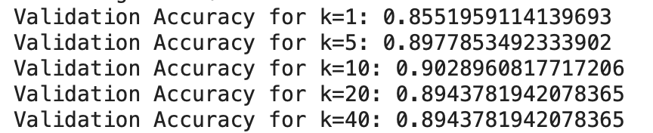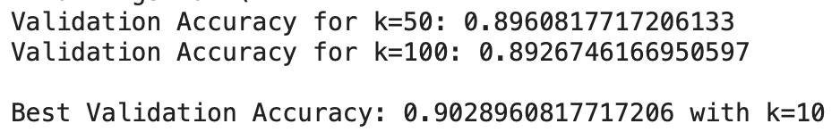

This is another run of the models:

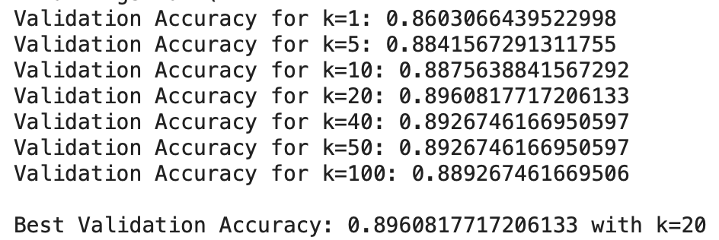

In both these runs you can see that the choice of k when you get to 5, 10, 20, 40, 50, and 100 results in very similar validation accuracies, this means that we can choose anyone of k = 5, 10, 20, 40, 50, 100 and get similar outcomes everytime we reshuffle the data.

We tried to train a decision tree classifier, and tuned the hyperparameters related to max_depth and min_sample_split, using both the entropy criterion and gini criterion. We chose to train the mode using both types of criterion and the values max_depths = [1, 5, 10, 15, 20, 25, 30, 50, 100], and min_samples_split = [2, 4, 8, 16, 32, 64, 128, 256, 512, 1024], based on these hyperparameters we found that the validation accuracies were not as high as to those compared to the KNN classifier:

This is one run of our models:

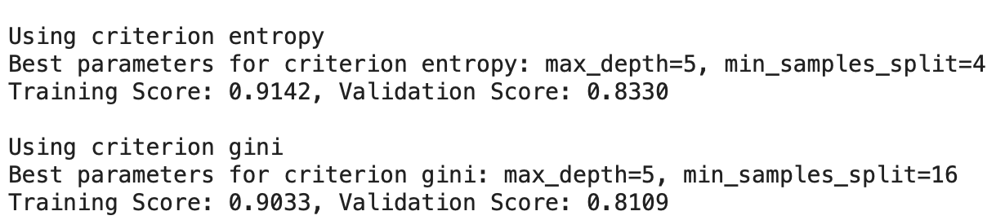

This is another run of our models:

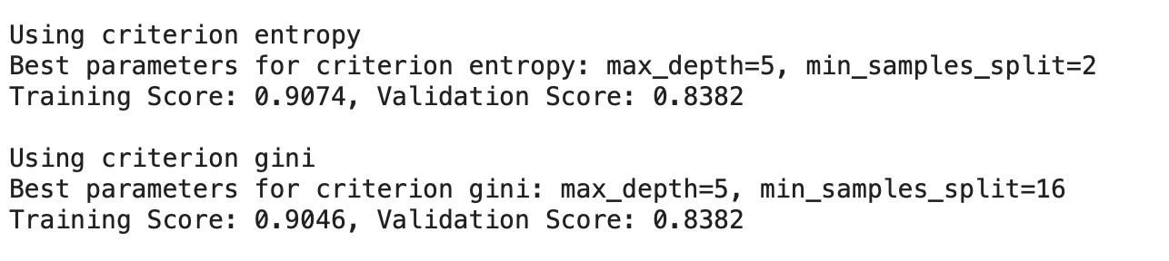

The resulting validation accuracies were not as high as the validation accuracies of the KNN classifier, but you can see that they were again very similar to one another.

We trained a Logistic Regression classifier using and changed the hyperparameter on the number of iterations, called the max_iter parameter. This parameter is used to determine how many iterations of gradient descent do we want the model to undergo before giving the best weights and bias possible for a specific value of max_iter. The default value is 100, so we thought to train the model on max_iter = [1, 10, 100, 200, 500, 1000] and compare the differences and the best weight and bias values that come from the change of this hyperparameter.

This is one run of our models:

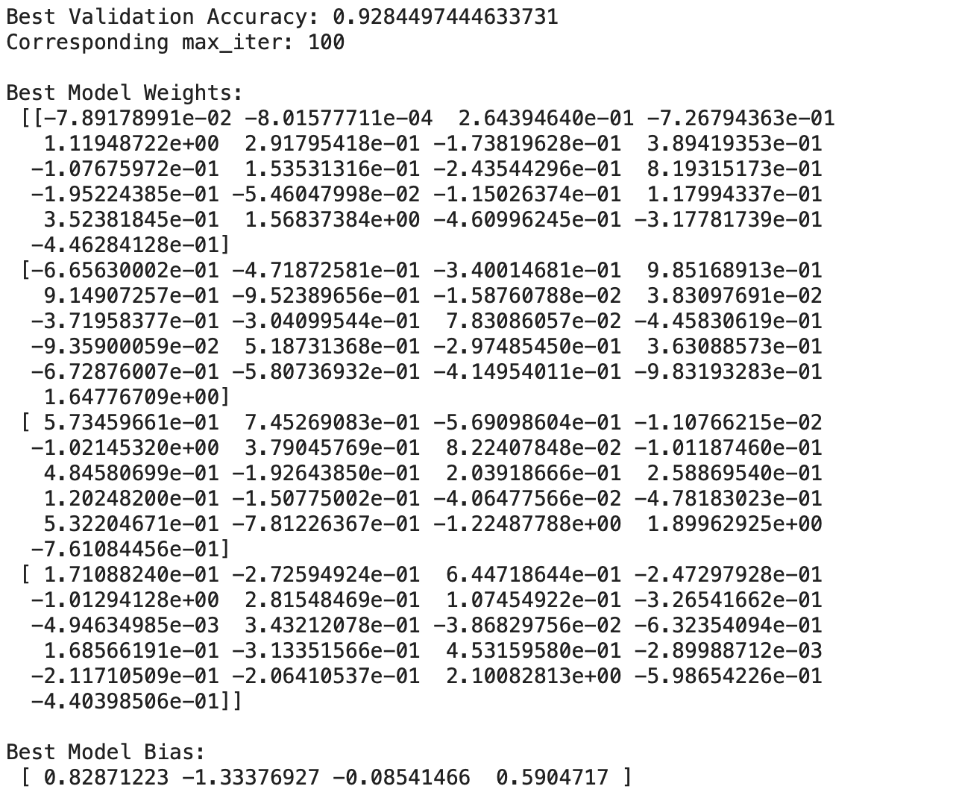

This is another run of our model:

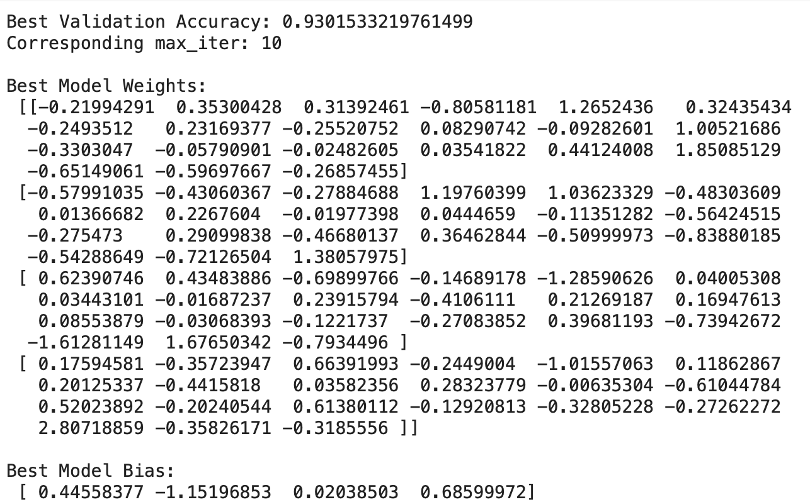

You can see here that the logistic regression model so far has yielded the best results overall for validation accuracy and you can see that on both of these runs of our models, the accuracies were again very similar.

The last model we trained was a 2 layer neural network that had and input layer of 21 units, representing the 21 total different features that we created sanitizing the data, and an output layer of 4 units, where 1 unit represents 1 of the 4 possible outcomes in our predictions Dubai, Paris, New York, and Rio De Janeiro. The hyperparameter is the number of units in the hidden layer. We train this model with many different numbers of hidden units from [1, 10, 21, 40, 50, 100] to see which number of hidden units yielded the best results and weights.

This is one run of our models:

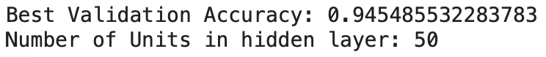

This is another run of our models:

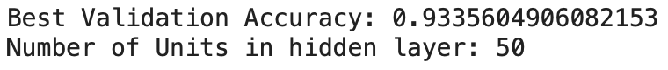

You can see that the Neural Network results in the best results that have been seen overall. Along with this the validation accuracy is around the same value for the neural network for both runs shown above as well.

– A clear description of what your final model choice looks like in the submitted pred.py file.

The final model that we decided to submit is a neural network model. We extracted the weights of the neural network during a certain run on the training data when the best unit was 21 hidden units. The output weights and biases corresponding to the 21 hidden units were a 21x21 matrix W1, a 21x1 vector b1, a 21x4 matrix W2, and a 4x1 vector b2.

Using this model on our test data we consistently get a final test accuracy that is around 93-97%. This depends on how the model decides to shuffle the data and distribute the data set into training, validation and test set, and since the weights extracted from the neural net are constant, this can also impact the final predictions.

The model uses numpy and the forward pass to make the predictions. By using the ReLU activation functions and softmax activation functions the model makes overall predictions. ReLU is used at the hidden layer, and softmax is used at the output layer. At the end once the output layer is computed by softmax, then the model uses the argmax function to take the output layer values and convert them into the final output predictions.

The final predictions of the model outputs what the overall testing accuracy of the model is.

Examples of outputs by our model:

Prediction:

After building and testing our models thoroughly, we have determined that the neural network model is the best model to choose and it is expected to perform with an accuracy of about 94% on the test set. This prediction is based on the model's consistent high performance on the validation set as well as our own test set, which closely resembles the complexity and distribution of the test set.

The neural network's superior performance over other models like decision trees, KNN, and logistic regression that we tried reflects the neural network's capacity to capture complex patterns within the data. This is also enhanced by our model's optimization and extensive hyperparameter tuning using advanced libraries to assist with picking the best hyperparameters. This process helped prevent overfitting, ensuring that the model's predictions are more reliable.
When we tested the model on our validation set, we got results around 93-95% accuracy scores. And we used our test set, which was 10% of the full dataset, we got results around 96-98%, as shown above. The reason we believe that our model would perform around 94% on the final test set is due to the consistent high scores our model got with the trials. Our prediction is slightly lower than the scores we received due to the fact that the way we split data, it ended up with a small testing dataset, 10% only.

In conclusion, our projection of 94% accuracy for the neural network on the test set is grounded in empirical evidence from mainly the model's performance during the validation phase and our own testing phase.

Workload Distribution:

A description of what each person in the group contributed to the project. A 1-2
sentence description of each person’s role is sufficient.

Ishan Gupta (guptai19): Worked on documentation showing all the trends and patterns in the data. Did research into how to clean the data, particularly in handling extreme values and nulls, based on industry standards.

Karanveer Singh (sing1871): Worked on data analysis by creating graphs and distributions of all inputs, also helped in changing data. (e.g changing the q10 from a single to multiple input, resulting in a 2% raise in accuracy) Also worked on documentation.

Puneetpal Powar (powarpun): Worked on Bag of Words implementation to sanitize question 10. Along with this, I worked on building the KNN, Logistic Regression, and Neural Network models. I also coded up the final forward pass of our overall model which uses a Neural Network.

Qais Firas Al-Khatib (khatibqa): Worked on sanitizing and formatting the datasets to meet our needs and goals as well as worked on building the decision tree model.

