**Self-Service Password Reset (SSPR)**

Self Service Password Reset gives users the ability to change or reset their password with no administrator involvement.

Azure Active Directory Premium P1 License is required to setup Self Service Password Reset.

How Do Self Service Password Reset Works?

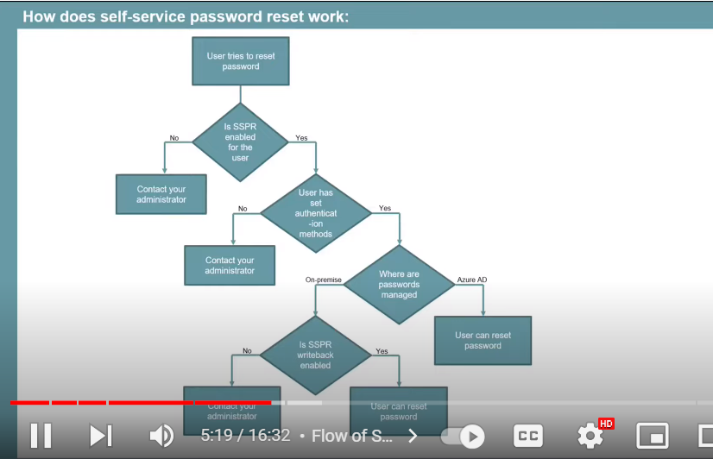

Steps for Setting up Self Service Password Reset:

Step 1: Go to Azure Active Directory🡪Users🡪Password Reset🡪Properties🡪Enable Self Service Password Reset for all users or for the selected ones.

Step 2: Under the Password Reset Section select the type of Authentication method.

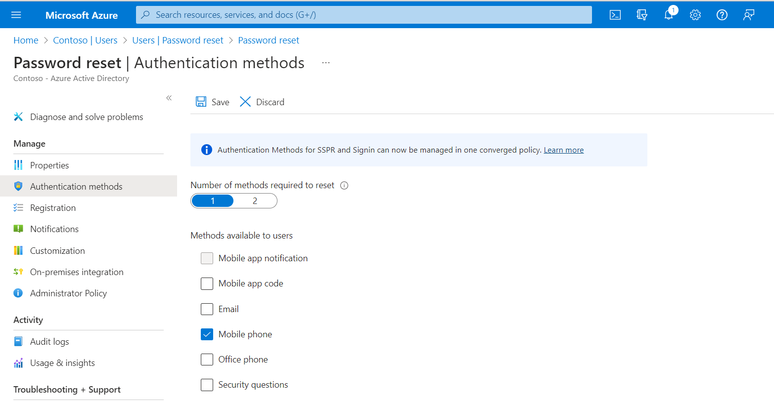

In Registration you can re-authenticate the users by setting up the number of days to validate.

You can also select whether the users should be notify if the password has been changed.

You can customize the helpdesk link for the users

After that logon to portal.office.com try to login with that particular user and verify the type of Authentication after try to reset the password.