EE239AS – PROJECT 1 REPORT

NETWORK BACKUP DATASET

1. When we plot actual copy sizes of all the files for a given workflow over time, we get a pattern. In each period, majority of the time, the file copy size is similar and then it peaks for a small time intervel before the next cycle begins.

Figures below show the plots of copy sizes of all the files plotted against the time (we have added the copy sizes for all the files at the particular time) for Workflow -1.

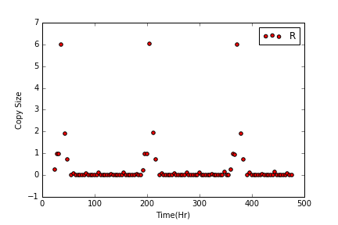
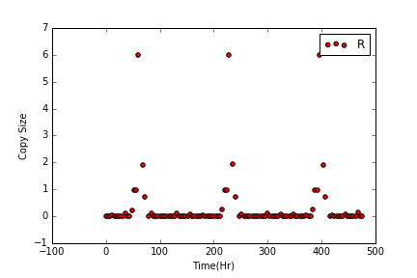
Figure for Workflow-1 days 1 to 20. Figure for Workflow-1 days 21 to 40
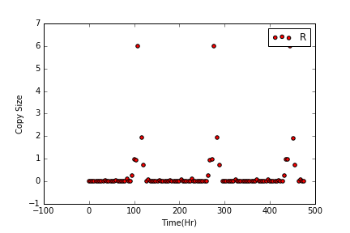
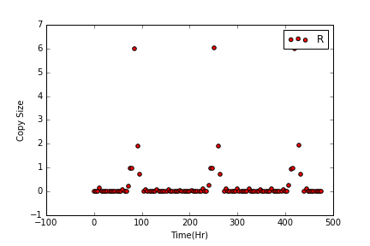

Figure for Workflow-1 days 41 to 60 Figure for Workflow-1 days 61 to 80

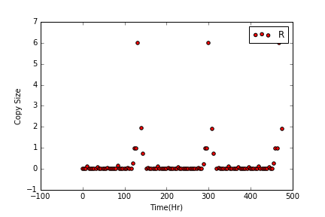

Figure for Workflow-1 days 81 to 100

Similar plots are given below for other workflows
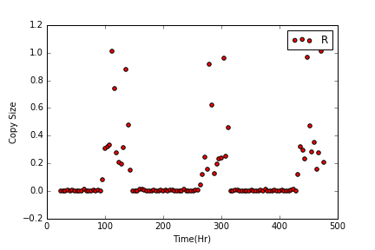
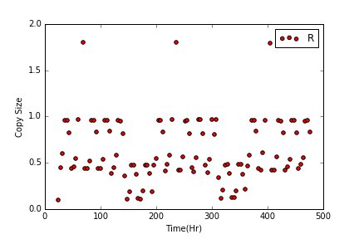

Figure for Workflow-0 days 1 to 20 Figure for Workflow-2 days 1 to 20

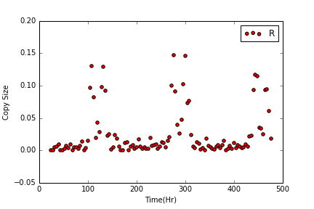
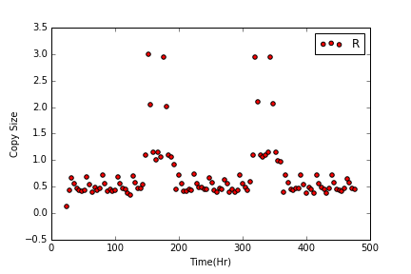

Figure for Workflow-3 days 1 to 20 Figure for Workflow-4 days 1 to 20

The other time plots for the workflows also show similar pattern.

2 Network Backup dataset

a) The indexes of the Significant variables(32) in the model(one-hot encoded) are as :
Indexes of selected features: [28, 29, 30, 31, 32, 33, 34, 35, 36, 37, 38, 39, 40, 41, 42, 43, 44, 45, 46, 48, 51, 52, 53, 54, 55, 56, 57, 58, 59, 60, 61, 62]

- RMSE obtained is as: 0.0903
- Fitted values and Actual values scattered plot over time:
- On evaluating the plot, actual and predicted copy sizes of all the files for a given workflow over time, we get a pattern. In each period, majority of the time, the file copy size is similar and then it peaks for a small time interval before the next cycle begins. However, the predicted copy size is found to be similar.
- Figures below show the plots of copy sizes of all the files (actual in Red and predicted in blue) plotted against the time (we have added the copy sizes for all the files at the particular time) for Workflow -1.
Workflow-1 Days 1-20
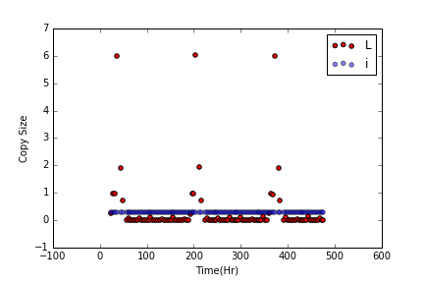

Workflow-1 Days 21-40
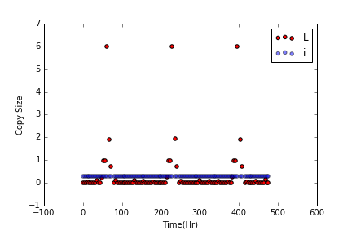

Workflow-1 Days 41-60
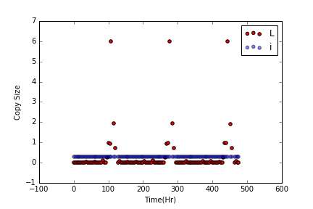
Workflow-1 Days 61-80
Workflow-1 Days 81-100
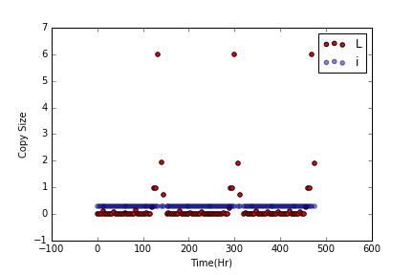
- The other Workflows were found to show a similar pattern.

- The Residuals versus Fitted values plot is as:

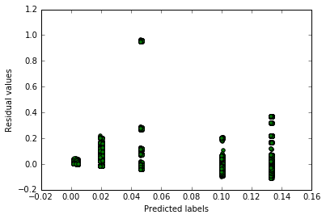

(b) Random forest model:

Random forest models have two parameters, the depth of tree and the number of estimators. These we tuned using 5 fold cross validation function. Following are the plots obtained for tuning these hyper parameters:

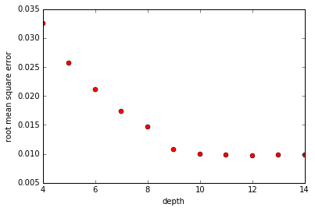
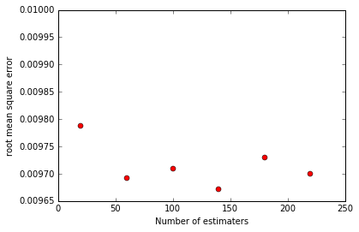

Based on these plots, the optimum depth of a tree was found to be 12 and the optimum value of number of estimators was found to be 140.

So Optimal Hyperparameters: Depth = 12, Number of estimators = 140.
With these parameters, best RMSE = 0.00967.

The RMSE for Random Forest is better than that obtained from linear regression.

The Models obtained from random forest algorithms show similar pattern as we obtained in part 1.
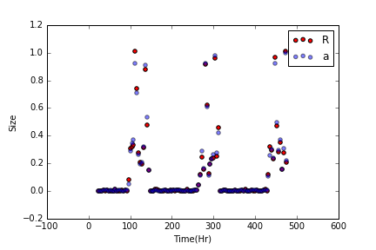

As we can see in the figure, the models almost fit on top of each other. The Red plot are the original values and the blue ones are the predicted values. The residual value plot for the same is given below:

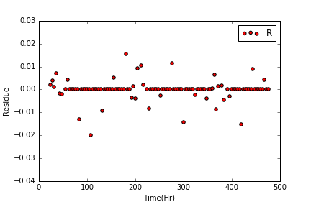

The plot is concentrated around zero showing good matching of the predicted and actual values.
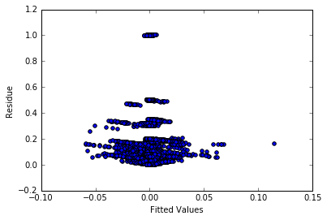

The graph shows residual vs fitted values. We see that since most of the error points are concentrated close to zero(expected as most labels are very close to zero). So labels which might not actualy be zero are predicted as zero.

(c) Neural Regression

The Neural Network model we used for regression is composed of one hidden layer. The number of nodes in the hidden layer and the learning rate were found using parameter tuning. Variation of RMSE for these two parameters is shown below.

Plots for Data size model

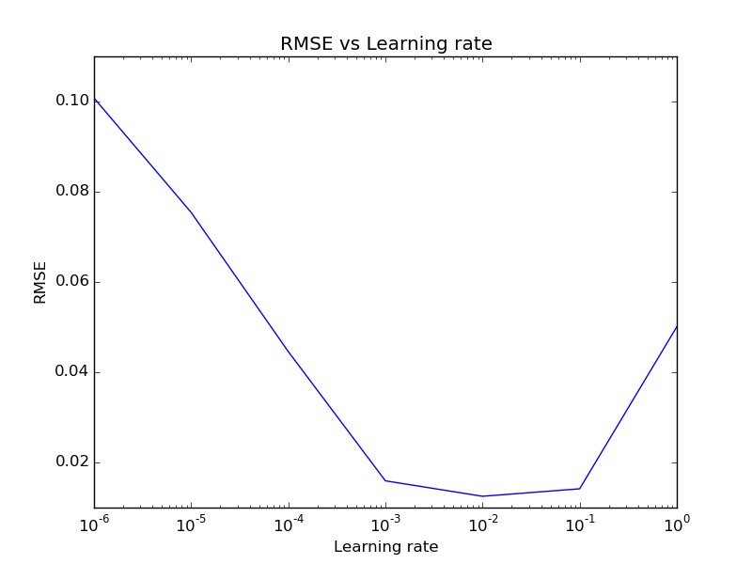
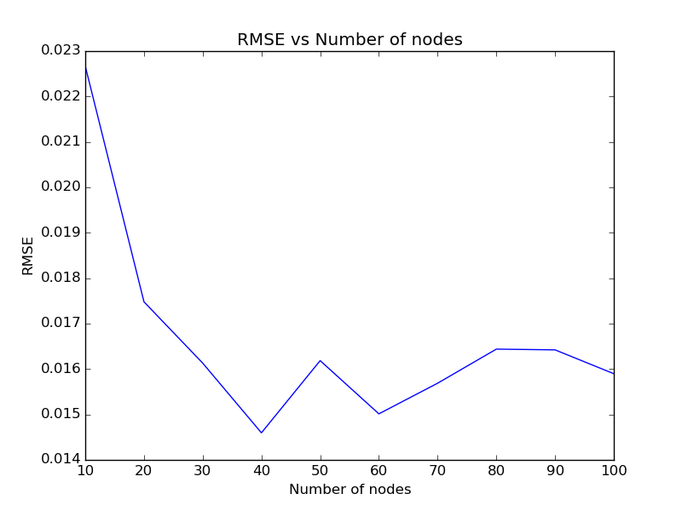

Based on these plots, the optimum parameters used for predicting Data size were as follows:

Number of nodes: 32
Learning Rate : 0.01

Plots for Data time model
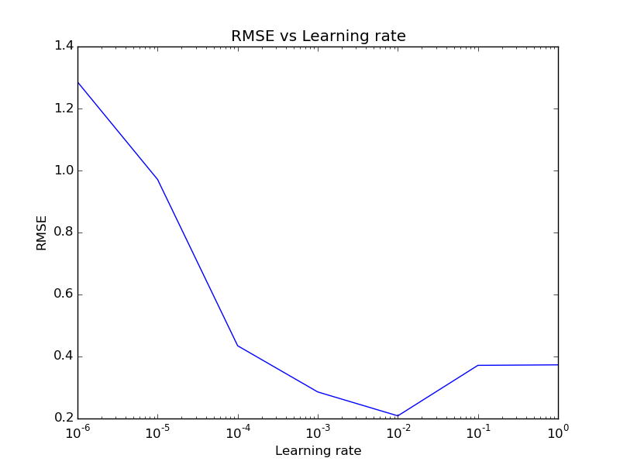
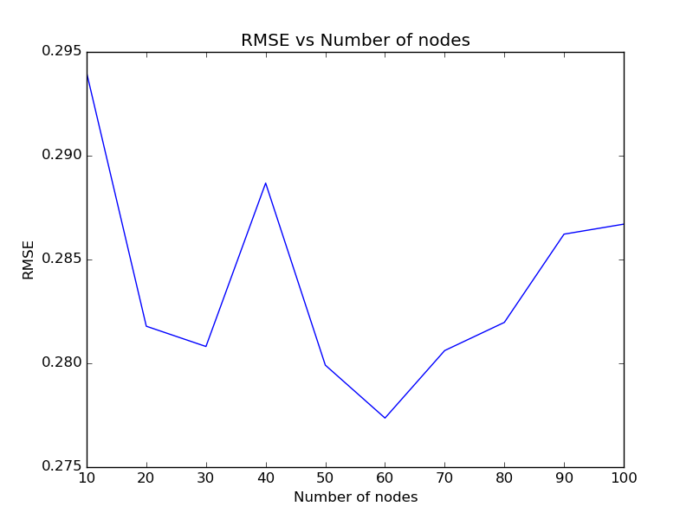

Based on these plots, the optimum parameters used were as follows:

Number of nodes: 60
Learning rate: 0.01

Cross validation RMSE using the tuned parameters:

Data set | RMSE
Data Size | 0.018
Backup time | 0.27

Summary of the parameters used for Neural network regression:

1. Number of nodes in hidden layer: 32 for predicting Data size and 60 for predicting Backup time.
2. Learning rated: 0.01 for both the models.
3. Activation function of hidden layer: Tanh
4. Activation function of hidden layer: Linear
5. Optmizer used: Adam.

Note:- Activation functions for the nodes and the Optimizer were not tuned, but were used according to the guidelines of the library. Primarily because these do not vary numerically as the other parameters do, but are more data specific in nature.

Piecewise Linear Regression Model
The dataset is splitted into training dataset(90%) and testing dataset(10%).Then separate the instances of the training dataset into five workflows and train 5 different Linear Regression models corresponding to each of the workflows separately. So, we are training a piece-wise linear regression model in this case. After training the different models, we then predict the labels on testing dataset from these trained models and calculate the RMSE. The RMSE on the testing dataset for this model comes out to be 0.05033662.
The RMSE in this case is less as compared to the linear regression model. So the fit is improved in this case.

Polynomial Regression Model
We used one-hot encoding to featurize the dataset.This increased the feature vector length to 64. So, for doing the polynomial regression, we have taken only the significant variables obtained from the linear regression model. Initially, the length of the feature vector was 64(after doing one-hot encoding), then we took 16 significant variables out of them and trained polynomial regression model for different degrees.

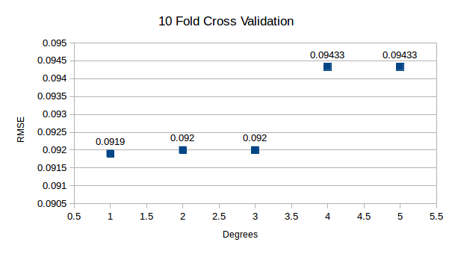
a) Graph plotted for average RMSE of the 10 Fold Cross Validation values

b) Graph plotted for a RMSE values for a fixed training and testing dataset

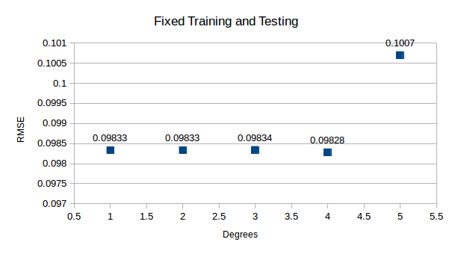

In the graph we can see that, for increasing degrees of polynomial function we are getting nearly same RMSE values.(This is after we have used one-hot encoding and took 16 significant variables from that.) Computational time for higher degrees was very high, so that was not performed. So according to the results using degree 5 will not give poor generalization. So we can fit our data on a polynomial function of degree 5.

Complexity of a model increases as it tends to overfit the training data. When model overfits the data, the RMSE value will be large on the testing dataset. When we do cross-validation we get to know that the model is overfitted, as we get high RMSE value. So, we can control the complexity of the model.
So cross-validation helps us to know whether the model is overfitted or not. An overfitted model will have more complexity and poor generalization.

4. Boston housing dataset

Linear Regression Model

- The Significant variables(6) obtained are:
- CHAS: Charles River dummy variable.
- NOX: nitric oxides concentration (parts per 10 million).
- RM: average number of rooms per dwelling.
- DIS: weighted distances to five Boston employment centers.
- PTRATIO: pupil-teacher ratio by town.
- LSTAT: % lower status of the population
- RMSE obtained is as : 5.0378
- The Residuals versus Fitted values plot is as:

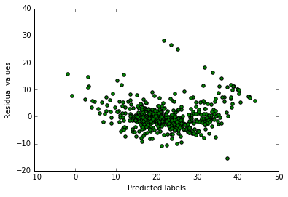
Housing dataset Random Forest Model:

Random forest models have two parameters, the depth of tree and the number of estimators. These we tuned using 5 fold cross validation function. Following are the plots obtained for tuning these hyper parameters:

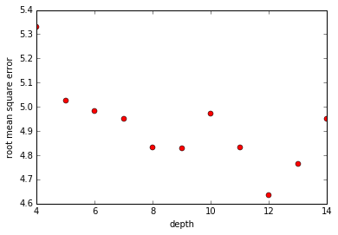
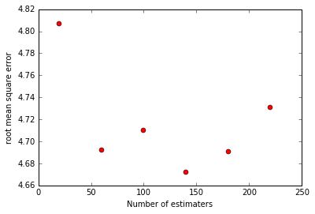

Based on these plots, the optimal parameters found were as follows:
Depth = 12 and No. of Estimators = 140,

For these parameters RMSE for the random forest algorithm is 4.728.

Plot for residue vs the fitted values for Housing dataset using Random Forest Model.
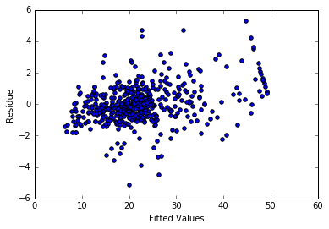

Here, we observe that that the random forest model fits well on the housing dataset. Most residue concentration is around 0. For large label values, the error seems to be more compared to labels which have values around the average 20 ($20,000).

Neural Network Regression on Housing data set

The network structure used for Housing data set was similar to that of network data set. The parameters involved were also same and were found using similar methods. The plots showing variation of RMSE with these parameters are shown below

Plots for Backup time
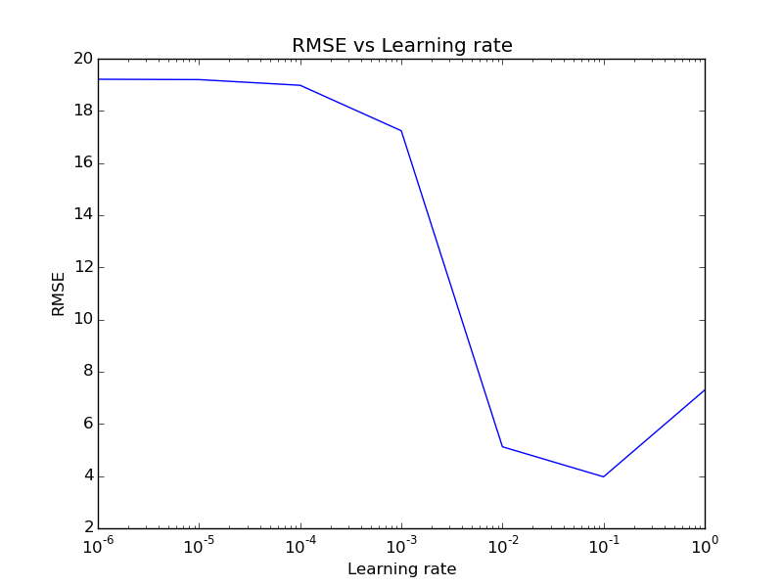
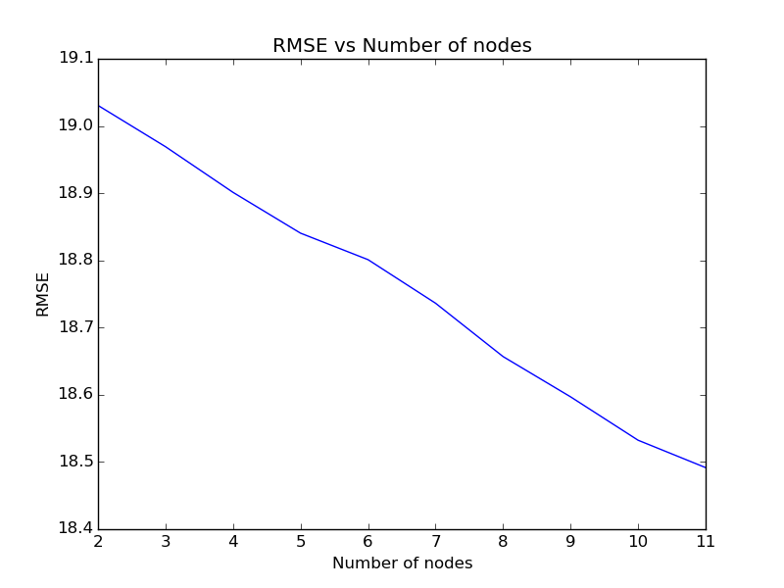

Cross validation RMSE using the tuned parameters:

Data set | RMSE
Housing | 5.99

Summary of the parameters used for Neural network regression:

1. Number of nodes in hidden layer: 11
2. Learning rated: 0.1
3. Activation function of hidden layer: Tanh
4. Activation function of hidden layer: Linear
5. Optmizer used: Adam.

Note:- Activation functions for the nodes and the Optimizer were not tuned, but were used according to the guidelines of the library. Primarily because these do not vary numerically as the other parameters do, but are more data specific in nature.

Polynomial Regression Model

This dataset was also used to fit the polynomial regression model for various degrees.

a) Graph plotted for average RMSE of the 10 Fold Cross Validation values
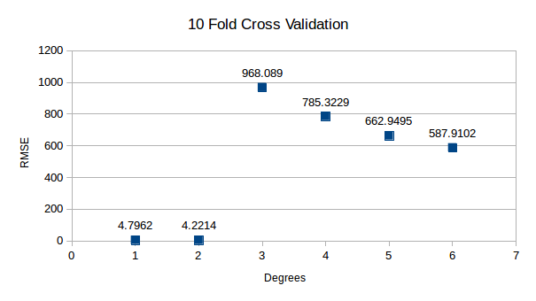
b) Graph plotted for a RMSE values for a fixed training and testing dataset
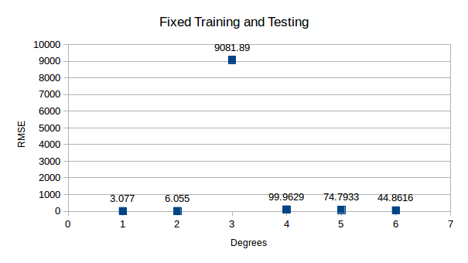
After degree 2, the RMSE values are large and the generalization of the model gets worse. So the optimal degree of fit is 2.

Ridge and Lasso regression

For Ridge and Lasso regression, we first tried the three given values of alpha = {0.001,0.01,0.1} and generated the plots for variation of RMSE with alpha. These are presented below.
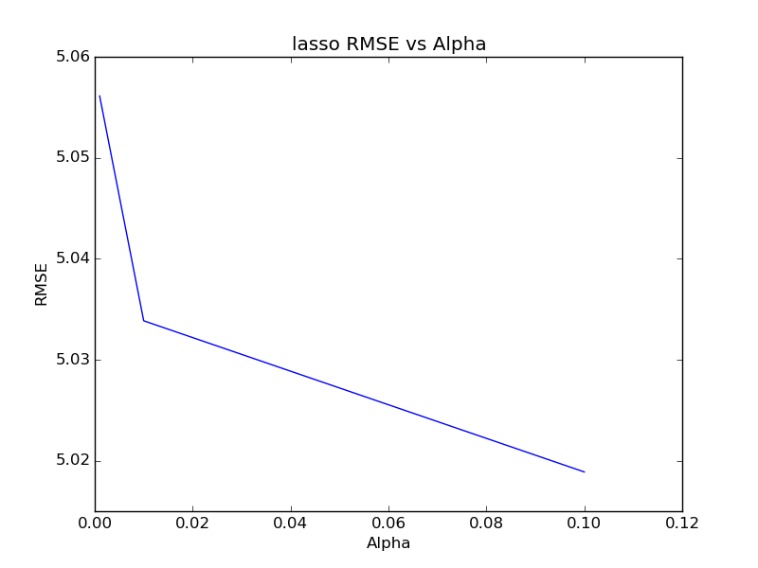
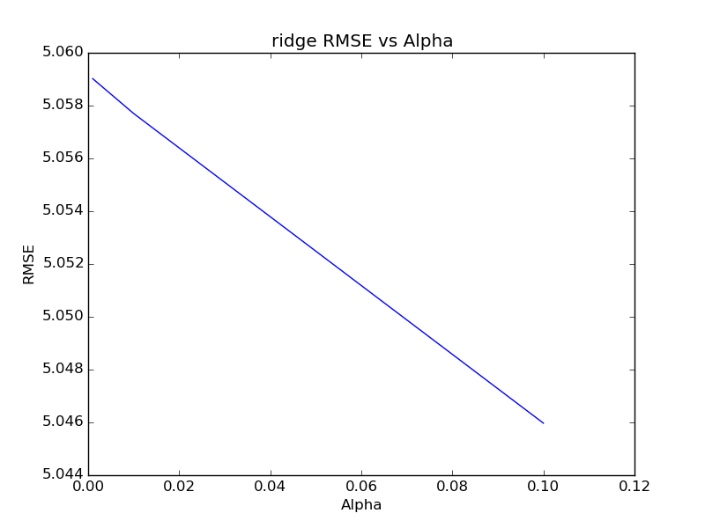

As per them, the minimum for both is achieved at alpha = 0.1, with values of RMSE as 5.04 and 5.01 for Ridge and Lasso respectively.

However, the graphs are rather inconclusive and we explored further by varying alpha between 0 and 1 with steps 0.05 for lasso and between 0 and 20 with step size 1 for ridge. The plots for these are presented below.

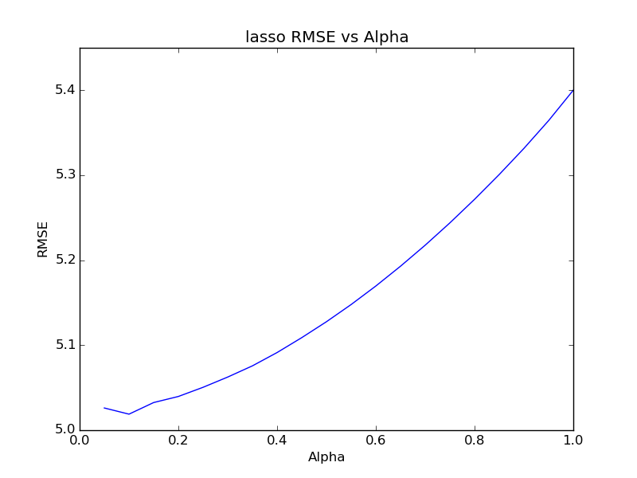
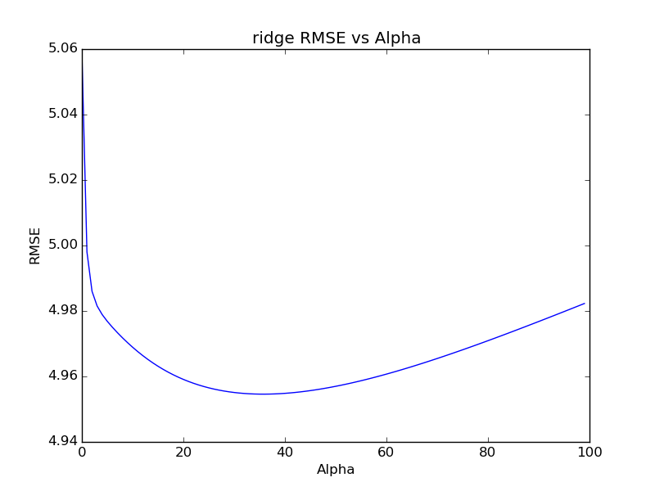

From these, plots it can be concluded the minimum RMSE was achieved at alpha = 0.1 for Lasso regression with an RMSE of 5.018. On the other hand, for Ridge regression, minimum RMSE of 4.95 was achieved at alpha = 36.

