**Group 10 Members:**

* Ishan Perhar
* Aidan Mark
* Nick Westly

**Status of Projects:**

* Server.py: Complete
* Client.py: Complete
* Enhanced_server.py: Complete
* Enhanced_client.py: Complete

**Deficiencies:**

* Man in the middle attack beyond the login process

**Tests Conducted:**

Test for 5 simultaneous connections:

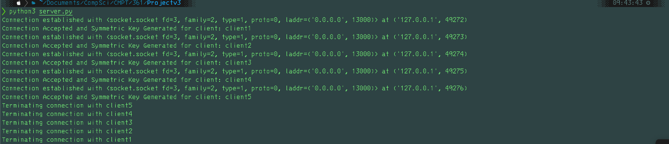

Tests for authorization:

* Wrong username & password:
  + 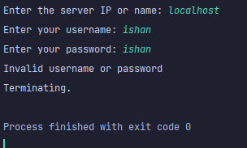
* Correct username wrong password:
  + 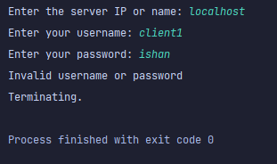
* A valid password wrong invalid username:
  + 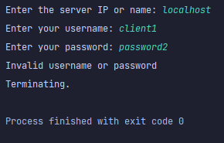
* A valid username and password:
  + 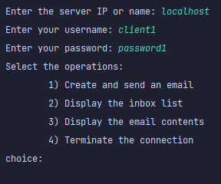

Menu Testing:

* Choice < 1:
  + 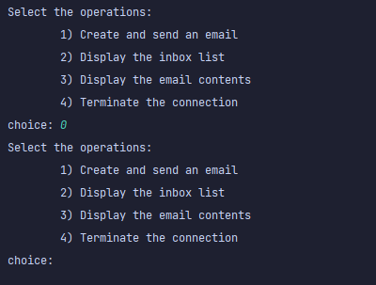
* Choice > 4:
  + 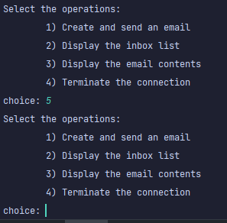
* Valid choice within range 1 -4:
  + 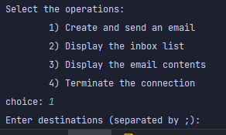

Send email option:

* Mailbox prior to tests:
  + 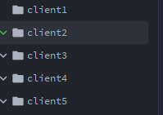
* Send to 5 clients at once:
  + 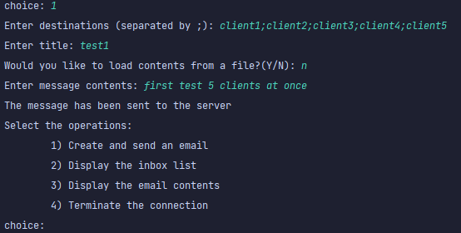
  + 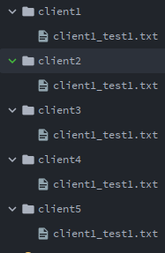
  + 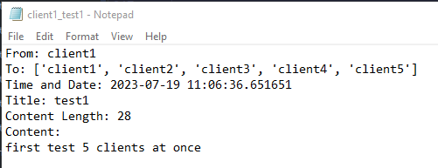
* Send to one client upload a file:
  + 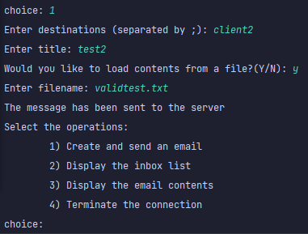
  + 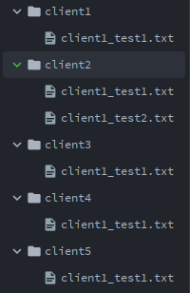
  + 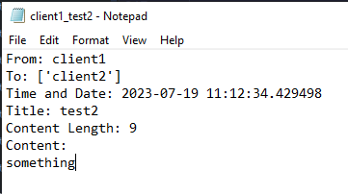
* Test uploading a file to big:
  + 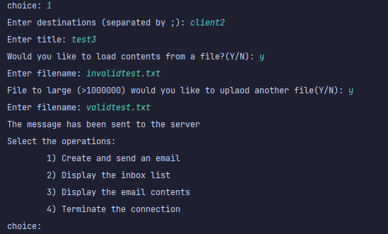
  + 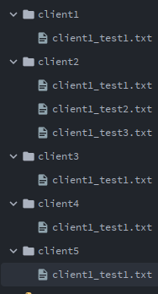

Display inbox:

* Display inbox when messages are in the inbox:
  + 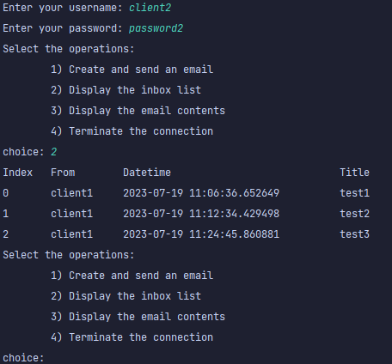
* Display inbox when no messages are in the inbox:
  + 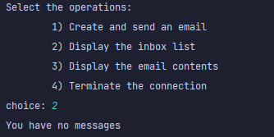

Display email:

* Display appropriate email given the index:
  + 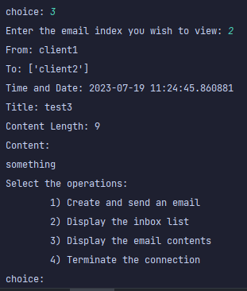
* Index < 0:
  + 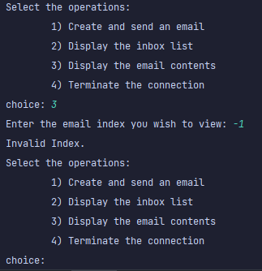
* Index > email range:
  + 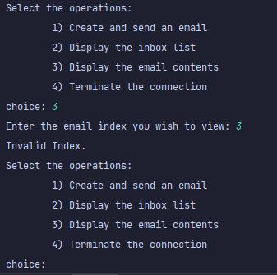

Terminate connection operation:

* If option 4 chosen:
  + 