Container Based Development

Docker is the first in market not the technology

But it’s the leader in market.

**If yore old you can remember**

1.Application ,database ,web server we use 3 physical servers

* We have to maintain that
* Network that
* Install os

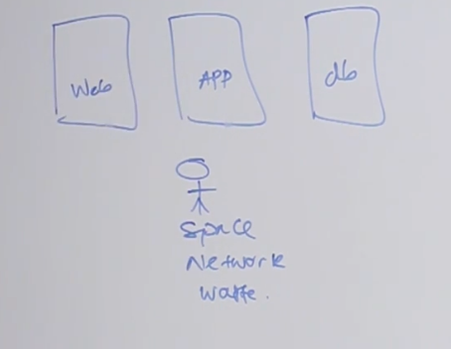

Then came the hypervisor

2. we get some high performance server and install hypervisor and segmented that in to 3.

But human nature is when we have something we want more

So still we have some pain.If we want one moere server instance we have to install os and configure and lot more work.Yes we can have vm image and build on top of that

But its not the best solution.We have to done some configuration.

Bootup time in virtusal machine

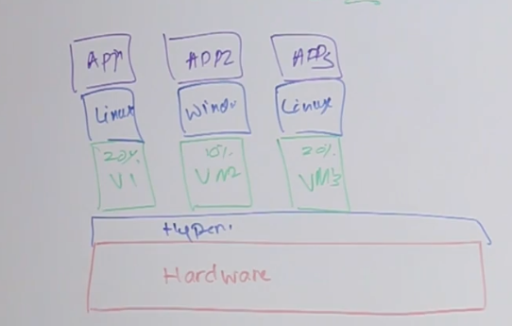

**Container Based New Generation**

3.

In this we install single os and run docker engine on top of it and

On docker engine we run dockers

so update patch config is solved.

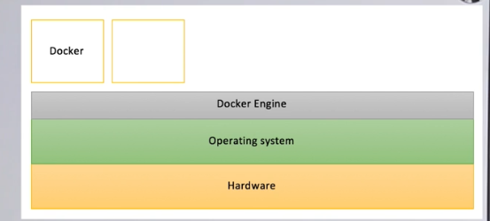

Our apps run inside Docker containers and docker is way smaller and resource acquire is minimum compared to hypervisor. 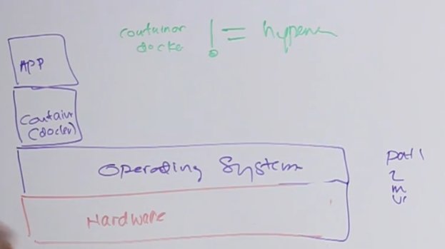

**Docker**

1. **Developed in go lang**
2. **OpenSource**
3. **Vm is hypervisor Docker is containers**
4. **Os is always started so no need to start it again**
5. **Very fast**
6. **Docker engine is not the Docker Project**
7. **Services security are built on top of docker engine**

Docker Registry

There are repos and we can pull their docker images and costomize them and push our ones to there.

If repo is public anyone can pull it

If private you only can pull it.

**Docker Hub ,Amazon**

**Docker orchestration**

**Assume application multiple services**

**Oauth, http when push this containers orchestration manage these orchestraion ,Kurbernet is a software we use to do this.**

**No persistence is myth its default in dockers if you have database docker you have persistence in it.**

**Continuous integration you can push and test your docker.**

**Docker Full tutorial**

<https://www.katacoda.com/courses/docker/deploying-first-container>

In this first scenario, you'll take the role of Jane, a developer who needs to deploy a new Key-Value Store for an application she's working with. After discussions, it's been decided to use Redis, a popular KV Store.

Jane is unfamiliar with how Redis is deployed but has heard Docker makes it straightforward to deploy services into development and production.

This scenario discusses how she will complete her task and deploy Redis as a Docker Container.

Jane's development environment has access to latest version of the Docker Engine via a machine called *docker*. Her local dev machine has the Docker Client installed and accessible via the command line.

**What Is Docker?**

Docker describes themselves as "an open platform for developers and sysadmins to build, ship, and run distributed applications".

Docker allows you to run containers. A container is a sandboxed process running an application and its dependencies on the host operating system. The application inside the container considers itself to be the only process running on the machine while the machine can run multiple containers independently.

**Step 1 - Running A Container**

The first task is to identify the name of the Docker Image which is configured to run *Redis*. With Docker, all containers are started based on a Docker Image. These images contain everything required to launch the process; the host doesn't require any configuration or dependencies.

Jane can find existing images at [registry.hub.docker.com/](https://registry.hub.docker.com/) or by using the command docker search <name>. For example, to find an image for *Redis*, you would use docker search redis.

**Task**

Using the search command, Jane has identified that the *Redis* Docker Image is called *redis* and wants to run the *latest* release. Because *Redis* is a database, Jane wants to run it as a background service while she continues to work.

To complete this step, launch a container in the background running an instance of Redis based on the official image.

The Docker CLI has a command called *run* which will start a container based on a Docker Image. The structure is *docker run <options> <image-name>*.

By default, Docker will run a command in the foreground. To run in the background, the option *-d* needs to be specified.

docker run -d redis

By default, Docker will run the *latest* version available. If a particular version was required, it could be specified as a tag, for example, version 3.2 would be *docker run -d redis:3.2*.

As this is the first time Jane is using the *Redis* image, it will be downloaded onto the Docker Host machine.

**docker run -d redis:latest**

#### Step 2 - Finding Running Containers

The launched container is running in the background, the docker ps command lists all running containers, the image used to start the container and uptime.

This command also displays the friendly name and ID that can be used to find out information about individual containers.

The command docker inspect <friendly-name|container-id> provides more details about a running container, such as IP address.

The command docker logs <friendly-name|container-id> will display messages the container has written to standard error or standard out.

#### Step 3 - Accessing Redis

Jane is happy that Redis is running, but is surprised that she cannot access it. The reason is that each container is sandboxed. If a service needs to be accessible by a process not running in a container, then the port needs to be exposed via the Host.

Once exposed, it is possible to access the process as if it were running on the host OS itself.

Jane knows that by default, Redis runs on port 6379. She has learned that by default other applications and library expect a Redis instance to be listening on the port.

#### Task

After reading the documentation, Jane discovers that ports are bound when containers are started using -p <host-port>:<container-port> option. Jane also discovers that it's useful to define a name when starting the container, this means she doesn't have to use Bash piping or keep looking up the name when trying to access the logs.

Jane finds the best way to solve her problem of running Redis in the background, with a name of redisHostPort on port 6379 is using the following command docker run -d --name redisHostPort -p 6379:6379 redis:latest

#### Protip

By default, the port on the host is mapped to 0.0.0.0, which means all IP addresses. You can specify a particular IP address when you define the port mapping, for example, -p 127.0.0.1:6379:6379

#### Step 4 - Accessing Redis

The problem with running processes on a fixed port is that you can only run one instance. Jane would prefer to run multiple Redis instances and configure the application depending on which port Redis is running on.

#### Task

After experimenting, Jane discovers that just using the option -p 6379 enables her to expose Redis but on a randomly available port. She decides to test her theory using docker run -d --name redisDynamic -p 6379 redis:latest

While this works, she now doesn't know which port has been assigned. Thankfully, this is discovered via docker port redisDynamic 6379

Jane also finds that listing the containers displays the port mapping information, docker ps

**Step 5 - Persisting Data**

After working with containers for a few days, Jane realises that the data stored keeps being removed when she deletes and re-creates a container. Jane needs the data to be persisted and reused when she recreates a container.

Containers are designed to be stateless. Binding directories (also known as volumes) is done using the option *-v <host-dir>:<container-dir>*. When a directory is mounted, the files which exist in that directory on the host can be accessed by the container and any data changed/written to the directory inside the container will be stored on the host. This allows you to upgrade or change containers without losing your data.

**Task**

Using the Docker Hub documentation for [Redis](https://hub.docker.com/_/redis/), Jane has investigated that the official Redis image stores logs and data into a /data directory.

Any data which needs to be saved on the Docker Host, and not inside containers, should be stored in */opt/docker/data/redis*.

The complete command to solve the task is docker run -d --name redisMapped -v /opt/docker/data/redis:/data redis

**Protip**

Docker allows you to use $PWD as a placeholder for the current directory.

#### Step 5 - Persisting Data

docker run -d --name redisMapped -v "$PWD/data":/data redis

**Step 6 - Running A Container In The Foreground**

Jane has been working with Redis as a background process. Jane wonders how containers work with foreground processes, such as *ps* or *bash*.

Previously, Jane used the *-d* to execute the container in a detached, background, state. Without specifying this, the container would run in the foreground. If Jane wanted to interact with the container (for example, to access a bash shell) she could include the options *-it*.

As well as defining whether the container runs in the background or foreground, certain images allow you to override the command used to launch the image. Being able to replace the default command makes it possible to have a single image that can be re-purposed in multiple ways. For example, the Ubuntu image can either run OS commands or run an interactive bash prompt using */bin/bash*

**Example**

The command docker run ubuntu ps launches an Ubuntu container and executes the command *ps* to view all the processes running in a container.

Using docker run -it ubuntu bash allows Jane to get access to a bash shell inside of a container.

CONTINUE

### Deploy Static HTML Website as Container

**Step 1 of 3**

#### Step 1 - Create Dockerfile

Docker Images start from a base image. The base image should include the platform dependencies required by your application, for example, having the JVM or CLR installed.

This base image is defined as an instruction in the Dockerfile. Docker Images are built based on the contents of a Dockerfile. The Dockerfile is a list of instructions describing how to deploy your application.

In this example, our base image is the Alpine version of Nginx. This provides the configured web server on the Linux Alpine distribution.

## Task

Create your Dockerfile for building your image by copying the contents below into the editor.

Copy to EditorFROM nginx:alpine

COPY . /usr/share/nginx/html

The first line defines our base image. The second line copies the content of the current directory into a particular location inside the container.

#### Step 2 - Build Docker Image

The Dockerfile is used by the Docker CLI build command. The build command executes each instruction within the Dockerfile. The result is a built Docker Image that can be launched and run your configured app.

The build command takes in some different parameters. The format is docker build -t <build-directory>. The -t parameter allows you to specify a friendly name for the image and a tag, commonly used as a version number. This allows you to track built images and be confident about which version is being started.

## Task

Build our static HTML image using the build command below.

docker build -t webserver-image:v1 .

You can view a list of all the images on the host using docker images.

The built image will have the name webserver-image with a tag of v1.

#### Step 3 - Run

The built Image can be launched in a consistent way to other Docker Images. When a container launches, it's sandboxed from other processes and networks on the host. When starting a container you need to give it permission and access to what it requires.

For example, to open and bind to a network port on the host you need to provide the parameter -p <host-port>:<container-port>.

## Task

Launch our newly built image providing the friendly name and tag. As it's a web server, bind port 80 to our host using the -p parameter.

docker run -d -p 80:80 webserver-image:v1

Once started, you'll be able to access the results of port 80 via curl docker

You now have a static HTML website being served by Nginx.

Summary

Yes, when the initial command finish its execution then the container stops.

You can start a stopped container using:

docker start container_name

If you want to see the output of your command then you should add -ai options:

docker start -ai container_name

PS. there is a docker restart container_name but that is used to restart a running container - I believe that is not your case

**Docker Logs**

## How to see docker container logs

### Introduction

If you are running your container in -d (detached mode) or by[docker remote API](http://littlebigextra.com/how-to-enable-remote-rest-api-on-docker-host/), you will not see any logs in console. To access running docker image or container logs you need to use docker logs command.

In this tutorial, I will list out various commands to display logs

To see docker containers logs make sure that first of all, docker container is running you can check this by using



|  |  |
| --- | --- |
| 1  2  3 | docker ps -a |

Once you have confirmed that docker container is up and running you can use following commands

*Know more about*[*deleting dangling/unused images on your disk*](http://littlebigextra.com/delete_docker_images/)

### To see all the logs of a particular container



|  |  |
| --- | --- |
| 1  2  3 | docker logs ContainerName/ContainerID |

### To follow docker log output or tail continuously



|  |  |
| --- | --- |
| 1  2  3 | docker logs --follow ContainerName/ContainerID |

### To see last n lines of logs

In this case, last 2500 lines will be displayed



|  |  |
| --- | --- |
| 1  2  3 | docker logs --tail 2500 ContainerName/ContainerID |

### To see logs since particular date or timestamp

First get the Timestamp format in logs using



|  |  |
| --- | --- |
| 1  2  3 | docker logs --timestamps ContainerName/ContainerID |

Now use the timestamp which should be in format like this 2017-05-03T10:00:59.935397007Z and use it to display logs

For e.g if only a day’s log needs to be viewed



|  |  |
| --- | --- |
| 1  2  3 | docker logs --since 2017-05-03 ContainerName/ContainerID |

For e.g if only a day’s log needs to be viewed since 10 am



|  |  |
| --- | --- |
| 1  2  3 | docker logs --since 2017-05-03T10:00 ContainerName/ContainerID |

<http://www.littlebigextra.com/view-docker-container-logs/>