SpringBoot

1st.A simple project

This project we use web and actuator dependencies.
First we check the pom file

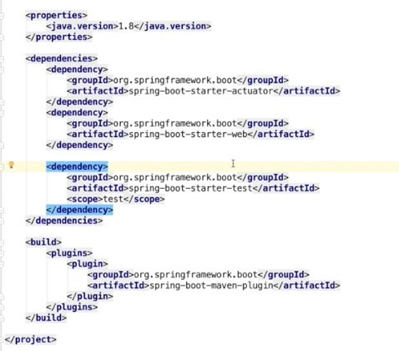
Ok we have 2 that we added web and actuator
Why starter ?
When added like this spring knows sub dependencies and add them
You can check by
mvn dependency:tree
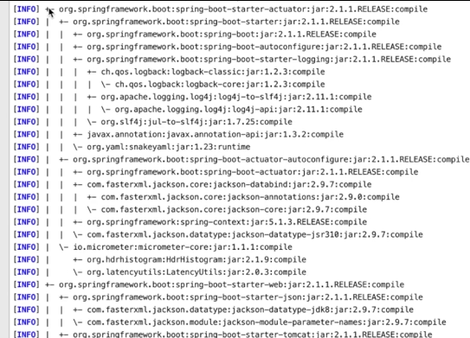

Basic Structure of spring app
Controller-Responsible to handle the traffic and also this is the last layer we meet so we have to handle exception here.

Service - Handle the business logic ,sometimes states (sessions)

Repository-Deal with Databases

Start Spring Boot Application

Many Spring Boot developers like their apps to use auto-configuration, component scan and be able to define extra configuration on their "application class". A single @SpringBootApplication annotation can be used to enable those three features, that is:
- @EnableAutoConfiguration: enable Spring Boot’s auto-configuration mechanism
- @ComponentScan: enable @Component scan on the package where the application is located (see the best practices)
- @Configuration: allow to register extra beans in the context or import additional configuration classes
The @SpringBootApplication annotation is equivalent to using @Configuration, @EnableAutoConfiguration, and @ComponentScan with their default attributes, as shown in the following example:
package com.example.myapplication;

import org.springframework.boot.SpringApplication;
import org.springframework.boot.autoconfigure.SpringBootApplication;

@SpringBootApplication // same as @Configuration @EnableAutoConfiguration @ComponentScan
public class Application {

public static void main(String[] args) {
SpringApplication.run(Application.class, args);
}

}

Controller
@RestController

https://www.baeldung.com/spring-request-param

Remember, we don't need to annotate the
@RestController-annotated controllers with the @ResponseBody annotation since Spring does it by default.
https://www.baeldung.com/spring-requestmapping

2. @RequestMapping Basics
Let's start with a simple example – mapping an HTTP request to a method using some basic criteria.

2.1. @RequestMapping – by Path
1  2  3  4  5 | @RequestMapping(value = "/ex/foos", method = RequestMethod.GET)  @ResponseBody  public String getFoosBySimplePath() {  return "Get some Foos";  }
To test out this mapping with a simple curl command, run:
1 | curl -i http://localhost:8080/spring-rest/ex/foos

2.2. @RequestMapping – the HTTP Method
The HTTP method parameter has no default – so if we don't specify a value, it's going to map to any HTTP request.
Here's a simple example, similar to the previous one – but this time mapped to an HTTP POST request:
1  2  3  4  5 | @RequestMapping(value = "/ex/foos", method = POST)  @ResponseBody  public String postFoos() {  return "Post some Foos";  }
To test the POST via a curl command:
1 | curl -i -X POST http://localhost:8080/spring-rest/ex/foos

3. RequestMapping and HTTP Headers

3.1. @RequestMapping With the headers Attribute
The mapping can be narrowed even further by specifying a header for the request:
1  2  3  4  5 | @RequestMapping(value = "/ex/foos", headers = "key=val", method = GET)  @ResponseBody  public String getFoosWithHeader() {  return "Get some Foos with Header";  }
To test the operation, we're going to use the curl header support:
1 | curl -i -H "key:val" http://localhost:8080/spring-rest/ex/foos
And even multiple headers via the header attribute of @RequestMapping:
1  2  3  4  5  6  7 | @RequestMapping(  value = "/ex/foos",  headers = { "key1=val1", "key2=val2" }, method = GET)  @ResponseBody  public String getFoosWithHeaders() {  return "Get some Foos with Header";  }
We can test this with the command:
1 | curl -i -H "key1:val1" -H "key2:val2" http://localhost:8080/spring-rest/ex/foos
Note that for the curl syntax for separating the header key and the header value is a colon, same as in the HTTP spec, while in Spring the equals sign is used.

3.2. @RequestMapping Consumes and Produces
Mapping media types produced by a controller method is worth special attention – we can map a request based on its Accept header via the @RequestMapping headers attribute introduced above:
1  2  3  4  5  6  7  8 | @RequestMapping(  value = "/ex/foos",  method = GET,  headers = "Accept=application/json")  @ResponseBody  public String getFoosAsJsonFromBrowser() {  return "Get some Foos with Header Old";  }
The matching for this way of defining the Accept header is flexible – it uses contains instead of equals, so a request such as the following would still map correctly:
1  2 | curl -H "Accept:application/json,text/html"  http://localhost:8080/spring-rest/ex/foos
Starting with Spring 3.1, the @RequestMapping annotation now has the produces and the consumes attributes, specifically for this purpose:
1  2  3  4  5  6  7  8  9 | @RequestMapping(  value = "/ex/foos",  method = RequestMethod.GET,  produces = "application/json"  )  @ResponseBody  public String getFoosAsJsonFromREST() {  return "Get some Foos with Header New";  }
Also, the old type of mapping with the headers attribute will automatically be converted to the new produces mechanism starting with Spring 3.1, so the results will be identical.
This is consumed via curl in the same way:
1  2 | curl -H "Accept:application/json"  http://localhost:8080/spring-rest/ex/foos
Additionally, produces support multiple values as well:
1  2  3  4  5 | @RequestMapping(  value = "/ex/foos",  method = GET,  produces = { "application/json", "application/xml" }  )
Keep in mind that these – the old way and the new way of specifying the accept header – are basically the same mapping, so Spring won't allow them together – having both these methods active would result in:
1  2  3  4  5  6  7  8  9  10  11  12  13  14  15 | Caused by: java.lang.IllegalStateException: Ambiguous mapping found.  Cannot map 'fooController' bean method  java.lang.String  org.baeldung.spring.web.controller  .FooController.getFoosAsJsonFromREST()  to  { [/ex/foos],  methods=[GET],params=[],headers=[],  consumes=[],produces=[application/json],custom=[]  }:  There is already 'fooController' bean method  java.lang.String  org.baeldung.spring.web.controller  .FooController.getFoosAsJsonFromBrowser()  mapped.
A final note on the new produces and consumes mechanism – these behave differently from most other annotations: when specified at the type level, the method level annotations do not complement but override the type level information.
And of course, if you want to dig deeper into building a REST API with Spring – check out the new REST with Spring course.

4. RequestMapping With Path Variables
Parts of the mapping URI can be bound to variables via the @PathVariable annotation.

4.1. Single @PathVariable
A simple example with a single path variable:
1  2  3  4  5  6 | @RequestMapping(value = "/ex/foos/{id}", method = GET)  @ResponseBody  public String getFoosBySimplePathWithPathVariable(  @PathVariable("id") long id) {  return "Get a specific Foo with id=" + id;  }
This can be tested with curl:
1 | curl http://localhost:8080/spring-rest/ex/foos/1
If the name of the method parameter matches the name of the path variable exactly, then this can be simplified by using @PathVariable with no value:
1  2  3  4  5  6 | @RequestMapping(value = "/ex/foos/{id}", method = GET)  @ResponseBody  public String getFoosBySimplePathWithPathVariable(  @PathVariable String id) {  return "Get a specific Foo with id=" + id;  }
Note that @PathVariable benefits from automatic type conversion, so we could have also declared the id as:
1 | @PathVariable long id

4.2. Multiple @PathVariable
More complex URI may need to map multiple parts of the URI to multiple values:
1  2  3  4  5  6  7 | @RequestMapping(value = "/ex/foos/{fooid}/bar/{barid}", method = GET)  @ResponseBody  public String getFoosBySimplePathWithPathVariables  (@PathVariable long fooid, @PathVariable long barid) {  return "Get a specific Bar with id=" + barid +  " from a Foo with id=" + fooid;  }
This is easily tested with a curl in the same way:
1 | curl http://localhost:8080/spring-rest/ex/foos/1/bar/2

4.3. @PathVariable With RegEx
Regular expressions can also be used when mapping the @PathVariable; for example, we will restrict the mapping to only accept numerical values for the id:
1  2  3  4  5  6 | @RequestMapping(value = "/ex/bars/{numericId:[\\d]+}", method = GET)  @ResponseBody  public String getBarsBySimplePathWithPathVariable(  @PathVariable long numericId) {  return "Get a specific Bar with id=" + numericId;  }
This will mean that the following URIs will match:
1 | http://localhost:8080/spring-rest/ex/bars/1
But this will not:
1 | http://localhost:8080/spring-rest/ex/bars/abc

5. RequestMapping With Request Parameters
@RequestMapping allows easy mapping of URL parameters with the @RequestParam annotation.
We are now mapping a request to a URI such as:
1 | http://localhost:8080/spring-rest/ex/bars?id=100
1  2  3  4  5  6 | @RequestMapping(value = "/ex/bars", method = GET)  @ResponseBody  public String getBarBySimplePathWithRequestParam(  @RequestParam("id") long id) {  return "Get a specific Bar with id=" + id;  }
We are then extracting the value of the id parameter using the @RequestParam(“id”) annotation in the controller method signature.
To send a request with the id parameter, we'll use the parameter support in curl:
1 | curl -i -d id=100 http://localhost:8080/spring-rest/ex/bars
In this example, the parameter was bound directly without having been declared first.
For more advanced scenarios, @RequestMapping can optionally define the parameters – as yet another way of narrowing the request mapping:
1  2  3  4  5  6 | @RequestMapping(value = "/ex/bars", params = "id", method = GET)  @ResponseBody  public String getBarBySimplePathWithExplicitRequestParam(  @RequestParam("id") long id) {  return "Get a specific Bar with id=" + id;  }
Even more flexible mappings are allowed – multiple params values can be set, and not all of them have to be used:
1  2  3  4  5  6  7  8  9 | @RequestMapping(  value = "/ex/bars",  params = { "id", "second" },  method = GET)  @ResponseBody  public String getBarBySimplePathWithExplicitRequestParams(  @RequestParam("id") long id) {  return "Narrow Get a specific Bar with id=" + id;  }
And of course, a request to a URI such as:
1 | http://localhost:8080/spring-rest/ex/bars?id=100&second=something
Will always be mapped to the best match – which is the narrower match, which defines both the id and the second parameter.

6. RequestMapping Corner Cases

6.1. @RequestMapping – Multiple Paths Mapped to the Same Controller Method
Although a single @RequestMapping path value is usually used for a single controller method, this is just good practice, not a hard and fast rule – there are some cases where mapping multiple requests to the same method may be necessary. For that case, the value attribute of @RequestMapping does accept multiple mappings, not just a single one:
1  2  3  4  5  6  7 | @RequestMapping(  value = { "/ex/advanced/bars", "/ex/advanced/foos" },  method = GET)  @ResponseBody  public String getFoosOrBarsByPath() {  return "Advanced - Get some Foos or Bars";  }
Now, both of these curl commands should hit the same method:
1  2 | curl -i http://localhost:8080/spring-rest/ex/advanced/foos  curl -i http://localhost:8080/spring-rest/ex/advanced/bars

6.2. @RequestMapping – Multiple HTTP Request Methods to the Same Controller Method
Multiple requests using different HTTP verbs can be mapped to the same controller method:
1  2  3  4  5  6  7  8 | @RequestMapping(  value = "/ex/foos/multiple",  method = { RequestMethod.PUT, RequestMethod.POST }  )  @ResponseBody  public String putAndPostFoos() {  return "Advanced - PUT and POST within single method";  }
With curl, both of these will now hit the same method:
1  2 | curl -i -X POST http://localhost:8080/spring-rest/ex/foos/multiple  curl -i -X PUT http://localhost:8080/spring-rest/ex/foos/multiple

6.3. @RequestMapping – a Fallback for All Requests
To implement a simple fallback for all requests using a particular HTTP method – for example, for a GET:
1  2  3  4  5 | @RequestMapping(value = "*", method = RequestMethod.GET)  @ResponseBody  public String getFallback() {  return "Fallback for GET Requests";  }
Or even for all requests:
1  2  3  4  5  6  7 | @RequestMapping(  value = "*",  method = { RequestMethod.GET, RequestMethod.POST ... })  @ResponseBody  public String allFallback() {  return "Fallback for All Requests";  }

6.4. Ambiguous Mapping Error
The ambiguous mapping error occurs when Spring evaluates two or more request mappings to be the same for different controller methods. A request mapping is the same when it has the same HTTP method, URL, parameters, headers, and media type. This, for example, is an ambiguous mapping:
1  2  3  4  5  6  7  8  9 | @GetMapping(value = "foos/duplicate" )  public String duplicate() {  return "Duplicate";  }  @GetMapping(value = "foos/duplicate" )  public String duplicateEx() {  return "Duplicate";  }
The exception thrown usually does have error messages along these lines:
1  2  3  4  5  6 | Caused by: java.lang.IllegalStateException: Ambiguous mapping.  Cannot map 'fooMappingExamplesController' method  public java.lang.String org.baeldung.web.controller.FooMappingExamplesController.duplicateEx()  to {[/ex/foos/duplicate],methods=[GET]}:  There is already 'fooMappingExamplesController' bean method  public java.lang.String org.baeldung.web.controller.FooMappingExamplesController.duplicate() mapped.
A careful reading of the error message points to the fact that Spring is unable to map the method org.baeldung.web.controller.FooMappingExamplesController.duplicateEx() as it has a conflicting mapping with an already mapped org.baeldung.web.controller.FooMappingExamplesController.duplicate().
The code snippet below will not result in ambiguous mapping error because both methods return different content types:
1  2  3  4  5  6  7  8  9 | @GetMapping(value = "foos/duplicate", produces = MediaType.APPLICATION_XML_VALUE)  public String duplicateXml() {  return "<message>Duplicate</message>";  }  @GetMapping(value = "foos/duplicate", produces = MediaType.APPLICATION_JSON_VALUE)  public String duplicateJson() {  return "{\"message\":\"Duplicate\"}";  }
This differentiation allows our controller to return the correct data representation based on the Accepts header supplied in the request.
Another way to resolve this is to update the URL assigned to either of the two methods involved.

7. New Request Mapping Shortcuts
Spring Framework 4.3 introduced a few new HTTP mapping annotations, all based on @RequestMapping:
- @GetMapping
- @PostMapping
- @PutMapping
- @DeleteMapping
- @PatchMapping
These new annotations can improve the readability and reduce the verbosity of the code. Let us look at these new annotations in action by creating a RESTful API that supports CRUD operations:
1  2  3  4  5  6  7  8  9  10  11  12  13  14  15  16  17  18  19  20  21 | @GetMapping("/{id}")  public ResponseEntity<?> getBazz(@PathVariable String id){  return new ResponseEntity<>(new Bazz(id, "Bazz"+id), HttpStatus.OK);  }  @PostMapping  public ResponseEntity<?> newBazz(@RequestParam("name") String name){  return new ResponseEntity<>(new Bazz("5", name), HttpStatus.OK);  }  @PutMapping("/{id}")  public ResponseEntity<?> updateBazz(  @PathVariable String id,  @RequestParam("name") String name) {  return new ResponseEntity<>(new Bazz(id, name), HttpStatus.OK);  }  @DeleteMapping("/{id}")  public ResponseEntity<?> deleteBazz(@PathVariable String id){  return new ResponseEntity<>(new Bazz(id), HttpStatus.OK);  }
A deep dive into these can be found here.

8. Spring Configuration
The Spring MVC Configuration is simple enough – considering that our FooController is defined in the following package:
1  2  3  4 | package org.baeldung.spring.web.controller;  @Controller  public class FooController { ... }
We simply need a @Configuration class to enable the full MVC support and configure classpath scanning for the controller:
1  2  3  4  5  6 | @Configuration  @EnableWebMvc  @ComponentScan({ "org.baeldung.spring.web.controller" })  public class MvcConfig {  //  }

1. Overview
Spring 4.3. introduced some very cool method-level composed annotations to smooth out the handling @RequestMapping in typical Spring MVC projects.
In this article, we will learn how to use them in an efficient way.

2. New Annotations
Typically, if we want to implement the URL handler using traditional @RequestMapping annotation, it would have been something like this:
1 | @RequestMapping(value = "/get/{id}", method = RequestMethod.GET)
The new approach makes it possible to shorten this simply to:
1 | @GetMapping("/get/{id}")
Spring currently supports five types of inbuilt annotations for handling different types of incoming HTTP request methods which are GET, POST, PUT, DELETE and PATCH. These annotations are:
- @GetMapping
- @PostMapping
- @PutMapping
- @DeleteMapping
- @PatchMapping
From the naming convention we can see that each annotation is meant to handle respective incoming request method type, i.e. @GetMapping is used to handle GET type of request method, @PostMapping is used to handle POST type of request method, etc.

3. How It Works
All of the above annotations are already internally annotated with @RequestMapping and the respective value in the method element.
For example, if we'll look at the source code of @GetMapping annotation, we can see that it's already annotated with RequestMethod.GET in the following way:
1  2  3  4  5  6  7 | @Target({ java.lang.annotation.ElementType.METHOD })  @Retention(RetentionPolicy.RUNTIME)  @Documented  @RequestMapping(method = { RequestMethod.GET })  public @interface GetMapping {  // abstract codes  }
All the other annotations are created in the same way, i.e. @PostMapping is annotated with RequestMethod.POST, @PutMapping is annotated with RequestMethod.PUT, etc.
The full source code of the annotations is available here.

4. Implementation
Let's try to use these annotations to build a quick REST application.
Please note that since we would use Maven to build the project and Spring MVC to create our application, we need to add necessary dependencies in the pom.xml:
1  2  3  4  5 | <dependency>  <groupId>org.springframework</groupId>  <artifactId>spring-webmvc</artifactId>  <version>5.2.2.RELEASE</version>  </dependency>
The latest version of spring-webmvc is available in the Central Maven Repository.
Now, we need to create the controller to map incoming request URL. Inside this controller, we would use all of these annotations one by one.

4.1. @GetMapping
1  2  3  4 | @GetMapping("/get")  public @ResponseBody ResponseEntity<String> get() {  return new ResponseEntity<String>("GET Response", HttpStatus.OK);  }
1  2  3  4  5  6 | @GetMapping("/get/{id}")  public @ResponseBody ResponseEntity<String>  getById(@PathVariable String id) {  return new ResponseEntity<String>("GET Response : "  + id, HttpStatus.OK);  }

4.2. @PostMapping
1  2  3  4 | @PostMapping("/post")  public @ResponseBody ResponseEntity<String> post() {  return new ResponseEntity<String>("POST Response", HttpStatus.OK);  }

4.3. @PutMapping
1  2  3  4 | @PutMapping("/put")  public @ResponseBody ResponseEntity<String> put() {  return new ResponseEntity<String>("PUT Response", HttpStatus.OK);  }

4.4. @DeleteMapping
1  2  3  4 | @DeleteMapping("/delete")  public @ResponseBody ResponseEntity<String> delete() {  return new ResponseEntity<String>("DELETE Response", HttpStatus.OK);  }

4.5. @PatchMapping
1  2  3  4 | @PatchMapping("/patch")  public @ResponseBody ResponseEntity<String> patch() {  return new ResponseEntity<String>("PATCH Response", HttpStatus.OK);  }
Points to note:
- We have used the necessary annotations to handle proper incoming HTTP methods with URI. For example, @GetMapping to handle “/get” URI, @PostMapping to handle “/post” URI and so on
- Since we are making an REST-based application, we are returning a constant string (unique to each request type) with 200 response code to simplify the application. We have used Spring's @ResponseBody annotation in this case.
- If we had to handle any URL path variable, we can simply do it in much less way we used to do in case of using @RequestMapping.

5. Testing the Application
To test the application we need to create a couple of test cases using JUnit. We would use SpringJUnit4ClassRunner to initiate the test class. We would create five different test cases to test each annotation and every handler we declared in the controller.
Let's simple the example test case of @GetMapping:
1  2  3  4  5  6  7  8  9  10  11  12  13  14 | @Test  public void giventUrl_whenGetRequest_thenFindGetResponse()  throws Exception {  MockHttpServletRequestBuilder builder = MockMvcRequestBuilders  .get("/get");  ResultMatcher contentMatcher = MockMvcResultMatchers.content()  .string("GET Response");  this.mockMvc.perform(builder).andExpect(contentMatcher)  .andExpect(MockMvcResultMatchers.status().isOk());  }
As we can see, we are expecting a constant string “GET Response“, once we hit the GET URL “/get”.
Now, let's create the test case to test @PostMapping:
1  2  3  4  5  6  7  8  9  10  11  12  13  14 | @Test  public void givenUrl_whenPostRequest_thenFindPostResponse()  throws Exception {  MockHttpServletRequestBuilder builder = MockMvcRequestBuilders  .post("/post");  ResultMatcher contentMatcher = MockMvcResultMatchers.content()  .string("POST Response");  this.mockMvc.perform(builder).andExpect(contentMatcher)  .andExpect(MockMvcResultMatchers.status().isOk());  }
In the same way, we created the rest of the test cases to test all of the HTTP methods.
Alternatively, we can always use any common REST client, for example, PostMan, RESTClient etc, to test our application. In that case, we need to be a little careful to choose correct HTTP method type while using the rest client. Otherwise, it would throw 405 error status.

6. Conclusion
In this article, we had a quick introduction to the different types of @RequestMapping shortcuts for quick web development using traditional Spring MVC framework. We can utilize these quick shortcuts to create a clean code base.

Difference
7
1) @RequestParam is used to extract query parameters
http://localhost:3000/api/group/test?id=4

@GetMapping("/group/test")
public ResponseEntity<?> test(@RequestParam Long id) {
System.out.println("This is test");
return ResponseEntity.ok().body(id);
}
while @PathVariable is used to extract data right from the URI:
http://localhost:3000/api/group/test/4

@GetMapping("/group/test/{id}")
public ResponseEntity<?> test(@PathVariable Long id) {
System.out.println("This is test");
return ResponseEntity.ok().body(id);
}
2) @RequestParam is more useful on a traditional web application where data is mostly passed in the query parameters while @PathVariable is more suitable for RESTful web services where URL contains values.
3) @RequestParam annotation can specify default values if a query parameter is not present or empty by using a defaultValue attribute, provided the required attribute is false:
@RestController
@RequestMapping("/home")
public class IndexController {

@RequestMapping(value = "/name")
String getName(@RequestParam(value = "person", defaultValue = "John") String personName) {
return "Required element of request param";
}

}

Spring Actuater

What it does ?
It provide important endpoints to our services for view information related to it.

How to acces ?

http://localhost:8080/actuater/health

Health works but some endpoints
not work because from spring 2 onward
its default disabel !

To Enable it in yml
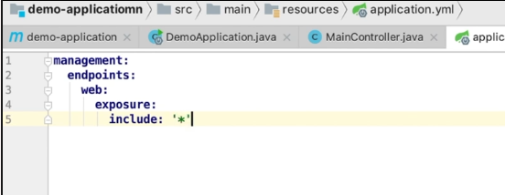

so now beans,metrics(lots of information)
dont do but ThreadDump and HeapDump is ok

Create Our Own Actuater Endpoint

Jpa and databases spring

how to make model class a entity class

@Entity
public class Student {
@Id
@GeneratedValue(strategy = GenerationType.AUTO)
private Integer id;
private String lastName;
private String firstName;
public Integer getId() {
return id;
}
public void setId(Integer id) {
this.id = id;
}
public String getLastName() {
return lastName;
}
public void setLastName(String lastName) {
this.lastName = lastName;
}
public String getFirstName() {
return firstName;
}
public void setFirstName(String firstName) {
this.firstName = firstName;
}
}

and yml file should be like this

spring:
datasource:
url: jdbc:mysql://localhost:3306/jpaX?createDatabaseIfNotExist=true
username: root
password: root
driver-class-name: com.mysql.jdbc.Driver
jpa:
hibernate:
naming:
physical-strategy: org.hibernate.boot.model.naming.PhysicalNamingStrategyStandardImpl
ddl-auto: 'create'

naming strategey mean all ways use our given names without putting default values

ddl-auto

For the record, the spring.jpa.hibernate.ddl-auto property is Spring Data JPA specific and is their way to specify a value that will eventually be passed to Hibernate under the property it knows, hibernate.hbm2ddl.auto.
The values create, create-drop, validate, and update basically influence how the schema tool management will manipulate the database schema at startup.
For example, the update operation will query the JDBC driver's API to get the database metadata and then Hibernate compares the object model it creates based on reading your annotated classes or HBM XML mappings and will attempt to adjust the schema on-the-fly.
1.
The update operation for example will attempt to add new columns, constraints, etc but will never remove a column or constraint that may have existed previously but no longer does as part of the object model from a prior run.

2.
Typically in test case scenarios, you'll likely use create-drop so that you create your schema, your test case adds some mock data, you run your tests, and then during the test case cleanup, the schema objects are dropped, leaving an empty database.

3.
In development, it's often common to see developers use update to automatically modify the schema to add new additions upon restart. But again understand, this does not remove a column or constraint that may exist from previous executions that is no longer necessary.
4.
In production, it's often highly recommended you use none or simply don't specify this property. That is because it's common practice for DBAs to review migration scripts for database changes, particularly if your database is shared across multiple services and applications.

Sumarry
hibernate.hbm2ddl.auto Automatically validates or exports schema DDL to the database when the SessionFactory is created. With create-drop, the database schema will be dropped when the SessionFactory is closed explicitly.
e.g. validate | update | create | create-drop
So the list of possible options are,

- validate: validate the schema, makes no changes to the database.

- update: update the schema.

- create: creates the schema, destroying previous data.

- create-drop: drop the schema when the SessionFactory is closed explicitly, typically when the application is stopped.

- none: does nothing with the schema, makes no changes to the database

Config Server(configuration store locally or repo)

In here we going to make a configuration service but with two storages one with local storage and other with git hub (repository) aka-config server+configuration store(local or repo)

Spring boot get configuration default by

classpath
resource dir
resource/config
current dir

local config
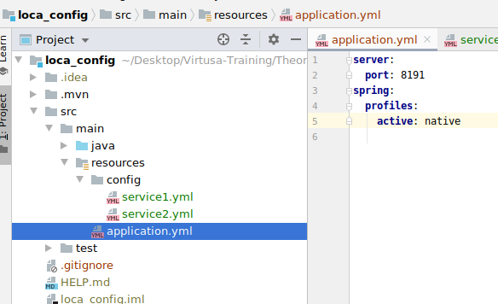

remember to add EnableConfigServer annotation to the
spring boot application

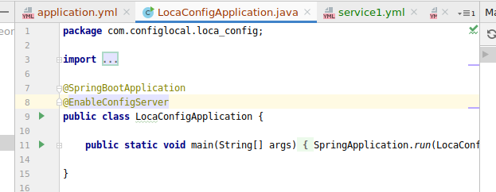
and set yml default file like this in next git configuration we going to set defferently.
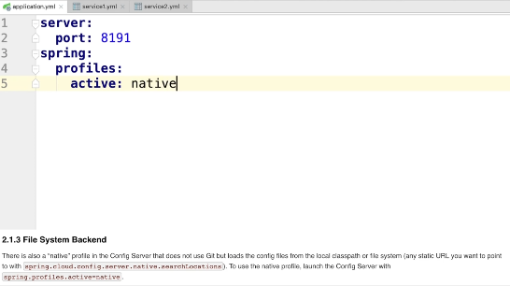

then access the config servers like this
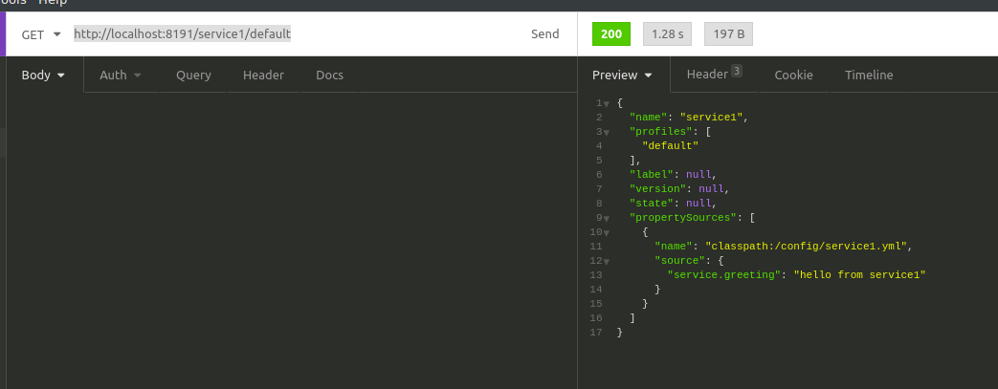
http://localhost:8191/service1/default

when we send the request to that spring auto added that properties to classpath
when requesting- http://localhost:8191/service1/default

2020-07-06 11:25:57.854 INFO 14133 --- [nio-8191-exec-6] o.s.c.c.s.e.NativeEnvironmentRepository : Adding property source: classpath:/config/service1.yml

when requesting-
http://localhost:8191/service2/default

2020-07-06 11:29:00.102 INFO 14133 --- [nio-8191-exec-9] o.s.c.c.s.e.NativeEnvironmentRepository : Adding property source: classpath:/config/service2.yml

Git backed config server
First we want to make the repo my one is like below.
the important fact to remember is although dir name not same as service name.but service name should follow following rules .But its a good practice to make dir also in service name for increased readability.

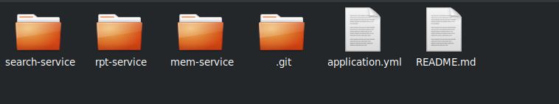

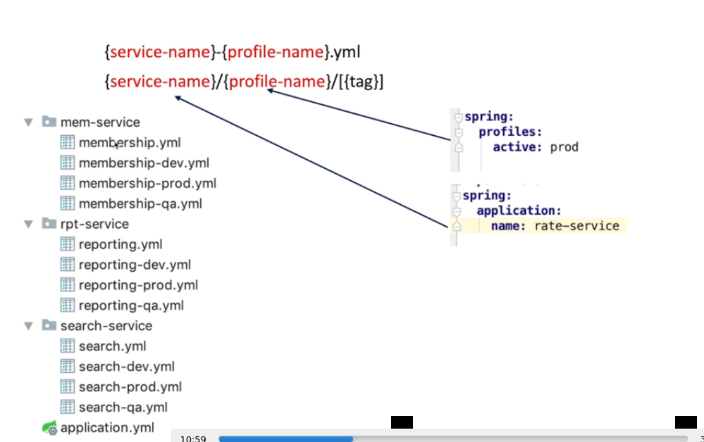

application.yml is the default
after that in project yml we must specify the uri
of the git we put configurations.

Take note dont put with .git we just need url

ok-https://github.com/ishanRox/spring-cloud-config-store

not ok- https://github.com/ishanRox/spring-cloud-config-store.git
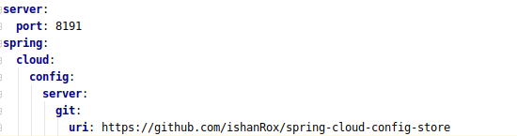

above is a public repo if this is a private repo u can specify by adding username and password
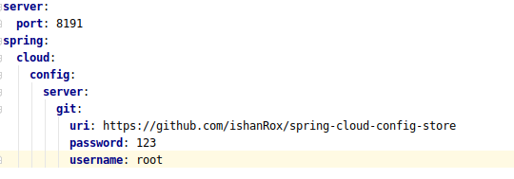

but Still there is a problem no matter what u call u get only one file with above configuration we will check

solution is add search paths:
we need to tell how to search in repos
so in our configuration we tell config to go inside dir which ends with “service” because out dir is made like mem-service,rpt-service...

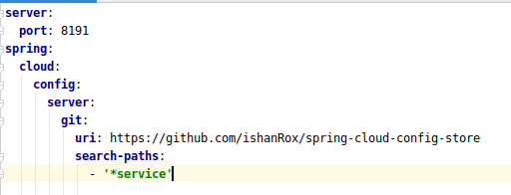

so now we can get related files

How calling of these services work

http://localhost:8191/{service name}/{profile name}

1. If you gave a wronge name for both service and profile or service it gives only default application.yml
here no service called account.
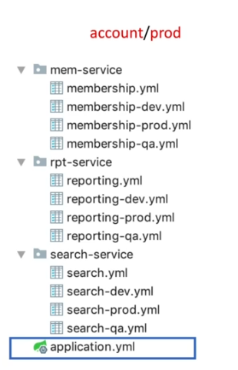

2.If you called service/default then it will return global default and default config inside the requested service.

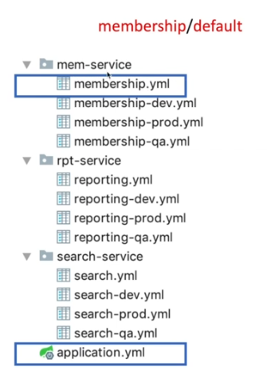

3.If you requested valid service/profile you will given global config , service-default config , and exact requested config (3 files).

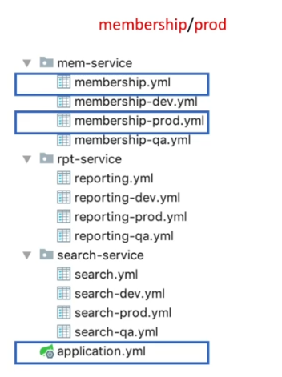

4.If requested service is valid but profile is wronge in that case repo dont have the exact file but gives the global defaule config and service-default config.
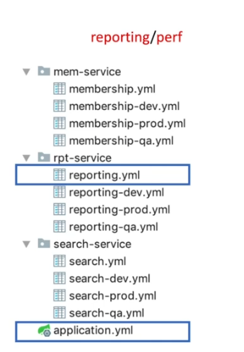

You can call this configuration as .yml and json also

http://localhost:8191/reporting-dev.yml
http://localhost:8191/reporting-dev.json

Making a service to consume configuration from this config server

1.You crate a spring boot application and set application.yml like this to get configuration from git config server that we made.

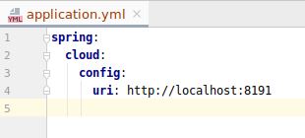

2.But because we didnt specify the exact port where to find configuration server it looks for default config server port and its set to 8888.

3.To fix this we must remember one thing that is spring fetch configuration before processing of application.yml .So the solution is to make boostrap.yml.

4, so in yml you need to specify which profiles configuration we want to load
in real life we dont hard code this but we change this dynamicaly.
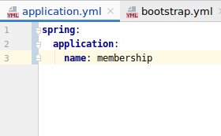

5.And in boostrap.yml we need to specify the config server.
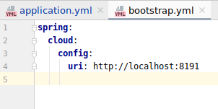

Remember not to set config server and pulled config not haing the same port.

Production Ready application

Vehicle rent programme(Rent cloud)

1.customer model application (not a spring boot ) but classic maven one(to avoid model customer in every project)

So we make this maven model class project and give that dependency to our other spring boot projects.
If we add common dependencies to this you dont have to re add dependencies to other projects (because of transitive dependencies)
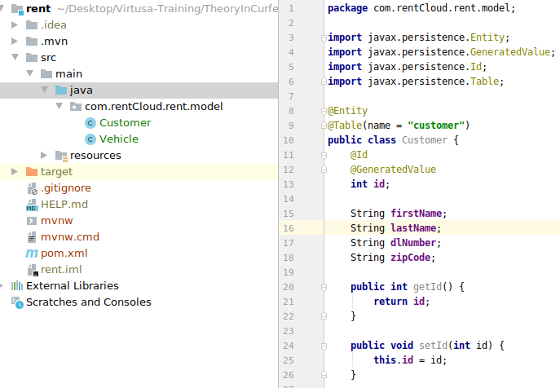

1. The project is only with models and this is tacken as dependency to other projects so we dont have to add dependency needed for these to others.

2. Then we make the rentCloudApp and refer this rent from that service we have to add rent apps dependency to rentCloudApp. (rent is just a maven project that give model data)
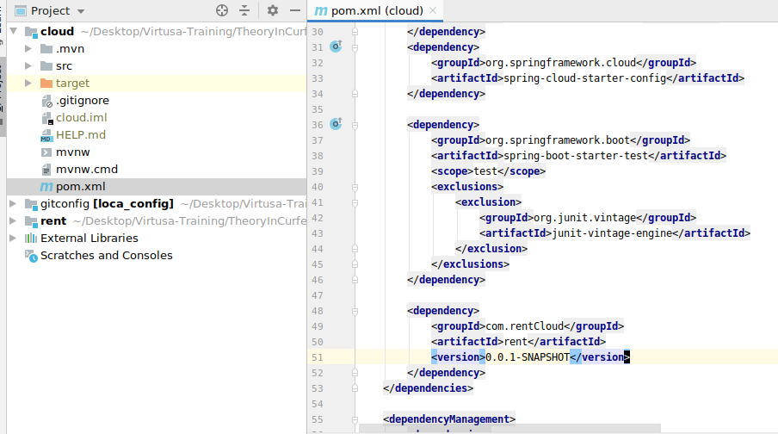

3. Now connect git backed server to this rentCloudApp .

In intelij go to
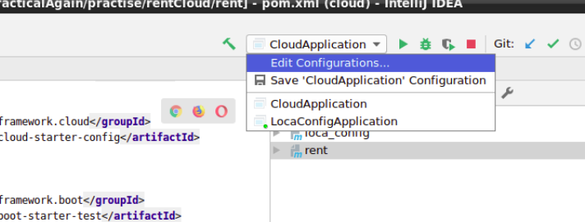

And set active profile
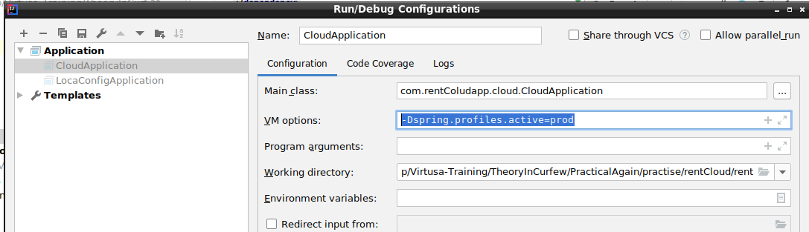

And set name of the application
so git-config calls by
(same as git name)
ApplicaitonName/active profile
memebership/prod
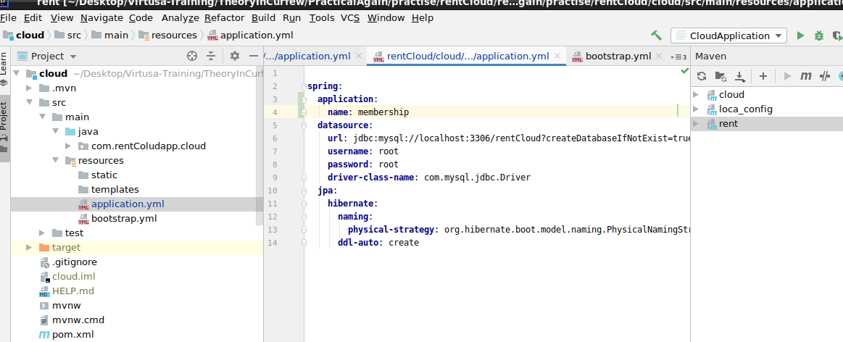

when its correctly done it download 3 files as default config, membership ,prod config

2020-07-18 23:57:42.155 INFO 25555 --- [ main] c.c.c.ConfigServicePropertySourceLocator : Located environment: name=membership, profiles=[prod], label=null, version=77f0a48e5df94805cf18cb8a8b6e041b90434797, state=null
2020-07-18 23:57:42.161 INFO 25555 --- [ main] b.c.PropertySourceBootstrapConfiguration : Located property source: [BootstrapPropertySource {name='bootstrapProperties-configClient'},
BootstrapPropertySource {name='bootstrapProperties-https://github.com/ishanRox/spring-cloud-config-store/mem-service/membership-prod.yml'},
BootstrapPropertySource {name='bootstrapProperties-https://github.com/ishanRox/spring-cloud-config-store/mem-service/membership.yml'},
BootstrapPropertySource {name='bootstrapProperties-https://github.com/ishanRox/spring-cloud-config-store/application.yml'}
]

If you can remember we add plain maven project dependencies to our project but when scanning for beans sprig boot check only for our package to add scan other project we add EntityScan to our

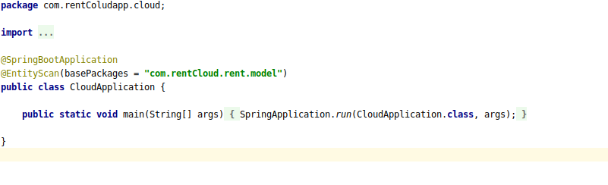

Securing Microservices

So our previouse services can access by any one
today we going to make these services secure and restrict access.

Oauth

Authentication is who u are

Autherization is what u can do (Apple Autherized dealers they are authorized to *DEAl*)
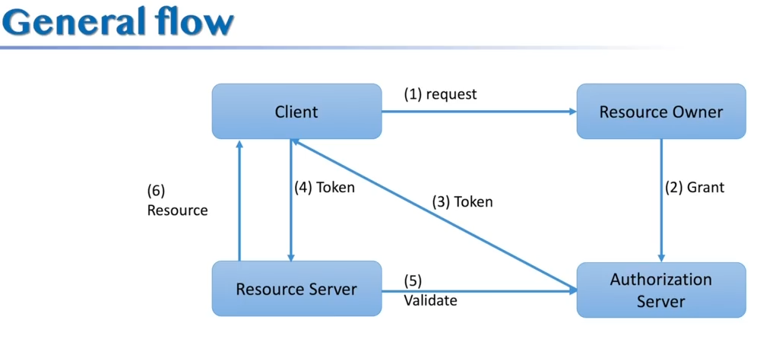
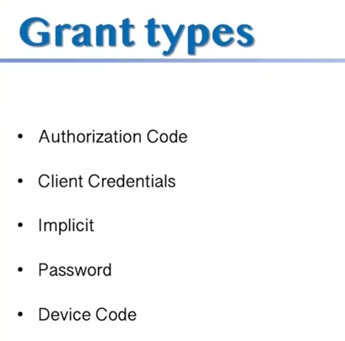
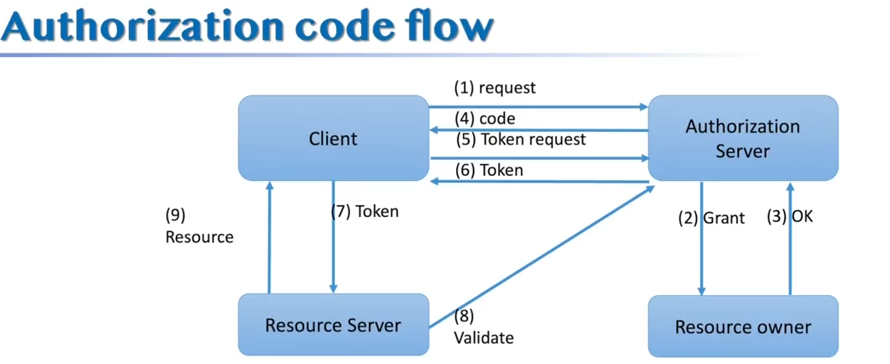

Its very easy to make Oauth server in spring boot

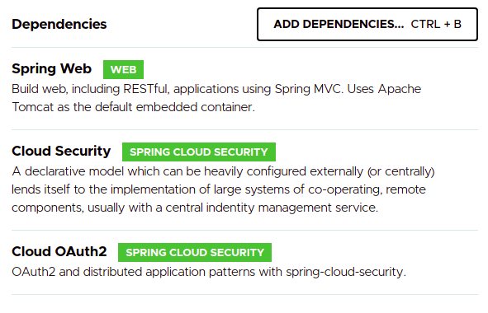

we need these dependencies to make oauth in spring boot and add @EnableAuthServer server thats it.

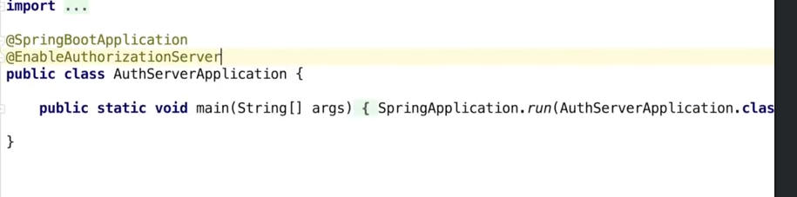

In this first app we just hard code client applications and there client id and secrets in professional and up coming service we can dynamicaly give and register apps to our authentication server .

IN GIT HUB IT(client id and secret) LOOKS LIKE THIS

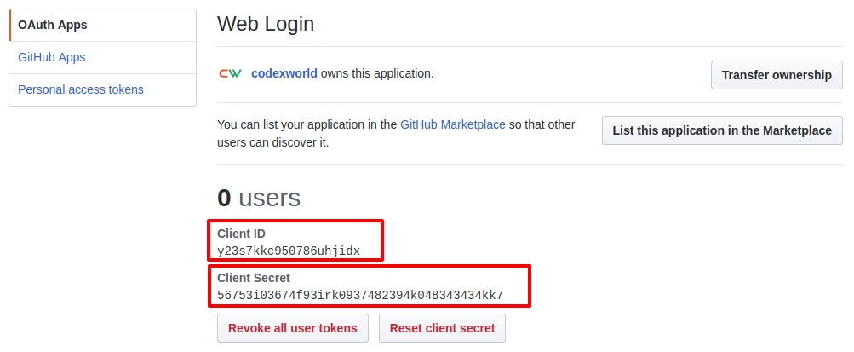

But in our app we going to hard code our client app

server:
port: 8282
spring:
security:
user:
name: ishan
password: ishan123
roles: ADMIN,USER
security:
oauth2:
client:
client-id: mobile
client-secret: pin
access-token-validity-seconds: 3600
authorized-grant-types: refresh_token,authorization_code,password,client_credentials
scope: READ,WRITE

when we run the service these are the steps

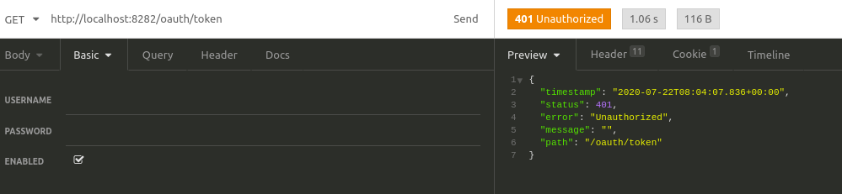
add the client-id and password
client-id: mobile
client-secret: pin

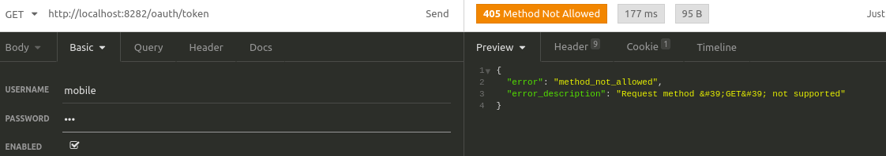

ok it didnt worked we will try by post -it worked but it says missing grant type
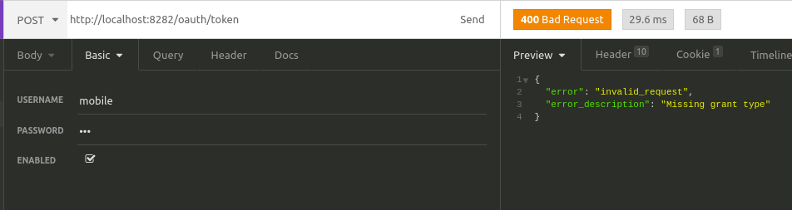

Then add url encoded form and add username and password
spring:
security:
user:
name: ishan
password: ishan123
roles: ADMIN,USER
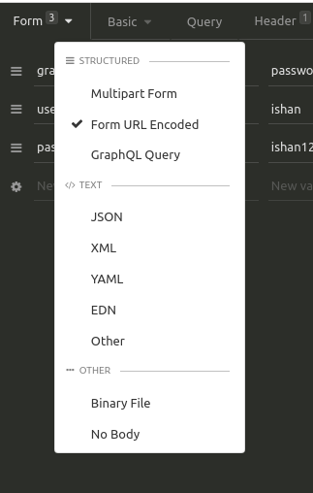

AH Voila it worked finally :-)
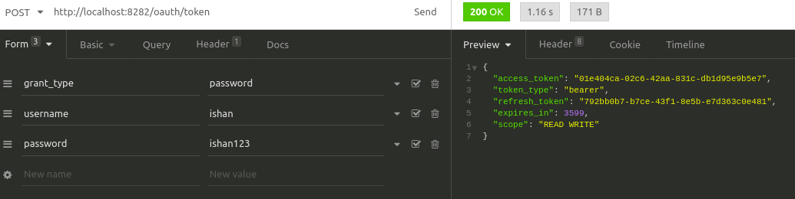
when token expires we can refresh it by our refresh token

Now we can check token but its forbidden because in newer spring security version checking is forbidden

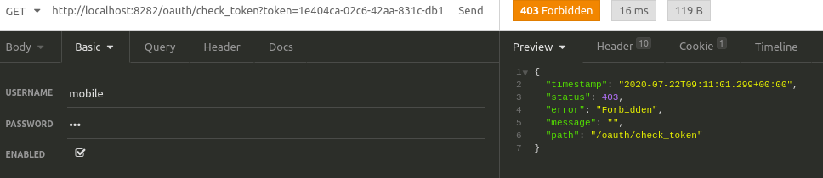

So we going to set check permit all
server:
port: 8282
spring:
security:
user:
name: ishan
password: ishan123
roles: ADMIN,USER
security:
oauth2:
client:
client-id: mobile
client-secret: pin
access-token-validity-seconds: 3600
authorized-grant-types: refresh_token,authorization_code,password,client_credentials
scope: READ,WRITE
authorization:
check-token-access: permitAll
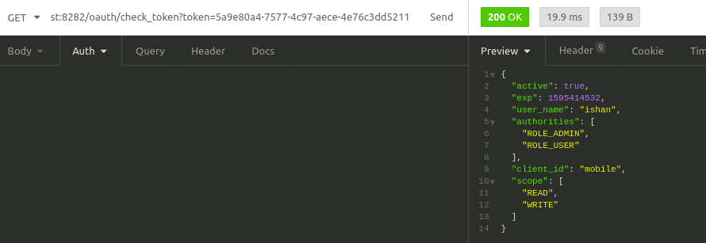

Is it ok to make this configuration in java without putting it to yml ?

Yes its ok and it provide more flexibility to our code
server:
port: 8282
spring:
security:
user:
name: ishan
password: ishan123
roles: ADMIN,USER
security:
oauth2:
client:
client-id: mobile
client-secret: pin
access-token-validity-seconds: 3600
authorized-grant-types: refresh_token,authorization_code,password,client_credentials
scope: READ,WRITE
authorization:
check-token-access: permitAll
And making it with java we can seperately give auth server lojic and client lojic
AuthServer
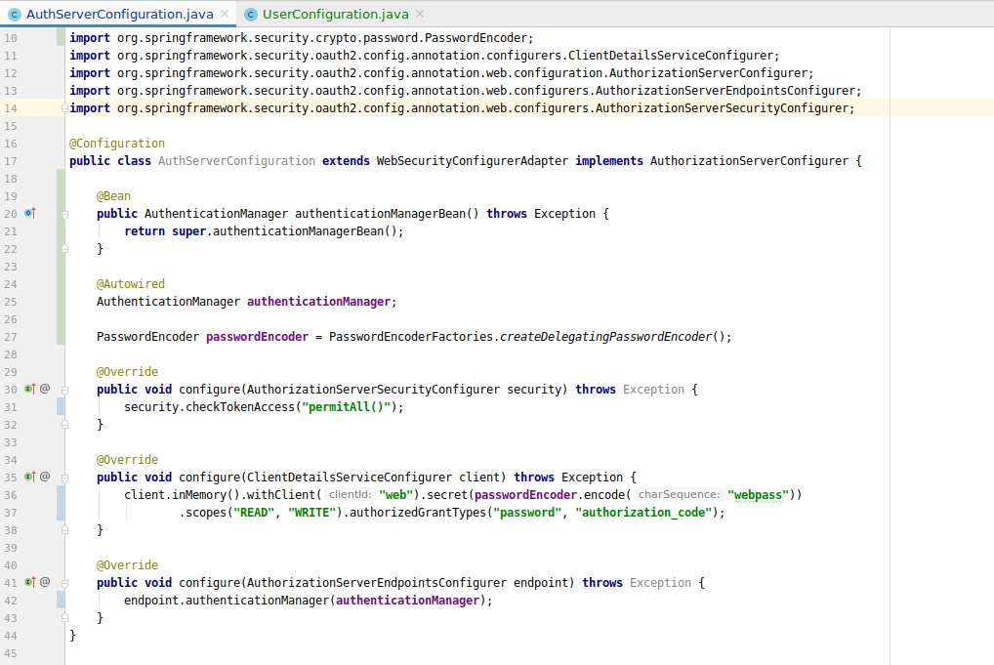

UserConfig

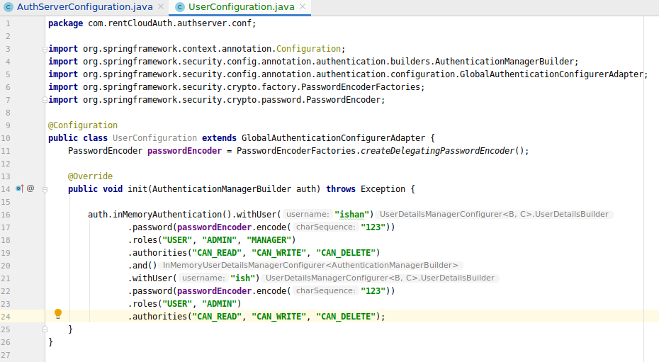

IMPORTANT TO NOTICE FOR UNDERSTANDING OAUTH2

https://www.codeproject.com/Articles/1171546/OAuth-Authorization-flows-explained-with-examples

https://www.javainuse.com/spring/springboot-oauth2-password-grant

https://developer.okta.com/blog/2018/06/29/what-is-the-oauth2-password-grant

The OAuth 2.0 Password Grant
The Password grant is one of the simplest OAuth grants and involves only one step: the application presents a traditional username and password login form to collect the user’s credentials and makes a POST request to the server to exchange the password for an access token. The POST request that the application makes looks like the example below
(application ekai server ekai ekama devla haduwoth thama meka danna ona palleha eka kiyawanna ).

a best explanation - https://developer.okta.com/blog/2018/06/29/what-is-the-oauth2-password-grant

When to use the Password Grant Type?
The Password grant requires that the application collect the user’s password. This is of course the exact problem that OAuth was created to avoid in the first place. So why is the Password grant included as part of OAuth?
While a service should never let a third party developer use the Password grant, it is quite reasonable for a service’s own application to ask the user to enter their password. For example, if you download Twitter’s mobile app, you wouldn’t be surprised if the first thing it does when you launch is ask for your Twitter password. In contrast, if you download a third-party Gmail app, it should use Google’s OAuth server rather than ask you to enter your Gmail password.
The benefit of this grant type is that it lets the application take advantage of the rest of the benefits that OAuth provides around access tokens and token lifetimes. Instead of storing the user’s password on the device, the application only has to touch the user’s password for as long as it takes to get the access token, then it can store and use the access token instead.

POST /oauth/token HTTP/1.1
Host: authorization-server.com
Content-type: application/x-www-form-urlencoded

grant_type=password
&username=exampleuser
&password=1234luggage
&client_id=xxxxxxxxxx
The POST parameters in this request are explained below.
- grant_type=password - This tells the server we’re using the Password grant type
- username= - The user’s username that they entered in the application
- password= - The user’s password that they entered in the application
- client_id= - The public identifier of the application that the developer obtained during registration from oauth2 server
- client_secret= - (optional) - If the application is a “confidential client” (not a mobile or JavaScript app), then the secret is included as well.which obtain from server.
- scope= - (optional) - If the application is requesting a token with limited scope, it should provide the requested scopes here.

Best analogy ever

Analogy terms :
Mother : User of the application.

Father : User’s signed up account site.( OAuth provider )

Son : Third party client , aka owner of the application.( OAuth client )

Imagine that your mom wants some grocery from market and she wants you to buy it for her.
Here’s the conversation which will explain you the meaning OAuth in layman terms :

Mother: Hey son, go to market and bring me some caffeine. Take the required money from your father.

Son: Okay.
>>(Son( our third party site ) goes to father( OAuth provider ).)
Son: Hey dad, Mom told me to take money from you since she wants some things from market.
>>(Father( OAuth provider ) asks mother( User ) about the permission to give money to their son( OAuth client ))

Father: Hey, Shall I give him money ? and how much? ( Authorization of your application takes place here. )

Mother: Yes, give him. ( Permission grant by mother aka ‘User’ )
>>( Son gets the required things from market and returns them to mom )
>> Here returning things to mother can be thought of redirecting the user( or logging him in specifically ) to the third party site.

https://medium.com/@lunaticmonk/oauth-explained-with-real-life-example-f0386ad63637

https://www.varonis.com/blog/what-is-oauth/

summary
https://swagger.io/docs/specification/authentication/oauth2/

- Authorization code – The most common flow, mostly used for server-side and mobile web applications. This flow is similar to how users sign up into a web application using their Facebook or Google account.
- Implicit – This flow requires the client to retrieve an access token directly. It is useful in cases when the user’s credentials cannot be stored in the client code because they can be easily accessed by the third party. It is suitable for web, desktop, and mobile applications that do not include any server component.
- Resource owner password credentials (or just password) – Requires logging in with a username and password. Since in that case the credentials will be a part of the request, this flow is suitable only for trusted clients (for example, official applications released by the API provider).
- Client Credentials – Intended for the server-to-server authentication, this flow describes an approach when the client application acts on its own behalf rather than on behalf of any individual user. In most scenarios, this flow provides the means to allow users specify their credentials in the client application, so it can access the resources under the client’s control.

Our Production ready server which have mysql database

first we must make the database according to format given by spring doc-schema.sql and data.sql after configuring we must rename data.sql to data.txt because if we going to add our operator and adming twise there going to be primary key conflicts
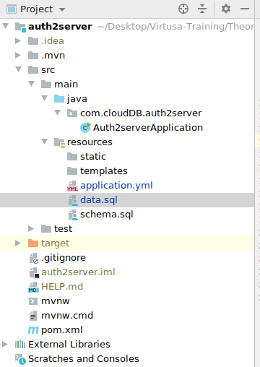
.so we rename and avoid adding data to database
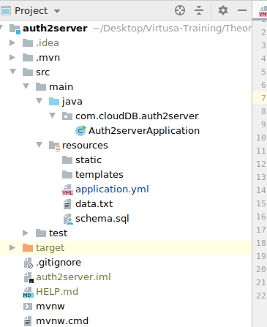

you get this error if u restart service without renameing the data.sql to data.txt
