Node.js® is a JavaScript runtime built on Chrome's V8 JavaScript engine.

Getting Started with Node

So, in this section, you learned that:

- Node is a runtime environment for executing JS code.

- Essentially, Node is a C++ program that embeds Chrome’s v8 engine, the fastest
JS engine in the world.

- We use Node to build fast and scalable networking applications. It’s a perfect
choice for building RESTful services.

- Node applications are single-threaded. That means a single thread is used to
serve all clients.

- Node applications are asynchronous or non-blocking by default. That means
when the application involves I/O operations (eg accessing the file system or the
network), the thread doesn’t wait (or block) for the result of the operation. It is
released to serve other clients.

- This architecture makes Node ideal for building I/O-intensive applications.

- You should avoid using Node for CPU-intensive applications, such as a video
encoding service. Because while executing these operations, other clients have
to wait for the single thread to finish its job and be ready to serve them.
- In Node, we don’t have browser environment objects such as window or the
document object. Instead, we have other objects that are not available in
browsers, such as objects for working with the file system, network, operating
system, etc.

NODE MODULES


we need modularity to seperate and maintain our code base

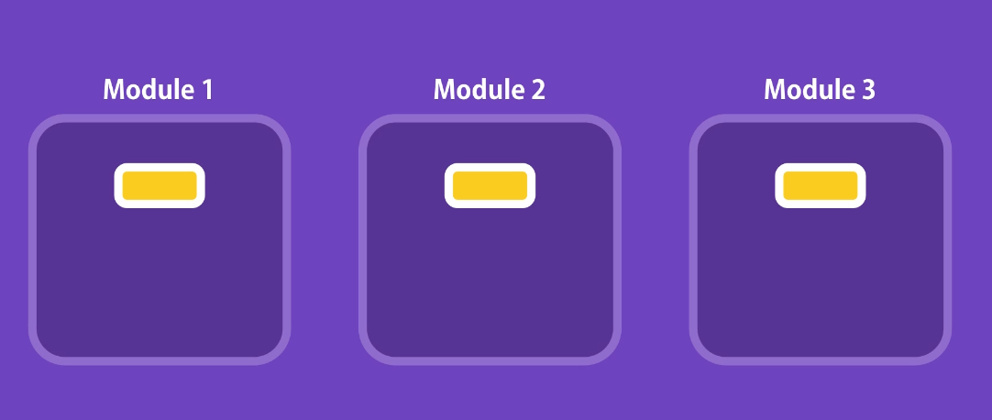
so 2 variables/functions with same name in different modules dont make conflicts and override them.

Node has variouse modules before using them u need to import and make them accessible for your module ur module is main module currently that u working.

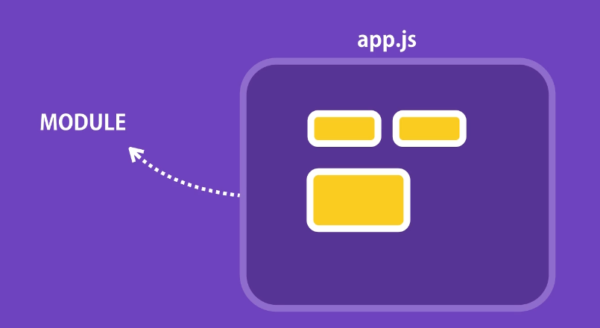

Creating a module

var and functions normally in our module is private but if we add them to export in module they become public to other modules.
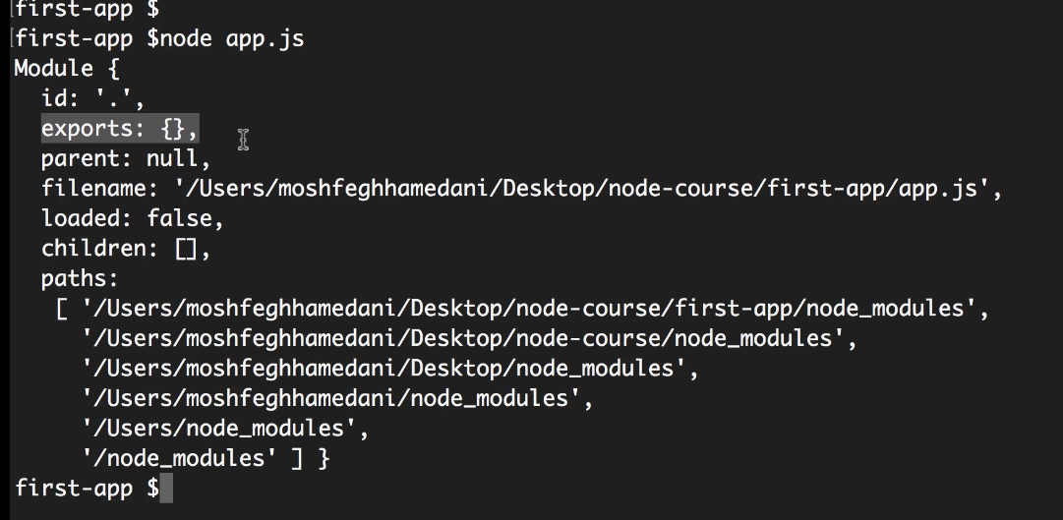

Addto eneeded to export module and u can access them in other modules
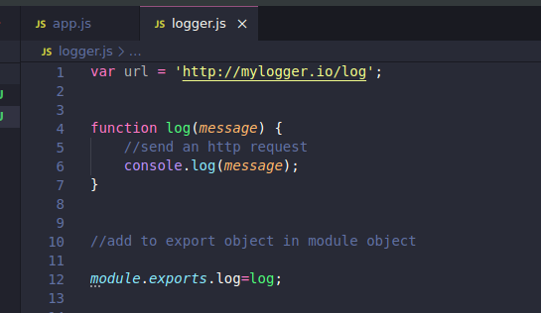

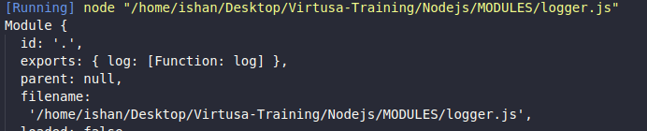
loading the added module

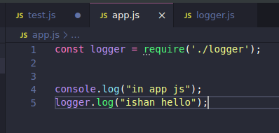

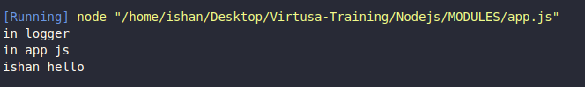

so variables and functios are private to that module they are not visible to others we need to require them how node does this ?


They doing it by

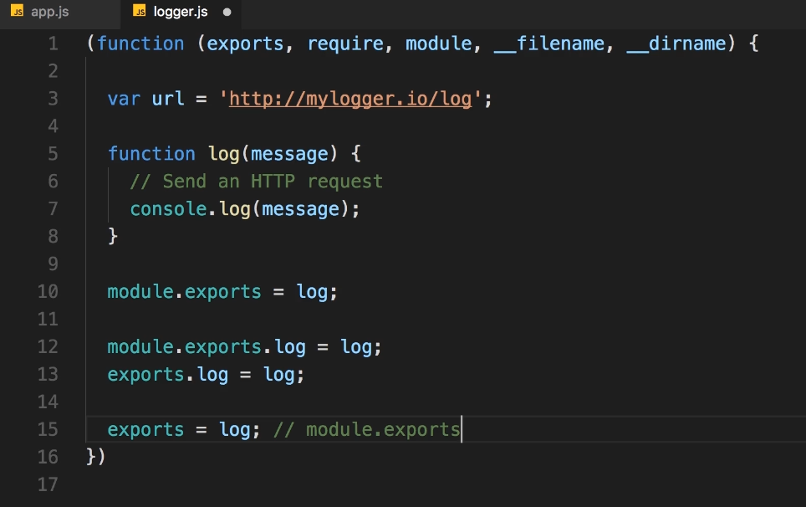
WRONGE

You can assign function to module.export but not to export why ?

Its because of the implementation
https://stackoverflow.com/questions/15908399/node-js-module-exports-assignment-resulting-in-method-undefined-error

var module = { exports: {} };
var exports = module.exports;

exports = { test: 'test' };

console.log(exports); // { test: 'test' }
console.log(module.exports); // {}
When require() looks for what to include, it uses module.exports

This is also important how this behave in node

https://stackoverflow.com/questions/43627622/what-is-the-global-object-in-nodejs#:~:text=While%20in%20browsers%20the%20global,be%20local%20to%20this%20module.

UseFull modules in node (like usefull packages in java)

