**Examples**

Given the string foobarbarfoo:

bar(?=bar) finds the 1st bar ("bar" which has "bar" after it)

bar(?!bar) finds the 2nd bar ("bar" which does not have "bar" after it)

(?<=foo)bar finds the 1st bar ("bar" which has "foo" before it)

(?<!foo)bar finds the 2nd bar ("bar" which does not have "foo" before it)

You can also combine them:

(?<=foo)bar(?=bar) finds the 1st bar ("bar" with "foo" before it and "bar" after it)

**Definitions**

Look ahead positive (?=)

Find expression A where expression B follows:

A(?=B)

Look ahead negative (?!)

Find expression A where expression B does not follow:

A(?!B)

Look behind positive (?<=)

Find expression A where expression B precedes:

(?<=B)A

Look behind negative (?<!)

Find expression A where expression B does not precede:

(?<!B)A

Atomic groups (?>)

An atomic group exits a group and throws away alternative patterns after the *first* matched pattern inside the group (backtracking is disabled).

* (?>foo|foot)s applied to foots will match its 1st alternative foo, then fail as s does not immediately follow, and stop as backtracking is disabled

A non-atomic group will allow backtracking; if subsequent matching ahead fails, it will backtrack and use alternative patterns until a match for the entire expression is found or all possibilities are exhausted.

* (foo|foot)s applied to foots will:
  1. match its 1st alternative foo, then fail as s does not immediately follow in foots, and backtrack to its 2nd alternative;
  2. match its 2nd alternative foot, then succeed as s immediately follows in foots, and stop.

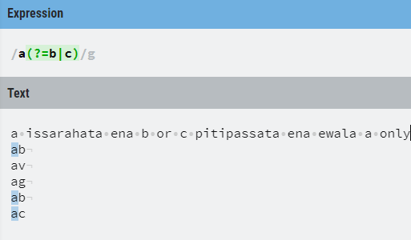

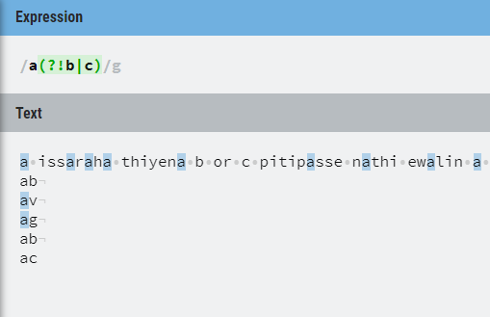

**ALL IN ONE**

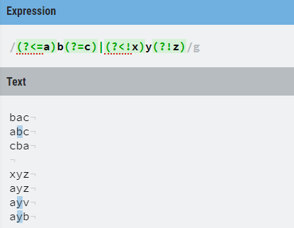

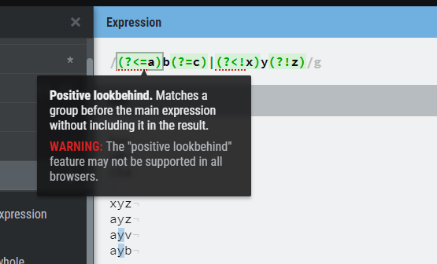

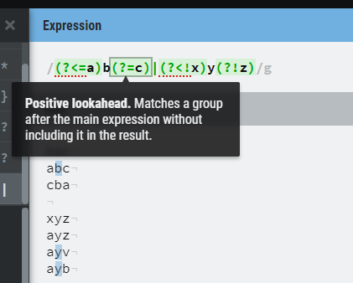

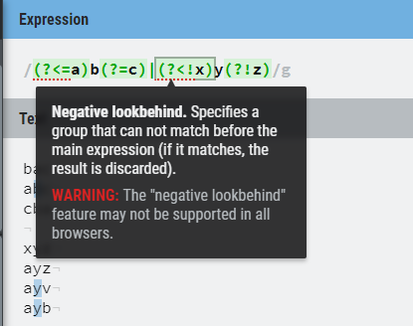

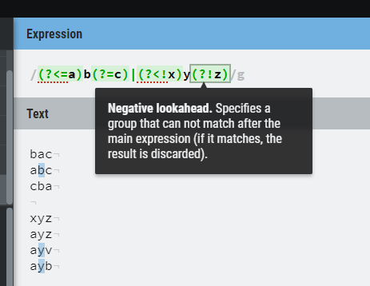

**(?: )=froget me 😊**

It means **only group** but do not remember the grouped part.

By default ( ) tells the regex engine to remember the part of the string that matches the pattern between it. But at times we just want to group a pattern without triggering the regex memory, to do that we use (?: in place of (

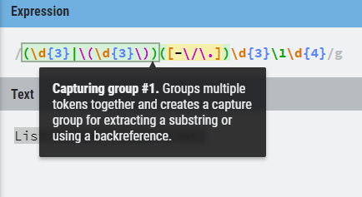

**Ignore the group by using ?:**

