Make a Promise but make it wise
In old days we have used callbacks then .then then now async await

problamatic code

//mimic the server behaviour
const posts = [
{ title: 'post one ', body: 'this is post one' },
{ title: 'post two ', body: 'this is post two ' }
];

function getPosts() {
setTimeout(_ => {
let output = '';
posts.forEach((post, index) => {
output += `<li>${post.title}</li>`;
});
console.log('result given by server');
document.body.innerHTML = output;
}, 1000);
}

function createPost(post) {
setTimeout(_ => {
posts.push(post);
console.log('post created');
}, 2000);
}

//mimic the server ends

//send a get request take 1s
//getPosts();
//send create request take 2s
//createPost({ title: 'post three new ishan', body: 'This is post 3' })

//because it takes only 1 s to get and 2 s to create result get first and after 1s only post added

//send create request take 2s
createPost({ title: 'post three new ishan', body: 'This is post 3' });

getPosts();

so we going to resolve this problem step by step

1. In here we make a fake server that create and give posts
we can call it and get posts and create posts problem is
getiing takes 1 second and creating posts takes 2 s .

no matter if we call get first and create second or create
first and get second(because 2 calls happen In same time) we get “get” result early and newly created post is not there.

This is the problem.

//send a get request take 1s
getPosts();
//send create request take 2s
createPost({ title: 'post three new ishan', body: 'This is post 3' })

To solve it ugliest way possible we can always check weather post is created and if created get the results(for this we must return something from server ‘ok message’ or some code but it also need wait until post add to array) or make a delay(im doing this).

We cant make delay using setTimeout and setInterval because they both are async methods which runs in background.

https://stackoverflow.com/questions/17883692/how-to-set-time-delay-in-javascript

So lord ishan make a for loop that run many times 1e7== large number and give a sleep time and check it with our current time,we can give a while true loop too or ugly ;; trick in for loop.

createPost({ title: 'post three new ishan', body: 'This is post 3' });

function sleep(milliseconds) {
var start = new Date().getTime();
while(true){
if ((new Date().getTime() - start) > milliseconds) {
break;
}
}
}

sleep(5000);

getPosts();

so now we can get all post with newly added posts because we wait(some time) but we dont know how much time we must wait its disgusting we imagine and add 5 seconds what happens if it takes more than 5 or less than 5 seconds ?

So we must use callback functions if we dont know the time the process going to be competed

so Im going to change the server createPost method to accept a function(yse now createPost is a higher order function) so after 2 seconds post added to the array and method passed called

function createPost(post, callback) {
setTimeout(_ => {
//both of this will happen after 2 seconds(adding posts and call callback)
posts.push(post);
console.log('post created');
//now we can call our callback
console.log('callback called');
callback();
}, 2000);
}

//mimic the server ends

//send a get request take 1s
//getPosts();
//send create request take 2s
//createPost({ title: 'post three new ishan', body: 'This is post 3' })

//because it takes only 1 s to get and 2 s to create result get first and after 1s only post added

//callback solution is here we pass getPost as a callback (remember we pass only the reference)
createPost({ title: 'post three new ishan', body: 'This is post 3' }, getPosts);

ok our word done it shows all of the posts



So Insted of callbacks we now use promises and its cool and
promising

now instead of getting a method and calling it we return a javascript promise to it .so we remove the callback from
createPost method and add a promise

promise consist of resolve and reject object reject carries a error object and resolve contains the resolved data.

Read about promises

https://developer.mozilla.org/en-US/docs/Web/JavaScript/Guide/Using_promises

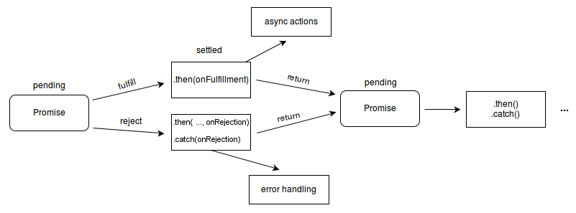

Promise object takes a callback function with (resolve,reject) and the modified code looks like this.

function createPost(post) {

return new Promise((resolve, reject) => {

setTimeout(_ => {

posts.push(post);

const error = false;

if (!error) {
resolve(‘success’);
} else {
reject('Error: something went wronge');
}

}, 2000);
});

}

//mimic the server ends

//send a get request take 1s
//getPosts();
//send create request take 2s
//createPost({ title: 'post three new ishan', body: 'This is post 3' })

//because it takes only 1 s to get and 2 s to create result get first and after 1s only post added

//callback solution is here we pass getPost as a callback (remember we pass only the reference)
createPost({ title: 'post three new ishan', body: 'This is post 3' }).then(
_ => {
console.log('after calling of unknown time function createPost');

getPosts()
}
);

we can directly assign the funtion like this too

createPost({ title: 'post three new ishan', body: 'This is post 3' }).then(getPosts);

And we can add data to success object and get that data from .then if no data and we try to get like a fool undifined occur

createPost({ title: 'post three new ishan', body: 'This is post 3' }).then(
(data) => {
console.log('okk');
console.log(data);
}
).catch(err => console.log(err));

if some error occure we can catch it through catch

promise.all()

The Promise.all() method takes an iterable of promises as an input, and returns a single Promise that resolves to an array of the results of the input promises. This returned promise will resolve when all of the input's promises have resolved, or if the input iterable contains no promises. It rejects immediately upon any of the input promises rejecting or non-promises throwing an error, and will reject with this first rejection message / error.
It is typically used when there are multiple asynchronous tasks that are dependent on one another to complete successfully, as it does not wait and will reject immediately upon any of the input promises rejecting.
In comparison, the promise returned by Promise.allSettled() will wait for all input promises to complete, regardless of whether or not one rejects. Consequently, it will always return the final result of every promise and function from the input iterable.
If one of the Promises rejects, the Promise.all will reject with a value of the rejection, but Promise.allSettled will resolve with an object of { status: 'rejected', reason: <error> } at that place in the array.
https://stackoverflow.com/questions/59784175/differences-between-promise-all-and-promise-allsettled-in-js

Promise.all([Promise.reject(1), Promise.resolve(2)])
.catch((err) => {
console.log('err', err);
});

Promise.allSettled([Promise.reject(1), Promise.resolve(2)])
.then(console.log);

Simple example

const promise1 = Promise.resolve('hello world');
const promise2 = 10;
const promise3 = new Promise((resolve, reject) => {
//this is same as resolve('Goodbye') setTimeout can take a method and pass para to it
setTimeout(resolve, 5000, 'Goodbye');
});
//const promise4 = fetch('https://jsonplaceholder.typicode.com/users'); not work in node cause node havent fetch()

//so to complete this it takes the longest time taken by promise amonge given in here 5 s
Promise.all([promise1, promise2, promise3]).then(val => console.log(val)).catch(console.log);

//with error (see the majic error viewed first and correct one give result this is becuase .
//all immediately go to catch if one fails)
Promise.all([promise1, promise2, promise3, Promise.reject('error happen')]).then(val => console.log(val)).catch(console.log);

//if we want to get result although one or more fails
Promise.allSettled([promise1, promise2, promise3, Promise.reject('error happen')]).then(val => console.log(val)).catch(console.log);

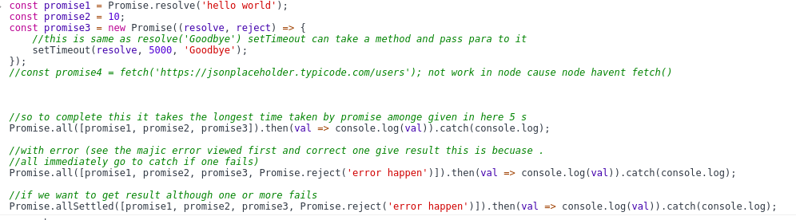
Output

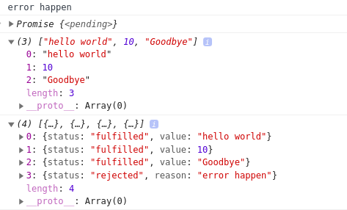

nice chrome shows us the pending promise part too

see .all gives array because it sure all are done
.allSettled give object with fulfilled state
last object of our array is not fulfilled(rejected).

Async await

no matter how good we expect more so this is it callbacks and promises are good but it leads to callback hell and if we want more tasks that depend on each other we use this .

async function init() {
//we telling wait untill createPost get result
await createPost({ title: 'post three new ishan', body: 'This is post 3' });
getPosts();

}

init();

iife method with asynch await

(async function () {
const request = await fetch('https://jsonplaceholder.typicode.com/users');
//we must get json again by fetch (little weird fetch api)
const data = await request.json();

const request2 = await (await fetch('https://randomuser.me/api/?results=1')).json();

console.log(data);
console.table(request2.results[0]);
})();

Promice .race

promise .race all about who wins first resolve or rejected it dosent matter slower ones rejected

//1st schenario
const promiseArray = [
new Promise((resolve, reject) => setTimeout(resolve, 1000, "one"))
,
new Promise((resolve, reject) => setTimeout(resolve, 2000, "two"))
,
new Promise((resolve, reject) => setTimeout(resolve, 3000, "three"))
,
new Promise((resolve, reject) => setTimeout(resolve, 4000, "four"))
];

//this takes 4 seconds because it wait till longest one completes
Promise.all(promiseArray).then(console.log).catch(error => console.log(`error happens in ${error}`));

//race is a race between promises it takes firstly completed one
Promise.race(promiseArray).then(console.log).catch(
(error) => console.log('error happens in ' + error)
);

//2nd schenario one promise rejected
const promiseArray1 = [
new Promise((resolve, reject) => setTimeout(resolve, 1000, "one"))
,
new Promise((resolve, reject) => setTimeout(resolve, 2000, "two"))
,
new Promise((resolve, reject) => setTimeout(reject, 3000, "three"))
,
new Promise((resolve, reject) => setTimeout(resolve, 4000, "four"))
];

//this takes 4 seconds because it wait till longest one completes
Promise.all(promiseArray1).then(console.log).catch(error => console.log(`error happens in ${error}`));

//race is a race between promises it takes firstly completed one
Promise.race(promiseArray1).then(console.log).catch(
console.log
);
//it donsent matter if it send a reject to other late ones it still gives first one no matter what happen to others
//apayata unath kalin yana scen eke porak race

//3nd schenario receving promise rejected(firstly finished promise or winner of the race)
const promiseArray1 = [
new Promise((resolve, reject) => setTimeout(reject, 1000, "one"))
,
new Promise((resolve, reject) => setTimeout(resolve, 2000, "two"))
,
new Promise((resolve, reject) => setTimeout(resolve, 3000, "three"))
,
new Promise((resolve, reject) => setTimeout(resolve, 4000, "four"))
];

//this takes 4 seconds because it wait till longest one completes
Promise.all(promiseArray1).then(console.log).catch(error => console.log(`error happens in ${error}`));

//race is a race between promises it takes firstly completed one in here that is rejected promise
Promise.race(promiseArray1).then(console.log).catch(
error => console.log(`error happens in ${error}`)
);
//in here firstly completed one is rejected so but it complete race first
//so no matter others completed or not 1 st complete one gives by race and error is catched

