Algorithems

Algorithms have a long history and the word can be traced back to the 9th century. At this time the Persian scientist, astronomer and mathematician Abdullah Muhammad bin Musa al-Khwarizmi, often cited as “The father of Algebra”, was indirect responsible for the creation of the term “Algorithm”.

We going to learn about sorting algorithems and time complexity and many more topics.

Time complexity

Time complexity why should we care ?

Imagine ram and sham got a problem from mr computer to calculate weather a number is prime or not .Prime numbers are numbers that have only 2 factors: 1 and themselves.

So ram got a loop running from (2 to n-1)

Sham got a loop from (2 to √n)
*how this happen – think like this if we check 8 is prime or not we dont have to check no more than half of it like 6,7 for sure cant divide 8 without remainders.
.

There was no difference between both until n got bigger and bigger lets see what happen By a picture.

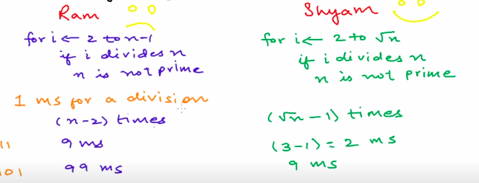

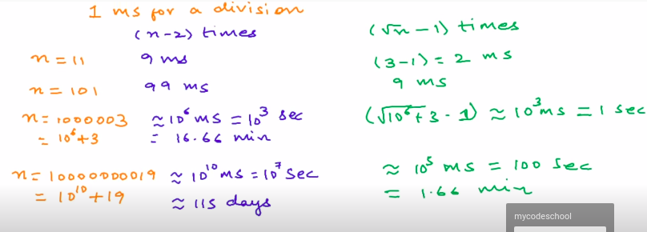

Here n is value in last value ram takes 115 days and sham takes only 1.66 minutes
in computer science solutions like in ram denoted by O(n) because Time propotional to n.And in sham like solutions Time propotional to √n it O(√n).

How to analyse the time Complexity

But running time depends on many more things here we only take care about input added to our algorithem that mean rate of growth of time with input.Other Factors like 1,2,3 we dont consider about that.

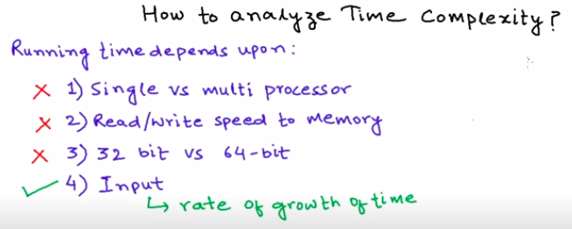

So we make imaginary model pc for this.

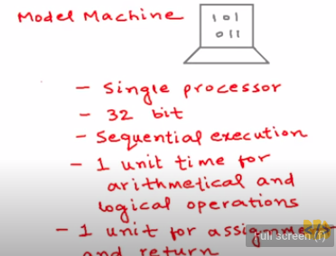

So we can run some algorithems in this and see time taken.

So this algorithem takes only 2 units of time in our model pc because for return it takes one unit and another for addition so 2 unit of time.For any two numbers this amount is same so this always takes a constant time.

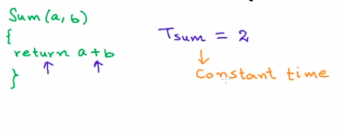

According to our model this algorithem is little bit complex
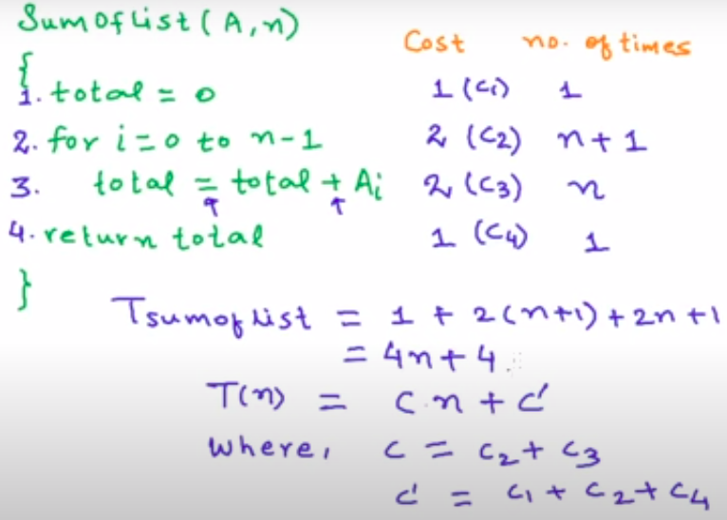

- In first line total has a assignment operator so we give 1 mark .

- And for the :-) for loop in 2nd line it got 1 assignment and one comparition so 2 units. n+1 number of iterations so we give n+1.

- For 3 rd line there is a assignment and + so it got 2 time units.

- For 4th line there is only a return statement so we give it 1 unit.

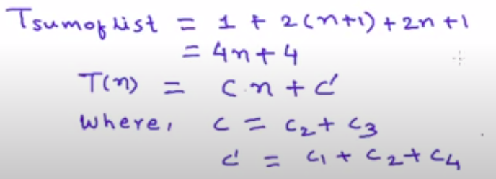

This is the sum of all values when we add all of these .

When we plot a graph with all these schenarios we can have this graph.

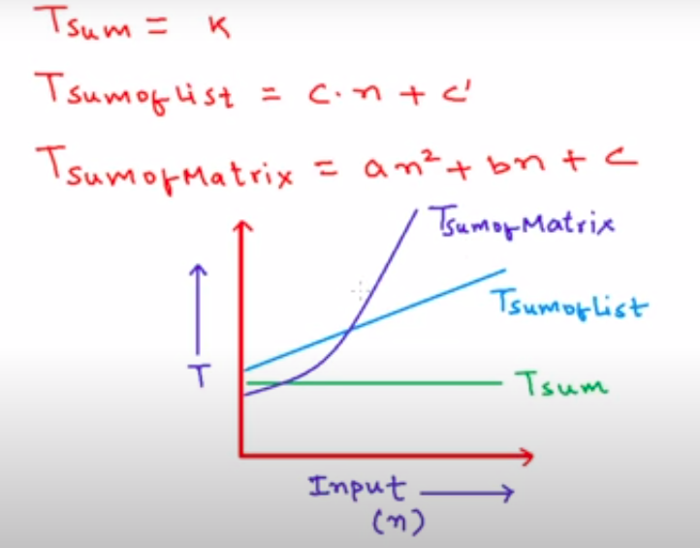

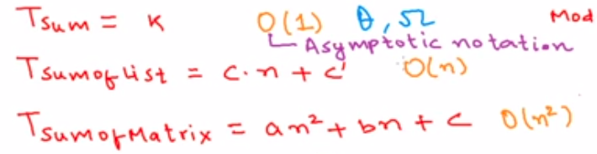

We dont need to care about all small things if its constant its o(1).
If its n^2 we can consider it as o(n^2).
And if its linear we can get O(n)

Asymptotic notations

We use three types of asymptotic notations to represent the growth of any algorithm, as input increases: Big Theta (Θ) Big Oh(O) Big Omega (Ω)

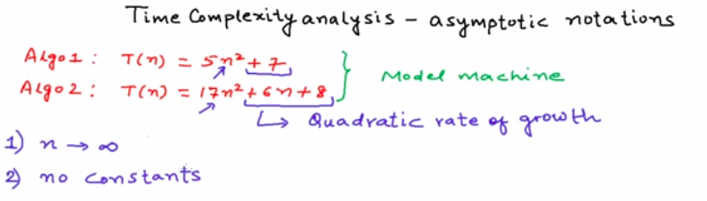

Consider these algo 1 and 2 in anymptotic notations we fo for a very huge input like imaginary infinity when going close to infinity constant like 7 in first algo or 6n+8 in second algo dont effect too much . And multipliers like 5 and 17 we can neglect those.

Best explanation
https://www.studytonight.com/data-structures/aysmptotic-notations

We use three types of asymptotic notations to represent the growth of any algorithm, as input increases:
- Big Theta (Θ)
- Big Oh(O)
- Big Omega (Ω)

Tight Bounds: Theta
When we say tight bounds, we mean that the time compexity represented by the Big-Θ notation is like the average value or range within which the actual time of execution of the algorithm will be.
For example, if for some algorithm the time complexity is represented by the expression 3n2 + 5n, and we use the Big-Θ notation to represent this, then the time complexity would be Θ(n2), ignoring the constant coefficient and removing the insignificant part, which is 5n.
Here, in the example above, complexity of Θ(n2) means, that the avaerage time for any input n will remain in between, k1 * n2 and k2 * n2, where k1, k2 are two constants, therby tightly binding the expression rpresenting the growth of the algorithm.
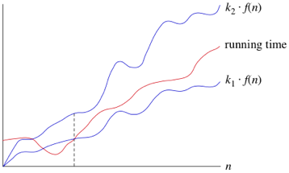

Upper Bounds: Big-O
This notation is known as the upper bound of the algorithm, or a Worst Case of an algorithm.
It tells us that a certain function will never exceed a specified time for any value of input n.
The question is why we need this representation when we already have the big-Θ notation, which represents the tightly bound running time for any algorithm. Let's take a small example to understand this.
Consider Linear Search algorithm, in which we traverse an array elements, one by one to search a given number.
In Worst case, starting from the front of the array, we find the element or number we are searching for at the end, which will lead to a time complexity of n, where n represents the number of total elements.
But it can happen, that the element that we are searching for is the first element of the array, in which case the time complexity will be 1.
Now in this case, saying that the big-Θ or tight bound time complexity for Linear search is Θ(n), will mean that the time required will always be related to n, as this is the right way to represent the average time complexity, but when we use the big-O notation, we mean to say that the time complexity is O(n), which means that the time complexity will never exceed n, defining the upper bound, hence saying that it can be less than or equal to n, which is the correct representation.
This is the reason, most of the time you will see Big-O notation being used to represent the time complexity of any algorithm, because it makes more sense.

Lower Bounds: Omega
Big Omega notation is used to define the lower bound of any algorithm or we can say the best case of any algorithm.
This always indicates the minimum time required for any algorithm for all input values, therefore the best case of any algorithm.
In simple words, when we represent a time complexity for any algorithm in the form of big-Ω, we mean that the algorithm will take atleast this much time to cmplete it's execution. It can definitely take more time than this too.

General Rules in time complexity
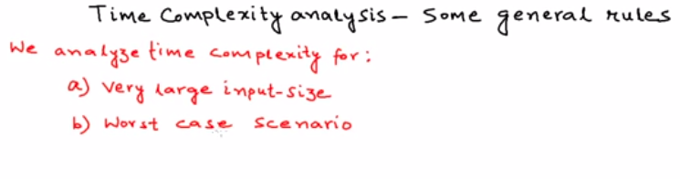

When taking equations

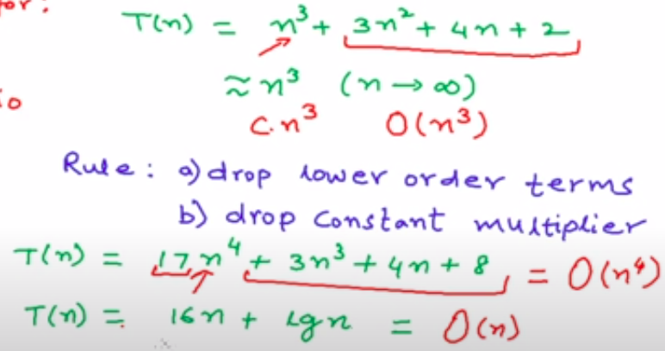
- In Equations like first (n^3+3n^2+4+2 )drop all lower order terms like 3n^2+4n+2 and keep only the highest n^3 so big O for this is O(n^3).

- In Second Equation (17n^4+3n^3+4n+8) get the value with highest power 17n^4 and when going for infinity (17)n^4 multipliers like 17 become insignificant so drop it too .For this Big o is O(n^4).

- You can definiately remove logs so answer to 3rd one is O(n).
Big OWith code samples

