Exp No: 1 | Setting Up the Environment And Preprocessing the Data

Aim:
To set up a fully functional machine learning development environment and to perform data preprocessing operations like handling missing values, encoding categorical variables, feature scaling, and splitting datasets.

Algorithm:
- Install Required Libraries:
  - Install numpy, pandas, matplotlib, seaborn, and scikit-learn using pip.
- Import Libraries.
- Load Dataset:
  - Load any dataset (e.g., Titanic or Iris) using pandas.
- Data Exploration:
  - Use df.info(), df.describe(), df.isnull().sum() to understand the data.
- Handle Missing Values:
  - Use .fillna() or .dropna() depending on the strategy.
- Encode Categorical Data:
  - Use pd.get_dummies() or LabelEncoder.
- Feature Scaling:
  - Normalize or standardize the numerical features using StandardScaler or MinMaxScaler.
- Split Dataset:
  - Use train_test_split() from sklearn to create training and testing sets.
- Display the Preprocessed Data.

Code:
# 1. Install necessary libraries (if not already installed)
# !pip install numpy pandas matplotlib seaborn scikit-learn

# 2. Import libraries
import pandas as pd
import numpy as np
from sklearn.model_selection import train_test_split
from sklearn.preprocessing import StandardScaler, LabelEncoder
import seaborn as sns
import matplotlib.pyplot as plt

# 3. Load dataset
df = sns.load_dataset(‘titanic’) # Titanic dataset
df.head()

# 4. Explore the dataset
print(df.info())
print(df.describe())
print(df.isnull().sum())

# 5. Handle missing values
# Fill age with median, embark_town with mode
df[‘age’].fillna(df[‘age’].median(), inplace=True)
df[‘embark_town’].fillna(df[‘embark_town’].mode()[0], inplace=True)
df.drop(columns=[‘deck’], inplace=True) # too many missing values

# 6. Encode categorical variables
# Convert ‘sex’ and ‘embark_town’ using LabelEncoder
le = LabelEncoder()
df[‘sex’] = le.fit_transform(df[‘sex’])
df[‘embark_town’] = le.fit_transform(df[‘embark_town’])

# Drop non-informative or redundant columns
df.drop(columns=[‘embarked’, ‘class’, ‘who’, ‘alive’, ‘adult_male’, ‘alone’], inplace=True)

# 7. Feature Scaling
scaler = StandardScaler()
numerical_cols = [‘age’, ‘fare’]
df[numerical_cols] = scaler.fit_transform(df[numerical_cols])

# 8. Split dataset
# Define features (X) and label (y)
X = df.drop(‘survived’, axis=1)
y = df[‘survived’]
X_train, X_test, y_train, y_test = train_test_split(X, y, test_size=0.2, random_state=42)

# 9. Show final preprocessed data
print(“Training Data Shape:”, X_train.shape)
print(“Test Data Shape:”, X_test.shape)
X_train.head()

Output:
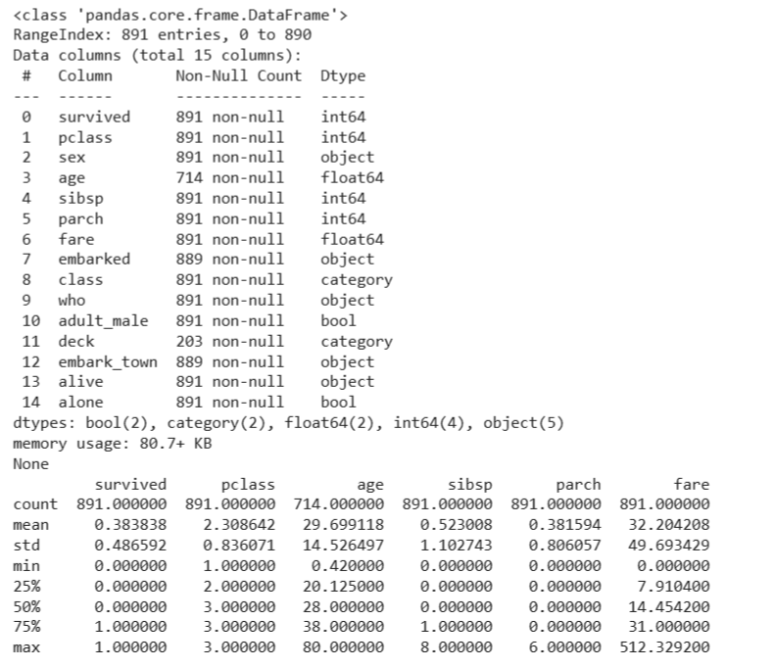
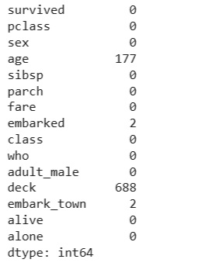
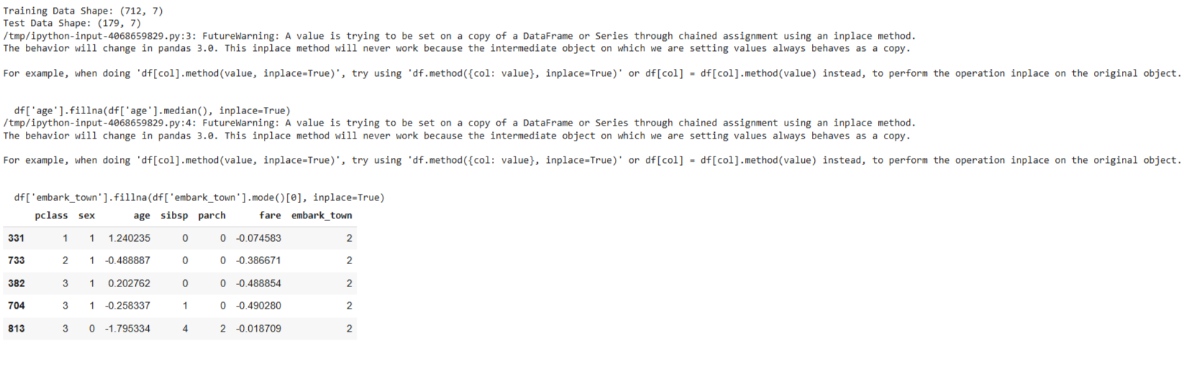

Exp No: 2 | Support Vector Machine (SVM) and Random Forest for Binary & Multiclass Classification

Aim
To build classification models using Support Vector Machines (SVM) and Random Forest, apply them to a dataset, and evaluate the models using performance metrics like accuracy and confusion matrix.
Algorithm
Part A: SVM Model
- Import necessary libraries
- Load and explore the dataset
- Handle missing values if any
- Encode categorical variables
- Split dataset into training and testing sets
- Build SVM classifier using SVC()
- Train and predict
- Evaluate the model using accuracy and confusion matrix
Part B: Random Forest Model
- Initialize Random Forest using RandomForestClassifier()
- Train and predict
- Evaluate and compare with SVM
Code:
# 1. Import libraries
import pandas as pd
from sklearn.datasets import load_iris
from sklearn.model_selection import train_test_split
from sklearn.preprocessing import StandardScaler
from sklearn.svm import SVC
from sklearn.ensemble import RandomForestClassifier
from sklearn.metrics import accuracy_score, confusion_matrix
import seaborn as sns
import matplotlib.pyplot as plt

# 2. Load dataset
iris = load_iris()
X = iris.data
y = iris.target

# 3. Feature scaling
scaler = StandardScaler()
X_scaled = scaler.fit_transform(X)

# 4. Train-test split
X_train, X_test, y_train, y_test = train_test_split(X_scaled, y, test_size=0.3, random_state=42)

# ----------------------------------
# Part A: SUPPORT VECTOR MACHINE
# ----------------------------------

# 5. Initialize and train SVM
svm_model = SVC(kernel='linear') # You can also try 'rbf', 'poly'
svm_model.fit(X_train, y_train)

# 6. Predict and evaluate SVM
y_pred_svm = svm_model.predict(X_test)
print("SVM Accuracy:", accuracy_score(y_test, y_pred_svm))
print("SVM Confusion Matrix:\n", confusion_matrix(y_test, y_pred_svm))

# ----------------------------------
# Part B: RANDOM FOREST
# ----------------------------------

# 7. Initialize and train Random Forest
rf_model = RandomForestClassifier(n_estimators=100, random_state=42)
rf_model.fit(X_train, y_train)

# 8. Predict and evaluate Random Forest
y_pred_rf = rf_model.predict(X_test)
print("Random Forest Accuracy:", accuracy_score(y_test, y_pred_rf))
print("Random Forest Confusion Matrix:\n", confusion_matrix(y_test, y_pred_rf))

# ----------------------------------
# 9. Visual comparison using seaborn heatmap
# ----------------------------------

plt.figure(figsize=(10, 4))

plt.subplot(1, 2, 1)
sns.heatmap(confusion_matrix(y_test, y_pred_svm), annot=True, cmap='Blues', fmt='d')
plt.title("SVM Confusion Matrix")

plt.subplot(1, 2, 2)
sns.heatmap(confusion_matrix(y_test, y_pred_rf), annot=True, cmap='Greens', fmt='d')
plt.title("Random Forest Confusion Matrix")
plt.tight_layout()
plt.show()

OUTPUT:
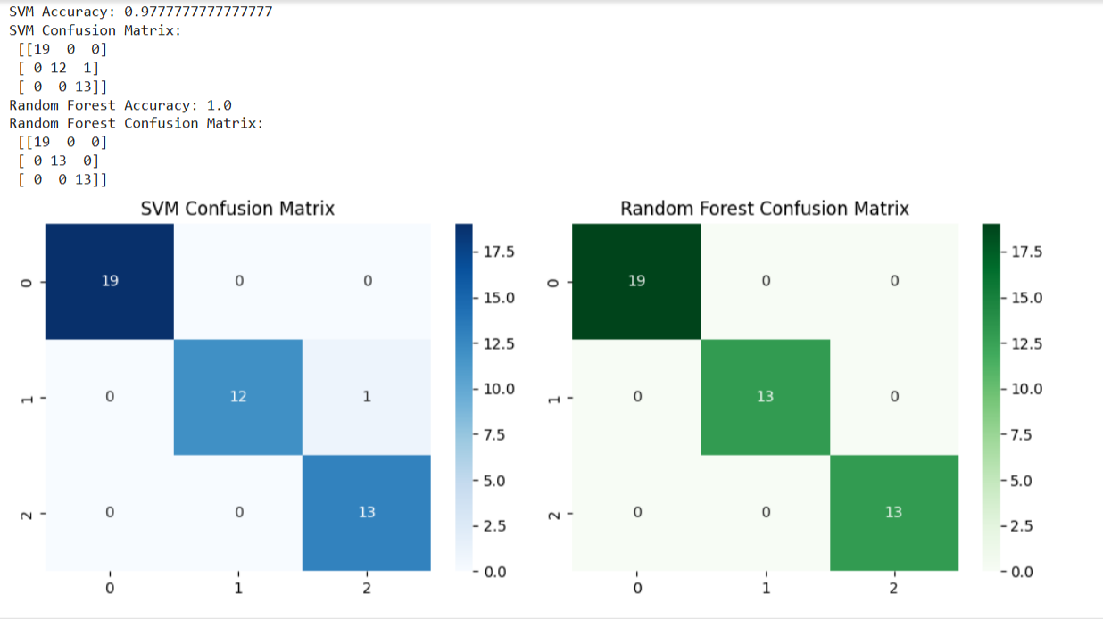

ExpNo:3 | Classification with Decision Trees

Aim
To implement a Decision Tree classifier and evaluate its performance using accuracy score and confusion matrix on a real-world dataset.
Algorithm
- Import necessary libraries
- Load a classification dataset (e.g., Iris or Titanic)
- Split the dataset into training and test sets
- Preprocess data if needed
- Train a DecisionTreeClassifier from sklearn.tree
- Predict on test data
- Evaluate using:
  - Confusion Matrix
  - Accuracy Score
- Visualize the Decision Tree (optional)
Code:
# Step 1: Import Libraries
from sklearn.datasets import load_iris
from sklearn.tree import DecisionTreeClassifier, plot_tree
from sklearn.model_selection import train_test_split
from sklearn.metrics import confusion_matrix, accuracy_score
import matplotlib.pyplot as plt
import seaborn as sns

# Step 2: Load Dataset
iris = load_iris()
X = iris.data
y = iris.target

# Step 3: Split the dataset
X_train, X_test, y_train, y_test = train_test_split(X, y, test_size=0.3, random_state=42)

# Step 4: Train the Decision Tree Classifier
dt_model = DecisionTreeClassifier(criterion='gini', random_state=0)
dt_model.fit(X_train, y_train)

# Step 5: Predict
y_pred = dt_model.predict(X_test)

# Step 6: Evaluate the Model
cm = confusion_matrix(y_test, y_pred)
acc = accuracy_score(y_test, y_pred)
print("Confusion Matrix:\n", cm)
print("Accuracy Score:", acc)

# Step 7: Visualize Confusion Matrix
sns.heatmap(cm, annot=True, cmap="Blues", xticklabels=iris.target_names, yticklabels=iris.target_names)
plt.xlabel("Predicted")
plt.ylabel("Actual")
plt.title("Confusion Matrix")
plt.show()

# Step 8: Visualize the Decision Tree
plt.figure(figsize=(12,8))
plot_tree(dt_model, filled=True, feature_names=iris.feature_names, class_names=iris.target_names)
plt.title("Decision Tree Visualization")
plt.show()

OUTPUT:
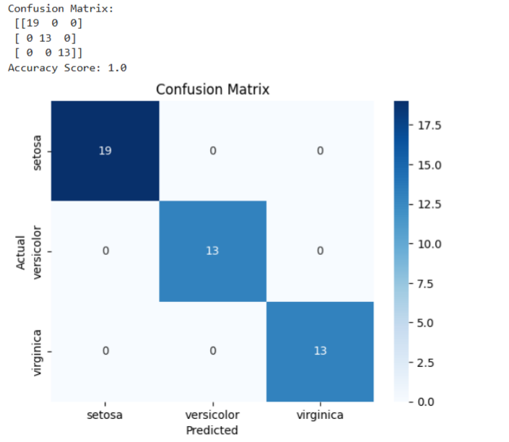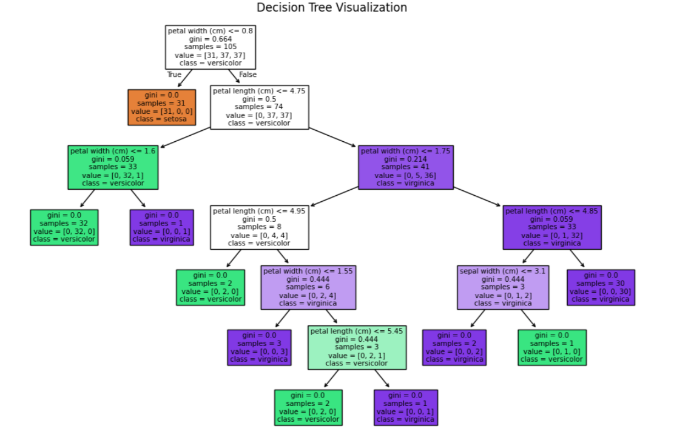
Exp No: 4A | Support Vector Machines (SVM)

Aim:
To build an SVM model for a binary classification task, tune its hyperparameters, and evaluate it using accuracy, precision, recall, F1-score, confusion matrix, and ROC-AUC.

Algorithm:
- Import libraries: numpy, pandas, matplotlib, sklearn.
- Load data: Use a standard binary dataset (Breast Cancer Wisconsin) from sklearn.datasets.
- Train/Test split: 80/20 split with a fixed random_state.
- Preprocess: Standardize features (StandardScaler).
- SVMs are sensitive to feature scale.
- Model selection: Use SVC (RBF kernel).
- Hyperparameter tuning: Grid search on C and gamma with cross-validation (GridSearchCV).
- Train final model: Fit on training data using best parameters.
- Evaluate: Predict on test set; compute metrics and plot ROC curve.
- Report: Best params, metrics, and brief observations.

CODE:
# =========================
# EXPERIMENT 4A — SVM (RBF)
# =========================

# 1) Imports
import numpy as np
import pandas as pd
import matplotlib.pyplot as plt

from sklearn.datasets import load_breast_cancer
from sklearn.model_selection import train_test_split, GridSearchCV
from sklearn.preprocessing import StandardScaler
from sklearn.svm import SVC
from sklearn.metrics import (
accuracy_score, precision_score, recall_score, f1_score,
confusion_matrix, classification_report, roc_auc_score, roc_curve
)

# 2) Load dataset (binary classification)
data = load_breast_cancer()
X = pd.DataFrame(data.data, columns=data.feature_names)
y = pd.Series(data.target, name="target") # 0 = malignant, 1 = benign

# 3) Train/test split
X_train, X_test, y_train, y_test = train_test_split(
X, y, test_size=0.20, random_state=42, stratify=y
)

# 4) Standardize features (important for SVMs)
scaler = StandardScaler()
X_train_sc = scaler.fit_transform(X_train)
X_test_sc = scaler.transform(X_test)

# 5) Define model
svm = SVC(kernel='rbf', probability=True, random_state=42)

# 6) Hyperparameter grid & tuning
param_grid = {
"C": [0.1, 1, 10, 100],
"gamma": ["scale", 0.01, 0.001, 0.0001]
}

grid = GridSearchCV(
estimator=svm,
param_grid=param_grid,
scoring='f1', # You can change to 'accuracy' or 'roc_auc'
cv=5,
n_jobs=-1,
verbose=0
)

grid.fit(X_train_sc, y_train)

print("Best Parameters from Grid Search:", grid.best_params_)
best_svm = grid.best_estimator_

# 7) Train final model & predict
best_svm.fit(X_train_sc, y_train)
y_pred = best_svm.predict(X_test_sc)
y_prob = best_svm.predict_proba(X_test_sc)[:, 1]

# 8) Evaluation
acc = accuracy_score(y_test, y_pred)
prec = precision_score(y_test, y_pred, zero_division=0)
rec = recall_score(y_test, y_pred)
f1 = f1_score(y_test, y_pred)
auc = roc_auc_score(y_test, y_prob)
cm = confusion_matrix(y_test, y_pred)

print("\n=== SVM (RBF) — Test Metrics ===")
print(f"Accuracy : {acc:.4f}")
print(f"Precision: {prec:.4f}")
print(f"Recall : {rec:.4f}")
print(f"F1-Score : {f1:.4f}")
print(f"ROC-AUC : {auc:.4f}")

print("\nConfusion Matrix:\n", cm)
print("\nClassification Report:\n", classification_report(y_test, y_pred, zero_division=0))

# 9) Plot ROC Curve
fpr, tpr, thresholds = roc_curve(y_test, y_prob)
plt.figure()
plt.plot(fpr, tpr, label=f"SVM (AUC = {auc:.3f})")
plt.plot([0, 1], [0, 1], linestyle="--", color='gray')
plt.xlabel("False Positive Rate")
plt.ylabel("True Positive Rate")
plt.title("ROC Curve — SVM (RBF)")
plt.legend()
plt.grid(True)
plt.show()

OUTPUT:
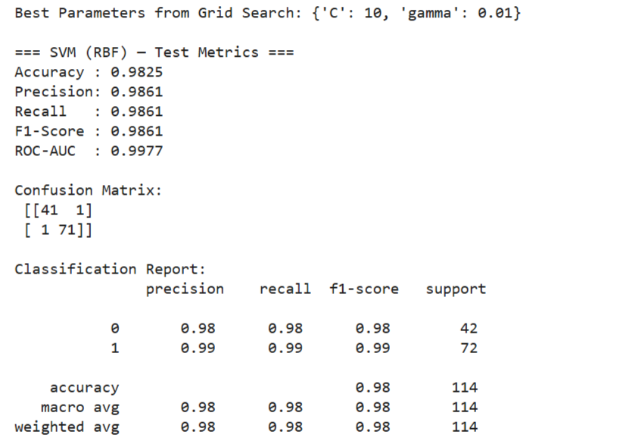
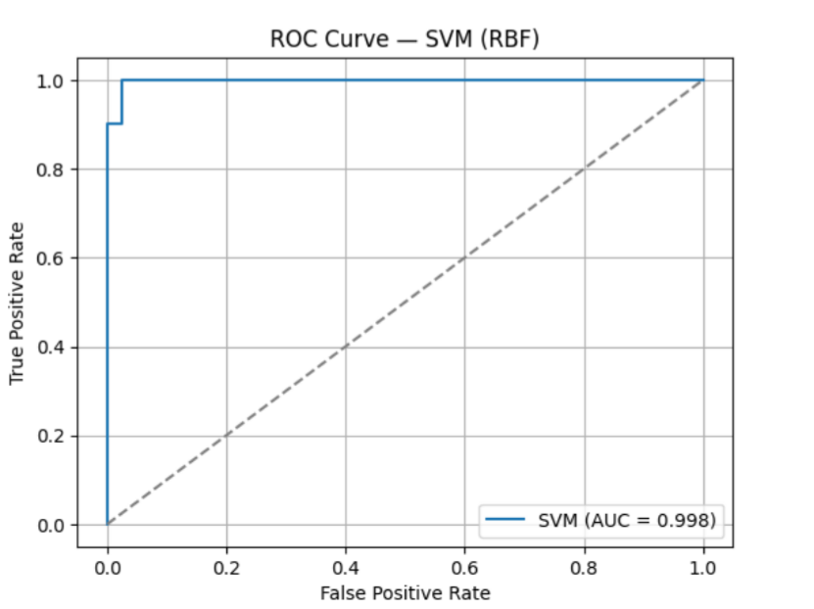

Exp No: 4B | Ensemble Methods: Random Forest

Aim:

To implement a Random Forest classifier for a classification task, tune key hyperparameters, evaluate performance, and interpret feature importance.

Algorithm:

- Import libraries.
- Load data (use same dataset to compare with SVM).
- Train/Test split with stratification.
- (Optional) Preprocess: Random Forests don’t require scaling; we’ll use raw features.
- Model: RandomForestClassifier.
- Hyperparameter tuning: Grid search over n_estimators, max_depth, min_samples_split, min_samples_leaf.
- Train the best model on training data.
- Evaluate with accuracy, precision, recall, F1, confusion matrix, ROC-AUC.
- Interpretation: Plot top feature importances.

CODE:
# ===========================================
# EXPERIMENT 4B — Random Forest Classifier
# ===========================================

# 1) Imports
import numpy as np
import pandas as pd
import matplotlib.pyplot as plt
from sklearn.datasets import load_breast_cancer
from sklearn.model_selection import train_test_split, GridSearchCV
from sklearn.ensemble import RandomForestClassifier
from sklearn.metrics import (
accuracy_score, precision_score, recall_score, f1_score,
confusion_matrix, classification_report, roc_auc_score, roc_curve
)
# 2) Load dataset (same as 4A for comparison)
data = load_breast_cancer()
X = pd.DataFrame(data.data, columns=data.feature_names)
y = pd.Series(data.target, name="target")

# 3) Train/test split (no scaling needed for RF)
X_train, X_test, y_train, y_test = train_test_split(
X, y, test_size=0.20, random_state=42, stratify=y
)

# 4) Define model
rf = RandomForestClassifier(random_state=42, n_jobs=-1)

# 5) Hyperparameter grid & tuning
param_grid = {
"n_estimators": [100],
"max_depth": [None, 10],
"min_samples_split": [2],
"min_samples_leaf": [1]
}
grid = GridSearchCV(
estimator=rf,
param_grid=param_grid,
scoring="f1",
cv=3,
n_jobs=-1,
verbose=0)
grid.fit(X_train, y_train)
print("Best Parameters (CV):", grid.best_params_)
best_rf = grid.best_estimator_

# 6) Train final model & predict
best_rf.fit(X_train, y_train)
y_pred = best_rf.predict(X_test)
y_prob = best_rf.predict_proba(X_test)[:, 1]

# 7) Evaluate
acc = accuracy_score(y_test, y_pred)
prec = precision_score(y_test, y_pred, zero_division=0)
rec = recall_score(y_test, y_pred)
f1 = f1_score(y_test, y_pred)
auc = roc_auc_score(y_test, y_prob)
cm = confusion_matrix(y_test, y_pred)

print("\n=== Random Forest — Test Metrics ===")
print(f"Accuracy : {acc:.4f}")
print(f"Precision: {prec:.4f}")
print(f"Recall : {rec:.4f}")
print(f"F1-Score : {f1:.4f}")
print(f"ROC-AUC : {auc:.4f}")

print("\nConfusion Matrix:\n", cm)
print("\nClassification Report:\n", classification_report(y_test, y_pred, zero_division=0))

# 8) Feature Importance (Top 10)
importances = pd.Series(best_rf.feature_importances_, index=X.columns)
top10 = importances.sort_values(ascending=False).head(10)

plt.figure()
top10[::-1].plot(kind="barh")
plt.xlabel("Importance")
plt.title("Top 10 Feature Importances — Random Forest")
plt.grid(axis="x", alpha=0.3)
plt.show()

# 9) ROC Curve
fpr, tpr, thresholds = roc_curve(y_test, y_prob)
plt.figure()
plt.plot(fpr, tpr, label=f"Random Forest (AUC = {auc:.3f})")
plt.plot([0, 1], [0, 1], linestyle="--", color='gray')
plt.xlabel("False Positive Rate")
plt.ylabel("True Positive Rate")
plt.title("ROC Curve — Random Forest")
plt.legend()
plt.grid(True)
plt.show()

OUTPUT:

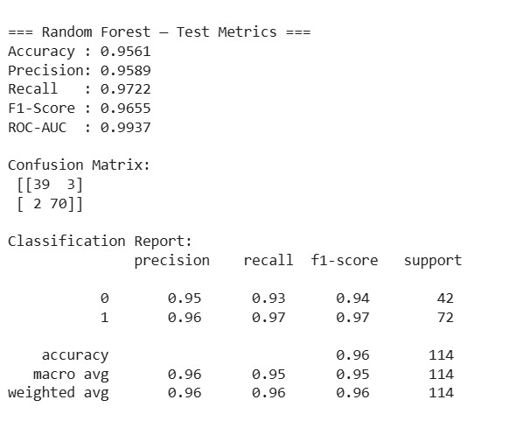

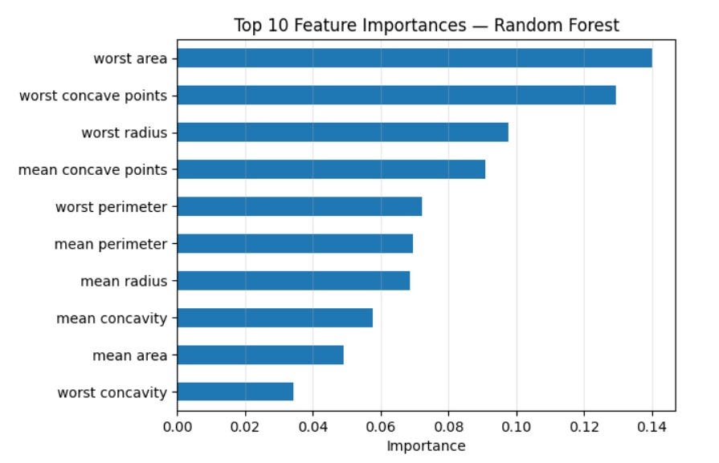

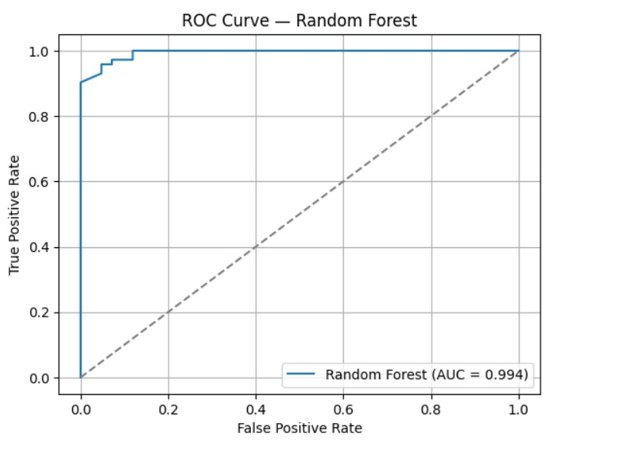

Exp No: 5 | Clustering with K-Means and Dimensionality Reduction with PCA

Aim:
To demonstrate the application of Unsupervised Learning models, specifically K-Means clustering for grouping data points and Principal Component Analysis (PCA) for dimensionality reduction and visualization, using a suitable dataset.

Algorithm:

1. K-Means Clustering

K-Means is an iterative clustering algorithm that aims to partition $n$ observations into $k$ clusters, where each observation belongs to the cluster with the nearest mean (centroid).

Steps:
1. Initialization: Choose $k$ initial centroids randomly from the dataset.
2. Assignment: Assign each data point to the cluster whose centroid is closest (e.g., using Euclidean distance).
3. Update: Recalculate the centroids as the mean of all data points assigned to that cluster.
4. Iteration: Repeat steps 2 and 3 until the centroids no longer move significantly or a maximum number of iterations is reached.

2. Principal Component Analysis (PCA)

PCA is a statistical procedure that uses an orthogonal transformation to convert a set of observations of possibly correlated variables into a set of values of linearly uncorrelated variables called principal components.

Steps:
1. Standardization: Standardize the dataset (mean = 0, variance = 1).
2. Covariance Matrix Calculation: Compute the covariance matrix of the standardized data.
3. Eigenvalue Decomposition: Calculate the eigenvalues and eigenvectors of the covariance matrix.
4. Feature Vector Creation: Sort the eigenvectors by decreasing eigenvalues and select the top $k$ eigenvectors to form a feature vector (projection matrix).
5. Projection: Project the original data onto the new feature space using the feature vector.

CODE:

# ===============================
# EXPERIMENT — K-Means & PCA
# ===============================

# Import necessary libraries
import numpy as np
import pandas as pd
import matplotlib.pyplot as plt
import seaborn as sns

from sklearn.datasets import make_blobs
from sklearn.preprocessing import StandardScaler
from sklearn.cluster import KMeans
from sklearn.decomposition import PCA
from sklearn.metrics import silhouette_score

# --- Part 1: K-Means Clustering ---

print("--- Part 1: K-Means Clustering ---")

# 1. Generate dataset
X, y = make_blobs(n_samples=300, centers=3, cluster_std=0.60, random_state=42)
df_kmeans = pd.DataFrame(X, columns=['Feature_1', 'Feature_2'])
print("\nOriginal K-Means Dataset Head:")
print(df_kmeans.head())

# 2. Elbow Method
wcss = []
for i in range(1, 11):
kmeans = KMeans(n_clusters=i, init='k-means++', max_iter=300, n_init=10, random_state=42)
kmeans.fit(X)
wcss.append(kmeans.inertia_)

plt.figure(figsize=(10, 6))
plt.plot(range(1, 11), wcss, marker='o', linestyle='--')
plt.title('Elbow Method for Optimal K (K-Means)')
plt.xlabel('Number of Clusters (K)')
plt.ylabel('WCSS')
plt.grid(True)
plt.show()

# 3. Apply K-Means with chosen K
optimal_k = 3
kmeans = KMeans(n_clusters=optimal_k, init='k-means++', max_iter=300, n_init=10, random_state=42)
clusters = kmeans.fit_predict(X)
df_kmeans['Cluster'] = clusters

# 4. Visualize K-Means clusters
plt.figure(figsize=(10, 8))
sns.scatterplot(x='Feature_1', y='Feature_2', hue='Cluster', data=df_kmeans, palette='viridis', s=100, alpha=0.8)
plt.scatter(kmeans.cluster_centers_[:, 0], kmeans.cluster_centers_[:, 1], s=300, c='red', marker='X', label='Centroids')
plt.title(f'K-Means Clustering with K={optimal_k}')
plt.xlabel('Feature 1')
plt.ylabel('Feature 2')
plt.legend()
plt.grid(True)
plt.show()

# 5. Silhouette Score
silhouette_avg = silhouette_score(X, clusters)
print(f"\nSilhouette Score for K-Means (K={optimal_k}): {silhouette_avg:.3f}")

# --- Part 2: Dimensionality Reduction with PCA ---

print("\n--- Part 2: Dimensionality Reduction with PCA ---")

# 1. Generate 4D dataset
X_pca, y_pca = make_blobs(n_samples=500, n_features=4, centers=4, cluster_std=1.0, random_state=25)
df_pca_original = pd.DataFrame(X_pca, columns=[f'Feature_{i+1}' for i in range(X_pca.shape[1])])
df_pca_original['True_Cluster'] = y_pca
print("\nOriginal PCA Dataset Head:")
print(df_pca_original.head())
print(f"Original PCA Dataset Shape: {df_pca_original.shape}")

# 2. Standardize
scaler = StandardScaler()
X_pca_scaled = scaler.fit_transform(X_pca)

# 3. PCA (4D → 2D)
pca = PCA(n_components=2)
principal_components = pca.fit_transform(X_pca_scaled)
df_principal_components = pd.DataFrame(principal_components, columns=['Principal_Component_1', 'Principal_Component_2'])
df_principal_components['True_Cluster'] = y_pca
explained_variance = pca.explained_variance_ratio_
print("\nPrincipal Components Head:")
print(df_principal_components.head())
print(f"\nExplained Variance Ratio: {explained_variance}")
print(f"Total Explained Variance by 2 PCs: {explained_variance.sum():.3f}")

# 4. Visualize PCA result
plt.figure(figsize=(10, 8))
sns.scatterplot(x='Principal_Component_1', y='Principal_Component_2', hue='True_Cluster',
data=df_principal_components, palette='Paired', s=100, alpha=0.8)
plt.title('PCA - Dimensionality Reduction to 2 Components')
plt.xlabel(f'PC1 ({explained_variance[0]*100:.2f}%)')
plt.ylabel(f'PC2 ({explained_variance[1]*100:.2f}%)')
plt.grid(True)
plt.show()

# 5. K-Means on PCA-reduced data
kmeans_pca = KMeans(n_clusters=4, init='k-means++', max_iter=300, n_init=10, random_state=42)
clusters_pca = kmeans_pca.fit_predict(principal_components)
df_principal_components['KMeans_Cluster_on_PCA'] = clusters_pca

plt.figure(figsize=(10, 8))
sns.scatterplot(x='Principal_Component_1', y='Principal_Component_2', hue='KMeans_Cluster_on_PCA',
data=df_principal_components, palette='viridis', s=100, alpha=0.8)
plt.scatter(kmeans_pca.cluster_centers_[:, 0], kmeans_pca.cluster_centers_[:, 1], s=300, c='red', marker='X', label='Centroids')
plt.title('K-Means Clustering on PCA-Reduced Data')
plt.xlabel('Principal Component 1')
plt.ylabel('Principal Component 2')
plt.legend()
plt.grid(True)
plt.show()

# 6. Silhouette Score for PCA-reduced KMeans
silhouette_avg_pca = silhouette_score(principal_components, clusters_pca)
print(f"\nSilhouette Score for K-Means on PCA-Reduced Data (K=4): {silhouette_avg_pca:.3f}")

OUTPUT:
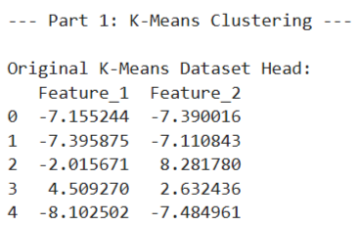

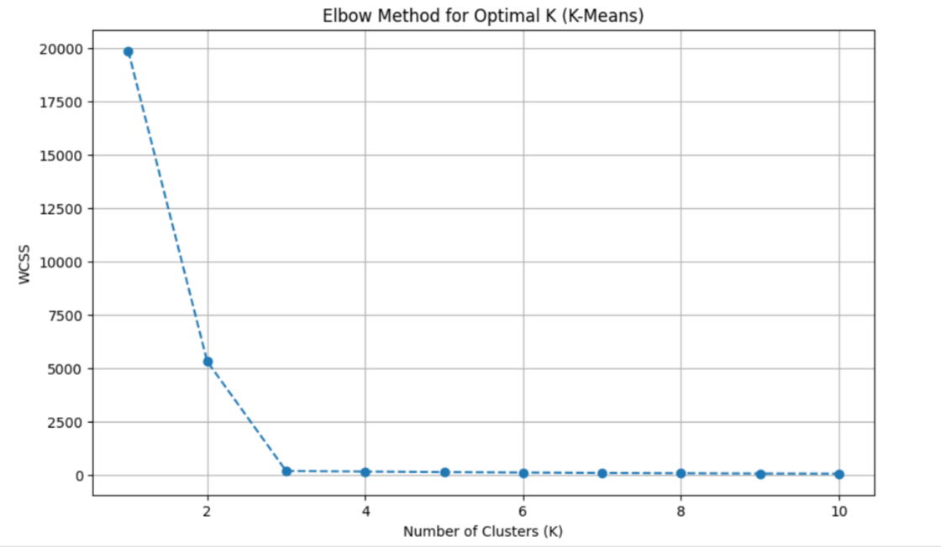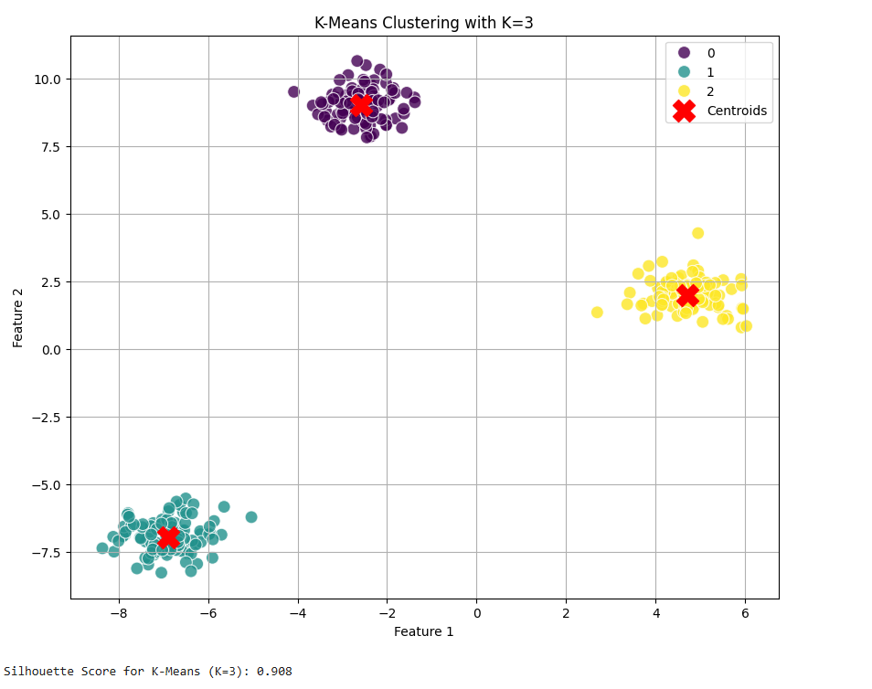
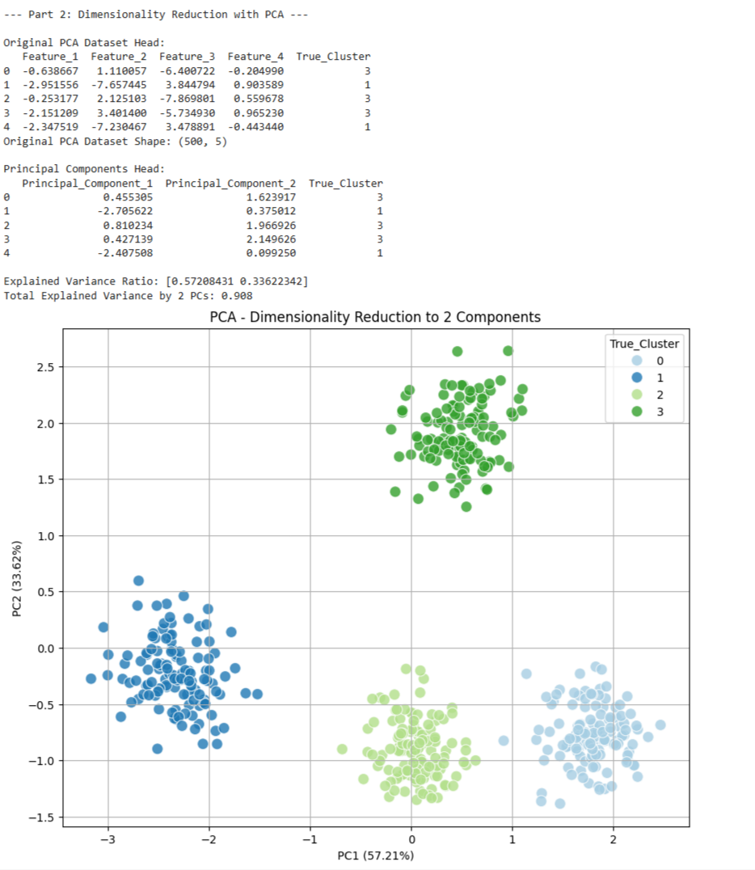

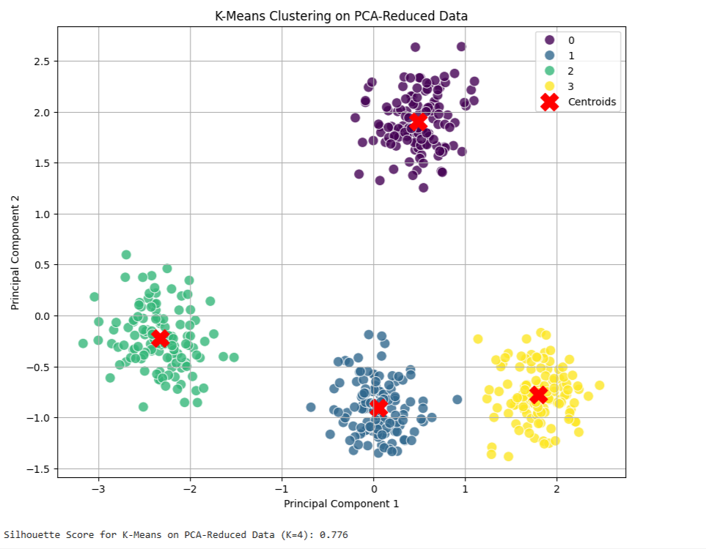

Exp No: 6 | Feedforward and Convolutional Neural Networks

Aim:
To demonstrate the construction and application of a simple Feedforward Neural Network (FNN) for classification and a Convolutional Neural Network (CNN) for image classification, utilizing the Keras API with TensorFlow backend.

Algorithm:

1. Feedforward Neural Network (FNN)

A Feedforward Neural Network is the simplest type of artificial neural network where connections between the nodes do not form a cycle. It consists of an input layer, one or more hidden layers, and an output layer. Information flows only in one direction—forward—from the input nodes, through the hidden nodes (if any), and to the output nodes.

Steps:
1. Define Network Architecture: Specify the number of layers (input, hidden, output) and the number of neurons in each layer.
2. Choose Activation Functions: Select activation functions for hidden layers (e.g., ReLU) and the output layer (e.g., Sigmoid for binary classification, Softmax for multi-class classification).
3. Define Loss Function: Choose a loss function appropriate for the task (e.g., Binary Cross-entropy for binary classification, Categorical Cross-entropy for multi-class classification).
4. Choose Optimizer: Select an optimization algorithm (e.g., Adam, SGD) to update network weights during training.
5. Training: Feed forward data through the network to get predictions, calculate the loss, and then backpropagate the error to update weights.
6. Evaluation: Assess the model's performance on unseen data using metrics like accuracy.

2. Convolutional Neural Network (CNN)

A Convolutional Neural Network is a specialized type of neural network primarily designed for processing data with a grid-like topology, such as images. Key components include convolutional layers, pooling layers, and fully connected layers.

Steps:
1. Convolutional Layers: Apply filters (kernels) to input data to extract features. Each filter detects a specific pattern (e.g., edges, textures).
2. Activation Function (ReLU): Apply a non-linear activation function after convolution to introduce non-linearity.
3. Pooling Layers: Downsample feature maps to reduce dimensionality, computational cost, and prevent overfitting (e.g., Max Pooling).
4. Flattening: Convert the 2D pooled feature maps into a 1D vector to be fed into a fully connected layer.
5. Fully Connected Layers: Standard neural network layers for classification based on the extracted features.
6. Output Layer: Final layer with an activation function (e.g., Softmax) to output class probabilities.
7. Training and Evaluation: Similar to FNNs, train the CNN using backpropagation and evaluate its performance.

CODE:
# Import necessary libraries
import numpy as np
import matplotlib.pyplot as plt
import tensorflow as tf
from tensorflow import keras
from tensorflow.keras import layers
from tensorflow.keras.datasets import mnist, fashion_mnist
from sklearn.metrics import classification_report, confusion_matrix
import seaborn as sns

# Suppress TensorFlow warnings for cleaner output
tf.keras.utils.disable_interactive_logging()

# --- Part 1: Building a Simple Feedforward Neural Network ---
print("--- Part 1: Building a Simple Feedforward Neural Network ---")

# 1. Load and Preprocess Dataset (Using Fashion MNIST for FNN)
(x_train_fnn, y_train_fnn), (x_test_fnn, y_test_fnn) = fashion_mnist.load_data()

print(f"\nOriginal FNN training data shape: {x_train_fnn.shape}")
print(f"Original FNN test data shape: {x_test_fnn.shape}")

# Flatten images to 1D array
x_train_fnn_flat = x_train_fnn.reshape(-1, 28 * 28)
x_test_fnn_flat = x_test_fnn.reshape(-1, 28 * 28)

# Normalize pixel values
x_train_fnn_norm = x_train_fnn_flat / 255.0
x_test_fnn_norm = x_test_fnn_flat / 255.0

print(f"Flattened & Normalized FNN training data shape: {x_train_fnn_norm.shape}")
print(f"Flattened & Normalized FNN test data shape: {x_test_fnn_norm.shape}")

# 2. Build FNN Model
model_fnn = keras.Sequential([
layers.Dense(128, activation='relu', input_shape=(784,)),
layers.Dropout(0.2),
layers.Dense(64, activation='relu'),
layers.Dense(10, activation='softmax')
])

# 3. Compile Model
model_fnn.compile(optimizer='adam',
loss='sparse_categorical_crossentropy',
metrics=['accuracy'])

print("\n--- FNN Model Summary ---")
model_fnn.summary()

# 4. Train Model
print("\n--- Training FNN Model ---")
history_fnn = model_fnn.fit(x_train_fnn_norm, y_train_fnn, epochs=10,
validation_split=0.1, verbose=1)

# 5. Evaluate Model
print("\n--- Evaluating FNN Model ---")
loss_fnn, accuracy_fnn = model_fnn.evaluate(x_test_fnn_norm, y_test_fnn, verbose=0)
print(f"FNN Test Loss: {loss_fnn:.4f}")
print(f"FNN Test Accuracy: {accuracy_fnn:.4f}")

# Classification report & confusion matrix
y_pred_fnn = np.argmax(model_fnn.predict(x_test_fnn_norm), axis=-1)
print("\n--- FNN Classification Report ---")
print(classification_report(y_test_fnn, y_pred_fnn))

print("\n--- FNN Confusion Matrix ---")
cm_fnn = confusion_matrix(y_test_fnn, y_pred_fnn)
plt.figure(figsize=(10, 8))
sns.heatmap(cm_fnn, annot=True, fmt="d", cmap="Blues", cbar=False)
plt.title("FNN Confusion Matrix")
plt.xlabel("Predicted Label")
plt.ylabel("True Label")
plt.show()

# Plot Accuracy & Loss
plt.figure(figsize=(12, 5))
plt.subplot(1, 2, 1)
plt.plot(history_fnn.history['accuracy'], label='Training Accuracy')
plt.plot(history_fnn.history['val_accuracy'], label='Validation Accuracy')
plt.title('FNN Model Accuracy')
plt.xlabel('Epoch')
plt.ylabel('Accuracy')
plt.legend()
plt.grid(True)

plt.subplot(1, 2, 2)
plt.plot(history_fnn.history['loss'], label='Training Loss')
plt.plot(history_fnn.history['val_loss'], label='Validation Loss')
plt.title('FNN Model Loss')
plt.xlabel('Epoch')
plt.ylabel('Loss')
plt.legend()
plt.grid(True)
plt.tight_layout()
plt.show()

# --- Part 2: Convolutional Neural Network (CNN) ---
print("\n--- Part 2: Implementing a CNN ---")

# 1. Load MNIST for CNN
(x_train_cnn, y_train_cnn), (x_test_cnn, y_test_cnn) = mnist.load_data()
print(f"\nOriginal CNN training data shape: {x_train_cnn.shape}")
print(f"Original CNN test data shape: {x_test_cnn.shape}")

# Reshape for channel dimension
x_train_cnn = x_train_cnn.reshape(x_train_cnn.shape[0], 28, 28, 1)
x_test_cnn = x_test_cnn.reshape(x_test_cnn.shape[0], 28, 28, 1)

# Normalize
x_train_cnn = x_train_cnn.astype('float32') / 255.0
x_test_cnn = x_test_cnn.astype('float32') / 255.0

print(f"Reshaped & Normalized CNN training data shape: {x_train_cnn.shape}")
print(f"Reshaped & Normalized CNN test data shape: {x_test_cnn.shape}")

num_classes_cnn = 10

# 2. Build CNN Model
model_cnn = keras.Sequential([
layers.Conv2D(32, (3, 3), activation='relu', input_shape=(28, 28, 1)),
layers.MaxPooling2D((2, 2)),
layers.Conv2D(64, (3, 3), activation='relu'),
layers.MaxPooling2D((2, 2)),
layers.Flatten(),
layers.Dense(128, activation='relu'),
layers.Dropout(0.5),
layers.Dense(num_classes_cnn, activation='softmax')
])

# 3. Compile Model
model_cnn.compile(optimizer='adam',
loss='sparse_categorical_crossentropy',
metrics=['accuracy'])

print("\n--- CNN Model Summary ---")
model_cnn.summary()

# 4. Train Model
print("\n--- Training CNN Model ---")
history_cnn = model_cnn.fit(x_train_cnn, y_train_cnn, epochs=10,
validation_split=0.1, verbose=1)

# 5. Evaluate Model
print("\n--- Evaluating CNN Model ---")
loss_cnn, accuracy_cnn = model_cnn.evaluate(x_test_cnn, y_test_cnn, verbose=0)
print(f"CNN Test Loss: {loss_cnn:.4f}")
print(f"CNN Test Accuracy: {accuracy_cnn:.4f}")

# Classification report & confusion matrix
y_pred_cnn = np.argmax(model_cnn.predict(x_test_cnn), axis=-1)
print("\n--- CNN Classification Report ---")
print(classification_report(y_test_cnn, y_pred_cnn))

print("\n--- CNN Confusion Matrix ---")
cm_cnn = confusion_matrix(y_test_cnn, y_pred_cnn)
plt.figure(figsize=(10, 8))
sns.heatmap(cm_cnn, annot=True, fmt="d", cmap="Blues", cbar=False)
plt.title("CNN Confusion Matrix")
plt.xlabel("Predicted Label")
plt.ylabel("True Label")
plt.show()

# Plot Accuracy & Loss
plt.figure(figsize=(12, 5))
plt.subplot(1, 2, 1)
plt.plot(history_cnn.history['accuracy'], label='Training Accuracy')
plt.plot(history_cnn.history['val_accuracy'], label='Validation Accuracy')
plt.title('CNN Model Accuracy')
plt.xlabel('Epoch')
plt.ylabel('Accuracy')
plt.legend()
plt.grid(True)

plt.subplot(1, 2, 2)
plt.plot(history_cnn.history['loss'], label='Training Loss')
plt.plot(history_cnn.history['val_loss'], label='Validation Loss')
plt.title('CNN Model Loss')
plt.xlabel('Epoch')
plt.ylabel('Loss')
plt.legend()
plt.grid(True)
plt.tight_layout()
plt.show()

# Optional: Visualize predictions
print("\n--- Sample CNN Predictions ---")
class_names_mnist = [str(i) for i in range(10)]
plt.figure(figsize=(10, 10))
for i in range(25):
plt.subplot(5, 5, i + 1)
plt.xticks([])
plt.yticks([])
plt.grid(False)
plt.imshow(x_test_cnn[i].reshape(28, 28), cmap=plt.cm.binary)
true_label = y_test_cnn[i]
predicted_label = y_pred_cnn[i]
color = 'green' if true_label == predicted_label else 'red'
plt.xlabel(f"True: {class_names_mnist[true_label]}\nPred: {class_names_mnist[predicted_label]}", color=color)
plt.suptitle("Sample CNN Predictions (Green: Correct, Red: Incorrect)", y=1.02, fontsize=16)
plt.tight_layout(rect=[0, 0, 1, 0.98])
plt.show()

OUTPUT:
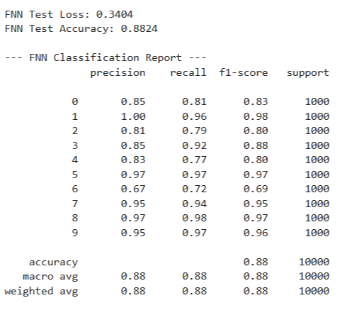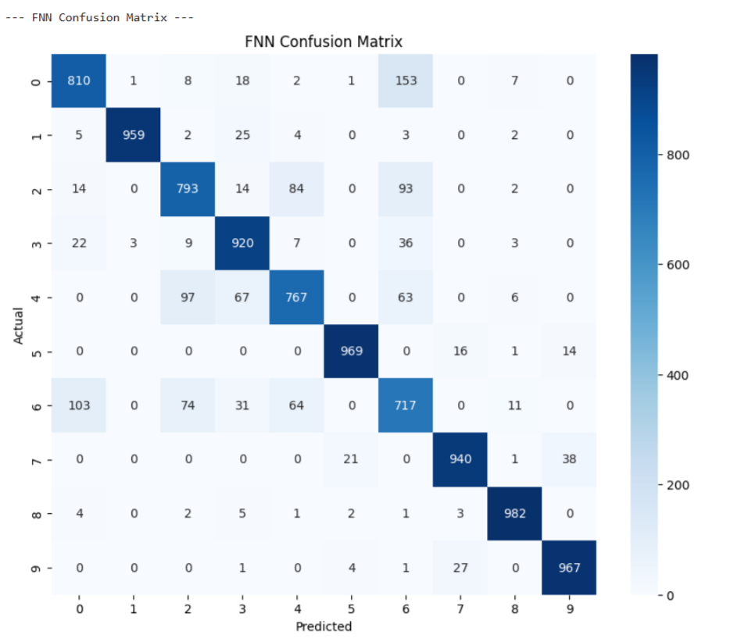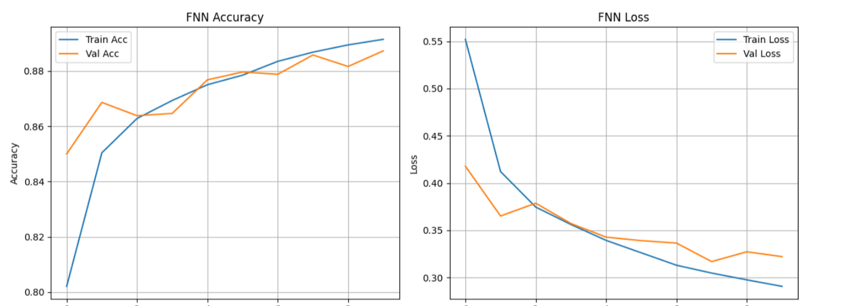

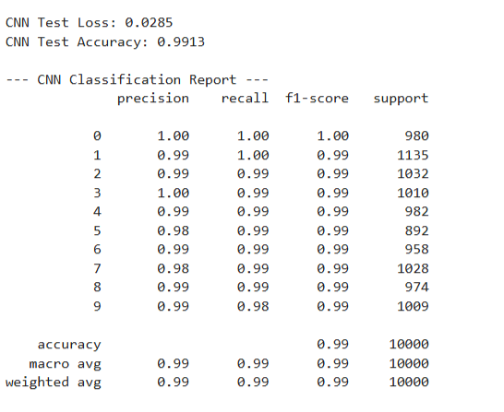
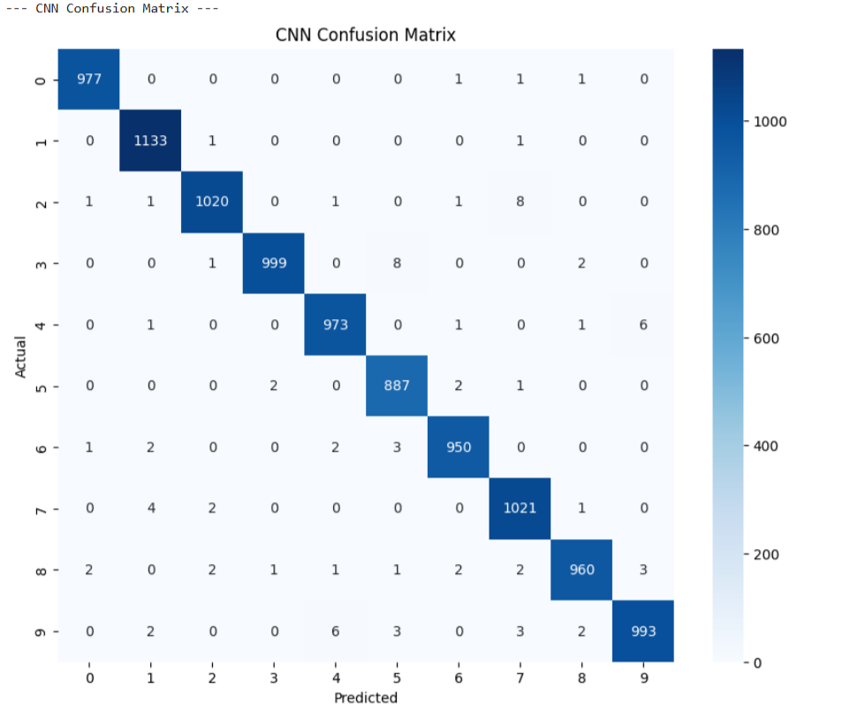
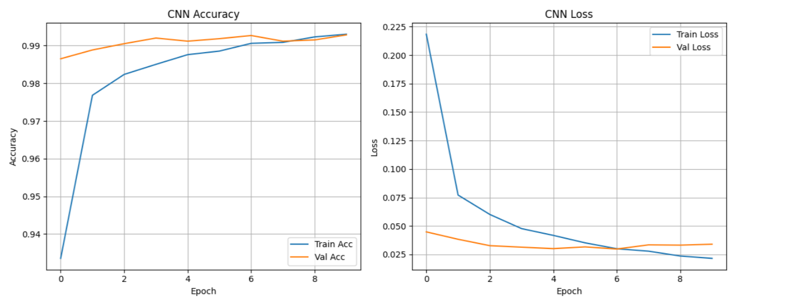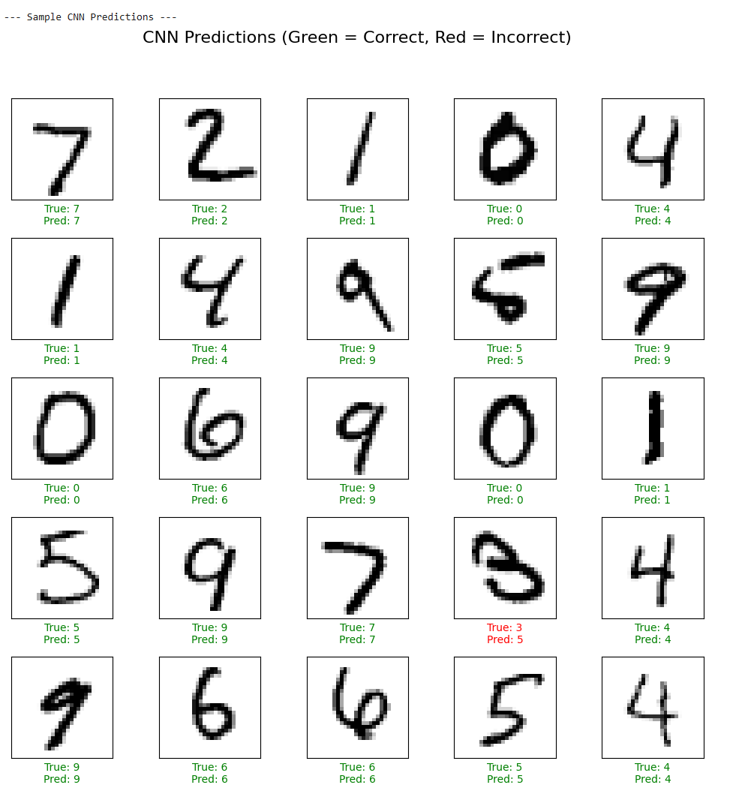

Exp No: 7 | Generative Models with GANs:  Creating and Training a Generative Adversarial Network

Aim:
To construct and train a Generative Adversarial Network (GAN) using the TensorFlow/Keras
framework. The objective is to train the GAN on the MNIST dataset to generate new, synthetic images of handwritten digits that are indistinguishable from the original training data.

Algorithm:
Generative Adversarial Networks (GANs)
GANs are a class of generative models that learn a training distribution by pitting two neural
networks against each other in a zero-sum game: a Generator and a Discriminator.

1. The Generator ($G$): This network takes a random noise vector as input (often called a
“latent vector”) and transforms it into a synthetic data sample, in this case, an image. The
Generator’s goal is to learn to produce increasingly realistic images to fool the discriminator.

2. The Discriminator ($D$): This is a binary classifier network. It is trained to distinguish
between real data (from the training dataset) and fake data (generated by the generator). Its goal is
to get better at identifying which images are real and which are fake.

3. The Adversarial Process:
Step A (Training the Discriminator): The discriminator is trained on a batch of both real
images (labeled as “real” or 1) and fake images from the generator (labeled as “fake” or 0). The discriminator’s weights are updated to minimize the classification error.
Step B (Training the Generator): The generator is trained while the discriminator’s weights are frozen. The generator creates fake images and feeds them to the discriminator. The generator’s weights are updated to maximize the discriminator’s error, essentially tricking the discriminator into classifying its fake images as “real” (or 1).

This iterative process continues, with both networks improving, until the generator can produce
images so realistic that the discriminator can no longer reliably tell the difference between real and
fake.

CODE:
# Import necessary libraries
import numpy as np
import matplotlib.pyplot as plt
import tensorflow as tf
from tensorflow import keras
from tensorflow.keras import layers
from tensorflow.keras.datasets import mnist
import os

# Suppress TensorFlow warnings for cleaner output
tf.keras.utils.disable_interactive_logging()

# --- Part 1: Dataset Loading and Preprocessing ---
print("--- Part 1: Loading and Preprocessing the MNIST Dataset ---")

(x_train, _), (_, _) = mnist.load_data()

x_train = x_train.reshape(x_train.shape[0], 28, 28, 1).astype('float32')
x_train = (x_train - 127.5) / 127.5 # Normalize to [-1, 1]

print(f"Normalized training data shape: {x_train.shape}")
print("Example of a normalized pixel value:", x_train[0, 0, 0, 0])

# --- Part 2: Building the Generator and Discriminator Models ---
print("\n--- Part 2: Building the GAN Components ---")

latent_dim = 100

# Generator
def build_generator():
model = keras.Sequential(name="generator")
model.add(layers.Dense(7 * 7 * 256, use_bias=False, input_shape=(latent_dim,)))
model.add(layers.BatchNormalization())
model.add(layers.LeakyReLU())
model.add(layers.Reshape((7, 7, 256)))
model.add(layers.Conv2DTranspose(128, (5, 5), strides=(1, 1), padding='same', use_bias=False))
model.add(layers.BatchNormalization())
model.add(layers.LeakyReLU())
model.add(layers.Conv2DTranspose(64, (5, 5), strides=(2, 2), padding='same', use_bias=False))
model.add(layers.BatchNormalization())
model.add(layers.LeakyReLU())
model.add(layers.Conv2DTranspose(1, (5, 5), strides=(2, 2), padding='same',
use_bias=False, activation='tanh'))
return model

generator = build_generator()
print("\n--- Generator Model Summary ---")
generator.summary()

# Discriminator
def build_discriminator():
model = keras.Sequential(name="discriminator")
model.add(layers.Conv2D(64, (5, 5), strides=(2, 2), padding='same', input_shape=[28, 28, 1]))
model.add(layers.LeakyReLU())
model.add(layers.Dropout(0.3))
model.add(layers.Conv2D(128, (5, 5), strides=(2, 2), padding='same'))
model.add(layers.LeakyReLU())
model.add(layers.Dropout(0.3))
model.add(layers.Flatten())
model.add(layers.Dense(1, activation='sigmoid'))
return model

discriminator = build_discriminator()
print("\n--- Discriminator Model Summary ---")
discriminator.summary()

# --- Part 3: Training Setup ---
cross_entropy = keras.losses.BinaryCrossentropy(from_logits=False)

def discriminator_loss(real_output, fake_output):
real_loss = cross_entropy(tf.ones_like(real_output), real_output)
fake_loss = cross_entropy(tf.zeros_like(fake_output), fake_output)
return real_loss + fake_loss

def generator_loss(fake_output):
return cross_entropy(tf.ones_like(fake_output), fake_output)

generator_optimizer = tf.keras.optimizers.Adam(learning_rate=1e-4)
discriminator_optimizer = tf.keras.optimizers.Adam(learning_rate=1e-4)

@tf.function
def train_step(images, latent_dim=latent_dim):
noise = tf.random.normal([batch_size, latent_dim])
with tf.GradientTape() as gen_tape, tf.GradientTape() as disc_tape:
generated_images = generator(noise, training=True)
real_output = discriminator(images, training=True)
fake_output = discriminator(generated_images, training=True)
gen_loss = generator_loss(fake_output)
disc_loss = discriminator_loss(real_output, fake_output)
gradients_of_generator = gen_tape.gradient(gen_loss, generator.trainable_variables)
gradients_of_discriminator = disc_tape.gradient(disc_loss, discriminator.trainable_variables)
generator_optimizer.apply_gradients(zip(gradients_of_generator, generator.trainable_variables))
discriminator_optimizer.apply_gradients(zip(gradients_of_discriminator, discriminator.trainable_variables))
return gen_loss, disc_loss

def generate_and_save_images(model, epoch, test_input):
predictions = model(test_input, training=False)
predictions_rescaled = (predictions * 0.5) + 0.5 # Scale back to [0, 1]
fig = plt.figure(figsize=(4, 4))
for i in range(predictions.shape[0]):
plt.subplot(4, 4, i + 1)
plt.imshow(predictions_rescaled[i, :, :, 0], cmap='gray')
plt.axis('off')
plt.suptitle(f"Epoch {epoch}", fontsize=16)
if not os.path.exists('images'):
os.makedirs('images')
plt.savefig(f'images/image_at_epoch_{epoch:04d}.png')
plt.show()

# Training parameters
EPOCHS = 200
batch_size = 256
num_examples_to_generate = 16
seed = tf.random.normal([num_examples_to_generate, latent_dim])

train_dataset = tf.data.Dataset.from_tensor_slices(x_train).shuffle(x_train.shape[0]).batch(batch_size)

# Training loop
def train(dataset, epochs):
print("\n--- Beginning GAN Training ---")
for epoch in range(epochs):
gen_loss_list = []
disc_loss_list = []
for image_batch in dataset:
gen_loss, disc_loss = train_step(image_batch)
gen_loss_list.append(gen_loss.numpy())
disc_loss_list.append(disc_loss.numpy())
avg_gen_loss = np.mean(gen_loss_list)
avg_disc_loss = np.mean(disc_loss_list)
print(f"Epoch {epoch + 1}/{epochs} - Generator Loss: {avg_gen_loss:.4f}, Discriminator Loss: {avg_disc_loss:.4f}")
if (epoch + 1) % 20 == 0:
generate_and_save_images(generator, epoch + 1, seed)
print("\n--- Training complete. Generating final images. ---")
generate_and_save_images(generator, epochs, seed)

# Run training
train(train_dataset, EPOCHS)

OUTPUT: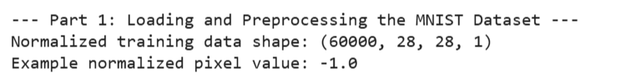
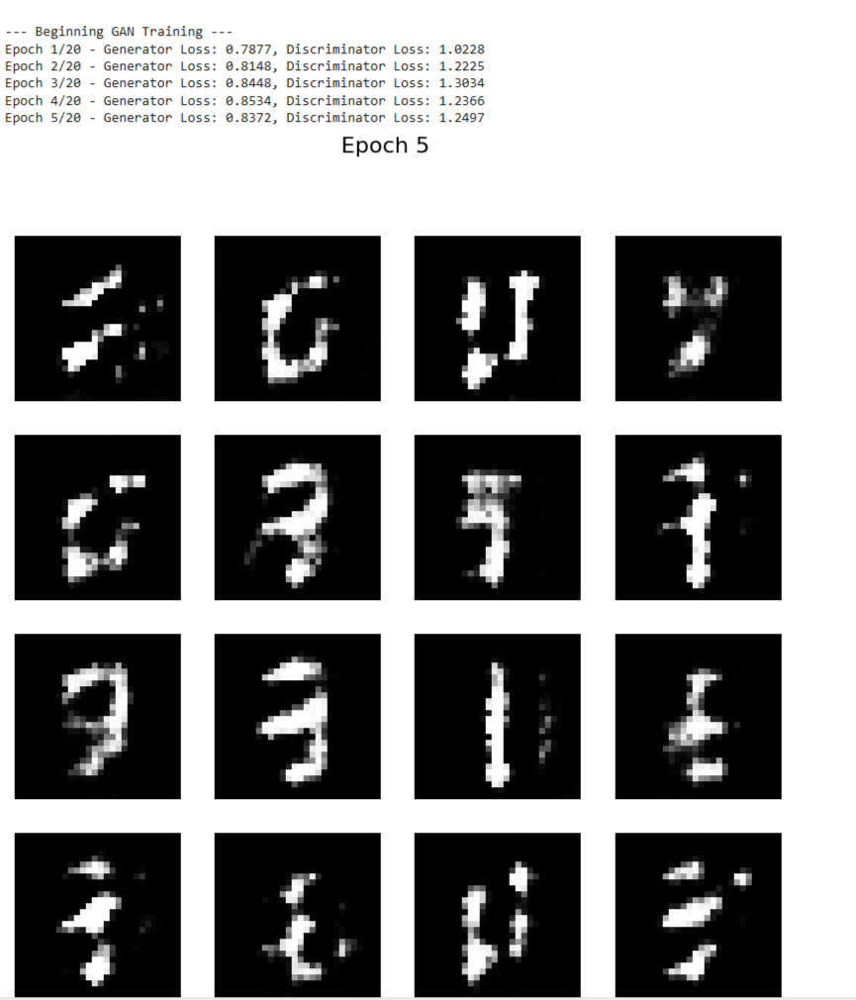

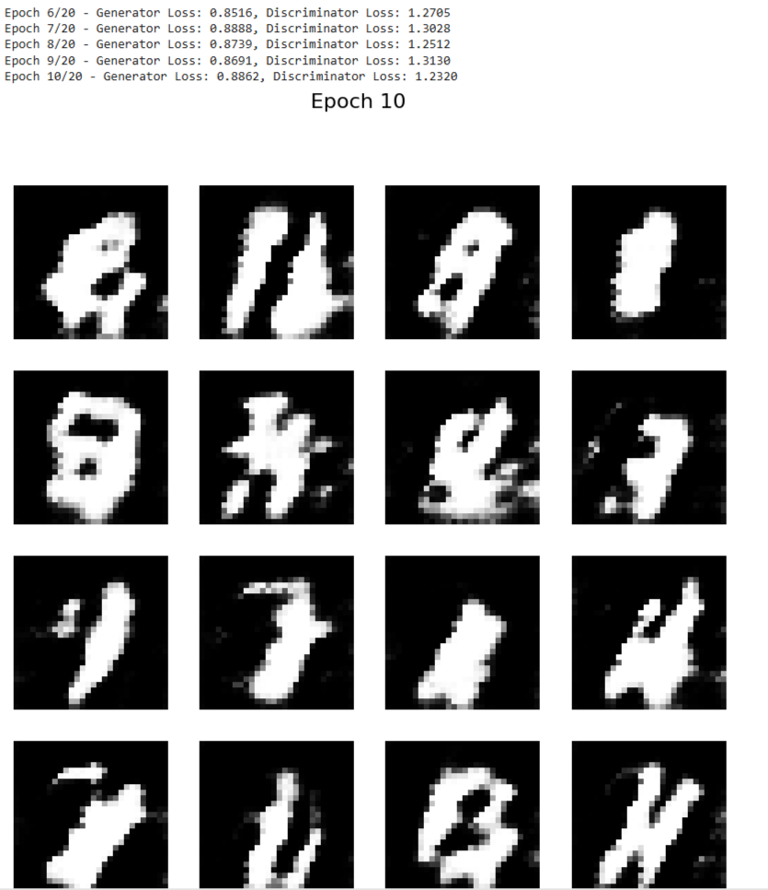

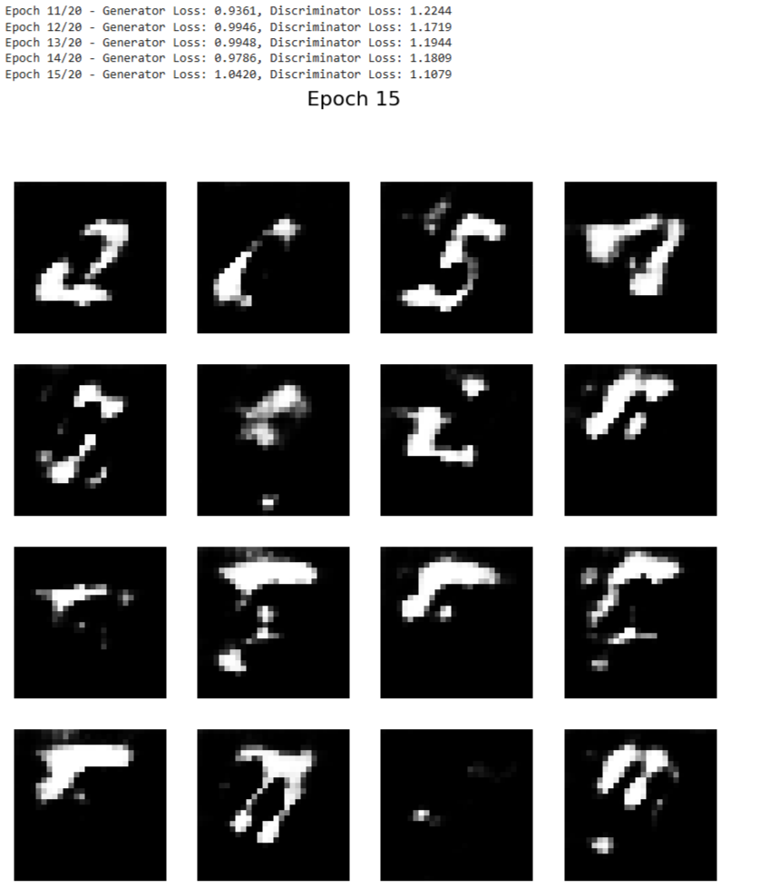

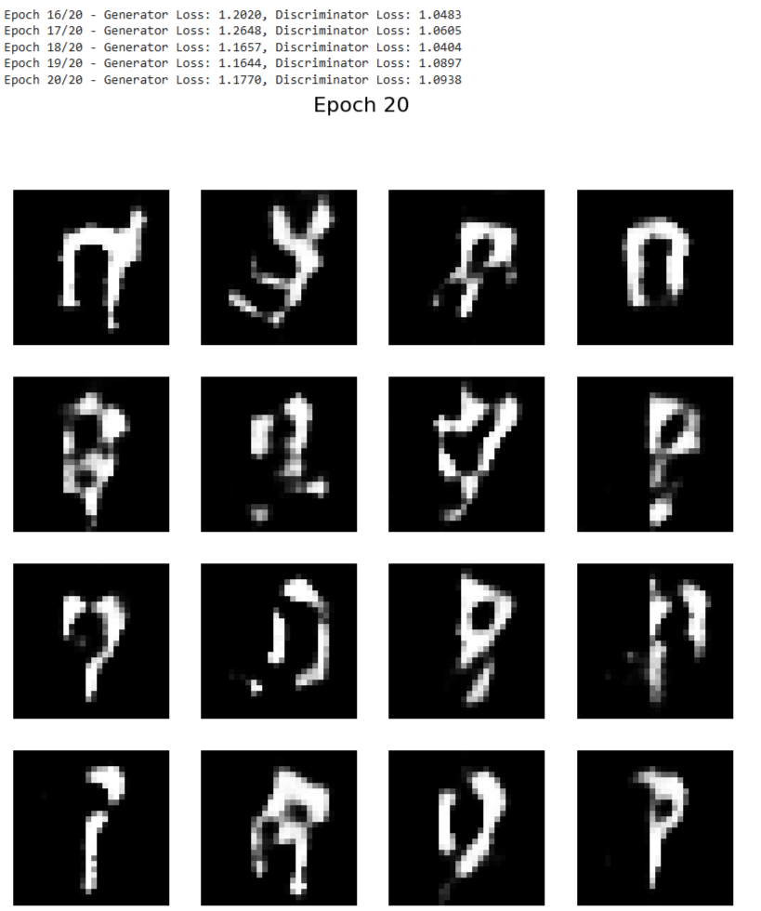

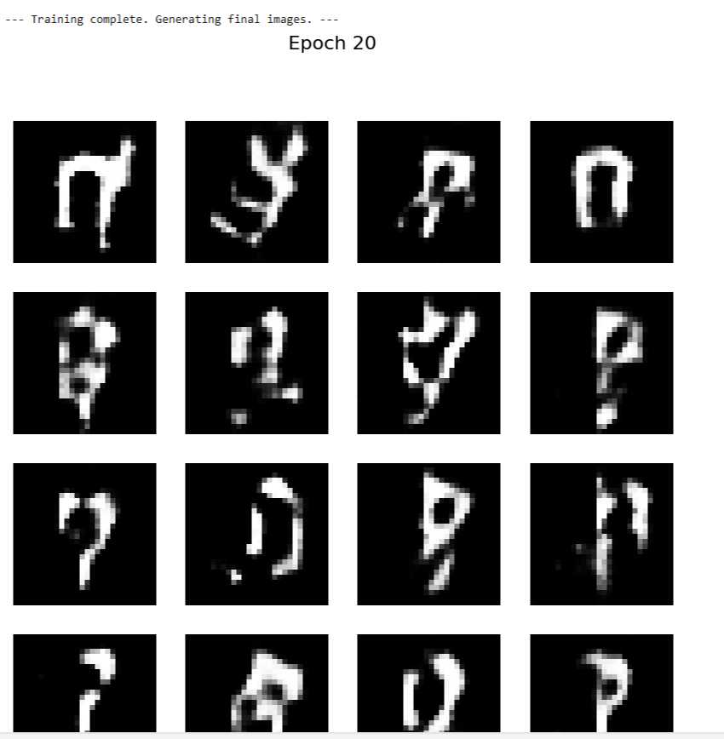

Exp No: 8 | Model Evaluation and Improvement:  Hyperparameter Tuning with Grid Search and Cross-Validation

Aim:
To demonstrate key techniques for model evaluation and improvement:
1. Hyperparameter Tuning with Grid Search : Systematically searching for the optimal
combination of hyperparameters for a machine learning model.
2. Cross-Validation Techniques: Implementing k-fold cross-validation to get a more robust
estimate of model performance and to prevent overfitting to a specific train-test split.

Algorithm:
1. Hyperparameter Tuning with Grid Search

Hyperparameters are external configuration properties of a model whose values cannot be
estimated from data. Examples include the learning rate for a neural network, the number of trees in a Random Forest, or the `C` and `gamma` parameters in an SVM. Tuning these parameters is crucial for optimal model performance.

Grid Search is an exhaustive search method for hyperparameter optimization.
Steps:
1. Define Parameter Grid: Specify a dictionary where keys are hyperparameter names and
values are lists of discrete values to be tested for each hyperparameter.
2. Instantiate Model: Choose a machine learning model.
3. Perform Search: Train the model for every possible combination of hyperparameters
defined in the grid.
4. Evaluate: For each combination, evaluate the model&#39;s performance using a specified scoring
metric (e.g., accuracy, F1-score) and often in conjunction with cross-validation.
5. Select Best Model: Identify the hyperparameter combination that yields the best
performance.

2. Cross-Validation Techniques

Cross-validation is a resampling procedure used to evaluate machine learning models on a limited data sample. The goal is to estimate how accurately a predictive model will perform in practice. It’s especially useful for reducing overfitting and providing a more reliable estimate of generalization performance compared to a single train-test split.

k-Fold Cross-Validation:
Steps:
1. Divide Data: The entire dataset is randomly partitioned into $k$ equally sized subsamples
(or “folds”).
2. Iterate $k$ Times:
In each iteration, one fold is used as the validation (or test) set, and the remaining $k-1$ folds
are used as the training set.The model is trained on the training set and evaluated on the validation set.
3. Aggregate Results: The performance metric (e.g., accuracy) from each of the $k$ iterations is collected.
4. Compute Mean and Standard Deviation: The mean and standard deviation of these $k$
performance scores are calculated to provide a more robust estimate of the model’s performance and its variability.

CODE:
# Import necessary libraries
import numpy as np
import pandas as pd
import matplotlib.pyplot as plt
import seaborn as sns
from sklearn.datasets import load_iris # A classic dataset for classification
from sklearn.model_selection import train_test_split, KFold, cross_val_score, GridSearchCV
from sklearn.svm import SVC # Support Vector Classifier, a common model for tuning
from sklearn.metrics import accuracy_score, classification_report, confusion_matrix
from sklearn.preprocessing import StandardScaler

# --- Part 1: Hyperparameter Tuning with Grid Search ---

print("--- Part 1: Hyperparameter Tuning with Grid Search ---")

# 1. Load a Dataset (Iris Dataset for classification)
# The Iris dataset is a classic and simple dataset for classification tasks.
# It contains measurements of iris flowers (sepal length, sepal width, petal length, petal width)
# and their corresponding species (Setosa, Versicolor, Virginica).
iris = load_iris()
X = iris.data
y = iris.target
feature_names = iris.feature_names
target_names = iris.target_names

print(f"\nDataset Features (X) shape: {X.shape}")
print(f"Dataset Labels (y) shape: {y.shape}")
print(f"Feature Names: {feature_names}")
print(f"Target Names: {target_names}")

# 2. Split Data into Training and Testing Sets
# It's crucial to split the data before scaling to prevent data leakage.
# The test set will be used for final model evaluation, after tuning.
X_train, X_test, y_train, y_test = train_test_split(X, y, test_size=0.3, random_state=42, stratify=y)

print(f"\nTraining set size: {X_train.shape[0]} samples")
print(f"Test set size: {X_test.shape[0]} samples")

# 3. Standardize Features
# Scaling features is important for SVMs as they are sensitive to feature scales.
# Fit scaler only on training data to prevent data leakage.
scaler = StandardScaler()
X_train_scaled = scaler.fit_transform(X_train)
X_test_scaled = scaler.transform(X_test)

print("\nFeatures standardized.")

# 4. Define the Model and Hyperparameter Grid
# We'll use a Support Vector Classifier (SVC) as our model.
# Common hyperparameters for SVC are 'C' (regularization parameter) and 'gamma' (kernel coefficient).
# 'kernel' also can be tuned (e.g., 'linear', 'rbf').

# Define the parameter grid for Grid Search
param_grid = {
'C': [0.1, 1, 10, 100], # Regularization parameter
'gamma': [1, 0.1, 0.01, 0.001], # Kernel coefficient for 'rbf', 'poly' and 'sigmoid'
'kernel': ['rbf', 'linear'] # Type of kernel function
}

print("\nHyperparameter grid defined:")
for param, values in param_grid.items():
print(f" {param}: {values}")

# 5. Perform Grid Search with Cross-Validation
# GridSearchCV automatically performs k-fold cross-validation for each combination.
# cv=5 means 5-fold cross-validation.
# scoring='accuracy' means we want to optimize for accuracy.
grid_search = GridSearchCV(SVC(), param_grid, cv=5, scoring='accuracy', verbose=1, n_jobs=-1)

print("\nStarting Grid Search with 5-fold Cross-Validation...")
# Fit GridSearchCV on the scaled training data
grid_search.fit(X_train_scaled, y_train)

print("\nGrid Search completed.")

# 6. Get the Best Parameters and Best Score
print(f"\nBest hyperparameters found: {grid_search.best_params_}")
print(f"Best cross-validation accuracy: {grid_search.best_score_:.4f}")

# 7. Evaluate the Best Model on the Test Set
# The best_estimator_ attribute provides the model trained with the best parameters.
best_model = grid_search.best_estimator_
y_pred_tuned = best_model.predict(X_test_scaled)

test_accuracy_tuned = accuracy_score(y_test, y_pred_tuned)
print(f"\nTest set accuracy with tuned model: {test_accuracy_tuned:.4f}")

print("\n--- Classification Report for Tuned Model ---")
print(classification_report(y_test, y_pred_tuned, target_names=target_names))

print("\n--- Confusion Matrix for Tuned Model ---")
cm_tuned = confusion_matrix(y_test, y_pred_tuned)
plt.figure(figsize=(8, 6))
sns.heatmap(cm_tuned, annot=True, fmt='d', cmap='Blues', xticklabels=target_names, yticklabels=target_names)
plt.title('Confusion Matrix (Tuned SVM)')
plt.xlabel('Predicted Label')
plt.ylabel('True Label')
plt.show()

# Visualize Grid Search results (optional, but good for understanding)
# Convert results to a DataFrame for easier analysis
results_df = pd.DataFrame(grid_search.cv_results_)
print("\n--- Top 5 Grid Search Results ---")
print(results_df[['param_C', 'param_gamma', 'param_kernel', 'mean_test_score', 'rank_test_score']].sort_values(by='rank_test_score').head())

# --- Part 2: Cross-Validation Techniques (k-fold) ---

print("\n--- Part 2: Cross-Validation Techniques (k-fold) ---")

# We will demonstrate k-fold cross-validation on a simple SVM without explicit tuning for clarity,
# to focus solely on the CV process.

# 1. Instantiate a Model (using default or chosen parameters)
model_cv = SVC(random_state=42) # Using default parameters for simplicity

# 2. Define k-fold Cross-Validation Strategy
# We'll use 5-fold cross-validation.
# KFold ensures that each fold is distinct.
# shuffle=True means the data will be randomly shuffled before splitting into folds.
# random_state for reproducibility.
k_folds = 5
kf = KFold(n_splits=k_folds, shuffle=True, random_state=42)

print(f"\nPerforming {k_folds}-fold cross-validation...")

# 3. Perform Cross-Validation and Get Scores
# cross_val_score performs the KFold splitting, training, and evaluation automatically.
# It returns an array of scores, one for each fold.
cv_scores = cross_val_score(model_cv, X_train_scaled, y_train, cv=kf, scoring='accuracy')

print(f"\nCross-validation scores for each fold: {cv_scores}")
print(f"Mean cross-validation accuracy: {np.mean(cv_scores):.4f}")
print(f"Standard deviation of cross-validation accuracy: {np.std(cv_scores):.4f}")

# 4. Visualize Cross-Validation Scores
plt.figure(figsize=(8, 5))
plt.bar(range(1, k_folds + 1), cv_scores, color='skyblue')
plt.axhline(y=np.mean(cv_scores), color='r', linestyle='--', label=f'Mean Accuracy ({np.mean(cv_scores):.4f})')
plt.title(f'{k_folds}-Fold Cross-Validation Accuracy Scores')
plt.xlabel('Fold Number')
plt.ylabel('Accuracy')
plt.ylim(0.8, 1.0) # Set y-axis limits for better visualization
plt.legend()
plt.grid(axis='y', linestyle='--')
plt.show()

# 5. Discuss why CV is useful
print("\n--- Why is Cross-Validation Important? ---")
print("1. More Reliable Performance Estimate: Reduces bias from a single train-test split.")
print("2. Better Generalization: Helps ensure the model performs well on unseen data.")
print("3. Efficient Data Usage: All data points are used for both training and validation across different folds.")
print("4. Detects Overfitting/Underfitting: Variability in scores can indicate instability.")

OUTPUT:
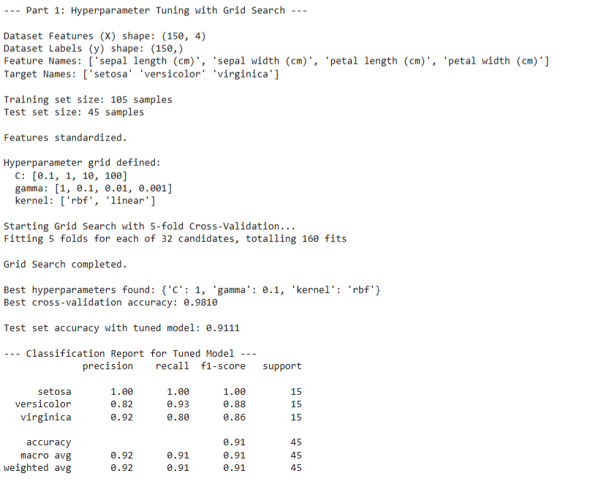
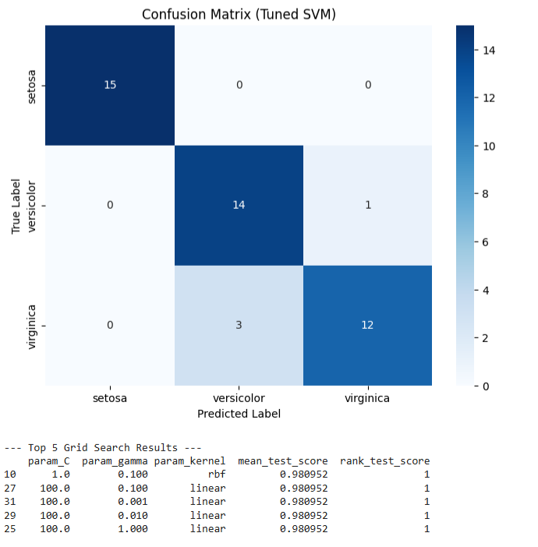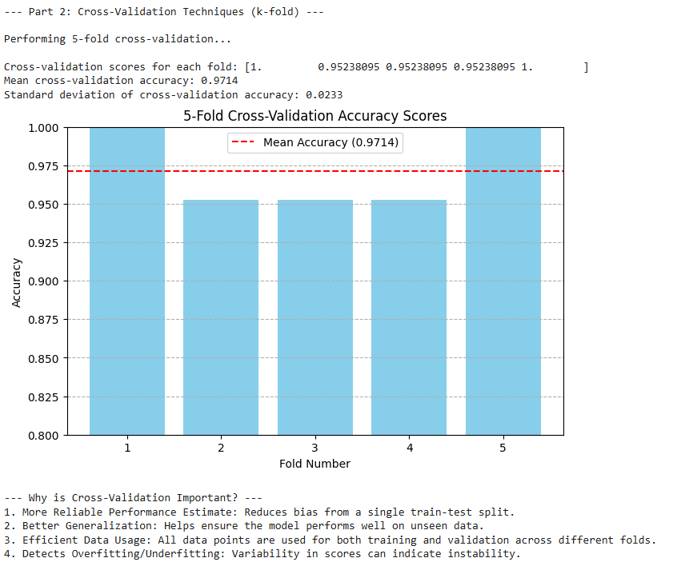
Exp No: 9 | Model Deployment:  REST API with Flask and Containerization with Docker

Aim:
To demonstrate the process of deploying a pre-trained machine learning model as a RESTful API using Flask, and then containerizing this API and model using Docker for easy deployment and portability.

Algorithm:
1. RESTful API Design (Flask)
Representational State Transfer (REST) is an architectural style for networked applications. A RESTful API uses standard HTTP methods (GET, POST, PUT, DELETE) to perform operations on resources.
Key Concepts:
Resources: Any data object that can be identified, named, addressed, or handled in the web. In our case, the ML model's prediction endpoint will be a resource.
Endpoints: Specific URLs that represent the resources.
HTTP Methods:
`POST`: Used to submit data to a specified resource (e.g., send new data for prediction).
`GET`: Used to request data from a specified resource (e.g., check API status).
Statelessness: Each request from a client to a server must contain all the information needed to understand the request. The server should not store any client context between requests.
JSON: JavaScript Object Notation is commonly used for data exchange between the client and the API.

2. Containerization with Docker
Docker is a platform that uses OS-level virtualization to deliver software in packages called containers. Containers are isolated from one another and bundle their own software, libraries, and configuration files.

Key Concepts:
Dockerfile: A text file that contains all the commands a user could call on the command line to assemble an image. It defines the environment, dependencies, and execution command for your application.
Image: A lightweight, standalone, executable package of software that includes everything needed to run an application: code, runtime, system tools, system libraries, and settings.
Container: A runnable instance of an image. You can create, start, stop, move, or delete a container.
Port Mapping: Connecting a port on the host machine to a port inside the Docker container.
CODE:
OUTPUT:

