|  |  |  |
| --- | --- | --- |
| **Ex.No.: 4** | | **WORKING WITH CONSTRAINTS** |
| **Date:** | 2/8/24 |

1. Add a table-level PRIMARY KEY constraint to the EMP table on the ID column.The constraint should be named at creation. Name the constraint my_emp_id_pk.

CREATE TABLE EMP ( EmpNo NUMBER(7) PRIMARY KEY,

Last_name VARCHAR2(25) NOT NULL,First_name VARCHAR2(25));

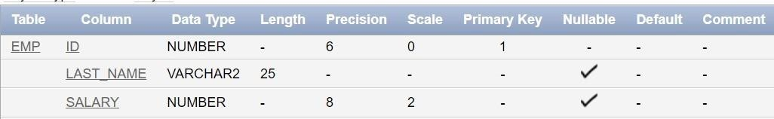

1. Create a PRIMAY KEY constraint to the DEPT table using the ID colum. The constraint should be named at creation. Name the constraint my_dept_id_pk.

CREATE TABLE DEPT (Dept_id NUMBER(6) NOT NULL,Dept_name

VARCHAR2(20) NOT NULL,Manager_id NUMBER(6), Location_id NUMBER(4),CONSTRAINT my_dept_id_pk PRIMARY KEY (Dept_id));

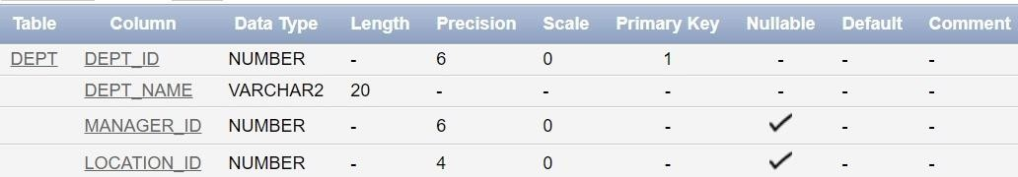

1. Add a column DEPT_ID to the EMP table. Add a foreign key reference on the EMP table that ensures that the employee is not assigned to nonexistent deparment. Name the constraint my_emp_dept_id_fk.

ALTER TABLE EMP ADD Dept_id NUMBER(6);

ALTER TABLE EMP ADD CONSTRAINT my_emp_dept_id_fk FOREIGN KEY (Dept_id) REFERENCES DEPT (Dept_id);

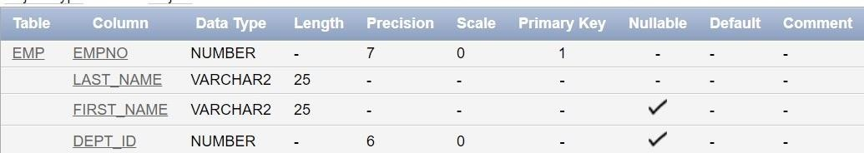

1. Modify the EMP table. Add a COMMISSION column of NUMBER data type, precision 2, scale 2. Add a constraint to the commission column that ensures that a commission value is greater than zero.

ALTER TABLE EMP

ADD Commission NUMBER(8,2) CONSTRAINT commission_check CHECK (Commission > 0);

