Echo_server

#include<sys/types.h>

#include<sys/socket.h>

#include<netinet/in.h>

#include<sys/stat.h>

#include<unistd.h>

#include<stdlib.h>

#include<stdio.h>

#include<fcntl.h>

#include <arpa/inet.h>

void str_echo(int connfd)

{

int n;

int bufsize = 1024;

char *buffer = malloc(bufsize);

//printf("inside the function");

again: while((n=recv(connfd, buffer, bufsize, 0))>0)

send(connfd,buffer,n,0);

//printf("%d n",n);

if(n<0)

goto again;

}

int main()

{

int cont,listenfd,connfd,addrlen,addrlen2,fd,pid,addrlen3;

//char fname[256];

struct sockaddr_in address,cli_address;

if ((listenfd = socket(AF_INET,SOCK_STREAM,0)) > 0) //sockfd

printf("The socket was created\n");

address.sin_family = AF_INET;

address.sin_addr.s_addr = INADDR_ANY;

address.sin_port = htons(15001);

printf("The address before bind %s ...\n",inet_ntoa(address.sin_addr) );

if (bind(listenfd,(struct sockaddr *)&address,sizeof(address)) == 0)

printf("Binding Socket\n");

printf("The address after bind %s ...\n",inet_ntoa(address.sin_addr) );

listen(listenfd,3);

printf("server is listening\n");

//server local address

getsockname(listenfd,(struct sockaddr *)&address,&addrlen3);

printf("The server's local address %s ...and port %d\n",inet_ntoa(address.sin_addr),htons(address.sin_port));

for(;;){

addrlen = sizeof(struct sockaddr_in);

connfd = accept(listenfd,(struct sockaddr *)&cli_address,&addrlen);

//printf("The address %s ...\n",inet_ntoa(address.sin_addr) );

addrlen2 = sizeof(struct sockaddr_in);

int i = getpeername(connfd,(struct sockaddr *)&cli_address,&addrlen);

printf("The Client %s is Connected...on port %d\n",inet_ntoa(cli_address.sin_addr),htons(cli_address.sin_port));

if((pid=fork())==0)

{

printf("inside child\n");

close(listenfd);

str_echo(connfd);

exit(0);

}

close(connfd);}

return 0 ;

}

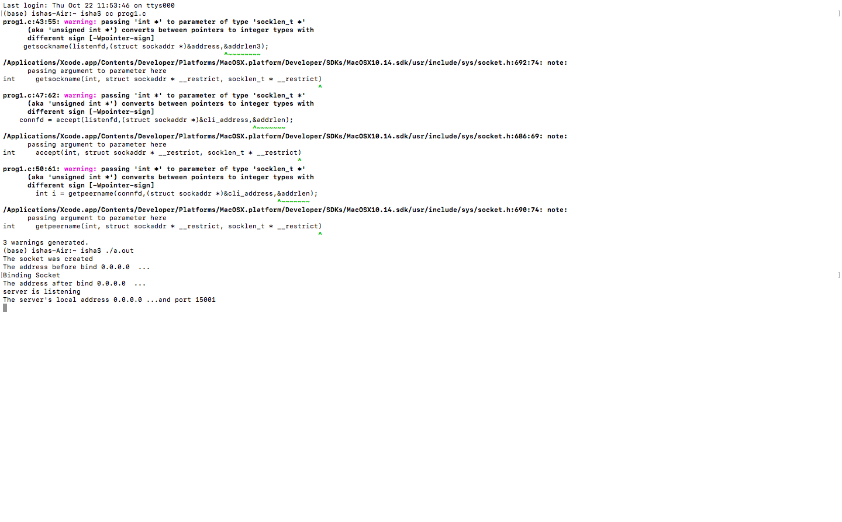

Echo_client

/*Client*/

#include<sys/socket.h>

#include<sys/types.h>

#include<netinet/in.h>

#include<unistd.h>

#include<stdlib.h>

#include<stdio.h>

void str_cli(FILE *fp, int sockfd)

{

int bufsize = 1024, cont;

char *buffer = malloc(bufsize);

while(fgets(buffer,bufsize,fp)!=NULL)

{

send(sockfd, buffer, sizeof(buffer), 0);

if((cont=recv(sockfd, buffer, bufsize, 0))>0) {

fputs(buffer,stdout);

}}

printf("\nEOF\n");

}

int main(int argc,char *argv[])

{

int create_socket;

//char fname[256];

struct sockaddr_in address;

if ((create_socket = socket(AF_INET,SOCK_STREAM,0)) > 0)

printf("The Socket was created\n");

address.sin_family = AF_INET;

address.sin_port = htons(15001);

inet_pton(AF_INET,argv[1],&address.sin_addr);

if (connect(create_socket,(struct sockaddr *) &address, sizeof(address)) == 0)

printf("The connection was accepted with the server %s...\n",argv[1]);

else

printf("error in connect \n");

//printf("Enter The Filename to Request : "); scanf("%s",fname);

//send(create_socket, fname, sizeof(fname), 0);

//printf("Request Accepted... Receiving File...\n\n");

//printf("The contents of file are...\n\n");

str_cli(stdin,create_socket);

return close(create_socket);

}

