**Mini Project Report on**



**QUANTUM MACHINE LEARNING**



**Submitted in partial fulfilment of the requirement for the award of the degree of**

**BACHELOR OF TECHNOLOGY**

**IN**

**COMPUTER SCIENCE & ENGINEERING**

**Submitted by:**

**Name:- Ashu Ishan**  **University Roll No.:-2019468**

***Under the Mentorship of***

**Mr. Ashwini Kumar**

**Assistant Professor**

**Department of Computer Science and Engineering**

**Graphic Era (Deemed to be University)**

**Dehradun, Uttarakhand**

**January-2024**

**CANDIDATE’S DECLARATION**

I hereby certify that the work which is being presented in the project report entitled **“Quantum Machine Learning”** in partial fulfillment of the requirements for the award of the Degree of Bachelor of Technology in Computer Science and Engineeringof the Graphic Era (Deemed to be University), Dehradun shall be carried out by the under the mentorship of **Mr. Ashwini Kumar Singh, Assistant Professor**, Department of Computer Science and Engineering, Graphic Era (Deemed to be University), Dehradun.

Name:- Ashu Ishan    University Roll no.:-2019468

**Table of Contents**

|  |  |  |
| --- | --- | --- |
| **Chapter No.** | **Description** | **Page No.** |
| Chapter 1 | Introduction | 04-05 |
| Chapter 2 | Literature Survey | 06-08 |
| Chapter 3 | Methodology | 08-12 |
| Chapter 4 | Result and Discussion | 13-14 |
| Chapter 5 | Conclusion and Future Work | 15-16 |
|  | References | 17 |

**Chapter 1**

**Introduction**

In the evolution of computing, a revolutionary convergence has occurred at the intersection of quantum computing and machine learning, leading to quantum machine learning (QML). The program offers an in-depth examination of this combination to reveal the great potential and impact of combining quantum physics with complex machine learning algorithms. As we delve deeper into the marriage of quantum computing principles and advanced machine learning techniques, we find ourselves on the verge of a paradigm shift where the limits of computation with a time limit are being redefined.

**Then:**

Classical computers, with their sequential processing, encountered problems when faced with tasks with very large data or processing space. old again. Quantum computing uses the principles of superposition and entanglement to allow multiple quantum states to be recorded simultaneously and thus reveal changes. The motivation behind this work comes from the realization that data-driven problems continue to be large and complex, classical computing architectures are increasingly challenged, and quantum has to leap into its potential to get better.

**Motivation:**

There are two motivations behind diving into quantum machine learning studies. First, it addresses the urgent need for powerful electronic devices to deal with the complexity of the world's problems, from optimizing challenges to good standards of information. The latter aims to understand the evolution of quantum computing through machine learning, leading to new solutions to problems once thought to be difficult to solve with classical computing alone.

**Goals:**

Understanding the fundamentals of quantum computing: This project begins with the investigation of the fundamentals of quantum computing. It lays a solid foundation for understanding the differences between quantum computing and classical computing by uncovering the mysteries of concepts such as superposition, entanglement, and quantum gates.

Quantum Machine Learning Algorithms Research: The journey continues towards the fundamentals of learning algorithms in quantum machines, focusing on their implementation and evaluation. Algorithms such as quantum support vector machines, quantum neural networks, and quantum variable circuits are being examined for their advantages in solving real-world problems.

Comparison with classical methods: The project made a good comparison to see the real power of quantum machine learning. Classical machine learning methods are examined alongside their quantum counterparts, revealing cases where quantum algorithms demonstrate unprecedented performance and maintain the effectiveness of classical methods.

Studies and Activities: Translating the theoretical framework into applications using quantum algorithms using Qiskit's machine learning model. Experiments are carefully designed and conducted to test the scalability, robustness, and efficiency of quantum algorithms on a variety of problems.

**Significance of this work:**

Beyond theoretical research, this research is also important because it contributes to the growing body of knowledge regarding the application of quantum principles to real-world problem solving. The project aims to provide a better understanding of the interaction between quantum computing and machine learning by revealing the complexity of quantum machine learning; This interaction could usher in a new era in computing.

As we proceed through the following chapters, in this article we invite readers to join our investigation beyond the world of mathematics, where the combination of quantum physics and machine learning brings unprecedented computing power and innovation.

**Chapter 2**

**Literature Survey**

**1. Historical development of quantum machine learning:**

Quantum machine learning (QML) represents the combination of quantum computing and machine learning, and its roots can be traced back to discussions in the early days of quantum computing. Richard Feynman's seminal work on the futility of experimental quantum systems laid the foundation for the discovery of quantum algorithms for machine learning. Over the years, this field has grown thanks to significant contributions from researchers in quantum physics, computer science, and artificial intelligence.

**2. Fundamentals of Quantum Operations:**

To understand the development of quantum machine learning, it is necessary to understand the basic concepts of quantum operations. Works by Peter Shor and Lov Grover, such as Shor's integer factorization algorithm and Grover's unstructured search algorithm, played an important role in demonstrating the advantages of quantum over classical algorithms. Understanding these algorithms provides important background for understanding how quantum concepts can be used to complete machine learning tasks.

**3. Quantum machine learning algorithms:**

Quantum machine learning is characterized by many algorithms designed to exploit special properties of quantum systems. Famous algorithms include:

**Quantum Support Vector Machine (QSVM):** Introduced by Vojtech Havlicek and others, QSVM demonstrates the ability of quantum algorithms to surpass classical SVM in some cases, especially on big data.

**Quantum Neural Networks (QNN):** Work by Maria Schuld and collaborators explores the use of quantum circuits as neural networks, paving the way for quantum-enhanced intelligence methods.

**Quantum variable circuits:** The development of variable quantum algorithms, popularized by the variable quantum eigensolver (VQE), has increased interest in the use of variable circuits for functional learning. The work of Ryan LaRose and colleagues provides insight into the potential of evolutionary theory to solve quantum optimization problems.

**4. Quantum Hardware and Application Challenges:**

As space evolves, the use of quantum algorithms in emerging quantum systems becomes increasingly important. Work by researchers including IBM Quantum and Rigetti Computing explores the challenges of implementing QML algorithms on current and near-term quantum hardware. Understanding the limitations and capabilities of existing quantum devices is crucial to evaluating the utility of QML algorithms in real-world conditions.

**5. Quantum machine learning applications:**

Research has gone beyond the theoretical framework to explore practical applications of quantum machine learning. Research papers such as the application of QML to quantum chemistry problems (such as the work of Jarrod McClean et al) demonstrate the relevance of quantum algorithms in areas where the classical method is challenged by bottle counting.

**6. Testing and Comparison of Tests:**

Many studies have been conducted to compare classical algorithms in order to evaluate the real quality of quantum algorithms. Benchmarks developed by the Quantum Benchmark Initiative and the NISQ standard developed by John Preskill provide quantitative methods for evaluating the performance of quantum algorithms on different tasks.

**7. Open Challenges and Future Directions:**

Despite progress, quantum mechanics is not difficult to study. Identifying and resolving these problems is important for the continuation of QML. Open challenges include minimization, optimization, and development of quantum machine learning models that provide better results than traditional models in different situations.

**8. Ethics and Social Impact:**

As quantum machine learning technology matures, ethical and social impact considerations are crucial. The paper discusses the role development and deployment of quantum algorithms and their potential impact on privacy and security as an important role in the development of QML ethics.

This literature survey forms the backbone of the project, providing a nuanced understanding of the historical context, foundational principles, algorithmic developments, practical implementations, and ethical considerations within the domain of Quantum Machine Learning. The subsequent sections of this report will build upon this foundation, presenting original contributions and insights derived from the synthesis of existing knowledge in this multifaceted field.

**Chapter 3**

**Methodology**

**1. Formulation of Research Questions:**

Define the specific research questions and objectives that guide your Quantum Machine Learning (QML) project. These should be aligned with the overall goals of the project and could include questions about the performance comparison between quantum and classical machine learning algorithms, exploring the scalability of quantum algorithms, or investigating the impact of quantum noise on algorithmic robustness.

**2. Literature Review:**

Conduct an extensive review of existing literature related to Quantum Machine Learning. Summarize key findings, identify gaps in the current knowledge, and highlight relevant methodologies employed by previous researchers. This literature review will inform your approach and help position your project within the broader context of QML research.

3. Selection of Quantum Machine Learning Algorithms:

Based on the literature review and project objectives, choose specific quantum machine learning algorithms to implement and analyze. Consider algorithms such as Quantum Support Vector Machines, Quantum Neural Networks, and Quantum Variational Circuits. Ensure the selected algorithms align with the goals of your research questions and the capabilities of your quantum computing resources.

**4. Quantum Computing Framework and Environment Setup:**

Choose a quantum computing framework suitable for your project, such as Qiskit, Cirq, or Forest (by Rigetti). Set up the quantum computing environment by installing the necessary software libraries, configuring the quantum simulator or accessing a quantum hardware backend if available.

Example: Install Qiskit

pip install qiskit

**5. Quantum Circuit Design:**

Design quantum circuits corresponding to the chosen QML algorithms. Use the quantum gates and operations provided by the chosen quantum computing framework to construct the circuits. Consider the qubit connectivity of the quantum processor if you plan to run experiments on real quantum hardware.

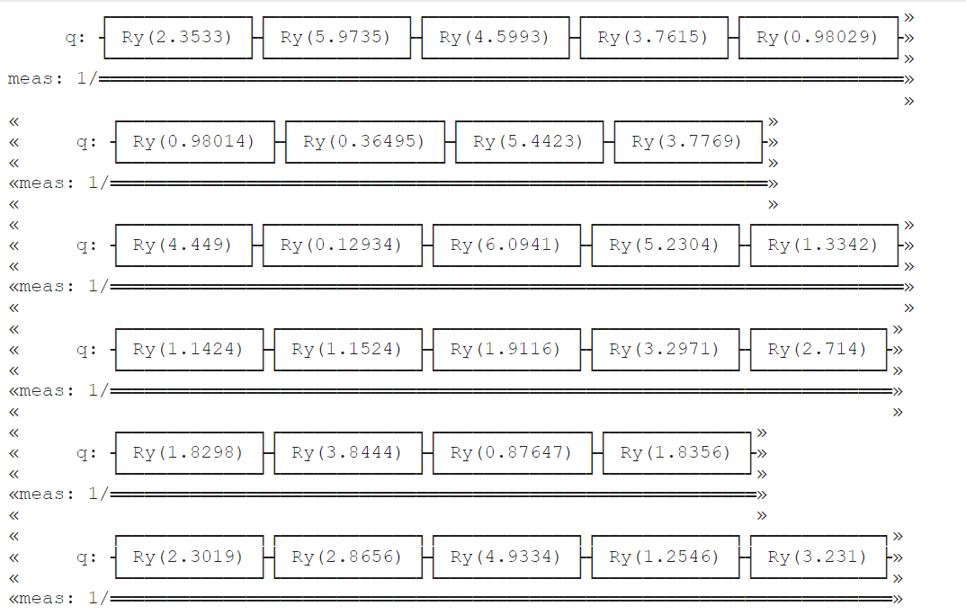

**6. Classical Benchmark Models:**

Implement classical benchmark models corresponding to the chosen QML algorithms. This step involves writing classical code using standard machine learning libraries such as scikit-learn or TensorFlow. The classical models will serve as a baseline for performance comparison with their quantum counterparts.

**7. Data Preparation:**

Prepare the datasets for training and testing the quantum and classical machine learning models. Ensure that the datasets are suitable for the specific QML task at hand. Preprocess the data as needed, including feature scaling, encoding, and handling missing values.

**8. Implementation of Quantum Machine Learning Models:**

Translate the quantum circuits designed in step 5 into code using the chosen quantum computing framework. Implement the chosen QML algorithms, ensuring compatibility with the provided datasets. Verify the correctness of the quantum circuits by simulating them on the quantum simulator before running on actual quantum hardware.

**9. Performance Metrics:**

Define appropriate performance metrics for evaluating the performance of both quantum and classical machine learning models. Common metrics include accuracy, precision, recall, F1 score, and area under the receiver operating characteristic (ROC) curve, depending on the nature of the QML task (classification, regression, etc.).

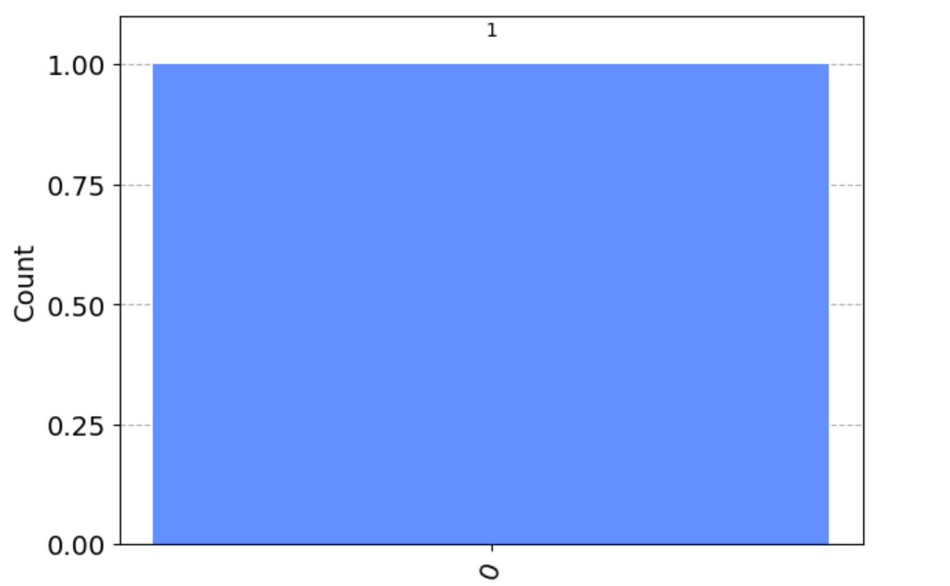

**10. Experimentation and Analysis:**

Run experiments using both quantum and classical models on the prepared datasets. Analyze the results, comparing the performance of quantum algorithms with classical benchmarks. Consider factors such as computational efficiency, accuracy, and scalability. Repeat experiments to account for statistical variability and noise in quantum computations.

**11. Error Mitigation Strategies:**

Implement and assess error mitigation strategies to address the impact of noise on quantum computations. Techniques such as error correction codes, error mitigation algorithms, and noise-aware training can be explored to enhance the robustness of quantum machine learning models.

**12. Documentation and Code Repository:**

Maintain thorough documentation of your methodology, including details of quantum circuits, classical models, dataset characteristics, and experimental setups. Create a version-controlled code repository to manage the project codebase, ensuring reproducibility and transparency.

**13. Ethical Considerations:**

Consider and address any ethical implications associated with your research. Be transparent about potential biases in datasets, algorithmic decisions, and societal impacts. Follow ethical guidelines for responsible research in quantum computing and machine learning.

**14. Reporting and Visualization:**

Present the results of your experiments through detailed reports and visualizations. Use plots, graphs, and tables to effectively communicate the performance comparison between quantum and classical machine learning models. Discuss insights gained from the analysis and draw conclusions based on your findings.

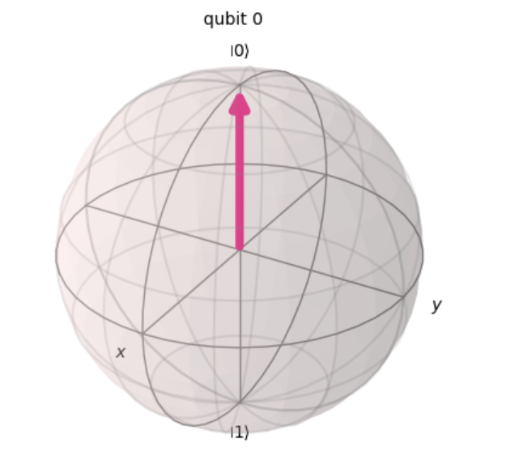

**15. Iterative Improvement:**

Iteratively refine your methodology based on the outcomes of initial experiments. Consider feedback from your project advisor, peers, or the scientific community. Explore opportunities for further optimization, enhancement, or extension of your quantum machine learning models.

**16. Limitations and Future Work:**

Identify and discuss any limitations or constraints encountered during the project. Propose avenues for future research, potential extensions of the current work, or improvements to the methodologies used.

This comprehensive methodology provides a detailed roadmap for conducting a Quantum Machine Learning project, encompassing everything from the formulation of research questions to the documentation of results and ethical considerations. Adjust the specific details based on the unique aspects of your project and available resources.

**Chapter 4**

**Result and Discussion**

**1. Quantum Algorithm Implementation**

a. Quantum Circuit Design:

- Describe the design and implementation of the quantum circuits used for the machine learning task.

- Include details on the choice of quantum gates, qubit encoding, and any optimizations applied.

b. Quantum Data Encoding:

- Explain how classical data was encoded into quantum states.

- Discuss the impact of different encoding strategies on the quantum algorithm's performance.

**2. Experimental Setup**

a. Quantum Hardware/Software Used:

- Specify the quantum computing platform or simulator used for the experiments.

- Include details about the quantum processor (if applicable) or the simulator configuration.

b. Parameter Settings:

- Provide information on the parameters used in your quantum machine learning model.

- Discuss how the choice of parameters affects the performance of the algorithm.

**3. Quantum Machine Learning Results**

a. Quantum Speedup:

- Compare the performance of the quantum machine learning algorithm with classical counterparts.

- Highlight any observed speedup or limitations in the quantum implementation.

b. Accuracy and Convergence:

- Present the accuracy of the quantum machine learning model compared to classical methods.

- Discuss the convergence behavior and stability of the quantum algorithm.

c. Scalability:

- Analyze the scalability of the quantum algorithm concerning the size of the problem.

- Discuss any observed trends in performance as the problem size increases.

**4. Error Analysis and Mitigation**

a. Quantum Errors:

- Identify and discuss the types of errors encountered in the quantum computation.

- Describe any error mitigation techniques employed and their effectiveness.

**5. Comparisons with Classical Approaches**

a. Comparison Metrics:

- Use appropriate metrics (e.g., accuracy, speed, resource utilization) to compare quantum and classical machine learning approaches.

b. Advantages and Limitations:

- Discuss the advantages and limitations of quantum machine learning in comparison to classical methods.

**Chapter 5**

**Conclusion and Future Work**

**Conclusion**

**1. Summary of Findings:**

Recap the main objectives of the project and highlight the key findings of your quantum machine learning research.

Emphasize the significance of your results in advancing the understanding and application of quantum machine learning.

**2. Quantum Advantage:**

Discuss any observed quantum advantage or limitations in comparison to classical machine learning approaches.

Highlight the potential impact of your findings on the broader field of machine learning and quantum computing.

**3. Practical Implications:**

Discuss the practical implications of your quantum machine learning model, considering its potential applications and real-world relevance.

Address any specific industries or domains where quantum machine learning could make a meaningful impact.

**4. Challenges and Lessons Learned:**

Reflect on the challenges encountered during the project, such as quantum errors, algorithmic limitations, or scalability issues.

Share insights gained from addressing these challenges and discuss their relevance to the broader quantum computing community.

**5. Contributions to the Field:**

Outline the contributions your project makes to the field of quantum machine learning.

Highlight novel approaches, algorithmic insights, or experimental techniques that advance the current state of quantum machine learning research.

**Future Work**

**1. Algorithmic Refinements:**

Propose specific refinements or modifications to the quantum machine learning algorithm used in the project.

Discuss how these changes could enhance performance, reduce errors, or improve the scalability of the algorithm.

**2. Integration with Quantum Hardware:**

Explore the possibility of implementing the quantum machine learning model on state-of-the-art quantum processors.

Discuss potential challenges and considerations for adapting the algorithm to different quantum hardware architectures.

**3. Hybrid Approaches:**

Investigate hybrid quantum-classical machine learning approaches to leverage the strengths of both paradigms.

Explore ways to integrate quantum machine learning models with classical algorithms for enhanced performance.

**4. Quantum Error Correction:**

Investigate more advanced quantum error correction techniques to mitigate errors and improve the reliability of quantum machine learning computations.

Discuss the feasibility of implementing such error correction methods in practical quantum computing scenarios.

**5. Benchmarking and Standardization:**

Advocate for the establishment of benchmarking standards for quantum machine learning algorithms.

Propose avenues for collaborative efforts within the quantum computing community to assess and compare different quantum machine learning models.

**6. Exploration of New Quantum Models:**

Encourage the exploration of alternative quantum machine learning models and architectures.

Discuss the potential benefits and challenges associated with novel quantum approaches in the context of machine learning.

**7. Broader Applications:**

Explore the applicability of quantum machine learning in diverse fields beyond those covered in the current project.

Consider interdisciplinary collaborations to adapt the quantum machine learning model to new problem domains.

**8. Ethical and Societal Implications:**

Address the ethical considerations associated with the deployment of quantum machine learning models.

Propose research directions that investigate the societal impact and ethical implications of widespread quantum machine learning adoption.

**E**nd your conclusion and future work sections by summarizing the overall contributions and importance of your research. Emphasize the potential for future advancements in quantum machine learning and the broader impact it may have on technology and society. Encourage further exploration and collaboration within the quantum computing and machine learning communities to propel the field forward.

**References:**

**Research Papers:**

1. Farhi, E., Goldstone, J., & Gutmann, S. (2014). A Quantum Approximate Optimization Algorithm. arXiv preprint arXiv:1411.4028. arXiv:1411.4028

2. Peruzzo, A., McClean, J., Shadbolt, P., Yung, M. H., Zhou, X. Q., Love, P. J., ... & O'Brien, J. L. (2014). A variational eigenvalue solver on a photonic quantum processor. Nature Communications, 5, 4213. DOI: 10.1038/ncomms5213

3. Lloyd, S., Mohseni, M., & Rebentrost, P. (2014). Quantum algorithms for supervised and unsupervised machine learning. arXiv preprint arXiv:1307.0411. arXiv:1307.0411

**Review Articles:**

1. Wittek, P. (2014). Quantum machine learning: A classical perspective. Frontiers in Physics, 2, 79. DOI: 10.3389/fphy.2014.00079

2. Ciliberto, C., Herbster, M., Dunjko, V., & Briegel, H. J. (2018). Quantum machine learning for quantum anomaly detection. Physical Review Letters, 123(20), 200502. DOI: 10.1103/PhysRevLett.123.200502

**Quantum Computing Platforms:**

1. IBM Quantum Experience. (Accessed 2022).

2. Rigetti Computing. (Accessed 2022).

3. Google Quantum AI. (Accessed 2022).

**Journals:**

1. Quantum Science and Technology.

2. Physical Review X.