**MSIS 2601 – Object Oriented Programming Assignment 1**

Screenshot of the command prompt terminal

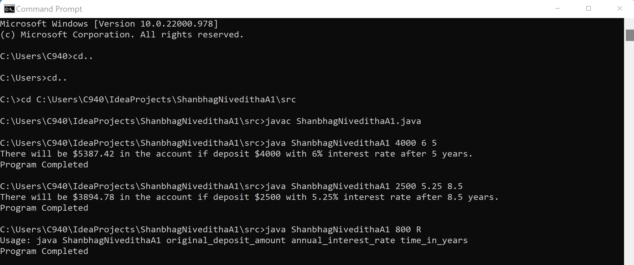

Screenshot of the in-built IDE (IntelliJ IDEA)

Test Case 1:

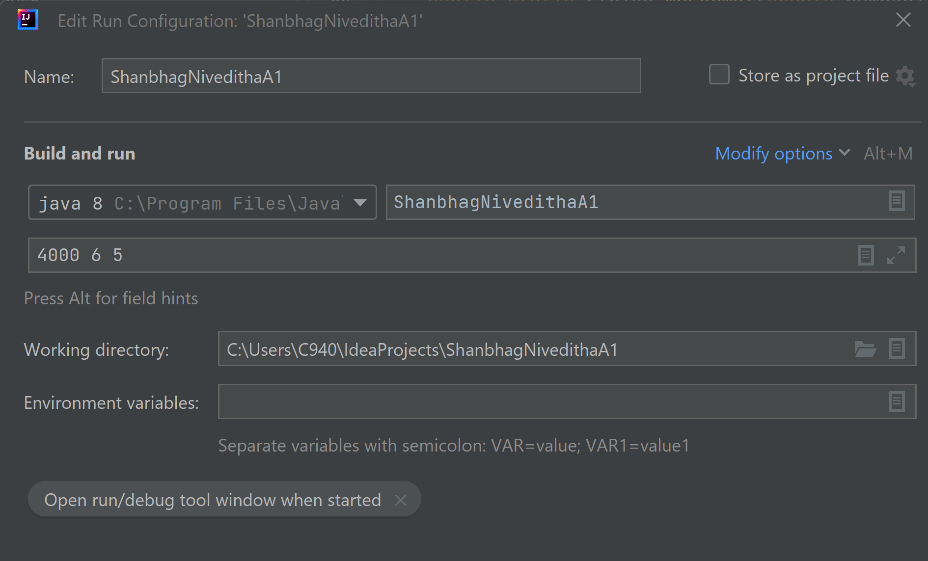

Output:

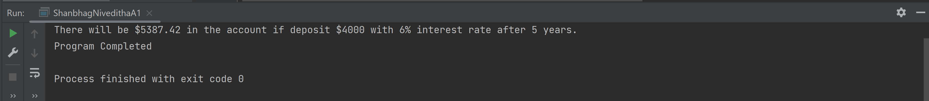

Test Case 2:

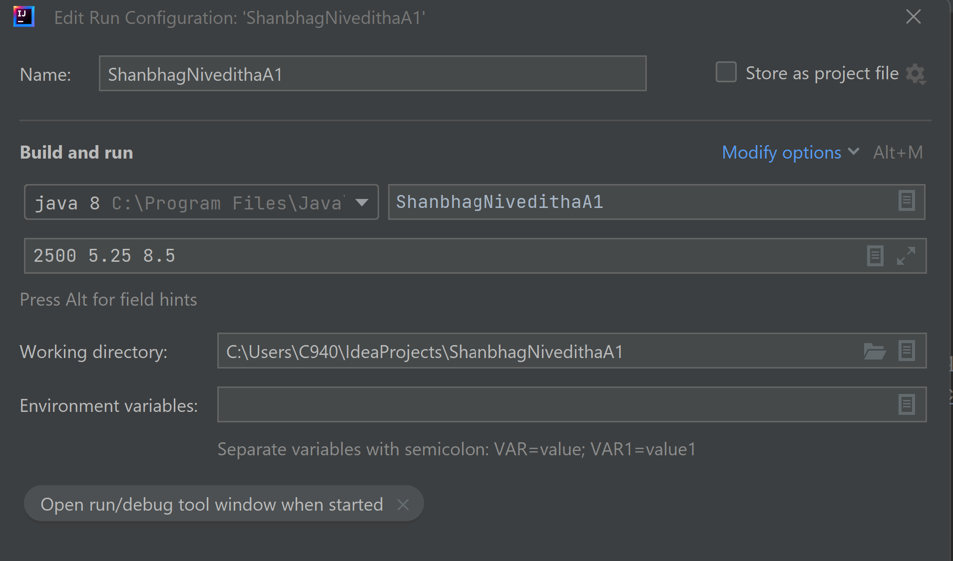

Output:

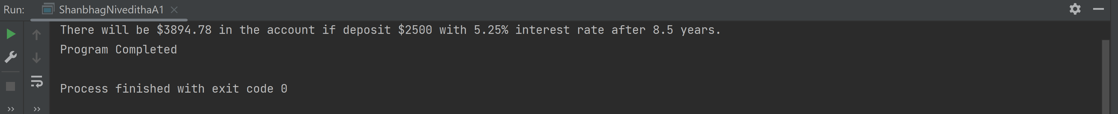

Test Case 3:

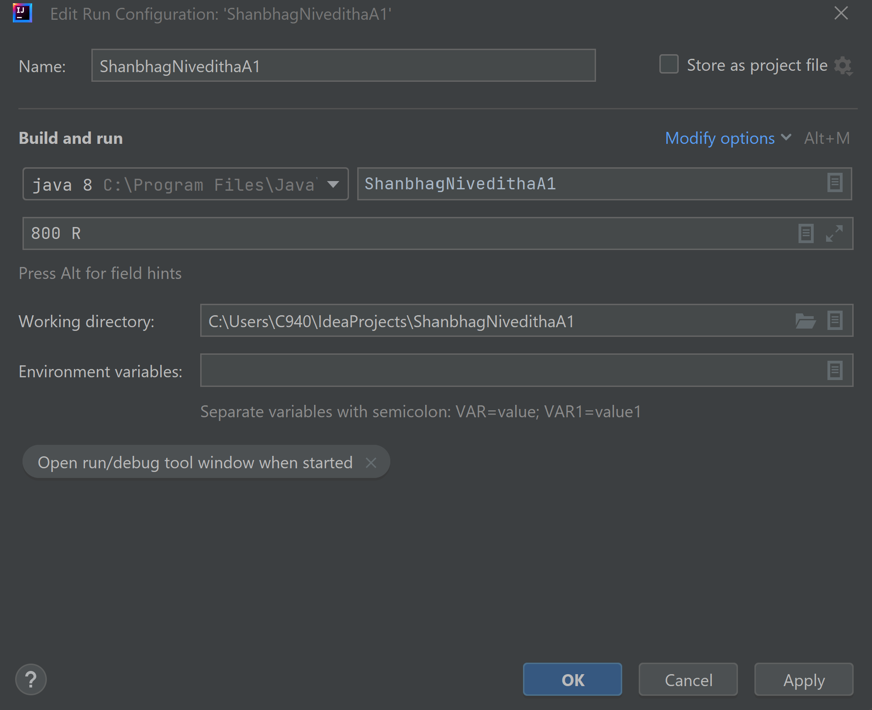

Output:

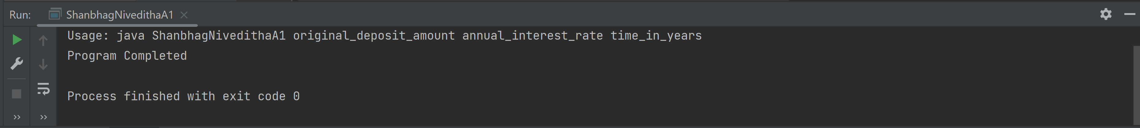

**References/Sources used to complete the assignment:**

1. https://www.math-only-math.com/compound-interest-when-interest-is-compounded-quarterly.html

2. https://www.geeksforgeeks.org/java-program-to-round-a-number-to-n-decimal-places/

3. https://www.w3schools.com/java/java_try_catch.asp