Suman Educational Trust’s

Dilkap Research Institute of Engineering and Management Studies

A PROJECT REPORT
ON

“Expense Tracker System”

Submitted By

Ishan Chaudhari (19)
Lavkush Tiwari (123)
Om Sahane (95)
Khan Mazin Rasheed Ahmed (59)



Second Year Engineering (Sem-IV)
Department of Computer Engineering
Dilkap Research Institute of Engineering and Management Studies
Campus: Village Mamdapur, post- Neral, Tal: Karjat, Pin- 410101
University of Mumbai
2025-2026

Suman Educational Trust’s

Dilkap Research Institute of Engineering and Management Studies

Department of Computer Engineering
Academic year 2025-26

CERTIFICATE
This is to certify that Mini project entitled “Expense Tracker System” is a bonafide work of Ishan Chaudhari (19), Lavkush Tiwari (123), Om Sahane (95), Khan Mazin Rasheed Ahmed (59) submitted to university of Mumbai in partial fulfilment of requirement for the award of degree of “Bachelor of Engineering” in “Computer Engineering”. from S.E Computer Engineering has satisfactorily fulfilled the requirements.

(Prof. Rajni Ratnaparkhi)
Project Guide

(Prof. Archana Mate) (Dr. Shashank Divgi)
Head of Department Principal

MINI PROJECT APPROVEL
This Mini project entitled “Expense Tracker System” by Ishan Chaudhari (19), Lavkush Tiwari (123), Om Sahane (95), Khan Mazin Rasheed Ahmed (59) is approved for the Degree of Bachelor of Engineering in Computer Engineering.
Examiners
1………………………………………..
(Internal Examiner Name & Sign)
1. .......................................................
(External Examiner Name & Sign)

Date:
Place: Neral

CONTENTS

SR.NO DESCRIPTION PAGE NO
Acknowledgement i
Abstract ii
List of figures iii
Chapter 1. Introduction 1
1.1 Introduction 1
1.2 Motivation 1
1.3 Problem Statement & Objectives 2
1.4 Organisation of Report 3

Chapter 2. Literature Survey 4

2.1 Survey of Existing System 4
2.2 Limitations Existing System 4
2.3 Project Modifications 4
2.4 Mini Project Contribution 5
Chapter 3. Proposed System 6

3.1 Introduction 6
3.2 Architecture/Framework 7
3.3 Algorithm 11
3.4 Details of Hardware & Software 13

Chapter 4. Experiment & Results 14

4.1 Implementation 14
Chapter 5. Conclusion & Future Work 21

5.1 Conclusion 21
5.2 Future Work 21
References 24

ACKNOWLEDGEMENT
We would like to express our gratitude and appreciation to all those who gave us the possibility to complete this project and this report. I and my team thank our head of department Prof. Archana Mate for giving us the accessory environment to acquire knowledge and skill. A special thanks to Prof. Rajni Ratnaparkhi, whose help, stimulating suggestions and encouragement, helped us to coordinate our project, especially in writing this report.
We would also like to acknowledge with much appreciation the crucial role of the staff of Computer Laboratory, who gave the permission to use all required machinery and the necessary material to complete the report special thanks goes to our friends, who gave suggestions about the source code.

ABSTRACT

The Expense Tracker System is a web-based application developed to help users manage and monitor their daily financial activities efficiently. The system allows users to record their income and expenses in a simple and organized manner. It provides features to add, edit, and delete transactions, making financial management more flexible and convenient. Users can categorize their expenses and view summaries of their spending over a selected period. The application also generates visual reports and charts to help users analyze their spending patterns. A dashboard provides a quick overview of total income, total expenses, and remaining balance. Budget management features help users control their spending and stay within financial limits. The system is designed with a user-friendly interface to ensure easy navigation and accessibility. Secure data handling and organized storage improve reliability and performance. Overall, the Expense Tracker System helps users track their finances effectively and supports better financial planning.

LIST OF FIGURES

CONTENTS PAGE NO

Use case diagram 7
Activity diagram 8
Block Diagram of Expense Tracker System 9
Class diagram 10

INTRODUCTION

Introduction
The Expense Tracker System is a web-based application designed to help users manage their personal finances effectively. In today's fast-paced world, keeping track of daily income and expenses is essential for better financial planning. Many individuals find it difficult to monitor where their money is being spent, which can lead to poor budgeting and financial imbalance. The Expense Tracker System provides a simple platform where users can record and manage their financial transactions. It allows users to add, edit, and categorize expenses and income, making financial records more organized. The system also provides summaries and graphical reports that help users understand their spending habits. By using this system, users can easily monitor their financial activities and maintain better control over their budget.

Motivation
- Awareness of Personal Spending
Many people are not fully aware of how much they spend daily or where their money goes. An expense tracking system helps users monitor their spending habits and become more conscious of their financial activities.

- Difficulty in Tracking Daily Expenses
Remembering and recording every expense manually can be difficult and time-consuming. The system provides a simple platform where users can easily record and manage their daily financial transactions.

- Need for Organized Financial Records
Traditional methods like notebooks or manual notes can become disorganized and hard to maintain. A digital expense tracker keeps all financial data stored systematically and allows users to access it anytime.

- Importance of Budget Control
Without proper tracking, people may overspend and lose control of their finances. The system helps users manage their budgets and monitor their expenses, encouraging better financial planning and responsible spending.

Problem statement and objectives

Problem statement
Managing daily income and expenses manually can be difficult and time-consuming. Many individuals rely on memory or handwritten records to track their financial activities, which often leads to inaccurate data and missed transactions. As a result, people find it hard to understand their actual spending patterns and financial status.
Without a proper system, it becomes challenging to organize financial records and analyze expenses effectively. Therefore, there is a need for a simple and user-friendly digital solution that allows users to record, manage, and monitor their financial transactions efficiently while providing clear insights into their spending behavior.

Key Objectives
The main objective of the Expense Tracker System is to help users manage their personal finances in a simple and efficient way. The system aims to provide an easy platform where users can record and monitor their income and expenses regularly. It also helps users understand their spending patterns and improve their financial planning.

- Record Financial Transactions
Allow users to add income and expense details easily.
Provide options to edit or delete transactions when required.
Store transaction data securely in the system database.

- Categorize Expenses
Enable users to classify expenses into different categories.
Help users identify where most of their money is being spent.
Improve organization and clarity of financial records.
- Provide Financial Summaries
Display total income, total expenses, and remaining balance.
Generate monthly or weekly summaries for better analysis.
Help users quickly understand their financial status.

- Visualize Data with Reports
Provide charts and graphs to represent spending patterns.
Allow users to analyze financial trends over time.
Make financial information easier to understand visually.

- Support Budget Management
Help users set spending limits for different categories.
Monitor expenses to ensure they stay within the budget.
Encourage responsible spending and better financial planning.

Organization of the Report
This report is organized into several sections to explain the development and functionality of the Expense Tracker System. The introduction section provides an overview of the project and its purpose. The motivation and problem statement describe the need for developing the system. The objectives section outlines the main goals of the project. Further sections of the report explain the system design, implementation details, modules, and technologies used in the development process. Finally, the report concludes with the results of the project and suggestions for future improvements.

LITERATURE SURVEY
Here's a structured analysis for the Expense Tracker System project, focusing on existing systems, their limitations, proposed modifications, and the unique contributions of this mini-project.

Survey of Existing Systems

Many applications are available today to help users manage their personal finances and track daily expenses. Popular applications such as Mint, Spendee, Wallet, and Money Manager allow users to record expenses and monitor their financial activities. These systems provide tools to analyze spending patterns and manage budgets effectively.
Some common features of existing expense tracking systems include:
- Recording daily expenses and income, along with categorizing transactions such as food, travel, and bills.
- Generating financial summaries and graphical reports to help users understand their spending habits.
These systems help users maintain better control over their finances and improve financial planning.

Limitations of Existing Systems

Although many expense tracking systems are available, they still have several limitations that reduce their usability for some users.

- Complex interfaces: Many applications include too many advanced features, which makes them difficult for beginners who only want to track daily expenses.
- Paid features: Some systems require users to purchase premium plans to access important features such as detailed reports, analytics, or budget tracking.
- Dependence on internet: Several applications require constant internet connectivity or bank integration, which may not always be convenient for users.
- Limited customization: Some existing systems do not allow users to easily modify categories, reports, or budgeting options according to their needs.

Project Modifications
To address these limitations, the Expense Tracker System project proposes the following enhancements:
- Simple user interface: The system provides a clean and easy interface that allows users to quickly add and manage their expenses without confusion.
- Expense and income tracking: Users can easily record both expenses and income, helping them maintain a clear record of their financial activities.
- Visual reports and graphs: The system generates charts and summaries that help users analyze their spending patterns more effectively.
- Better organization of data: Expenses are categorized properly so users can view reports and track their spending in an organized way.

Mini Project Contribution

The Expense Tracker System mini-project aims to contribute the following:
- Simple expense management: The system allows users to easily record and track their daily expenses and income in an organized way.

- Categorized financial records: Expenses are divided into categories such as food, travel, bills, and others to help users analyze their spending.

- Visual reports and dashboard: The system provides charts and summaries that help users understand their financial activities clearly.

- Budget monitoring: Users can monitor their spending and compare it with their available balance to manage their finances better.

- User-friendly interface: The application is designed with a clean and simple interface so that users can use it easily without technical knowledge.

This project demonstrates how a simple web-based application can help users manage their daily financial records efficiently. It also helps users understand their spending habits through visual reports and summaries. Overall, the system improves financial awareness and supports better money management.

PROPOSED SYSTEM

Proposed system Introduction

The proposed system, ExpensePro – Expense Tracker System, is a web-based application developed to help users effectively manage and monitor their daily financial activities. In today’s fast-paced digital environment, individuals often find it difficult to keep track of their expenses and income manually. Traditional methods such as writing expenses in notebooks or maintaining simple spreadsheets are time-consuming and may lead to calculation errors or loss of records.
The Expense Tracker System aims to provide a simple and efficient solution for recording and managing personal financial transactions. The system allows users to add, update, and delete expense and income records while categorizing them into different types such as food, transportation, shopping, and other daily expenses. This helps users maintain a clear and organized record of their financial activities.
The proposed system also provides a dashboard that displays financial summaries, including total expenses, total income, remaining balance, and budget status. In addition, the system generates graphical reports such as weekly expense graphs, category distribution charts, and monthly summaries. These visual representations help users easily understand their spending patterns and make better financial decisions.
The application is designed as a user-friendly web platform using modern technologies such as Python with the Flask framework for backend development, HTML, CSS, and JavaScript for the frontend interface, and MongoDb as the database for storing financial records. The system provides a responsive and interactive interface that allows users to manage their expenses conveniently.
Overall, the proposed Expense Tracker System helps users maintain financial discipline by providing an organized platform to record, analyze, and monitor their income and expenses. It simplifies personal financial management and enables users to gain better control over their spending habits through clear summaries and visual reports.

Architecture/Framework

ExpensePro

Register

Login

Add Expenses


Logout
View Dashboard
Edit/Delete Expense
Set Budget Limit
Add Income

USER

Fig. 3.1 : Use Case Diagram
Activity Diagram of Expense Tracker System

The following activity diagram represents the workflow of the Expense Tracker System. It shows the sequence of operations performed by the user and the system from data entry to result generation.

Explanation:
- The user logs into the system.
- The user enters income or expense details.
- The system processes the input data.
- The data is stored in the database.
- The system calculates totals and generates reports.
- The results are displayed to the user in the form of summaries and charts.

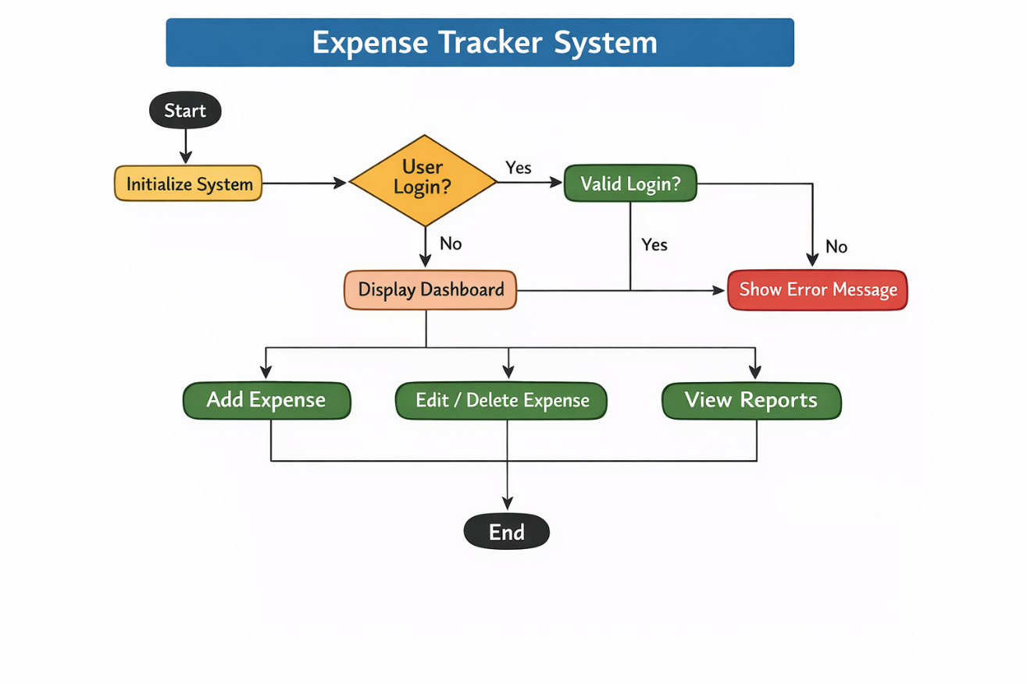

Fig. 3.2 : Activity Diagram

Block Diagram of Expense Tracker System
The following block diagram illustrates the overall architecture of the Expense Tracker System.
User → Web Interface → Backend (Flask) → Database (MongoDB) → Processing & Analysis → Dashboard & Reports
Explanation:
- User Input:
The user enters data such as income, expenses, category, and description through the web interface.
- Web Interface:
The frontend developed using HTML, CSS, and JavaScript collects user input and sends it to the backend.
- Backend Processing (Flask):
The Flask framework processes the data, performs validations, and handles application logic.
- Database (MongoDB):
All financial data is stored securely in the MongoDB database.
- Processing & Analysis:
The system analyzes data to calculate totals, detect patterns, and compare budgets.
- Output (Dashboard & Reports):
The system displays results in the form of summaries, charts, and reports for easy understanding.
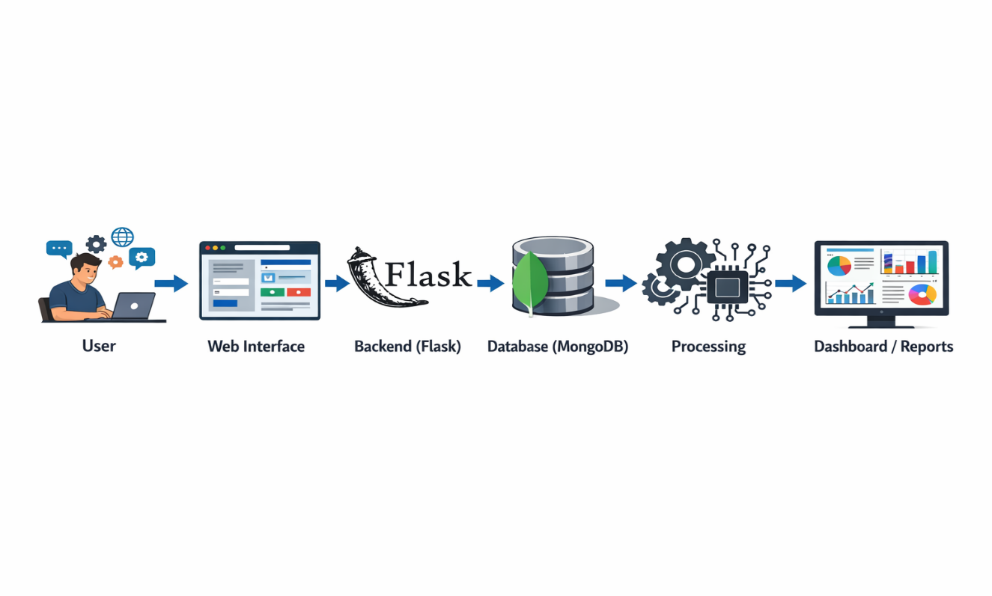

Fig. 3.3 : Block Diagram of Expense Tracker System
CLASS DIAGRAM

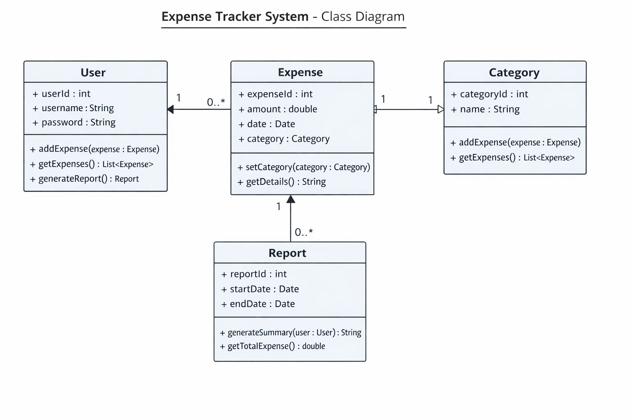
Fig. 3.4 : Class Diagram

3.3 Algorithm and Process Diagram
Expense Tracker System: Personal Finance Tracking Algorithm:
Objective: To develop a system that helps users record, monitor, and analyze their income and expenses to manage personal finances effectively.

3.3.1 Algorithm Steps:
- Data Collection
Input: Transaction data (date, amount, category, description)
The system collects financial transaction records entered by the user. These transactions are stored in the database for further processing and analysis.
- Data Categorization
The system organizes transactions into categories such as food, rent, transportation, and entertainment.
If a transaction is not categorized automatically, the user can manually select the appropriate category.
- Budget Analysis
The system compares the user's expenses with predefined budget limits.
If the spending exceeds the set budget, the system generates alerts to notify the user.
- Pattern Recognition
The system analyses past transaction data to identify spending patterns
Detect spending trends (e.g., high spending on weekends).
- Expense Filtering
The system allows users to filter expenses based on date, category, or amount.
- Recommendation Engine
Suggest ways to save money (e.g., "You spent 40% more on dining this month. Consider cooking at home.").
Provide personalized budgeting tips based on trends.
- Visualization & Reporting
Display spending summaries in charts and graphs. Generate monthly reports for user insights.
3.3.2 Process design

- User Registration and Login
The system allows users to create an account by providing basic details such as username, email, and password.
After registration, users can securely log in to access their personal expense tracking dashboard.
2. Adding Income and Expenses
Users can add their income and expense details by entering information such as amount, date, category, and description.
The system stores these records in the database for tracking and future analysis.
3. Expense Management
The system allows users to view, edit, or delete previously recorded expenses.
This feature helps users maintain accurate financial records and update transactions when required.
4. Budget Management
Users can set monthly budgets for their expenses.
The system monitors the spending and compares it with the defined budget limits.
5. Expense Analysis
The system analyses the stored transaction data to calculate total income, total expenses, and remaining balance.
This helps users understand their financial condition during a specific time period.
6. Report Generation
The system generates reports using charts and graphs to visually represent spending patterns.
These reports help users analyse their financial behaviour and make better budgeting decisions.
7. Dashboard Display
The dashboard shows a summary of income, expenses, and budget status for a quick financial overview.

3.4 Details of Hardware and Software
Hardware requirements :
  - Processor: Dual core processor (intel core i3 or AMD Ryzen 3)
  - PC with 4GB RAM.
  - Storage: 100 MB of hard disk space for the dependencies
  - A stable internet connection is required if you plan to deploy the app to cloud server or use any external APIs.

Software requirements :
  - Operating system :- Windows, macOS, Linux
  - Language:- Python
  - Database:- MongoDb
  - IDE:- Visual Studio Code
  - Browser:- Google Chrome

4. EXPERIMENT AND RESULT

"ExpensePro," which appears to be an expense management application.
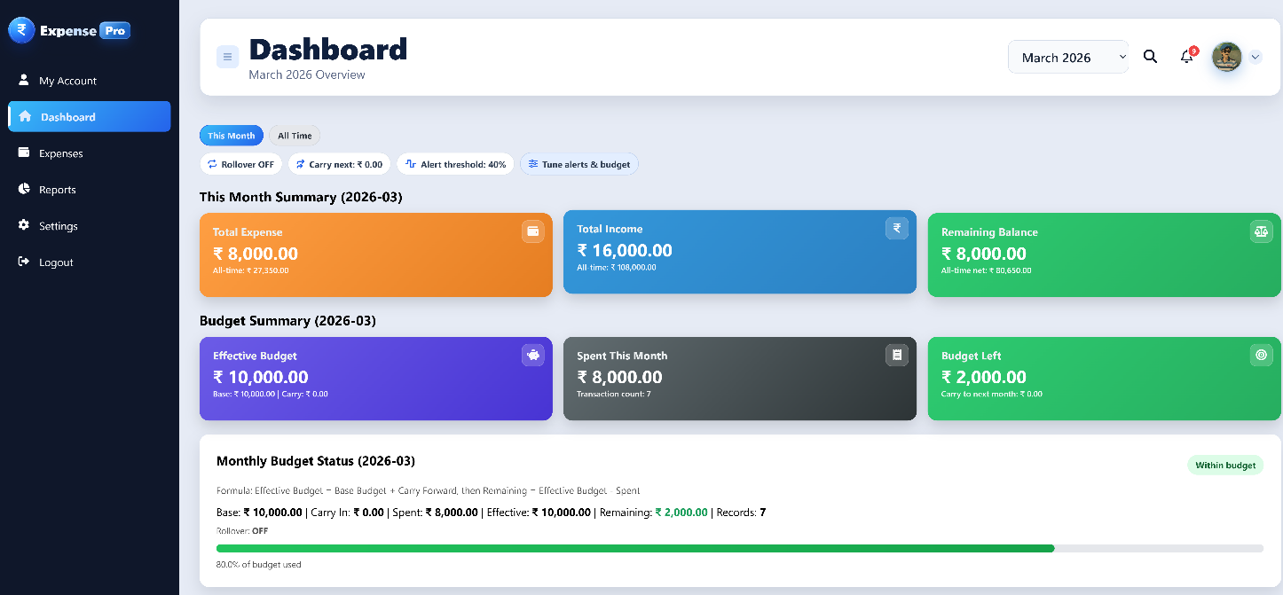
Fig. 4.1 : Navigation Panel

- Navigation Panel (Left Sidebar):
The Navigation Panel is located on the left side of the ExpensePro interface. It allows users to easily navigate between different sections of the application. The panel contains the following options:
- My Account – Displays the user's account information.
- Dashboard – Shows the summary of income, expenses, and budget details.
- Expenses – Allows users to add, view, and manage expenses and income.
- Reports – Provides graphical reports and spending analysis.
- Settings – Enables users to configure application preferences.
- Logout – Allows the user to securely exit the system.
This navigation panel provides a simple and user-friendly way for users to access different functionalities of the ExpensePro system.
- Main Content Area (Right Section):
Header ("Dashboard – March 2026 Overview"): Displays the title of the current page and indicates that the user is viewing the dashboard along with the monthly financial overview.
Month Selection Dropdown ("March 2026"): Allows users to select different months in order to view financial summaries, expenses, income, and reports for a specific time period.
Dashboard Summary Cards: The main content area also displays important financial information such as Total Expense, Total Income, Remaining Balance, Budget Summary, and Budget Status, helping users quickly understand their financial situation.
Charts and Expense Insights: Graphs and alerts such as Recent Expenses, Last 7 Days Expense Chart, Category Spending Breakdown, and Smart Anomaly Alerts provide visual insights into spending patterns.
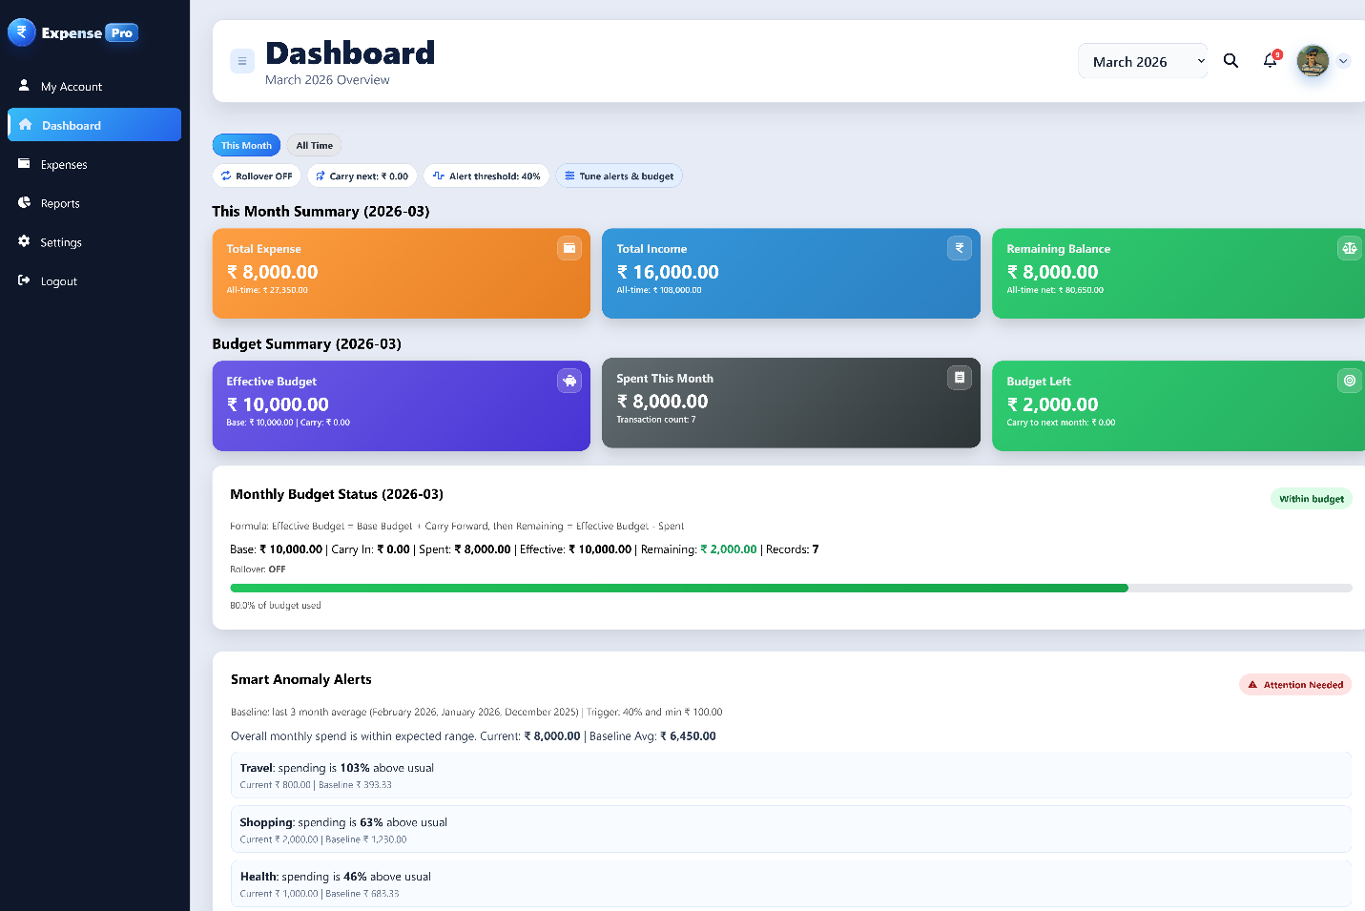
Fig. 4.2 : Dashboard

Overview :-
Navigation Panel (Left Sidebar)
The Dashboard is the main interface of the ExpensePro system. It provides a summary of the user's financial activities for the selected month.
The dashboard displays the following information:
1. Monthly Summary
The monthly summary section includes:
- Total Expense – Displays the total amount spent during the selected month.
- Total Income – Shows the total income recorded for the month.
- Remaining Balance – Calculates the difference between total income and total expenses.
This summary helps users quickly understand their financial status.
2. Budget Summary
The Budget Summary section helps users track how much of their budget has been used.
It displays:
- Effective Budget – The total budget allocated for the month.
- Spent This Month – The total amount spent so far.
- Budget Left – The remaining amount available in the budget.
A progress bar is also displayed to visually represent the percentage of the budget that has been used.
3. Smart Anomaly Alerts
The Smart Anomaly Alerts feature identifies unusual spending behavior by comparing the user's current spending with the average spending of previous months.
For example, the system detects when spending in categories such as:
- Travel
- Shopping
- Health
is significantly higher than usual. These alerts help users become aware of abnormal spending patterns and encourage better financial management.
4. Expenses Section
The Expenses page allows users to manage their daily financial transactions. The page shows a list of recorded expenses along with their details.
Each expense record contains the following information:
- Amount – The amount of money spent.
- Category – The type of expense such as Food, Shopping, Bills, Travel, etc.
- Description – A short note describing the expense.
- Date – The date when the expense was recorded.
- Time – The time when the transaction occurred.
Each entry also contains two action buttons:
- Edit Button – Allows users to modify the expense details.
- Delete Button – Allows users to remove the expense from the system.
5. Purpose of the Expenses Page
The main purpose of the Expenses page is to:
- Help users record and track their daily expenses.
- Provide an organized list of all financial transactions.
- Allow users to edit or delete expense records when needed.
This feature helps users maintain accurate and updated financial data.
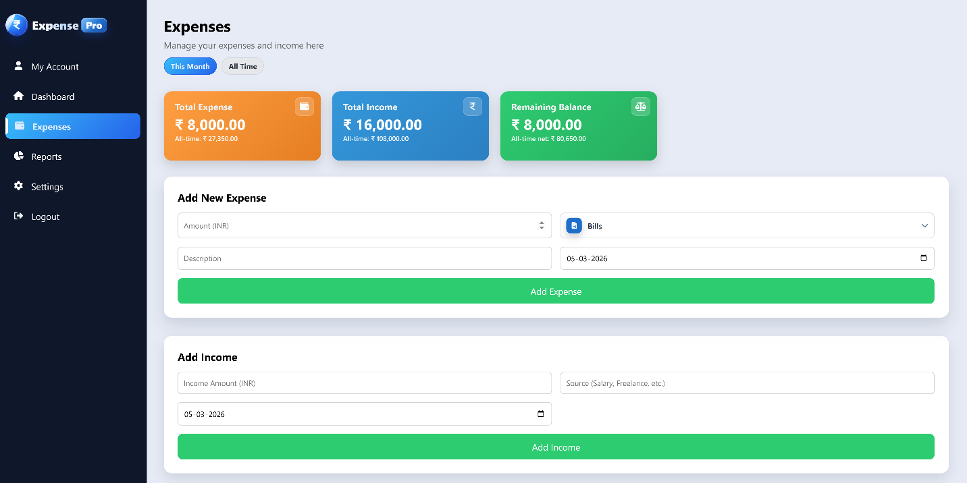
Fig. 4.3 : Adding a New Expense and Income
- Adding a New Expense and Income
ExpensePro allows users to add both expenses and income transactions.
Adding a New Expense
Users can add a new expense by entering the following details:
- Amount
- Category
- Description
- Date
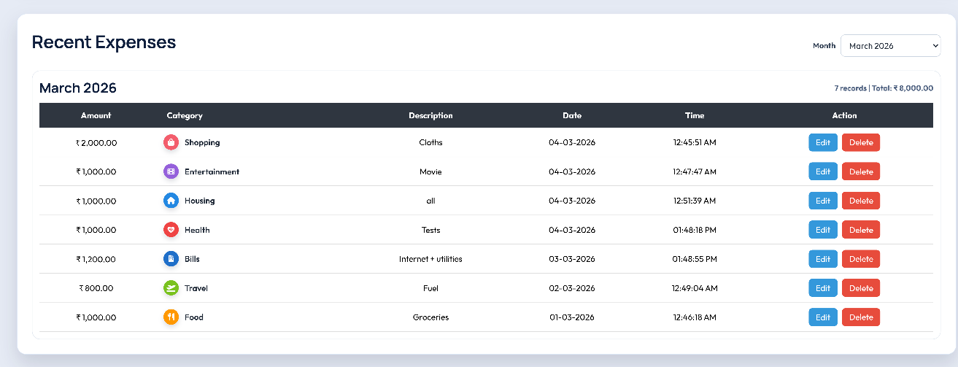
Fig. 4.4 : Recent Expense
After submitting the form, the expense is stored in the system and displayed in the expense list.
Adding Income
The system also allows users to record income details including:
- Income Amount
- Income Source
- Date
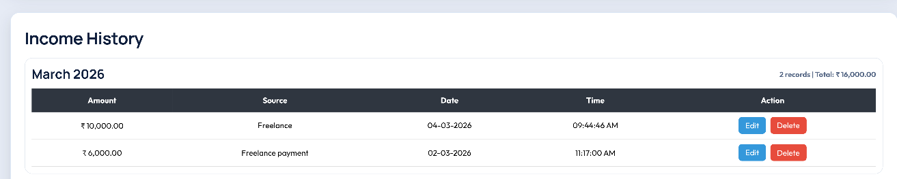
Fig. 4.5 : Income History
Recording income helps the system calculate the user's total balance and budget accurately.

- Viewing and Managing Expenses
The system allows users to perform several operations on recorded transactions:
Viewing Expenses
Users can view all recorded expenses in a structured table format.
Editing Expenses
Users can modify previously entered expenses if corrections are needed.
Deleting Expenses
Users can remove unwanted or incorrect expense records using the delete option.
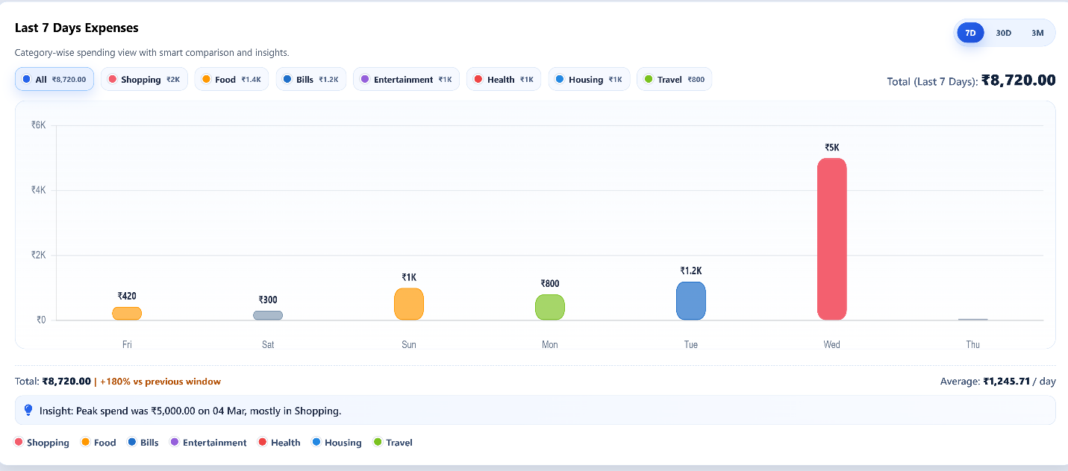
Fig. 4.6 : Expense Graph

Graphical Representation of Expenses
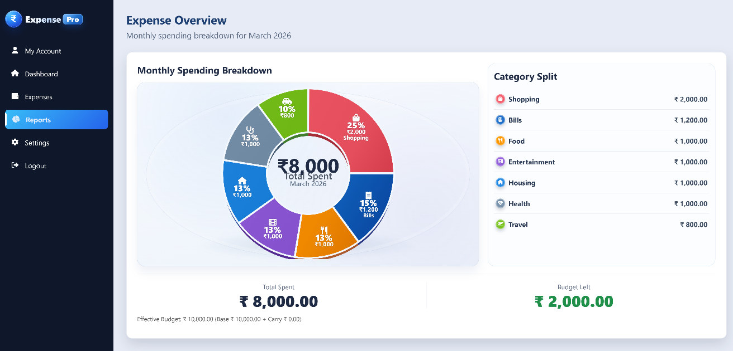
Fig. 4.7 : Category Chart

Reports and Category Chart
The Reports section provides visual representation of the user's spending patterns using charts.
The Category Chart displays a graphical breakdown of expenses according to different categories such as:
- Shopping
- Bills
- Food
- Entertainment
- Health
- Housing
- Travel
The chart shows the percentage and total amount spent in each category, allowing users to easily understand where most of their money is being spent.
This visualization helps users analyze their financial behavior and make better budgeting decisions.
Purpose of ExpensePro
The main purpose of the ExpensePro Expense Tracker System is to help users effectively manage their income and expenses.
The system provides:
- Easy expense recording
- Budget monitoring
- Spending analysis
- Visual financial reports
- Smart alerts for unusual spending
By using ExpensePro, users can improve their financial planning and maintain better control over their spending habits.

5. CONCLUSION AND FUTURE SCOPE

5.1 Conclusion
The ExpensePro Expense Tracker System was successfully developed to help users manage their daily financial activities in an efficient and organized way. The system provides a simple interface that allows users to record their income and expenses, monitor their budget, and analyze their spending patterns.
Through the dashboard, users can easily view their monthly income, total expenses, remaining balance, and budget status. The system also provides visual reports and charts that help users understand how their money is distributed across different expense categories such as food, shopping, travel, and bills.
One of the important features of the system is the Smart Anomaly Alert, which detects unusual spending patterns by comparing current expenses with previous averages. This helps users become more aware of their spending behavior and make better financial decisions.
The Expenses module allows users to add, edit, and delete expense records, ensuring that financial data remains accurate and up to date. The Reports section provides graphical representations of financial data, making it easier for users to analyze their spending habits.
Overall, the ExpensePro system successfully achieves its objective of providing a user-friendly and effective expense management solution.

5.2 Future Scope
Although the current version of the ExpensePro Expense Tracker System provides essential features for managing income and expenses, there are many opportunities to enhance the system in the future. The following improvements can be implemented to make the application more powerful and user-friendly.

1. Mobile Application Development
In the future, a mobile application version of ExpensePro can be developed for Android and iOS devices. A mobile app would allow users to record expenses instantly whenever they make a purchase. This would make the system more convenient and accessible for users who prefer managing their finances on smartphones.
2. Cloud-Based Data Storage
Currently, the system stores data locally in the database. In future versions, the system can be integrated with cloud storage services so that users can access their financial data from multiple devices. Cloud synchronization would also improve data security and allow automatic backups.

3. Advanced Data Analytics
The system can include advanced analytical tools to provide deeper insights into user spending behavior. Features such as monthly comparisons, trend analysis, and predictive budgeting could help users make better financial decisions.

4. Bank and Payment Integration
ExpensePro could be integrated with online banking systems or digital payment platforms such as UPI, debit cards, or mobile wallets. This integration would allow automatic detection and recording of transactions, reducing the need for manual data entry.

5. Multi-User Support
Future versions of the system can support multiple user accounts. This would allow families or organizations to track expenses collectively while maintaining individual profiles and access permissions.

6. Export and Download Reports
Another useful enhancement would be the ability to export reports in PDF, Excel, or CSV format. Users could download their monthly or yearly financial reports for documentation, financial planning, or record keeping.

7. Budget Planning and Notifications
The system can include budget planning tools where users set spending limits for different categories. The application could send notifications or alerts when spending approaches or exceeds the allocated budget.

8. AI-Based Financial Suggestions
In the future, artificial intelligence can be integrated to provide personalized financial recommendations. The system could analyze spending habits and suggest ways to save money or optimize expenses.

9. Enhanced Security Features
Additional security measures such as two-factor authentication (2FA), encrypted data storage, and secure login systems can be implemented to protect user financial data.

This expanded future scope demonstrates that the ExpensePro system has strong potential for further development and improvement, making it a useful financial management tool for individuals and organizations
REFERENCES
[1] S. Jha, P. Jha, R. Singh, S. Kumari and Lokesh, “Design and Implementation of a Web-Based Expense Tracker System for Personal Finance Management,” International Journal of Research in Engineering & Science, vol. 9, no. 6, 2025, doi:10.5281/zenodo.18066941.
[2] J. Mohan, D. Santosh Tonape, D. Bhargav, G. Vinay Reddy and K. Akshay, “Expense Tracker – An Expense Tracking Application Using OCR and Random Forest Algorithm,” International Journal of Engineering Research and Science & Technology, vol. 21, no. 3(1), pp. 1795–1802, 2025, doi:10.62643/ijerst.2025.v21.n3(1).pp1795-1802.
[3] S. Bakar and R. Rosbi, “Design of a Personal Financial Management System,” International Journal of Scientific & Technology Research, vol. 7, no. 10, pp. 191–195, 2018.
[4] A. Kumar and R. Singh, “Web-Based Personal Expense Management System,” International Journal of Computer Applications, vol. 182, no. 44, pp. 1–5, 2019.
[5] N. Sharma and P. Aggarwal, “A Study on Personal Financial Management Systems,” International Journal of Advanced Research in Computer Science, vol. 10, no. 2, 2019.
[6] M. Patel and J. Patel, “Development of Smart Expense Tracker Application,” International Journal of Innovative Research in Technology, vol. 6, no. 12, 2020.
[7] R. Smith, “An Overview of the Tesseract OCR Engine,” in Proceedings of the International Conference on Document Analysis and Recognition (ICDAR), 2007.
[8] S. Kumar and A. Verma, “Receipt Data Extraction Using OCR and Machine Learning,” International Journal of Engineering Research & Technology (IJERT), 2021.
[9] L. Breiman, “Random Forests,” Machine Learning, vol. 45, no. 1, pp. 5–32, 2001.
[10] M. Fowler, Patterns of Enterprise Application Architecture, Addison-Wesley, 2002.
[11] R. S. Pressman, Software Engineering: A Practitioner’s Approach, 7th ed., McGraw-Hill, 2010.
[12] Python Software Foundation, “Python Documentation,” 2024. [Online]. Available: https://docs.python.org. [Accessed: Mar. 24, 2026].
[13] Pallets Projects, “Flask Documentation,” 2024. [Online]. Available: https://flask.palletsprojects.com. [Accessed: Mar. 24, 2026].
[14] MongoDB Inc., “MongoDB Documentation,” 2024. [Online]. Available: https://www.mongodb.com/docs. [Accessed: Mar. 24, 2026].
[15] W3Schools, “HTML, CSS and JavaScript Tutorials,” [Online]. Available: https://www.w3schools.com. [Accessed: Mar. 24, 2026].

