Project Euler #607

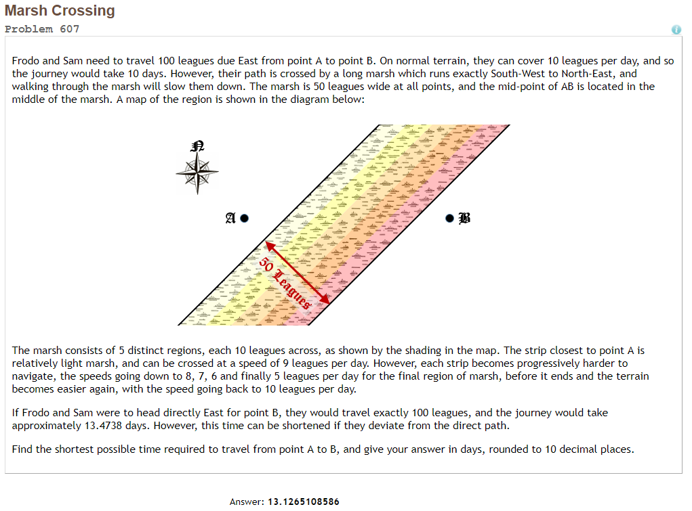

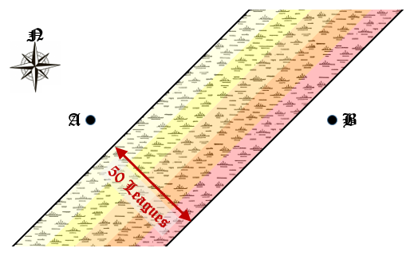

100 leagues

${100}/{\sqrt{2}}$ leagues

${100}/{\sqrt{2}}$ leagues

Let  be the entrance angle to the  region.  
 be the horizontal distance of each region,  
and  the speed on each region.

.

.



Using “Lagrange Multipliers”:







Using “fsolve” to find  (from equation ),  
and then using equation  to find the minimal time.

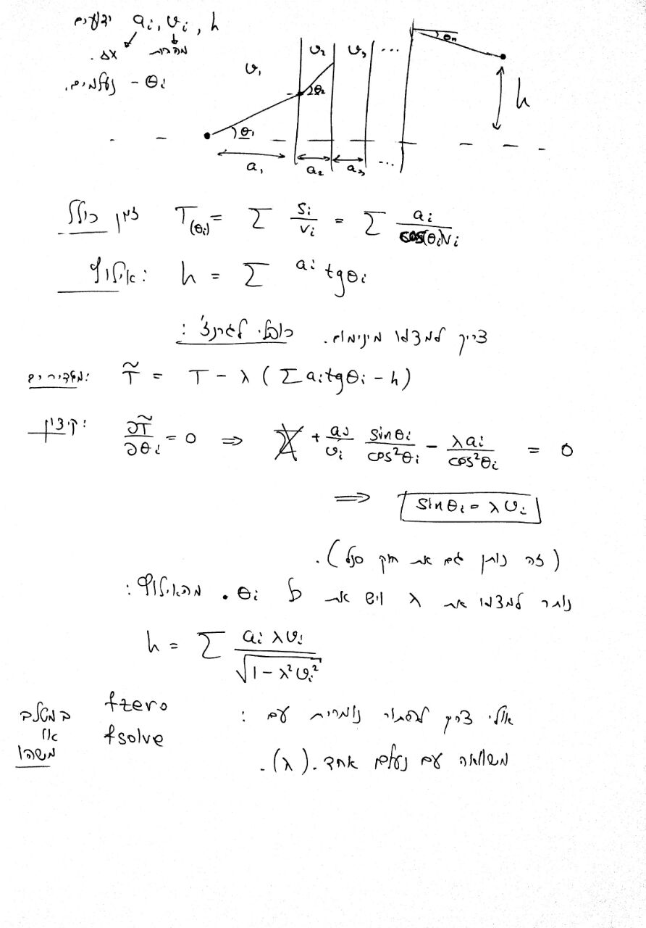Solution of Hillel Sanhedrai