WEB DEVELOPMENT CAPSTONE PROJECT REPORT
Project Title: EduAccess – Free Quality Education Resource Hub
Target SDG: SDG 4 (Quality Education)
Student Name: Isha Negi

1. Selected SDG and Reason for Selection
- Selected Goal: Sustainable Development Goal 4 - Quality Education.
- Core Objective: Ensure inclusive and equitable quality education and promote lifelong learning opportunities for all.
- Reason for Selection: Across the globe, millions of students lack access to affordable, organized, and quality study resources. Textbooks and specialized coaching platforms are often expensive, creating a wide educational divide between privileged and underprivileged students. EduAccess is designed to bridge this gap by providing a 100% free, responsive, and open-access portal where students can find curated notes, video tutorials, and interactive study tools.

2. Problem Statement
- The Core Issue: Educational resources online are highly fragmented, unorganized, or locked behind paywalls.
- Affected Audience: High school students, university undergraduates, and self-learners who cannot afford subscription-based learning platforms.
- Impact & Severity: Without structured study material, self-learners spend excessive time searching for reliable sources, leading to poor conceptual clarity and reduced academic outcomes.
- Consequences of Non-Resolution: The digital and educational divide will continue to widen, limiting career and skill development opportunities for underprivileged youth.

3. Proposed Solution
- Overview: EduAccess is a lightweight, responsive web application that centralizes core academic subjects into a clean, easy-to-navigate interface.
- How It Works:
  - Students can select their subject of interest from the interactive course grid.
  - Each subject section provides structured study notes, downloadable reference materials, and embedded high-quality video tutorials.
  - A feedback and resource request form allows users to submit requests for specific study materials or report broken links.
- Key Benefits: No mandatory login or hidden subscription fees, mobile-first design for low-bandwidth environments, and high accessibility across all screen sizes.

4. Key Features & Functionality
- Dynamic Header & Navigation: Fully responsive navigation menu with fast jump links to Courses, About, and Contact sections.
- Subject Resource Grid: Visual card components utilizing CSS Flexbox and Grid to showcase subject categories with hover animations.
- Resource Filter & Search: A frontend search bar that lets users filter study materials by keyword or topic dynamically.
- Embedded Learning Content: Embedded YouTube video tutorials and structured HTML text sections for seamless reading.
- Interactive Contact/Feedback Form: Form validation using JavaScript to allow users to submit requests and feedback.

5. Technology Stack
- Frontend: HTML5 (Semantic elements), CSS3 (Flexbox, CSS Grid, Media Queries for responsiveness), JavaScript (DOM manipulation, Event Listeners).
- Version Control & Hosting: Git, GitHub for open-source code hosting, and GitHub Pages for live deployment.

6. Project Screenshots (Proof of Work)
1.Homepage & Navigation Dashboard: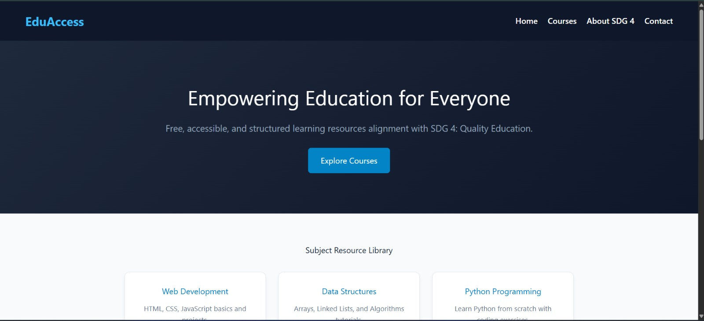
2. Subject Resource Grid & Course Content:
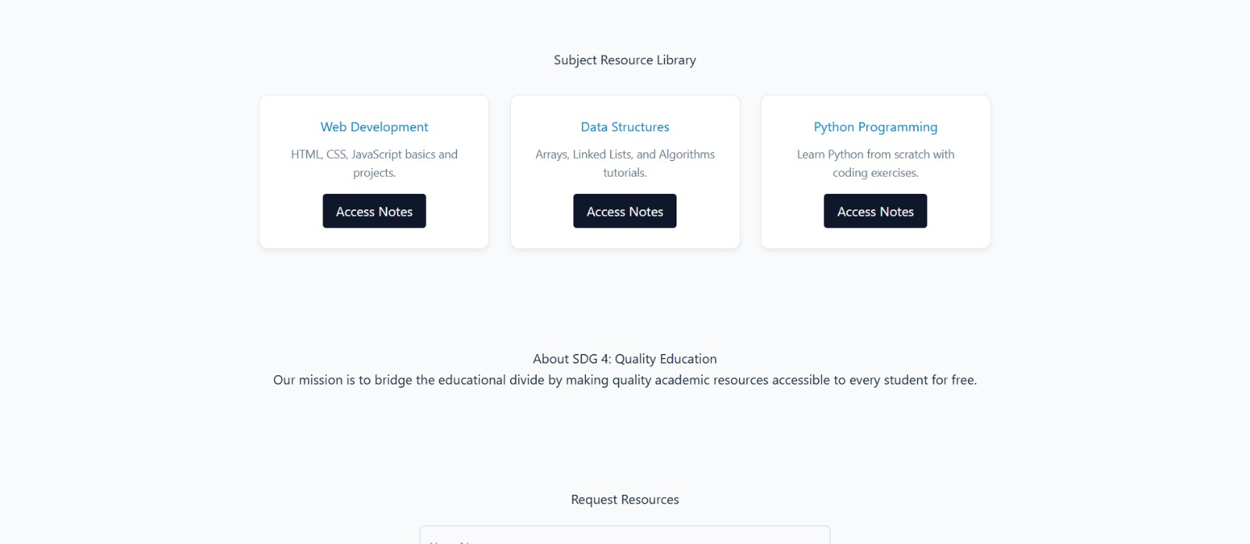
- Contact & Feedback Form:
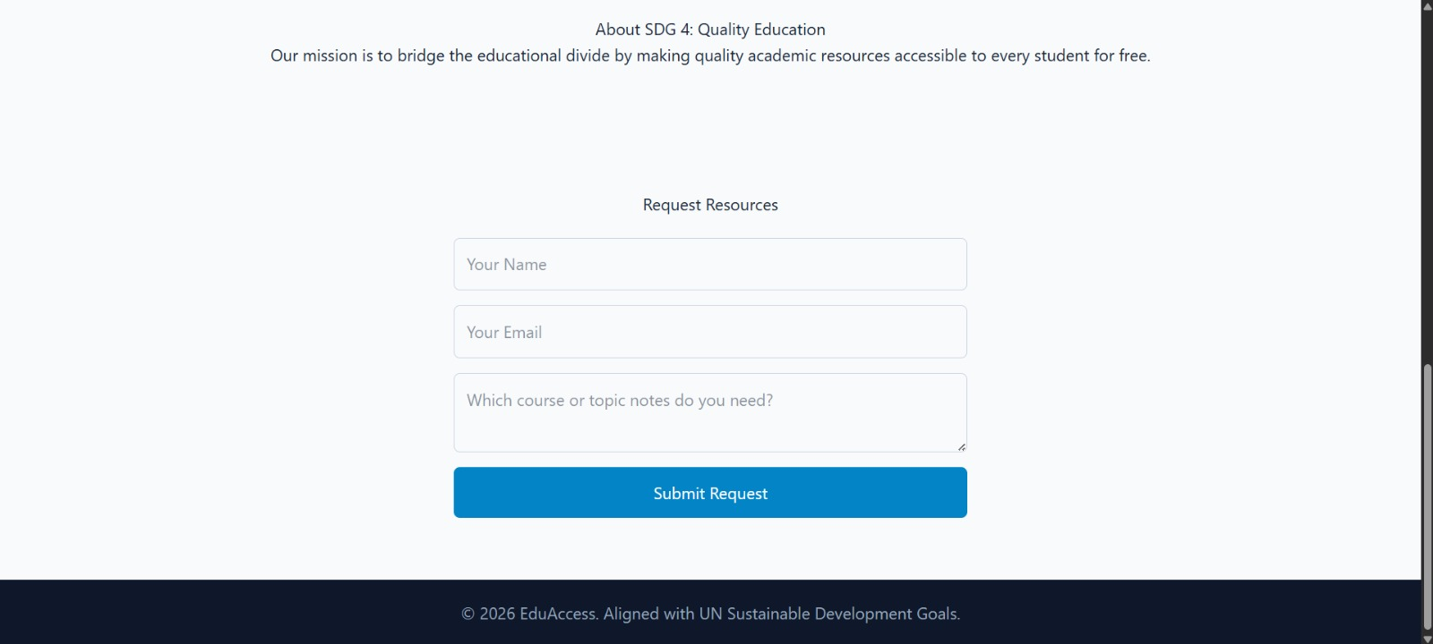

7. Open Source Repository & Links
- GitHub Repository Link: [https://github.com/ishanegi7/SDG4-EduAccess]
- Live Website Deployment Link: https://sdg-4-edu-access-ishanegi.vercel.app/

8. Future Scope
- User Authentication & Personalization: Adding a backend database (Node.js/Express and MongoDB) to allow users to save progress and bookmark notes.
- Interactive Quiz System: Implementing multiple-choice quizzes at the end of each module to test student understanding.
- Progressive Web App (PWA): Converting the application into a PWA so students can download notes for offline offline viewing in low-connectivity areas.

